Android Notes V2

1.0: Introduction to Android

**Contents:**

* [What is Android?](https://google-developer-training.github.io/android-developer-fundamentals-course-concepts-v2/unit-1-get-started/lesson-1-build-your-first-app/1-0-c-introduction-to-android/1-0-c-introduction-to-android.html#introduction)
* [Why develop apps for Android?](https://google-developer-training.github.io/android-developer-fundamentals-course-concepts-v2/unit-1-get-started/lesson-1-build-your-first-app/1-0-c-introduction-to-android/1-0-c-introduction-to-android.html#why)
* [Android versions](https://google-developer-training.github.io/android-developer-fundamentals-course-concepts-v2/unit-1-get-started/lesson-1-build-your-first-app/1-0-c-introduction-to-android/1-0-c-introduction-to-android.html#versions)
* [The challenges of Android app development](https://google-developer-training.github.io/android-developer-fundamentals-course-concepts-v2/unit-1-get-started/lesson-1-build-your-first-app/1-0-c-introduction-to-android/1-0-c-introduction-to-android.html#challenges)
* [Learn more](https://google-developer-training.github.io/android-developer-fundamentals-course-concepts-v2/unit-1-get-started/lesson-1-build-your-first-app/1-0-c-introduction-to-android/1-0-c-introduction-to-android.html#learnmore)

What is Android?

Android is an operating system and programming platform developed by Google for mobile phones and other mobile devices, such as tablets. It can run on many different devices from many different manufacturers. Android includes a software development kit (SDK) that helps you write original code and assemble software modules to create apps for Android users. Android also provides a marketplace to distribute apps. All together, Android represents an *ecosystem* for mobile apps.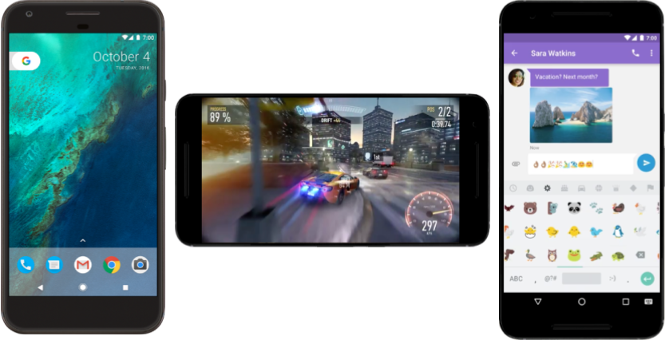

Why develop apps for Android?

Developers create apps for a variety of reasons. They may need to address business requirements or build new services or businesses, or they may want to offer games and other types of content for users. Developers choose to develop for Android in order to reach the majority of mobile device users.

Most popular platform for mobile apps

As the world's most popular mobile platform, Android powers hundreds of millions of mobile devices in more than 190 countries around the world. It has the largest installed base of any mobile platform and is still growing fast. Every day another million users power up their Android-powered devices for the first time and start looking for apps, games, and other digital content.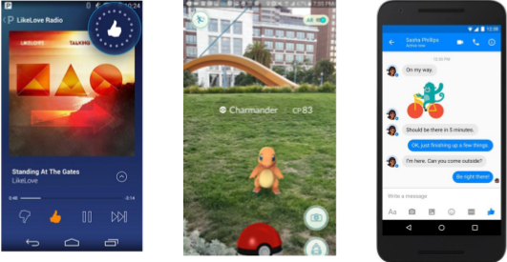

Best experience for app users

Android provides a touchscreen user interface (UI) for interacting with apps. Android's UI is mainly based on direct manipulation. People use touch gestures such as swiping, tapping, and pinching to manipulate on-screen objects. In addition to the keyboard, there's a customizable on-screen keyboard for text input. Android can also support game controllers and full-size physical keyboards connected by Bluetooth or USB.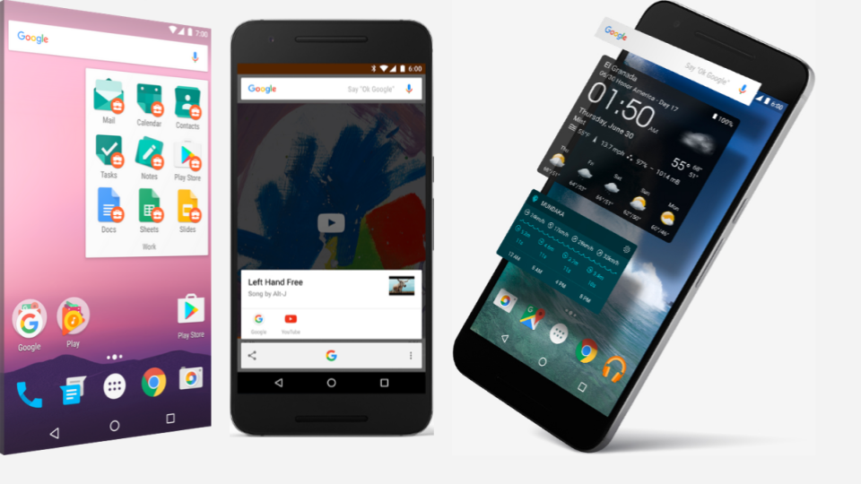

The Android home screen can contain several panes of *app icons*, which launch their associated apps. Home screen panes can also contain *app widgets*, which display live, auto-updating content such as the weather, the user's email inbox, or a news ticker. Android can also play multimedia content such as music, animation, and video. The figure above shows app icons on the home screen (left), playing music (center), and displaying app widgets (right). Along the top of the screen is a status bar, showing information about the device and its connectivity. The Android home screen may be made up of several panes, and the user swipes back and forth between the panes.

Android is designed to provide immediate response to user input. Besides a dynamic interface that responds immediately to touch, an Android-powered device can vibrate to provide haptic feedback. Many apps take advantage of internal hardware such as accelerometers, gyroscopes, and proximity sensors to respond to additional user actions. These sensors can also detect screen rotation. For example, you could design a racing game where the user rotates the device as if it were a steering wheel.

The Android platform, based on the [Linux kernel](https://en.wikipedia.org/wiki/Linux_kernel), is designed primarily for touchscreen mobile devices such as mobile phones and tablets. Because Android-powered devices are usually battery-powered, Android is designed to manage processes to keep power consumption at a minimum, providing longer battery use.

It's easy to develop apps

To develop apps that take advantage of the Android operating system and UI, use the Android software development kit (SDK). The SDK includes software libraries of prewritten code, a debugger, a device emulator, documentation, sample code, and tutorials. Use the SDK to create apps that look great and take advantage of the hardware capabilities available on each Android-powered device.

To develop apps using the SDK, you use the [Java programming language](https://en.wikipedia.org/wiki/Java_(programming_language)) to develop the app and [Extensible Markup Language](https://en.wikipedia.org/wiki/XML) (XML) files to describe data resources. By writing the code in Java and creating a single app binary, you create an app that can run on both phone and tablet form factors. You can declare your UI in lightweight sets of XML resources. For example, create one set for parts of the UI that are common to all form factors, and other sets for features specific to phones or tablets. At runtime, Android applies the correct resource sets based on the device's screen size, screen density, locale, and so on.

To help you develop your apps efficiently, Google offers an integrated development environment (IDE) called [Android Studio](https://developer.android.com/studio/index.html). It offers advanced features for developing, debugging, and packaging Android apps. Using Android Studio, you can develop for any Android-powered device, or create virtual devices that emulate any hardware configuration.

Android provides a rich development architecture. You don't need to know much about the components of this architecture, but it is useful to know what is available in the system for your app to use. The following diagram shows the major components of the Android *stack*—the operating system and development architecture.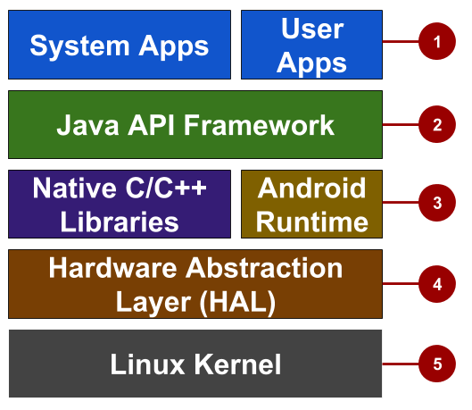

In the figure above:

1. *Apps:* Your apps live at this level, along with core system apps for email, SMS messaging, calendars, internet browsing, and contacts.
2. *Java API framework:* All features for Android development, such as [UI components](https://developer.android.com/guide/topics/ui/overview.html), [resource management](https://developer.android.com/guide/topics/resources/overview.html), and [lifecycle management](https://developer.android.com/guide/components/activities.html), are available through application programming interfaces (APIs). You don't need to know the details of how the APIs work. You only need to learn how to use them.
3. *Libraries and Android runtime:* Each app runs in its own process, with its own instance of the Android runtime. Android includes a set of core runtime libraries that provide most of the functionality of the Java programming language. Many core Android system components and services are built from native code that require native libraries written in C and C++. These native libraries are available to apps through the Java API framework.
4. *Hardware abstraction layer (HAL):* This layer provides standard interfaces that expose device hardware capabilities to the higher-level Java API framework. The HAL consists of multiple library modules, each of which implements an interface for a specific type of hardware component, such as the camera or Bluetooth module.
5. *Linux kernel:* The foundation of the Android platform is the Linux kernel. The layers above the Linux kernel rely on the Linux kernel for threading, low-level memory management, and other underlying functionality. Using a Linux kernel enables Android to take advantage of Linux-based security features and allows device manufacturers to develop hardware drivers for a well-known kernel.

Many distribution options

You can distribute your Android app in many different ways: email, website, or an app marketplace such as [Google Play](https://play.google.com/store). Android users download billions of apps and games from the Google Play store each month. Google Play is a digital distribution service, operated and developed by Google, that serves as the official app store for Android. Google Play lets consumers to browse and download apps developed with the Android SDK.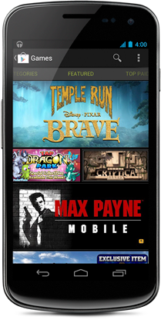

Android versions

Google provides major incremental upgrades to the Android operating system using confectionery-themed names. The latest major release is Android 8.0 "Oreo".

|  |  |  |  |
| --- | --- | --- | --- |
| **Code name** | **Version number** | **Initial release date** | **API level** |
| N/A | 1.0 | 23 September 2008 | 1 |
| 1.1 | 9 February 2009 | 2 |  |
| [Cupcake](https://en.wikipedia.org/wiki/Android_Cupcake) | 1.5 | 27 April 2009 | 3 |
| [Donut](https://en.wikipedia.org/wiki/Android_Donut)https://google-developer-training.github.io/android-developer-fundamentals-course-concepts-v2/images/1-0-c-introduction-to-android/donut_circle.png | 1.6 | 15 September 2009 | 4 |
| [Eclair](https://en.wikipedia.org/wiki/Android_Eclair)https://google-developer-training.github.io/android-developer-fundamentals-course-concepts-v2/images/1-0-c-introduction-to-android/eclair_circle.png | 2.0 – 2.1 | 26 October 2009 | 5–7 |
| [Froyo](https://en.wikipedia.org/wiki/Android_Froyo)https://google-developer-training.github.io/android-developer-fundamentals-course-concepts-v2/images/1-0-c-introduction-to-android/froyo_circle.png | 2.2 – 2.2.3 | 20 May 2010 | 8 |
| [Gingerbread](https://en.wikipedia.org/wiki/Android_Gingerbread)https://google-developer-training.github.io/android-developer-fundamentals-course-concepts-v2/images/1-0-c-introduction-to-android/gingerbread_circle.png | 2.3 – 2.3.7 | 6 December 2010 | 9–10 |
| [Honeycomb](https://en.wikipedia.org/wiki/Android_Honeycomb)https://google-developer-training.github.io/android-developer-fundamentals-course-concepts-v2/images/1-0-c-introduction-to-android/honeycomb_circle.png | 3.0 – 3.2.6 | 22 February 2011 | 11–13 |
| [Ice Cream Sandwich](https://en.wikipedia.org/wiki/Android_Ice_Cream_Sandwich)https://google-developer-training.github.io/android-developer-fundamentals-course-concepts-v2/images/1-0-c-introduction-to-android/icecream_circle.png | 4.0 – 4.0.4 | 18 October 2011 | 14–15 |
| [Jelly Bean](https://developer.android.com/about/versions/jelly-bean.html)https://google-developer-training.github.io/android-developer-fundamentals-course-concepts-v2/images/1-0-c-introduction-to-android/jellybean_circle.png | 4.1 – 4.3.1 | 9 July 2012 | 16–18 |
| [KitKat](https://developer.android.com/about/versions/kitkat.html)https://google-developer-training.github.io/android-developer-fundamentals-course-concepts-v2/images/1-0-c-introduction-to-android/kitkat_circle.png | 4.4 – 4.4.4 | 31 October 2013 | 19–20 |
| [Lollipop](https://developer.android.com/about/versions/lollipop.html)https://google-developer-training.github.io/android-developer-fundamentals-course-concepts-v2/images/1-0-c-introduction-to-android/lollipop_circle.png | 5.0 – 5.1.1 | 12 November 2014 | 21–22 |
| [Marshmallow](https://developer.android.com/about/versions/marshmallow/index.html)https://google-developer-training.github.io/android-developer-fundamentals-course-concepts-v2/images/1-0-c-introduction-to-android/marshmallow_circle.png | 6.0 – 6.0.1 | 5 October 2015 | 23 |
| [Nougat](https://developer.android.com/about/versions/nougat/index.html)https://google-developer-training.github.io/android-developer-fundamentals-course-concepts-v2/images/1-0-c-introduction-to-android/nougat.png | 7.0 | 22 August 2016 | 24 |
| [Oreo](https://developer.android.com/about/versions/oreo/)https://google-developer-training.github.io/android-developer-fundamentals-course-concepts-v2/images/1-0-c-introduction-to-android/oreo_circle.png | 8.0 | August 21, 2017 | 26 |

**Tip**: See previous versions and their features at [The Android Story](https://www.android.com/history). The [dashboard for platform versions](http://developer.android.com/about/dashboards/index.html)shows the distribution of active devices running each version of Android, based on the number of devices that visit the Google Play store. It's a good practice to support about 90% of the active devices, while targeting your app to the latest version.

**Note:**To provide the best features and functionality across Android versions, use the [Android Support Library](https://developer.android.com/tools/support-library/index.html) in your app. This library allows your app to use recent Android platform APIs on older devices.

The challenges of Android app development

While the Android platform provides rich functionality for app development, there are still a number of challenges you need to address, such as:

* Building for a multiscreen world
* Getting performance right
* Keeping your code and your users more secure
* Making sure your app is compatible with older platform versions
* Understanding the market and the user

Building for a multi-screen world

Android runs on billions of handheld devices around the world and supports various form factors including wearable devices and televisions. Devices come in different sizes and shapes, which affects how you design the screens and UI elements in your apps.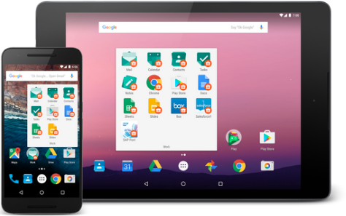

In addition, device manufacturers may add their own UI elements, styles, and colors to differentiate their products. Each manufacturer offers different features with respect to keyboard forms, screen size, or camera buttons. An app running on one device may look a bit different on another. Your challenge, as a developer, is to design UI elements that work on all devices.

Maximizing app performance

An app's *performance* is determined by how fast it runs, how easily it connects to the network, and how well it manages battery and memory usage. Performance is affected by factors such as battery life, multimedia content, and internet access. Be aware that some features you design for your app may cause performance problems for users. For example, to save the user's battery power, enable background services only when they are necessary.

Keeping your code and your users more secure

You need to take precautions to make your code, and the user's experience when they use your app, as secure as possible.

* Use tools such as ProGuard, which is provided in Android Studio. ProGuard detects and removes unused classes, fields, methods, and attributes.
* Encrypt all of your app's code and resources while packaging the app.
* To protect critical user information such as logins and passwords, secure your communication channel to protect data in transit across the internet, as well as data at rest on the device.

Remaining compatible with older versions of Android

The Android platform continues to improve and provide new features you can add to your apps. However, you should ensure that your app can still run on devices with older versions of Android. It is impractical to focus only on the most recent Android version, as not all users may have upgraded or may be able to upgrade their devices. Fortunately Android Studio provides options for developers to more easily remain compatible with older versions.

# 1.1: Your first Android app

**Contents:**

* [The development process](https://google-developer-training.github.io/android-developer-fundamentals-course-concepts-v2/unit-1-get-started/lesson-1-build-your-first-app/1-1-c-your-first-android-app/1-1-c-your-first-android-app.html#development)
* [Using Android Studio](https://google-developer-training.github.io/android-developer-fundamentals-course-concepts-v2/unit-1-get-started/lesson-1-build-your-first-app/1-1-c-your-first-android-app/1-1-c-your-first-android-app.html#android)
* [Exploring a project](https://google-developer-training.github.io/android-developer-fundamentals-course-concepts-v2/unit-1-get-started/lesson-1-build-your-first-app/1-1-c-your-first-android-app/1-1-c-your-first-android-app.html#exploring)
* [Understanding the Android manifest](https://google-developer-training.github.io/android-developer-fundamentals-course-concepts-v2/unit-1-get-started/lesson-1-build-your-first-app/1-1-c-your-first-android-app/1-1-c-your-first-android-app.html#manifest)
* [Understanding the build process](https://google-developer-training.github.io/android-developer-fundamentals-course-concepts-v2/unit-1-get-started/lesson-1-build-your-first-app/1-1-c-your-first-android-app/1-1-c-your-first-android-app.html#build_configuration)
* [Running the app on an emulator or a device](https://google-developer-training.github.io/android-developer-fundamentals-course-concepts-v2/unit-1-get-started/lesson-1-build-your-first-app/1-1-c-your-first-android-app/1-1-c-your-first-android-app.html#testing)
* [Using the log](https://google-developer-training.github.io/android-developer-fundamentals-course-concepts-v2/unit-1-get-started/lesson-1-build-your-first-app/1-1-c-your-first-android-app/1-1-c-your-first-android-app.html#log)
* [Related practical](https://google-developer-training.github.io/android-developer-fundamentals-course-concepts-v2/unit-1-get-started/lesson-1-build-your-first-app/1-1-c-your-first-android-app/1-1-c-your-first-android-app.html#relatedpractical)
* [Learn more](https://google-developer-training.github.io/android-developer-fundamentals-course-concepts-v2/unit-1-get-started/lesson-1-build-your-first-app/1-1-c-your-first-android-app/1-1-c-your-first-android-app.html#learnmore)

This chapter describes how to develop applications using Android Studio, which is an integrated development environment (IDE) for Android.

## The development process

An Android app project begins with an idea and a definition of the requirements necessary to realize that idea. You may want to sketch user interfaces (UIs) for the various app functions. To show what a UI would look like and how it would work, use drawings, mockups, and prototypes.

When you are ready to start coding, you use Android Studio to go through the following steps: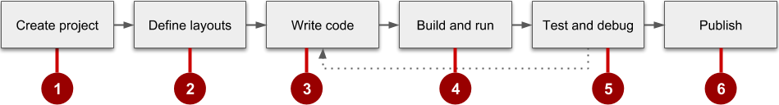

1. Create the project in Android Studio and choose an appropriate template.
2. Define a layout for each screen that has UI elements. You can place UI elements on the screen using the layout editor, or you can write code directly in the Extensible Markup Language (XML).
3. Write code using the Java programming language. Create source code for all of the app's components.
4. Build and run the app on real and virtual devices. Use the default build configuration or create custom builds for different versions of your app.©
5. Test and debug the app's logic and UI.
6. Publish the app by assembling the final APK (package file) and distributing it through channels such as Google Play.

## Using Android Studio

Android Studio provides a unified development environment for creating apps for all Android-powered devices. Android Studio includes code templates with sample code for common app features, extensive testing tools and frameworks, and a flexible build system.

### Starting an Android Studio project

After you have successfully installed the Android Studio IDE, double-click the Android Studio application icon to start it. Click **Start a new Android Studio project** in the Welcome window, and name the project the same name that you want to use for the app.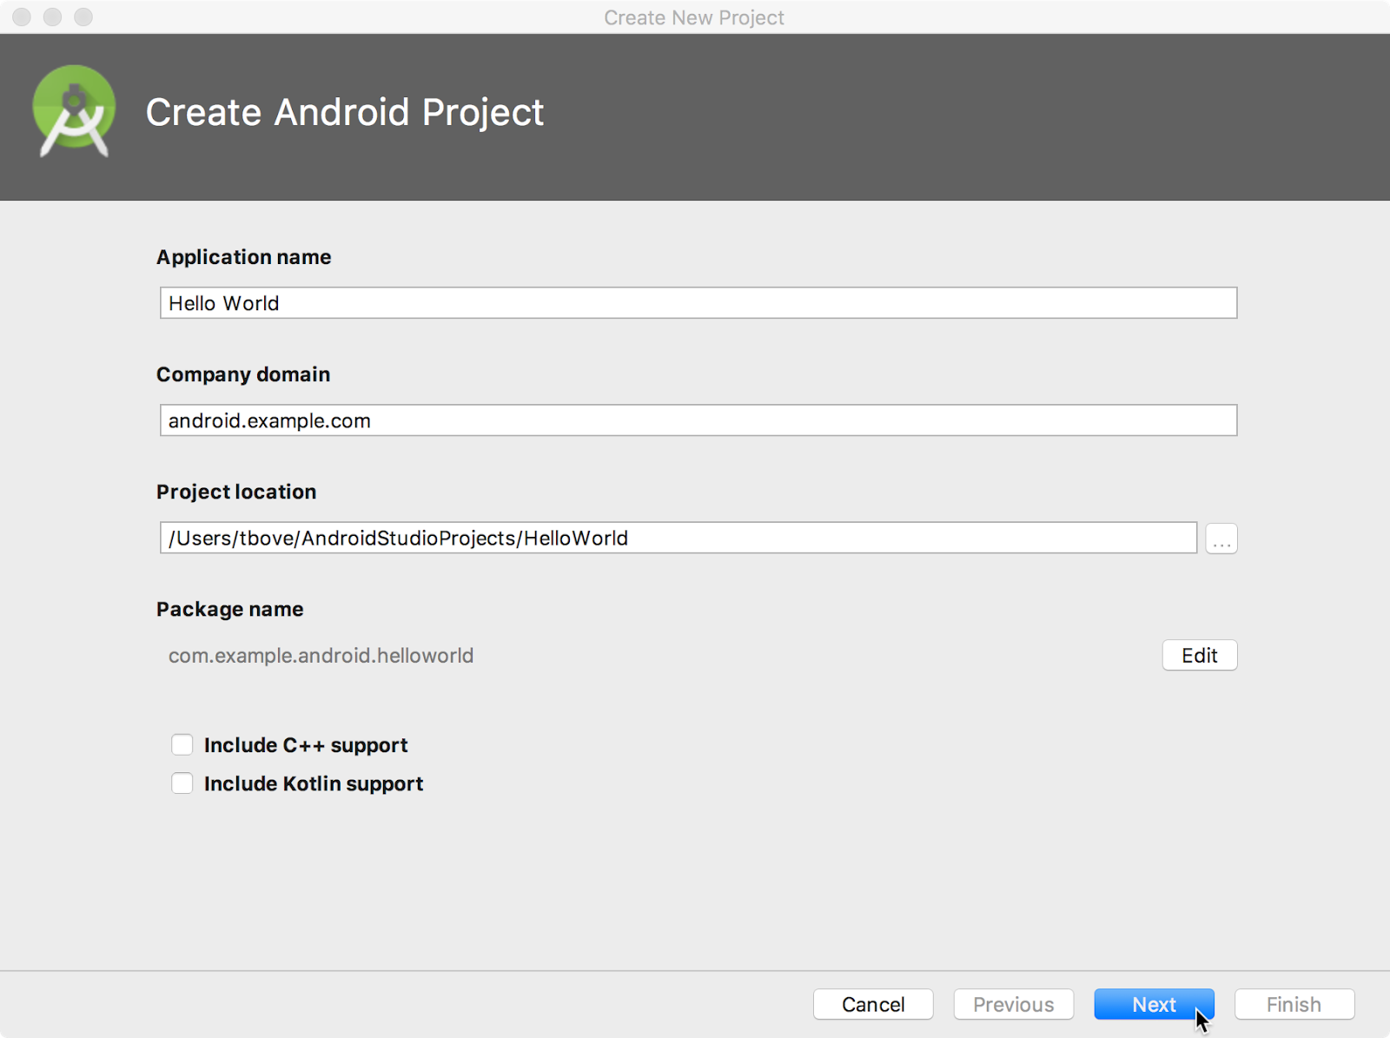

When choosing a unique **Company domain**, keep in mind that apps published to Google Play must have a unique package name. Because domains are unique, prepending the app's name with your name, or your company's domain name, should provide an adequately unique package name. If you don't plan to publish the app, you can accept the default example domain. Be aware that changing the package name later is extra work.

### Choosing target devices and the minimum SDK

When choosing Target Android Devices, **Phone and Tablet** are selected by default, as shown in the figure below. The choice shown in the figure for the Minimum SDK—**API 15: Android 4.0.3 (IceCreamSandwich)**—makes your app compatible with 97% of Android-powered devices active on the Google Play Store.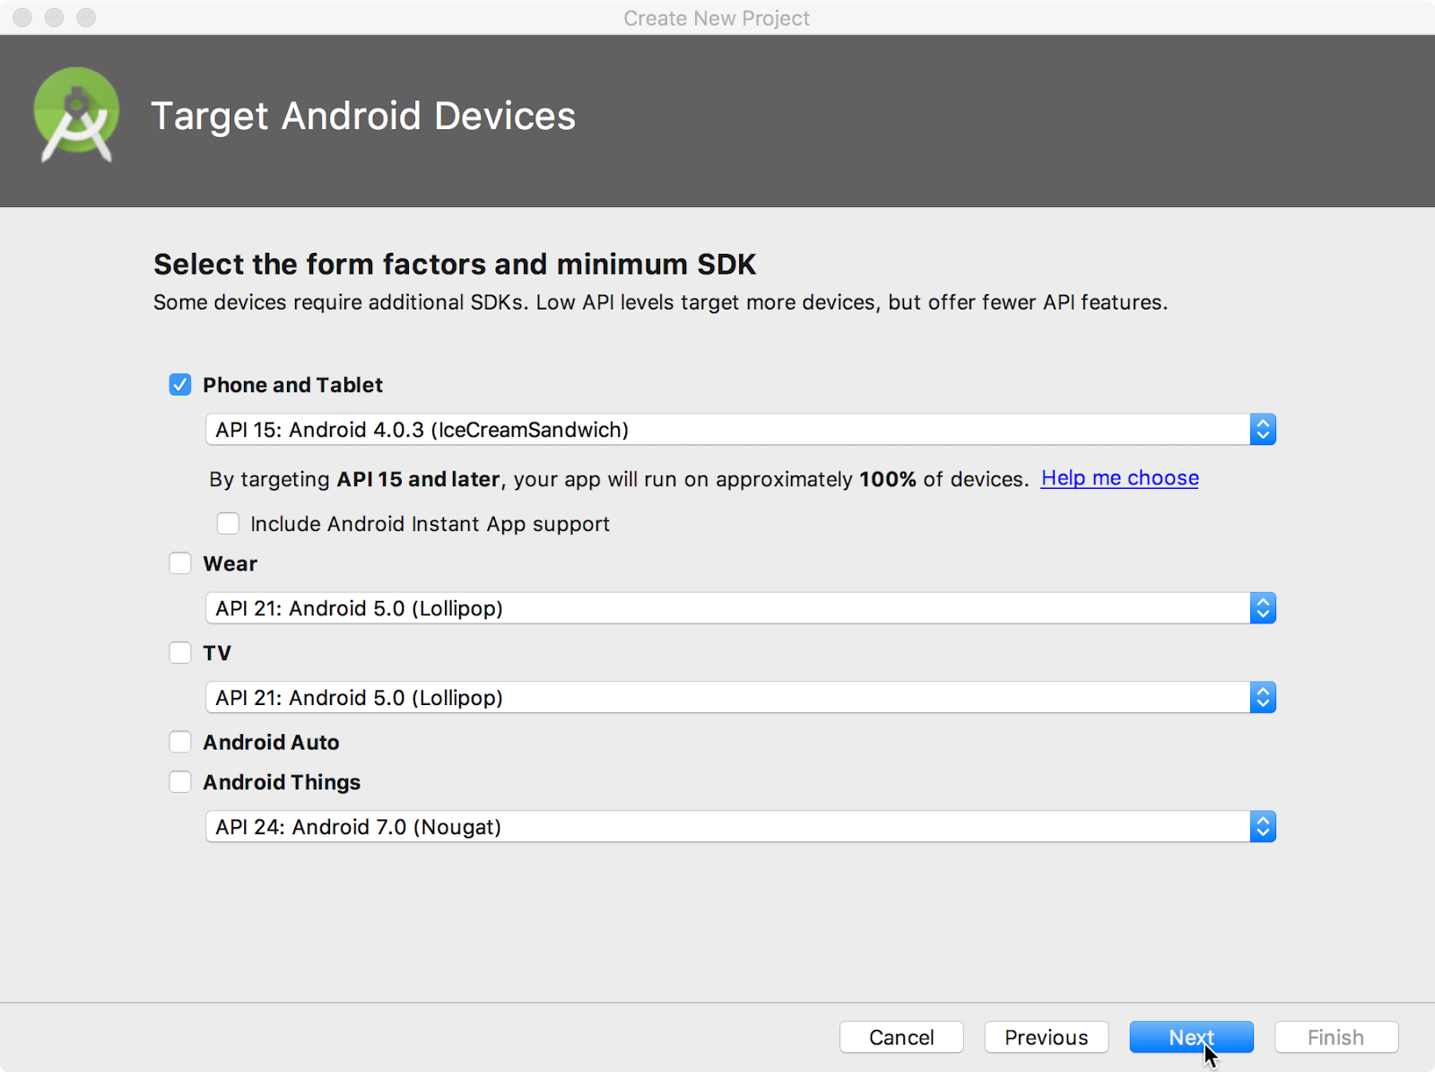

Different devices run different versions of the Android system, such as Android 4.0.3 or Android 4.4. Each successive version often adds new APIs not available in the previous version. To indicate which set of APIs are available, each version specifies an API level. For instance, Android 1.0 is API level 1 and Android 4.0.3 is API level 15.

The Minimum SDK declares the minimum Android version for your app. Each successive version of Android provides compatibility for apps that were built using the APIs from previous versions. That means your app should always be compatible with future versions of Android, if you use the documented Android APIs.

### Choosing an Activity template

An [Activity](https://developer.android.com/reference/android/app/Activity.html) is a single, focused thing that the user can do. It is a crucial component of any Android app. An Activity typically has a layout associated with it that defines how UI elements appear on a screen.

Android Studio pre-populates your project with minimal code for an Activity and layout based on a template. Available Activity templates range from a virtually blank template (**Add No Activity**) to an Activity that includes navigation and an options menu.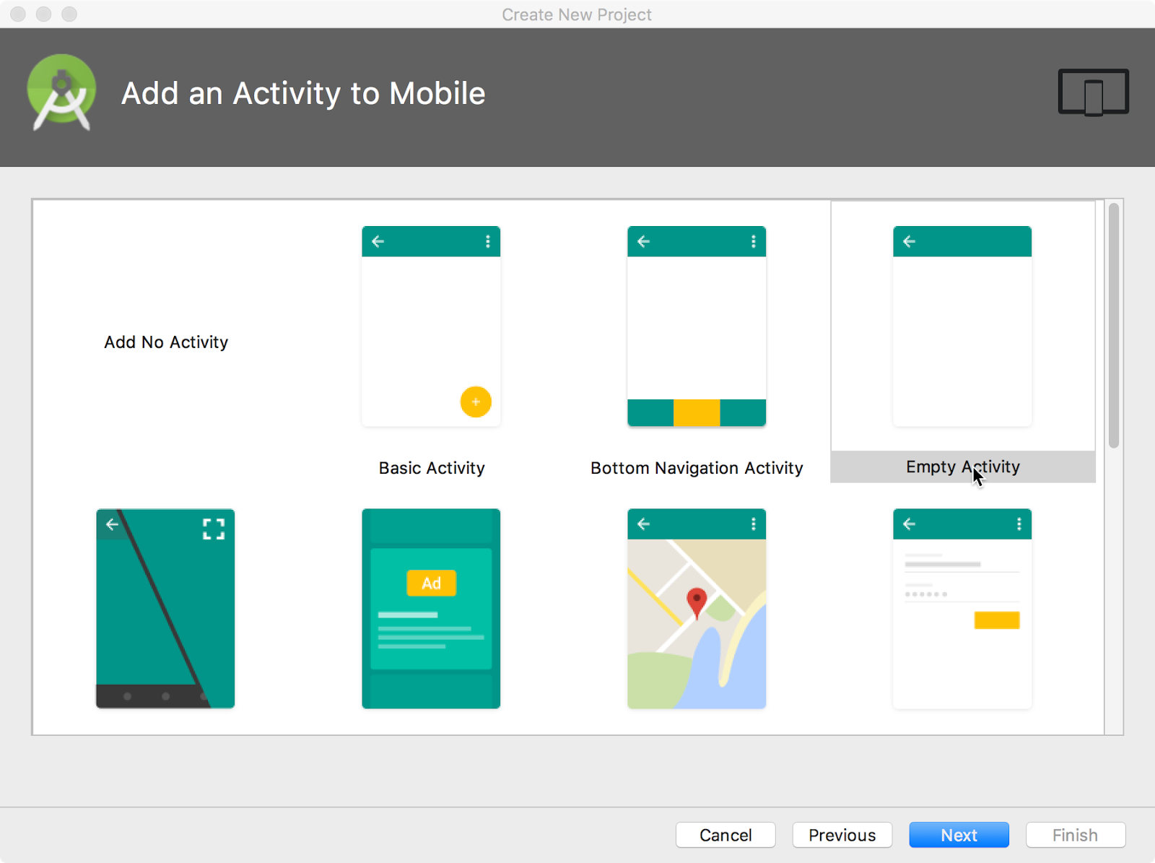

You can customize the Activity after you select your template. For example, the **Empty Activity** choice provides a single Activity with a single layout resource for the screen. The **Configure Activity**screen appears after you click **Next**. On the **Configure Activity** screen you can accept the commonly used name for the Activity (such as MainActivity), or you can change the name.

**Tip**: This course covers the Activity class in more detail in another practical. You can also read [Introduction to Activities](https://developer.android.com/guide/components/activities/intro-activities.html) for a comprehensive introduction.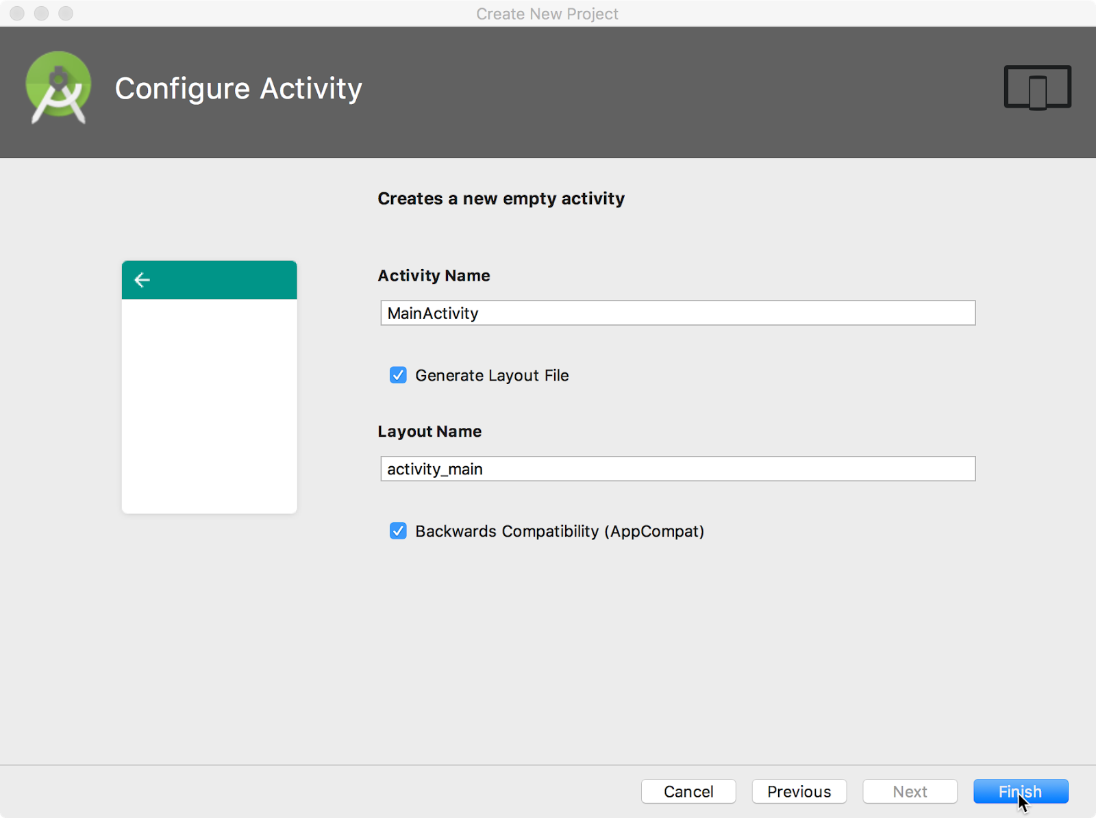

The **Configure Activity** screen differs depending on which template you chose. In most cases you can select the following options, if they are not already selected:

* **Generate Layout file**: Leave this checkbox selected to create the layout resource connected to this Activity, which is usually named activity_main. The layout defines the UI for the Activity.
* **Backwards Compatibility (AppCompat):**Leave this checkbox selected to include the AppCompatlibrary. Use the AppCompat library to make sure that the app is compatible with previous versions of Android, even if the app uses features found only in newer Android versions.

Android Studio creates a folder for your projects, and builds the project with [Gradle](https://gradle.org/).

**Tip**: See the [Configure your build](https://developer.android.com/studio/build/index.html) developer page for detailed information.

## Exploring a project

An Android Studio project contains all of the source code and all resources for an app. The resources include layouts, strings, colors, dimensions, and images. The Android Studio main window is made up of several logical areas, or panes, as shown in the figure below.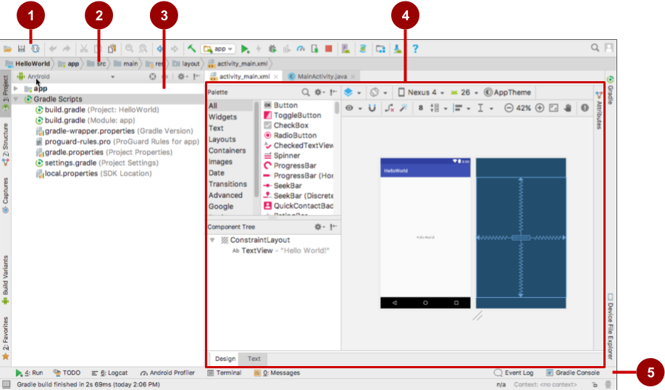

In the figure above:

1. Toolbar: Provides a wide range of actions, including running the Android app and launching Android tools.
2. Navigation bar: Navigate through the project and open files for editing.
3. **Project**pane: Displays project files in a hierarchy. The selected hierarchy in the figure above is **Android**.
4. Editor: The contents of a selected file in the project. For example, after you select a layout (as shown in the figure above), the editor pane shows the layout editor with tools to edit the layout. After you select a Java code file, the editor pane shows the Java code with tools for editing the code.
5. Tabs along the left, right, and bottom of the window: You can click tabs to open other panes, such as **Logcat** to open the **Logcat** pane with log messages, or **TODO** to manage tasks.

The status bar at the bottom of the Android Studio window displays the status of the project and Android Studio itself, as well as any warnings or messages. You can watch the build progress in the status bar.

**Tip**: You can organize the main window to give yourself more screen space by hiding or moving panes. You can also use keyboard shortcuts to access most features. See [Keyboard Shortcuts](https://developer.android.com/studio/intro/keyboard-shortcuts.html) for a complete list.

### Using the Project pane

You can view the project organization in several ways in the Project pane. If it is not already selected, click the **Project** tab. (The **Project** tab is in the vertical tab column on the left side of the Android Studio window.)

The Project pane appears. To view the project in the standard Android project hierarchy, select **Android**from the Down arrow at the top of the **Project** pane.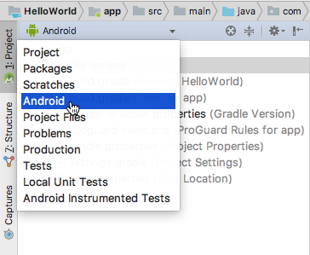

**Note:**This chapter and other chapters refer to the Project pane, when set to **Android**, as the **Project > Android** pane.

#### **Gradle files**

When you first create an app project, the **Project > Android** pane appears with the Gradle Scriptsfolder expanded as shown below. If the Gradle Scripts folder is not expanded, click the triangle to expand it. This folder contains all the files needed by the build system.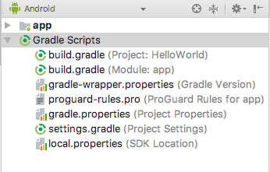

The build.gradle(Module:app) file specifies additional libraries and the module's build configuration. The Activity template that you select creates this file. The file includes the minSdkVersion attribute that declares the minimum version for the app, and the targetSdkVersion attribute that declares the highest (newest) version for which the app has been optimized.

This file also includes a list of dependencies, which are libraries required by the code—such as the AppCompat library for supporting a wide range of Android versions.

#### **App code**

To view and edit the Java code, expand the app folder, the java folder, and the com.example.android.helloworld folder. Double-click the MainActivity java file to open it in the code editor.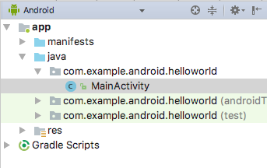

The java folder includes Java class files. Each [Activity](https://developer.android.com/reference/android/app/Activity.html), [Service](https://developer.android.com/reference/android/app/Service.html), or other component (such as a [Fragment](https://developer.android.com/reference/android/app/Fragment.html)) is defined as a Java class, usually in its own file. Tests and other Java class files are also located here.

The java folder contains three subfolders:

* com.example.hello.helloworld (or the domain name you have specified)**:**All the files for a package are in a folder named after the package. For your Hello World app, there is one package, and it contains only MainActivity.java. The first Activity (screen) that the user sees, which also initializes app-wide resources, is customarily called MainActivity. (The file extension is omitted in the **Project > Android** pane.)
* com.example.hello.helloworld(androidTest): This folder is for your instrumented tests, and starts out with a skeleton test file.
* com.example.hello.helloworld(test): This folder is for your unit tests and starts out with an automatically created skeleton unit test file.

#### **Layout files**

To view and edit a layout file, expand the res folder and the layout folder to see the layout file. In the figure below, the layout file is called activity_main.xml.

Double-click the file to open it in the layout editor. Layout files are written in XML.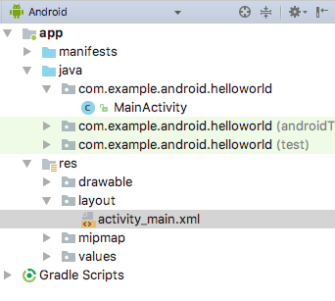

#### **Resource files**

The res folder holds resources, such as layouts, strings, and images. An Activity is usually associated with a layout of UI views that are defined as an XML file. This XML file is usually named after its Activity. The res folder includes these subfolders:

* drawable: Store all your app's images in this folder.
* layout: Every Activity has at least one XML layout file that describes the UI. For Hello World, this folder contains activity_main.xml.
* mipmap: The launcher icons are stored in this folder. There is a subfolder for each supported screen density. Android uses the screen density (the number of pixels per inch) to determine the required image resolution. Android groups all actual screen densities into generalized densities, such as medium (mdpi), high (hdpi), or extra-extra-extra-high (xxxhdpi). The ic_launcher.png folder contains the default launcher icons for all the densities supported by your app.
* values: Instead of hardcoding values like strings, dimensions, and colors in your XML and Java files, it is best practice to define them in their respective values files. This practice makes it easier to change the values and keep the values consistent across your app.

The values subfolder includes these subfolders:

* colors.xml: Shows the default colors for your chosen theme. You can add your own colors or change the colors based on your app's requirements.
* dimens.xml: Store the sizes of views and objects for different resolutions.
* strings.xml: Create resources for all your strings. Doing this makes it easy to translate the strings to other languages.
* styles.xml**:** All the styles for your app and theme go here. Styles help give your app a consistent look for all UI elements.

### Using the editor pane

If you select a file, the editor pane appears. A tab appears for the file so that you can open multiple files and switch between them. For example, if you double-click the **activity_main.xml** layout file in the **Project > Android** pane, the layout editor appears as shown below.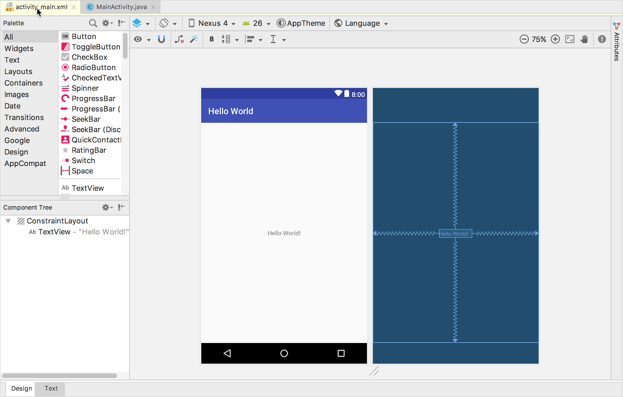

If you double-click the **MainActivity** file in the **Project > Android** pane, the editor changes to the code editor as shown below, with a tab for **MainActivity.java**: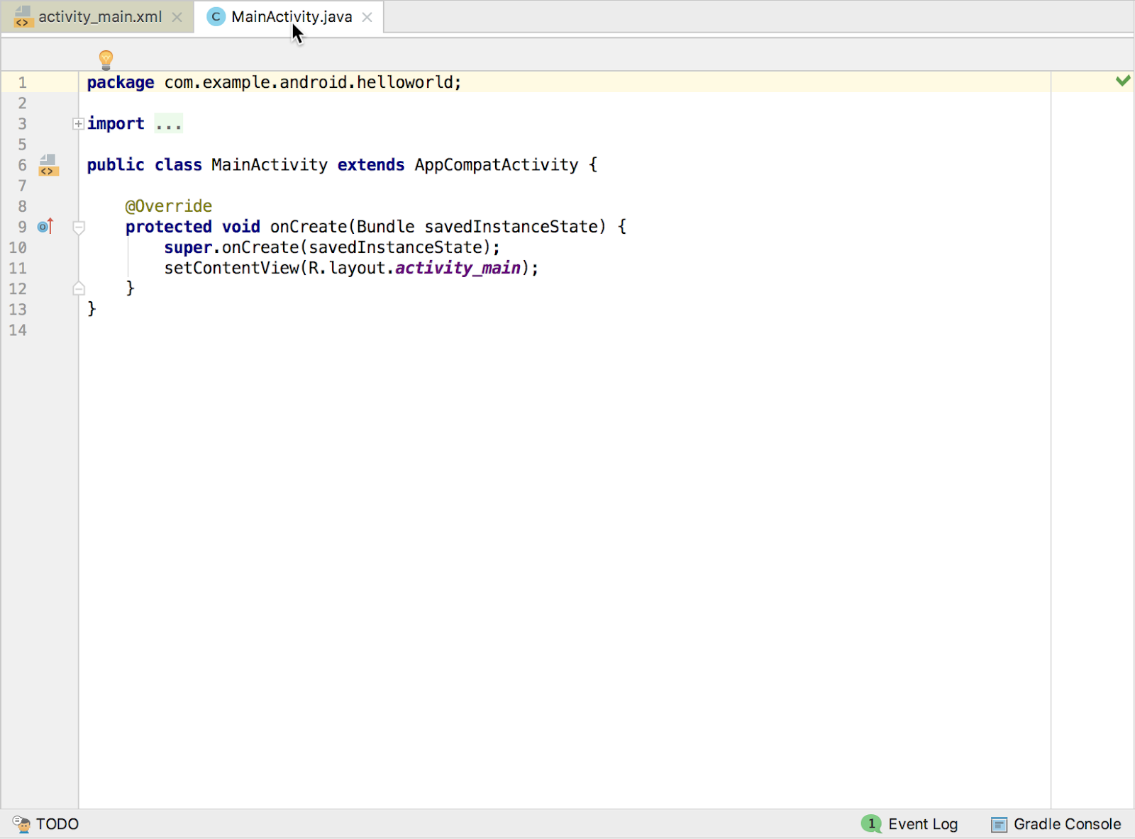

At the top of the MainActivity.java file is a package statement that defines the app package. This package statement is followed by an import block condensed with ..., as shown in the figure above. Click the dots to expand the block to view it. The import statements import libraries needed for the app. For example, the following statement imports the AppCompatActivity library:

import android.support.v7.app.AppCompatActivity;

Each Activity in an app is implemented as a Java class. The following class declaration extends the AppCompatActivity class to implement features in a way that is backward-compatible with previous versions of Android:

public class MainActivity extends AppCompatActivity {

// ... Rest of the code for the class.

}

## Understanding the Android manifest

Before the Android system can start an app component such as an Activity, the system must know that the Activity exists. It does so by reading the app's AndroidManifest.xml file, which describes all of the components of your Android app. Each Activity must be listed in this XML file, along with all components for the app.

To view and edit the AndroidManifest.xml file, expand the manifests folder in the **Project > Android**pane, and double-click AndroidManifest.xml. Its contents appear in the editing pane:

<?xml version="1.0" encoding="utf-8"?>

<manifest xmlns:android="http://schemas.android.com/apk/res/android"

package="com.example.android.helloworld">

<application

android:allowBackup="true"

android:icon="@mipmap/ic_launcher"

android:label="@string/app_name"

android:roundIcon="@mipmap/ic_launcher_round"

android:supportsRtl="true"

android:theme="@style/AppTheme">

<activity android:name=".MainActivity">

<intent-filter>

<action android:name="android.intent.action.MAIN" />

<category android:name="android.intent.category.LAUNCHER" />

</intent-filter>

</activity>

</application>

</manifest>

### Android namespace and application tag

The Android Manifest is coded in XML and always uses the Android namespace:

xmlns:android="http://schemas.android.com/apk/res/android"

package="com.example.android.helloworld">

The package expression shows the unique package name of the new app. Do not change the package expression after the app is published.

The <application> tag, with its closing </application> tag, defines the manifest settings for the entire app.

### Automatic backup

The android:allowBackup attribute enables automatic app data backup:

android:allowBackup="true"

Setting the android:allowBackup attribute to true enables the app to be backed up automatically and restored as needed. Users invest time and effort to configure apps. Switching to a new device can cancel out all that careful configuration. The system performs this automatic backup for nearly all app data by default, and does so without the developer having to write any additional app code.

For apps whose target SDK version is Android 6.0 (API level 23) and higher, devices running Android 6.0 and higher automatically create backups of app data to the cloud because the android:allowBackupattribute defaults to true if omitted. For apps < API level 22 you have to explicitly add the android:allowBackup attribute and set it to true.

**Tip**: To learn more about the automatic backup for apps, see [Configuring Auto Backup for Apps](https://developer.android.com/training/backup/autosyncapi.html).

### The app icon

The android:icon attribute sets the icon for the app:

android:allowBackup="true"

android:icon="@mipmap/ic_launcher"

The android:icon attribute assigns to the app an icon in the mipmap folder (inside the res folder in the **Project > Android** pane). The icon appears on the home screen or in the Search Apps screen for launching the app. The icon is also used as the default icon for app components.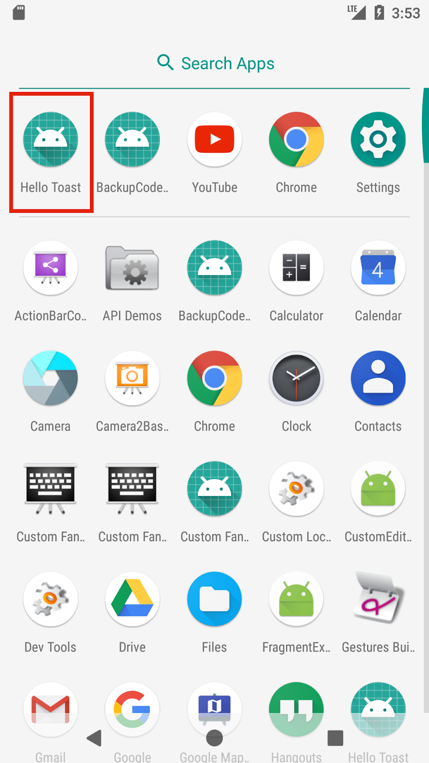

### App label and string resources

The android:label attribute shows the string "Hello World" highlighted. If you click the string, it changes to show the string resource @string/app_name:

android:label="@string/app_name"

**Tip**: To see the context menu, ctrl-click or right-click app_name in the editor pane. Select **Go To > Declaration** to see where the string resource is declared: in the strings.xml file. When you select **Go To > Declaration** or open the file by double-clicking strings.xml inside the values folder in the **Project > Android** pane, the file's contents appear in the editor pane.

After opening the strings.xml file, you can see that the string name app_name is set to Hello World. You can change the app name by changing the Hello World string to something else. String resources are described in a separate lesson.

### App theme

The android:theme attribute sets the app's theme, which defines the appearance of UI elements such as text:

android:theme="@style/AppTheme">

The theme attribute is set to the standard theme AppTheme. Themes are described in a separate lesson.

### Declaring the Android version

Different devices may run different versions of the Android system, such as Android 4.0 or Android 4.4. Each successive version can add new APIs not available in the previous version. To indicate which set of APIs are available, each version specifies an API level. For instance, Android 1.0 is API level 1 and Android 4.4 is API level 19.

The API level allows a developer to declare the minimum version with which the app is compatible, using the <uses-sdk> manifest tag and its minSdkVersion attribute. For example, the Calendar Provider APIs were added in Android 4.0 (API level 14). If your app can't function without these APIs, declare API level 14 as the app's minimum supported version like this:

<manifest xmlns:android="http://schemas.android.com/apk/res/android"

package="com.example.android.helloworld">

<uses-sdk android:minSdkVersion="14" android:targetSdkVersion="19" />

// ... Rest of manifest information

</manifest>

The minSdkVersion attribute declares the minimum version for the app, and the targetSdkVersionattribute declares the highest (newest) version which has been optimized within the app. Each successive version of Android provides compatibility for apps that were built using the APIs from previous versions, so the app should always be compatible with future versions of Android while using the documented Android APIs.

The targetSdkVersion attribute does not prevent an app from being installed on Android versions that are higher (newer) than the specified value. Even so, the target attribute is important, because it indicates to the system whether the app should inherit behavior changes in newer versions.

If you don't update the targetSdkVersion to the latest version, the system assumes that your app requires backward-compatible behaviors when it runs on the latest version. For example, among the behavior changes in Android 4.4, alarms created with the AlarmManager APIs are now inexact by default so that the system can batch app alarms and preserve system power. If your target API level is lower than "19", the system retains the previous API's behavior for your app.

## Understanding the build process

The Android application package (APK) is the package file format for distributing and installing Android mobile apps. The build process involves tools and processes that automatically convert each project into an APK.

Android Studio uses Gradle as the foundation of the build system, with more Android-specific capabilities provided by the Android Plugin for Gradle. This build system runs as an integrated tool from the Android Studio menu.

### Understanding build.gradle files

When you create a project, Android Studio automatically generates the necessary build files in the Gradle Scripts folder in the **Project > Android** pane. Android Studio build files are named build.gradle as shown below:

### build.gradle (Project: apptitle)

This file is the top-level build file for the entire project, located in the root project folder, which defines build configurations that apply to all modules in your project. This file, generated by Android Studio, should not be edited to include app dependencies.

If a dependency is something other than a local library or file tree, Gradle looks for the files in whichever online repositories are specified in the repositories block of this file. By default, new Android Studio projects declare JCenter and Google (which includes the [Google Maven repository](https://maven.google.com/)) as the repository locations:

allprojects {

repositories {

google()

jcenter()

}

}

### build.gradle (Module: app)

Android Studio creates separate build.gradle (Module: app) files for each module. You can edit the build settings to provide custom packaging options for each module, such as additional build types and product flavors, and to override settings in the manifest or top-level build.gradle file. This file is most often the file to edit when changing app-level configurations, such as declaring dependencies in the dependencies section. The following shows the contents of a project's build.gradle (Module: app) file:

apply plugin: 'com.android.application'

android {

compileSdkVersion 26

defaultConfig {

applicationId "com.example.android.helloworld"

minSdkVersion 15

targetSdkVersion 26

versionCode 1

versionName "1.0"

testInstrumentationRunner

"android.support.test.runner.AndroidJUnitRunner"

}

buildTypes {

release {

minifyEnabled false

proguardFiles getDefaultProguardFile('proguard-android.txt'),

'proguard-rules.pro'

}

}

}

dependencies {

implementation fileTree(dir: 'libs', include: ['*.jar'])

implementation 'com.android.support:appcompat-v7:26.1.0'

implementation 'com.android.support.constraint:constraint-layout:1.0.2'

testImplementation 'junit:junit:4.12'

androidTestImplementation 'com.android.support.test:runner:1.0.1'

androidTestImplementation

'com.android.support.test.espresso:espresso-core:3.0.1'

}

The build.gradle files use Gradle syntax. Gradle is a Domain Specific Language (DSL) for describing and manipulating the build logic using [Groovy](http://groovy-lang.org/), which is a dynamic language for the Java Virtual Machine (JVM). You don't need to learn Groovy to make changes, because the Android Plugin for Gradle introduces most of the DSL elements you need.

**Tip**: To learn more about the Android plugin DSL, read the [DSL reference documentation](http://google.github.io/android-gradle-dsl/current/index.html).

#### **Plugin and Android blocks**

In the build.gradle (Module: app) file above, the first statement applies the Android-specific Gradle plug-in build tasks:

apply plugin: 'com.android.application'

android {

compileSdkVersion 26

// ... Rest of android block.

}

The android { } block specifies the target SDK version for compiling the app code ( compileSdkVersion 26) and several blocks of information.

#### **The defaultConfig block**

Core settings and entries for the app are specified in the defaultConfig { } block within the android { } block:

defaultConfig {

applicationId "com.example.android.helloworld"

minSdkVersion 15

targetSdkVersion 26

versionCode 1

versionName "1.0"

testInstrumentationRunner

"android.support.test.runner.AndroidJUnitRunner"

}

The minSdkVersion and targetSdkVersion settings override any AndroidManifest.xml settings for the minimum SDK version and the target SDK version. See "Declaring the Android version" previously in this chapter for background information on these settings.

The testInstrumentationRunner statement adds the instrumentation support for testing the UI using Espresso and UIAutomator. These tools are described in a separate lesson.

#### **Build types**

Build types for the app are specified in a buildTypes { } block, which controls how the app is built and packaged.

buildTypes {

release {

minifyEnabled false

proguardFiles getDefaultProguardFile('proguard-android.txt'),

'proguard-rules.pro'

}

}

The build type specified is release for the app's release. Another common build type is debug. Configuring build types is described in a separate lesson.

#### **Dependencies**

Dependencies for the app are defined in the dependencies { } block, which is the part of the build.gradle file that is most likely to change as you start developing code that depends on other libraries. The block is part of the standard Gradle API and belongs outside the android { } block.

dependencies {

implementation fileTree(dir: 'libs', include: ['*.jar'])

implementation 'com.android.support:appcompat-v7:26.1.0'

implementation 'com.android.support.constraint:constraint-layout:1.0.2'

testImplementation 'junit:junit:4.12'

androidTestImplementation 'com.android.support.test:runner:1.0.1'

androidTestImplementation

'com.android.support.test.espresso:espresso-core:3.0.1'

}

In the snippet above, the statement implementation fileTree(dir: 'libs', include: ['*.jar']) adds a dependency of all ".jar" files inside the libs folder.

### Syncing your project

When you make changes to the build configuration files in a project, Android Studio requires that you sync the project files. During the sync, Android Studio imports the build configuration changes and runs checks to make sure the configuration won't create build errors.

To sync the project files, click **Sync Now** in the notification bar that appears when making a change (as shown in the figure below), or click the **Sync Project with Gradle Files** button  in the menu bar.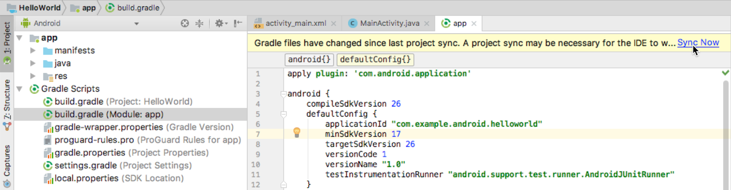

If Android Studio notices any errors with the configuration — for example, if the source code uses API features that are only available in an API level higher than the compileSdkVersion—the **Messages**window appears to describe the issue.

## Running the app on an emulator or a device

With virtual device emulators, you can test an app on different devices such as tablets or smartphones—with different API levels for different Android versions—to make sure it looks good and works for most users. You don't have to depend on having a physical device available for app development.

The [Android Virtual Device (AVD) manager](http://developer.android.com/tools/devices/managing-avds.html) creates a virtual device or emulator that simulates the configuration for a particular type of Android-powered device. Use the AVD Manager to define the hardware characteristics of a device and its API level, and to save it as a virtual device configuration. When you start the Android emulator, it reads a specified configuration and creates an emulated device on your computer that behaves exactly like a physical version of that device.

### Creating a virtual device

To run an emulator on your computer, use the AVD Manager to create a configuration that describes the virtual device. Select **Tools > Android > AVD Manager**, or click the **AVD Manager** icon  in the toolbar.

The **Your Virtual Devices** screen appears showing all of the virtual devices created previously. Click the **+Create Virtual Device** button to create a new virtual device.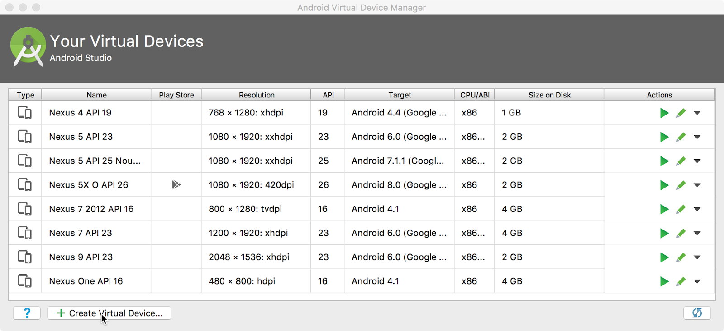

You can select a device from a list of predefined hardware devices. For each device, the table provides a column for its diagonal display size (**Size**), screen resolution in pixels (**Resolution**), and pixel density (**Density**). For example, the pixel density of the Nexus 5 device is xxhdpi, which means the app uses the icons in the xxhdpi folder of the mipmap folder. Likewise, the app uses layouts and drawables from folders defined for that density.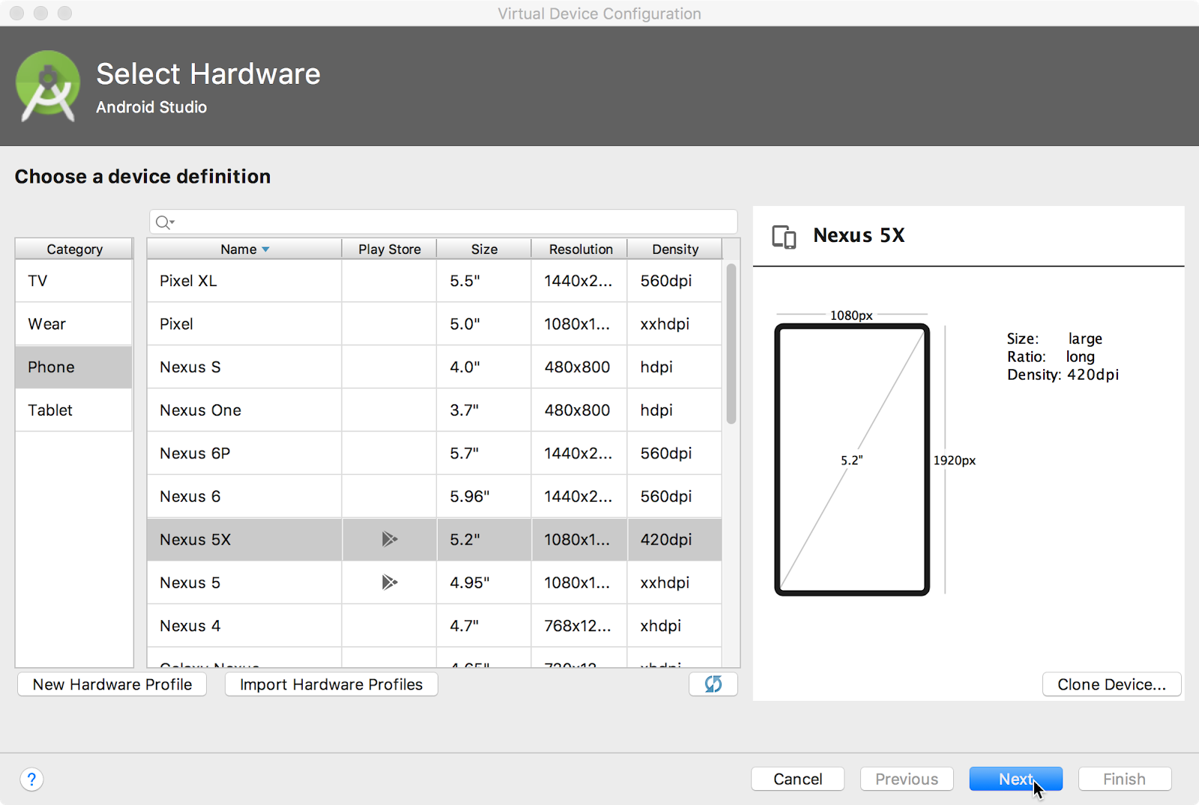

After you click **Next**, the **System Image** screen appears for choosing the version of the Android system for the device. The **Recommended** tab shows the recommended systems for the device. More versions are available under the **x86 Images** and **Other Images** tabs. If a **Download** link is visible next to a system image version, it is not installed yet. Click the link to start the download, and click **Finish** when it's done.

### Running the app on the virtual device

To run the app on the virtual device you created in the previous section, follow these steps:

1. In Android Studio, select **Run > Run app** or click the  **Run icon** in the toolbar.
2. In the Select Deployment Target window, under Available Emulators, select the virtual device you created, and click **OK**.

The emulator starts and boots just like a physical device. Depending on the speed of your computer, the startup process might take a while. The app builds, and once the emulator is ready, Android Studio uploads the app to the emulator and runs it.

You should see the app created from the Empty Activity template ("Hello World") as shown in the following figure, which also shows Android Studio's **Run** pane that displays the actions performed to run the app on the emulator.

**Tip**: When testing on a virtual device, it is a good practice to start it up once, at the very beginning of your session. Do not close it until you are done testing your app, so that your app doesn't have to go through the device startup process again. To close the virtual device, select **Quit** from the menu or press **Control-Q** in Windows or **Command-Q** in macOS.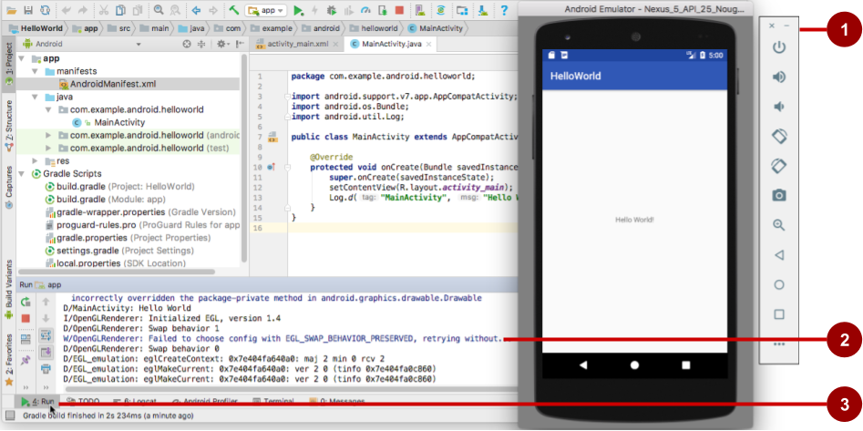

The figure above shows the emulator and the run log:

1. The Emulator running the app.
2. The **Run**pane, which shows the actions taken to install and run the app.
3. The **Run** tab, which you click to open or close the **Run** pane.

### Running the app on a physical device

Always test your apps on a physical device. While emulators are useful, they can't show all possible device states, such as what happens if an incoming call occurs while the app is running. To run the app on a physical device, you need the following:

* An Android-powered device such as a phone or tablet.
* A data cable to connect your Android-powered device to your computer via the USB port.
* If you are using a Linux or Windows system, you may need to perform additional steps to run on a hardware device. Check the [Using Hardware Devices](http://developer.android.com/tools/device.html) documentation. You may also need to install the appropriate USB driver for your device. See [OEM USB Drivers](http://developer.android.com/tools/extras/oem-usb.html).

To let Android Studio communicate with your Android-powered device, you must turn on USB Debugging on the device. You enable USB Debugging in the device's **Developer options** settings. (Note that enabling USB Debugging is not the same as rooting your device.)

On Android 4.2 and higher, the **Developer options** screen is hidden by default. To show developer options and enable USB Debugging:

1. On your device, open **Settings > About phone** and tap **Build number** seven times.
2. Return to the previous screen (**Settings**). **Developer options** appears at the bottom of the list. Tap **Developer options**.
3. Select **USB Debugging**.
4. Connect the device and run the app from Android Studio.

## Using the log

The log is a powerful debugging tool you can use to look at values, execution paths, and exceptions. After you add logging statements to an app, your log messages appear along with general log messages in the **Logcat** pane.

### Viewing log messages

To see the **Logcat** pane, click the **Logcat** tab at the bottom of the Android Studio window as shown in the figure below.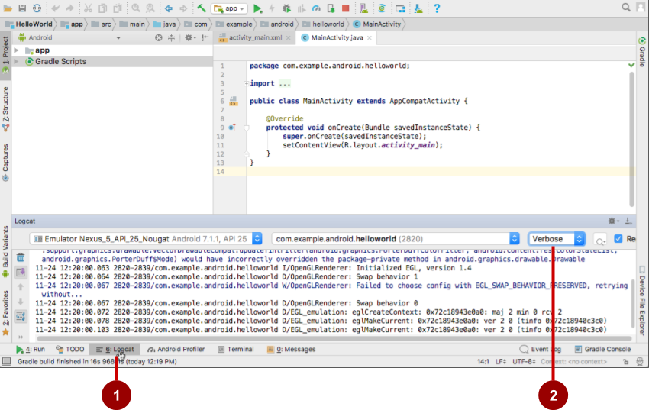

In the figure above:

1. The **Logcat** tab for opening and closing the **Logcat** pane, which displays information about your app as it is running. If you add Log statements to your app, Log messages appear here.
2. The Log level menu set to **Verbose** (the default), which shows all Log messages. Other settings include **Debug**, **Error**, **Info**, and **Warn**.

### Adding logging statements to your app

Logging statements add whatever messages you specify to the log. Adding logging statements at certain points in the code allows the developer to look at values, execution paths, and exceptions. For example, the following logging statement adds "MainActivity" and "Hello World" to the log:

Log.d("MainActivity", "Hello World");

The following are the elements of this statement:

* Log: The [Log](http://developer.android.com/reference/android/util/Log.html) class for sending log messages to the **Logcat** pane.
* d: The **Debug**Log level setting to filter log message display in the **Logcat** pane. Other log levels are e for **Error**, w for **Warn**, and i for **Info**. You assign a log level so that you can filter the log messages using the drop-down menu in the center of the **Logcat** pane.
* "MainActivity": The first argument is a tag which can be used to filter messages in the **Logcat**pane. This tag is commonly the name of the Activity from which the message originates. However, you can name the tag anything that is useful to you for debugging.
* "Hello world": The second argument is the actual message.

By convention, log tags are defined as constants for the Activity:

private static final String LOG_TAG = MainActivity.class.getSimpleName();

Use the constant in the logging statements:

Log.d(LOG_TAG, "Hello World");

After you add the Log.d statement shown above, follow these steps to see the log message:

1. If the **Logcat** pane is not already open, click the **Logcat** tab at the bottom of Android Studio to open it.
2. Change the Log level in the **Logcat** pane to **Debug**. (You can also leave the Log level as **Verbose**, because there are so few log messages.)
3. Run your app on a virtual device.

The following message should appear in the **Logcat** pane:

11-24 14:06:59.001 4696-4696/? D/MainActivity: Hello World

# 1.2: Layouts and resources for the UI

**Contents:**

* [Views](https://google-developer-training.github.io/android-developer-fundamentals-course-concepts-v2/unit-1-get-started/lesson-1-build-your-first-app/1-2-c-layouts-and-resources-for-the-ui/1-2-c-layouts-and-resources-for-the-ui.html#view)
* [The layout editor](https://google-developer-training.github.io/android-developer-fundamentals-course-concepts-v2/unit-1-get-started/lesson-1-build-your-first-app/1-2-c-layouts-and-resources-for-the-ui/1-2-c-layouts-and-resources-for-the-ui.html#layouteditor)
* [Editing XML directly](https://google-developer-training.github.io/android-developer-fundamentals-course-concepts-v2/unit-1-get-started/lesson-1-build-your-first-app/1-2-c-layouts-and-resources-for-the-ui/1-2-c-layouts-and-resources-for-the-ui.html#xml)
* [Resource files](https://google-developer-training.github.io/android-developer-fundamentals-course-concepts-v2/unit-1-get-started/lesson-1-build-your-first-app/1-2-c-layouts-and-resources-for-the-ui/1-2-c-layouts-and-resources-for-the-ui.html#adding_resources)
* [Responding to View clicks](https://google-developer-training.github.io/android-developer-fundamentals-course-concepts-v2/unit-1-get-started/lesson-1-build-your-first-app/1-2-c-layouts-and-resources-for-the-ui/1-2-c-layouts-and-resources-for-the-ui.html#click)
* [Related practicals](https://google-developer-training.github.io/android-developer-fundamentals-course-concepts-v2/unit-1-get-started/lesson-1-build-your-first-app/1-2-c-layouts-and-resources-for-the-ui/1-2-c-layouts-and-resources-for-the-ui.html#relatedpractical)
* [Learn more](https://google-developer-training.github.io/android-developer-fundamentals-course-concepts-v2/unit-1-get-started/lesson-1-build-your-first-app/1-2-c-layouts-and-resources-for-the-ui/1-2-c-layouts-and-resources-for-the-ui.html#learnmore)

This chapter describes the screen's user interface (UI) layout and other resources you create for your app, and the code you would use to respond to a user's tap of a UI element.

## Views

The UI consists of a hierarchy of objects called views — every element of the screen is a [View](https://developer.android.com/reference/android/view/View.html). The View class represents the basic building block for all UI components, and the base class for classes that provide interactive UI components such as buttons, checkboxes, and text entry fields.

A View has a location, expressed as a pair of left and top coordinates, and two dimensions, expressed as a width and a height. The unit for location and dimensions is the density-independent pixel (dp).

The Android system provides hundreds of predefined View subclasses. Commonly used Viewsubclasses described over several lessons include:

* [TextView](http://developer.android.com/reference/android/widget/TextView.html) for displaying text
* [EditText](https://developer.android.com/reference/android/widget/EditText.html) to enable the user to enter and edit text
* [Button](https://developer.android.com/reference/android/widget/Button.html) and other clickable elements (such as [RadioButton](https://developer.android.com/reference/android/widget/RadioButton.html), [CheckBox](https://developer.android.com/reference/android/widget/CheckBox.html), and [Spinner](https://developer.android.com/reference/android/widget/Spinner.html)) to provide interactive behavior
* [ScrollView](https://developer.android.com/reference/android/widget/ScrollView.html) and [RecyclerView](https://developer.android.com/reference/android/support/v7/widget/RecyclerView.html) to display scrollable items
* [ImageView](https://developer.android.com/reference/android/widget/ImageView.html) for displaying images
* [ConstraintLayout](https://developer.android.com/reference/android/support/constraint/ConstraintLayout.html) and [LinearLayout](https://developer.android.com/reference/android/widget/LinearLayout.html) for containing other views and positioning them

You can define a View to appear on the screen and respond to a user tap. A View can also be defined to accept text input, or to be invisible until needed.

You can specify View elements in layout resource files. Layout resources are written in XML and listed within the **layout** folder in the **res** folder in the **Project > Android** pane.

### ViewGroup groups

View elements can be grouped inside a [ViewGroup](https://developer.android.com/reference/android/view/ViewGroup.html), which acts as a container. The relationship is parent-child, in which the parent is a ViewGroup, and the child is a View or another ViewGroup. The following are commonly used ViewGroup groups:

* [ConstraintLayout](https://developer.android.com/reference/android/support/constraint/ConstraintLayout.html): A group that places UI elements (child View elements) using constraint connections to other elements and to the layout edges (parent View).
* [ScrollView](https://developer.android.com/reference/android/widget/ScrollView.html): A group that contains one other child View element and enables scrolling the child View element.
* [RecyclerView](https://developer.android.com/reference/android/support/v7/widget/RecyclerView.html): A group that contains a list of other View elements or ViewGroup groups and enables scrolling them by adding and removing View elements dynamically from the screen.

### Layout ViewGroup groups

The View elements for a screen are organized in a hierarchy. At the root of this hierarchy is a [ViewGroup](https://developer.android.com/reference/android/view/ViewGroup.html)that contains the layout of the entire screen. The ViewGroup can contain child View elements or other ViewGroup groups as shown in the following figure.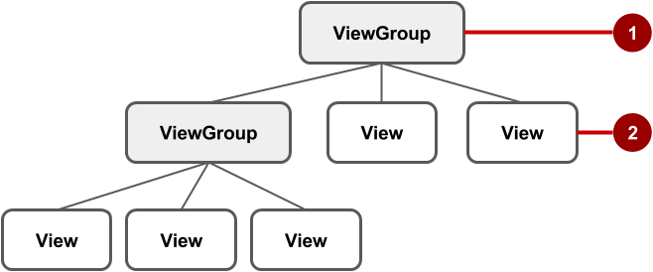

In the figure above:

1. The root ViewGroup.
2. The first set of child View elements and ViewGroup groups whose parent is the root.

Some ViewGroup groups are designated as layouts because they organize child View elements in a specific way and are typically used as the root ViewGroup. Some examples of layouts are:

* [ConstraintLayout](http://tools.android.com/tech-docs/layout-editor): A group of child View elements using constraints, edges, and guidelines to control how the elements are positioned relative to other elements in the layout. ConstraintLayoutwas designed to make it easy to click and drag View elements in the layout editor.
* [LinearLayout](https://developer.android.com/reference/android/widget/LinearLayout.html): A group of child View elements positioned and aligned horizontally or vertically.
* [RelativeLayout](https://developer.android.com/reference/android/widget/RelativeLayout.html): A group of child View elements in which each element is positioned and aligned relative to other elements within the ViewGroup. In other words, the positions of the child Viewelements can be described in relation to each other or to the parent ViewGroup.
* [TableLayout](https://developer.android.com/reference/android/widget/TableLayout.html): A group of child View elements arranged into rows and columns.
* [FrameLayout](https://developer.android.com/reference/android/widget/FrameLayout.html): A group of child View elements in a stack. FrameLayout is designed to block out an area on the screen to display one View. Child View elements are drawn in a stack, with the most recently added child on top. The size of the FrameLayout is the size of its largest child View element.
* [GridLayout](https://developer.android.com/reference/android/widget/GridLayout.html): A group that places its child View elements in a rectangular grid that can be scrolled.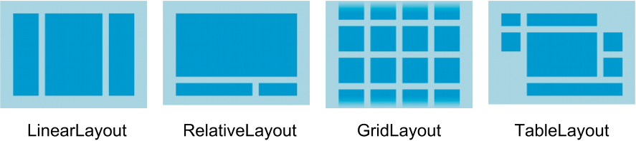

**Tip**: Learn more about different layout types in [Common Layout Objects](https://developer.android.com/guide/topics/ui/layout-objects.html).

A simple example of a LinearLayout with child View elements is shown below as a diagram of the layout file (activity_main.xml), along with a hierarchy diagram (top right) and a screenshot of the actual finished layout (bottom right).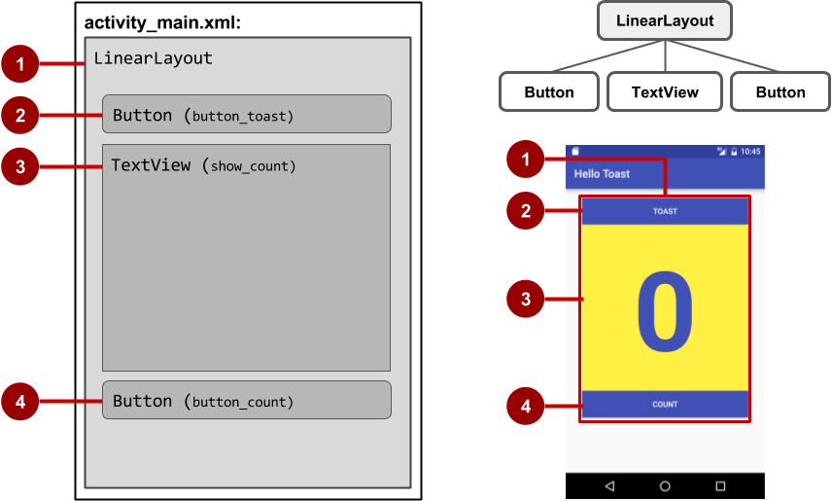

In the figure above:

1. LinearLayout, the root ViewGroup, contains all the child View elements in a vertical orientation.
2. Button (button_toast). The first child View element appears at the top in the LinearLayout.
3. TextView (show_count). The second child View element appears under the first child View element in the LinearLayout.
4. Button (button_count). The third child View element appears under the second child Viewelement in the LinearLayout.

The layout hierarchy can grow to be complex for an app that shows many View elements on a screen. It's important to understand the hierarchy, as it affects whether View elements are visible and how efficiently they are drawn.

**Tip**: You can explore the layout hierarchy of your app using [Hierarchy Viewer](https://developer.android.com/studio/profile/hierarchy-viewer-walkthru.html). It shows a tree view of the hierarchy and lets you analyze the performance of View elements on an Android-powered device. Performance issues are covered in a subsequent chapter.

## The layout editor

You define layouts in the layout editor, or by entering XML code.

The layout editor shows a visual representation of XML code. You can drag View elements into the design or blueprint pane and arrange, resize, and specify attributes for them. You immediately see the effect of changes you make.

To use the layout editor, double-click the XML layout file (**activity_main.xml**). The layout editor appears with the **Design** tab at the bottom highlighted. (If the **Text** tab is highlighted and you see XML code, click the **Design** tab.) For the Empty Activity template, the layout is as shown in the figure below.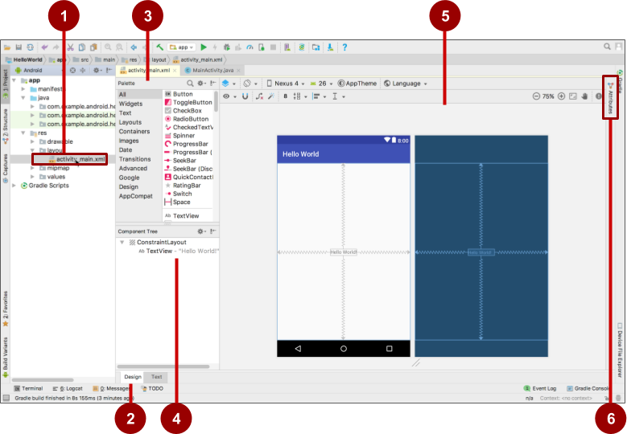

1. XML layout file (**activity_main.xml**).
2. **Design** and **Text** tabs. Click **Design** to see the layout editor, or **Text** to see XML code.
3. **Palette** pane. The Palette pane provides a list of UI elements and layouts. Add an element or layout to the UI by dragging it into the design pane.
4. **Component Tree**. The Component Tree pane shows the layout hierarchy. Click a View element or ViewGroup in this pane to select it. View elements are organized into a tree hierarchy of parents and children, in which a child inherits the attributes of its parent. In the figure above, the TextView is a child of the ConstraintLayout.
5. Design and blueprint panes. Drag View elements from the **Palette** pane to the design or blueprint pane to position them in the layout. In the figure above, the layout shows only one element: a TextView that displays "Hello World".
6. **Attributes** tab. Click **Attributes** to display the **Attributes** pane for setting attributes for a Viewelement.

### Layout editor toolbars

The layout editor toolbars provide buttons to configure your layout and change its appearance. The top toolbar lets you configure the appearance of the layout preview in the layout editor: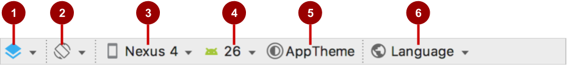

The figure above shows the top toolbar of the layout editor:

1. **Select Design Surface**: Select **Design** to display a color preview of the UI elements in your layout, or **Blueprint** to show only outlines of the elements. To see both panes side by side, select **Design + Blueprint**.
2. **Orientation in Editor**: Select **Portrait** or **Landscape** to show the preview in a vertical or horizontal orientation. The orientation setting lets you preview the layout orientations without running the app on an emulator or device. To create alternative layouts, select **Create Landscape Variation** or other variations.
3. **Device in Editor**: Select the device type (phone/tablet, Android TV, or Android Wear).
4. **API Version in Editor**: Select the version of Android to use to show the preview.
5. **Theme in Editor**: Select a theme (such as **AppTheme**) to apply to the preview.
6. **Locale in Editor**: Select the language and locale for the preview. This list displays only the languages available in the string resources (see the lesson on localization for details on how to add languages). You can also select **Preview as Right To Left** to see the layout as if an RTL language had been chosen.

The layout editor also offers a second toolbar that lets you configure the appearance of UI elements in a ConstraintLayout and zoom in and out of the preview: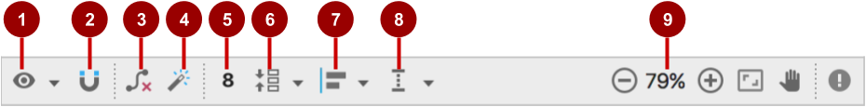

The figure above shows the ConstraintLayout editing toolbar:

1. **Show**: Select **Show Constraints** and **Show Margins** to show them in the preview, or to stop showing them.
2. **Autoconnect**: Enable or disable Autoconnect. With Autoconnect enabled, you can drag any element (such as a Button) to any part of a layout to generate constraints against the parent layout.
3. **Clear All Constraints**: Clear all constraints in the entire layout.
4. **Infer Constraints**: Create constraints by inference.
5. **Default Margins**: Set the default margins.
6. **Pack**: Pack or expand the selected elements.
7. **Align**: Align the selected elements.
8. **Guidelines**: Add vertical or horizontal guidelines.
9. Zoom controls: Zoom in or out.

### Using ConstraintLayout

The layout editor offers more features in the **Design** tab when you use a ConstraintLayout, including handles for defining constraints.

A constraint is a connection or alignment to another UI element, to the parent layout, or to an invisible guideline. Each constraint appears as a line extending from a circular handle. After you select a UI element in the **Component Tree** pane or click it in the layout editor, the element shows a resizing handle on each corner and a circular constraint handle in the middle of each side.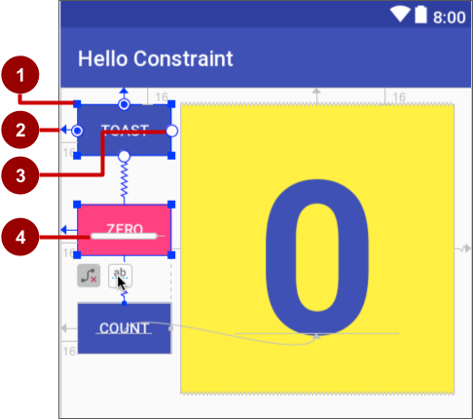

The figure above shows the constraint and resizing handles on View elements in a layout:

1. **Resizing handle**.
2. **Constraint line and handle**. In the figure, the constraint aligns the left side of the **Toast**Button to the left side of the layout.
3. **Constraint handle** without a constraint line.
4. **Baseline handle**. The baseline handle aligns the text baseline of an element to the text baseline of another element.

In the blueprint or design panes, the following handles appear on the TextView element:

* **Constraint handle**: To create a constraint, click a constraint handle, shown as a circle on each side of an element. Then drag the circle to another constraint handle or to a parent boundary. A zigzag line represents the constraint.
* **Resizing handle**: You can drag the square resizing handles to resize the element. While dragging, the handle changes to an angled corner.

You can drag the resizing handles on each corner of the UI element to resize it, but doing so hard-codes the width and height dimensions, which you should avoid for most elements because hard-coded dimensions don't adapt to different screen densities.

#### **Constraining a UI element**

To add a constraint to a UI element, click the circular handle and drag a line to another element or to the side of a layout, as shown in the two animated figures below. To remove a constraint from an element, click the circular handle.



The constraints you define in the layout editor are created as XML attributes, which you can see in the **Text** tab as described in "[Editing XML directly](https://google-developer-training.github.io/android-developer-fundamentals-course-concepts-v2/unit-1-get-started/lesson-1-build-your-first-app/1-2-c-layouts-and-resources-for-the-ui/1-2-c-layouts-and-resources-for-the-ui.html#xml)" in this chapter. For example, the following XML code is created constraining the top of an element to the top of its parent:

app:layout_constraintTop_toTopOf="parent"

#### **Using a baseline constraint**

You can align one UI element that contains text, such as a TextView or Button, with another UI element that contains text. A baseline constraint lets you constrain the elements so that the text baselines match. Select the UI element that has text, and then hover your pointer over the element until the baseline constraint button  appears underneath the element.

Click the baseline constraint button. The baseline handle appears, blinking in green as shown in the animated figure. Drag a baseline constraint line to the baseline of the other UI element.

**Tip**: For an in-depth tutorial on using ConstraintLayout, see [Using ConstraintLayout to design your views](https://codelabs.developers.google.com/codelabs/constraint-layout/index.html).

### Using the Attributes pane

The **Attributes** pane offers access to all of the XML attributes you can assign to a UI element. You can find the attributes (known as properties) common to all views in the [View](http://developer.android.com/reference/android/view/View.html) class documentation.

To show the **Attributes** pane, click the **Attributes** tab on the right side of the layout editor. The **Attributes** pane includes a square sizing panel called the view inspector. The symbols inside the view inspector represent the height and width settings.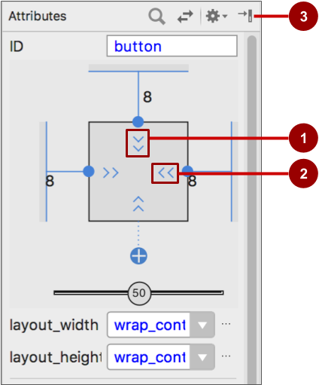

The figure above shows the **Attributes** pane:

1. **Vertical view size control**. The vertical size control, which appears on the top and bottom of the view inspector, specifies the layout_height property. The angles indicate that this size control is set to wrap_content, which means the UI element expands vertically as needed to fit its contents. The "8" indicates a standard margin set to 8 dp.
2. **Horizontal view size control**. The horizontal size control, which appears on the left and right of the view inspector, specifies the layout_width. The angles indicate that this size control is set to wrap_content, which means the UI element expands horizontally as needed to fit its contents, up to a margin of 8 dp.
3. **Attributes** pane close button. Click to close the pane.

The layout_width and layout_height attributes in the **Attributes** pane change as you change the inspector's horizontal and vertical size controls. These attributes can take one of three values for a ConstraintLayout:

* The match_constraint setting expands the UI element to fill its parent by width or height up to a margin, if a margin is set. The parent in this case is the ConstraintLayout.
* The wrap_content setting shrinks the UI element to the size of its content. If there is no content, the element becomes invisible.
* To specify a fixed size that's adjusted for the screen size of the device, set a number of dp ([density-independent pixels](https://developer.android.com/training/multiscreen/screendensities.html)). For example, 16dp means 16 density-independent pixels.

**Tip**: If you change the layout_width attribute using its popup menu, the layout_width attribute is set to zero because there is no set dimension. This setting is the same as match_constraint—the UI element can expand as much as possible to meet constraints and margin settings.

The **Attributes** pane offers access to all of the attributes you can assign to a View element. You can enter values for each attribute, such as the android:id, background, textColor, and text attributes.

### Creating layout variants for orientations and devices

You can preview an app's layout with a horizontal orientation, and with different devices, without having to run the app on an emulator or device.

To preview the layout for a different orientation, click the **Orientation in Editor** button  in the top toolbar. To show the layout in a horizontal orientation, select **Switch to Landscape**. To return to vertical orientation, select **Switch to Portrait**.

You can also preview the layout for different devices. Click the **Device in Editor** button  in the top toolbar, and select a different device in the drop-down menu. For example, select **Nexus 4**, **Nexus 5**, and then **Pixel** to see differences in the previews.

To create a variant of the layout strictly for the horizontal orientation, leaving the vertical orientation layout alone: click the **Orientation in Editor** button and select **Create Landscape Variation**. A new editor window opens with the **land/activity_main.xml** tab showing the layout for the landscape (horizontal) orientation. You can change this layout, which is specifically for horizontal orientation, without changing the original portrait (vertical) orientation.

In the **Project > Android** pane, look inside the **res > layout** directory. You see that Android Studio automatically creates the variant for you, called activity_main.xml (land).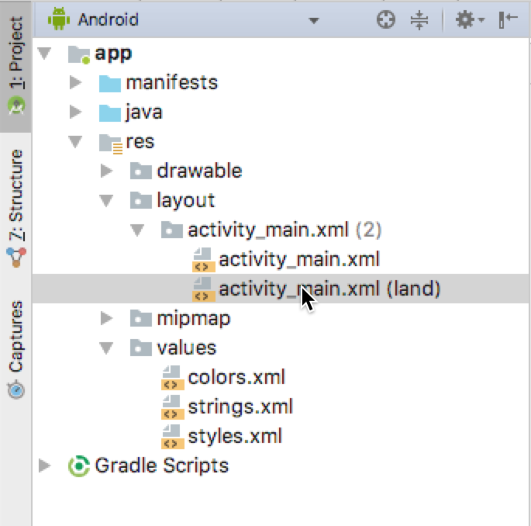

To create a layout variant for tablet-sized screens, click the **Orientation in Editor** button and select **Create layout x-large Variation**. A new editor window opens with the **xlarge/activity_main.xml** tab showing the layout for a tablet-sized device. The editor also picks a tablet device, such as the Nexus 9 or Nexus 10, for the preview. In the **Project > Android** pane, look inside the **res > layout** directory. You see that Android Studio automatically creates the variant for you, called activity_main.xml (xlarge). You can change this layout, which is specifically for tablets, without changing the other layouts.

## Editing XML directly

It is sometimes quicker and easier to edit the XML code directly, especially when copying and pasting the code for similar views.

To view and edit the XML code, open the XML layout file. The layout editor appears with the **Design** tab at the bottom highlighted. Click the **Text** tab to see the XML code. The following shows the XML code for a LinearLayout with two Button elements with a TextView in the middle:

<LinearLayout xmlns:android="http://schemas.android.com/apk/res/android"

xmlns:app="http://schemas.android.com/apk/res-auto"

xmlns:tools="http://schemas.android.com/tools"

android:layout_width="match_parent"

android:layout_height="match_parent"

android:orientation="vertical"

tools:context="com.example.android.hellotoast.MainActivity">

<Button

android:id="@+id/button_toast"

android:layout_width="match_parent"

android:layout_height="wrap_content"

android:layout_marginEnd="8dp"

android:layout_marginStart="8dp"

android:layout_marginTop="8dp"

android:background="@color/colorPrimary"

android:onClick="showToast"

android:text="@string/button_label_toast"

android:textColor="@android:color/white" />

<TextView

android:id="@+id/show_count"

android:layout_width="match_parent"

android:layout_height="wrap_content"

android:gravity="center_vertical"

android:layout_marginBottom="8dp"

android:layout_marginEnd="8dp"

android:layout_marginStart="8dp"

android:layout_marginTop="8dp"

android:background="#FFFF00"

android:text="@string/count_initial_value"

android:textAlignment="center"

android:textColor="@color/colorPrimary"

android:textSize="160sp"

android:textStyle="bold"

android:layout_weight="1"/>

<Button

android:id="@+id/button_count"

android:layout_width="match_parent"

android:layout_height="wrap_content"

android:layout_marginBottom="8dp"

android:layout_marginEnd="8dp"

android:layout_marginStart="8dp"

android:background="@color/colorPrimary"

android:onClick="countUp"

android:text="@string/button_label_count"

android:textColor="@android:color/white" />

</LinearLayout>

### XML attributes (view properties)

Views have properties that define where a view appears on the screen, its size, how the view relates to other views, and how it responds to user input. When defining views in XML or in the layout editor's **Attributes** pane, the properties are referred to as attributes.

For example, in the following XML description of a TextView, the android:id, android:layout_width, android:layout_height, android:background, are XML attributes that are translated automatically into the TextView properties:

<TextView

android:id="@+id/show_count"

android:layout_width="match_parent"

android:layout_height="wrap_content"

android:background="@color/myBackgroundColor"

android:textStyle="bold"

android:text="@string/count_initial_value" />

Attributes generally take this form:

android:attribute_name="value"

The attribute_name is the name of the attribute. The value is a string with the value for the attribute. For example:

android:textStyle="bold"

If the value is a resource, such as a color, the @ symbol specifies what kind of resource. For example:

android:background="@color/myBackgroundColor"

The background attribute is set to the color resource identified as myBackgroundColor, which is declared to be #FFF043. Color resources are described in [Style-related attributes](https://google-developer-training.github.io/android-developer-fundamentals-course-concepts-v2/unit-1-get-started/lesson-1-build-your-first-app/1-2-c-layouts-and-resources-for-the-ui/1-2-c-layouts-and-resources-for-the-ui.html#style_related) in this chapter.

Every View and ViewGroup supports its own variety of XML attributes:

* Some attributes are specific to a View subclass. For example, the TextView subclass supports the textSize attribute. Any elements that extend the TextView subclass inherit these subclass-specific attributes.
* Some attributes are common to all View elements, because they are inherited from the root [View](https://developer.android.com/reference/android/view/View.html)class. The android:id attribute is one example.

For descriptions of specific attributes, see the overview section of the [View](https://developer.android.com/reference/android/view/View.html) class documentation.

### Identifying a View

To uniquely identify a View and reference it from your code, you must give it an id. The android:idattribute lets you specify a unique id—a resource identifier for a View.

For example:

android:id="@+id/button_count"

The @+id/button_count part of the attribute creates an id called button_count for a Button (a subclass of View). You use the plus (+) symbol to indicate that you are creating a new id.

### Referencing a View

To refer to an existing resource identifier, omit the plus (+) symbol. For example, to refer to a View by its id in another attribute, such as android:layout_toLeftOf (described in the next section) to control the position of a View, you would use:

android:layout_toLeftOf="@id/show_count"

In the attribute above, @id/show_count refers to the View with the resource identifier show_count. The attribute positions the element to be "to the left of" the show_count View.

### Positioning a View

Some layout-related positioning attributes are required for a View or a ViewGroup, and automatically appear when you add the View or ViewGroup to the XML layout.

#### **LinearLayout positioning**

LinearLayout is required to have these attributes set:

* [android:layout_width](https://developer.android.com/reference/android/view/ViewGroup.LayoutParams.html#attr_android:layout_width)
* [android:layout_height](https://developer.android.com/reference/android/view/ViewGroup.LayoutParams.html#attr_android:layout_height)
* [android:orientation](https://developer.android.com/reference/android/widget/LinearLayout.html#attr_android:orientation)

The android:layout_width and android:layout_height attributes can take one of three values:

* match_parent expands the UI element to fill its parent by width or height. When the LinearLayout is the root ViewGroup, it expands to the size of the device screen. For a UI element within a root ViewGroup, it expands to the size of the parent ViewGroup.
* wrap_content shrinks the UI element to the size of its content. If there is no content, the element becomes invisible.
* Use a fixed number of dp ([density-independent pixels](https://developer.android.com/training/multiscreen/screendensities.html)) to specify a fixed size, adjusted for the screen size of the device. For example, 16dp means 16 density-independent pixels. Density-independent pixels and other dimensions are described in "[Dimensions](https://google-developer-training.github.io/android-developer-fundamentals-course-concepts-v2/unit-1-get-started/lesson-1-build-your-first-app/1-2-c-layouts-and-resources-for-the-ui/1-2-c-layouts-and-resources-for-the-ui.html#dimensions)" in this chapter.

The android:orientation can be:

* horizontal**:** Views are arranged from left to right.
* vertical**:** Views are arranged from top to bottom.

Other layout-related attributes include:

* android:layout_gravity: This attribute is used with a UI element to control where the element is arranged within its parent. For example, the following attribute centers the UI element horizontally within the parent ViewGroup:

android:layout_gravity="center_horizontal"

* Padding is the space, measured in density-independent pixels, between the edges of the UI element and the element's content, as shown in the figure below.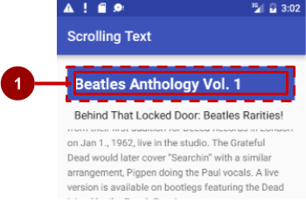

In the figure above: (1) Padding is the space between the edges of the TextView (dashed lines) and the content of the TextView (solid line). Padding is not the same as margin, which is the space from the edge of the View to its parent.

The size of a View includes its padding. The following are commonly used padding attributes:

* android:padding: Sets the padding of all four edges.
* android:paddingTop: Sets the padding of the top edge.
* android:paddingBottom: Sets the padding of the bottom edge.
* android:paddingLeft: Sets the padding of the left edge.
* android:paddingRight: Sets the padding of the right edge.
* android:paddingStart: Sets the padding of the start of the view, in pixels. Used in place of the padding attributes listed above, especially with views that are long and narrow.
* android:paddingEnd: Sets the padding of the end edge of the view, in pixels. Used along with android:paddingStart.

**Tip**: To see all of the XML attributes for a LinearLayout, see the Summary section of the [LinearLayout](https://developer.android.com/reference/android/widget/LinearLayout.html)class definition. Other root layouts, such as [RelativeLayout](http://developer.android.com/guide/topics/ui/layout/relative.html) and [AbsoluteLayout](https://developer.android.com/reference/android/widget/AbsoluteLayout.html), also list their XML attributes in the Summary sections.

#### **RelativeLayout Positioning**

Another useful Viewgroup for layout is [RelativeLayout](https://developer.android.com/reference/android/widget/RelativeLayout.html), which you can use to position child Viewelements relative to each other or to the parent. The attributes you can use with RelativeLayout include the following:

* [android:layout_toLeftOf](https://developer.android.com/reference/android/widget/RelativeLayout.LayoutParams.html#attr_android:layout_toLeftOf): Positions the right edge of this View to the left of another View (identified by its ID).
* [android:layout_toRightOf](https://developer.android.com/reference/android/widget/RelativeLayout.LayoutParams.html#attr_android:layout_toRightOf): Positions the left edge of this View to the right of another View(identified by its ID).
* [android:layout_centerHorizontal](https://developer.android.com/reference/android/widget/RelativeLayout.LayoutParams.html#attr_android:layout_centerHorizontal): Centers this View horizontally within its parent.
* [android:layout_centerVertical](https://developer.android.com/reference/android/widget/RelativeLayout.LayoutParams.html#attr_android:layout_centerVertical): Centers this View vertically within its parent.
* [android:layout_alignParentTop](https://developer.android.com/reference/android/widget/RelativeLayout.LayoutParams.html#attr_android:layout_alignParentTop): Positions the top edge of this View to match the top edge of the parent.
* [android:layout_alignParentBottom](https://developer.android.com/reference/android/widget/RelativeLayout.LayoutParams.html#attr_android:layout_alignParentBottom): Positions the bottom edge of this View to match the bottom edge of the parent.

For a complete list of attributes for View and View subclass elements in a RelativeLayout, see [RelativeLayout.LayoutParams](https://developer.android.com/reference/android/widget/RelativeLayout.LayoutParams.html).

### Style-related attributes

You specify style attributes to customize the appearance of a View. A View that doesn't have style attributes, such as android:textColor, android:textSize, and android:background, takes on the styles defined in the app's theme.

The following are style-related attributes used in lesson on using the layout editor:

* android:background: Specifies a color or drawable resource to use as the background.
* android:text: Specifies text to display in the view.
* android:textColor: Specifies the text color.
* android:textSize: Specifies the text size.
* android:textStyle: Specifies the text style, such as bold.

## Resource files

Resource files are a way of separating static values from code so that you don't have to change the code itself to change the values. You can store all the strings, layouts, dimensions, colors, styles, and menu text separately in resource files.

Resource files are stored in folders located in the res folder when viewing the Project > Android pane. These folders include:

* drawable: For images and icons
* layout: For layout resource files
* menu: For menu items
* mipmap: For pre-calculated, optimized collections of app icons used by the Launcher
* values: For colors, dimensions, strings, and styles (theme attributes)

The syntax to reference a resource in an XML layout is as follows:

@package_name:resource_type/resource_name

* package_name is the name of the package in which the resource is located. The package name is not required when you reference resources that are stored in the res folder of your project, because these resources are from the same package.
* resource_type is the R subclass for the resource type. See [Resource Types](https://developer.android.com/guide/topics/resources/available-resources.html) for more about the resource types and how to reference them.
* resource_name is either the resource filename without the extension, or the android:name attribute value in the XML element.

For example, the following XML layout statement sets the android:text attribute to a string resource:

android:text="@string/button_label_toast"

* No package_name is included, because the resource is stored in the strings.xml file in the project.
* The resource_type is string.
* The resource_name is button_label_toast.

Another example: this XML layout statement sets the android:background attribute to a color resource, and since the resource is defined in the project (in the colors.xml file), the package_name is not specified:

android:background="@color/colorPrimary"

In the following example, the XML layout statement sets the android:textColor attribute to a colorresource. However, the resource is not defined in the project but supplied by Android, so you need to specify the package_name, which is android, followed by a colon:

android:textColor="@android:color/white"

**Tip**: For more about accessing resources from code, see [Accessing Resources](http://developer.android.com/guide/topics/resources/accessing-resources.html). For Android color constants, see the [Android standard R.color resources](http://developer.android.com/reference/android/R.color.html).

### Values resource files

Keeping values such as strings and colors in separate resource files makes it easier to manage them, especially if you use them more than once in your layouts.

For example, it is essential to keep strings in a separate resource file for translating and localizing your app, so that you can create a string resource file for each language without changing your code. Resource files for images, colors, dimensions, and other attributes are handy for developing an app for different device screen sizes and orientations.

### Strings

String resources are located in the strings.xml file (inside **res > values** in the **Project > Android** pane). You can edit this file directly by opening it in the editor pane:

<resources>

<string name="app_name">Hello Toast</string>

<string name="button_label_count">Count</string>

<string name="button_label_toast">Toast</string>

<string name="count_initial_value">0</string>

</resources>

The name (for example, button_label_count) is the resource name you use in your XML code, as in the following attribute:

android:text="@string/button_label_count"

The string value of this name is the word (Count) enclosed within the <string></string> tags. (You don't use quotation marks unless the quotation marks are part of the string value.)

### Extracting strings to resources

You should also extract hard-coded strings in an XML layout file to string resources.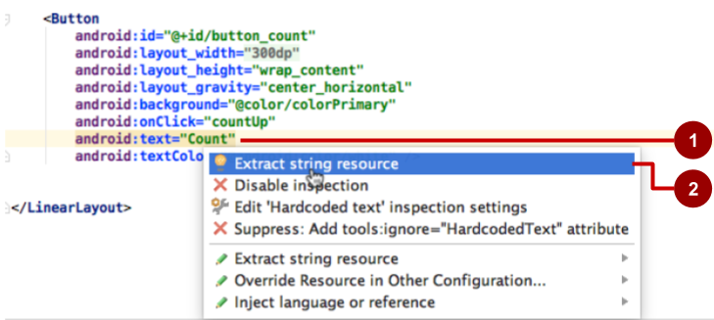

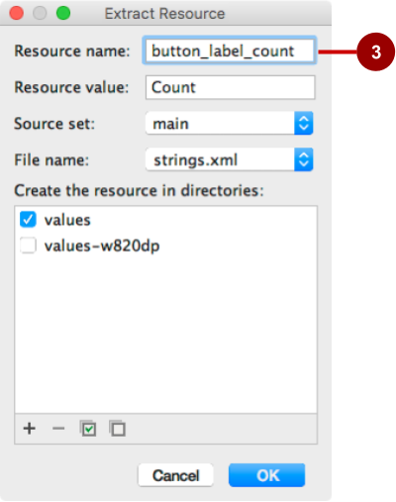

To extract a hard-coded string in an XML layout, follow these steps, as shown in the figure above:

1. Click the hard-coded string and press **Alt-Enter** in Windows, or **Option-Return** in Mac OS X.
2. Select **Extract string resource**.
3. Edit the **Resource name** for the string value.

You can then use the resource name in your XML code. Use the expression "@string/resource_name"(including quotation marks) to refer to the string resource:

android:text="@string/button_label_count"

### Colors

Color resources are located in the colors.xml file (inside **res > values** in the **Project > Android** pane). You can edit this file directly in the editor pane:

<resources>

<color name="colorPrimary">#3F51B5</color>

<color name="colorPrimaryDark">#303F9F</color>

<color name="colorAccent">#FF4081</color>

<color name="myBackgroundColor">#FFF043</color>

</resources>

The name (for example, colorPrimary) is the resource name you use in your XML code:

android:textColor="@color/colorPrimary"

The color value of this name is the hexadecimal color value (#3F51B5) enclosed within the <color></color> tags. The hexadecimal value specifies red, green, and blue (RGB) values. The value always begins with a pound (#) character, followed by the Alpha-Red-Green-Blue information. For example, the hexadecimal value for black is #000000, while the hexadecimal value for a variant of sky blue is #559fe3. Base color values are listed in the [Color](https://developer.android.com/reference/android/graphics/Color.html) class documentation.

The colorPrimary color is one of the predefined base colors and is used for the app bar. In a production app, you could, for example, customize this to fit your brand. Using the base colors for other UI elements creates a uniform UI.

**Tip**: For the Material Design specification for Android colors, see [Style](https://material.google.com/style/color.html) and [Using the Material Theme](https://developer.android.com/training/material/theme.html). For common color hexadecimal values, see [Color Hex Color Codes](http://www.color-hex.com/). For Android color constants, see the [Android standard R.color resources](http://developer.android.com/reference/android/R.color.html).

You can see a small block of the color choice in the left margin next to the color resource declaration in colors.xml, and also in the left margin next to the attribute that uses the resource name in the layout XML file.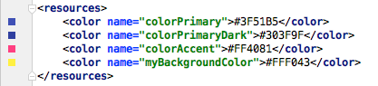



**Tip**: To see the color in a popup, turn on the Autopopup documentation feature. Select **Preferences > Editor > General > Code Completion**, and select the "Autopopup documentation in (ms)" option. You can then hover your cursor over a color resource name to see the color.

### Dimensions

To make dimensions easier to manage, you should separate the dimensions from your code, especially if you need to adjust your layout for devices with different screen densities. Keeping dimensions separate from code also makes it easy to have consistent sizing for UI elements, and to change the size of multiple elements by changing one dimension resource.

Dimension resources are located in the dimens.xml file (inside **res > values** in the **Project > Android**pane). The dimens.xml file can actually be a folder holding more than one dimens.xml file—one for each device screen resolution. You can edit each dimens.xml file directly:

<resources>

<!-- Default screen margins, per the Android Design guidelines. -->

<dimen name="activity_horizontal_margin">16dp</dimen>

<dimen name="activity_vertical_margin">16dp</dimen>

<dimen name="my_view_width">300dp</dimen>

<dimen name="count_text_size">200sp</dimen>

<dimen name="counter_height">300dp</dimen>

</resources>

The name (for example, activity_horizontal_margin) is the resource name you use in the XML code:

android:paddingLeft="@dimen/activity_horizontal_margin"

The value of this name is the measurement (16dp) enclosed within the <dimen></dimen> tags.

You can extract dimensions in the same way as strings:

1. Click the hard-coded dimension, and press **Alt-Enter** in Windows, or press **Option-Return** in Mac OS X.
2. Select **Extract dimension resource**.
3. Edit the **Resource name** for the dimension value.

[Density-independent pixels](https://developer.android.com/training/multiscreen/screendensities.html) (dp) are independent of screen resolution. For example, 10px (10 fixed pixels) look a lot smaller on a higher resolution screen, but Android scales 10dp (10 device-independent pixels) to look right on different resolution screens. Text sizes can also be set to look right on different resolution screens using scaled-pixel (sp) sizes.

**Tip**: For more information about dp and sp units, see [Supporting Different Densities](http://developer.android.com/training/multiscreen/screendensities.html).

### Styles

A style is a resource that specifies common attributes such as height, padding, font color, font size, background color. Styles are meant for attributes that modify the look of the view.

Styles are defined in the styles.xml file (inside **res > values** in the **Project > Android** pane). You can edit this file directly. Styles are covered in a later chapter, along with the Material Design Specification.

### Other resource files

Android Studio defines other resources that are covered in other chapters:

* Images and icons: The drawable folder provides icon and image resources. If your app does not have a drawable folder, you can manually create it inside the res folder. For more information about drawable resources, see [Drawable Resources](https://developer.android.com/guide/topics/resources/drawable-resource.html) in the App Resources section of the Android Developer's Guide.
* Optimized icons: The mipmap folder typically contains pre-calculated, optimized collections of app icons used by the Launcher. Expand the folder to see that versions of icons are stored as resources for different screen densities.
* Menus: You can use an XML resource file to define menu items and store them in your project in the menu folder. Menus are described in a later chapter.

## Responding to View clicks

A click event occurs when the user taps or clicks a clickable View, such as a [Button](https://developer.android.com/reference/android/widget/Button.html), [ImageButton](https://developer.android.com/reference/android/widget/ImageButton.html), [ImageView](https://developer.android.com/reference/android/widget/ImageView.html), or [FloatingActionButton](https://developer.android.com/reference/android/support/design/widget/FloatingActionButton.html). When such an event occurs, your code performs an action. In order to make this pattern work, you have to:

* Write a Java method that performs the specific action you want the app to do when this event occurs. This method is typically referred to as an event handler.
* Associate this event-handler method to the View, so that the method executes when the event occurs.

### The onClick attribute

Android Studio provides a shortcut for setting up a clickable View, and for associating an event handler with the View: use the android:onClick attribute in the XML layout.

For example, the following XML attribute sets a Button to be clickable, and sets showToast() as the event handler:

<Button

android:id="@+id/button_toast"

android:onClick="showToast"

When the user taps the button_toast Button, the button's android:onClick attribute calls the showToast() method. In order to work with the android:onClick attribute, the showToast() method must be public and return void. To know which View called the method, the showToast() method must require a view parameter.

Android Studio provides a shortcut for creating an event handler stub (a placeholder for a method that you can fill in later) in the code for the Activity associated with the XML layout. Follow these steps:

1. Inside the XML layout file (such as activity_main.xml), click the method name in the android:onClick attribute statement (showToast in the XML snippet above).
2. Press **Alt-Enter** in Windows or **Option-Return** in Mac OS X, and select **Create onClick event handler**.
3. Select the Activity associated with the layout file (such as **MainActivity**) and click **OK**. Android Studio creates a placeholder method stub in MainActivity.java as shown below.

public void showToast(View view) {

// Do something in response to the button click.

}

### Updating a View

To update a View, for example to replace the text in a TextView, your code must first instantiate an object from the View. Your code can then update the object, which updates the screen.

To refer to the View in your code, use the [findViewById()](https://developer.android.com/reference/android/view/View.html#findViewById(int)) method of the View class, which looks for a View based on the resource id. For example, the following statement sets mShowCount to be the TextView in the layout with the resource id show_count:

mShowCount = (TextView) findViewById(R.id.show_count);

From this point on, your code can use mShowCount to represent the TextView, so that when you update mShowCount, the TextView is updated.

For example, when the following Button with the android:onClick attribute is tapped, onClick calls the countUp() method:

android:onClick="countUp"

You can implement countUp() to increment the count, convert the count to a string, and set the string as the text for the mShowCount object:

public void countUp(View view) {

mCount++;

if (mShowCount != null)

mShowCount.setText(Integer.toString(mCount));

}

Since you had already associated mShowCount with the TextView for displaying the count, the mShowCount.setText() method updates the TextView on the screen.

1.3: Text and scrolling views

**Contents:**

* [TextView](https://google-developer-training.github.io/android-developer-fundamentals-course-concepts-v2/unit-1-get-started/lesson-1-build-your-first-app/1-3-c-text-and-scrolling-views/1-3-c-text-and-scrolling-views.html#textview)
* [Scrolling views](https://google-developer-training.github.io/android-developer-fundamentals-course-concepts-v2/unit-1-get-started/lesson-1-build-your-first-app/1-3-c-text-and-scrolling-views/1-3-c-text-and-scrolling-views.html#scrolling_views)
* [Related practical](https://google-developer-training.github.io/android-developer-fundamentals-course-concepts-v2/unit-1-get-started/lesson-1-build-your-first-app/1-3-c-text-and-scrolling-views/1-3-c-text-and-scrolling-views.html#relatedpractical)
* [Learn more](https://google-developer-training.github.io/android-developer-fundamentals-course-concepts-v2/unit-1-get-started/lesson-1-build-your-first-app/1-3-c-text-and-scrolling-views/1-3-c-text-and-scrolling-views.html#learnmore)

This chapter describes one of the most often used [View](https://developer.android.com/reference/android/view/View.html) subclasses in apps: the [TextView](https://developer.android.com/reference/android/widget/TextView.html), which shows textual content on the screen. A TextView can be used to show a message, a response from a database, or even entire magazine-style articles that users can scroll. This chapter also shows how you can create a scrolling view of text and other elements.

TextView

One View subclass you may use often is the [TextView](https://developer.android.com/reference/android/widget/TextView.html) class, which displays text on the screen. You can use TextView for a View of any size, from a single character or word to a full screen of text. You can add a resource id to the TextView in the layout, and control how the text appears using attributes in the layout file.

You can refer to a TextView in your Java code by using its resource id in order to update the text or its attributes from your code. If you want to allow users to edit the text, use [EditText](https://developer.android.com/reference/android/widget/EditText.html), a subclass of TextView that allows text input and editing. You learn all about EditText in another lesson.

TextView attributes

You can use XML attributes for a TextView to control:

* Where the TextView is positioned in a layout (like any other view)
* How the TextView itself appears, such as with a background color
* What the text looks like within the TextView, such as the initial text and its style, size, and color

For example, to set the width, height, and initial text value of the view:

<TextView

android:layout_width="wrap_content"

android:layout_height="wrap_content"

android:text="Hello World!"

<!-- more attributes -->

/>

You can extract the text string into a string resource (perhaps called hello_world) that's easier to maintain for multiple-language versions of the app, or if you need to change the string in the future. After extracting the string, use the string resource name with @string/ to specify the text:

<TextView

android:layout_width="wrap_content"

android:layout_height="wrap_content"

android:text="@string/hello_world"

<!-- more attributes -->

/>

In addition to android:layout_width and android:layout_height (which are required for a TextView), the most often used attributes with TextView are the following:

* [android:text](https://developer.android.com/reference/android/widget/TextView.html#attr_android:text): Set the text to display.
* [android:textColor](https://developer.android.com/reference/android/widget/TextView.html#attr_android:textColor): Set the color of the text. You can set the attribute to a color value, a predefined resource, or a theme. Color resources and themes are described in other chapters.
* [android:textAppearance](https://developer.android.com/reference/android/widget/TextView.html#attr_android:textAppearance): The appearance of the text, including its color, typeface, style, and size. You set this attribute to a predefined style resource or theme that already defines these values.
* [android:textSize](https://developer.android.com/reference/android/widget/TextView.html#attr_android:textSize): Set the text size (if not already set by android:textAppearance). Use sp (scaled-pixel) sizes such as 20sp or 14.5sp, or set the attribute to a predefined resource or theme.
* [android:textStyle](https://developer.android.com/reference/android/widget/TextView.html#attr_android:textStyle): Set the text style (if not already set by android:textAppearance). Use normal, bold, italic, or bold|italic.
* [android:typeface](https://developer.android.com/reference/android/widget/TextView.html#attr_android:typeface): Set the text typeface (if not already set by android:textAppearance). Use normal, sans, serif, or monospace.
* [android:lineSpacingExtra](https://developer.android.com/reference/android/widget/TextView.html#attr_android:lineSpacingExtra): Set extra spacing between lines of text. Use sp (scaled-pixel) or dp (device-independent pixel) sizes, or set the attribute to a predefined resource or theme.
* [android:autoLink](https://developer.android.com/reference/android/widget/TextView.html#attr_android:autoLink): Controls whether links such as URLs and email addresses are automatically found and converted to clickable (touchable) links.

Use one of the following with android:autoLink:

* none: Match no patterns (default).
* web: Match web URLs.
* email: Match email addresses.
* phone: Match phone numbers.
* map: Match map addresses.
* all: Match all patterns (equivalent to web|email|phone|map).

For example, to set the attribute to match web URLs, use android:autoLink="web".

Using embedded tags in text

In an app that accesses magazine or newspaper articles, the articles that appear would probably come from an online source or might be saved in advance in a database on the device. You can also create text as a single long string in the strings.xml resource.

In either case, the text may contain embedded HTML tags or other text formatting codes. To properly display in a text view, text must be formatted following these rules:

* Enter **\n** to represent the end of a line, and another **\n** to represent a blank line. You need to add end-of-line characters to keep paragraphs from running into each other.
* If you have an apostrophe (') in your text, you must *escape* it by preceding it with a backslash (**\'**). If you have a double-quote in your text, you must also escape it (**\"**). You must also escape any other non-ASCII characters. See the "[Formatting and Styling](https://developer.android.com/guide/topics/resources/string-resource.html#FormattingAndStyling)" section of String Resources for more details.
* Enter the HTML and **</b>** tags around words that should be in bold.
* Enter the HTML and **</i>** tags around words that should be in italics. Note, however, that if you use curled apostrophes within an italic phrase, you should replace them with straight apostrophes.
* You can combine bold and italics by combining the tags, as in ***...***words...**</i></b>**. Other HTML tags are ignored.
* To create a long string of text in the strings.xml file, enclose the entire text within <string name="*your_string_name*"></string> (*your_string_name* is the name you provide the string resource, such as article_text).
* As you enter or paste text in the strings.xml file, the text lines don't wrap around to the next line—they extend beyond the right margin. This is the correct behavior—each new line of text starting at the left margin represents an entire paragraph.

**Tip:**If you want to see the text wrapped in strings.xml, you can press Return to enter hard line endings, or format the text first in a text editor with hard line endings. The endings will not be displayed on the screen.

Referring to a TextView in code

To refer to a TextView in your Java code, use its resource id. For example, to update a TextView with new text, you would:

1. Find the TextView and assign it to a variable. You use the [findViewById()](https://developer.android.com/reference/android/view/View.html#findViewById(int)) method of the Viewclass, and refer to the view you want to find using this format:
2. R.id.view_id

In which *view_id* is the resource identifier for the view (such as show_count) :

mShowCount = (TextView) findViewById(R.id.show_count);

1. After retrieving the View as a TextView member variable, you can then set the text to new text (in this case, mCount_text) using the [setText()](https://developer.android.com/reference/android/widget/TextView.html#setText(java.lang.CharSequence)) method of the TextView class:
2. mShowCount.setText(mCount_text);

Scrolling views

If the information you want to show in your app is larger than the device's display, you can create a *scrolling view* that the user can scroll vertically by swiping up or down, or horizontally by swiping right or left.

You would typically use a scrolling view for news stories, articles, or any lengthy text that doesn't completely fit on the display. You can also use a scrolling view to combine views (such as a TextViewand a Button) within a scrolling view.

Creating a layout with a ScrollView

The [ScrollView](https://developer.android.com/reference/android/widget/ScrollView.html) class provides the layout for a vertical scrolling view. (For horizontal scrolling, you would use [HorizontalScrollView](https://developer.android.com/reference/android/widget/HorizontalScrollView.html).) ScrollView is a subclass of [FrameLayout](https://developer.android.com/reference/android/widget/FrameLayout.html), which means that you can place only *one*View as a child within it; that child contains the entire contents to scroll.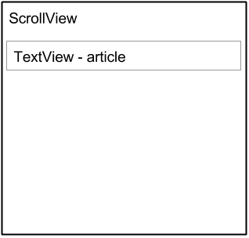

Even though you can place only one child View inside a ScrollView, the child View can be a [ViewGroup](https://developer.android.com/reference/android/view/ViewGroup.html) with a hierarchy of child View elements, such as a [LinearLayout](https://developer.android.com/reference/android/widget/LinearLayout.html). A good choice for a Viewwithin a ScrollView is a LinearLayout that is arranged in a vertical orientation.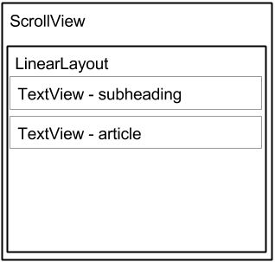

ScrollView and performance

All of the contents of a ScrollView (such as a ViewGroup with View elements) occupy memory and the view hierarchy even if portions are not displayed on screen. This makes ScrollView useful for smoothly scrolling pages of free-form text, because the text is already in memory. However, a ScrollView with a ViewGroup with View elements can use up a lot of memory, which can affect the performance of the rest of your app.

Using nested instances of LinearLayout can also lead to an excessively deep view hierarchy, which can slow down performance. Nesting several instances of LinearLayout that use the android:layout_weightattribute can be especially expensive as each child View needs to be measured twice. Consider using flatter layouts such as [RelativeLayout](https://developer.android.com/reference/android/widget/RelativeLayout.html) or [GridLayout](https://developer.android.com/reference/android/widget/GridLayout.html) to improve performance.

Complex layouts with ScrollView may suffer performance issues, especially with images. We recommend that you *not* use images within a ScrollView. To display long lists of items, or images, consider using a [RecyclerView](https://developer.android.com/reference/android/support/v7/widget/RecyclerView.html), which is covered in another lesson.

ScrollView with a TextView

To display a scrollable magazine article on the screen, you might use a [RelativeLayout](https://developer.android.com/reference/android/widget/RelativeLayout.html) that includes a separate TextView for the article heading, another for the article subheading, and a third TextView for the scrolling article text (see the figure below), set within a ScrollView. The only part of the screen that would scroll would be the ScrollView with the article text.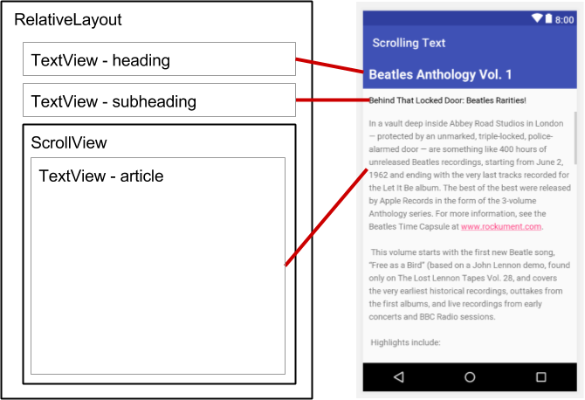

ScrollView with a LinearLayout

A ScrollView can contain only one child View; however, that View can be a [ViewGroup](https://developer.android.com/reference/android/view/ViewGroup.html) that contains several View elements, such as [LinearLayout](https://developer.android.com/reference/android/widget/LinearLayout.html). You can *nest* a ViewGroup such as LinearLayout *within*the ScrollView, thereby scrolling everything that is inside the LinearLayout.

For example, if you want the subheading of an article to scroll along with the article even if they are separate TextView elements, add a LinearLayout to the ScrollView as a single child View as shown in the figure below, and then move the TextView subheading and article elements into the LinearLayout. The user scrolls the entire LinearLayout which includes the subheading and the article.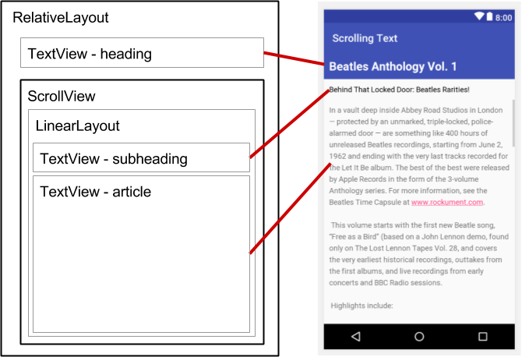

When adding a LinearLayout inside a ScrollView, use match_parent for the LinearLayoutandroid:layout_width attribute to match the width of the parent ScrollView, and use wrap_content for the LinearLayout android:layout_height attribute to make it only large enough to enclose its contents.

Since ScrollView only supports vertical scrolling, you must set the LinearLayout orientation attribute to vertical (android:orientation="vertical"), so that the entire LinearLayout will scroll vertically. For example, the following XML layout scrolls the article TextView along with the article_subheadingTextView:

<ScrollView

android:layout_width="wrap_content"

android:layout_height="wrap_content"

android:layout_below="@id/article_heading">

<LinearLayout

android:layout_width="match_parent"

android:layout_height="wrap_content"

android:orientation="vertical">

<TextView

android:id="@+id/article_subheading"

android:layout_width="match_parent"

android:layout_height="wrap_content"

android:padding="@dimen/padding_regular"

android:text="@string/article_subtitle"

android:textAppearance=

"@android:style/TextAppearance.DeviceDefault" />

<TextView

android:id="@+id/article"

android:layout_width="wrap_content"

android:layout_height="wrap_content"

android:autoLink="web"

android:lineSpacingExtra="@dimen/line_spacing"

android:padding="@dimen/padding_regular"

android:text="@string/article_text" />

</LinearLayout>

</ScrollView>

2.1: Activities and intents

**Contents:**

* [Introduction](https://google-developer-training.github.io/android-developer-fundamentals-course-concepts-v2/unit-1-get-started/lesson-2-activities-and-intents/2-1-c-activities-and-intents/2-1-c-activities-and-intents.html#chapterstart)
* [About Activity](https://google-developer-training.github.io/android-developer-fundamentals-course-concepts-v2/unit-1-get-started/lesson-2-activities-and-intents/2-1-c-activities-and-intents/2-1-c-activities-and-intents.html#aboutactivities)
* [Creating an Activity](https://google-developer-training.github.io/android-developer-fundamentals-course-concepts-v2/unit-1-get-started/lesson-2-activities-and-intents/2-1-c-activities-and-intents/2-1-c-activities-and-intents.html#creatingactivities)
* [About Intent](https://google-developer-training.github.io/android-developer-fundamentals-course-concepts-v2/unit-1-get-started/lesson-2-activities-and-intents/2-1-c-activities-and-intents/2-1-c-activities-and-intents.html#aboutintents)
* [Starting an Activity with an explicit Intent](https://google-developer-training.github.io/android-developer-fundamentals-course-concepts-v2/unit-1-get-started/lesson-2-activities-and-intents/2-1-c-activities-and-intents/2-1-c-activities-and-intents.html#startingactivitywithexplicitintent)
* [Passing data from one Activity to another](https://google-developer-training.github.io/android-developer-fundamentals-course-concepts-v2/unit-1-get-started/lesson-2-activities-and-intents/2-1-c-activities-and-intents/2-1-c-activities-and-intents.html#passingdatabetweenactivities)
* [Getting data back from an Activity](https://google-developer-training.github.io/android-developer-fundamentals-course-concepts-v2/unit-1-get-started/lesson-2-activities-and-intents/2-1-c-activities-and-intents/2-1-c-activities-and-intents.html#gettingdatabackfromactivity)
* [Activity navigation](https://google-developer-training.github.io/android-developer-fundamentals-course-concepts-v2/unit-1-get-started/lesson-2-activities-and-intents/2-1-c-activities-and-intents/2-1-c-activities-and-intents.html#activitynavigation)
* [Related practical](https://google-developer-training.github.io/android-developer-fundamentals-course-concepts-v2/unit-1-get-started/lesson-2-activities-and-intents/2-1-c-activities-and-intents/2-1-c-activities-and-intents.html#relatedpractical)
* [Learn more](https://google-developer-training.github.io/android-developer-fundamentals-course-concepts-v2/unit-1-get-started/lesson-2-activities-and-intents/2-1-c-activities-and-intents/2-1-c-activities-and-intents.html#learnmore)

Introduction

In this chapter you learn about the [Activity](https://developer.android.com/reference/android/app/Activity.html) class, the major building block of your app's user interface (UI). You also learn about using an [Intent](https://developer.android.com/reference/android/content/Intent.html) to communicate from one activity to another.

About activities

An *activity* represents a single screen in your app with an interface the user can interact with. For example, an email app might have one activity that shows a list of new emails, another activity to compose an email, and another activity for reading individual messages. Your app is probably a collection of activities that you create yourself, or that you reuse from other apps.

Although the activities in your app work with each other to form a cohesive user experience, each activity is independent of the others. This enables your app to start an activity in another app, and it enables other apps to start activities in your app (if your app allows this). For example, a messaging app could start an activity in a camera app to take a picture, then start an activity in an email app to let the user share the picture in email.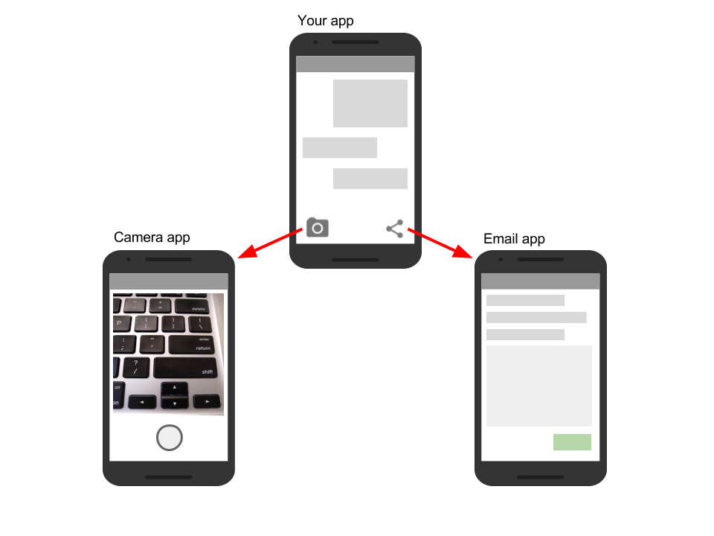

Typically, one Activity in an app is specified as the "main" activity, for example MainActivity. The user sees the main activity when they launch the app for the first time. Each activity can start other activities to perform different actions.

Each time a new activity starts, the previous activity is stopped, but the system preserves the activity in a stack (the "back stack"). When the user is done with the current activity and presses the Back button, the activity is popped from the stack and destroyed, and the previous activity resumes.

When an activity is stopped because a new activity starts, the first activity is notified by way of the activity lifecycle callback methods. The [*activity lifecycle*](https://developer.android.com/guide/components/activities/activity-lifecycle.html) is the set of states an Activity can be in: when the activity is first created, when it's stopped or resumed, and when the system destroys it. You learn more about the activity lifecycle in a later chapter.

Creating an Activity

To implement an [Activity](https://developer.android.com/reference/android/app/Activity.html) in your app, do the following:

* Create an Activity Java class.
* Implement a basic UI for the Activity in an XML layout file.
* Declare the new Activity in the AndroidManifest.xml file.

When you create a new project for your app, or add a new Activity to your app by choosing **File > New > Activity**, the template automatically performs the steps listed above.

Create the Activity

When you create a new project in Android Studio and choose the **Backwards Compatibility (AppCompat)** option, the MainActivity is, by default, a subclass of the [AppCompatActivity](https://developer.android.com/reference/android/support/v7/app/AppCompatActivity.html) class. The AppCompatActivity class lets you use up-to-date Android app features such as the app bar and Material Design, while still enabling your app to be compatible with devices running older versions of Android.

Here is a skeleton subclass of AppCompatActivity:

public class MainActivity extends AppCompatActivity {

@Override

protected void onCreate(Bundle savedInstanceState) {

super.onCreate(savedInstanceState);

setContentView(R.layout.activity_main);

}

}

The first task for you in your Activity subclass is to implement the standard Activity lifecycle callback methods (such as [onCreate()](https://developer.android.com/reference/android/app/Activity.html#onCreate(android.os.Bundle))) to handle the state changes for your Activity. These state changes include things such as when the Activity is created, stopped, resumed, or destroyed. You learn more about the Activity lifecycle and lifecycle callbacks in a different chapter.

The one required callback your app must implement is the [onCreate()](https://developer.android.com/reference/android/app/Activity.html#onCreate(android.os.Bundle)) method. The system calls this method when it creates your Activity, and all the essential components of your Activity should be initialized here. Most importantly, the onCreate() method calls [setContentView()](https://developer.android.com/reference/android/app/Activity.html#setContentView(int)) to create the primary layout for the Activity.

You typically define the UI for your Activity in one or more XML layout files. When the setContentView() method is called with the path to a layout file, the system creates all the initial views from the specified layout and adds them to your Activity. This is often referred to as *inflating* the layout.

You may often also want to implement the [onPause()](https://developer.android.com/reference/android/app/Activity.html#onPause()) method in your Activity. The system calls this method as the first indication that the user is leaving your Activity (though it does not always mean that the Activity is being destroyed). This is usually where you should commit any changes that should be persisted beyond the current user session (because the user might not come back). You learn more about onPause() and all the other lifecycle callbacks in a later chapter.

In addition to lifecycle callbacks, you may also implement methods in your Activity to handle other behavior such as user input or button clicks.

Implement the activity's UI

The UI for an activity is provided by a hierarchy of View elements, which controls a particular space within the activity window and can respond to user interaction.

The most common way to define a UI using View elements is with an XML layout file stored as part of your app's resources. Defining your layout in XML enables you to maintain the design of your UI separately from the source code that defines the activity behavior.

You can also create new View elements directly in your activity code by inserting new View objects into a ViewGroup, and then passing the root ViewGroup to setContentView(). After your layout has been inflated—regardless of its source—you can add more View elements anywhere in the View hierarchy.

Declare the Activity in AndroidManifest.xml

Each Activity in your app must be declared in the AndroidManifest.xml file with the <activity>element, inside the <application> section. When you create a new project or add a new Activity to your project in Android Studio, the AndroidManifest.xml file is created or updated to include skeleton declarations for each Activity. Here's the declaration for MainActivity:

<activity android:name=".MainActivity" >

<intent-filter>

<action android:name="android.intent.action.MAIN" />

<category android:name="android.intent.category.LAUNCHER" />

</intent-filter>

</activity>

The <activity> element includes a number of attributes to define properties of the Activity such as its label, icon, or theme. The only required attribute is android:name, which specifies the class name for the Activity (such as MainActivity). See the [<activity>](https://developer.android.com/guide/topics/manifest/activity-element.html) element reference for more information on Activity declarations.

The <activity> element can also include declarations for Intent filters. The Intent filters specify the kind of Intent your Activity will accept.

<intent-filter>

<action android:name="android.intent.action.MAIN" />

<category android:name="android.intent.category.LAUNCHER" />

</intent-filter>

Intent filters must include at least one <action> element, and can also include a <category> and optional <data>. The MainActivity for your app needs an Intent filter that defines the "main" action and the "launcher" category so that the system can launch your app. Android Studio creates this Intentfilter for the MainActivity in your project.

The <action> element specifies that this is the "main" entry point to the app. The <category> element specifies that this Activity should be listed in the system's app launcher (to allow users to launch this Activity).

Each Activity in your app can also declare Intent filters, but only your MainActivity should include the "main" action. You learn more about how to use an implicit Intent and Intent filters in a later section.

Add another Activity to your project

The MainActivity for your app and its associated layout file is supplied by an Activity template in Android Studio such as Empty Activity or Basic Activity. You can add a new Activity to your project by choosing **File > New > Activity**. Choose the Activity template you want to use, or open the Gallery to see all the available templates.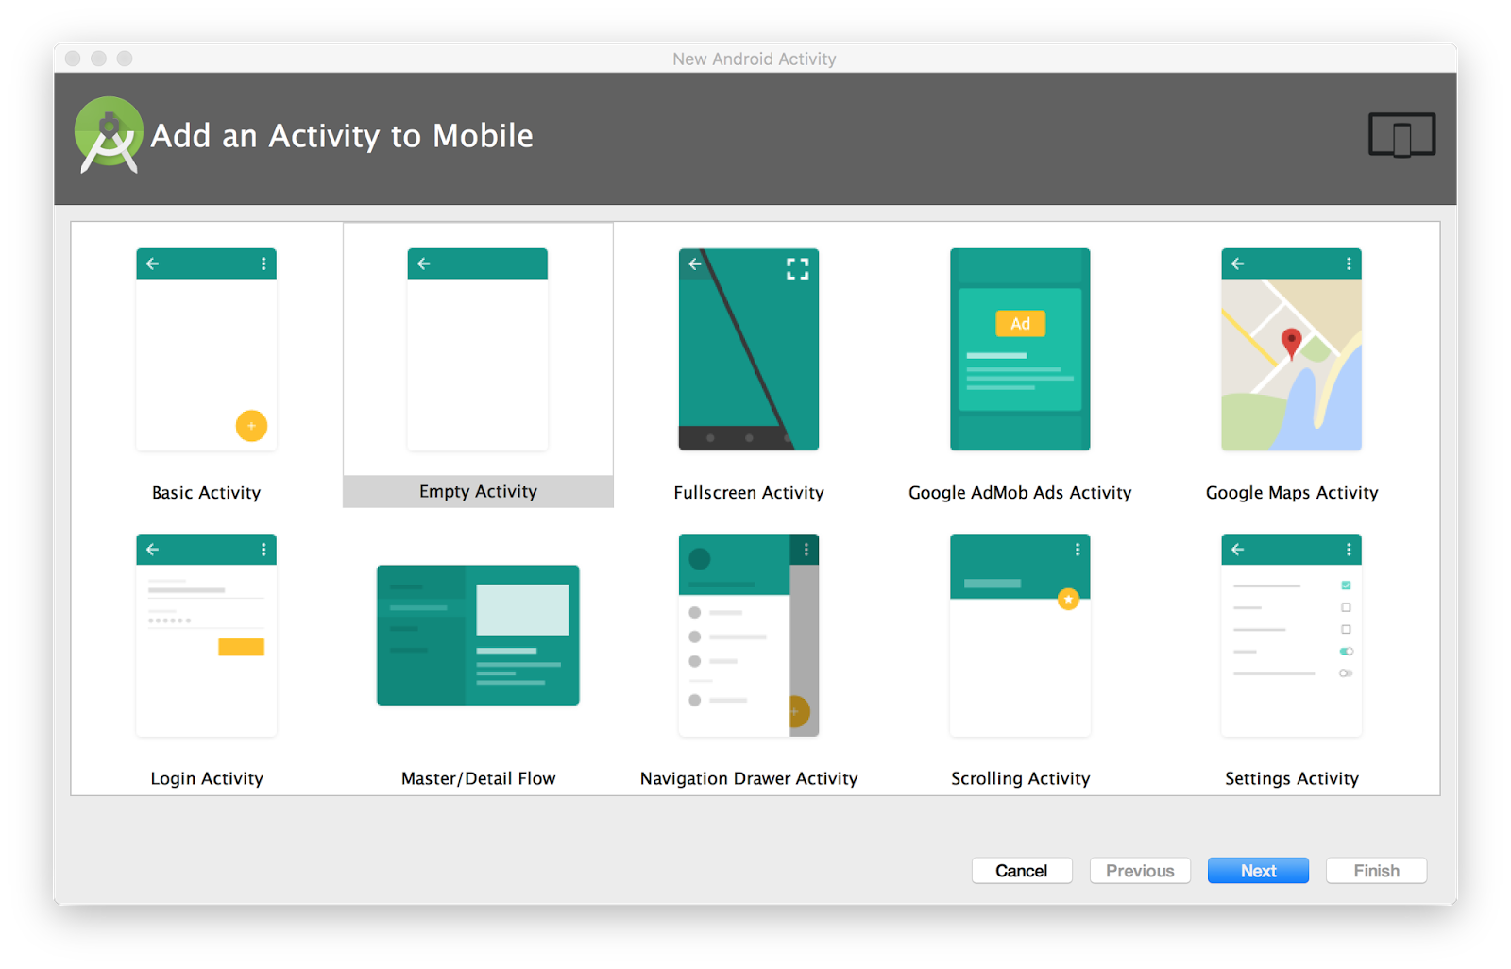

When you choose an Activity template, you see the same set of screens for creating the new activity that you did when you created the project. Android Studio provides three things for each new activity in your app:

* A Java file for the new Activity with a skeleton class definition and onCreate() method. The new Activity, like MainActivity, is a subclass of AppCompatActivity.
* An XML file containing the layout for the new activity. Note that the setContentView() method in the Activity class inflates this new layout.
* An additional <activity> element in the AndroidManifest.xml file that specifies the new activity. The second Activity definition does not include any Intent filters. If you plan to use this activity only within your app (and not enable that activity to be started by any other app), you do not need to add filters.

About intents

Each activity is started or activated with an [Intent](https://developer.android.com/reference/android/content/Intent.html), which is a message object that makes a request to the Android runtime to start an activity or other app component in your app or in some other app.

When your app is first started from the device home screen, the Android runtime sends an Intent to your app to start your app's main activity (the one defined with the MAIN action and the LAUNCHER category in the AndroidManifest.xml file). To start another activity in your app, or to request that some other activity available on the device perform an action, you build your own intent and call the startActivity() method to send the intent.

In addition to starting an activity, an intent can also be used to pass data between one activity and another. When you create an intent to start a new activity, you can include information about the data you want that new activity to operate on. So, for example, an email Activity that displays a list of messages can send an Intent to the Activity that displays that message. The display activity needs data about the message to display, and you can include that data in the intent.

In this chapter you learn about using intents with activities, but intents can also be used to start services or broadcast receivers. You learn how to use those app components in another practical.

Intent types

Intents can be *explicit* or *implicit*:

* *Explicit intent:*You specify the receiving activity (or other component) using the activity's fully qualified class name. You use explicit intents to start components in your own app (for example, to move between screens in the UI), because you already know the package and class name of that component.
* *Implicit intent:*You do *not* specify a specific activity or other component to receive the intent. Instead, you declare a general action to perform, and the Android system matches your request to an activity or other component that can handle the requested action. You learn more about using implicit intents in another practical.

Intent objects and fields

For an explicit Intent, the key fields include the following:

* The Activity *class* (for an explicit Intent). This is the class name of the Activity or other component that should receive the Intent; for example, com.example.SampleActivity.class. Use the Intent constructor or the setComponent(), setComponentName(), or setClassName() methods to specify the class.
* The Intent *data.* The Intent data field contains a reference to the data you want the receiving Activity to operate on as a Uri object.
* Intent *extras.*These are key-value pairs that carry information the receiving Activity requires to accomplish the requested action.
* Intent [*flags*](https://developer.android.com/reference/android/content/Intent.html#setFlags(int))*.*These are additional bits of metadata, defined by the Intent class. The flags may instruct the Android system how to launch an Activity or how to treat it after it's launched.

For an implicit Intent, you may need to also define the Intent action and category. You learn more about Intent actions and categories in another chapter.

Starting an Activity with an explicit Intent

To start a specific Activity from another Activity, use an explicit Intent and the [startActivity()](https://developer.android.com/reference/android/app/Activity.html#startActivity(android.content.Intent,%20android.os.Bundle))method. An explicit Intent includes the fully qualified class name for the Activity or other component in the Intent object. All the other Intent fields are optional, and null by default.

For example, if you want to start the ShowMessageActivity to show a specific message in an email app, use code like this:

Intent messageIntent = new Intent(this, ShowMessageActivity.class);

startActivity(messageIntent);

The intent constructor takes two arguments for an explicit Intent:

* An application context. In this example, the Activity class provides the context (this).
* The specific component to start (ShowMessageActivity.class).

Use the startActivity() method with the new Intent object as the only argument. The startActivity() method sends the Intent to the Android system, which launches the ShowMessageActivity class on behalf of your app. The new Activity appears on the screen, and the originating Activity is paused.

The started Activity remains on the screen until the user taps the Back button on the device, at which time that Activity closes and is reclaimed by the system, and the originating Activity is resumed. You can also manually close the started Activity in response to a user action (such as a Button click) with the [finish()](https://developer.android.com/reference/android/app/Activity.html#finish()) method:

public void closeActivity (View view) {

finish();

}

Passing data from one Activity to another

In addition to simply starting one Activity from another Activity, you also use an Intent to *pass information* from one Activity to another. The Intent object you use to start an Activity can include Intent *data* (the URI of an object to act on), or Intent *extras*, which are bits of additional data the Activity might need.

In the first (sending) Activity, you:

1. Create the Intent object.
2. Put data or extras into that Intent.
3. Start the new Activity with startActivity().

In the second (receiving) Activity, you:

1. Get the Intent object the Activity was started with.
2. Retrieve the data or extras from the Intent object.

When to use Intent data or Intent extras

You can use either Intent data or Intent extras to pass data from one Activity to another. There are several key differences between data and extras that determine which you should use.

The Intent *data* can hold only one piece of information: a URI representing the location of the data you want to operate on. That URI could be a web page URL (http://), a telephone number (tel://), a geographic location (geo://) or any other custom URI you define.

Use the Intent data field:

* When you only have one piece of information you need to send to the started Activity.
* When that information is a data location that can be represented by a URI.

Intent *extras* are for any other arbitrary data you want to pass to the started Activity. Intent extras are stored in a [Bundle](https://developer.android.com/reference/android/os/Bundle.html) object as key and value pairs. A Bundle is a map, optimized for Android, in which a key is a string, and a value can be any primitive or object type (objects must implement the [Parcelable](https://developer.android.com/reference/android/os/Parcelable.html)interface). To put data into the Intent extras you can use any of the [Intent](https://developer.android.com/reference/android/content/Intent.html) class putExtra() methods, or create your own Bundle and put it into the Intent with [putExtras()](https://developer.android.com/reference/android/content/Intent.html#putExtras(android.os.Bundle)).

Use the Intent extras:

* If you want to pass more than one piece of information to the started Activity.
* If any of the information you want to pass is not expressible by a URI.

Intent data and extras are not exclusive; you can use data for a URI and extras for any additional information the started Activity needs to process the data in that URI.

Add data to the Intent

To add data to an explicit Intent from the originating Activity, create the Intent object as you did before:

Intent messageIntent = new Intent(this, ShowMessageActivity.class);

Use the [setData()](https://developer.android.com/reference/android/content/Intent.html#setData(android.net.Uri)) method with a Uri object to add that URI to the Intent. Some examples of using setData() with URIs:

// A web page URL

messageIntent.setData(Uri.parse("http://www.google.com"));

// a Sample file URI

messageIntent.setData(Uri.fromFile(new File("/sdcard/sample.jpg")));

// A sample content: URI for your app's data model

messageIntent.setData(Uri.parse("content://mysample.provider/data"));

// Custom URI

messageIntent.setData(Uri.parse("custom:" + dataID + buttonId));

Keep in mind that the data field can only contain a single URI; if you call setData() multiple times only the last value is used. Use Intent extras to include additional information (including URIs.)

After you've added the data, you can start the Activity with the Intent as usual:

startActivity(messageIntent);

Add extras to the Intent

To add Intent extras to an explicit Intent from the originating Activity:

1. Determine the keys to use for the information you want to put into the extras, or define your own. Each piece of information needs its own unique key.
2. Use the putExtra() methods to add your key/value pairs to the Intent extras. Optionally you can create a [Bundle](https://developer.android.com/reference/android/os/Bundle.html) object, add your data to the Bundle, and then add the Bundle to the Intent.

The [Intent](https://developer.android.com/reference/android/content/Intent.html) class includes extra keys you can use, defined as constants that begin with the word EXTRA_. For example, you could use [Intent.EXTRA_EMAIL](https://developer.android.com/reference/android/content/Intent.html#EXTRA_EMAIL) to indicate an array of email addresses (as strings), or [Intent.EXTRA_REFERRER](https://developer.android.com/reference/android/content/Intent.html#EXTRA_REFERRER) to specify information about the originating Activity that sent the Intent.

You can also define your own Intent extra keys. Conventionally you define Intent extra keys as static variables with names that begin with EXTRA_. To guarantee that the key is unique, the string value for the key itself should be prefixed with your app's fully qualified class name. For example:

public final static String EXTRA_MESSAGE =

"com.example.mysampleapp.MESSAGE";

public final static String EXTRA_POSITION_X = "com.example.mysampleapp.X";

public final static String EXTRA_POSITION_Y = "com.example.mysampleapp.Y";

Create an Intent object (if one does not already exist):

Intent messageIntent = new Intent(this, ShowMessageActivity.class);

Use a putExtra() method with a key to put data into the Intent extras. The Intent class defines many putExtra() methods for different kinds of data:

messageIntent.putExtra(EXTRA_MESSAGE, "this is my message");

messageIntent.putExtra(EXTRA_POSITION_X, 100);

messageIntent.putExtra(EXTRA_POSITION_Y, 500);

Alternately, you can create a new Bundle and populate that Bundle with your Intent extras. [Bundle](https://developer.android.com/reference/android/os/Bundle.html)defines many "put" methods for different kinds of primitive data as well as objects that implement Android's [Parcelable](https://developer.android.com/reference/android/os/Parcelable.html) interface or Java's [Serializable](https://developer.android.com/reference/java/io/Serializable.html).

Bundle extras = new Bundle();

extras.putString(EXTRA_MESSAGE, "this is my message");

extras.putInt(EXTRA_POSITION_X, 100);

extras.putInt(EXTRA_POSITION_Y, 500);

After you've populated the Bundle, add it to the Intent with the [putExtras()](https://developer.android.com/reference/android/content/Intent.html#putExtras(android.os.Bundle)) method (note the "s" in Extras):

messageIntent.putExtras(extras);

Start the Activity with the Intent as usual:

startActivity(messageIntent);

Retrieve the data from the Intent in the started Activity

When you start an Activity with an Intent, the started Activity has access to the Intent and the data it contains.

To retrieve the Intent the Activity (or other component) was started with, use the [getIntent()](https://developer.android.com/reference/android/app/Activity.html#getIntent())method:

Intent intent = getIntent();

Use [getData()](https://developer.android.com/reference/android/content/Intent.html#getData()) to get the URI from that Intent:

Uri locationUri = intent.getData();

To get the extras out of the Intent, you need to know the keys for the key/value pairs. You can use the standard Intent extras if you used those, or you can use the keys you defined in the originating Activity (if they were defined as public.)

Use one of the getExtra() methods to extract extra data out of the Intent object:

String message = intent.getStringExtra(MainActivity.EXTRA_MESSAGE);

int positionX = intent.getIntExtra(MainActivity.EXTRA_POSITION_X);

int positionY = intent.getIntExtra(MainActivity.EXTRA_POSITION_Y);

Or you can get the entire extras Bundle from the Intent and extract the values with the various [Bundle](https://developer.android.com/reference/android/os/Bundle.html)methods:

Bundle extras = intent.getExtras();

String message = extras.getString(MainActivity.EXTRA_MESSAGE);

Getting data back from an Activity

When you start an Activity with an Intent, the originating Activity is paused, and the new Activityremains on the screen until the user clicks the Back button, or you call the finish() method in a click handler or other function that ends the user's involvement with this Activity.

Sometimes when you send data to an Activity with an Intent, you would like to also get data back from that Intent. For example, you might start a photo gallery Activity that lets the user pick a photo. In this case your original Activity needs to receive information about the photo the user chose back from the launched Activity.

To launch a new Activity and get a result back, do the following steps in your originating Activity:

1. Instead of launching the Activity with startActivity(), call [startActivityForResult()](https://developer.android.com/reference/android/app/Activity.html#startActivityForResult(android.content.Intent,%20int)) with the Intent and a request code.
2. Create a new Intent in the launched Activity and add the return data to that Intent.
3. Implement onActivityResult() in the originating Activity to process the returned data.

You learn about each of these steps in the following sections.

Use startActivityForResult() to launch the Activity

To get data back from a launched Activity, start that Activity with the [startActivityForResult()](https://developer.android.com/reference/android/app/Activity.html#startActivityForResult(android.content.Intent,%20int))method instead of startActivity().

startActivityForResult(messageIntent, TEXT_REQUEST);

The startActivityForResult() method, like startActivity(), takes an Intent argument that contains information about the Activity to be launched and any data to send to that Activity. The startActivityForResult() method, however, also needs a request code.

The request code is an integer that identifies the request and can be used to differentiate between results when you process the return data. For example, if you launch one Activity to take a photo and another to pick a photo from a gallery, you need different request codes to identify which request the returned data belongs to.

Conventionally you define request codes as static integer variables with names that include REQUEST. Use a different integer for each code. For example:

public static final int PHOTO_REQUEST = 1;

public static final int PHOTO_PICK_REQUEST = 2;

public static final int TEXT_REQUEST = 3;

Return a response from the launched Activity

The response data from the launched Activity back to the originating Activity is sent in an Intent, either in the data or the extras. You construct this return Intent and put the data into it in much the same way you do for the sending Intent. Typically your launched Activity will have an onClick() or other user input callback method in which you process the user's action and close the Activity. This is also where you construct the response.

To return data from the launched Activity, create a new empty Intent object.

Intent returnIntent = new Intent();

**Note:**To avoid confusing sent data with returned data, use a new Intent object rather than reusing the original sending Intent object.

A return result Intent does not need a class or component name to end up in the right place. The Android system directs the response back to the originating Activity for you.

Add data or extras to the Intent the same way you did with the original Intent. You may need to define keys for the return Intent extras at the start of your class.

public final static String EXTRA_RETURN_MESSAGE =

"com.example.mysampleapp.RETURN_MESSAGE";

Then put your return data into the Intent as usual. In the following, the return message is an Intentextra with the key EXTRA_RETURN_MESSAGE.

messageIntent.putExtra(EXTRA_RETURN_MESSAGE, mMessage);

Use the setResult() method with a response code and the Intent with the response data:

setResult(RESULT_OK,replyIntent);

The response codes are defined by the [Activity](https://developer.android.com/reference/android/app/Activity.html) class, and can be

* RESULT_OK: The request was successful.
* RESULT_CANCELED: The user canceled the operation.
* RESULT_FIRST_USER: For defining your own result codes.

You use the result code in the originating Activity.

Finally, call finish() to close the Activity and resume the originating Activity:

finish();

Read response data in onActivityResult()

Now that the launched Activity has sent data back to the originating Activity with an Intent, that first Activity must handle that data. To handle returned data in the originating Activity, implement the onActivityResult() callback method. Here is a simple example.

public void onActivityResult(int requestCode, int resultCode, Intent data) {

super.onActivityResult(requestCode, resultCode, data);

if (requestCode == TEXT_REQUEST) {

if (resultCode == RESULT_OK) {

String reply =

data.getStringExtra(SecondActivity.EXTRA_RETURN_MESSAGE);

// process data

}

}

}

The three arguments to onActivityResult() contain all the information you need to handle the return data.

* *Request code:*The request code you set when you launched the Activity with startActivityForResult(). If you launch a different Activity to accomplish different operations, use this code to identify the specific data you're getting back.
* *Result code:* the result code set in the launched Activity, usually one of RESULT_OK or RESULT_CANCELED.
* *Intent data:*the Intent that contains the data returned from the launch Activity.

The example method shown above shows the typical logic for handling the request and response codes. The first test is for the TEXT_REQUEST request, and that the result was successful. Inside the body of those tests you extract the return information out of the Intent. Use getData() to get the Intent data, or getExtra() to retrieve values out of the Intent extras with a specific key.

Activity navigation

Any app of any complexity that you build will include more than one Activity. As your users move around your app and from one Activity to another, consistent navigation becomes more important to the app's user experience. Few things frustrate users more than basic navigation that behaves in inconsistent and unexpected ways. Thoughtfully designing your app's navigation will make using your app predictable and reliable for your users.

Android system supports two different forms of navigation strategies for your app.

* Back (temporal) navigation, provided by the device Back button, and the back stack.
* Up (ancestral) navigation, provided by you as an option in the app bar.

Back navigation, tasks, and the back stack

Back navigation allows your users to return to the previous Activity by tapping the device back button . Back navigation is also called *temporal* navigation because the back button navigates the history of recently viewed screens, in reverse chronological order.

The *back stack* is the set of each Activity that the user has visited and that can be returned to by the user with the back button. Each time a new Activity starts, it is pushed onto the back stack and takes user focus. The previous Activity is stopped but is still available in the back stack. The back stack operates on a "last in, first out" mechanism, so when the user is done with the current Activity and presses the Back button, that Activity is popped from the stack (and destroyed) and the previous Activity resumes.

Because an app can start an Activity both inside and outside a single app, the back stack contains each Activity that has been launched by the user in reverse order. Each time the user presses the Back button, each Activity in the stack is popped off to reveal the previous one, until the user returns to the Home screen.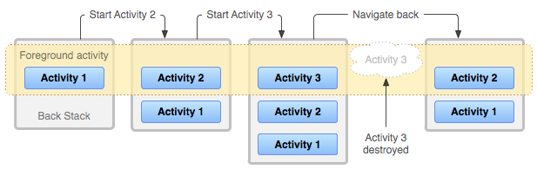

Android provides a back stack for each *task*. A task is an organizing concept for each Activity the user interacts with when performing an operation, whether they are inside your app or across multiple apps. Most tasks start from the Android home screen, and tapping an app icon starts a task (and a new back stack) for that app. If the user uses an app for a while, taps home, and starts a new app, that new app launches in its own task and has its own back stack. If the user returns to the first app, that first task's back stack returns. Navigating with the Back button returns only to the Activity in the current task, not for all tasks running on the device. Android enables the user to navigate between tasks with the overview or recent tasks screen, accessible with the square button on lower right corner of the device  .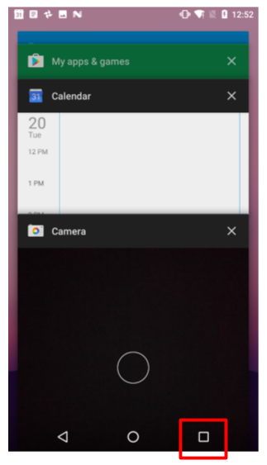

In most cases you don't have to worry about managing either tasks or the back stack for your app—the system keeps track of these things for you, and the back button is always available on the device.

There may, however, be times where you may want to override the default behavior for tasks or for the back stack. For example, if your screen contains an embedded web browser where users can navigate between web pages, you may wish to use the browser's default back behavior when users press the device's *Back* button, rather than returning to the previous Activity. You may also need to change the default behavior for your app in other special cases such as with notifications or widgets, where an Activity deep within your app may be launched as its own task, with no back stack at all. You learn more about managing tasks and the back stack in a later section.

Up navigation

Up navigation, sometimes referred to as ancestral or logical navigation, is used to navigate within an app based on the explicit hierarchical relationships between screens. With Up navigation, each Activity is arranged in a hierarchy, and each "child" Activity shows a left-facing arrow in the app bar  that returns the user to the "parent" Activity. The topmost Activity in the hierarchy is usually MainActivity, and the user cannot go up from there.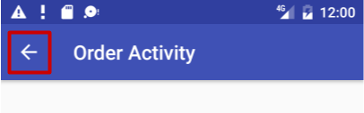

For instance, if the main Activity in an email app is a list of all messages, selecting a message launches a second Activity to display that single email. In this case the message Activity would provide an Up button that returns to the list of messages.

The behavior of the Up button is defined by you in each Activity based on how you design your app's navigation. In many cases, Up and Back navigation may provide the same behavior: to just return to the previous Activity. For example, a Settings Activity may be available from any Activity in your app, so "up" is the same as back—just return the user to their previous place in the hierarchy.

Providing Up behavior for your app is optional, but a good design practice, to provide consistent navigation for your app.

Implement Up navigation with a parent Activity

With the standard template projects in Android Studio, it's straightforward to implement Up navigation. If one Activity is a child of another Activity in your app's Activity hierarchy, specify the parent of that other Activity in the AndroidManifest.xml file.

Beginning in Android 4.1 (API level 16), declare the logical parent of each Activity by specifying the android:parentActivityName attribute in the <activity> element. To support older versions of Android, include <meta-data> information to define the parent Activity explicitly. Use both methods to be backwards-compatible with all versions of Android.

The following are the skeleton definitions in AndroidManifest.xml for both a main (parent) Activity(MainActivity) and a second (child) Activity (SecondActivity):

<application

android:allowBackup="true"

android:icon="@mipmap/ic_launcher"

android:label="@string/app_name"

android:roundIcon="@mipmap/ic_launcher_round"

android:supportsRtl="true"

android:theme="@style/AppTheme">

<!-- The main activity (it has no parent activity) -->

<activity android:name=".MainActivity">

<intent-filter>

<action android:name="android.intent.action.MAIN" />

<category android:name="android.intent.category.LAUNCHER" />

</intent-filter>

</activity>

<!-- The child activity) -->

<activity android:name=".SecondActivity"

android:label = "Second Activity"

android:parentActivityName=".MainActivity">

<meta-data

android:name="android.support.PARENT_ACTIVITY"

android:value="com.example.android.twoactivities.MainActivity" />

</activity>

</application>

You learn more about Up navigation and other user navigation features in another practical.

2.2: Activity lifecycle and state

**Contents:**

* [Introduction](https://google-developer-training.github.io/android-developer-fundamentals-course-concepts-v2/unit-1-get-started/lesson-2-activities-and-intents/2-2-c-activity-lifecycle-and-state/2-2-c-activity-lifecycle-and-state.html#chapterstart)
* [About the Activity lifecycle](https://google-developer-training.github.io/android-developer-fundamentals-course-concepts-v2/unit-1-get-started/lesson-2-activities-and-intents/2-2-c-activity-lifecycle-and-state/2-2-c-activity-lifecycle-and-state.html#aboutlifecycle)
* [Activity states and lifecycle callback methods](https://google-developer-training.github.io/android-developer-fundamentals-course-concepts-v2/unit-1-get-started/lesson-2-activities-and-intents/2-2-c-activity-lifecycle-and-state/2-2-c-activity-lifecycle-and-state.html#activitystatesandcallbacks)
* [Configuration changes and Activity state](https://google-developer-training.github.io/android-developer-fundamentals-course-concepts-v2/unit-1-get-started/lesson-2-activities-and-intents/2-2-c-activity-lifecycle-and-state/2-2-c-activity-lifecycle-and-state.html#configurationchanges)
* [Related practical](https://google-developer-training.github.io/android-developer-fundamentals-course-concepts-v2/unit-1-get-started/lesson-2-activities-and-intents/2-2-c-activity-lifecycle-and-state/2-2-c-activity-lifecycle-and-state.html#relatedpractical)
* [Learn more](https://google-developer-training.github.io/android-developer-fundamentals-course-concepts-v2/unit-1-get-started/lesson-2-activities-and-intents/2-2-c-activity-lifecycle-and-state/2-2-c-activity-lifecycle-and-state.html#learnmore)

Introduction

In this chapter you learn about the activity lifecycle, the callback events you can implement to perform tasks in each stage of the lifecycle, and how to handle Activity instance states throughout the activity lifecycle.

About the activity lifecycle

The activity lifecycle is the set of states an activity can be in during its entire lifetime, from the time it's created to when it's destroyed and the system reclaims its resources. As the user interacts with your app and other apps on the device, activities move into different states.

For example:

* When you start an app, the app's main activity ("Activity 1" in the figure below) is started, comes to the foreground, and receives the user focus.
* When you start a second activity ("Activity 2" in the figure below), a new activity is created and started, and the main activity is stopped.
* When you're done with the Activity 2 and navigate back, Activity 1 resumes. Activity 2 stops and is no longer needed.
* If the user doesn't resume Activity 2, the system eventually destroys it.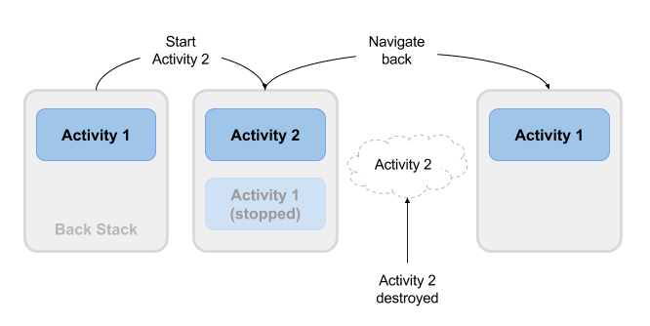

Activity states and lifecycle callback methods

When an Activity transitions into and out of the different lifecycle states as it runs, the Android system calls several lifecycle callback methods at each stage. All of the callback methods are hooks that you can override in each of your Activity classes to define how that Activity behaves when the user leaves and re-enters the Activity. Keep in mind that the lifecycle states (and callbacks) are per Activity, not per app, and you may implement different behavior at different points in the lifecycle of each Activity.

This figure shows each of the Activity states and the callback methods that occur as the Activitytransitions between different states:

Depending on the complexity of your Activity, you probably don't need to implement all the lifecycle callback methods in an Activity. However, it's important that you understand each one and implement those that ensure your app behaves the way users expect. Managing the lifecycle of an Activity by implementing callback methods is crucial to developing a strong and flexible app.

Activity created: the onCreate() method

@Override

public void onCreate(Bundle savedInstanceState) {

super.onCreate(savedInstanceState);

// The activity is being created.

}

Your Activity enters into the created state when it is started for the first time. When an Activity is first created, the system calls the onCreate() method to initialize that Activity. For example, when the user taps your app icon from the Home screen to start that app, the system calls the onCreate() method for the Activity in your app that you've declared to be the "launcher" or "main" Activity. In this case the main Activity onCreate() method is analogous to the main() method in other programs.

Similarly, if your app starts another Activity with an Intent (either explicit or implicit), the system matches your Intent request with an Activity and calls onCreate() for that new Activity.

The onCreate() method is the only required callback you must implement in your Activity class. In your onCreate() method you perform basic app startup logic that should happen only once, such as setting up the user interface, assigning class-scope variables, or setting up background tasks.

Created is a transient state; the Activity remains in the created state only as long as it takes to run onCreate(), and then the Activity moves to the started state.

Activity started: the onStart() method

@Override

protected void onStart() {

super.onStart();

// The activity is about to become visible.

}

After your Activity is initialized with onCreate(), the system calls the onStart() method, and the Activity is in the started state. The onStart() method is also called if a stopped Activity returns to the foreground, such as when the user clicks the Back button or the Up button to navigate to the previous screen. While onCreate() is called only once when the Activity is created, the onStart() method may be called many times during the lifecycle of the Activity as the user navigates around your app.

When an Activity is in the started state and visible on the screen, the user cannot interact with it until onResume() is called, the Activity is running, and the Activity is in the foreground.

Typically you implement onStart() in your Activity as a counterpart to the onStop() method. For example, if you release hardware resources (such as GPS or sensors) when the Activity is stopped, you can re-register those resources in the onStart() method.

Started, like created, is a transient state. After starting, the Activity moves into the resumed (running) state.

Activity resumed/running: the onResume() method

@Override

protected void onResume() {

super.onResume();

// The activity has become visible (it is now "resumed").

}

Your Activity is in the resumed state when it is initialized, visible on screen, and ready to use. The resumed state is often called the running state, because it is in this state that the user is actually interacting with your app.

The first time the Activity is started the system calls the onResume() method just after onStart(). The onResume() method may also be called multiple times, each time the app comes back from the paused state.

As with the onStart() and onStop() methods, which are implemented in pairs, you typically only implement onResume() as a counterpart to onPause(). For example, if in the onPause() method you halt any animations, you would start those animations again in onResume().

The Activity remains in the resumed state as long as the Activity is in the foreground and the user is interacting with it. From the resumed state the Activity can move into the paused state.

Activity paused: the onPause() method

@Override

protected void onPause() {

super.onPause();

// Another activity is taking focus

// (this activity is about to be "paused").

}

The paused state can occur in several situations:

* The Activity is going into the background, but has not yet been fully stopped. This is the first indication that the user is leaving your Activity.
* The Activity is only partially visible on the screen, because a dialog or other transparent Activityis overlaid on top of it.
* In multi-window or split screen mode (API 24), the Activity is displayed on the screen, but some other Activity has the user focus.

The system calls the onPause() method when the Activity moves into the paused state. Because the onPause() method is the first indication you get that the user may be leaving the Activity, you can use onPause() to stop animation or video playback, release any hardware-intensive resources, or commit unsaved Activity changes (such as a draft email).

The onPause() method should execute quickly. Don't use onPause() for CPU-intensive operations such as writing persistent data to a database. The app may still be visible on screen as it passes through the paused state, and any delays in executing onPause() can slow the user's transition to the next Activity. Implement any heavy-load operations when the app is in the stopped state instead.

Note that in multi-window mode (API 24), your paused Activity may still fully visible on the screen. In this case you do not want to pause animations or video playback as you would for a partially visible Activity. You can use the inMultiWindowMode() method in the Activity class to test whether your app is running in multi-window mode.

Your Activity can move from the paused state into the resumed state (if the user returns to the Activity) or to the stopped state (if the user leaves the Activity altogether).

Activity stopped: the onStop() method

@Override

protected void onStop() {

super.onStop();

// The activity is no longer visible (it is now "stopped")

}

An Activity is in the stopped state when it's no longer visible on the screen. This is usually because the user started another activity or returned to the home screen. The Android system retains the activity instance in the back stack, and if the user returns to the activity, the system restarts it. If resources are low, the system might kill a stopped activity altogether.

The system calls the onStop() method when the activity stops. Implement the onStop() method to save persistent data and release resources that you didn't already release in onPause(), including operations that may have been too heavyweight for onPause().

Activity destroyed: the onDestroy() method

@Override

protected void onDestroy() {

super.onDestroy();

// The activity is about to be destroyed.

}

When your Activity is destroyed it is shut down completely, and the Activity instance is reclaimed by the system. This can happen in several cases:

* You call finish() in your Activity to manually shut it down.
* The user navigates back to the previous Activity.
* The device is in a low memory situation where the system reclaims any stopped Activity to free more resources.
* A device configuration change occurs. You learn more about configuration changes later in this chapter.

Use onDestroy() to fully clean up after your Activity so that no component (such as a thread) is running after the Activity is destroyed.

Note that there are situations where the system will simply kill the hosting process for the Activitywithout calling this method (or any others), so you should not rely on onDestroy() to save any required data or Activity state. Use onPause() or onStop() instead.

Activity restarted: the onRestart() method

@Override

protected void onRestart() {

super.onRestart();

// The activity is about to be restarted.

}

The restarted state is a transient state that only occurs if a stopped Activity is started again. In this case the onRestart() method is called between onStop() and onStart(). If you have resources that need to be stopped or started you typically implement that behavior in onStop() or onStart() rather than onRestart().

Configuration changes and Activity state

Earlier in the section on onDestroy() you learned that your Activity may be destroyed when the user navigates back, or when your code executes the finish() method, or when the system needs to free resources. Another way an Activity can be destroyed is when the device undergoes a *configuration change*.

Configuration changes occur on the device, in runtime, and invalidate the current layout or other resources in your Activity. The most common form of a configuration change is when the device is rotated. When the device rotates from portrait to landscape, or from landscape to portrait, the layout for your app needs to change. The system recreates the Activity to help that Activity adapt to the new configuration by loading alternative resources (such as a landscape-specific layout).

Other configuration changes can include a change in locale (the user chooses a different system language), or the user enters multi-window mode (Android 7). In multi-window mode, if you have configured your app to be resizeable, Android recreates the Activity to use a layout definition for the new, smaller size.

When a configuration change occurs, the Android system shuts down your activity, calling onPause(), onStop(), and onDestroy(). Then the system restarts the activity from the beginning, calling onCreate(), onStart(), and onResume().

Activity instance state

When an Activity is destroyed and recreated, there are implications for the runtime state of that Activity. When an Activity is paused or stopped, the state of the Activity is retained because that Activity is still held in memory. When an Activity is recreated, the state of the Activity and any user progress in that Activity is lost, with these exceptions:

* Some Activity state information is automatically saved by default. The state of View elements in your layout with a unique ID (as defined by the android:id attribute in the layout) are saved and restored when an Activity is recreated. In this case, the user-entered values in EditText elements are usually retained when the Activity is recreated.
* The Intent that was used to start the Activity, and the information stored in the data or extras for that Intent, remains available to that Activity when it is recreated.

The Activity state is stored as a set of key/value pairs in a [Bundle](https://developer.android.com/reference/android/os/Bundle.html) object called the Activity *instance state* . The system saves default state information to instance state Bundle just before the Activity is stopped, and passes that Bundle to the new Activity instance to restore.

You can add your own instance data to the instance state Bundle by overriding the onSaveInstanceState() callback. The state Bundle is passed to the onCreate() method, so you can restore that instance state data when your Activity is created. There is also a corresponding onRestoreInstanceState() callback you can use to restore the state data.

Test that your Activity behaves correctly when the user rotates the device, because device rotation is a common use case. Implement instance state if you need to.

**Note:**The Activity instance state is particular to a specific instance of an Activity, running in a single task. If the user force-quits the app or reboots the device, or if the Android system shuts down the app process to preserve memory, the Activity instance state is lost. To keep state changes across app instances and device reboots, you need to write that data to shared preferences. You learn more about shared preferences in another chapter.

Saving Activity instance state

To save information to the instance state Bundle, use the onSaveInstanceState() callback. This is not a lifecycle callback method, but it is called when the user is leaving your Activity (sometime before the onStop() method).

@Override

public void onSaveInstanceState(Bundle savedInstanceState) {

super.onSaveInstanceState(savedInstanceState);

// save your state data to the instance state bundle

}

The onSaveInstanceState() method is passed a Bundle object (a collection of key/value pairs) when it is called. This is the instance state Bundle to which you will add your own Activity state information.

You learned about [Bundle](https://developer.android.com/reference/android/os/Bundle.html) in a previous chapter when you added keys and values to the Intent extras. Add information to the instance state Bundle in the same way, with keys you define and the various "put" methods defined in the Bundle class:

@Override

public void onSaveInstanceState(Bundle savedInstanceState) {

super.onSaveInstanceState(savedInstanceState);

// Save the user's current game state

savedInstanceState.putInt("score", mCurrentScore);

savedInstanceState.putInt("level", mCurrentLevel);

}

Don't forget to call through to the superclass, to make sure the state of the View hierarchy is also saved to the Bundle.

Restoring Activity instance state

Once you've saved the Activity instance state, you also need to restore it when the Activity is recreated. You can do this one of two places:

* The onCreate() callback method, which is called with the instance state Bundle when the Activityis created.
* The onRestoreInstanceState() callback, which is called after onStart() after the Activity is created.

Most of the time the better place to restore the Activity state is in onCreate(), to ensure that your UI, including the state, is available as soon as possible.

To restore the saved instances state in onCreate(), test for the existence of a state Bundle before you try to get data out of it. When your Activity is started for the first time there will be no state and the Bundle will be null.

@Override

protected void onCreate(Bundle savedInstanceState) {

// Always call the superclass first

super.onCreate(savedInstanceState);

// Check if recreating a previously destroyed instance.

if (savedInstanceState != null) {

// Restore value of members from saved state.

mCurrentScore = savedInstanceState.getInt("score");

mCurrentLevel = savedInstanceState.getInt("level");

} else {

// Initialize members with default values for a new instance.

// ...

}

// ... Rest of code

}

2.3: Implicit intents

**Contents:**

* [Introduction](https://google-developer-training.github.io/android-developer-fundamentals-course-concepts-v2/unit-1-get-started/lesson-2-activities-and-intents/2-3-c-implicit-intents/2-3-c-implicit-intents.html#chapterstart)
* [Understanding an implicit Intent](https://google-developer-training.github.io/android-developer-fundamentals-course-concepts-v2/unit-1-get-started/lesson-2-activities-and-intents/2-3-c-implicit-intents/2-3-c-implicit-intents.html#aboutimplicitintents)
* [Sending an implicit Intent](https://google-developer-training.github.io/android-developer-fundamentals-course-concepts-v2/unit-1-get-started/lesson-2-activities-and-intents/2-3-c-implicit-intents/2-3-c-implicit-intents.html#sendingimplicitintents)
* [Receiving an implicit Intent](https://google-developer-training.github.io/android-developer-fundamentals-course-concepts-v2/unit-1-get-started/lesson-2-activities-and-intents/2-3-c-implicit-intents/2-3-c-implicit-intents.html#receivingimplicitintents)
* [Sharing data with ShareCompat.IntentBuilder](https://google-developer-training.github.io/android-developer-fundamentals-course-concepts-v2/unit-1-get-started/lesson-2-activities-and-intents/2-3-c-implicit-intents/2-3-c-implicit-intents.html#sharingdatawithsharecompat)
* [Managing tasks](https://google-developer-training.github.io/android-developer-fundamentals-course-concepts-v2/unit-1-get-started/lesson-2-activities-and-intents/2-3-c-implicit-intents/2-3-c-implicit-intents.html#managingtasksandactivities)
* [Activity launch modes](https://google-developer-training.github.io/android-developer-fundamentals-course-concepts-v2/unit-1-get-started/lesson-2-activities-and-intents/2-3-c-implicit-intents/2-3-c-implicit-intents.html#activitylaunchmodes)
* [Task affinities](https://google-developer-training.github.io/android-developer-fundamentals-course-concepts-v2/unit-1-get-started/lesson-2-activities-and-intents/2-3-c-implicit-intents/2-3-c-implicit-intents.html#taskaffinities)
* [Related practical](https://google-developer-training.github.io/android-developer-fundamentals-course-concepts-v2/unit-1-get-started/lesson-2-activities-and-intents/2-3-c-implicit-intents/2-3-c-implicit-intents.html#relatedpractical)
* [Learn more](https://google-developer-training.github.io/android-developer-fundamentals-course-concepts-v2/unit-1-get-started/lesson-2-activities-and-intents/2-3-c-implicit-intents/2-3-c-implicit-intents.html#learnmore)

Introduction

In a previous chapter you learned how to launch a specific activity in your app with an explicit intent. In this chapter you learn how to send and receive an *implicit* intent. In an implicit intent, you declare a general action to perform, and the system matches your request with an activity.

You also learn more about Android *tasks*, and how you can configure your apps to associate new activities with different tasks.

Understanding an implicit Intent

In an earlier chapter you learned how to start an activity from an activity by specifying the class name of the activity to start in an *explic*it intent. This is the most basic way to use an intent: To start an [Intent](http://developer.android.com/reference/android/content/Intent.html) or other app component and pass data to it (and sometimes receive data).

A more flexible use of an [Intent](http://developer.android.com/reference/android/content/Intent.html) is the *implicit* intent. You don't specify the exact activity (or other component) to run—instead, you include just enough information in the intent about the task you want to perform. The Android system matches the information in your request intent with any activity available on the device that can perform that task. If there's only one activity that matches, that activity is launched. If more than one activity matches the intent, the user is presented with an app chooser and picks which app they would like to perform the task.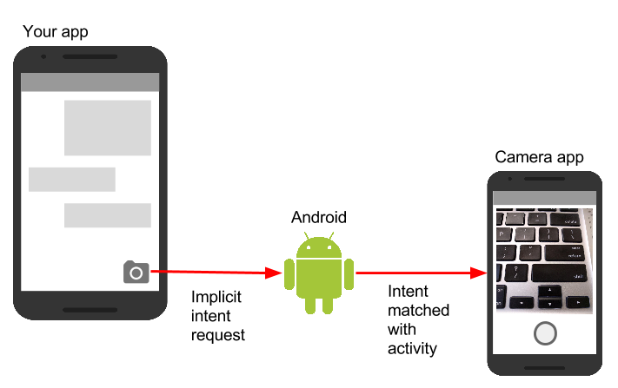

For example, you have an app that lists available snippets of video. If the user touches an item in the list, you want to play that video snippet. Rather than implementing an entire video player in your own app, you can launch an Intent that specifies the task as "play an object of type video." The Android system then matches your request with an Activity that has registered itself to play objects of type video.

An Activity registers itself with the system as being able to handle an implicit Intent with Intent*filters*, declared in the AndroidManifest.xml file. For example, the main Activity (and only the main Activity) for your app has an Intent filter that declares it the main Activity for the launcher category. This Intent filter is how the Android system knows to start that specific Activity in your app when the user taps the icon for your app on the device home screen.

Intent actions, categories, and data

An implicit Intent, like an explicit Intent, is an instance of the [Intent](http://developer.android.com/reference/android/content/Intent.html) class. In addition to the parts of an Intent you learned about in an earlier chapter (such as the Intent data and extras), these fields are used by an implicit Intent:

* The Intent *action*, which is the generic action the receiving Activity should perform. The available Intent actions are defined as constants in the [Intent](http://developer.android.com/reference/android/content/Intent.html) class and begin with the word ACTION_. A common Intent action is ACTION_VIEW, which you use when you have some information that an Activity can show to the user, such as a photo to view in a gallery app, or an address to view in a map app. You can specify the action for an Intent in the Intent constructor, or with the setAction() method.
* An Intent *category*, which provides additional information about the category of component that should handle the Intent. Intent categories are optional, and you can add more than one category to an Intent. Intent categories are also defined as constants in the Intent class and begin with the word CATEGORY_. You can add categories to the Intent with the addCategory() method.
* The data *type*, which indicates the MIME type of data the Activity should operate on. Usually, the data type is inferred from the URI in the Intent data field, but you can also explicitly define the data type with the setType() method.

Intent actions, categories, and data types are used both by the Intent object you create in your sending Activity, as well as in the Intent filters you define in the AndroidManifest.xml file for the receiving Activity. The Android system uses this information to match an implicit Intent request with an Activity or other component that can handle that Intent.

Sending an implicit Intent

Starting an Activity with an implicit Intent, and passing data from one Activity to another, works much the same way as it does for an explicit Intent:

1. In the sending Activity, create a new Intent object.
2. Add information about the request to the Intent object, such as data or extras.
3. Send the Intent with startActivity() (to just start the Activity) or startActivityforResult() (to start the Activity and expect a result back).

When you create an implicit Intent object, you:

* Do *not* specify the specific Activity or other component to launch.
* Add an Intent action or Intent categories (or both).
* Resolve the Intent with the system before calling startActivity() or startActivityforResult().
* Show an app chooser for the request (optional).

Create implicit Intent objects

To use an implicit Intent, create an Intent object as you did for an explicit Intent, only without the specific component name.

Intent sendIntent = new Intent();

You can also create the Intent object with a specific action:

Intent sendIntent = new Intent(Intent.ACTION_VIEW);

Once you have an Intent object you can add other information (category, data, extras) with the various Intent methods. For example, this code creates an implicit Intent object, sets the Intent action to ACTION_SEND, defines an Intent extra to hold the text, and sets the type of the data to the MIME type "text/plain".

Intent sendIntent = new Intent();

sendIntent.setAction(Intent.ACTION_SEND);

sendIntent.putExtra(Intent.EXTRA_TEXT, textMessage);

sendIntent.setType("text/plain");

Resolve the Activity before starting it

When you define an implicit Intent with a specific action and/or category, there is a possibility that there won't be *any*Activity on the device that can handle your request. If you just send the Intent and there is no appropriate match, your app will crash.

To verify that an Activity or other component is available to receive your Intent, use theresolveActivity() method with the system package manager like this:

if (sendIntent.resolveActivity(getPackageManager()) != null) {

startActivity(chooser);

}

If the result of resolveActivity() is not null, then there is at least one app available that can handle the Intent, and it's safe to call startActivity(). Do not send the Intent if the result is null.

If you have a feature that depends on an external Activity that may or may not be available on the device, a best practice is to test for the availability of that external Activity before the user tries to use it. If there is no Activity that can handle your request (that is, resolveActivity() returns null), disable the feature or provide the user an error message for that feature.

Show the app chooser

To find an Activity or other component that can handle your Intent requests, the Android system matches your implicit Intent with an Activity whose Intent filters indicate that they can perform that action. If there are multiple apps installed that match, the user is presented with an app chooser that lets them select which app they want to use to handle that Intent.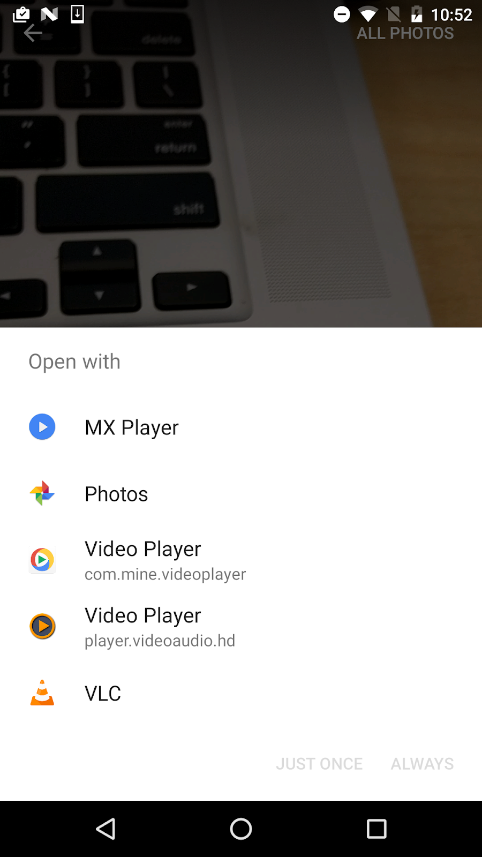

In many cases the user has a preferred app for a given task, and they will select the option to always use that app for that task. However, if multiple apps can respond to the Intent and the user might want to use a different app each time, you can choose to explicitly show a chooser dialog every time. For example, when your app performs a "share this" action with the [ACTION_SEND](https://developer.android.com/reference/android/content/Intent.html#ACTION_SEND) action, users may want to share using a different app depending on the current situation.

To show the chooser, you create a wrapper Intent for your implicit Intent with the createChooser()method, and then resolve and call startActivity() with that wrapper Intent. The createChooser()method also requires a string argument for the title that appears on the chooser. You can specify the title with a string resource as you would any other string.

For example:

// The implicit Intent object

Intent sendIntent = new Intent(Intent.ACTION_SEND);

// Always use string resources for UI text.

String title = getResources().getString(R.string.chooser_title);

// Create the wrapper intent to show the chooser dialog.

Intent chooser = Intent.createChooser(sendIntent, title);

// Resolve the intent before starting the activity

if (sendIntent.resolveActivity(getPackageManager()) != null) {

startActivity(chooser);

}

Receiving an implicit Intent

If you want an Activity in your app to respond to an implicit Intent (from your own app or other apps), declare one or more Intent filters in the AndroidManifest.xml file. Each Intent filter specifies the type of Intent it accepts based on the action, data, and category for the Intent. The system will deliver an implicit Intent to your app component only if that Intent can pass through one of your Intent filters.

**Note:**An explicit Intent is always delivered to its target, regardless of any Intent filters the component declares. Conversely, if an Activity does not include Intent filters, it can only be launched with an explicit Intent.

Once your Activity is successfully launched with an implicit Intent, you can handle that Intent and its data the same way you did an explicit Intent, by:

1. Getting the Intent object with getIntent().
2. Getting Intent data or extras out of that Intent.
3. Performing the task the Intent requested.
4. Returning data to the calling Activity with another Intent, if needed.

Intent filters

Define Intent filters with one or more <intent-filter> elements in the AndroidManifest.xml file, nested in the corresponding <activity> element. Inside <intent-filter>, specify the type of intent your activity can handle. The Android system matches an implicit intent with an activity or other app component only if the fields in the Intent object match the Intent filters for that component.

An Intent filter may contain the following elements, which correspond to the fields in the Intent object described above:

* <action>: The Intent action that the activity accepts.
* <data>: The type of data accepted, including the MIME type or other attributes of the data URI (such as scheme, host, port, and path).
* <category>: The Intent category.

For example, the main Activity for your app includes this <intent-filter> element, which you saw in an earlier chapter:

<intent-filter>

<action android:name="android.intent.action.MAIN" />

<category android:name="android.intent.category.LAUNCHER" />

</intent-filter>

This Intent filter has the action MAIN and the category LAUNCHER. The <action> element specifies that this is the app's "main" entry point. The <category> element specifies that this activity should be listed in the system's app launcher (to allow users to launch the activity). Only the main activity for your app should have this Intent filter.

Here's another example for an implicit Intent that shares a bit of text. This Intent filter matches the implicit Intent example from the previous section:

<activity android:name="ShareActivity">

<intent-filter>

<action android:name="android.intent.action.SEND"/>

<category android:name="android.intent.category.DEFAULT"/>

<data android:mimeType="text/plain"/>

</intent-filter>

</activity>

You can specify more than one action, data, or category for the same Intent filter, or have multiple Intent filters per Activity to handle each different kind of Intent.

The Android system tests an implicit Intent against an Intent filter by comparing the parts of that Intent to each of the three Intent filter elements (action, category, and data). The Intent must pass all three tests or the Android system won't deliver the Intent to the component. However, because a component may have multiple Intent filters, an Intent that does not pass through one of a component's filters might make it through on another filter.

Actions

An Intent filter can declare zero or more <action> elements for the Intent action. The action is defined in the name attribute, and consists of the string "android.intent.action." plus the name of the Intent action, minus the ACTION_ prefix. So, for example, an implicit Intent with the action ACTION_VIEW matches an Intent filter whose action is android.intent.action.VIEW.

For example, this Intent filter matches either ACTION_EDIT and ACTION_VIEW:

<intent-filter>

<action android:name="android.intent.action.EDIT" />

<action android:name="android.intent.action.VIEW" />

</intent-filter>

To get through this filter, the action specified in the incoming Intent object must match at least one of the actions. You must include at least one Intent action for an incoming implicit Intent to match.

Categories

An Intent filter can declare zero or more <category> elements for Intent categories. The category is defined in the name attribute, and consists of the string "android.intent.category." plus the name of the Intent category, minus the CATEGORY prefix.

For example, this Intent filter matches either CATEGORY_DEFAULT and CATEGORY_BROWSABLE:

<intent-filter>

<category android:name="android.intent.category.DEFAULT" />

<category android:name="android.intent.category.BROWSABLE" />

</intent-filter>

Note that any Activity that you want to accept an implicit Intent must include the android.intent.category.DEFAULT Intent filter. This category is applied to all implicit Intent objects by the Android system.

Data

An Intent filter can declare zero or more <data> elements for the URI contained in the Intent data. As the Intent data consists of a URI and (optionally) a MIME type, you can create an Intent filter for various aspects of that data, including:

* URI Scheme
* URI Host
* URI Path
* Mime type

For example, this Intent filter matches any data Intent with a URI scheme of http and a MIME type of either "video/mpeg" or "audio/mpeg".

<intent-filter>

<data android:mimeType="video/mpeg" android:scheme="http" />

<data android:mimeType="audio/mpeg" android:scheme="http" />

</intent-filter>

Sharing data using ShareCompat.IntentBuilder

Share actions are an easy way for users to share items in your app with social networks and other apps. Although you can build a share action in your own app using an implicit Intent with the ACTION_SENDaction, Android provides the [ShareCompat.IntentBuilder](http://developer.android.com/reference/android/support/v4/app/ShareCompat.IntentBuilder.html) helper class to easily implement sharing in your app.

**Note:**For apps that target Android releases after API 14, you can use the ShareActionProviderclass for share actions instead of ShareCompat.IntentBuilder. The ShareCompat class is part of the V4 support library, and allows you to provide share actions in apps in a backward-compatible fashion. ShareCompat provides a single API for sharing on both old and new Android devices. You learn more about the Android support libraries in another chapter.

With the ShareCompat.IntentBuilder class you do not need to create or send an implicit Intent for the share action. Use the methods in [ShareCompat.IntentBuilder](http://developer.android.com/reference/android/support/v4/app/ShareCompat.IntentBuilder.html) to indicate the data you want to share as well as any additional information. Start with the from() method to create a new Intent builder, add other methods to add more data, and end with the startChooser() method to create and send the Intent. You can chain the methods together like this:

ShareCompat.IntentBuilder

.from(this) // information about the calling activity

.setType(mimeType) // mime type for the data

.setChooserTitle("Share this text with: ") //title for the app chooser

.setText(txt) // intent data

.startChooser(); // send the intent

Managing tasks

In a previous chapter you learned about tasks and the back stack. The task for your app contains its own stack that contains each Activity the user has visited while using your app. As the user navigates around your app, Activity instances for that task are pushed and popped from the stack for that task.

Most of the time the user's navigation from one Activity to another Activity and back again through the stack is straightforward. Depending on the design and navigation of your app there may be complications, especially with an Activity started from another app and other tasks.

For example, say you have an app with three Activity objects: A, B, and C. A launches B with an Intent, and B launches C. C, in turn sends an Intent to launch A. In this case the system creates a *second instance* of A on the top of the stack, rather than bringing the already-running instance to the foreground. Depending on how you implement each Activity, the two instances of A can get out of sync and provide a confusing experience for a user navigating back through the stack.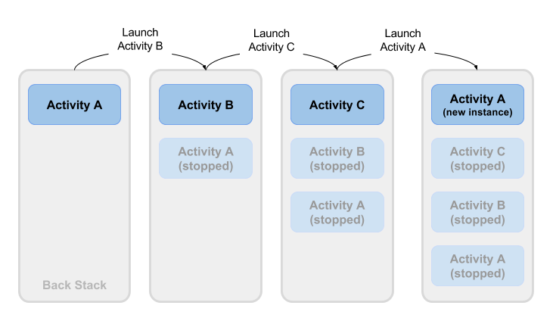

Or, say your Activity C can be launched from a second app with an implicit Intent. The user runs the second app, which has its own task and its own back stack. If that app uses an implicit Intent to launch your Activity C, a new instance of C is created and placed on the back stack for that second app's task. Your app still has its own task, its own back stack, and its own instance of C.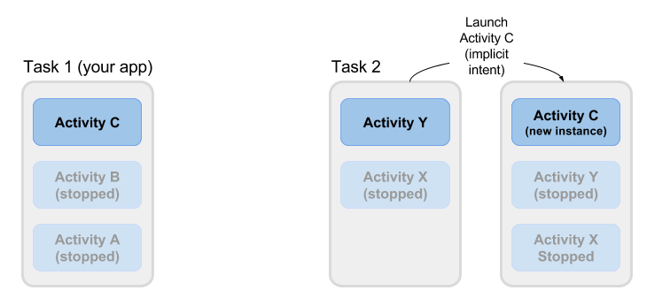

Much of the time the Android's default behavior for tasks works fine and you don't have to worry about how each Activity is associated with tasks, or how they exist in the back stack. If you want to change the normal behavior, Android provides a number of ways to manage tasks and each Activity within those tasks, including:

* Activity launch modes, to determine how an Activity should be launched.
* Task affinities, which indicate which task a launched Activity belongs to.

Activity launch modes

Use Activity launch modes to indicate how each new Activity should be treated when launched—that is, if the Activity should be added to the current task, or launched into a new task. Define launch modes for the Activity with attributes on the <activity> element of the AndroidManifest.xml file, or with flags set on the Intent that starts that Activity.

Activity attributes

To define a launch mode for an Activity add the android:launchMode attribute to the <activity>element in the AndroidManifest.xml file. This example uses a launch mode of "standard", which is the default.

<activity

android:name=".SecondActivity"

android:label="@string/activity2_name"

android:parentActivityName=".MainActivity"

android:launchMode="standard">

<!-- More attributes ... -->

</activity>

There are four launch modes available as part of the <activity> element:

* "standard" (the default): A new Activity is launched and added to the back stack for the current task. An Activity can be instantiated multiple times, a single task can have multiple instances of the same Activity, and multiple instances can belong to different tasks.
* "singleTop": If an instance of an Activity exists at the top of the back stack for the current task and an Intent request for that Activity arrives, Android routes that Intent to the existing Activity instance rather than creating a new instance. A new Activity is still instantiated if there is an existing Activity anywhere in the back stack other than the top.
* "singleTask": When the Activity is launched the system creates a new task for that Activity. If another task already exists with an instance of that Activity, the system routes the Intent to that Activity instead.
* "singleInstance": Same as single task, except that the system doesn't launch any other Activityinto the task holding the Activity instance. The Activity is always the single and only member of its task.

The vast majority of apps will only use the standard or single top launch modes. See the [android:launchMode](https://developer.android.com/guide/topics/manifest/activity-element.html#lmode) attribute for more detailed information on launch modes.

Intent flags

Intent flags are options that specify how the activity (or other app component) that receives the intent should handle that intent. Intent flags are defined as constants in the Intent class and begin with the word FLAG_. You add Intent flags to an Intent object with setFlag() or addFlag().

Three specific Intent flags are used to control activity launch modes, either in conjunction with the launchMode attribute or in place of it. Intent flags always take precedence over the launch mode in case of conflicts.

* [FLAG_ACTIVITY_NEW_TASK](https://developer.android.com/reference/android/content/Intent.html#FLAG_ACTIVITY_NEW_TASK): start the Activity in a new task. This behavior is the same as for singleTask launch mode.
* [FLAG_ACTIVITY_SINGLE_TOP](https://developer.android.com/reference/android/content/Intent.html#FLAG_ACTIVITY_SINGLE_TOP): if the Activity to be launched is at the top of the back stack, route the Intent to that existing Activity instance. Otherwise create a new Activity instance. This is the same behavior as the singleTop launch mode.
* [FLAG_ACTIVITY_CLEAR_TOP](https://developer.android.com/reference/android/content/Intent.html#FLAG_ACTIVITY_CLEAR_TOP): If an instance of the Activity to be launched already exists in the back stack, destroy any other Activity on top of it and route the Intent to that existing instance. When used in conjunction with FLAG_ACTIVITY_NEW_TASK, this flag locates any existing instances of the Activity in any task and brings it to the foreground.

See the [Intent](https://developer.android.com/reference/android/content/Intent.html) class for more information about other available Intent flags.

Handle a new Intent

When the Android system routes an Intent to an existing Activity instance, the system calls the onNewIntent() callback method (usually just before the onResume() method). The onNewIntent() method includes an argument for the new Intent that was routed to the Activity. Override the onNewIntent()method in your class to handle the information from that new Intent.

Note that the getIntent() method—to get access to the Intent that launched the Activity—*always*retains the original Intent that launched the Activity instance. Call setIntent() in the onNewIntent()method:

@Override

public void onNewIntent(Intent intent) {

super.onNewIntent(intent);

// Use the new intent, not the original one

setIntent(intent);

}

Any call to getIntent() after this returns the new Intent.

Task affinities

Task affinities indicate which task an Activity prefers to belong to when that Activity instance is launched. By default each Activity belongs to the app that launched it. An Activity from outside an app launched with an implicit Intent belongs to the app that sent the implicit Intent.

To define a task affinity, add the android:taskAffinity attribute to the <activity> element in the AndroidManifest.xml file. The default task affinity is the package name for the app (declared in <manifest>). The new task name should be unique and different from the package name. This example uses "com.example.android.myapp.newtask" for the affinity name.

<activity

android:name=".SecondActivity"

android:label="@string/activity2_name"

android:parentActivityName=".MainActivity"

android:taskAffinity="com.example.android.myapp.newtask">

<!-- More attributes ... -->

</activity>

Task affinities are often used with the singleTask launch mode or the [FLAG_ACTIVITY_NEW_TASK](https://developer.android.com/reference/android/content/Intent.html#FLAG_ACTIVITY_NEW_TASK) Intentflag to place a new Activity in its own named task. If the new task already exists, the Intent is routed to that task and that affinity.

Another use of task affinities is reparenting, which enables a task to move from the Activity in which it was launched to the Activity it has an affinity for. To enable task reparenting, add a task affinity attribute to the <activity> element and set android:allowTaskReparenting to true.

<activity

android:name=".SecondActivity"

android:label="@string/activity2_name"

android:parentActivityName=".MainActivity"

android:taskAffinity="com.example.android.myapp.newtask"

android:allowTaskReparenting="true" >

<!-- More attributes ... -->

</activity>

3.1: The Android Studio debugger

**Contents:**

* [About debugging](https://google-developer-training.github.io/android-developer-fundamentals-course-concepts-v2/unit-1-get-started/lesson-3-testing,-debugging,-and-using-support-libraries/3-1-c-the-android-studio-debugger/3-1-c-the-android-studio-debugger.html#aboutdebugging)
* [Running the debugger](https://google-developer-training.github.io/android-developer-fundamentals-course-concepts-v2/unit-1-get-started/lesson-3-testing,-debugging,-and-using-support-libraries/3-1-c-the-android-studio-debugger/3-1-c-the-android-studio-debugger.html#runningdebugger)
* [Using breakpoints](https://google-developer-training.github.io/android-developer-fundamentals-course-concepts-v2/unit-1-get-started/lesson-3-testing,-debugging,-and-using-support-libraries/3-1-c-the-android-studio-debugger/3-1-c-the-android-studio-debugger.html#usingbreakpoints)
* [Stepping through code](https://google-developer-training.github.io/android-developer-fundamentals-course-concepts-v2/unit-1-get-started/lesson-3-testing,-debugging,-and-using-support-libraries/3-1-c-the-android-studio-debugger/3-1-c-the-android-studio-debugger.html#steppingthroughcode)
* [Viewing execution stack frames](https://google-developer-training.github.io/android-developer-fundamentals-course-concepts-v2/unit-1-get-started/lesson-3-testing,-debugging,-and-using-support-libraries/3-1-c-the-android-studio-debugger/3-1-c-the-android-studio-debugger.html#viewingexecutionstackframes)
* [Inspecting and modifying variables](https://google-developer-training.github.io/android-developer-fundamentals-course-concepts-v2/unit-1-get-started/lesson-3-testing,-debugging,-and-using-support-libraries/3-1-c-the-android-studio-debugger/3-1-c-the-android-studio-debugger.html#inspectingmodifyingvariables)
* [Setting watches](https://google-developer-training.github.io/android-developer-fundamentals-course-concepts-v2/unit-1-get-started/lesson-3-testing,-debugging,-and-using-support-libraries/3-1-c-the-android-studio-debugger/3-1-c-the-android-studio-debugger.html#settingwatches)
* [Evaluating expressions](https://google-developer-training.github.io/android-developer-fundamentals-course-concepts-v2/unit-1-get-started/lesson-3-testing,-debugging,-and-using-support-libraries/3-1-c-the-android-studio-debugger/3-1-c-the-android-studio-debugger.html#evaluatingexpressions)
* [More tools for debugging](https://google-developer-training.github.io/android-developer-fundamentals-course-concepts-v2/unit-1-get-started/lesson-3-testing,-debugging,-and-using-support-libraries/3-1-c-the-android-studio-debugger/3-1-c-the-android-studio-debugger.html#moretoolsfordebugging)
* [Trace logging and the Android manifest](https://google-developer-training.github.io/android-developer-fundamentals-course-concepts-v2/unit-1-get-started/lesson-3-testing,-debugging,-and-using-support-libraries/3-1-c-the-android-studio-debugger/3-1-c-the-android-studio-debugger.html#tracelogging)
* [Related practical](https://google-developer-training.github.io/android-developer-fundamentals-course-concepts-v2/unit-1-get-started/lesson-3-testing,-debugging,-and-using-support-libraries/3-1-c-the-android-studio-debugger/3-1-c-the-android-studio-debugger.html#relatedpractical)
* [Learn more](https://google-developer-training.github.io/android-developer-fundamentals-course-concepts-v2/unit-1-get-started/lesson-3-testing,-debugging,-and-using-support-libraries/3-1-c-the-android-studio-debugger/3-1-c-the-android-studio-debugger.html#learnmore)

In this chapter you'll learn about debugging your apps in Android Studio.

About debugging

Debugging is the process of finding and fixing errors (bugs) or unexpected behavior in your code. All code has bugs, from incorrect behavior in your app, to behavior that excessively consumes memory or network resources, to actual app freezing or crashing.

Bugs can result for many reasons:

* Errors in your design or implementation
* Android framework limitations (or bugs)
* Missing requirements or assumptions for how the app should work
* Device limitations (or bugs)

Use the debugging, testing, and profiling capabilities in Android Studio to help you reproduce, find, and resolve all of these problems. Those capabilities include:

* The **Logcat** pane for log messages
* The **Debugger** pane for viewing frames, threads, and variables
* Debug mode for running apps with breakpoints
* Test frameworks such as JUnit or Espresso
* Dalvik Debug Monitor Server (DDMS), to track resource usage

In this chapter you learn how to debug your app with the Android Studio debugger, set and view breakpoints, step through your code, and examine variables.

Running the debugger

Running an app in debug mode is similar to running the app. You can either run an app in debug mode, or attach the debugger to an already-running app.

Run your app in debug mode

To start debugging, click  **Debug** in the toolbar. Android Studio builds an APK, signs it with a debug key, installs it on your selected device, then runs it and opens the **Debug** pane with the **Debugger** and **Console** tabs.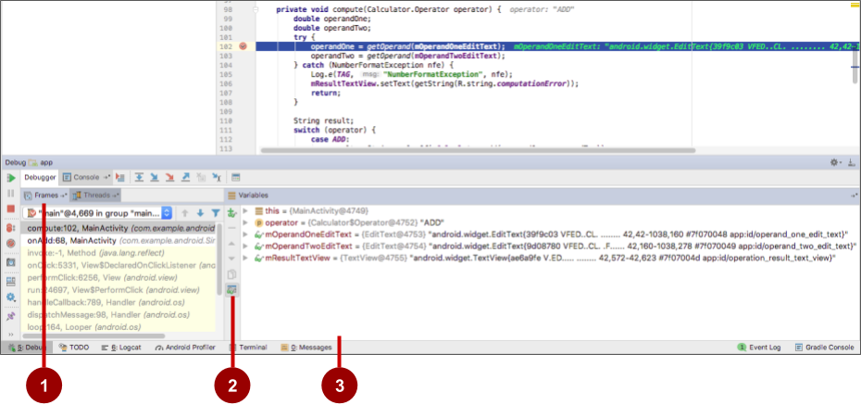

The figure above shows the **Debug** pane with the **Debugger** and **Console** tabs. The **Debugger** tab is selected, showing the **Debugger** pane with the following features:

1. **Frames** tab**:** Click to show the **Frames** pane with the current execution stack frames for a given thread. The execution stack shows each class and method that have been called in your app and in the Android runtime, with the most recent method at the top.

Click the **Threads** tab to replace the **Frames** pane with the **Threads** pane.

1. **Watches** button**:** Click to show the **Watches** pane within the **Variables** pane, which shows the values for any variable watches you have set. Watches allow you to keep track of a specific variable in your program, and see how that variable changes as your program runs.
2. **Variables**pane**:** Shows the variables in the current scope and their values. Each variable in this pane has an expand icon to expand the list of object properties for the variable. Try expanding a variable to explore its properties.

Debug a running app

If your app is already running on a device or emulator, start debugging that app with these steps:

1. Select **Run > Attach debugger to Android process** or click the  **Attach**icon in the toolbar.
2. In the **Choose Process** dialog, select the process to which you want to attach the debugger.

By default, the debugger shows the device and app process for the current project, as well as any connected hardware devices or virtual devices on your computer. Check the **Show all processes**option to show all processes on all devices.

1. Click **OK**. The **Debug** pane appears as before.

Resume or stop debugging

To resume executing an app after debugging it, select **Run > Resume Program** or click the Resume icon.

To stop debugging your app, select **Run > Stop** or click the Stop icon  in the toolbar.

Using breakpoints

Android Studio supports several types of breakpoints that trigger different debugging actions. The most common type is a breakpoint that pauses the execution of your app at a specified line of code. While paused, you can examine variables, evaluate expressions, then continue execution line by line to determine the causes of runtime errors.

You can set a breakpoint on any executable line of code.

Add breakpoints

To add a breakpoint to a line in your code, use these steps:

1. Locate the line of code where you want to pause execution.
2. Click in the left gutter of the editor pane at that line, next to the line numbers. A red dot appears at that line, indicating a breakpoint. The red dot includes a check mark if the app is already running in debug mode.

As an alternative, you can choose **Run > Toggle Line Breakpoin**t or press **Control-F8** (**Command-F8** on a Mac) to set or clear a breakpoint at a line.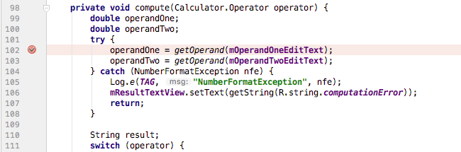

If your app is already running, you don't need to update it to add the breakpoint.

If you click a breakpoint by mistake, you can undo it by clicking the breakpoint. If you clicked a line of code that is not executable, the red dot includes an "**x**" and a warning appears that the line of code is not executable.

When your code execution reaches the breakpoint, Android Studio pauses execution of your app. You can then use the tools in the **Debug** pane to view the state of the app and debug that app as it runs.

View and configure breakpoints

To view all the breakpoints you've set and configure breakpoint settings, click the **View Breakpoints** icon on the left edge of the **Debug** pane. The **Breakpoints** window appears.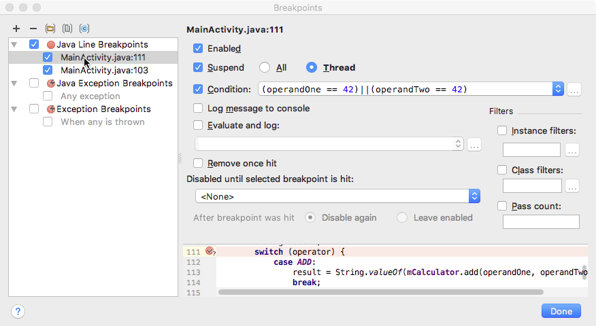

In this window all the breakpoints you have set appear in the left pane, and you can enable or disable each breakpoint with the checkboxes. If a breakpoint is disabled, Android Studio does not pause your app when execution reaches that breakpoint.

Select a breakpoint from the list to configure its settings. You can configure a breakpoint to be disabled at first and have the system enable it after a different breakpoint is encountered. You can also configure whether a breakpoint should be disabled after it has been reached.

To set a breakpoint for any exception, select **Exception Breakpoints** in the list of breakpoints.

Disable (mute) all breakpoints

Disabling a breakpoint enables you to temporarily "mute" that breakpoint without removing it from your code. If you remove a breakpoint altogether you also lose any conditions or other features you created for that breakpoint, so disabling it can be a better choice.

To mute all breakpoints, click the **Mute Breakpoints**icon  . Click the icon again to enable (unmute) all breakpoints.

Use conditional breakpoints

Conditional breakpoints are breakpoints that only stop execution of your app if the test in the condition is true. To define a test for a conditional breakpoint, use these steps:

1. **Right-click** (or **Control-click**) a breakpoint, and enter a test in the **Condition** field.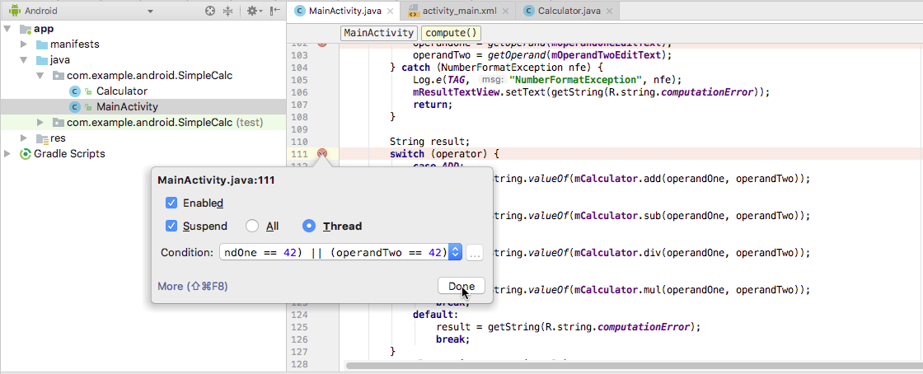

The test you enter in this field can be any Java expression as long as it returns a boolean value. You can use variable names from your app as part of the expression.

You can also use the **Breakpoints** window to enter a breakpoint condition.

1. Run your app in debug mode. Execution of your app stops at the conditional breakpoint, if the condition evaluates to true.

Stepping through code

After your app's execution has stopped because a breakpoint has been reached, you can execute your code from that point one line at a time with the **Step Over**, **Step Into**, and **Step Out** functions.

To use any of the step functions:

1. Begin debugging your app. Pause the execution of your app with a breakpoint.

Your app's execution stops, and the **Debugger** pane shows the current state of the app. The current line is highlighted in your code.

1. Click the **Step Over** icon  , select **Run > Step Over,** or press **F8**. **Step Over** executes the next line of the code in the current class and method, executing all of the method calls on that line and remaining in the same file.
2. Click the **Step Into**icon  , select **Run > Step Into,** or press **F7**. **Step Into** jumps into the execution of a method call on the current line (as compared to just executing that method and remaining on the same line). The **Frames** pane (which you'll learn about in the next section) updates to show the new stack frame (the new method). If the method call is contained in another class, the file for that class is opened and the current line in that file is highlighted. You can continue stepping over lines in this new method call, or step deeper into other methods.
3. Click the **Step Out**icon  , select **Run > Step Out,** or press **Shift-F8**. **Step Out** finishes executing the current method and returns to the point where that method was called.
4. To resume normal execution of the app, select **Run > Resume Program** or click the Resume icon.

Viewing execution stack frames

The **Frames**pane of the **Debug** pane allows you to inspect the execution stack and the specific frame that caused the current breakpoint to be reached.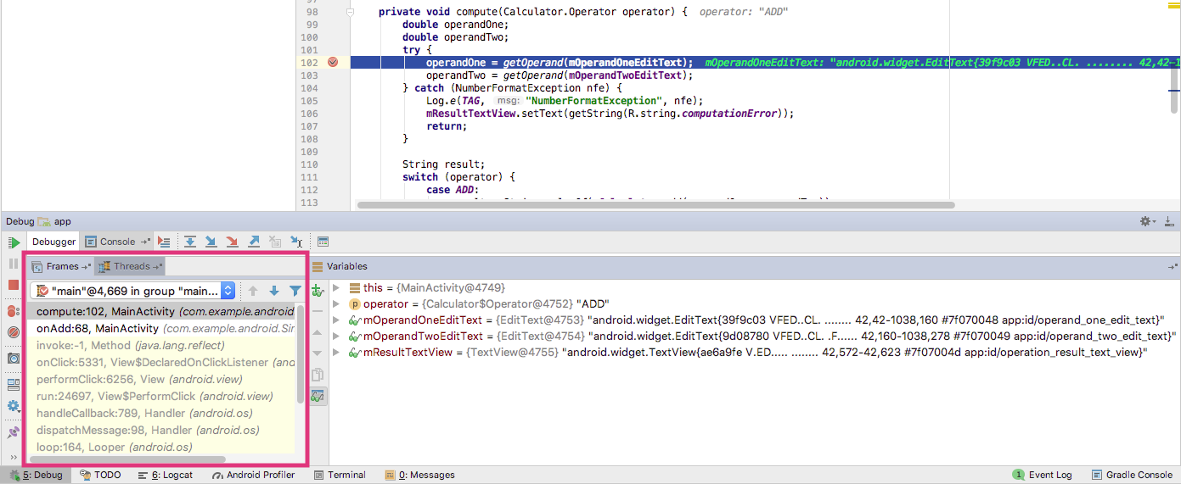

The execution stack shows all the classes and methods (frames) that are being executed up to this point in the app, in reverse order (most recent frame first). As execution of a particular frame finishes, that frame is popped from the stack and execution returns to the next frame.

Clicking a line for a frame in the **Frames** pane opens the associated source in the editor and highlights the line where that frame was initially executed. The **Variables** and **Watches** panes also update to reflect the state of the execution environment when that frame was last entered.

Inspecting and modifying variables

The **Variables** pane of the **Debugger** pane allows you to inspect the variables available at the current stack frame when the system stops your app on a breakpoint. Variables that hold objects or collections such as arrays can be expanded to view their components.

The **Variables** pane also allows you to evaluate expressions on the fly using static methods or variables available within the selected frame.

If the **Variables** pane is not visible, click the **Restore Variables View** icon  .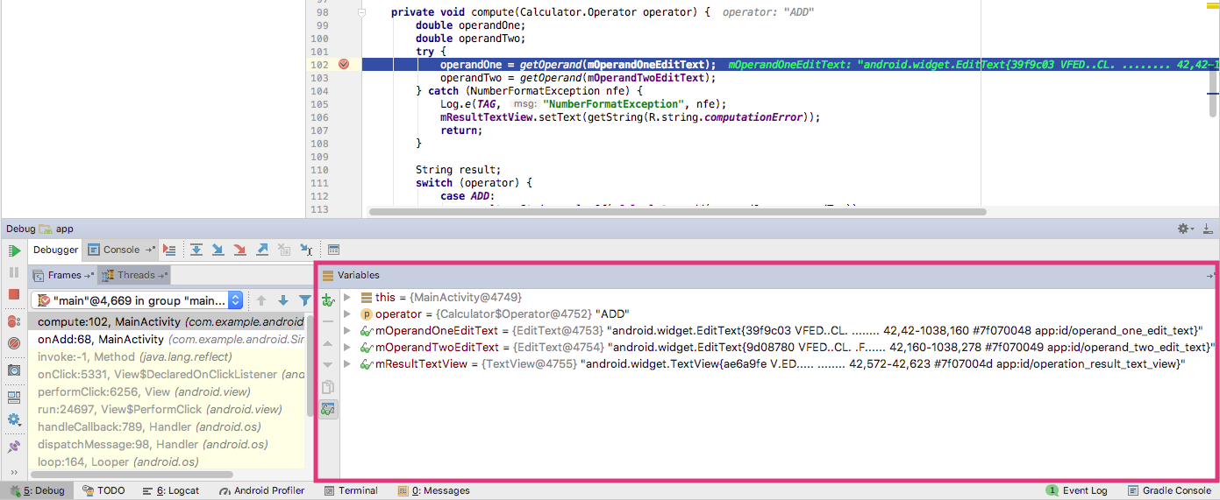

To modify variables in your app as it runs:

1. **Right-click** (or **Control-click**) any variable in the **Variables** pane, and select **Set Value**. You can also press **F2**.
2. Enter a new value for the variable, and press **Return**.

The value you enter must be of the appropriate type for that variable, or Android Studio returns a "type mismatch" error.

Setting watches

The **Watches** pane provides similar functionality to the **Variables** pane except that expressions added to the **Watches** pane persist between debugging sessions. Add watches for variables and fields that you access frequently or that provide state that is helpful for the current debugging session.

To use watches:

1. Begin debugging your app.
2. Click the **Show Watches** icon  . The **Watches** pane appears next to the **Variables** pane.
3. In the **Watches** pane, click the plus (**+**) button. In the text box that appears, type the name of the variable or expression you want to watch and then press **Enter**.

Remove an item from the Watches list by selecting the item and then clicking the minus (**–**) button.

Change the order of the elements in the **Watches** pane list by selecting an item and then clicking the up or down icons.

Evaluating expressions

Use **Evaluate Expression** to explore the state of variables and objects in your app, including calling methods on those objects. To evaluate an expression:

1. Click the **Evaluate Expression** icon  , or select **Run > Evaluate Expression**.

The **Evaluate Code Fragment** window appears. You can also right-click on any variable and choose **Evaluate Expression**.

1. Enter any Java expression into the top field of the **Evaluate Code Fragment** window, and click **Evaluate**.

The Result field shows the result of that expression. Note that the result you get from evaluating an expression is based on the app's current state. Depending on the values of the variables in your app at the time you evaluate expressions, you may get different results. Changing the values of variables in your expressions also changes the current running state of the app.

More tools for debugging

Android Studio and the Android SDK include a number of other tools to help you find and correct issues in your code.

System log (**Logcat** pane)

As you've learned in another chapter, you can use the [Log](https://developer.android.com/reference/android/util/Log.html) class to send messages to the Android system log, and view those messages in Android Studio in the **Logcat** pane.

To write log messages in your code, use the [Log](https://developer.android.com/reference/android/util/Log.html) class. Log messages help you understand the execution flow by collecting the system debug output while you interact with your app. Log messages can tell you what part of your app failed. For more information about logging, see [Reading and Writing Logs](https://developer.android.com/studio/command-line/logcat.html).

Tracing and logging

Analyzing traces allows you to see how much time is spent in certain methods, and which ones are taking the longest times.

To create the trace files, include the [Debug](https://developer.android.com/reference/android/os/Debug.html) class and call one of the [startMethodTracing()](https://developer.android.com/reference/android/os/Debug.html#startMethodTracing()) methods. In the call, you specify a base name for the trace files that the system generates.

To stop tracing, call [stopMethodTracing()](https://developer.android.com/reference/android/os/Debug.html#stopMethodTracing()). These methods start and stop method tracing across the entire virtual machine. For example, you could call [startMethodTracing()](https://developer.android.com/reference/android/os/Debug.html#startMethodTracing()) in the onCreate() method of your Activity, and call [stopMethodTracing()](https://developer.android.com/reference/android/os/Debug.html#stopMethodTracing()) in the onDestroy() method of that Activity.

Other tools

* The [Android Debug Bridge](https://developer.android.com/studio/command-line/adb.html) (ADB) is a command-line tool that lets you communicate with an emulator instance or connected Android-powered device.
* The [Android Profiler](https://developer.android.com/studio/profile/android-profiler.html) provides real-time data for your app's CPU, memory, and network activity. You can perform sample-based method tracing to time your code execution, capture heap dumps, view memory allocations, and inspect the details of network-transmitted files.
* The [CPU Profiler](https://developer.android.com/studio/profile/cpu-profiler.html) helps you inspect your app's CPU usage and thread activity in real-time, and record method traces, so you can optimize and debug your app's code.
* The [Network Profiler](https://developer.android.com/studio/profile/network-profiler.html) displays real-time network activity on a timeline, showing data sent and received, as well as the current number of connections. This lets you examine how and when your app transfers data, and optimize the underlying code appropriately.

Trace logging and the AndroidManifest.xml file

There are multiple types of debugging available to you beyond setting breakpoints and stepping through code. You can also use logging and tracing to find issues with your code. When you have a trace log file (generated by adding tracing code to your app), you can load the log files in [Traceview](https://developer.android.com/studio/profile/traceview.html), which displays the log data in two panes:

* A [timeline pane](https://developer.android.com/studio/profile/traceview#timeline_pane) describes when each thread and method started and stopped.
* A [profile pane](https://developer.android.com/studio/profile/traceview#profile_pane) provides a summary of what happened inside a method.

Likewise, to make the app debuggable even when the app is running on a device in user mode, you can set android:debuggable in the <application> tag of the AndroidManifest.xml file to "true". By default, the debuggable value is set to "false".

You can create and configure build types in the module-level build.gradle file inside the android {}block. When you create a new module, Android Studio creates the debug and release build types for you. Although the debug build type doesn't appear in the build configuration file, Android Studio configures it with [debuggable true](http://google.github.io/android-gradle-dsl/current/com.android.build.gradle.internal.dsl.BuildType.html#com.android.build.gradle.internal.dsl.BuildType:debuggable). This allows you to debug the app on secure Android-powered devices and configures APK signing with a generic debug keystore. If you want to add or change certain settings, add the debug build type to your configuration.

When you prepare your app for release, you must remove all the extra code in your source files that you wrote for testing purposes.

In addition to prepping the code itself, there are a few other tasks you need to complete in order to get your app ready to publish. These include:

* Removing logging statements.
* Remove any calls to show Toast messages.
* Disable debugging in the AndroidManifest.xml file by either removing android:debuggable attribute from the <application> tag, or setting android:debuggable to "false".
* Remove all debug tracing calls from your source code files such as startMethodTracing() and stopMethodTracing().

All these changes made for debugging must be removed from your code before release because they can impact the execution and performance production code.

3.2: App testing

**Contents:**

* [About testing](https://google-developer-training.github.io/android-developer-fundamentals-course-concepts-v2/unit-1-get-started/lesson-3-testing,-debugging,-and-using-support-libraries/3-2-c-app-testing/3-2-c-app-testing.html#abouttesting)
* [Setting up testing](https://google-developer-training.github.io/android-developer-fundamentals-course-concepts-v2/unit-1-get-started/lesson-3-testing,-debugging,-and-using-support-libraries/3-2-c-app-testing/3-2-c-app-testing.html#settinguptesting)
* [Creating and running unit tests](https://google-developer-training.github.io/android-developer-fundamentals-course-concepts-v2/unit-1-get-started/lesson-3-testing,-debugging,-and-using-support-libraries/3-2-c-app-testing/3-2-c-app-testing.html#creatingrunningunittests)
* [Related practical](https://google-developer-training.github.io/android-developer-fundamentals-course-concepts-v2/unit-1-get-started/lesson-3-testing,-debugging,-and-using-support-libraries/3-2-c-app-testing/3-2-c-app-testing.html#relatedpractical)
* [Learn more](https://google-developer-training.github.io/android-developer-fundamentals-course-concepts-v2/unit-1-get-started/lesson-3-testing,-debugging,-and-using-support-libraries/3-2-c-app-testing/3-2-c-app-testing.html#learnmore)

In this chapter you get an overview of Android testing, and you learn about creating and running local unit tests in Android Studio with JUnit.

About testing

Even though you have an app that compiles and runs and looks the way you want it to on different devices, you must make sure that your app will behave the way you expect it to in every situation, especially as your app grows and changes. Even if you try to manually test your app every time you make a change—a tedious prospect at best—you might miss something or not anticipate what end users might do with your app to cause it to fail.

Writing and running tests is a critical part of the software development process. [Test-driven development](https://en.wikipedia.org/wiki/Test-driven_development)(TDD) is a popular software development philosophy that places tests at the core of all software development for an app or service.This does not negate the need for further testing, it merely gives you a solid baseline to work with.

Testing your code can help you catch issues early in development—when they are the least expensive to address—and improve the robustness of your code as your app gets larger and more complex. With tests in your code, you can exercise small portions of your app in isolation, and in an automatable and repeatable manner for more efficient testing.

The code you write to test your app doesn't end up in the production version of your app; it lives only on your development machine, alongside your app's code in Android Studio.

Types of tests

Android supports several different kinds of tests and testing frameworks. Two basic forms of testing Android Studio supports are local unit tests and instrumented tests.

*Local unit tests* are tests that are compiled and run entirely on your local machine with the Java Virtual Machine (JVM). Use local unit tests to test the parts of your app (such as the internal logic) that do not need access to the Android framework or an Android-powered device or emulator, or those for which you can create fake ("mock" or stub) objects that pretend to behave like the framework equivalents.

*Instrumented tests* are tests that run on an Android-powered device or emulator. These tests have access to the Android framework and to [Instrumentation](https://developer.android.com/reference/android/app/Instrumentation.html) information such as the app's [Context](https://developer.android.com/reference/android/content/Context.html). You can use instrumented tests for unit testing, user interface (UI) testing, or integration testing, making sure that the components of your app interact correctly with other apps. Most commonly, you use instrumented tests for UI testing, which allows you to test that your app behaves correctly when a user interacts with your app or enters a specific input.

For most forms of user interface testing, you use the Espresso framework, which allows you to write automated UI tests. You'll learn about instrumented tests and Espresso in another chapter.

Unit Testing

Unit tests should be the fundamental tests in your app testing strategy. By creating and running unit tests against your code, you can verify that the logic of individual functional code areas or units is correct. Running unit tests after every build helps you catch and fix problems introduced by code changes to your app.

A unit test generally exercises the functionality of the smallest possible unit of code (which could be a method, class, or component) in a repeatable way. Create unit tests when you need to verify the logic of specific code in your app. For example, if you unit test a class, your test might check that the class is in the right state. For a method, you might test its behavior for different values of its parameters, especially null.

Typically, you test the unit of code in isolation, and your test monitors changes only to that unit. You can use a mocking framework such as [Mockito](http://mockito.org/) to isolate your unit from its dependencies.You can also write your unit tests for Android in [JUnit 4](https://junit.org/junit4/), a common unit testing framework for Java code.

The Android Testing Support Library

The Android Testing Support Library provides the infrastructure and APIs for testing Android apps, including support for JUnit 4. With the testing support library you can build and run test code for your apps.

You may already have the Android Testing Support Library installed with Android Studio. To check for the Android Support Repository, follow these steps:

1. In Android Studio choose **Tools > Android > SDK Manager**.
2. Click the **SDK Tools** tab, and look for the Support Repository.
3. If necessary, update or install the library.

The Android Testing Support Library classes are located under the android.support.test package. There are also older testing APIs in android.test. You should use the support libraries first, when given a choice between the support libraries and the older APIs, as the support libraries help build and distribute tests in a cleaner and more reliable fashion than directly coding against the API itself.

Setting up testing

To prepare your project for testing in Android Studio, you need to:

* Organize your tests in a *source set*.
* Configure your project's Gradle dependencies to include testing-related APIs.

Android Studio source sets

*Source sets* are collections of code in your project that are for different build targets or other "flavors" of your app. When Android Studio creates your project, it creates three source sets for you:

* The *main* source set, for your app's code and resources.
* The (test) source set, for your app's local unit tests. The source set shows (test) after the package name.
* The (androidTest) source set, for Android instrumented tests. The source set shows (androidTest)after the package name.

Source sets appear in the Android Studio **Project > Android** pane under the package name for your app. The main source set includes just the package name. The test and androidTest source sets have the package name followed by (test) or (androidTest), respectively.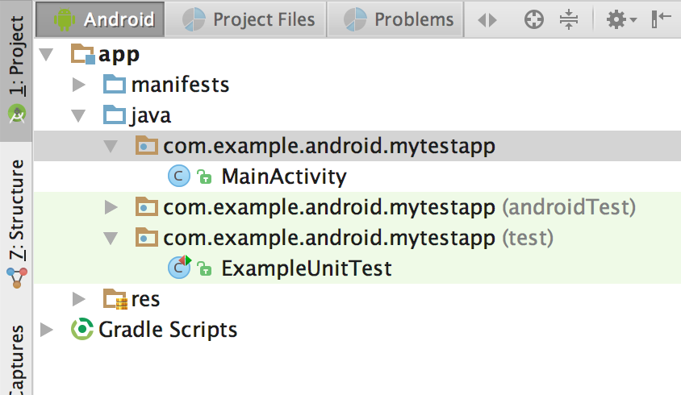

These source sets correspond to folders in the src directory for your project. For example, the files for the test source set are located in src/test/java.

Configuring Gradle for test dependencies

To use the unit testing APIs, you may need to configure the dependencies for your project. The default Gradle build file, provided by Activity templates such as the Empty Activity template, includes some of these dependencies, but you may need to add more dependencies for additional testing features such as matching or mocking frameworks.

In your app project's build.gradle (Module: app) file, the following dependency should already be included (if not, you should add it):

testImplementation 'junit:junit:4.12'

The androidTestImplementation dependencies are required for UI testing with Espresso, described in another chapter:

androidTestImplementation 'com.android.support.test:runner:1.0.1'

androidTestImplementation

'com.android.support.test.espresso:espresso-core:3.0.1'

Note that the version numbers for these libraries may have changed. If Android Studio reports a newer library, update the number to reflect the current version.

You may also want to add dependencies for the optional Hamcrest matchers and the Mokito framework:

testCompile 'org.hamcrest:hamcrest-library:1.3'

testCompile 'org.mockito:mockito-core:1.10.19'

After editing the build.gradle (Module: app) file, you must sync your project to continue. Click **Sync Now** in Android Studio when prompted.

Configuring a test runner

A test runner is a library or set of tools that enables testing to occur and the results to be printed to a log. Your Android project has access to a basic JUnit test runner as part of the JUnit4 APIs. The Android test support library includes a test runner for instrumented and Espresso tests, [AndroidJUnitRunner](https://developer.android.com/reference/android/support/test/runner/AndroidJUnitRunner.html), which also supports JUnit 3 and 4.

This chapter demonstrates the default runner for unit tests, which is supplied by Activity templates such as the Empty Activity template. In your app project's build.gradle (Module: app) file, the following test runner should already be included in the defaultConfig section (if not, you should add it):

testInstrumentationRunner "android.support.test.runner.AndroidJUnitRunner"

Creating and running unit tests

Create your unit tests as a generic Java file using the JUnit 4 APIs, and store those tests in the (test)source set. Each Android Studio project template includes this source set and a sample Java test file called ExampleUnitTest.

Creating a new test class

To create a new test class file, add a Java file to the (test) source set for your project. Test class files for unit testing are typically named for the class in your app that you are testing, with "Test" appended. For example, if you have a class called Calculator in your app, the class for your unit tests would be CalculatorTest.

To add a new test class file, follow these steps:

1. Expand the **java** folder and the folder for your app's test source set. The existing unit test class files are shown.
2. **Right-click** (or **Control-click**) on the test source set folder and select **New > Java Class.**
3. Name the file and click **OK**.

Writing your tests

Use JUnit 4 syntax and annotations to write your tests. For example, the test class shown below includes the following annotations:

* The @RunWith annotation indicates the test runner that should be used for the tests in this class.
* The @SmallTest annotation indicates that this is a small (and fast) test.
* The @Before annotation marks a method as being the setup for the test.
* The @Test annotation marks a method as an actual test.

For more information on JUnit annotations, see [JUnit 4 API Reference](http://junit.sourceforge.net/javadoc/org/junit/package-summary.html).

@RunWith(JUnit4.class)

@SmallTest

public class CalculatorTest {

private Calculator mCalculator;

// Set up the environment for testing

@Before

public void setUp() {

mCalculator = new Calculator();

}

// test for simple addition

@Test

public void addTwoNumbers() {

double resultAdd = mCalculator.add(1d, 1d);

assertThat(resultAdd, is(equalTo(2d)));

}

}

The addTwoNumbers() method is the actual test. The key part of a unit test is the assertion, which is defined here by the assertThat() method. Assertions are expressions that must evaluate and result in a value of true for the test to pass. For more information on assertions, see the JUnit reference documentation for the [Assert](http://junit.org/junit4/javadoc/4.12/org/junit/Assert.html) class.

JUnit 4 provides a number of assertion methods, but assertThat() is the most flexible, as it allows for general-purpose comparison methods called *matchers*. The Hamcrest framework is commonly used for matchers ("Hamcrest" is an anagram for matchers). Hamcrest includes a large number of comparison methods as well as enabling you to write your own. For more information on the Hamcrest framework, see the [Java Hamcrest](http://hamcrest.org/JavaHamcrest/) homepage.

Note that the addTwoNumbers() method in this example includes only one assertion. The general rule for unit tests is to provide a separate test method for every individual assertion. Grouping more than one assertion into a single method can make your tests harder to debug if only one assertion fails, and obscures the tests that do succeed.

Running your tests

To run your local unit tests, follow these steps:

* To run a single test, **right-click** (or **Control-click**) that test method and select **Run**.
* To test all the methods in a test class, **right-click** (or **Control-click**) the test file in the **Android > Project** pane, and select **Run**.
* To run all tests in a directory, **right-click** (or **Control-click**) on the directory and select **Run tests**.

The project builds, if necessary, and the testing view appears at the bottom of the screen. If all the tests you ran are successful, the progress bar at the top of the view turns green. A status message in the footer also reports "Tests Passed."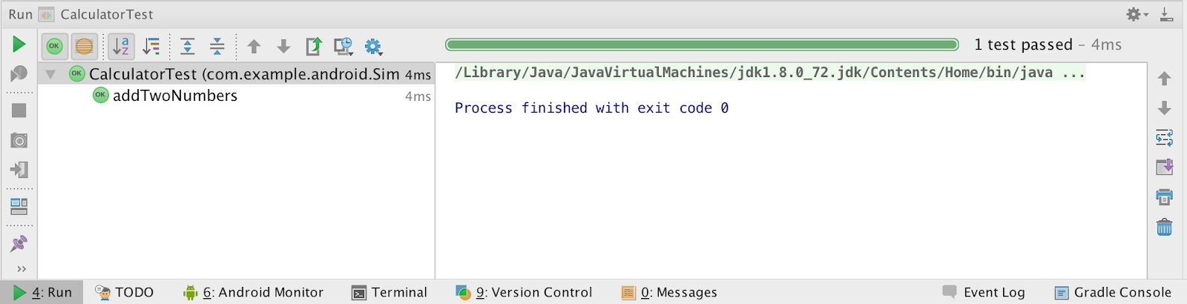

3.3: The Android Support Library

**Contents:**

* [About the Android Support Library](https://google-developer-training.github.io/android-developer-fundamentals-course-concepts-v2/unit-1-get-started/lesson-3-testing,-debugging,-and-using-support-libraries/3-3-c-the-android-support-library/3-3-c-the-android-support-library.html#aboutandroidsupportlibrary)
* [Support libraries and features](https://google-developer-training.github.io/android-developer-fundamentals-course-concepts-v2/unit-1-get-started/lesson-3-testing,-debugging,-and-using-support-libraries/3-3-c-the-android-support-library/3-3-c-the-android-support-library.html#supportlibrariesfeatures)
* [Setting up and using the Android Support Library](https://google-developer-training.github.io/android-developer-fundamentals-course-concepts-v2/unit-1-get-started/lesson-3-testing,-debugging,-and-using-support-libraries/3-3-c-the-android-support-library/3-3-c-the-android-support-library.html#settingupandusing)
* [Checking system versions](https://google-developer-training.github.io/android-developer-fundamentals-course-concepts-v2/unit-1-get-started/lesson-3-testing,-debugging,-and-using-support-libraries/3-3-c-the-android-support-library/3-3-c-the-android-support-library.html#checkingsystemversions)
* [Related practical](https://google-developer-training.github.io/android-developer-fundamentals-course-concepts-v2/unit-1-get-started/lesson-3-testing,-debugging,-and-using-support-libraries/3-3-c-the-android-support-library/3-3-c-the-android-support-library.html#relatedpractical)
* [Learn more](https://google-developer-training.github.io/android-developer-fundamentals-course-concepts-v2/unit-1-get-started/lesson-3-testing,-debugging,-and-using-support-libraries/3-3-c-the-android-support-library/3-3-c-the-android-support-library.html#learnmore)

In this chapter you explore the Android Support Library, which is part of the Android SDK tools. You can use the Android Support Library to get backward-compatible versions of new Android features, plus user interface (UI) elements not included in the standard Android framework.

About the Android Support Library

The Android SDK tools include a number libraries collectively called the *Android Support Library*. This package of libraries provides several features that are not built into the standard Android framework, and provides backward compatibility for older devices. Include any of these libraries in your app to incorporate that library's functionality.

**Note:** The Android Support library is a different package from the Android **Testing** Support library you learned about in another chapter. The testing support library provides tools and APIs just for testing, whereas the more general support library provides features of all kinds (but no testing).

Features

The features of the Android Support Library include:

* Backward-compatible versions of framework components. These compatibility libraries allow you to use features and components available on newer versions of the Android platform even when your app is running on an older platform version. For example, older devices may not have access to newer features such as fragments, app bars (also known as action bars), or Material Design elements. The support library provides access to those features on older devices.
* Additional layout and UI elements. The support library includes views and layouts that can be useful for your app, but are not included in the standard Android framework. For example, the [RecyclerView](https://developer.android.com/reference/android/support/v7/widget/RecyclerView.html)view that you will use in another chapter is part of the support library.
* Support for different device form factors, such as TV or wearables: For example, the [Leanback](https://developer.android.com/reference/android/support/v17/leanback/package-summary.html) library includes components specific to app development on TV devices.
* Design support: The [design support library](http://android-developers.blogspot.com/2015/05/android-design-support-library.html) includes components to support Material Design elements in your app, including floating action buttons (FAB). You'll learn more about Material Design in a later chapter.
* Various other features such as palette support, annotations, percentage-based layout dimensions, and preferences.

Backward Compatibility

Support libraries allow apps running on older versions of the Android platform to support features made available on newer versions of the platform. For example, an app running on a version of Android lower than 5.0 (API level 21) that relies on framework classes cannot display Material Design elements, as that version of the Android framework doesn't support Material Design. However, if the app incorporates the v7 appcompat library, that app has access to many of the features available in API level 21, including support for Material Design. As a result, your app can deliver a more consistent experience across a broader range of platform versions.

The support library APIs also provide a compatibility layer between different versions of the framework APIs. This compatibility layer transparently intercepts API calls and changes either the arguments passed, handles the operation itself, or redirects the operation. In the case of the support libraries, by using the compatibility layer's methods, you can ensure interoperability between older and newer Android releases. Each new release of Android adds new classes and methods, and possibly deprecates some older classes and methods. The support libraries include compatibility classes that can be used for backward compatibility.You can identify these classes by their names, which include "Compat" (such as [ActivityCompat](https://developer.android.com/reference/android/support/v4/app/ActivityCompat.html)).

When an app calls one of the support class's methods, the behavior of that method depends on the underlying Android version. If the device includes the necessary framework functionality, the support library uses the framework. If the device is running an older version of Android, the support library makes an attempt to implement similar compatible behavior with the APIs it has available.

For most cases you do not need to write complex code that checks the version of Android and performs different operations based on that version. You can rely on the support library to do those checks and choose appropriate behavior.

When in doubt, choose a support library compatibility class over the framework class.

Versions

Each package in the support library has a version number in three parts (*x.y.z*) that corresponds to an Android API level, and to a particular revision of that library. For example, a support library version number of *22.3.4* is version 3.4 of the support library for API 22.

As a general rule, use the most recent version of the support library for the API your app is compiled and targeted for, or a newer version. For example, if your app targets API 26, use the version 26.*x.x* of the support library.

You can always use a newer support library than the one for your targeted API. For example, if your app targets API 22 you can use version 25 or higher of the support library. The reverse is not true—you cannot use an older support library with a newer API. As a general rule, you should try to use the most up-to-date API and support libraries in your app.

API Levels

In addition to the actual version number, the name of the support library itself indicates the API level that the library is backward-compatible with. You cannot use a support library in your app for an API higher than the minimum API your app supports. For example, if the minimum API your app supports is 10, you cannot use the v13 support library or v14 preferences support library in your app. If your app uses multiple support libraries, your minimum API must be higher than the largest number—that is, if you include support libraries for v7, v13, and v14 your minimum API must be at least 14.

All of the support libraries, including the v4 and v7 libraries, require a minimum SDK of API 9.

Support libraries and features

This section describes the important features provided by the libraries in the Android Support Library. You'll learn about many of the features described in this section in other chapters.

v4 support library

The v4 support libraries include the largest set of APIs compared to the other libraries, including support for app components, user interface features, accessibility, data handling, network connectivity, and programming utilities.

The v4 support libraries include these specific components:

* v4 compat library: Compatibility wrappers (classes that include the word "Compat") for a number of core framework APIs.
* v4 core-utils library: Provides a number of utility classes
* v4 core-ui library: Implements a variety of UI-related components.
* v4 media-compat library: Backports portions of the media framework from API 21.
* v4 fragment library: Adds support for Android fragments.

v7 support library

The v7 support library includes both compatibility libraries and additional features.

The v7 support library includes all the v4 support libraries, so you don't have to add those separately. A dependency on the v7 support library is included in every new Android Studio project, and new activities in your project extend from AppCompatActivity.

The v7 support libraries include these specific components:

* v7 appcompat library: Adds support for the app bar UI design pattern and support for Material Design UI implementations.
* v7 cardview library: Provides the [CardView](https://developer.android.com/reference/android/support/v7/widget/CardView.html) class, a view that lets you show information inside cards.
* v7 gridlayout library: Includes the [GridLayout](https://developer.android.com/reference/android/support/v7/widget/GridLayout.html) class, which allows you to arrange UI elements using a grid of rectangular cells
* v7 mediarouter library: Provides [MediaRouter](https://developer.android.com/reference/android/support/v7/media/MediaRouter.html) and related media classes that support Google Cast.
* v7 palette library: Implements the [Palette](https://developer.android.com/reference/android/support/v7/graphics/Palette.html) class, which lets you extract prominent colors from an image.
* v7 recyclerview library: Provides the [RecyclerView](https://developer.android.com/reference/android/support/v7/widget/RecyclerView.html) class, a view for efficiently displaying large data sets by providing a limited window of data items.
* v7 preference library: Provides APIs to support preference objects in app settings.

Other libraries

* v8 renderscript library: Adds support for the [RenderScript](https://developer.android.com/guide/topics/renderscript/compute.html), a framework for running computationally intensive tasks at high performance.
* v13 support library: Provides support for using a Fragment with the [FragmentCompat](https://developer.android.com/reference/android/support/v13/app/FragmentCompat.html) class and additional Fragment support classes.
* v14 preference support library, and v17 preference support library for TV: provides APIs to add support for preference interfaces on mobile devices and TV.
* v17 leanback library: Provides APIs to support building UIs on TV devices.
* Annotations support library: Contains APIs to support adding annotation metadata to your apps.
* Design support library: Adds support for various Material Design components and patterns such as navigation drawers, floating action buttons (FAB), snackbars, and [tabs](https://developer.android.com/design/building-blocks/tabs.html).
* Custom Tabs support library: Adds support for adding and managing custom tabs in your apps.
* Percent support library: Enables you to add and manage percentage based dimensions in your app.
* App recommendation support library for TV: Provides APIs to support adding content recommendations in your app running on TV devices.

Setting up and using the Android Support Library

The Android Support Library package is part of the Android SDK, and available to download in the Android SDK manager. To set up your project to use any of the support libraries, use these steps:

1. Download the support library with the Android SDK manager, or verify that the support libraries are already available.
2. Find the library dependency statement for the support library you're interested in.
3. Add that dependency statement to the dependencies section of your build.gradle (Module: app)file.

Download the support library

In Android Studio, you'll use the Android Support Repository—the repository in the SDK manager for all support libraries—to get access to the library from within your project.

You may already have the Android support libraries downloaded and installed with Android Studio. To verify that you have the support libraries available, follow these steps:

1. In Android Studio, select **Tools > Android > SDK Manager**, or click the SDK Manager  icon. The SDK Manager preference pane appears.
2. Click the **SDK Tools** tab and expand **Support Repository**, as shown in the figure below.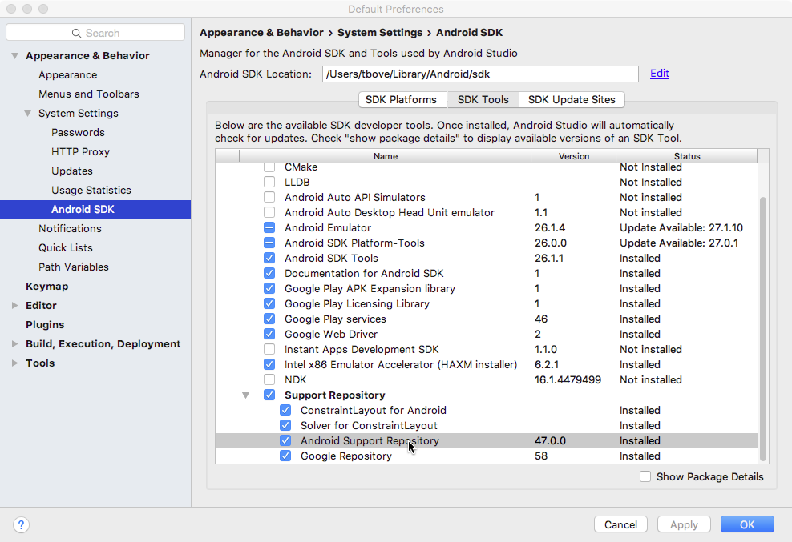
3. Look for **Android Support Repository** in the list. If **Installed** appears in the Status column, you're all set. Click **Cancel**.

If **Not installed** or **Update Available**appears, click the checkbox next to **Android Support Repository**. A download icon should appear next to the checkbox. Click **OK.**

1. Click **OK** again, and then **Finish** when the support repository has been installed.

Find a library dependency statement

To provide access to a support library from your project, you add that library to your Gradle build file as a dependency. Dependency statements have a specific format that includes the name and version number of the library.

1. Visit the [Support Library Features](https://developer.android.com/topic/libraries/support-library/features.html) page on [developer.android.com](http://developer.android.com/).
2. Find the library you're interested in on that page, for example, the [Design Support Library](https://developer.android.com/topic/libraries/support-library/features#material-design)for Material Design support.
3. Copy the dependency statement shown at the end of the section. For example, the dependency for the design support library looks like this:

com.android.support:design:26.1.0

The version number at the end of the line may vary from the one shown above. You will update the version number when you add the dependency to the build.gradle file in the next step.

Add the dependency to your build.gradle file

The Gradle scripts for your project manage how your app is built, including specifying the dependencies your app has on other libraries. To add a support library to your project, modify your Gradle build files to include the dependency to that library you found in the previous section.

1. In Android Studio, make sure the **Project > Android** pane is open.
2. Expand **Gradle Scripts** and open the **build.gradle (Module: app)** file.

Note that build.gradle for the overall project (build.gradle (Project: *app_name* )) is a different file from the build.gradle for the app module.

1. Locate the dependencies section near the end of the file.

The dependencies section for a new project already includes dependencies for several other libraries.

1. Add a dependency for the support library that includes the statement you copied in the previous task. For example, a complete dependency on the design support library looks like this:

compile 'com.android.support:design:26.1.0'

1. Update the version number, if necessary.

If the version number you specified is lower than the currently available library version number, Android Studio warns you that an updated version is available. ("a newer version of com.android.support:design is available"). Edit the version number to the updated version, or enter **Alt-Enter**(**Option-Return** on a Mac) and select **Change to *xx.xx.x*** from the menu, where *xx.xx.x* is the most up-to-date version available.

1. Click **Sync Now** to sync your updated gradle files with the project, if prompted.

Using the support library APIs

All the support library classes are contained in the android.support packages. For example, android.support.v7.app.AppCompatActivity is the fully qualified name for the AppCompatActivity class, from which all of your activities extend.

Support Library classes that provide support for existing framework APIs typically have the same name as framework class but are located in the android.support class packages. Make sure that when you import those classes you use the right package name for the class you're interested in. For example, when applying the ActionBar class, use one of:

* android.support.v7.app.ActionBar when using the Support Library.
* android.app.ActionBar when developing only for API level 11 or higher.

The support library also includes several View classes used in XML layout files. In the case of the Viewelements (such as CoordinatorLayout), you must always use the fully qualified name in the XML element for that View:

<android.support.design.widget.CoordinatorLayout

xmlns:android="http://schemas.android.com/apk/res/android"

android:layout_width="match_parent"

android:layout_height="match_parent"

android:orientation="vertical">

</android.support.design.widget.CoordinatorLayout>

You'll learn about CoordinatorLayout in another chapter.

Checking system versions

Although the support library can help you implement single apps that work across Android platform versions, there may be times when you need to check for the version of Android your app is running on, and provide the correct code for that version.

Android provides a unique code for each platform version in the [Build](https://developer.android.com/reference/android/os/Build.html) constants class. Use these codes within your app to test for the version and to ensure that the code that depends on higher API levels is executed only when those APIs are available on the system.

private void setUpActionBar() {

// Make sure we're running on Honeycomb or higher to use ActionBar APIs

if (Build.VERSION.SDK_INT >= Build.VERSION_CODES.HONEYCOMB) {

ActionBar actionBar = getActionBar();

actionBar.setDisplayHomeAsUpEnabled(true);

} else { // do something else }

}

# 4.1: Buttons and clickable images

**Contents:**

* [Designing for interactivity](https://google-developer-training.github.io/android-developer-fundamentals-course-concepts-v2/unit-2-user-experience/lesson-4-user-interaction/4-1-c-buttons-and-clickable-images/4-1-c-buttons-and-clickable-images.html#interaction_design)
* [Designing buttons](https://google-developer-training.github.io/android-developer-fundamentals-course-concepts-v2/unit-2-user-experience/lesson-4-user-interaction/4-1-c-buttons-and-clickable-images/4-1-c-buttons-and-clickable-images.html#using_buttons)
* [Responding to button-click events](https://google-developer-training.github.io/android-developer-fundamentals-course-concepts-v2/unit-2-user-experience/lesson-4-user-interaction/4-1-c-buttons-and-clickable-images/4-1-c-buttons-and-clickable-images.html#responding_button)
* [Using clickable images](https://google-developer-training.github.io/android-developer-fundamentals-course-concepts-v2/unit-2-user-experience/lesson-4-user-interaction/4-1-c-buttons-and-clickable-images/4-1-c-buttons-and-clickable-images.html#image_buttons)
* [Using a floating action button](https://google-developer-training.github.io/android-developer-fundamentals-course-concepts-v2/unit-2-user-experience/lesson-4-user-interaction/4-1-c-buttons-and-clickable-images/4-1-c-buttons-and-clickable-images.html#floating_action)
* [Recognizing gestures](https://google-developer-training.github.io/android-developer-fundamentals-course-concepts-v2/unit-2-user-experience/lesson-4-user-interaction/4-1-c-buttons-and-clickable-images/4-1-c-buttons-and-clickable-images.html#gestures)
* [Related practical](https://google-developer-training.github.io/android-developer-fundamentals-course-concepts-v2/unit-2-user-experience/lesson-4-user-interaction/4-1-c-buttons-and-clickable-images/4-1-c-buttons-and-clickable-images.html#relatedpractical)
* [Learn more](https://google-developer-training.github.io/android-developer-fundamentals-course-concepts-v2/unit-2-user-experience/lesson-4-user-interaction/4-1-c-buttons-and-clickable-images/4-1-c-buttons-and-clickable-images.html#learnmore)

## Designing for interactivity

The user interface (UI) that appears on a screen of an Android-powered device consists of a hierarchy of objects called views. Every element of the screen is a view.

The [View](https://developer.android.com/reference/android/view/View.html) class represents the basic building block for all UI components. View is the base class for classes that provide interactive UI components, such as [Button](https://developer.android.com/reference/android/widget/Button.html) elements. Users tap these elements on a touchscreen or click them using a pointing device. Any element that users tap or click to perform an action is called a clickable element.

For an Android app, user interaction typically involves tapping, typing, using gestures, or talking. The Android framework provides corresponding user interface (UI) elements such as buttons, clickable images, menus, keyboards, text entry fields, and a microphone.

When designing an interactive app, make sure your app is intuitive; that is, your app should perform as your users expect it to perform. For example, when you rent a car, you expect the steering wheel, gear shift, headlights, and indicators to be in a certain place. Another example is that when you first enter a room, you expect the light switch to be in a certain place. Similarly, when a user starts an app, the user expects buttons and images to be clickable. Don't violate established expectations, or you'll make it harder for your users to use your app.

**Note:** Android users expect UI elements to act in certain ways, so it's important that your app be consistent with other Android apps. To satisfy your users, create a layout that gives users predictable choices.

In this chapter you learn how to create buttons and clickable images for triggering actions.

## Designing buttons

People like to press buttons. [Show someone a big red button](https://play.google.com/store/apps/details?id=com.klikapp.bigredbutton&hl=en) with a message that says "Do not press" and the person will probably press the button, just for the pleasure of pressing a big red button. (That the button is forbidden is also a factor.)

You use the [Button](https://developer.android.com/reference/android/widget/Button.html) class to make a button for an Android app. Buttons can have the following design:

* Text only, as shown on the left side of the figure below.
* Icon only, as shown in the center of the figure below.
* Both text and an icon, as shown on the right side of the figure below.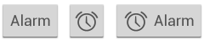

When the user touches or clicks a button, the button performs an action. The button's text or icon should provide a hint about what that action will be. (Buttons are sometimes called "push-buttons" in Android documentation.)

A button is usually a rectangle or rounded rectangle with a descriptive caption or icon in its center. Android Button elements follow the guidelines in the [Android Material Design specification](https://material.io/design/components/buttons.html). (You learn more about Material Design in another lesson.)

Android offers several types of Button elements, including raised buttons and flat buttons as shown in the figure below. Each button has three states: normal, disabled, and pressed.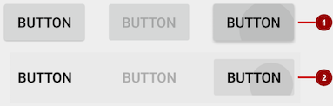

In the figure above:

1. Raised button in three states: normal, disabled, and pressed
2. Flat button in three states: normal, disabled, and pressed

### Designing raised buttons

A raised button is an outlined rectangle or rounded rectangle that appears lifted from the screen—the shading around it indicates that it is possible to tap or click it. The raised button can show text, an icon, or both.

To use raised buttons that conform to the Material Design specification, follow these steps:

1. If your **build.gradle (Module: app)** file doesn't include the android.support:appcompat-v7 library, add it to the dependencies section:
2. compile 'com.android.support:appcompat-v7:26.1.0.'

In the snippet above, 26.1.0 is the version number. If the version number you specified is lower than the currently available library version number, Android Studio will warn you ("a newer version is available"). Update the version number to the one Android Studio tells you to use.

1. Make your Activity extend android.support.v7.app.AppCompatActivity:
2. public class MainActivity extends AppCompatActivity {
3. // ...
4. }
5. Use the Button element in the layout file. A raised Button is the default style.
6. <Button
7. android:layout_width="wrap_content"
8. android:layout_height="wrap_content"
9. <!-- more attributes ... -->
10. />

Use raised Button elements to give more prominence to actions in layouts with a lot of varying content. A raised Button adds dimension to a flat layout—it shows a background shadow when touched (pressed) or clicked, as shown below.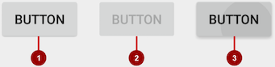

In the figure above:

1. Normal state: A raised Button.
2. Disabled state: When disabled, the Button is dimmed out and not active in the app's context. In most cases you would hide an inactive Button, but there may be times when you would want to show it as disabled.
3. Pressed state: The pressed state, with a larger background shadow, indicates that the Button is being touched or clicked. When you attach a callback to the Button (such as the android:onClickattribute), the callback is called when the Button is in this state.

#### **Creating a raised button with text**

Some raised Button elements are best designed as text, without an icon, such as a **Save** button, because an icon by itself might not convey an obvious meaning. The [Button](https://developer.android.com/reference/android/widget/Button.html) class extends the TextViewclass. To use it, add it to the XML layout:

<Button

android:layout_width="wrap_content"

android:layout_height="wrap_content"

android:text="@string/button_text"

<!-- more attributes ... -->

/>

The best practice with a text Button is to define a very short word as a string resource (button_text in the example above), so that the string can be translated. For example, **Save** could be translated into French as **Enregistrer** without changing any of the code.

#### **Creating a raised button with an icon and text**

While a Button usually displays text that tells the user what the action is, a raised Button can also display an icon along with text.

##### **Choosing an icon**

To choose images of a standard icon that are resized for different displays, follow these steps:

1. Expand **app > res** in the **Project > Android** pane, and right-click (or Command-click) the **drawable**folder.
2. Choose **New > Image Asset**. The Configure Image Asset dialog appears.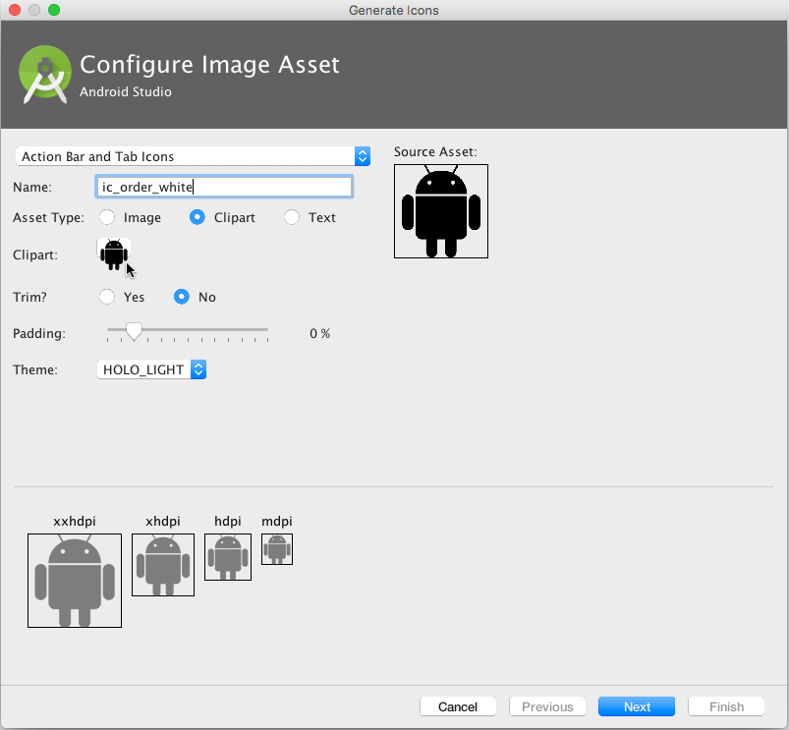
3. Choose **Action Bar and Tab Icons** in the drop-down menu. (For a complete description of this dialog, see [Create app icons with Image Asset Studio](http://developer.android.com/tools/help/image-asset-studio.html).)
4. Click the **Clipart:** image (the Android logo) to select a clip art image as the icon. A page of icons appears as shown below. Click the icon you want to use.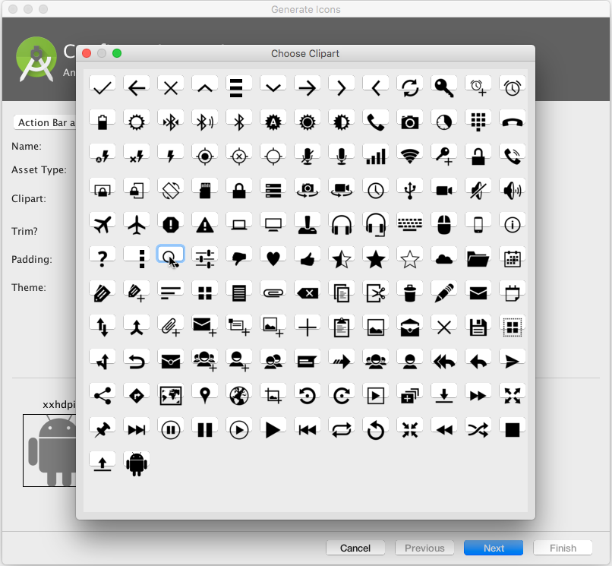
5. Optional: Choose **HOLO_DARK** from the **Theme** drop-down menu to set the icon to be white against a dark-colored or black background.
6. Optional: Depending on the shape of the icon, you may want to add padding to the icon so that the icon doesn't crowd the text. Drag the Padding slider to the right to add more padding.
7. Click **Next**, and then click **Finish** in the Confirm Icon Path dialog. The icon name should now appear in the **app > res > drawable** folder.

Vector images of a standard icon are automatically resized for different sizes of device displays. To choose vector images, follow these steps:

1. Expand **app > res** in the **Project > Android** pane, and right-click (or Command-click) the **drawable**folder.
2. Choose **New > Vector Asset** for an icon that automatically resizes itself for each display.
3. The Vector Asset Studio dialog appears for a vector asset. Click the **Material Icon** radio button, and then click the **Choose** button to choose an icon from the Material Design specification. (For a complete description of this dialog, see [Add Multi-Density Vector Graphics](https://developer.android.com/studio/write/vector-asset-studio.html).)
4. Click **Next** after choosing an icon, and click **Finish** to finish. The icon name should now appear in the **app > res > drawable** folder.

##### **Adding the button with text and icon to the layout**

To create a button with text and an icon as shown in the figure below, use a Button in your XML layout. Add the android:drawableLeft attribute to draw the icon to the left of the button's text, as shown in the figure below:

<Button

android:layout_width="wrap_content"

android:layout_height="wrap_content"

android:text="@string/button_text"

android:drawableLeft="@drawable/button_icon"

<!-- more attributes ... -->

/>

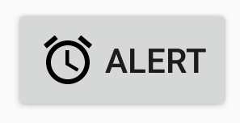

#### **Creating a raised button with only an icon**

If the icon is universally understood, you may want to use it instead of text.

To create a raised button with just an icon or image (no text), use the [ImageButton](https://developer.android.com/reference/android/widget/ImageButton.html) class, which extends the [ImageView](https://developer.android.com/reference/android/widget/ImageView.html) class. You can add an ImageButton to your XML layout as follows:

<ImageButton

android:layout_width="wrap_content"

android:layout_height="wrap_content"

android:src="@drawable/button_icon"

<!-- more attributes ... -->

/>

#### **Changing the style and appearance of raised buttons**

The simplest way to show a more prominent raised button is to use a different background color for the button. You can specify the android:background attribute with a drawable or color resource:

android:background="@color/colorPrimary"

The appearance of your button—the background color and font—may vary from one device to another, because devices by different manufacturers often have different default styles for input controls. You can control exactly how your buttons and other input controls are styled using a theme that you apply to your entire app.

For instance, to ensure that all devices that can run the Holo theme will use the Holo theme for your app, declare the following in the <application> element of the AndroidManifest.xml file:

android:theme="@android:style/Theme.Holo"

After adding the declaration above, the app will be displayed using the theme.

Apps designed for Android 4.0 and higher can also use the DeviceDefault public theme family. DeviceDefault themes are aliases for the device's native look and feel. The DeviceDefault theme family and widget style family offer ways for developers to target the device's native theme with all customizations intact.

For Android apps running on 4.0 and newer, you have the following options:

* Use a theme, such as one of the Holo themes, so that your app has the exact same look across all Android-powered devices running 4.0 or newer. In this case, the app's look does not change when running on a device with a different default skin or custom skin.
* Use one of the DeviceDefault themes so that your app takes on the look of the device's default skin.
* Don't use a theme, but you may have unpredictable results on some devices.

Recommended reading:

* If you're not familiar with Android's style and theme system, you should read [Styles and themes](http://developer.android.com/guide/topics/ui/themes.html).
* For information about using the Holo theme while supporting older devices, see the blog post [Holo Everywhere](http://android-developers.blogspot.com/2012/01/holo-everywhere.html).
* For a guide on styling and customizing buttons using XML, see [Buttons](https://developer.android.com/guide/topics/ui/controls/button.html) in the Android developer documentation.
* For a comprehensive guide to designing buttons, see [Buttons](https://material.google.com/components/buttons.html) in the Material Design specification.

### Designing flat buttons

A flat button, also known as a text button or borderless button, is a text-only button that looks flat and doesn't have a shadow. The major benefit of flat buttons is simplicity: a flat button doesn't distract the user from the main content as much as a raised button does. Flat buttons are useful for dialogs that require user interaction, as shown in the figure below. In this case, you want the button to use the same font and style as the surrounding text to keep the look and feel consistent across all the elements in the dialog.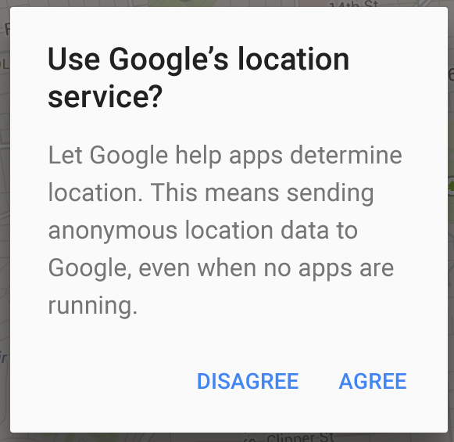

Flat buttons have no borders or background, but they do change their appearance when they change to different states.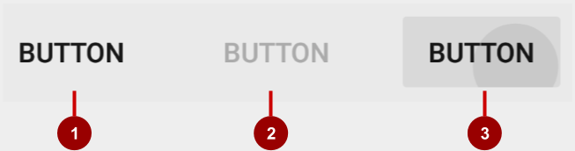

In the figure above:

1. Normal state: In its normal state, the button looks just like ordinary text.
2. Disabled state: When the text is dimmed out, the button is not active in the app's context.
3. Pressed state: A background shadow indicates that the button is being tapped or clicked. When you attach a callback (such as the android:onClick attribute) to the button, the callback is called when the button is in this state.

**Note:** If you use a flat button within a layout, be sure to use padding to set it off from the surrounding text, so that the user can easily see it.

To create a flat button, use the [Button](https://developer.android.com/reference/android/widget/Button.html) class. Add a Button to your XML layout, and apply "?android:attr/borderlessButtonStyle" as the style attribute:

<Button

android:id="@+id/button_send"

android:layout_width="wrap_content"

android:layout_height="wrap_content"

android:text="@string/button_send"

android:onClick="sendMessage"

style="?android:attr/borderlessButtonStyle" />

## Responding to button-click events

An event listener is an interface in the [View](https://developer.android.com/reference/android/view/View.html) class that contains a single callback method. The Android system calls the method when the user triggers the View to which the listener is registered.

To respond to a user tapping or clicking a button, use the event listener called [OnClickListener](https://developer.android.com/reference/android/view/View.OnClickListener.html), which contains one method, onClick(). To provide functionality when the user clicks, you implement this onClick() method.

For more about event listeners and other UI events, see [Input events overview](https://developer.android.com/guide/topics/ui/ui-events.html) in the Android developer documentation.

### Adding onClick() to the layout element

A quick way to set up an OnClickListener for a clickable element in your Activity code and assign a callback method is to add the android:onClick attribute to the element in the XML layout.

For example, a Button in the layout would include the android:onClick attribute:

<Button

android:id="@+id/button_send"

android:layout_width="wrap_content"

android:layout_height="wrap_content"

android:text="@string/button_send"

android:onClick="sendMessage" />

When a user clicks the Button, the Android framework calls the sendMessage() method in the Activity:

public void sendMessage(View view) {

// Do something in response to button click

}

The callback method for the android:onClick attribute must be public, return void, and define a Viewas its only parameter (this is the View that was tapped). Use the method to perform a task or call other methods as a response to the Button tap.

### Using the button-listener design pattern

You can also handle the click event in your Java code using the button-listener design pattern, shown in the figure below. For more information on the "listener" design pattern, see [Creating Custom Listeners](http://guides.codepath.com/android/Creating-Custom-Listeners).

Use the event listener [View.OnClickListener](https://developer.android.com/reference/android/view/View.OnClickListener.html), which is an interface in the [View](https://developer.android.com/reference/android/view/View.html) class that contains a single callback method, [onClick()](https://developer.android.com/reference/android/view/View.OnClickListener.html#onClick(android.view.View)). The method is called by the Android framework when the view is triggered by user interaction.

The event listener must already be registered to the View in order to be called for the event. Follow these steps to register the listener and use it (refer to the figure below the steps):

1. Use the [findViewById()](https://developer.android.com/reference/android/view/View.html#findViewById(int)) method of the View class to find the Button in the XML layout file:
2. Button button = findViewById(R.id.button_send);
3. Get a new View.OnClickListener and register it to the Button by calling the [setOnClickListener()](https://developer.android.com/reference/android/view/View.html#setOnClickListener(android.view.View.OnClickListener))method. The argument to setOnClickListener() takes an object that implements the View.OnClickListener interface, which has one method: onClick().
4. button.setOnClickListener(new View.OnClickListener() {
5. // ... The onClick method goes here.
6. }
7. Override the onClick() method:
8. button.setOnClickListener(new View.OnClickListener() {
9. @Override
10. public void onClick(View v) {
11. // Do something in response to button click
12. }
13. }
14. Do something in response to the button click, such as perform an action.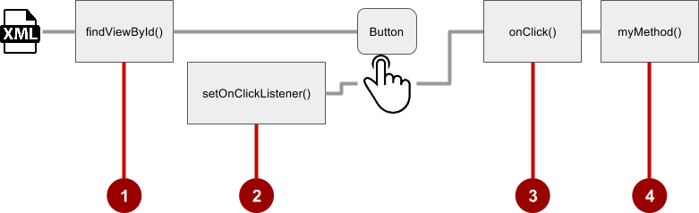

### Using the event listener interface for other events

Other events can occur with UI elements, and you can use the callback methods already defined in the event listener interfaces to handle them. The methods are called by the Android framework when the view—to which the listener has been registered—is triggered by user interaction. You therefore must set the appropriate listener to use the method. The following are some of the listeners available in the Android framework and the callback methods associated with each one:

* onClick() from [View.OnClickListener](https://developer.android.com/reference/android/view/View.OnClickListener.html): Handles a click event in which the user touches and then releases an area of the device display occupied by a View. The onClick() callback has no return value.
* onLongClick() from [View.OnLongClickListener](https://developer.android.com/reference/android/view/View.OnLongClickListener.html): Handles an event in which the user maintains touch on a View for an extended period. This method returns a boolean to indicate whether you have consumed the event, and the event should not be carried further. That is, return true to indicate that you have handled the event and the event should stop here. Return false if you have not handled the event, or if the event should continue to any other listeners.
* onTouch() from [View.OnTouchListener](https://developer.android.com/reference/android/view/View.OnTouchListener.html): Handles any form of touch contact with the screen including individual or multiple touches and gesture motions, including a press, a release, or any movement gesture on the screen (within the bounds of the UI element). A [MotionEvent](https://developer.android.com/reference/android/view/MotionEvent.html) is passed as an argument, which includes directional information, and it returns a boolean to indicate whether your listener consumes this event.
* onFocusChange() from [View.OnFocusChangeListener](https://developer.android.com/reference/android/view/View.OnFocusChangeListener.html): Handles when focus moves away from the current View as the result of interaction with a trackball or navigation key.
* onKey() from [View.OnKeyListener](https://developer.android.com/reference/android/view/View.OnKeyListener.html): Handles when a key on a hardware device is pressed while a View has focus.

## Using clickable images

You can turn any View, such as an [ImageView](https://developer.android.com/reference/android/widget/ImageView.html), into a button by adding the android:onClick attribute in the XML layout. The image for the ImageView must already be stored in the **drawable** folder of your project.

**Note:** To bring images into your Android Studio project, create or save the image in PNG or JPEG format, and copy the image file into the **app > src > main > res > drawable** folder of your project. For more information about drawable resources, see [Drawable resources](https://developer.android.com/guide/topics/resources/drawable-resource.html) in the Android developer documentation.

For example, the following images in the drawable folder (icecream_circle.jpg, donut_circle.jpg, and froyo_circle.jpg) are defined for ImageView elements arranged in a LinearLayout: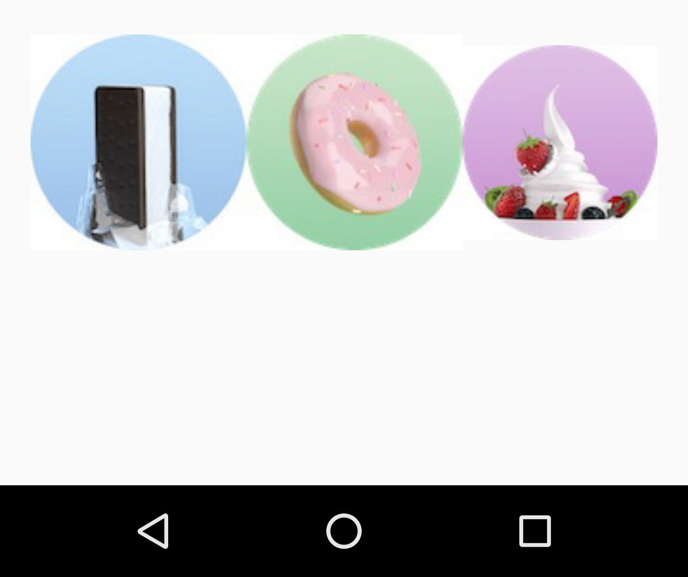

<LinearLayout

android:layout_width="match_parent"

android:layout_height="match_parent"

android:orientation="horizontal"

android:layout_marginTop="260dp">

<ImageView

android:layout_width="wrap_content"

android:layout_height="wrap_content"

android:src="@drawable/icecream_circle"

android:onClick="orderIcecream"/>

<ImageView

android:layout_width="wrap_content"

android:layout_height="wrap_content"

android:src="@drawable/donut_circle"

android:onClick="orderDonut"/>

<ImageView

android:layout_width="wrap_content"

android:layout_height="wrap_content"

android:src="@drawable/froyo_circle"

android:onClick="orderFroyo"/>

</LinearLayout>

## Using a floating action button

A floating action button ([FloatingActionButton](https://developer.android.com/reference/android/support/design/widget/FloatingActionButton.html)), shown below as #1 in the figure below, is a circular button that appears to float above the layout.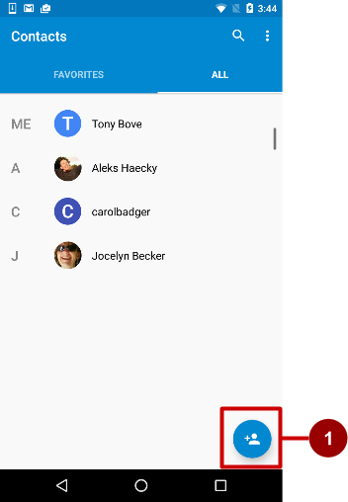

You should use a floating action button only to represent the primary action for a screen. For example, the primary action for the Contacts app main screen is adding a contact, as shown in the figure above. A floating action button is the right choice if your app requires an action to be persistent and readily available on a screen. Only one floating action button is recommended per screen.

The floating action button uses the same type of icons that you would use for a button with an icon, or for actions in the app bar at the top of the screen. You can add an icon as described previously in "Choosing an icon for the button".

If you start your project or Activity with the Basic Activity template, Android Studio adds a floating action button to the layout file for the Activity. To create a floating action button yourself, use the [FloatingActionButton](https://developer.android.com/reference/android/support/design/widget/FloatingActionButton.html) class, which extends the [ImageButton](https://developer.android.com/reference/android/widget/ImageButton.html) class. You can add a floating action button to your XML layout as follows:

<android.support.design.widget.FloatingActionButton

android:id="@+id/fab"

android:layout_width="wrap_content"

android:layout_height="wrap_content"

android:layout_gravity="bottom|end"

android:layout_margin="@dimen/fab_margin"

android:src="@drawable/ic_fab_chat_button_white" />

* Floating action buttons, by default, are 56 x 56 dp in size. It is best to use the default size unless you need the smaller version to create visual continuity with other screen elements.
* You can set the mini size (30 x 40 dp) with the app:fabSize attribute: app:fabSize="mini"
* To set it back to the default size (56 x 56 dp): app:fabSize="normal"

For more design instructions involving floating action buttons, see [Components– Buttons: Floating Action Button](https://material.google.com/components/buttons-floating-action-button.html) in the Material Design Spec.

## Recognizing gestures

A touch gesture occurs when a user places one or more fingers on the touchscreen, and your app interprets that pattern of touches as a particular gesture, such as a tap, touch & hold, double-tap, fling, or scroll.

Android provides a variety of classes and methods to help you create and detect gestures. Although your app should not depend on touch gestures for basic behaviors (because the gestures may not be available to all users in all contexts), adding touch-based interaction to your app can greatly increase its usefulness and appeal.

To provide users with a consistent, intuitive experience, your app should follow the accepted Android conventions for touch gestures. The [Gestures design guide](http://developer.android.com/design/patterns/gestures.html) shows you how to design common gestures in Android apps. For more code samples and details, see [Using touch gestures](https://developer.android.com/training/gestures/index.html) in the Android developer documentation.

### Detecting common gestures

If your app uses common gestures such as double tap, long press, fling, and so on, you can take advantage of the [GestureDetector](https://developer.android.com/reference/android/view/GestureDetector.html) class for detecting common gestures. Use [GestureDetectorCompat](https://developer.android.com/reference/android/support/v4/view/GestureDetectorCompat.html), which is provided as a compatibility implementation of the framework's GestureDetector class which guarantees the newer focal point scrolling behavior from Jellybean MR1 on all platform versions. This class should be used only with motion events reported for touch devices—don't use it for trackball or other hardware events.

GestureDetectorCompat lets you detect common gestures without processing the individual touch events yourself. It detects various gestures and events using [MotionEvent](https://developer.android.com/reference/android/view/MotionEvent.html) objects, which report movements by a finger (or mouse, pen, or trackball).

The following snippets show how you would use GestureDetectorCompat and the GestureDetector.SimpleOnGestureListener class.

#### **Creating an instance of GestureDetectorCompat**

To use [GestureDetectorCompat](https://developer.android.com/reference/android/support/v4/view/GestureDetectorCompat.html), create an instance (mDetector in the snippet below) of the GestureDetectorCompat class, using the onCreate() method in the Activity (such as MainActivity):

public class MainActivity extends Activity {

private GestureDetectorCompat mDetector;

@Override

public void onCreate(Bundle savedInstanceState) {

super.onCreate(savedInstanceState);

setContentView(R.layout.activity_main);

mDetector = new GestureDetectorCompat(this, new

MyGestureListener());

// ... Rest of onCreate code.

}

// ... Rest of code.

}

When you instantiate a GestureDetectorCompat object, one of the parameters it takes is a class that you must create, which is MyGestureListener in the snippet above. The class you create should do one of the following:

* Implement the [GestureDetector.OnGestureListener](https://developer.android.com/reference/android/view/GestureDetector.OnGestureListener.html) interface to detect all standard gestures, or
* Extend the [GestureDetector.SimpleOnGestureListener](https://developer.android.com/reference/android/view/GestureDetector.SimpleOnGestureListener.html) class, which you can use to process only a few gestures by overriding the methods you need.

SimpleOnGestureListener provides methods such as [onDown()](https://developer.android.com/reference/android/view/GestureDetector.SimpleOnGestureListener.html#onDown(android.view.MotionEvent)), [onLongPress()](https://developer.android.com/reference/android/view/GestureDetector.SimpleOnGestureListener.html#onLongPress(android.view.MotionEvent)), [onFling()](https://developer.android.com/reference/android/view/GestureDetector.SimpleOnGestureListener.html#onFling(android.view.MotionEvent,%20android.view.MotionEvent,%20float,%20float)), [onScroll()](https://developer.android.com/reference/android/view/GestureDetector.SimpleOnGestureListener.html#onScroll(android.view.MotionEvent,%20android.view.MotionEvent,%20float,%20float)), and [onSingleTapUp()](https://developer.android.com/reference/android/view/GestureDetector.SimpleOnGestureListener.html#onSingleTapUp(android.view.MotionEvent)).

#### **Extending GestureDetector.SimpleOnGestureListener**

Create the class MyGestureListener as a separate Activity (**MyGestureListener**) to extend GestureDetector.SimpleOnGestureListener. Override the [onFling()](https://developer.android.com/reference/android/view/GestureDetector.SimpleOnGestureListener.html#onFling(android.view.MotionEvent,%20android.view.MotionEvent,%20float,%20float)) and [onDown()](https://developer.android.com/reference/android/view/GestureDetector.SimpleOnGestureListener.html#onDown(android.view.MotionEvent)) methods to show log statements about the event:

class MyGestureListener

extends GestureDetector.SimpleOnGestureListener {

private static final String DEBUG_TAG = "Gestures";

@Override

public boolean onDown(MotionEvent event) {

Log.d(DEBUG_TAG,"onDown: " + event.toString());

return true;

}

@Override

public boolean onFling(MotionEvent event1, MotionEvent event2,

float velocityX, float velocityY) {

Log.d(DEBUG_TAG, "onFling: " +

event1.toString()+event2.toString());

return true;

}

}

#### **Intercepting touch events**

To intercept touch events, override the [onTouchEvent()](https://developer.android.com/reference/android/support/v4/view/GestureDetectorCompat.html#onTouchEvent(android.view.MotionEvent)) callback of the [GestureDetectorCompat](https://developer.android.com/reference/android/support/v4/view/GestureDetectorCompat.html) class:

@Override

public boolean onTouchEvent(MotionEvent event){

this.mDetector.onTouchEvent(event);

return super.onTouchEvent(event);

}

### Detecting all gestures

To detect all types of gestures, you need to perform two essential steps:

1. Gather data about touch events.
2. Interpret the data to see if it meets the criteria for any of the gestures your app supports.

The gesture starts when the user first touches the screen, continues as the system tracks the position of the user's finger or fingers, and ends when the system captures the event of the user's fingers leaving the screen. Throughout this interaction, an object of the [MotionEvent](https://developer.android.com/reference/android/view/MotionEvent.html) class is delivered to [onTouchEvent()](https://developer.android.com/reference/android/support/v4/view/GestureDetectorCompat.html#onTouchEvent(android.view.MotionEvent)), providing the details. Your app can use the data provided by the MotionEvent to determine if a gesture it cares about happened.

For example, when the user first touches the screen, the [onTouchEvent()](https://developer.android.com/reference/android/view/GestureDetector.html#onTouchEvent(android.view.MotionEvent)) method is triggered on the View that was touched, and a [MotionEvent](https://developer.android.com/reference/android/view/MotionEvent.html) object reports movement by a finger (or mouse, pen, or trackball) in terms of:

* An action code: Specifies the state change that occurred, such as a finger tapping down or lifting up.
* A set of axis values: Describes the position in X and Y coordinates of the touch and information about the pressure, size and orientation of the contact area.

The individual fingers or other objects that generate movement traces are referred to as pointers. Some devices can report multiple movement traces at the same time. Multi-touch screens show one movement trace for each finger. Motion events contain information about all of the pointers that are currently active even if some of them have not moved since the last event was delivered. Based on the interpretation of the [MotionEvent](https://developer.android.com/reference/android/view/MotionEvent.html) object, the [onTouchEvent()](https://developer.android.com/reference/android/view/GestureDetector.html#onTouchEvent(android.view.MotionEvent)) method triggers the appropriate callback on the [GestureDetector.OnGestureListener](https://developer.android.com/reference/android/view/GestureDetector.OnGestureListener.html) interface.

Each MotionEvent pointer has a unique id that is assigned when it first goes down (indicated by ACTION_DOWN or ACTION_POINTER_DOWN). A pointer id remains valid until the pointer eventually goes up (indicated by ACTION_UP or ACTION_POINTER_UP) or when the gesture is canceled (indicated by ACTION_CANCEL). The MotionEvent class provides methods to query the position and other properties of pointers, such as [getX(int)](https://developer.android.com/reference/android/view/MotionEvent.html#getX(int)), [getY(int)](https://developer.android.com/reference/android/view/MotionEvent.html#getY(int)), [getAxisValue(int)](https://developer.android.com/reference/android/view/MotionEvent.html#getAxisValue(int)), [getPointerId(int)](https://developer.android.com/reference/android/view/MotionEvent.html#getPointerId(int)), and [getToolType(int)](https://developer.android.com/reference/android/view/MotionEvent.html#getToolType(int)).

The interpretation of the contents of a MotionEvent varies significantly depending on the source class of the device. On touchscreens, the pointer coordinates specify absolute positions such as view X/Y coordinates. Each complete gesture is represented by a sequence of motion events with actions that describe pointer state transitions and movements.

A gesture starts with a motion event with ACTION_DOWN that provides the location of the first pointer down. As each additional pointer goes down or up, the framework generates a motion event with ACTION_POINTER_DOWN or ACTION_POINTER_UP accordingly. Pointer movements are described by motion events with ACTION_MOVE. A gesture ends when the final pointer goes up as represented by a motion event with ACTION_UP, or when the gesture is canceled with ACTION_CANCEL.

To intercept touch events in an Activity or View, override the onTouchEvent() callback as shown in the snippet below. You can use the [getActionMasked()](https://developer.android.com/reference/android/support/v4/view/MotionEventCompat.html#getActionMasked(android.view.MotionEvent)) method of the [MotionEventCompat](https://developer.android.com/reference/android/support/v4/view/MotionEventCompat.html#getActionMasked(android.view.MotionEvent)) class to extract the action the user performed from the event parameter. (MotionEventCompat is a helper for accessing features in a MotionEvent, which was introduced after API level 4 in a backwards compatible fashion.) This gives you the raw data you need to determine if a gesture you care about occurred:

public class MainActivity extends Activity {

// ...

// This example shows an Activity, but you would use the same approach if

// you were subclassing a View.

@Override

public boolean onTouchEvent(MotionEvent event){

int action = MotionEventCompat.getActionMasked(event);

switch(action) {

case (MotionEvent.ACTION_DOWN) :

Log.d(DEBUG_TAG,"Action was DOWN");

return true;

case (MotionEvent.ACTION_MOVE) :

Log.d(DEBUG_TAG,"Action was MOVE");

return true;

case (MotionEvent.ACTION_UP) :

Log.d(DEBUG_TAG,"Action was UP");

return true;

case (MotionEvent.ACTION_CANCEL) :

Log.d(DEBUG_TAG,"Action was CANCEL");

return true;

case (MotionEvent.ACTION_OUTSIDE) :

Log.d(DEBUG_TAG,"Movement occurred outside bounds " +

"of current screen element");

return true;

default :

return super.onTouchEvent(event);

}

}

4.2: Input controls

**Contents:**

* [Input controls](https://google-developer-training.github.io/android-developer-fundamentals-course-concepts-v2/unit-2-user-experience/lesson-4-user-interaction/4-2-c-input-controls/4-2-c-input-controls.html#input)
* [Checkboxes](https://google-developer-training.github.io/android-developer-fundamentals-course-concepts-v2/unit-2-user-experience/lesson-4-user-interaction/4-2-c-input-controls/4-2-c-input-controls.html#using_checkboxes)
* [Radio buttons](https://google-developer-training.github.io/android-developer-fundamentals-course-concepts-v2/unit-2-user-experience/lesson-4-user-interaction/4-2-c-input-controls/4-2-c-input-controls.html#using_radio)
* [Spinner](https://google-developer-training.github.io/android-developer-fundamentals-course-concepts-v2/unit-2-user-experience/lesson-4-user-interaction/4-2-c-input-controls/4-2-c-input-controls.html#using_spinner)
* [Toggle buttons and switches](https://google-developer-training.github.io/android-developer-fundamentals-course-concepts-v2/unit-2-user-experience/lesson-4-user-interaction/4-2-c-input-controls/4-2-c-input-controls.html#using_toggle)
* [Text input](https://google-developer-training.github.io/android-developer-fundamentals-course-concepts-v2/unit-2-user-experience/lesson-4-user-interaction/4-2-c-input-controls/4-2-c-input-controls.html#text_input)
* [Related practical](https://google-developer-training.github.io/android-developer-fundamentals-course-concepts-v2/unit-2-user-experience/lesson-4-user-interaction/4-2-c-input-controls/4-2-c-input-controls.html#relatedpractical)
* [Learn more](https://google-developer-training.github.io/android-developer-fundamentals-course-concepts-v2/unit-2-user-experience/lesson-4-user-interaction/4-2-c-input-controls/4-2-c-input-controls.html#learnmore)

Input controls

This chapter introduces the Android *input controls.* Input controls are interactive elements in your app's UI that accept data input. Users input data to apps by entering text or numbers into fields using the on-screen keyboard. Users also select options from checkboxes, radio buttons, and drop-down menus, and they change settings and turn on or turn off certain features.

Android provides a variety of input controls for your UI. The figure below shows some popular ones.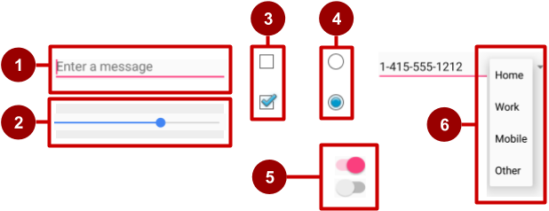

In the figure above:

1. [EditText](https://developer.android.com/reference/android/widget/EditText.html) field (subclass of TextView) for entering text using a keyboard
2. [SeekBar](https://developer.android.com/reference/android/widget/SeekBar.html) for sliding left or right to a setting
3. [CheckBox](https://developer.android.com/reference/android/widget/CheckBox.html) elements for selecting one or more options
4. [RadioGroup](https://developer.android.com/reference/android/widget/RadioGroup.html) of [RadioButton](https://developer.android.com/reference/android/widget/RadioButton.html) elements for selecting one option
5. [Switch](https://developer.android.com/reference/android/widget/Switch.html) for turning on or turning off an option
6. [Spinner](https://developer.android.com/reference/android/widget/Spinner.html) drop-down menu for selecting one option

When your app needs to get data from the user, try to make the process as easy for the user as it can be. For example, anticipate the source of the data, minimize the number of user gestures such as taps and swipes, and pre-fill forms when possible.

The user expects input controls to work in your app the same way they work in other apps. For example, users expect a Spinner to show a drop-down menu, and they expect text-editing fields to show a keyboard when tapped. Don't violate established expectations, or you'll make it harder for your users to use your app.

Input controls for making choices

Android offers ready-made input controls for the user to select one or more choices:

* [Checkbox](https://developer.android.com/reference/android/widget/CheckBox.html): Select one or more choices from a set of choices by tapping or clicking checkboxes.
* [RadioGroup](https://developer.android.com/reference/android/widget/RadioGroup.html) of radio buttons: Select one choice from a set of choices by clicking one circular "radio" button. Radio buttons are useful if you are providing only two or three choices.
* [ToggleButton](https://developer.android.com/reference/android/widget/ToggleButton.html) and [Switch](https://developer.android.com/reference/android/widget/Switch.html): Turn an option on or off.
* [Spinner](https://developer.android.com/reference/android/widget/Spinner.html): Select one choice from a set of choices in a drop-down menu. A Spinner is useful for three or more choices, and takes up little room in your layout.

Input controls and the View focus

If your app has several UI input elements, which element gets input from the user first? For example, if you have several EditText elements for the user to enter text, which element (that is, which [View](https://developer.android.com/reference/android/view/View.html)) receives the text? The View that "has the focus" receives user input.

*Focus* indicates which View is selected. The user can initiate focus by tapping on a View, for example a specific EditText element. You can define a *focus order* that defines how focus moves from one element to another when the user taps the **Return** key, **Tab** key, or arrow keys. You can also control focus programmatically by calling requestFocus() on any View that is focusable.

In addition to being focusable, input controls can be *clickable*. If a view's clickable attribute is set to true, then the view can react to click events. You can also make an element clickable programmatically.

What's the difference between *focusable* and *clickable*?

* A *focusable* view is allowed to gain focus from a touchscreen, external keyboard, or other input device.
* A *clickable* view is any view that reacts to being tapped or clicked.

Android-powered devices use many input methods, including directional pads (D-pads), trackballs, touchscreens, external keyboards, and more. Some devices, like tablets and smartphones, are navigated primarily by touch. Other device have no touchscreen. Because a user might navigate through your UI with an input device such as D-pad or a trackball, make sure you do the following:

* Make it visually clear which View has focus, so that the user knows where the input goes.
* Explicitly set the focus in your code to provide a path for users to navigate through the input elements using directional keys or a trackball.

Fortunately, in most cases you don't need to control focus yourself. Android provides "touch mode" for devices that respond to touch, such as smartphones and tablets. When the user begins interacting with the UI by touching it, only View elements with isFocusableInTouchMode() set to true, such as text input fields, are focusable. Other View elements that are touchable, such as Button elements, don't take focus when touched. If the user clicks a directional key or scrolls with a trackball, the device exits "touch mode" and finds a view to take focus.

Focus movement is based on a natural algorithm that finds the nearest neighbor in a given direction:

* When the user taps the screen, the topmost View under the tap is in focus, providing touch access for the child View elements of the topmost View.
* If you set an EditText view to a single line (such as the textPersonName value for the [android:inputType](https://developer.android.com/reference/android/widget/TextView.html#attr_android:inputType) attribute), the user can tap the right-arrow key on the on-screen keyboard to close the keyboard and shift focus to the next input control View based on what the Android system finds.

The system usually finds the nearest input control in the same direction the user was navigating (up, down, left, or right).

If there are multiple input controls that are nearby and in the same direction, the system scans from left to right, top to bottom.

* Focus can also shift to a different View if the user interacts with a directional control, such as a D-pad or trackball.

You can influence the way Android handles focus by arranging input controls such as EditText elements in a certain layout from left to right and top to bottom, so that focus shifts from one to the other in the sequence you want.

If the algorithm does not give you what you want, you can override it by adding the nextFocusDown, nextFocusLeft, nextFocusRight, and nextFocusUp XML attributes to your layout file:

1. Add one of these attributes to a View to decide where to go upon leaving the View—in other words, which View should be the *next*View.
2. Define the value of the attribute to be the id of the next View. For example:

<LinearLayout

<!-- Other attributes... -->

android:orientation="vertical" >

<Button android:id="@+id/top"

<!-- Other Button attributes... -->

android:nextFocusUp="@+id/bottom" />

<Button android:id="@+id/bottom"

<!-- Other Button attributes... -->

android:nextFocusDown="@+id/top"/>

</LinearLayout>

In a vertical LinearLayout, navigating up from the first Button would not ordinarily go anywhere, nor would navigating down from the second Button. But in the example above, the top Button has specified the bottom Button as the nextFocusUp (and vice versa), so the navigation focus will cycle from top-to-bottom and bottom-to-top.

To declare a View as focusable in your UI (when it is traditionally not), add the android:focusable XML attribute to the View in the layout, and set its value to true. You can also declare a View as focusable while in "touch mode" by setting android:focusableInTouchMode set to true.

You can also explicitly set the focus or find out which View has focus by using the following methods:

* Call [onFocusChanged](https://developer.android.com/reference/android/view/View.html#onFocusChanged(boolean,%20int,%20android.graphics.Rect)) to determine where focus came from.
* To find out which View currently has the focus, call [Activity.getCurrentFocus()](https://developer.android.com/reference/android/app/Activity.html#getCurrentFocus()), or use [ViewGroup.getFocusedChild()](https://developer.android.com/reference/android/view/ViewGroup.html#getFocusedChild()) to return the focused child of a View (if any).
* To find the View in the hierarchy that currently has focus, use [findFocus()](https://developer.android.com/reference/android/view/ViewGroup.html#findFocus()).
* Use [requestFocus](https://developer.android.com/reference/android/view/View.html#requestFocus()) to give focus to a specific View.
* To change whether a View can take focus, call [setFocusable](https://developer.android.com/reference/android/view/View.html#setFocusable(boolean)).
* To set a listener that is notified when the View gains or loses focus, use [setOnFocusChangeListener](https://developer.android.com/reference/android/view/View.html#setOnFocusChangeListener(android.view.View.OnFocusChangeListener)).

In this chapter, you learn more about focus with EditText elements.

Checkboxes

Use a set of checkboxes when you want the user to select *any number*of choices, including zero choices:

* Each checkbox is independent of the other boxes in the set, so selecting one box doesn't clear the other boxes. (If you want to limit the user's selection to one choice, use radio buttons.)
* A user can clear a checkbox that was already selected.

Users expect checkboxes to appear in a vertical list, like a to-do list, or side-by-side if the labels are short.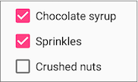

Each checkbox is a separate [CheckBox](https://developer.android.com/reference/android/widget/CheckBox.html) element in your XML layout. To create multiple checkboxes in a vertical orientation, use a vertical LinearLayout:

<LinearLayout xmlns:android="http://schemas.android.com/apk/res/android"

android:orientation="vertical"

android:layout_width="fill_parent"

android:layout_height="fill_parent">

<CheckBox android:id="@+id/checkbox1_chocolate"

android:layout_width="wrap_content"

android:layout_height="wrap_content"

android:text="@string/chocolate_syrup" />

<CheckBox android:id="@+id/checkbox2_sprinkles"

android:layout_width="wrap_content"

android:layout_height="wrap_content"

android:text="@string/sprinkles" />

<CheckBox android:id="@+id/checkbox3_nuts"

android:layout_width="wrap_content"

android:layout_height="wrap_content"

android:text="@string/crushed_nuts" />

</LinearLayout>

Typically programs retrieve the state of each CheckBox when a user taps or clicks a **Submit** or **Done**Button in the same Activity, which uses the android:onClick attribute to call a method such as onSubmit():

<Button

android:layout_width="wrap_content"

android:layout_height="wrap_content"

android:text="@string/submit"

android:onClick="onSubmit"/>

The callback method—onSubmit() in the example above—must be public, return void, and define a View as a parameter (the view that was clicked). In this callback method you can determine whether a CheckBox is selected by using the [isChecked()](https://developer.android.com/reference/android/widget/CompoundButton.html#isChecked()) method (inherited from [CompoundButton](https://developer.android.com/reference/android/widget/CompoundButton.html)).

The isChecked() method returns true if there is a check mark in the box. For example, the following statement assigns true or false to checked, depending on whether the checkbox is checked:

boolean checked = ((CheckBox) view).isChecked();

The following code snippet shows the onSubmit() method checking to see which CheckBox is selected, using the resource id for the CheckBox:

public void onSubmit(View view) {

StringBuffer toppings = new

StringBuffer().append(getString(R.string.toppings_label));

if (((CheckBox) findViewById(R.id.checkbox1_chocolate)).isChecked()) {

toppings.append(getString(R.string.chocolate_syrup_text));

}

if (((CheckBox) findViewById(R.id.checkbox2_sprinkles)).isChecked()) {

toppings.append(getString(R.string.sprinkles_text));

}

if (((CheckBox) findViewById(R.id.checkbox3_nuts)).isChecked()) {

toppings.append(getString(R.string.crushed_nuts_text));

}

// Code to display the result...

}

**Tip**: To respond quickly to a CheckBox—such as display a message (like an alert), or show a set of further options—you can use the android:onClick attribute in the XML layout for each CheckBox to declare the callback method for that CheckBox. The callback method must be defined within the Activity that hosts this layout.

For more information about checkboxes, see [Checkboxes](https://developer.android.com/guide/topics/ui/controls/checkbox.html) in the Android developer documentation.

Radio buttons

Use radio buttons when you have two or more options that are mutually exclusive. When the user selects one, the others are automatically deselected. (If you want to enable more than one selection from the set, use checkboxes.)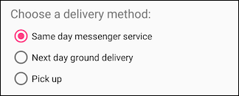

Users expect radio buttons to appear as a vertical list, or side-by-side if the labels are short.

Each radio button is an instance of the [RadioButton](https://developer.android.com/reference/android/widget/RadioButton.html) class. Radio buttons are normally placed within a [RadioGroup](https://developer.android.com/reference/android/widget/RadioGroup.html) in a layout. When several RadioButton elements are inside a RadioGroup, selecting one RadioButton clears all the others.

Add RadioButton elements to your XML layout within a RadioGroup:

<RadioGroup

android:layout_width="wrap_content"

android:layout_height="wrap_content"

android:layout_marginLeft="24dp"

android:layout_marginStart="24dp"

android:orientation="vertical"

app:layout_constraintStart_toStartOf="parent"

app:layout_constraintTop_toBottomOf="@id/delivery_label">

<RadioButton

android:id="@+id/sameday"

android:layout_width="wrap_content"

android:layout_height="wrap_content"

android:onClick="onRadioButtonClicked"

android:text="Same day messenger service" />

<RadioButton

android:id="@+id/nextday"

android:layout_width="wrap_content"

android:layout_height="wrap_content"

android:onClick="onRadioButtonClicked"

android:text="Next day ground delivery" />

<RadioButton

android:id="@+id/pickup"

android:layout_width="wrap_content"

android:layout_height="wrap_content"

android:onClick="onRadioButtonClicked"

android:text="Pick up" />

</RadioGroup>

Use the android:onClick attribute for each RadioButton to declare the click handler, which must be defined within the Activity that hosts the layout. In the layout above, clicking any RadioButton calls the same onRadioButtonClicked() method in the Activity. You could also create separate click handlers in the Activity for each RadioButton.

The click handler method must be public, return void, and define a View as its only parameter (the view that was clicked). The following shows one click handler, onRadioButtonClicked(), for all the RadioButton elements in the RadioGroup. It uses a switch case block to check the resource id for the RadioButton element to determine which one was checked:

public void onRadioButtonClicked(View view) {

// Check to see if a button has been clicked.

boolean checked = ((RadioButton) view).isChecked();

// Check which radio button was clicked.

switch(view.getId()) {

case R.id.sameday:

if (checked)

// Code for same day service ...

break;

case R.id.nextday:

if (checked)

// Code for next day delivery ...

break;

case R.id.pickup:

if (checked)

// Code for pick up ...

break;

}

}

**Tip**: To give users a chance to review their radio button selection before the app responds, you could implement a **Submit** or **Done** button as shown previously with checkboxes, and remove the android:onClick attributes from the radio buttons. Then add the onRadioButtonClicked() method to the android:onClick attribute for the **Submit** or **Done** button.

For more information about radio buttons, see [Radio Buttons](https://developer.android.com/guide/topics/ui/controls/radiobutton.html) in the Android developer documentation.

Spinner

A [Spinner](https://developer.android.com/reference/android/widget/Spinner.html) provides a quick way for the user to select one value from a set. The user taps on the spinner to see a drop-down list with all available values.

A spinner works well when the user has more than three choices, because spinners scroll as needed, and a spinner doesn't take up much space in your layout. If you are providing only two or three choices and you have space in your layout, you might want to use radio buttons instead of a spinner.

**Tip**: For more information about spinners, see the [Spinners](http://developer.android.com/guide/topics/ui/controls/spinner.html) guide.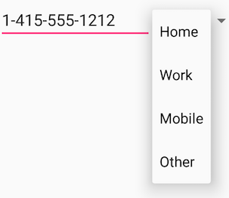

If you have a long list of choices, a spinner might extend beyond your layout, forcing the user to scroll. A spinner scrolls automatically, with no extra code needed. However, making the user scroll through a long list (such as a list of countries) isn't recommended, because it can be hard for the user to select an item.

To create a spinner, use the [Spinner](https://developer.android.com/reference/android/widget/Spinner.html) class, which creates a View that displays individual spinner values as child View elements and lets the user pick one. Follow these steps:

1. Create a Spinner element in your XML layout, and specify its values using an array and an [ArrayAdapter](https://developer.android.com/reference/android/widget/ArrayAdapter.html).
2. Create the Spinner and its adapter using the [SpinnerAdapter](https://developer.android.com/reference/android/widget/SpinnerAdapter.html) class.
3. To define the selection callback for the Spinner, update the Activity that uses the Spinner to implement the [AdapterView.OnItemSelectedListener](https://developer.android.com/reference/android/widget/AdapterView.OnItemSelectedListener.html) interface.

Create the Spinner UI element

To create a spinner in your XML layout, add a Spinner element, which provides the drop-down list:

<Spinner

android:id="@+id/label_spinner"

android:layout_width="wrap_content"

android:layout_height="wrap_content"/>

Specify values for the Spinner

Add an adapter that fills the Spinner list with values. An *adapter* is like a bridge, or intermediary, between two incompatible interfaces. For example, a memory card reader acts as an adapter between the memory card and a laptop. You plug the memory card into the card reader, and plug the card reader into the laptop, so that the laptop can read the memory card.

The adapter takes the data set you've specified (an array in this example), and makes a View for each item in the data set (a View within the Spinner), as shown in the figure below.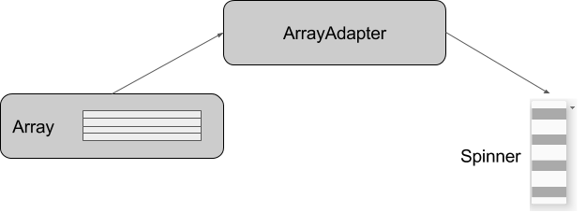

The [SpinnerAdapter](https://developer.android.com/reference/android/widget/SpinnerAdapter.html) class, which implements the Adapter class, allows you to define two different views: one that shows the data values in the Spinner itself, and one that shows the data in the drop-down list when the Spinner is touched or clicked.

The values you provide for the Spinner can come from any source, but must be provided through a SpinnerAdapter, such as an [ArrayAdapter](https://developer.android.com/reference/android/widget/ArrayAdapter.html) if the values are easily stored in an array. The following shows a simple array called labels_array of predetermined values in the strings.xml file:

<string-array name="labels_array">

<item>Home</item>

<item>Work</item>

<item>Mobile</item>

<item>Other</item>

</string-array>

**Tip**: You can use a [CursorAdapter](https://developer.android.com/reference/android/widget/CursorAdapter.html) if the values are provided from a source such as a stored file or a database. You learn more about stored data in another lesson.

Implement the OnItemSelectedListener interface in the Activity

To define the selection callback for the Spinner, update the Activity that uses the Spinner to implement the [AdapterView.OnItemSelectedListener](https://developer.android.com/reference/android/widget/AdapterView.OnItemSelectedListener.html) interface:

public class OrderActivity extends AppCompatActivity implements

AdapterView.OnItemSelectedListener {

As you type **AdapterView.** in the statement above, Android Studio automatically imports the AdapterViewwidget. The reason why you need the AdapterView is because you need an adapter—specifically an [ArrayAdapter](https://developer.android.com/reference/android/widget/ArrayAdapter.html)—to assign the array to the Spinner.

After typing **OnItemSelectedListener** in the statement above, wait a few seconds for a red light bulb to appear in the left margin. Click the bulb and choose **Implement methods**. The onItemSelected() and onNothingSelected() methods, which are required for OnItemSelectedListener, should already be highlighted, and the "Insert @Override" option should be checked. Click **OK**.

Android Studio automatically adds empty onItemSelected() and onNothingSelected() callback methods to the bottom of the Activity. Both methods use the parameter AdapterView<?>. The <?> is a Java type wildcard, enabling the method to be flexible enough to accept any type of AdapterView as an argument.

Create the Spinner and its adapter

Create the Spinner, and set its listener to the Activity that implements the callback methods. The best place to do this is after the Activity layout is inflated in the onCreate() method. Follow these steps:

1. Instantiate a Spinner in the onCreate() method using the label_spinner element in the layout, and set its listener (spinner.setOnItemSelectedListener) in the onCreate() method, as shown in the following code snippet:
2. @Override
3. protected void onCreate(Bundle savedInstanceState) {
4. // ... Rest of onCreate code ...
5. // Create the spinner.
6. Spinner spinner = findViewById(R.id.label_spinner);
7. if (spinner != null) {
8. spinner.setOnItemSelectedListener(this);
9. }
10. // Create ArrayAdapter using the string array and default spinner layout.

The code snippet above uses findViewById() to find the Spinner by its id (label_spinner). It then sets the onItemSelectedListener to whichever Activity implements the callbacks (this) using the [setOnItemSelectedListener()](https://developer.android.com/reference/android/widget/AdapterView.html#setOnItemSelectedListener(android.widget.AdapterView.OnItemSelectedListener)) method

1. Continuing to edit the onCreate() method, add a statement that creates the ArrayAdapter with the string array (labels_array) using the Android-supplied Spinner layout for each item (layout.simple_spinner_item):
2. // Create ArrayAdapter using the string array and default spinner layout.
3. ArrayAdapter<CharSequence> adapter = ArrayAdapter.createFromResource(this,
4. R.array.labels_array, android.R.layout.simple_spinner_item);
5. // Specify the layout to use when the list of choices appears.

As shown in the snippet above, you use the [createFromResource()](https://developer.android.com/reference/android/widget/ArrayAdapter.html#createFromResource(android.content.Context,%20int,%20int)) method to create the adapter. It takes as arguments the Activity (this) that implements the callbacks for processing the results of the Spinner, the array (labels_array), and the layout for each spinner item (layout.simple_spinner_item).

The simple_spinner_item layout used in this step, and the simple_spinner_dropdown_item layout used in the next step, are the default predefined layouts provided by Android in the [R.layout](https://developer.android.com/reference/android/R.layout.html#simple_spinner_item) class. You should use these layouts unless you want to define your own layouts for the items in the Spinner and its appearance.

1. Specify the layout for the Spinner choices to be simple_spinner_dropdown_item, and then apply the adapter to the Spinner:
2. // Specify the layout to use when the list of choices appears.
3. adapter.setDropDownViewResource
4. (android.R.layout.simple_spinner_dropdown_item);
5. // Apply the adapter to the spinner.
6. if (spinner != null) {
7. spinner.setAdapter(adapter);
8. }
9. // ... End of onCreate code ...

The snippet above uses [setAdapter()](https://developer.android.com/reference/android/widget/AdapterView.html#setAdapter(T)) to apply the adapter to the Spinner. You should use the simple_spinner_dropdown_item default layout, unless you want to define your own layout for the Spinner appearance.

Add code to respond to Spinner selections

When the user chooses an item from the spinner's drop-down list, here's what happens and how you retrieve the item:

1. The Spinner receives an on-item-selected event.
2. The event triggers the calling of the onItemSelected() callback method of the [AdapterView.OnItemSelectedListener](https://developer.android.com/reference/android/widget/AdapterView.OnItemSelectedListener.html) interface.
3. Retrieve the selected item in the Spinner using the [getItemAtPosition()](https://developer.android.com/reference/android/widget/AdapterView.html#getItemAtPosition(int)) method of the AdapterView class:
4. public void onItemSelected(AdapterView<?> adapterView, View view, int
5. i, long l) {
6. String spinner_item = adapterView.getItemAtPosition(i).toString();
7. // Do something with spinner_item string.
8. }

The arguments for onItemSelected() are as follows:

|  |  |
| --- | --- |
| **parent AdapterView** | **The AdapterView where the selection happened** |
| view View | The View within the AdapterView that was clicked |
| int pos | The position of the View in the adapter |
| long id | The row id of the item that is selected |

Implement/override the onNothingSelected() callback method of the [AdapterView.OnItemSelectedListener](https://developer.android.com/reference/android/widget/AdapterView.OnItemSelectedListener.html) interface to do something if nothing is selected.

For more information about using spinners, see [Spinners](http://developer.android.com/guide/topics/ui/controls/spinner.html) in the Android developer documentation.

Toggle buttons and switches

A toggle input control lets the user change a setting between on and off. Android provides the [ToggleButton](https://developer.android.com/reference/android/widget/ToggleButton.html) class, which shows a raised button with "OFF" and "ON".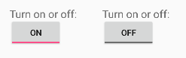

Examples of toggles include the on/off switches for Wi-Fi, Bluetooth, and other options in the Settings app.

Android also provides the [Switch](https://developer.android.com/reference/android/widget/Switch.html) class, which is a short slider that looks like a rocker switch for on and off. Both are extensions of the CompoundButton class.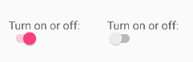

Using a toggle button

Create a toggle button by using a ToggleButton element in your XML layout:

<ToggleButton

android:layout_width="wrap_content"

android:layout_height="wrap_content"

android:id="@+id/my_toggle"

android:text="

android:onClick="onToggleClick"/>

**Tip**: The android:text attribute does not provide a text label for a toggle button—the toggle button always shows either "ON" or "OFF". To provide a text label next to or above the toggle button, use a separate TextView.

To respond to the toggle tap, declare an android:onClick callback method for the ToggleButton:

* The onClick() method must be defined in the Activity hosting the layout, and it must be publicand return void.
* As its only parameter, the onClick() method must define a View—this will be the View that is clicked.

Use [CompoundButton.OnCheckedChangeListener()](https://developer.android.com/reference/android/widget/CompoundButton.OnCheckedChangeListener.html) to detect the state change of the toggle. Create a CompoundButton.OnCheckedChangeListener object and assign it to the toggle by calling setOnCheckedChangeListener(). For example, the onToggleClick() method checks whether the toggle is on or off, and displays a Toast message:

public void onToggleClick(View view) {

ToggleButton toggle = findViewById(R.id.my_toggle);

toggle.setOnCheckedChangeListener(new

CompoundButton.OnCheckedChangeListener() {

public void onCheckedChanged(CompoundButton buttonView,

boolean isChecked) {

StringBuffer onOff = new StringBuffer().append("On or off? ");

if (isChecked) { // The toggle is enabled

onOff.append("ON ");

} else { // The toggle is disabled

onOff.append("OFF ");

}

Toast.makeText(getApplicationContext(), onOff.toString(),

Toast.LENGTH_SHORT).show();

}

});

}

**Tip**: You can also programmatically change the state of a ToggleButton using the [setChecked(boolean)](https://developer.android.com/reference/android/widget/CompoundButton.html#setChecked(boolean))method. Be aware, however, that the method specified by the android:onClick() attribute will not be executed in this case.

Using a switch

A switch is a separate instance of the [Switch](https://developer.android.com/reference/android/widget/Switch.html) class, which extends the [CompoundButton](https://developer.android.com/reference/android/widget/CompoundButton.html) class just like ToggleButton. Create a toggle switch by using a Switch element in your XML layout:

<Switch

android:layout_width="wrap_content"

android:layout_height="wrap_content"

android:id="@+id/my_switch"

android:text="@string/turn_on_or_off"

android:onClick="onSwitchClick"/>

The android:text attribute defines a string that appears to the left of the Switch, as shown below: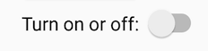

To respond to the Switch tap, declare an android:onClick callback method for the Switch—the code is basically the same as for a ToggleButton. The method must be defined in the Activity hosting the layout, and it must be public, return void, and define a View as its only parameter (this will be the View that was clicked). Use [CompoundButton.OnCheckedChangeListener()](https://developer.android.com/reference/android/widget/CompoundButton.OnCheckedChangeListener.html) to detect the state change of the Switch. Create a CompoundButton.OnCheckedChangeListener object and assign it to the Switch by calling setOnCheckedChangeListener(). For example, the onSwitchClick() method checks whether the Switch is on or off, and displays a Toast message:

public void onSwitchClick(View view) {

Switch aSwitch = findViewById(R.id.my_switch);

aSwitch.setOnCheckedChangeListener(new

CompoundButton.OnCheckedChangeListener() {

public void onCheckedChanged(CompoundButton buttonView,

boolean isChecked) {

StringBuffer onOff = new StringBuffer().append("On or off? ");

if (isChecked) { // The switch is enabled

onOff.append("ON ");

} else { // The switch is disabled

onOff.append("OFF ");

}

Toast.makeText(getApplicationContext(), onOff.toString(),

Toast.LENGTH_SHORT).show();

}

});

}

**Tip**: You can also programmatically change the state of a Switch using the [setChecked(boolean)](https://developer.android.com/reference/android/widget/CompoundButton.html#setChecked(boolean))method. Be aware, however, that the method specified by the android:onClick() attribute will not be executed in this case.

For more information about toggles, see [Toggle Buttons](https://developer.android.com/guide/topics/ui/controls/togglebutton.html) in the Android developer documentation.

Text input

Use the [EditText](https://developer.android.com/reference/android/widget/EditText.html) class to get user input that consists of textual characters, including numbers and symbols. EditText extends the TextView class, to make the TextView editable.

Customizing an EditText for user input

Create an EditText view by adding an EditText to your layout with the following XML:

<EditText

android:id="@+id/edit_simple"

android:layout_height="wrap_content"

android:layout_width="match_parent">

android:hint="@string/enter_text_here"

</EditText>

Multiple lines of text

By default, the EditText view allows multiple lines of input as shown in the figure below, and suggests full words the user can tap. Tapping the **Return** (also known as **Enter**) key on the keyboard starts a new line in the same EditText.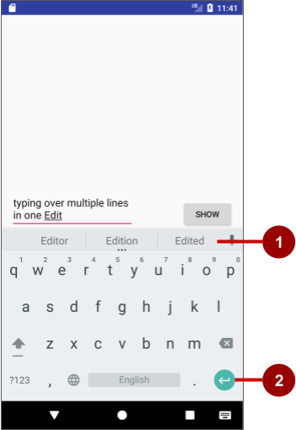

In the figure above:

1. Suggestions to tap
2. Return (Enter) key

Message or single line of text

If you add the [android:inputType](https://developer.android.com/reference/android/widget/TextView.html#attr_android:inputType) attribute to the EditText you can customize it. For example, the following code uses android:inputType="textShortMessage" to show an EditText that offers a single line for typing a message, as shown on the left side of the figure below. An emoji (smiley face) takes the place of a **Return** key, changing the keyboard to emoji. To close the keyboard, the user taps the down-arrow key, which replaces the Back button in the bottom row of buttons.

<EditText

android:id="@+id/edit_simple"

android:layout_height="wrap_content"

android:layout_width="match_parent">

android:hint="@string/enter_text_here"

android:inputType="textShortMessage"

</EditText>

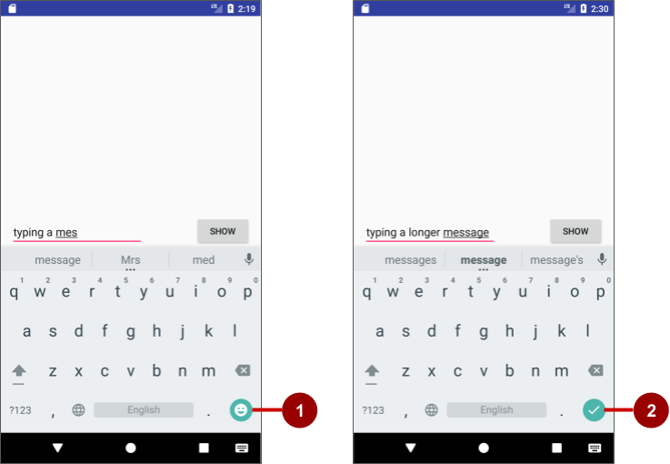

In the figure above:

1. Emoji key
2. Done key

Use android:inputType="textLongMessage" to show an EditText that offers a single line for typing a message, as shown on the right side of the figure above, with a **Done** key that closes the keyboard and advances the focus to the next View. This behavior is useful if you want the user to fill out a form consisting of EditText fields, so that the user can advance quickly to the next EditText field.

**Tip**: The Android Studio layout editor lets you drag a **Plain Text** element from the **Palette** to the layout. This element is, by default, an EditText with its android:inputType set to textPersonName for entering a person's name. It provides a single line of text with suggestions and a **Done** key, just like textLongMessage. You can change the element to use a different **inputType** (android:inputType) value in the **Attributes** pane, as shown in the figure below.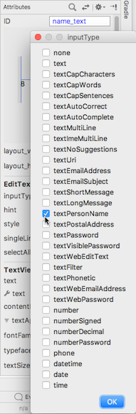

Attributes for customizing an EditText view

The following are generally used attributes for customizing an EditText:

* android:inputType="textCapCharacters": Set the text entry to all capital letters.
* android:inputType="textCapSentences": Start each sentence with a capital letter.
* android:inputType="textMultiLine": Set the text field to enable multiple lines. This value is useful for combining with other attributes. To combine values, concatenate them using the pipe (|) character.
* android:inputType="textPassword": Turn each character the user enters into a dot to conceal an entered password.
* android:inputType="number": Restrict text entry to numbers.
* android:textColorHighlight="#7cff88": Set the background color of selected (highlighted) text.
* android:hint="@string/my_hint": Set text to appear in the field that provides a hint for the user, such as "Enter a message".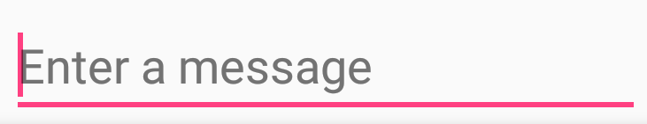

For a list of EditText attributes, including inherited TextView attributes, see the "Summary" of the [EditText](https://developer.android.com/reference/android/widget/EditText.html) class description.

Getting the user's input

To use the user's input in your app, set up layout and code by following these steps:

1. Add an EditText element to the XML layout for the Activity. Be sure to identify this element with an android:id so that you can refer to it by its id:
2. android:id="@+id/editText_main"
3. In the Java code for the same Activity, refer to the EditText by using the [findViewById()](https://developer.android.com/reference/android/view/View.html#findViewById(int)) method to find the View by its id (editText_main):
4. EditText editText = findViewById(R.id.editText_main);
5. Use the [getText()](https://developer.android.com/reference/android/widget/TextView.html#getText()) method to obtain the text as a character sequence (CharSequence). You can convert the character sequence into a string using the [toString()](https://developer.android.com/reference/java/lang/CharSequence.html#toString()) method, which returns a string for the character sequence.
6. String showString = editText.getText().toString();

Use the [valueOf()](https://developer.android.com/reference/java/lang/Integer.html#valueOf(java.lang.String)) method of the Integer class to convert the string to an integer if the input is an integer.

Customizing the keyboard

The Android system shows an on-screen keyboard—known as a *soft* input method—when an EditTextin the UI receives focus. To provide the best user experience, you can customize the keyboard to show, for example, a numeric keypad for entering phone number, or a keyboard for entering email addresses with the **@** symbol conveniently located near the space key.

To customize the keyboard, use the [android:inputType](https://developer.android.com/reference/android/widget/TextView.html#attr_android:inputType) attribute for the EditText with the following values:

* textEmailAddress: Show an email keyboard with the **@** symbol conveniently located next to the space key.
* phone: Show a numeric phone keypad.
* date: Show a numeric keypad with a slash for entering the date.
* time: Show a numeric keypad with a colon for entering the time.
* datetime: Show a numeric keypad with a slash *and* colon for entering the date and time.

**Tip**: You can use the pipe (**|**) character (Java bitwise OR) to combine attribute values for the android:inputType attribute:

android:inputType="textAutoCorrect|textCapSentences"

For details about the android:inputType attribute, see [Specify the input method type](http://developer.android.com/training/keyboard-input/style.html) [in the developer documentation](http://developer.android.com/training/keyboard-input/style.html). For a complete list of constant values for android:inputType, see [android:inputType](https://developer.android.com/reference/android/widget/TextView.html#attr_android:inputType).

Changing the "action" key in the keyboard

The "action" key for an EditText keyboard is the **Done** or **Return** key. You can change the "action" key to something else, such as a **Send** key, and change the action it performs.

To use a **Send** key and an action that dials a phone number, use the android:inputType attribute for the EditText element set to phone. Then use the [android:imeOptions](https://developer.android.com/reference/android/widget/TextView.html#attr_android:imeOptions) attribute with the actionSend value:

android:inputType="phone"

android:imeOptions="actionSend"

In the onCreate() method for the Activity, you can use setOnEditorActionListener() to set the listener for the EditText to detect if the key is pressed:

EditText editText = findViewById(R.id.editText_main);

if (editText != null)

editText.setOnEditorActionListener

(new TextView.OnEditorActionListener() {

// If view is found, set the listener for editText.

});

To respond to the pressed key, override onEditorAction() and use the IME_ACTION_SEND constant in the [EditorInfo](https://developer.android.com/reference/android/view/inputmethod/EditorInfo.html) class. In the snippet below, the key is used to call the dialNumber() method to dial the phone number:

@Override

public boolean onEditorAction(TextView textView, int actionId, KeyEvent keyEvent) {

boolean mHandled = false;

if (actionId == EditorInfo.IME_ACTION_SEND) {

dialNumber();

mHandled = true;

}

return mHandled;

}

You would then need a dialNumber() method, which would use an implicit intent with ACTION_DIAL to pass the phone number to another app that can dial the number.

# 4.3: Menus and pickers

**Contents:**

* [Types of menus](https://google-developer-training.github.io/android-developer-fundamentals-course-concepts-v2/unit-2-user-experience/lesson-4-user-interaction/4-3-c-menus-and-pickers/4-3-c-menus-and-pickers.html#types)
* [The app bar and options menu](https://google-developer-training.github.io/android-developer-fundamentals-course-concepts-v2/unit-2-user-experience/lesson-4-user-interaction/4-3-c-menus-and-pickers/4-3-c-menus-and-pickers.html#app_bar)
* [Contextual menus](https://google-developer-training.github.io/android-developer-fundamentals-course-concepts-v2/unit-2-user-experience/lesson-4-user-interaction/4-3-c-menus-and-pickers/4-3-c-menus-and-pickers.html#contextual)
* [Popup menu](https://google-developer-training.github.io/android-developer-fundamentals-course-concepts-v2/unit-2-user-experience/lesson-4-user-interaction/4-3-c-menus-and-pickers/4-3-c-menus-and-pickers.html#popup)
* [Dialogs and pickers](https://google-developer-training.github.io/android-developer-fundamentals-course-concepts-v2/unit-2-user-experience/lesson-4-user-interaction/4-3-c-menus-and-pickers/4-3-c-menus-and-pickers.html#dialogs_and_pickers)
* [Related practical](https://google-developer-training.github.io/android-developer-fundamentals-course-concepts-v2/unit-2-user-experience/lesson-4-user-interaction/4-3-c-menus-and-pickers/4-3-c-menus-and-pickers.html#relatedpractical)
* [Learn more](https://google-developer-training.github.io/android-developer-fundamentals-course-concepts-v2/unit-2-user-experience/lesson-4-user-interaction/4-3-c-menus-and-pickers/4-3-c-menus-and-pickers.html#learnmore)

## Types of menus

A menu is a set of options. The user can select from a menu to perform a function, for example searching for information, saving information, editing information, or navigating to a screen. The figure below shows the types of menus that the Android system offers.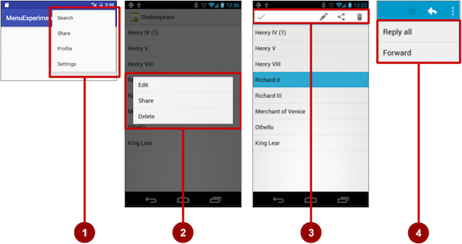

1. Options menu: Appears in the app bar and provides the primary options that affect use of the app itself. Examples of menu options: **Search** to perform a search, **Share** to share a link, and **Settings** to navigate to a Settings Activity.
2. Contextual menu: Appears as a floating list of choices when the user performs a long tap on an element on the screen. Examples of menu options: **Edit** to edit the element, **Delete** to delete it, and **Share** to share it over social media.
3. Contextual action bar: Appears at the top of the screen overlaying the app bar, with action items that affect the selected element or elements. Examples of menu options: **Edit**, **Share**, and **Delete** for one or more selected elements.
4. Popup menu: Appears anchored to a View such as an ImageButton, and provides an overflow of actions or the second part of a two-part command. Example of a popup menu: the Gmail app anchors a popup menu to the app bar for the message view with **Reply**, **Reply All**, and **Forward**.

## The app bar and options menu

The app bar (also called the action bar) is a dedicated space at the top of each Activity screen. When you create an Activity from a template (such as Empty Template), an app bar is automatically included for the Activity.

The app bar by default shows the app title, or the name defined in AndroidManifest.xml by the android:label attribute for the Activity. The app bar may also include the Up button for navigating up to the parent activity. Up navigation is described in the chapter on using the app bar for navigation.

The options menu in the app bar usually provides navigation to other screens in the app, or options that affect using the app itself. (The options menu should not include options that act on an element on the screen. For that you use a contextual menu, described later in this chapter.)

For example, your options menu might let the user navigate to another activity to place an order. Or your options menu might let the user change settings or profile information, or do other actions that have a global impact on the app.

The options menu appears in the right corner of the app bar. The app bar is split into four functional areas that apply to most apps, as shown in the figure below.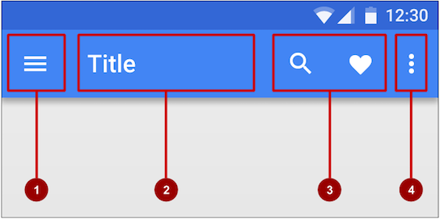

In the figure above:

1. Navigation button or Up button: Use a navigation button in this space to open a navigation drawer, or use an Up button for navigating up through your app's screen hierarchy to the parent activity. Both are described in the next chapter.
2. Title: The title in the app bar is the app title, or the name defined in AndroidManifest.xml by the android:label attribute for the activity.
3. Action icons for the options menu: Each action icon appears in the app bar and represents one of the options menu's most frequently used items. Less frequently used options menu items appear in the overflow options menu.
4. Overflow options menu: The overflow icon opens a popup with option menu items that are not shown as icons in the app bar.

Frequently used options menu items should appear as icons in the app bar. The overflow options menu shows the rest of the menu: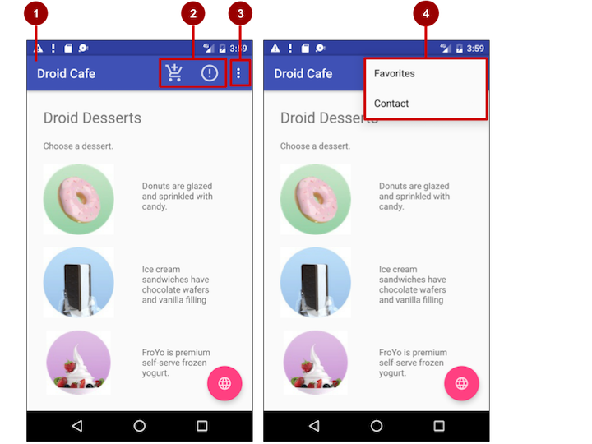

In the above figure:

1. **App bar**. The app bar includes the app title, the options menu, and the overflow button.
2. **Options menu action icons**. The first two options menu items appear as icons in the app bar.
3. **Overflow button**. The overflow button (three vertical dots) opens a menu that shows more options menu items.
4. **Options overflow menu**. After clicking the overflow button, more options menu items appear in the overflow menu.

### Adding the app bar

Each activity that uses the default theme also has an [ActionBar](https://developer.android.com/reference/android/app/ActionBar.html) as its app bar. Some themes also set up an ActionBar as an app bar by default. When you start an app from a template such as Empty Activity, an ActionBar appears as the app bar.

Features were added to the native ActionBar over time, so the behavior of the native ActionBardepends on the version of Android that the device is running. For this reason, if you add an options menu, use the [v7 appcompat](https://developer.android.com/topic/libraries/support-library/packages#v7-appcompat) support library's [Toolbar](https://developer.android.com/reference/android/support/v7/widget/Toolbar.html) as an app bar:

* Toolbar makes it easy to set up an app bar that works on a wide range of devices.
* Toolbar gives you room to customize your app bar later, as your app develops.
* Toolbar includes the most recent features, and it works for any device that can use the support library.

To use Toolbar as an activity's app bar (instead of using the default ActionBar), you can start your project with the Basic Activity template. That template implements Toolbar for the activity, and it implements a rudimentary options menu with one item, **Settings**.

**Tip**: If you use the Basic Activity template, you can skip the rest of this section, because the template provides everything you need.

If you are not using the Basic Activity template, this section describes how to add Toolbar yourself. The following are the general steps:

1. Add the support libraries appcompat and design.
2. Use a NoActionBar theme and styles for the app bar and background.
3. Add an AppBarLayout and a Toolbar to the layout.
4. Add code to the Activity to set up the app bar.

#### **Adding the support libraries**

If you start an app project using the Basic Activity template, the template adds the following support libraries for you, so you can skip this step.

If you are not using the Basic Activity template, add two things to your project: the [appcompat support library](https://developer.android.com/topic/libraries/support-library/packages#v7-appcompat) for the Toolbar class, and the design library for the NoActionBar themes:

1. Choose **Tools > Android > SDK Manager** to check whether the Android Support Repository is installed. If the repository is not installed, install it.
2. Open the build.gradle file for your app, and add the support library feature project identifiers to the dependencies section. For example, to include support:appcompat and support:design, add:
3. compile 'com.android.support:appcompat-v7:26.1.0'
4. compile 'com.android.support:design:26.1.0'

**Note:** If necessary, update the version numbers for dependencies. If the version number you specified is lower than the currently available library version number, Android Studio warns you. Update the version number to the one Android Studio tells you to use.

#### **Using themes to design the app bar**

If you start an app project using the Basic Activity template, the template adds the theme to replace the ActionBar with a Toolbar, so you can skip this step.

If you are not using the Basic Activity template, you can use the Toolbar class for the app bar by turning off the default ActionBar using a NoActionBar theme for the activity. Themes in Android are similar to styles, except that they are applied to an entire app or activity rather than to a specific view.

When you create a new project in Android Studio, an app theme is automatically generated for you. For example, if you start an app project with the Empty Activity or Basic Activity template, the AppThemetheme is provided in styles.xml. To see this file, expand the **res > values** folder in the **Project > Android** pane.

**Tip**: You learn more about themes in the chapter on drawables, styles, and themes.

You can modify the theme to provide a style for the app bar and app background. Follow these steps to make the app bar stand out against its background:

1. Open **styles.xml**. You should already have the following in the file within the <resources> section:
2. <!-- Base application theme. -->
3. <style name="AppTheme" parent="Theme.AppCompat.Light.DarkActionBar">
4. <!-- Customize your theme here. -->
5. <item name="colorPrimary">@color/colorPrimary</item>
6. <item name="colorPrimaryDark">@color/colorPrimaryDark</item>
7. <item name="colorAccent">@color/colorAccent</item>
8. </style>

AppTheme "inherits"—takes on all the styles—from a parent theme called Theme.AppCompat.Light.DarkActionBar, which is a standard theme supplied with Android. However, you can override an inherited style with another style by adding the other style to **styles.xml**.

1. Add the AppTheme.NoActionBar, AppTheme.AppBarOverlay, and AppTheme.PopupOverlay styles under the AppTheme style, as shown below. These styles will override the style attributes with the same names in AppTheme, affecting the appearance of the app bar and the app's background:
2. <style name="AppTheme.NoActionBar">
3. <item name="windowActionBar">false</item>
4. <item name="windowNoTitle">true</item>
5. </style>
6. <style name="AppTheme.AppBarOverlay"
7. parent="ThemeOverlay.AppCompat.Dark.ActionBar" />
8. <style name="AppTheme.PopupOverlay"
9. parent="ThemeOverlay.AppCompat.Light" />
10. Open **AndroidManifest.xml** and add the NoActionBar theme in appcompat to the <application>element. Using this theme prevents the app from using the native ActionBar class to provide the app bar:
11. <activity
12. <!-- android:name and android:label code goes here. -->
13. android:theme="@style/AppTheme.NoActionBar">
14. <!-- intent filter code would go here if needed. -->
15. </activity>

#### **Adding AppBarLayout and a Toolbar to the layout**

If you start an app project using the Basic Activity template, the template adds the AppBarLayout and Toolbar for you, so you can skip this step.

If you are not using the Basic Activity template, you can include the [Toolbar](https://developer.android.com/reference/android/support/v7/widget/Toolbar.html) in an Activity layout by adding an AppBarLayout and a Toolbar element. [AppBarLayout](https://developer.android.com/reference/android/support/design/widget/AppBarLayout.html) is a vertical LinearLayout which implements many of the features of the material designs app bar concept, such as scrolling gestures. Keep in mind the following:

1. AppBarLayout must be a direct child within a CoordinatorLayout root view group, and Toolbar must be a direct child within AppBarLayout, placed at the top of the Activity layout. Shown below is a layout that uses this structure:
2. <android.support.design.widget.CoordinatorLayout
3. xmlns:android="http://schemas.android.com/apk/res/android"
4. xmlns:app="http://schemas.android.com/apk/res-auto"
5. xmlns:tools="http://schemas.android.com/tools"
6. android:layout_width="match_parent"
7. android:layout_height="match_parent"
8. tools:context="com.example.android.droidcafeinput.MainActivity">
9. <android.support.design.widget.AppBarLayout
10. android:layout_width="match_parent"
11. android:layout_height="wrap_content"
12. android:theme="@style/AppTheme.AppBarOverlay">
13. <android.support.v7.widget.Toolbar
14. android:id="@+id/toolbar"
15. android:layout_width="match_parent"
16. android:layout_height="?attr/actionBarSize"
17. android:background="?attr/colorPrimary"
18. app:popupTheme="@style/AppTheme.PopupOverlay" />
19. </android.support.design.widget.AppBarLayout>
20. <include layout="@layout/content_main" />
21. </android.support.design.widget.CoordinatorLayout>
22. AppBarLayout also requires a separate content layout sibling for the content that scrolls underneath the app bar. You can add this sibling as a view group (such as RelativeLayout or LinearLayout) in the same layout file, or in a separate layout file. The above XML snippet uses an include layout to include the content layout in content_main.xml.
23. Set the content sibling's view group to use the scrolling behavior AppBarLayout.ScrollingViewBehavior:
24. app:layout_behavior="@string/appbar_scrolling_view_behavior"

The layout behavior for the RelativeLayout is set to the string resource @string/appbar_scrolling_view_behavior. This string resource controls how the screen scrolls in relation to the app bar at the top. The resource represents the following string, which is defined in the values.xml file (which you should not modify):

android.support.design.widget.AppBarLayout$ScrollingViewBehavior

This behavior is defined by the [AppBarLayout.ScrollingViewBehavior](https://developer.android.com/reference/android/support/design/widget/AppBarLayout.ScrollingViewBehavior.html) class. Any View or view group that can scroll vertically to support nested scrolling for [AppBarLayout](https://developer.android.com/reference/android/support/design/widget/AppBarLayout.html) siblings should use this behavior.

#### **Adding code to set up the app bar**

If you start an app project using the Basic Activity template, the template adds the code needed to set up the app bar, so you can skip this step.

If you are not using the Basic Activity template, you can follow these steps to set up the app bar in the Activity:

1. Make sure that any Activity that you want to show an app bar extends [AppCompatActivity](https://developer.android.com/reference/android/support/v7/app/AppCompatActivity.html):
2. public class MainActivity extends AppCompatActivity {
3. // ... Activity code
4. }
5. In the onCreate() method for the Activity, call [setSupportActionBar()](https://developer.android.com/reference/android/support/v7/app/AppCompatActivity.html#setSupportActionBar(android.support.v7.widget.Toolbar)) with the Toolbar. The setSupportActionBar() method sets the Toolbar as the app bar for the Activity:
6. @Override
7. protected void onCreate(Bundle savedInstanceState) {
8. super.onCreate(savedInstanceState);
9. setContentView(R.layout.activity_main);
10. Toolbar toolbar = findViewById(R.id.toolbar);
11. setSupportActionBar(toolbar);
12. }

The Activity now shows the app bar. By default, the app bar contains just the name of the app.

### Adding the options menu

Android provides a standard XML format to define options menu items. Instead of building the menu in your Activity code, you can define the menu and all its items in an XML [menu resource](https://developer.android.com/guide/topics/resources/menu-resource.html). A menu resource defines an application menu (options menu, context menu, or popup menu) that can be inflated with [MenuInflater](https://developer.android.com/reference/android/view/MenuInflater.html), which loads the resource as a [Menu](https://developer.android.com/reference/android/view/Menu.html) object in your Activity.

If you start an app project using the Basic Activity template, the template adds the menu resource for you and inflates the options menu with MenuInflater, so you can skip this step and go right to "Defining how menu items appear".

If you are not using the Basic Activity template, use the resource-inflate design pattern, which makes it easy to create an options menu. Follow these steps (refer to the figure below):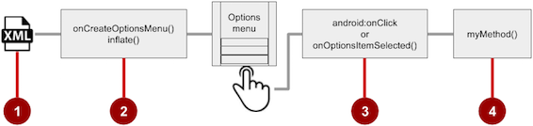

1. **XML menu resource**. Create an XML menu resource file for the menu items, and assign appearance and position attributes as described in the next section.
2. **Inflating the menu**. Override the [onCreateOptionsMenu()](https://developer.android.com/reference/android/app/Activity.html#onCreateOptionsMenu(android.view.Menu)) method in your Activity to inflate the menu.
3. **Handling menu-item clicks**. Menu items are View elements, so you can use the android:onClickattribute for each menu item. However, the [onOptionsItemSelected()](https://developer.android.com/reference/android/app/Activity.html#onOptionsItemSelected(android.view.MenuItem)) method can handle all the menu-item clicks in one place and determine which menu item the user clicked, which makes your code easier to understand.
4. **Performing actions**. Create a method to perform an action for each options menu item.

#### **Creating an XML resource for the menu**

Follow these steps to add menu items to an XML menu resource:

1. Select the **res** folder in the **Project > Android** pane and choose **File > New > Android resource directory**.
2. Choose **menu** in the **Resource** type drop-down menu, and click **OK**.
3. Select the new **menu** folder, and choose **File > New > Menu resource file**.
4. Enter the name, such as **menu_main**, and click **OK**. The new menu_main.xml file now resides within the **menu** folder.
5. Open **menu_main.xml** and click the **Text** tab to show the XML code.
6. Add menu items using the <item ... /> tag. In this example, the item is **Settings**:
7. <menu xmlns:android="http://schemas.android.com/apk/res/android"
8. xmlns:app="http://schemas.android.com/apk/res-auto"
9. xmlns:tools="http://schemas.android.com/tools"
10. tools:context="com.example.android.droidcafeinput.MainActivity">
11. <item
12. android:id="@+id/action_settings"
13. android:orderInCategory="100"
14. android:title="Settings"
15. app:showAsAction="never" />

After setting up and inflating the XML resource in the Activity, the overflow icon in the app bar, when clicked, would show the options menu with just one option (**Settings**).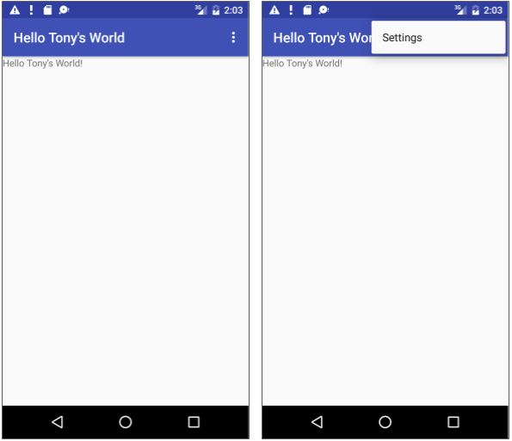

#### **Defining how menu items appear**

If you start an app project using the Basic Activity template, the template adds the options menu with one option: **Settings**.

To add more options menu items, add more <item ... /> tags in the **menu_main.xml** file. For example, in the following snippet, two menu items are defined: @string/settings (**Settings**) and @string/action_order (**Order**):

<item

android:id="@+id/action_settings"

android:title="@string/settings" />

<item

android:id="@+id/action_order"

android:icon="@drawable/ic_order_white"

android:title="@string/action_order"/>

Within each <item ... /> tag, you add attributes that define how the menu item appears. For example, you can define the order of the item's appearance relative to other items, and whether the item can appear as an icon in the app bar. The following items are placed in the overflow menu:

* Any item that you set to not appear in the app bar.
* Any item that can't fit in the app bar, given the display orientation.

Whenever possible, show the most-used actions using icons in the app bar so that the user can tap these actions without having to first tap the overflow button.

**Adding icons for menu items**

To specify icons for actions, first add the icons as image assets to the **drawable** folder by following the steps below. (For a comlete description, see [Create app icons with Image Asset Studio](https://developer.android.com/studio/write/image-asset-studio).)

1. Expand **res** in the Project > Android pane, and right-click (or Command-click) **drawable**.
2. Choose **New > Image Asset**. The Configure Image Asset dialog appears.
3. Choose **Action Bar and Tab Items** in the drop-down menu.
4. Edit the name of the icon (for example, **ic_order_white**for the **Order** menu item).
5. Click the clip art image (the Android logo) to select a clip art image as the icon. A page of icons appears. Click the icon you want to use.
6. (Optional) Choose **HOLO_DARK** from the **Theme** drop-down menu. This sets the icon to be white against a dark-colored (or black) background. Click **Next**.
7. Click **Finish** in the Confirm Icon Path dialog.

**Icon and appearance attributes**

Use the following attributes to govern the menu item's appearance:

* android:icon: An image to use as the menu item icon. For example, the following menu item defines ic_order_white as its icon:
* <item
* android:id="@+id/action_order"
* android:icon="@drawable/ic_order_white"
* android:title="@string/action_order"/>
* android:title: A string for the title of the menu item.
* android:titleCondensed: A string to use as a condensed title for situations in which the normal title is too long.

#### **Position attributes**

Use the android:orderInCategory attribute to specify the order in which the menu items appear in the menu, with the lowest number appearing higher in the menu. This is usually the order of importance of the item within the menu. For example, if you want **Order** to be first, followed by **Status**, **Favorites**, and **Contact**, the following table shows the priority of these items in the menu:

|  |  |
| --- | --- |
| **Menu item** | **orderInCategory attribute** |
| Order | 10 |
| Status | 20 |
| Favorites | 30 |
| Contact | 40 |

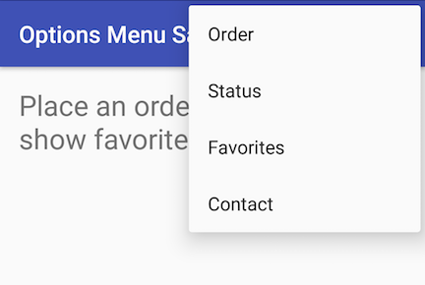

**Note:** While the numbers 1, 2, 3, and 4 would work in the above example, the numbers 10, 20, 30, and 40 leave ample room for menu items to be added later, between these four items.

Use the app:showAsAction attribute to show menu items as icons in the app bar, with the following values:

* "always": Always place this item in the app bar. Use this only if it's critical that the item appear in the app bar (such as a Search icon). If you set multiple items to always appear in the app bar, they might overlap something else in the app bar, such as the app title.
* "ifRoom": Only place this item in the app bar if there is room for it. If there is not enough room for all the items marked "ifRoom", the items with the lowest orderInCategory values are displayed in the app bar. The remaining items are displayed in the overflow menu.
* "never": Never place this item in the app bar. Instead, list the item in the app bar's overflow menu.
* "withText": Also include the title text (defined by android:title) with the item. This attribute is used primarily to include the title with the icon in the app bar, because if the item appears in the overflow menu, the title text appears regardless.

For example, the following menu item's icon appears in the app bar only if there is room for it:

<item

android:id="@+id/action_favorites"

android:icon="@drawable/ic_favorites_white"

android:orderInCategory="40"

android:title="@string/action_favorites"

app:showAsAction="ifRoom" />



In the above figure:

1. **Options menu action icons**. The first two menu items appear as action icons in the app bar: **Order**(the shopping cart icon) and **Info** (the "**i**" icon).
2. **Overflow button**. Clicking the overflow button shows the overflow menu.
3. **Options overflow menu**. The overflow menu shows more of the options menu: **Favorites** (the heart icon) and **Contact**. **Favorites** doesn't fit into the app bar in vertical orientation, but may appear in horizontal orientation on a smartphone, or in both orientations on a tablet, as shown below.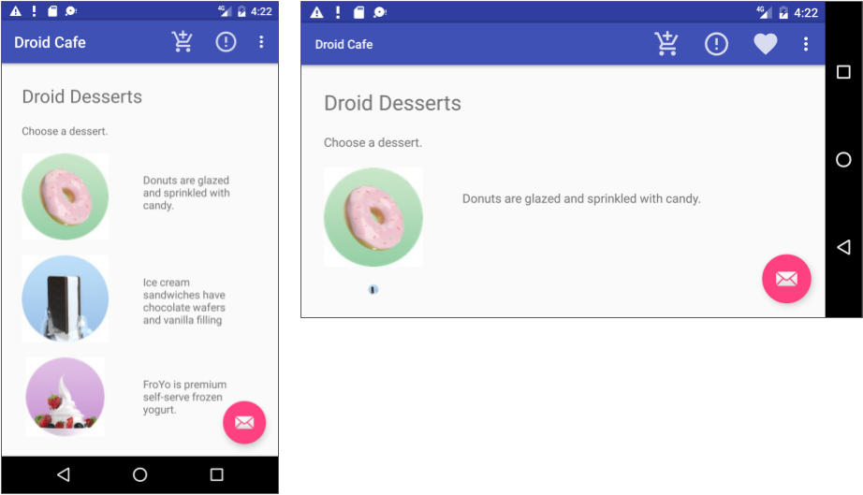

#### **Inflating the menu resource**

If you start an app project using the Basic Activity template, the template adds the code for inflating the options menu with MenuInflater, so you can skip this step.

If you are not using the Basic Activity template, inflate the menu resource in your activity by overriding the [onCreateOptionsMenu()](https://developer.android.com/reference/android/app/Activity.html#onCreateOptionsMenu(android.view.Menu)) method and using the [getMenuInflater()](https://developer.android.com/reference/android/app/Activity.html#getMenuInflater()) method of the Activity class.

The getMenuInflater() method returns a [MenuInflater](https://developer.android.com/reference/android/view/MenuInflater.html), which is a class used to instantiate menu XML files into Menu objects. The MenuInflater class provides the [inflate()](https://developer.android.com/reference/android/view/MenuInflater.html#inflate(int,%20android.view.Menu)) method, which takes two parameters:

* The resource id for an XML layout resource to load (R.menu.menu_main in the following example).
* The [Menu](https://developer.android.com/reference/android/view/Menu.html) to inflate into (menu in the following example).
* @Override
* public boolean onCreateOptionsMenu(Menu menu) {
* getMenuInflater().inflate(R.menu.menu_main, menu);
* return true;
* }

#### **Handling the menu-item click**

As with a Button, the android:onClick attribute defines a method to call when this menu item is clicked. You must declare the method in the Activity as public and accept a MenuItem as its only parameter, which indicates the item clicked.

For example, you could define the **Favorites** item in the menu resource file to use the android:onClickattribute to call the onFavoritesClick() method:

<item

android:id="@+id/action_favorites"

android:icon="@drawable/ic_favorites_white"

android:orderInCategory="40"

android:title="@string/action_favorites"

app:showAsAction="ifRoom"

android:onClick="onFavoritesClick" />

You would declare the onFavoritesClick() method in the Activity:

public void onFavoritesClick(MenuItem item) {

// The item parameter indicates which item was clicked.

// ... Add code to handle the Favorites click.

}

However, the [onOptionsItemSelected()](https://developer.android.com/reference/android/app/Activity.html#onOptionsItemSelected(android.view.MenuItem)) method can handle all the menu-item clicks in one place and determine which menu item the user clicked. This makes your code easier to understand.

For example, you can use a switch case block to call the appropriate method (such as showOrder) based on the menu item's id. You retrieve the id using the [getItemId()](https://developer.android.com/reference/android/widget/Adapter.html#getItemId(int)) method:

@Override

public boolean onOptionsItemSelected(MenuItem item) {

switch (item.getItemId()) {

case R.id.action_order:

showOrder();

return true;

case R.id.action_status:

showStatus();

return true;

case R.id.action_contact:

showContact();

return true;

default:

// Do nothing

}

return super.onOptionsItemSelected(item);

}

## Contextual menus

Use a contextual menu to allow users to take an action on a selected [View](https://developer.android.com/reference/android/view/View.html). Contextual menus are most often used for items in a [RecyclerView](https://developer.android.com/reference/android/support/v7/widget/RecyclerView.html), [GridView](https://developer.android.com/reference/android/widget/GridView.html), or other view collection in which the user can perform direct actions on each item.

Android provides two kinds of contextual menus:

* A context menu, shown on the left side in the figure below, appears as a floating list of menu items when the user performs a long tap on a View. It is typically used to modify the View or use it in some fashion. For example, a context menu might include **Edit** to edit the contents of a View, **Delete**to delete a View, and **Share** to share a View over social media. Users can perform a contextual action on one selected View at a time.
* A contextual action bar, shown on the right side of the figure below, appears at the top of the screen in place of the app bar or underneath the app bar, with action items that affect one or more selected View elements. Users can perform an action on multiple View elements at once, if your app allows it.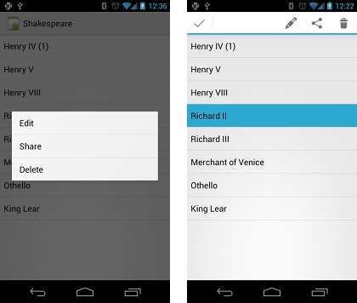

### Floating context menu

The familiar resource-inflate design pattern is used to create a context menu, modified to include registering (associating) the context menu with a View. The pattern consists of the steps shown in the figure below.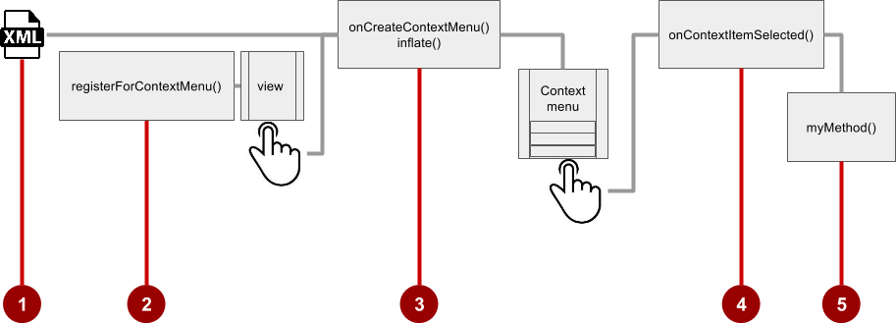

1. Create an XML menu resource file for the menu items. Assign appearance and position attributes as described in the previous section for the options menu.
2. Register a View to the context menu using the [registerForContextMenu()](https://developer.android.com/reference/android/app/Activity.html#registerForContextMenu(android.view.View)) method of the Activityclass.
3. Implement the [onCreateContextMenu()](https://developer.android.com/reference/android/view/View.OnCreateContextMenuListener.html#onCreateContextMenu(android.view.ContextMenu,%20android.view.View,%20android.view.ContextMenu.ContextMenuInfo)) method in your Activity to inflate the menu.
4. Implement the [onContextItemSelected()](https://developer.android.com/reference/android/app/Activity.html#onContextItemSelected(android.view.MenuItem)) method in your Activity to handle menu-item clicks.
5. Create a method to perform an action for each context menu item.

#### **Creating the XML resource file**

To create the XML menu resource directory and file, follow the steps in the previous section for the options menu. However, use a different name for the file, such as menu_context. Add the context menu items within <item ... /> tags.

For example, the following code defines the **Edit** menu item:

<item

android:id="@+id/context_edit"

android:title="Edit"

android:orderInCategory="10"/>

#### **Registering a View to the context menu**

To register a View to the context menu, call the [registerForContextMenu()](https://developer.android.com/reference/android/app/Activity.html#registerForContextMenu(android.view.View)) method with the View. Registering a context menu for a view sets the [View.OnCreateContextMenuListener](https://developer.android.com/reference/android/view/View.OnCreateContextMenuListener.html) on the View to this activity, so that [onCreateContextMenu()](https://developer.android.com/reference/android/app/Activity.html#onCreateContextMenu(android.view.ContextMenu,%20android.view.View,%20android.view.ContextMenu.ContextMenuInfo)) is called when it's time to show the context menu. (You implement onCreateContextMenu in the next section.)

For example, in the onCreate() method for the Activity, you would add registerForContextMenu():

// Registering the context menu to the TextView of the article.

TextView article_text = findViewById(R.id.article);

registerForContextMenu(article_text);

Multiple views can be registered to the same context menu. If you want each item in a [ListView](https://developer.android.com/reference/android/widget/ListView.html) or [GridView](https://developer.android.com/reference/android/widget/GridView.html) to provide the same context menu, register all items for a context menu by passing the [ListView](https://developer.android.com/reference/android/widget/ListView.html) or [GridView](https://developer.android.com/reference/android/widget/GridView.html) to [registerForContextMenu()](https://developer.android.com/reference/android/app/Activity.html#registerForContextMenu(android.view.View)).

#### **Implementing the onCreateContextMenu() method**

When the registered View receives a long-click event, the system calls the [onCreateContextMenu()](https://developer.android.com/reference/android/view/View.OnCreateContextMenuListener.html#onCreateContextMenu(android.view.ContextMenu,%20android.view.View,%20android.view.ContextMenu.ContextMenuInfo))method, which you can override in your Activity. (Long-click events are also called touch & hold events and long-press events.)

The onCreateContextMenu() method is where you define the menu items, usually by inflating a menu resource.

For example:

@Override

public void onCreateContextMenu(ContextMenu menu, View v,

ContextMenu.ContextMenuInfo menuInfo) {

super.onCreateContextMenu(menu, v, menuInfo);

MenuInflater inflater = getMenuInflater();

inflater.inflate(R.menu.menu_context, menu);

}

In the code above:

* The menu parameter for onCreateContextMenu() is the context menu to be built.
* The v parameter is the View registered for the context menu.
* The menuInfo parameter is extra information about the View registered for the context menu. This information varies depending on the class of the v parameter, which could be a RecyclerView or a GridView.

If you are registering a RecyclerView or a GridView, you instantiate a [ContextMenu.ContextMenuInfo](https://developer.android.com/reference/android/view/ContextMenu.ContextMenuInfo.html)object to provide information about the item selected, and pass it as menuInfo, such as the row id, position, or child View.

The [MenuInflater](https://developer.android.com/reference/android/view/MenuInflater.html) class provides the [inflate()](https://developer.android.com/reference/android/view/MenuInflater.html#inflate(int,%20android.view.Menu)) method, which takes two parameters:

* The resource id for an XML layout resource to load. In the example above, the id ismenu_context.
* The [Menu](https://developer.android.com/reference/android/view/Menu.html) to inflate into. In the example above, the Menu is menu.

#### **Implementing the onContextItemSelected() method**

When the user clicks on a menu item, the system calls the [onContextItemSelected()](https://developer.android.com/reference/android/app/Activity.html#onContextItemSelected(android.view.MenuItem)) method. You override this method in your Activity in order to determine which menu item was clicked, and for which view the menu is appearing. You also use it to implement the appropriate action for the menu items, such as editNote() and shareNote() in the following code snippet for the **Edit** and **Share** menu items:

@Override

public boolean onContextItemSelected(MenuItem item) {

switch (item.getItemId()) {

case R.id.context_edit:

editNote();

return true;

case R.id.context_share:

shareNote();

return true;

default:

return super.onContextItemSelected(item);

}

}

The above code snippet uses the [getItemId()](https://developer.android.com/reference/android/view/MenuItem.html#getItemId()) method to get the id for the selected menu item, and uses it in a switch case block to determine which action to take. The id is the android:id attribute assigned to the menu item in the XML menu resource file.

When the user performs a long-click on the article in the TextView, the floating context menu appears and the user can click a menu item.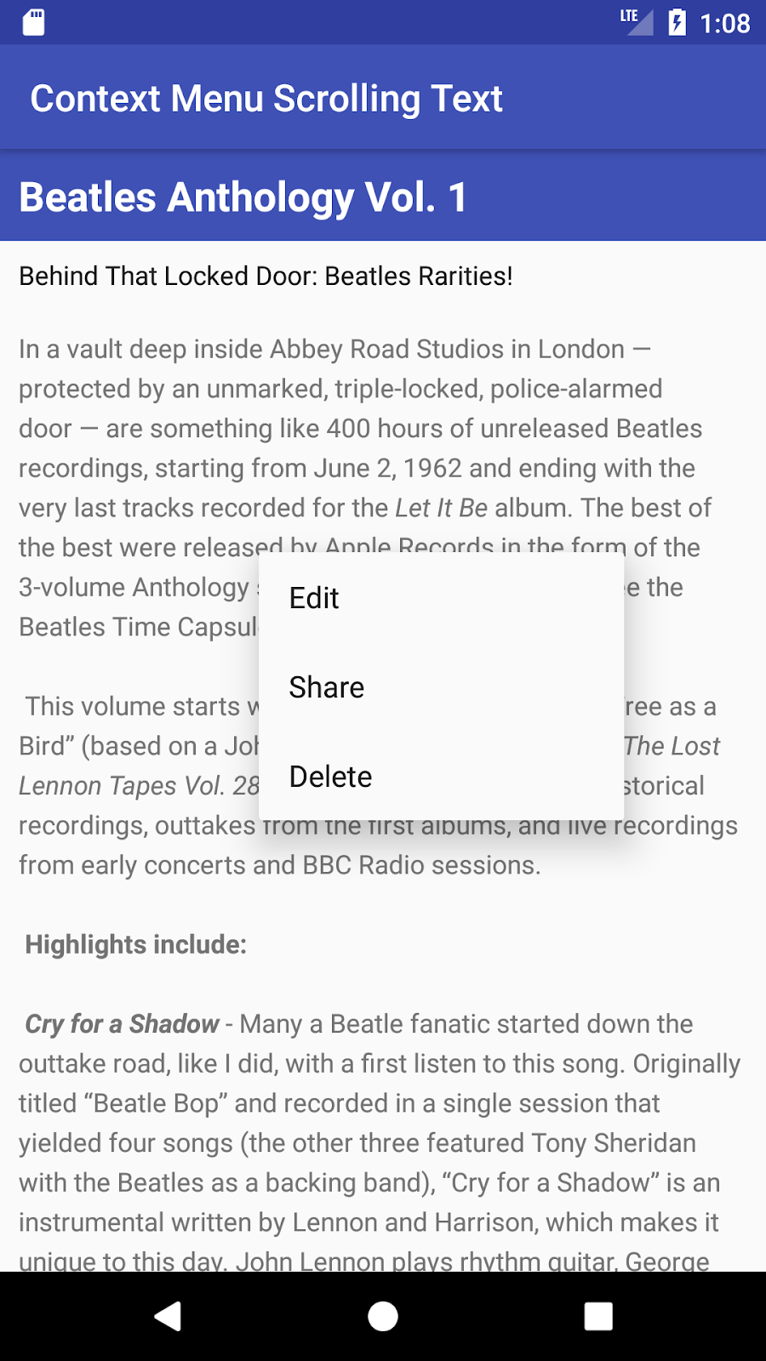

If you are using the menuInfo information for a RecyclerView or a GridView, you would add a statement before the switch case block to gather the specific information about the selected View (for info) by using [AdapterView.AdapterContextMenuInfo](https://developer.android.com/reference/android/widget/AdapterView.AdapterContextMenuInfo.html):

AdapterView.AdapterContextMenuInfo info =

(AdapterView.AdapterContextMenuInfo) item.getMenuInfo();

### Contextual action bar

A contextual action bar appears at the top of the screen to present actions the user can perform on a View after long-clicking the View, as shown in the figure below.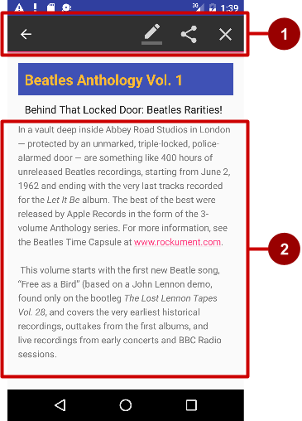

In the above figure:

1. **Contextual action bar**. The bar offers three actions on the right side (**Edit**, **Share**, and **Delete**) and the **Done** button (left arrow icon) on the left side.
2. **View**. View on which a long-click triggers the contextual action bar.

The contextual action bar appears only when contextual action mode, a system implementation of [ActionMode](https://developer.android.com/reference/android/view/ActionMode.html), occurs as a result of the user performing a long-click on one or more selected Viewelements.

ActionMode represents UI mode for providing alternative interaction, replacing parts of the normal UI until finished. For example, text selection is implemented as an ActionMode, as are contextual actions that work on a selected item on the screen. Selecting a section of text or long-clicking a view triggers ActionMode.

While this mode is enabled, the user can select multiple items, if your app allows it. The user can also deselect items, and continue to navigate within the activity. ActionMode is disabled when one of the following things occur:

* The user deselects all items.
* The user presses the Back button.
* The user taps **Done** (the left-arrow icon) on the left side of the action bar.

When ActionMode is disabled, the contextual action bar disappears.

Follow these steps to create a contextual action bar, as shown in the figure below: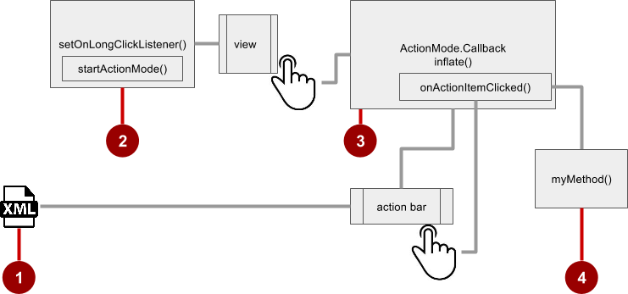

1. Create an XML menu resource file for the menu items, and assign an icon to each one (as described in a previous section).
2. Set the long-click listener using [setOnLongClickListener()](https://developer.android.com/reference/android/view/View.html#setOnLongClickListener(android.view.View.OnLongClickListener)) to the View that should trigger the contextual action bar. Call [startActionMode()](https://developer.android.com/reference/android/app/Activity.html#startActionMode(android.view.ActionMode.Callback)) within the setOnLongClickListener() method when the user performs a long tap on the View.
3. Implement the [ActionMode.Callback](https://developer.android.com/reference/android/view/ActionMode.Callback.html) interface to handle the ActionMode lifecycle. Include in this interface the action for responding to a menu-item click in the [onActionItemClicked()](https://developer.android.com/reference/android/view/ActionMode.Callback.html#onActionItemClicked(android.view.ActionMode,%20android.view.MenuItem)) callback method.
4. Create a method to perform an action for each context menu item.

#### **Creating the XML resource file**

Create the XML menu resource directory and file by following the steps in the previous section on the options menu. Use a suitable name for the file, such as menu_context. Add icons for the context menu items. For example, the **Edit** menu item would have these attributes:

<item

android:id="@+id/context_edit"

android:orderInCategory="10"

android:icon="@drawable/ic_action_edit_white"

android:title="Edit" />

The standard contextual action bar has a dark background. Use a light or white color for the icons. If you are using clip art icons, choose **HOLO_DARK** for the **Theme** drop-down menu when creating the new image asset.

#### **Setting the long-click listener**

Use [setOnLongClickListener()](https://developer.android.com/reference/android/view/View.html#setOnLongClickListener(android.view.View.OnLongClickListener)) to set a long-click listener to the View that should trigger the contextual action bar. Add the code to set the long-click listener to the Activity using the onCreate() method. Follow these steps:

1. Declare the member variable mActionMode:
2. private ActionMode mActionMode;

You will call [startActionMode()](https://developer.android.com/reference/android/app/Activity.html#startActionMode(android.view.ActionMode.Callback)) to enable [ActionMode](https://developer.android.com/reference/android/view/ActionMode.html), which returns the ActionMode created. By saving this in a member variable (mActionMode), you can make changes to the contextual action bar in response to other events.

1. Set up the contextual action bar listener in the onCreate() method, using View as the type in order to use the setOnLongClickListener:
2. @Override
3. protected void onCreate(Bundle savedInstanceState) {
4. // ... The rest of the onCreate code.
5. View articleView = findViewById(article);
6. articleView.setOnLongClickListener(new View.OnLongClickListener()
7. {
8. // Start ActionMode after long-click.
9. });
10. }

#### **Implementing the ActionMode.Callback interface**

Before you can add the code to onCreate() to start ActionMode, you must implement the [ActionMode.Callback](https://developer.android.com/reference/android/view/ActionMode.Callback.html) interface to manage the ActionMode lifecycle. In its callback methods, you can specify the actions for the contextual action bar, and respond to clicks on action items.

1. Add the following method to the Activity to implement the interface:
2. public ActionMode.Callback mActionModeCallback = new
3. ActionMode.Callback() {
4. // ... Code to create ActionMode.
5. }
6. Add the onCreateActionMode() code within the brackets of the above method to create ActionMode:
7. @Override
8. public boolean onCreateActionMode(ActionMode mode, Menu menu) {
9. // Inflate a menu resource providing context menu items
10. MenuInflater inflater = mode.getMenuInflater();
11. inflater.inflate(R.menu.menu_context, menu);
12. return true;
13. }

The [onCreateActionMode()](https://developer.android.com/reference/android/view/ActionMode.Callback.html#onCreateActionMode(android.view.ActionMode,%20android.view.Menu)) method inflates the menu using the same pattern used for a floating context menu. But this inflation occurs only when ActionMode is created, which is when the user performs a long-click. The [MenuInflater](https://developer.android.com/reference/android/view/MenuInflater.html) class provides the [inflate()](https://developer.android.com/reference/android/view/MenuInflater.html#inflate(int,%20android.view.Menu)) method, which takes as a parameter the resource id for an XML layout resource to load (menu_context in the above example), and the [Menu](https://developer.android.com/reference/android/view/Menu.html) to inflate into (menu in the above example).

1. Add the [onActionItemClicked()](https://developer.android.com/reference/android/view/ActionMode.Callback.html#onActionItemClicked(android.view.ActionMode,%20android.view.MenuItem)) method with your handlers for each menu item:
2. @Override
3. public boolean onActionItemClicked(ActionMode mode, MenuItem item) {
4. switch (item.getItemId()) {
5. case R.id.context_edit:
6. editNote();
7. mode.finish();
8. return true;
9. case R.id.context_share:
10. shareNote();
11. mode.finish();
12. return true;
13. default:
14. return false;
15. }

The above code above uses the [getItemId()](https://developer.android.com/reference/android/view/MenuItem.html#getItemId()) method to get the id for the selected menu item, and uses it in a switch case block to determine which action to take. The id in each case statement is the android:id attribute assigned to the menu item in the XML menu resource file.

The actions shown are the editNote() and shareNote() methods, which you create in the Activity. After the action is picked, you use the mode.finish() method to close the contextual action bar.

1. Add the [onPrepareActionMode()](https://developer.android.com/reference/android/view/ActionMode.Callback.html#onPrepareActionMode(android.view.ActionMode,%20android.view.Menu)) and [onDestroyActionMode()](https://developer.android.com/reference/android/view/ActionMode.Callback.html#onDestroyActionMode(android.view.ActionMode)) methods, which manage the ActionMode lifecycle:
2. @Override
3. public boolean onPrepareActionMode(ActionMode mode, Menu menu) {
4. return false; // Return false if nothing is done.
5. }

The onPrepareActionMode() method shown above is called each time ActionMode occurs, and is always called after onCreateActionMode().

@Override

public void onDestroyActionMode(ActionMode mode) {

mActionMode = null;

}

The onDestroyActionMode() method shown above is called when the user exits ActionMode by clicking **Done** in the contextual action bar, or clicking on a different view.

The following is the full code for the [ActionMode.Callback](https://developer.android.com/reference/android/view/ActionMode.Callback.html) interface implementation:

public ActionMode.Callback mActionModeCallback = new

ActionMode.Callback() {

@Override

public boolean onCreateActionMode(ActionMode mode, Menu menu) {

// Inflate a menu resource providing context menu items

MenuInflater inflater = mode.getMenuInflater();

inflater.inflate(R.menu.menu_context, menu);

return true;

}

// Called each time ActionMode is shown. Always called after

// onCreateActionMode.

@Override

public boolean onPrepareActionMode(ActionMode mode, Menu menu) {

return false; // Return false if nothing is done

}

// Called when the user selects a contextual menu item

@Override

public boolean onActionItemClicked(ActionMode mode, MenuItem item) {

switch (item.getItemId()) {

case R.id.context_edit:

editNote();

mode.finish();

return true;

case R.id.context_share:

shareNote();

mode.finish();

return true;

default:

return false;

}

}

// Called when the user exits the action mode

@Override

public void onDestroyActionMode(ActionMode mode) {

mActionMode = null;

}

};

#### **Starting ActionMode**

You use [startActionMode()](https://developer.android.com/reference/android/app/Activity.html#startActionMode(android.view.ActionMode.Callback)) to start ActionMode after the user performs a long-click.

To start ActionMode, add the onLongClick() method within the brackets of the setOnLongClickListenermethod in onCreate():

@Override

protected void onCreate(Bundle savedInstanceState) {

// ... Rest of onCreate code

articleView.setOnLongClickListener(new View.OnLongClickListener() {

// Called when the user long-clicks on articleView

public boolean onLongClick(View view) {

if (mActionMode != null) return false;

// Start the contextual action bar

// using the ActionMode.Callback.

mActionMode =

MainActivity.this.startActionMode(mActionModeCallback);

view.setSelected(true);

return true;

}

});

}

The above code first ensures that the ActionMode instance is not recreated if it's already active by checking whether mActionMode is null before starting the action mode:

if (mActionMode != null) return false;

When the user performs a long-click, the call is made to startActionMode() using the ActionMode.Callback interface, and the contextual action bar appears at the top of the display. The [setSelected()](https://developer.android.com/reference/android/view/View.html#setSelected(boolean)) method changes the state of this View to selected (set to true).

The following is the code for the onCreate() method in the Activity, which now includes setOnLongClickListener() and startActionMode():

@Override

protected void onCreate(Bundle savedInstanceState) {

super.onCreate(savedInstanceState);

setContentView(R.layout.activity_main);

// set up the contextual action bar listener

View articleView = findViewById(article);

articleView.setOnLongClickListener(new View.OnLongClickListener() {

// Called when the user long-clicks on articleView.

public boolean onLongClick(View view) {

if (mActionMode != null) return false;

// Start the contextual action bar using the ActionMode.Callback.

mActionMode =

MainActivity.this.startActionMode(mActionModeCallback);

view.setSelected(true);

return true;

}

});

}

## Popup menu

A [PopupMenu](https://developer.android.com/reference/android/widget/PopupMenu.html) is a vertical list of items anchored to a [View](https://developer.android.com/reference/android/view/View.html). It appears below the anchor View if there is room, or above the View otherwise.

A popup menu is typically used to provide an overflow of actions (similar to the overflow action icon for the options menu) or the second part of a two-part command. Use a popup menu for extended actions that relate to regions of content in your Activity. Unlike a context menu, a popup menu is anchored to a Button, is always available, and its actions generally do not affect the content of the View.

For example, the Gmail app uses a popup menu anchored to the overflow icon in the app bar when showing an email message. The popup menu items **Reply**, **Reply All**, and **Forward** are related to the email message, but don't affect or act on the message. Actions in a popup menu should not directly affect the corresponding content (use a contextual menu to directly affect selected content). As shown below, a popup can be anchored to the overflow action button in the app bar.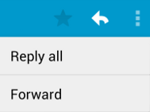

### Creating a popup menu

Follow these steps to create a popup menu (refer to figure below):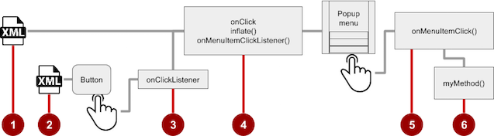

1. Create an XML menu resource file for the popup menu items, and assign appearance and position attributes (as described in a previous section).
2. Add an [ImageButton](https://developer.android.com/reference/android/widget/ImageButton.html) for the popup menu icon in the XML activity layout file.
3. Assign [onClickListener()](https://developer.android.com/reference/android/view/View.OnClickListener.html) to the ImageButton.
4. Override the onClick() method to inflate the popup menu and register it with [PopupMenu.OnMenuItemClickListener](https://developer.android.com/reference/android/widget/PopupMenu.OnMenuItemClickListener.html).
5. Implement the [onMenuItemClick()](https://developer.android.com/reference/android/view/MenuItem.OnMenuItemClickListener.html#onMenuItemClick(android.view.MenuItem)) method.
6. Create a method to perform an action for each popup menu item.

#### **Creating the XML resource file**

Create the XML menu resource directory and file by following the steps in a previous section. Use a suitable name for the file, such as menu_popup.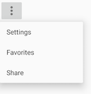

#### **Adding an ImageButton for the icon to click**

Use an [ImageButton](https://developer.android.com/reference/android/widget/ImageButton.html) in the Activity layout for the icon that triggers the popup menu. Popup menus are anchored to a View in the Activity, such as an ImageButton. The user clicks it to see the menu.

<ImageButton

android:layout_width="wrap_content"

android:layout_height="wrap_content"

android:id="@+id/button_popup"

android:src="@drawable/@drawable/ic_action_popup"/>

#### **Assigning onClickListener to the button**

1. Create a member variable (mButton) in the Activity class definition:
2. public class MainActivity extends AppCompatActivity {
3. private ImageButton mButton;
4. // ... Rest of Activity code
5. }
6. In the onCreate() method for the same Activity, assign [onClickListener()](https://developer.android.com/reference/android/view/View.OnClickListener.html) to the ImageButton:
7. // ... Rest of Activity code
8. @Override
9. protected void onCreate(Bundle savedInstanceState) {
10. // ... Rest of onCreate code
11. mButton = (ImageButton) findViewById(R.id.button_popup);
12. mButton.setOnClickListener(new View.OnClickListener() {
13. // Define onClick here ...
14. });
15. }

#### **Inflating the popup menu**

As part of the setOnClickListener() method within onCreate(), add the onClick() method to inflate the popup menu and register it with [PopupMenu.OnMenuItemClickListener](https://developer.android.com/reference/android/widget/PopupMenu.OnMenuItemClickListener.html):

// Define onClick here ...

@Override

public void onClick(View v) {

// Create the instance of PopupMenu.

PopupMenu popup = new PopupMenu(MainActivity.this, mButton);

// Inflate the Popup using XML file.

popup.getMenuInflater().inflate(R.menu.menu_popup, popup.getMenu());

// Register the popup with OnMenuItemClickListener.

popup.setOnMenuItemClickListener(new

PopupMenu.OnMenuItemClickListener() {

// Add onMenuItemClick here...

// Perform action here ...

}

The method instantiates a [PopupMenu](https://developer.android.com/reference/android/widget/PopupMenu.html) object, which is popup in the example above. Then the method uses the [MenuInflater](https://developer.android.com/reference/android/view/MenuInflater.html) class and its [inflate()](https://developer.android.com/reference/android/view/MenuInflater.html#inflate(int,%20android.view.Menu)) method.

The inflate() method takes the following parameters:

* The resource id for an XML layout resource to load, which is menu_popup in the example above.
* The [Menu](https://developer.android.com/reference/android/view/Menu.html) to inflate into, which is popup.getMenu() in the example above.

The code then registers the popup with the listener, [PopupMenu.OnMenuItemClickListener](https://developer.android.com/reference/android/widget/PopupMenu.OnMenuItemClickListener.html).

#### **Implementing onMenuItemClick**

To perform an action when the user selects a popup menu item, implement the [onMenuItemClick()](https://developer.android.com/reference/android/widget/PopupMenu.OnMenuItemClickListener.html#onMenuItemClick(android.view.MenuItem))callback within the above setOnClickListener() method. Finish the method with popup.show to show the popup menu:

// Add onMenuItemClick here...

public boolean onMenuItemClick(MenuItem item) {

// Perform action here ...

return true;

}

});

// Show the popup menu.

popup.show();

## Dialogs and pickers

A dialog is a window that appears on top of the display or fills the display, interrupting the flow of Activity. Dialogs inform users about a specific task and may contain critical information, require decisions, or involve multiple tasks.

For example, an alert dialog might require the user to click **Continue** after reading it, or give the user a choice to agree with an action by clicking a positive button (such as **OK** or **Accept**), or to disagree by clicking a negative button (such as **Cancel**).

You can also use a dialog to provide choices in the style of radio buttons, as shown on the right side of the figure below.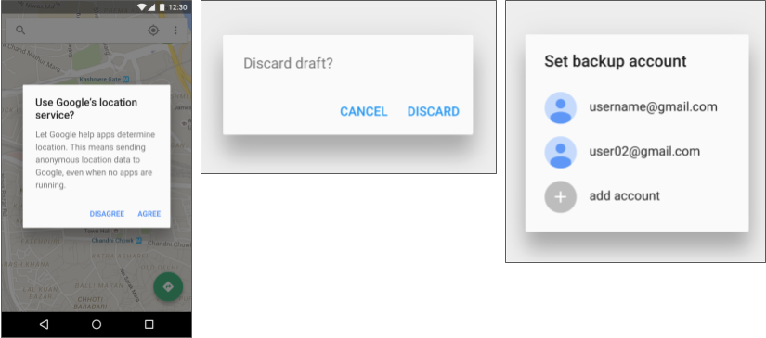

The base class for all dialog components is a [Dialog](https://developer.android.com/reference/android/app/Dialog.html). There are several useful Dialog subclasses for alerting the user on a condition, showing status or progress, displaying information on a secondary device, or selecting or confirming a choice, as shown on the left side of the figure below. The Android SDK also provides ready-to-use dialog subclasses such as pickers for picking a time or a date, as shown on the right side of the figure below. Pickers allow users to enter information in a predetermined, consistent format that reduces the chance for input error.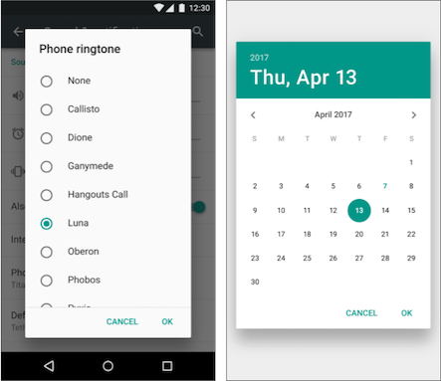

Dialogs always retain focus until dismissed or a required action has been taken.

**Tip**: Best practices recommend using dialogs sparingly as they interrupt the user's workflow. Read the [Dialogs design guide](https://www.google.com/design/spec/components/dialogs.html) for additional best design practices, and [Dialogs](https://developer.android.com/guide/topics/ui/dialogs.html) in the Android developer documentation for code examples.

The [Dialog](https://developer.android.com/reference/android/app/Dialog.html) class is the base class for dialogs, but you should avoid instantiating Dialog directly unless you are creating a custom dialog. For standard Android dialogs, use one of the following subclasses:

* [AlertDialog](https://developer.android.com/reference/android/app/AlertDialog.html): A dialog that can show a title, up to three buttons, a list of selectable items, or a custom layout.
* [DatePickerDialog](https://developer.android.com/reference/android/app/DatePickerDialog.html): A dialog with a predefined UI that lets the user select a date.
* [TimePickerDialog](https://developer.android.com/reference/android/app/TimePickerDialog.html): A dialog with a predefined UI that lets the user select a time.

### Showing an alert dialog

Alerts are urgent interruptions, requiring acknowledgement or action, that inform the user about a situation as it occurs, or an action before it occurs (as in discarding a draft). You can provide buttons in an alert to make a decision. For example, an alert dialog might require the user to click **Continue** after reading it, or give the user a choice to agree with an action by clicking a positive button (such as **OK** or **Accept**), or to disagree by clicking a negative button (such as **Disagree** or **Cancel**).

Use the [AlertDialog](https://developer.android.com/reference/android/app/AlertDialog.html) subclass of the [Dialog](https://developer.android.com/reference/android/app/Dialog.html) class to show a standard dialog for an alert. The AlertDialog class allows you to build a variety of dialog designs. An alert dialog can have the following regions (refer to the diagram below):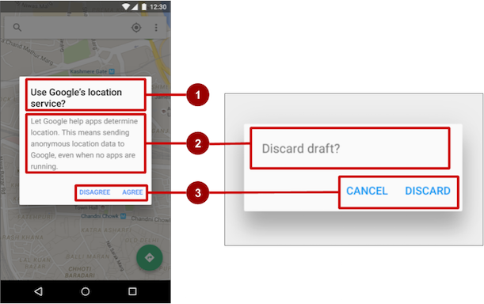

1. Title: A title is optional. Most alerts don't need titles. If you can summarize a decision in a sentence or two by either asking a question (such as, "Discard draft?") or making a statement related to the action buttons (such as, "Click OK to continue"), don't bother with a title. Use a title if the situation is high-risk, such as the potential loss of connectivity or data, and the content area is occupied by a detailed message, a list, or custom layout.
2. Content area: The content area can display a message, a list, or other custom layout.
3. Action buttons: You should use no more than three action buttons in a dialog, and most have only two.

#### **Building the AlertDialog**

The [AlertDialog.Builder](https://developer.android.com/reference/android/app/AlertDialog.Builder.html) class uses the builder design pattern, which makes it easy to create an object from a class that has a lot of required and optional attributes and would therefore require a lot of parameters to build. Without this pattern, you would have to create constructors for combinations of required and optional attributes; with this pattern, the code is easier to read and maintain. For more information about the builder design pattern, see [Builder pattern](https://en.wikipedia.org/wiki/Builder_pattern).

Use [AlertDialog.Builder](https://developer.android.com/reference/android/app/AlertDialog.Builder.html) to build a standard alert dialog, with [setTitle()](https://developer.android.com/reference/android/app/AlertDialog.Builder.html#setTitle(int)) to set its title, [setMessage()](https://developer.android.com/reference/android/app/AlertDialog.Builder.html#setMessage(int))to set its message, and [setPositiveButton()](https://developer.android.com/reference/android/app/AlertDialog.Builder.html#setPositiveButton(int,%20android.content.DialogInterface.OnClickListener)) and [setNegativeButton()](https://developer.android.com/reference/android/app/AlertDialog.Builder.html#setNegativeButton(int,%20android.content.DialogInterface.OnClickListener)) to set its buttons.

If AlertDialog.Builder is not recognized as you enter it, you may need to add the following importstatements to the Activity:

import android.content.DialogInterface;

import android.support.v7.app.AlertDialog;

The following creates the dialog object (myAlertBuilder) and sets the title (the string resource alert_title) and message (the string resource alert_message):

AlertDialog.Builder myAlertBuilder = new

AlertDialog.Builder(MainActivity.this);

myAlertBuilder.setTitle(R.string.alert_title);

myAlertBuilder.setMessage(R.string.alert_message);

#### **Setting the button actions for the alert dialog**

Use the [setPositiveButton()](https://developer.android.com/reference/android/app/AlertDialog.Builder.html#setPositiveButton(int,%20android.content.DialogInterface.OnClickListener)) and [setNegativeButton()](https://developer.android.com/reference/android/app/AlertDialog.Builder.html#setNegativeButton(int,%20android.content.DialogInterface.OnClickListener)) methods to set the button actions for the alert dialog. These methods require a title for the button and the [DialogInterface.OnClickListener](https://developer.android.com/reference/android/content/DialogInterface.OnClickListener.html) class that defines the action to take when the user presses the button:

myAlertBuilder.setPositiveButton("OK", new

DialogInterface.OnClickListener() {

public void onClick(DialogInterface dialog, int which) {

// User clicked OK button.

// ... Action to take when OK is clicked.

}

});

myAlertBuilder.setNegativeButton("Cancel", new

DialogInterface.OnClickListener() {

public void onClick(DialogInterface dialog, int which) {

// User clicked the CANCEL button.

// ... Action to take when CANCEL is clicked.

}

});

You can add only one of each button type to an AlertDialog. For example, you can't have more than one "positive" button.

**Tip**: You can also set a "neutral" button with [setNeutralButton()](https://developer.android.com/reference/android/app/AlertDialog.Builder.html#setNeutralButton(int,%20android.content.DialogInterface.OnClickListener)). The neutral button appears between the positive and negative buttons. Use a neutral button, such as **Remind me later**, if you want the user to be able to dismiss the dialog and decide later.

#### **Displaying the dialog**

To display the dialog, call its show() method:

alertDialog.show();

### Date and time pickers

Android provides ready-to-use dialogs, called pickers, for picking a time or a date. Use them to ensure that your users pick a valid time or date that is formatted correctly and adjusted to the user's locale. Each picker provides controls for selecting each part of the time (hour, minute, AM/PM) or date (month, day, year).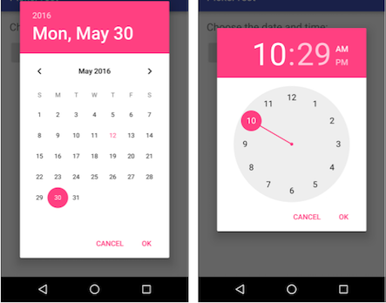

When showing a picker, you should use an instance of [DialogFragment](https://developer.android.com/reference/android/support/v4/app/DialogFragment.html), a subclass of [Fragment](https://developer.android.com/reference/android/support/v4/app/Fragment.html), which displays a dialog window floating on top of its Activity window. A Fragment is a behavior or a portion of a UI within an Activity. It's like a mini-Activity within the main Activity, with its own lifecycle. A Fragment receives its own input events, and you can add or remove it while the Activity is running. You might combine multiple Fragment elements in a single Activity to build a multiple-pane UI, or reuse a Fragment in more than one Activity. To learn about Fragment, see [Fragments](http://developer.android.com/guide/components/fragments.html) in the API Guide.

One benefit of using a Fragment for a picker is that you can isolate the code sections for managing the date and the time for various locales that display date and time in different ways. You can also use DialogFragment to manage the dialog lifecycle.

**Tip**: Another benefit of using fragments for the pickers is that you can implement different layout configurations, such as a basic dialog on handset-sized displays or an embedded part of a layout on large displays.

#### **Adding a fragment**

To add a Fragment for the date picker, create a blank Fragment without a layout XML, and without factory methods or interface callbacks:

1. Expand **app > java > com.example.android...** and select an Activity (such as **MainActivity**).
2. Choose **File > New > Fragment > Fragment (Blank)**, and name the Fragment (such as **DatePickerFragment**). Clear all three checkbox options so that you do not create a layout XML, do not include Fragment factory methods, and do not include interface callbacks. You don't need to create a layout for a standard picker. Click **Finish** to create the Fragment.

#### **Extending DialogFragment for the picker**

The next step is to create a standard picker with a listener. Follow these steps:

1. Edit the DatePickerFragment class definition to extend DialogFragment and implement [DatePickerDialog.OnDateSetListener](https://developer.android.com/reference/android/app/DatePickerDialog.OnDateSetListener.html) to create a standard date picker with a listener. See [Pickers](http://developer.android.com/guide/topics/ui/controls/pickers.html) for more information about extending DialogFragment for a date picker:
2. public class DatePickerFragment extends DialogFragment
3. implements DatePickerDialog.OnDateSetListener {

As you type **DialogFragment** and **DatePickerDialog.OnDateSetListener**, Android Studio automatically adds several import statements to the import block at the top, including:

import android.app.DatePickerDialog;

import android.support.v4.app.DialogFragment;

In addition, a red bulb icon appears in the left margin after a few seconds.

1. Click the red bulb icon and choose **Implement methods** from the popup menu. A dialog appears with [onDateSet()](https://developer.android.com/reference/android/app/DatePickerDialog.OnDateSetListener.html#onDateSet(android.widget.DatePicker,%20int,%20int,%20int)) already selected and the **Insert @Override** option selected. Click **OK** to create the empty onDateSet() method. This method will be called when the user sets the date.

After adding the empty onDateSet() method, Android Studio automatically adds the following in the import block at the top:

import android.widget.DatePicker;

The onDateSet() parameters should be int i, int i1, and int i2. Change the names of these parameters to ones that are more readable:

public void onDateSet(DatePicker datePicker,

int year, int month, int day)

1. When you extend DialogFragment, you should override the [onCreateDialog()](https://developer.android.com/reference/android/support/v4/app/DialogFragment.html#onCreateDialog(android.os.Bundle)) callback method, rather than onCreateView. Replace the entire onCreateView() method with onCreateDialog() that returns Dialog, and annotate onCreateDialog() with @NonNull to indicate that the return value Dialog can't be null. Android Studio displays a red bulb next to the method because it doesn't return anything yet.
2. @NonNull
3. @Override
4. public Dialog onCreateDialog(Bundle savedInstanceState) {
5. }
6. You use your version of the callback method to initialize the year, month, and day for the date picker. For example, you can add the following code to onCreateDialog() to initialize the year, month, and day from [Calendar](https://developer.android.com/reference/java/util/Calendar.html), and return the dialog and these values to the Activity. As you enter **Calendar.getInstance()**, specify the import to be **java.util.Calendar**.
7. // Use the current date as the default date in the picker.
8. final Calendar c = Calendar.getInstance();
9. int year = c.get(Calendar.YEAR);
10. int month = c.get(Calendar.MONTH);
11. int day = c.get(Calendar.DAY_OF_MONTH);

The [Calendar](https://developer.android.com/reference/java/util/Calendar.html) class sets the default date as the current date—it converts between a specific instant in time and a set of calendar fields such as YEAR, MONTH, DAY_OF_MONTH, and HOUR. Calendar is locale-sensitive. The Calendar getInstance() method returns a Calendar whose fields are initialized with the current date and time.

1. Add the following statement to the end of the method to create a new instance of the date picker and return it:
2. // Create a new instance of DatePickerDialog and return it.
3. return new DatePickerDialog(
4. getActivity(), this, year, month, day);

#### **Showing the picker**

To show the picker, add a method to the Activity that creates an instance of [FragmentManager](https://developer.android.com/reference/android/app/FragmentManager.html) using [getSupportFragmentManager()](https://developer.android.com/reference/android/support/v4/app/FragmentActivity.html#getSupportFragmentManager()). You can then use the method as the handler for the android:onClickattribute for a button or other input control.

public void showDatePicker(View view) {

DialogFragment newFragment = new DatePickerFragment();

newFragment.show(getSupportFragmentManager(),"datePicker");

}

For more information about the Fragment class, see [Fragments](http://developer.android.com/guide/components/fragments.html).

#### **Processing the user's picker choice**

When the user makes a selection in the date picker, the system calls the onDateSet() method, so you can use onDateSet() to manipulate the chosen date:

1. Open an Activity and add a method that takes the year, month, and day as arguments. You can then use this method to take action. For example, in this method you can convert the month, day, and year to separate strings so that you can concatenate them with slash marks for the U.S. date format:
2. public void processDatePickerResult(
3. int year, int month, int day) {
4. String month_string = Integer.toString(month + 1);
5. String day_string = Integer.toString(day);
6. String year_string = Integer.toString(year);
7. String dateMessage = (month_string + "/"
8. + day_string + "/" + year_string);
9. // ... Code to do some action with dateMessage.
10. }

The month integer returned by the date picker starts counting at 0 for January, so you need to add 1 to it to show months starting at 1.

1. Add code to the onDateSet() method in the Fragment to invoke processDatePickerResult() in the activity and pass it the year, month, and day:
2. @Override
3. public void onDateSet(DatePicker datePicker,
4. int year, int month, int day) {
5. MainActivity activity = (MainActivity) getActivity();
6. activity.processDatePickerResult(year, month, day);
7. }

When you use the getActivity() method in a Fragment, the method returns the activity with which the fragment is associated. You need to do this because you can't call a method in the activity without the activity context—you would have to use an intent, as you learned in another lesson. The activity inherits the context, so you can use the activity as the context for calling the method, as in activity.processDatePickerResult.

#### **The time picker**

Follow the same procedures outlined above for a date picker, with the following differences:

* The Fragment should extend DialogFragment and implement [TimePickerDialog.OnTimeSetListener](https://developer.android.com/reference/android/app/TimePickerDialog.OnTimeSetListener.html).
* Override the [onTimeSet()](https://developer.android.com/reference/android/app/TimePickerDialog.OnTimeSetListener.html#onTimeSet(android.widget.TimePicker,%20int,%20int)) method.
* Use onCreateDialog() to initialize the time and return the dialog, as you did with the date picker.
* Create a method to instantiate the picker DialogFragment, as you did with the date picker.
* Create a method to process the result as you did with the date picker.
* Use onTimeSet() to get the time and pass it to the method to process the result.

# 4.4: User navigation

**Contents:**

* [Providing users with a path through your app](https://google-developer-training.github.io/android-developer-fundamentals-course-concepts-v2/unit-2-user-experience/lesson-4-user-interaction/4-4-c-user-navigation/4-4-c-user-navigation.html#chapterstart)
* [Back-button navigation](https://google-developer-training.github.io/android-developer-fundamentals-course-concepts-v2/unit-2-user-experience/lesson-4-user-interaction/4-4-c-user-navigation/4-4-c-user-navigation.html#back_button)
* [Hierarchical navigation patterns](https://google-developer-training.github.io/android-developer-fundamentals-course-concepts-v2/unit-2-user-experience/lesson-4-user-interaction/4-4-c-user-navigation/4-4-c-user-navigation.html#hierarchical)
* [Ancestral navigation (the Up button)](https://google-developer-training.github.io/android-developer-fundamentals-course-concepts-v2/unit-2-user-experience/lesson-4-user-interaction/4-4-c-user-navigation/4-4-c-user-navigation.html#ancestral)
* [Descendant navigation](https://google-developer-training.github.io/android-developer-fundamentals-course-concepts-v2/unit-2-user-experience/lesson-4-user-interaction/4-4-c-user-navigation/4-4-c-user-navigation.html#descendant)
* [Lateral navigation with tabs and swipes](https://google-developer-training.github.io/android-developer-fundamentals-course-concepts-v2/unit-2-user-experience/lesson-4-user-interaction/4-4-c-user-navigation/4-4-c-user-navigation.html#lateral)
* [Related practical](https://google-developer-training.github.io/android-developer-fundamentals-course-concepts-v2/unit-2-user-experience/lesson-4-user-interaction/4-4-c-user-navigation/4-4-c-user-navigation.html#relatedpractical)
* [Learn more](https://google-developer-training.github.io/android-developer-fundamentals-course-concepts-v2/unit-2-user-experience/lesson-4-user-interaction/4-4-c-user-navigation/4-4-c-user-navigation.html#learnmore)

## Providing users with a path through your app

In the early stages of developing an app, you should determine the path you want users to take through your app to do each task. (The tasks are things like placing an order or browsing content.) Each path enables users to navigate across, into, and out of the tasks and pieces of content within the app.

Often you need several paths through your app that offer the following types of navigation:

* Back navigation, where users navigate to the previous screen using the Back button.
* Hierarchical navigation, where users navigate through a hierarchy of screens. The hierarchy is organized with a parent screen for every set of child screens.

## Back-button navigation

Back-button navigation—navigation back through the history of screens—is deeply rooted in the Android system. Android users expect the Back button in the bottom left corner of every screen to take them to the previous screen. The set of historical screens always starts with the user's Launcher (the device's Home screen), as shown in the figure below. Pressing Back enough times should return the user back to the Launcher.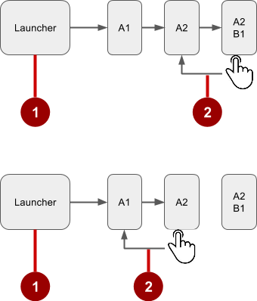

In the figure above:

1. Starting from Launcher.
2. Clicking the Back button to navigate to the previous screen.

You don't have to manage the Back button in your app. The system handles tasks and the back stack—the list of previous screens—automatically. The Back button by default simply traverses this list of screens, removing the current screen from the list as the user presses it.

There are, however, cases where you may want to override the behavior for the Back button. For example, if your screen contains an embedded web browser in which users can interact with page elements to navigate between web pages, you may wish to trigger the embedded browser's default back behavior when users press the device's Back button.

The [onBackPressed()](https://developer.android.com/reference/android/app/Activity.html#onBackPressed()) method of the [Activity](https://developer.android.com/reference/android/app/Activity.html) class is called whenever the Activity detects the user's press of the Back key. The default implementation simply finishes the current Activity, but you can override this to do something else:

@Override

public void onBackPressed() {

// Add the Back key handler here.

return;

}

If your code triggers an embedded browser with its own behavior for the Back key, you should return the Back key behavior to the system's default behavior if the user uses the Back key to go beyond the beginning of the browser's internal history.

## Hierarchical navigation patterns

To give the user a path through the full range of an app's screens, the best practice is to use some form of hierarchical navigation. An app's screens are typically organized in a parent-child hierarchy, as shown in the figure below: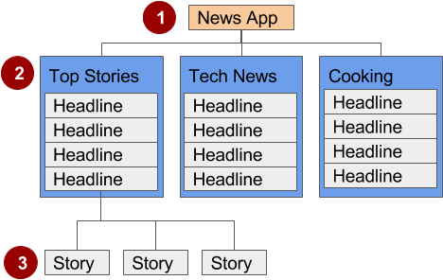

In the figure above:

1. Parent screen
2. First-level child screen siblings
3. Second-level child screen siblings

### Parent screen

A parent screen (such as a news app's home screen) enables navigation down to child screens.

* The main [Activity](https://developer.android.com/reference/android/app/Activity.html) of an app is usually the parent screen.
* Implement a parent screen as an activity with descendant navigation to one or more child screens.

### First-level child screen siblings

Siblings are screens in the same position in the hierarchy that share the same parent screen (like brothers and sisters).

* In the first level of siblings, the child screens may be collection screens that collect the headlines of stories, as shown above.
* Implement each child screen as an Activity or [Fragment](https://developer.android.com/reference/android/app/Fragment.html).
* Implement lateral navigation to navigate from one sibling to another on the same level.
* If there is a second level of screens, the first level child screen is the parent to the second level child screen siblings. Implement descendant navigation to the second-level child screens.

### Second-level child screen siblings

In news apps and others that offer multiple levels of information, the second level of child screen siblings might offer content, such as stories.

* Implement each second-level child screen sibling as another Activity or Fragment.
* Stories at this level may include embedded story elements such as videos, maps, and comments, which might be implemented as fragments.

You can enable the user to navigate up to and down from a parent, and sideways among siblings:

* Descendant navigation: Navigating down from a parent screen to a child screen.
* Ancestral navigation: Navigating up from a child screen to a parent screen.
* Lateral navigation: Navigating from one sibling to another sibling (at the same level).

You can use the main Activity of the app as a parent screen, and then add an Activity or Fragmentfor each child screen.

### Main Activity with an activity for each child

If the first-level child screen siblings have another level of child screens under them, you should implement each first-level screen as an activity, so that the lifecycle of each screen is managed properly before calling any second-level child screens.

For example, in the figure above, the parent screen is most likely the main activity. An app's main activity (usually MainActivity.java) is typically the parent screen for all other screens in your app. You implement a navigation pattern in the main activity to enable the user to go to another activity or fragment. For example, you can implement navigation using an [Intent](https://developer.android.com/reference/android/content/Intent.html) that starts an Activity.

**Tip**: Using an [Intent](https://developer.android.com/reference/android/content/Intent.html) in the current activity to start another activity adds the current activity to the call stack, so that the Back button in the other activity (described in the previous section) returns the user to the current activity.

As you've learned, the Android system initiates code in an Activity with callback methods that manage the Actactivityivity lifecycle for you. (A previous lesson covers the activity lifecycle; for more information, see [Activities](https://developer.android.com/training/basics/activity-lifecycle/index.html) in the Android developer documentation.)

The declaration of each child activity is defined in the AndroidManifest.xml file with its parent activity. For example, the following defines OrderActivity as a child of the parent MainActivity:

<activity android:name=".OrderActivity"

android:label="@string/title_activity_order"

android:parentActivityName=

"com.example.android.droidcafe.MainActivity">

<meta-data

android:name="android.support.PARENT_ACTIVITY"

android:value=".MainActivity"/>

</activity>

### Main Activity with a Fragment for each child

If the child screen siblings do not have another level of child screens under them, you can define each one as a [Fragment](https://developer.android.com/reference/android/app/Fragment.html), which represents a behavior or portion of a UI within in an activity. Think of a fragment as a modular section of an activity which has its own lifecycle, receives its own input events, and which you can add or remove while the activity is running.

You can add more than one fragment in a single activity. For example, in a section sibling screen showing a news story and implemented as an Activity, you might have a child screen for a video clip implemented as a Fragment. You would implement a way for the user to navigate to the video clip Fragment, and then back to the Activity that shows the story.

## Ancestral navigation (the Up button)

With ancestral navigation in a multitier hierarchy, you enable the user to go up from a section sibling to the collection sibling, and then up to the parent screen.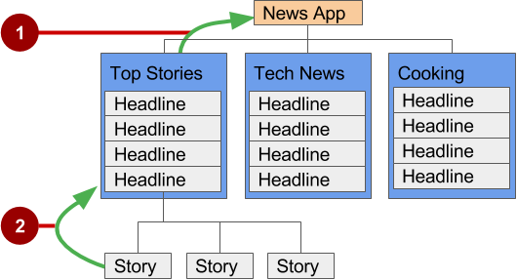

In the figure above:

1. **Up** button for ancestral navigation from the first-level siblings to the parent.
2. **Up** button for ancestral navigation from second-level siblings to the first-level child screen acting as a parent screen.

The **Up** button is used to navigate within an app based on the hierarchical relationships between screens. For example (referring to the figure above):

* If a first-level child screen offers headlines to navigate to second-level child screens, the second-level child screen siblings should offer **Up** buttons that return to the first-level child screen, which is their shared parent.
* If the parent screen offers navigation to first-level child siblings, then the first-level child siblings should offer an **Up** button that returns to the parent screen.
* If the parent screen is the topmost screen in an app (that is, the app's home screen), it should not offer an **Up** button.

**Tip:** The Back button below the screen differs from the **Up** button. The Back button provides navigation to whatever screen you viewed previously. If you have several children screens that the user can navigate through using a lateral navigation pattern (as described later in this chapter), the Back button would send the user back to the previous child screen, not to the parent screen. Use an **Up** button if you want to provide ancestral navigation from a child screen back to the parent screen. For more information about Up navigation, see [Providing Up Navigation](http://developer.android.com/training/implementing-navigation/ancestral.html). See the concept chapter on menus and pickers for details on how to implement the app bar.

To provide the **Up** button for a child screen Activity, declare the parent of the Activity to be the main Activity in the AndroidManifest.xml file:

<activity android:name="com.example.android.droidcafeinput.OrderActivity"

android:label="Order Activity"

android:parentActivityName=".MainActivity">

<meta-data android:name="android.support.PARENT_ACTIVITY"

android:value=".MainActivity"/>

</activity>

The snippet above in AndroidManifest.xml declares the parent for the child screen OrderActivity to be MainActivity. It also sets the android:label to a title for the Activity screen to be "Order Activity". The child screen now includes the **Up** button in the app bar (highlighted in the figure below), which the user can tap to navigate back to the parent screen.

## Descendant navigation

With descendant navigation, you enable the user to go from the parent screen to a first-level child screen, and from a first-level child screen down to a second-level child screen.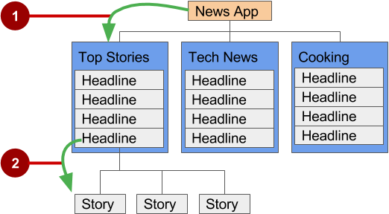

In the figure above:

1. Descendant navigation from parent to first-level child screen
2. Descendant navigation from headline in a first-level child screen to a second-level child screen

### Buttons or targets

The best practice for descendant navigation from the parent screen to collection siblings is to use buttons or simple targets such as an arrangement of images or iconic buttons (also known as a dashboard). When the user touches a button, the collection sibling screen opens, replacing the current context (screen) entirely.

**Tip:** Buttons and simple targets are rarely used for navigating to section siblings within a collection. See lists, carousels, and cards in the next section.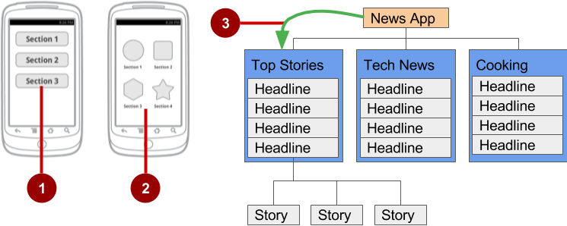

In the figure above:

1. Buttons on a parent screen
2. Targets (Image buttons or icons) on a parent screen
3. Descendant navigation pattern from parent screen to first-level child siblings

A dashboard usually has either two or three rows and columns, with large touch targets to make it easy to use. Dashboards are best when each collection sibling is equally important. You can use a [LinearLayout](https://developer.android.com/reference/android/widget/LinearLayout.html), [RelativeLayout](https://developer.android.com/reference/android/widget/RelativeLayout.html), or [GridLayout](https://developer.android.com/reference/android/widget/GridLayout.html). See [Layouts](https://developer.android.com/guide/topics/ui/declaring-layout.html) for an overview of how layouts work.

### Navigation drawer

A navigation drawer is a panel that usually displays navigation options on the left edge of the screen, as shown on the right side of the figure below. It is hidden most of the time, but is revealed when the user swipes a finger from the left edge of the screen or touches the navigation icon in the app bar, as shown on the left side of the figure below.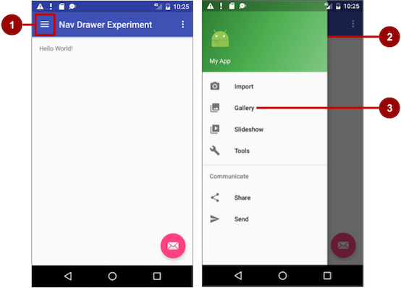

In the figure above:

1. Navigation icon in the app bar
2. Navigation drawer
3. Navigation drawer menu item

A good example of a navigation drawer is in the Gmail app, which provides access to the inbox, labeled email folders, and settings. The best practice for employing a navigation drawer is to provide descendant navigation from the parent Activity to all of the other child screens in an app. It can display many navigation targets at once—for example, it can contain buttons (like a dashboard), tabs, or a list of items (like the Gmail drawer).

To make a navigation drawer in your app, you need to create the following layouts:

* A navigation drawer as the Activity layout root ViewGroup
* A navigation View for the drawer itself
* An app bar layout that includes room for a navigation icon button
* A content layout for the Activity that displays the navigation drawer
* A layout for the navigation drawer header

Follow these general steps:

1. Populate the navigation drawer menu with item titles and icons.
2. Set up the navigation drawer and item listeners in the Activity code.
3. Handle the navigation menu item selections.

### Creating the navigation drawer layout

To create a navigation drawer layout, use the [DrawerLayout](https://developer.android.com/reference/android/support/v4/widget/DrawerLayout.html) APIs available in the [Support Library](https://developer.android.com/tools/support-library/index.html). For design specifications, follow the design principles for navigation drawers in the [Navigation Drawer](https://developer.android.com/design/patterns/navigation-drawer.html) design guide.

To add a navigation drawer, use a DrawerLayout as the root ViewGroup of your Activity layout. Inside the DrawerLayout, add one View that contains the main content for the screen (your primary layout when the drawer is hidden) and another View, typically a [NavigationView](https://developer.android.com/reference/android/support/design/widget/NavigationView.html), that contains the contents of the navigation drawer.

**Tip:**To make your layouts simpler to understand, use the include tag to include an XML layout within another XML layout.

For example, the following layout uses:

* A DrawerLayout as the root of the Activity layout in activity_main.xml.
* The main content of screen defined in the app_bar_main.xml layout file.
* A [NavigationView](https://developer.android.com/reference/android/support/design/widget/NavigationView.html) that represents a standard navigation menu that can be populated by a menu resource XML file.

Refer to the figure below that corresponds to this layout:

<android.support.v4.widget.DrawerLayout

xmlns:android="http://schemas.android.com/apk/res/android"

xmlns:app="http://schemas.android.com/apk/res-auto"

xmlns:tools="http://schemas.android.com/tools"

android:id="@+id/drawer_layout"

android:layout_width="match_parent"

android:layout_height="match_parent"

android:fitsSystemWindows="true"

tools:openDrawer="start">

<include

layout="@layout/app_bar_main"

android:layout_width="match_parent"

android:layout_height="match_parent" />

<android.support.design.widget.NavigationView

android:id="@+id/nav_view"

android:layout_width="wrap_content"

android:layout_height="match_parent"

android:layout_gravity="start"

android:fitsSystemWindows="true"

app:headerLayout="@layout/nav_header_main"

app:menu="@menu/activity_main_drawer" />

</android.support.v4.widget.DrawerLayout>

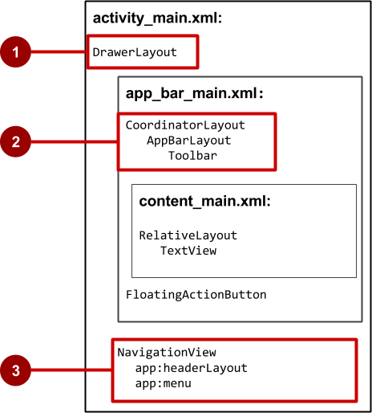

In the figure above:

1. [DrawerLayout](https://developer.android.com/reference/android/support/v4/widget/DrawerLayout.html) is the root ViewGroup of the Activity layout.
2. The included app_bar_main.xml uses a [CoordinatorLayout](https://developer.android.com/reference/android/support/design/widget/CoordinatorLayout.html) as its root, and defines the app bar layout with a [Toolbar](https://developer.android.com/reference/android/support/v7/widget/Toolbar.html) which will include the navigation icon to open the drawer.
3. The [NavigationView](https://developer.android.com/reference/android/support/design/widget/NavigationView.html) defines the navigation drawer layout and its header, and adds menu items to it.

Note the following in the activity_main.xml layout:

* The android:id for the DrawerLayout is drawer_layout. You will use this id to instantiate a drawer object in your code.
* The android:id for the NavigationView is nav_view. You will use this id to instantiate a navigationView object in your code.
* The NavigationView must specify its horizontal gravity with the android:layout_gravity attribute. Use the "start" value for this attribute (rather than "left"), so that if the app is used with right-to-left (RTF) languages, the drawer appears on the right rather than the left side.

android:layout_gravity="start"

* Use the android:fitsSystemWindows="true" attribute to set the padding of the DrawerLayout and the NavigationView to ensure the contents don't overlay the system windows. DrawerLayout uses fitsSystemWindows as a sign that it needs to inset its children (such as the main content ViewGroup), but still draw the top status bar background in that space. As a result, the navigation drawer appears to be overlapping, but not obscuring, the translucent top status bar. The insets you get from fitsSystemWindows will be correct on all platform versions to ensure that your content does not overlap with system-provided UI components.

#### **The navigation drawer header**

The NavigationView specifies the layout for the header of the navigation drawer with the attribute app:headerLayout="@layout/nav_header_main". The nav_header_main.xml file defines the layout of this header to include an ImageView and a TextView, which is typical for a navigation drawer, but you could also include other View elements.

**Tip**: The header's height should be 160dp, which you should extract into a dimension resource (nav_header_height).

The following is the code for the nav_header_main.xml file:

<LinearLayout

xmlns:android="http://schemas.android.com/apk/res/android"

android:layout_width="match_parent"

android:layout_height="@dimen/nav_header_height"

android:background="@drawable/side_nav_bar"

android:gravity="bottom"

android:orientation="vertical"

android:paddingBottom="@dimen/activity_vertical_margin"

android:paddingLeft="@dimen/activity_horizontal_margin"

android:paddingRight="@dimen/activity_horizontal_margin"

android:paddingTop="@dimen/activity_vertical_margin"

android:theme="@style/ThemeOverlay.AppCompat.Dark">

<ImageView

android:id="@+id/imageView"

android:layout_width="wrap_content"

android:layout_height="wrap_content"

android:paddingTop="@dimen/nav_header_vertical_spacing"

android:src="@android:drawable/sym_def_app_icon" />

<TextView

android:layout_width="match_parent"

android:layout_height="wrap_content"

android:paddingTop="@dimen/nav_header_vertical_spacing"

android:text="@string/my_app_title"

android:textAppearance="@style/TextAppearance.AppCompat.Body1" />

</LinearLayout>

#### **The app bar layout**

The include tag in the activity_main.xml layout file includes the app_bar_main.xml layout file, which uses a [CoordinatorLayout](https://developer.android.com/reference/android/support/design/widget/CoordinatorLayout.html) as its root. The app_bar_main.xml file defines the app bar layout with the [Toolbar](https://developer.android.com/reference/android/support/v7/widget/Toolbar.html) class as shown previously in the chapter about menus and pickers. It also defines a floating action button, and uses an include tag to include the content_main.xml layout.

The following is the code for the app_bar_main.xml file:

<android.support.design.widget.CoordinatorLayout

xmlns:android="http://schemas.android.com/apk/res/android"

xmlns:app="http://schemas.android.com/apk/res-auto"

xmlns:tools="http://schemas.android.com/tools"

android:layout_width="match_parent"

android:layout_height="match_parent"

android:fitsSystemWindows="true"

tools:context="com.example.android.navigationexperiments.MainActivity">

<android.support.design.widget.AppBarLayout

android:layout_width="match_parent"

android:layout_height="wrap_content"

android:theme="@style/AppTheme.AppBarOverlay">

<android.support.v7.widget.Toolbar

android:id="@+id/toolbar"

android:layout_width="match_parent"

android:layout_height="?attr/actionBarSize"

android:background="?attr/colorPrimary"

app:popupTheme="@style/AppTheme.PopupOverlay" />

</android.support.design.widget.AppBarLayout>

<include layout="@layout/content_main" />

<android.support.design.widget.FloatingActionButton

android:id="@+id/fab"

android:layout_width="wrap_content"

android:layout_height="wrap_content"

android:layout_gravity="bottom|end"

android:layout_margin="@dimen/fab_margin"

android:src="@android:drawable/ic_dialog_email" />

</android.support.design.widget.CoordinatorLayout>

Note the following:

* The app_bar_main.xml layout uses a [CoordinatorLayout](https://developer.android.com/reference/android/support/design/widget/CoordinatorLayout.html) as its root, and includes the content_main.xml layout.
* The app_bar_main.xml layout uses the android:fitsSystemWindows="true" attribute to set the padding of the app bar to ensure that it doesn't overlay the system windows such as the status bar.

#### **The content layout for the main activity screen**

The layout above uses an include tag to include the content_main.xml layout, which defines the layout of the main Activity screen. In the example layout below, the main Activity screen shows a TextViewthat displays the string "Hello World!". The following is the code for the content_main.xml file:

<RelativeLayout

xmlns:android="http://schemas.android.com/apk/res/android"

xmlns:app="http://schemas.android.com/apk/res-auto"

xmlns:tools="http://schemas.android.com/tools"

android:layout_width="match_parent"

android:layout_height="match_parent"

android:paddingBottom="@dimen/activity_vertical_margin"

android:paddingLeft="@dimen/activity_horizontal_margin"

android:paddingRight="@dimen/activity_horizontal_margin"

android:paddingTop="@dimen/activity_vertical_margin"

app:layout_behavior="@string/appbar_scrolling_view_behavior"

tools:context="com.example.android.navigationexperiments.MainActivity"

tools:showIn="@layout/app_bar_main">

<TextView

android:layout_width="wrap_content"

android:layout_height="wrap_content"

android:text="@string/hello_world" />

</RelativeLayout>

Note the following:

* The content_main.xml layout must be the first child in the DrawerLayout because the drawer must be on top of the content. In our layout above, the content_main.xm layout is included in the app_bar_main.xml layout, which is the first child.
* The content_main.xml layout uses a RelativeLayout ViewGroup set to match the parent view's width and height, because it represents the entire UI when the navigation drawer is hidden.
* The layout behavior for the RelativeLayout is set to the string resource @string/appbar_scrolling_view_behavior, which controls the scrolling behavior of the screen in relation to the app bar at the top. The [AppBarLayout.ScrollingViewBehavior](https://developer.android.com/reference/android/support/design/widget/AppBarLayout.ScrollingViewBehavior.html) class defines this behavior. View elements that scroll vertically should use this behavior, because it supports nested scrolling to automatically scroll any [AppBarLayout](https://developer.android.com/reference/android/support/design/widget/AppBarLayout.html) siblings.

### Populating the navigation drawer menu

The NavigationView in the activity_main.xml layout specifies the menu items for the navigation drawer using the following statement:

app:menu="@menu/activity_main_drawer"

The menu items are defined in the activity_main_drawer.xml file, which is located under **app > res > menu** in the **Project > Android** pane. The <group></group> tag defines a menu group—a collection of items that share traits, such as whether they are visible, enabled, or checkable. A group must contain one or more <item></> elements and be a child of a <menu> element, as shown below. In addition to defining each menu item's title with the android:title attribute, the file also defines each menu item's icon with the android:icon attribute.

The group is defined with the android:checkableBehavior attribute. This attribute lets you put interactive elements within the navigation drawer, such as toggle switches that can be turned on or off, and checkboxes and radio buttons that can be selected. The choices for this attribute are:

* single: Only one item from the group can be selected. Use for radio buttons.
* all: All items can be selected. Use for checkboxes.
* none: No items can be selected.

The following XML code snippet shows how to define a menu group:

<menu xmlns:android="http://schemas.android.com/apk/res/android">

<group android:checkableBehavior="none">

<item

android:id="@+id/nav_camera"

android:icon="@drawable/ic_menu_camera"

android:title="@string/import_camera" />

<item

android:id="@+id/nav_gallery"

android:icon="@drawable/ic_menu_gallery"

android:title="@string/gallery" />

<item

android:id="@+id/nav_slideshow"

android:icon="@drawable/ic_menu_slideshow"

android:title="@string/slideshow" />

<item

android:id="@+id/nav_manage"

android:icon="@drawable/ic_menu_manage"

android:title="@string/tools" />

</group>

<item android:title="@string/communicate">

<menu>

<item

android:id="@+id/nav_share"

android:icon="@drawable/ic_menu_share"

android:title="@string/share" />

<item

android:id="@+id/nav_send"

android:icon="@drawable/ic_menu_send"

android:title="@string/send" />

</menu>

</item>

</menu>

### Setting up the navigation drawer and item listeners

To use a listener for the navigation drawer's menu items, the Activity hosting the navigation drawer must implement the [OnNavigationItemSelectedListener](https://developer.android.com/reference/android/support/design/widget/NavigationView.OnNavigationItemSelectedListener.html) interface:

1. Implement NavigationView.OnNavigationItemSelectedListener in the class definition:
2. public class MainActivity extends AppCompatActivity implements
3. NavigationView.OnNavigationItemSelectedListener {

This interface offers the [onNavigationItemSelected()](https://developer.android.com/reference/android/support/design/widget/NavigationView.OnNavigationItemSelectedListener.html#onNavigationItemSelected(android.view.MenuItem)) method, which is called when an item in the navigation drawer menu item is tapped. As you enter OnNavigationItemSelectedListener, the red light bulb appears on the left margin.

1. Click the light bulb, choose **Implement methods**, and choose the **onNavigationItemSelected(item:MenuItem):boolean** method.

Android Studio adds a stub for the method:

@Override

public boolean onNavigationItemSelected(MenuItem item) {

return false;

}

You learn how to use this stub in the next section.

1. Before setting up the navigation item listener, add code to the onCreate() method for the Activityto instantiate the DrawerLayout and NavigationView objects (drawer and navigationView in the code below):
2. @Override
3. protected void onCreate(Bundle savedInstanceState) {
4. // ... Rest of onCreate code.
5. DrawerLayout drawer = (DrawerLayout)
6. findViewById(R.id.drawer_layout);
7. ActionBarDrawerToggle toggle =
8. new ActionBarDrawerToggle(this, drawer, toolbar,
9. R.string.navigation_drawer_open,
10. R.string.navigation_drawer_close);
11. if (drawer != null) {
12. drawer.addDrawerListener(toggle);
13. }
14. toggle.syncState();
15. NavigationView navigationView = (NavigationView)
16. findViewById(R.id.nav_view);
17. if (navigationView != null) {
18. navigationView.setNavigationItemSelectedListener(this);
19. }
20. }

The code above instantiates an [ActionBarDrawerToggle](https://developer.android.com/reference/android/support/v7/app/ActionBarDrawerToggle.html), which substitutes a special drawable for the **Up** button in the app bar, and links the Activity to the DrawerLayout. The special drawable appears as a "hamburger" navigation icon when the drawer is closed, and animates into an arrow as the drawer opens.

**Note:** Be sure to use the [ActionBarDrawerToggle](https://developer.android.com/reference/android/support/v7/app/ActionBarDrawerToggle.html) in support-library-v7.appcompact, not the version in support-library-v4.

**Tip:**You can customize the animated toggle by defining the [drawerArrowStyle](https://developer.android.com/reference/android/support/v7/appcompat/R.styleable.html#DrawerArrowToggle) in your ActionBar theme. For more detailed information about the ActionBar theme, see [Adding the App Bar](https://developer.android.com/training/appbar/index.html) in the Android Developer documentation.

The code above implements [addDrawerListener()](https://developer.android.com/reference/android/support/v4/widget/DrawerLayout.html#addDrawerListener(android.support.v4.widget.DrawerLayout.DrawerListener)) to listen for drawer open and close events, so that when the user taps custom drawable button, the navigation drawer slides out.

You must also use the [syncState()](https://developer.android.com/reference/android/support/v7/app/ActionBarDrawerToggle.html#syncState()) method of [ActionBarDrawerToggle](https://developer.android.com/reference/android/support/v7/app/ActionBarDrawerToggle.html) to synchronize the state of the drawer indicator. The synchronization must occur after the DrawerLayout instance state has been restored, and any other time when the state may have diverged in such a way that the ActionBarDrawerToggle was not notified.

The code above ends by setting a listener, setNavigationItemSelectedListener(), to the navigation drawer to listen for item clicks.

The ActionBarDrawerToggle also lets you specify the strings to use to describe the open/close drawer actions for accessibility services. Define the strings in your strings.xml file:

<string name="navigation_drawer_open">Open navigation drawer</string>

<string name="navigation_drawer_close">Close navigation drawer</string>

### Handling navigation menu item selections

Add code to the [onNavigationItemSelected()](https://developer.android.com/reference/android/support/design/widget/NavigationView.OnNavigationItemSelectedListener.html#onNavigationItemSelected(android.view.MenuItem)) method stub to handle menu item selections. This method is called when an item in the navigation drawer menu is tapped. You can use switch case statements to take the appropriate action based on the menu item's id, which you can retrieve using the [getItemId()](https://developer.android.com/reference/android/widget/Adapter.html#getItemId(int))method:

@Override

public boolean onNavigationItemSelected(MenuItem item) {

DrawerLayout drawer = (DrawerLayout) findViewById(R.id.drawer_layout);

// Handle navigation view item clicks here.

switch (item.getItemId()) {

case R.id.nav_camera:

// Handle the camera import action (for now display a toast).

drawer.closeDrawer(GravityCompat.START);

displayToast(getString(R.string.chose_camera));

return true;

case R.id.nav_gallery:

// Handle the gallery action (for now display a toast).

drawer.closeDrawer(GravityCompat.START);

displayToast(getString(R.string.chose_gallery));

return true;

case R.id.nav_slideshow:

// Handle the slideshow action (for now display a toast).

drawer.closeDrawer(GravityCompat.START);

displayToast(getString(R.string.chose_slideshow));

return true;

case R.id.nav_manage:

// Handle the tools action (for now display a toast).

drawer.closeDrawer(GravityCompat.START);

displayToast(getString(R.string.chose_tools));

return true;

case R.id.nav_share:

// Handle the share action (for now display a toast).

drawer.closeDrawer(GravityCompat.START);

displayToast(getString(R.string.chose_share));

return true;

case R.id.nav_send:

// Handle the send action (for now display a toast).

drawer.closeDrawer(GravityCompat.START);

displayToast(getString(R.string.chose_send));

return true;

default:

return false;

}

}

After the user taps a navigation drawer selection or taps outside the drawer, the DrawerLayout[closeDrawer()](https://developer.android.com/reference/android/support/v4/widget/DrawerLayout.html#closeDrawer(int)) method closes the drawer.

### Lists and carousels

Use a scrolling list, such as a [RecyclerView](https://developer.android.com/reference/android/support/v7/widget/RecyclerView.html), to provide navigation targets for descendant navigation. Vertically scrolling lists are often used for a screen that lists stories, with each list item acting as a button to each story. For more visual or media-rich content items such as photos or videos, you may want to use a horizontally scrolling list (also known as a carousel). These UI elements are good for presenting items in a collection (for example, a list of news stories).

You learn about RecyclerView in another chapter.

### Master/detail navigation flow

In a master/detail navigation flow, a master screen contains a list of items, and a detail screen shows detailed information about one item. You usually implement descendant navigation using one of the following techniques:

* Use an intent to starts an activity that represents the detail screen. For more information about intents, see [Intents and Intent Filters](https://developer.android.com/guide/components/intents-filters.html) in the Android developer documentation.
* When adding a Settings Activity, extend [PreferenceActivity](https://developer.android.com/reference/android/preference/PreferenceActivity.html) to create a two-pane master/detail layout to support large screens. Replace the activity content with a Settings Fragment. This is a useful pattern if you have multiple groups of settings and need to support tablet-sized screens as well as smartphones. You learn about the Settings activity and PreferenceActivity in another chapter. For more information about using fragments, see [Fragments](https://developer.android.com/guide/components/fragments.html) in the Android developer documentation.

Smartphones are best suited for displaying one screen at a time—for example a master screen (on the left side of the figure below) and a detail screen (on the right side of the figure below).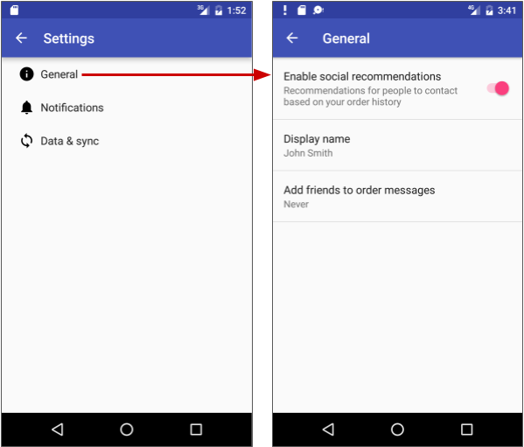

On the other hand, tablet displays, especially when viewed in the landscape orientation, are best suited for showing multiple content panes at a time: the master on the left, and the detail to the right, as shown below.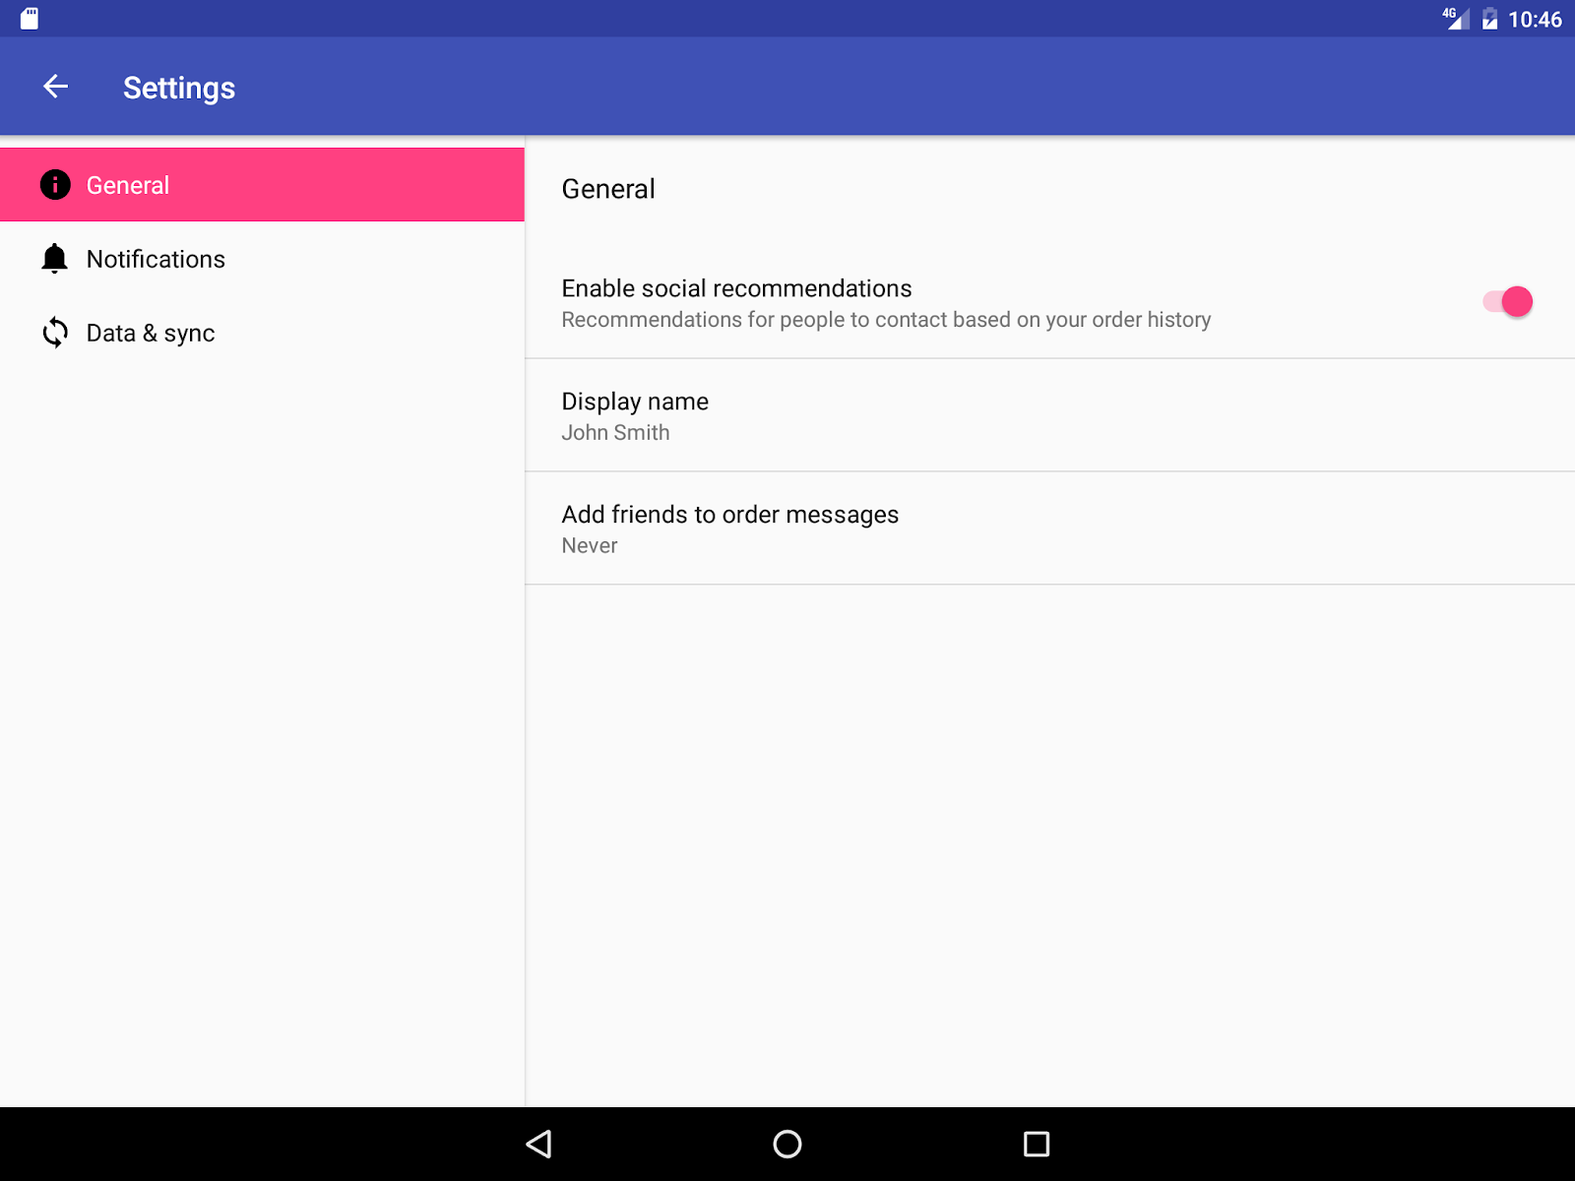

### Options menu in the app bar

The app bar typically contains the options menu, which is most often used for navigation patterns for descendant navigation. It may also contain an **Up** button for ancestral navigation, a nav icon for opening a navigation drawer, and a filter icon to filter page views. You learn how to set up the options menu and the app bar in another chapter.

## Lateral navigation with tabs and swipes

With lateral navigation, you enable the user to go from one sibling to another (at the same level in a multitier hierarchy). For example, if your app provides several categories of stories (such as Top Stories, Tech News, and Cooking, as shown in the figure below), you would want to provide your users the ability to navigate from one category to the next, or from one top story to the next, without having to navigate back up to the parent screen.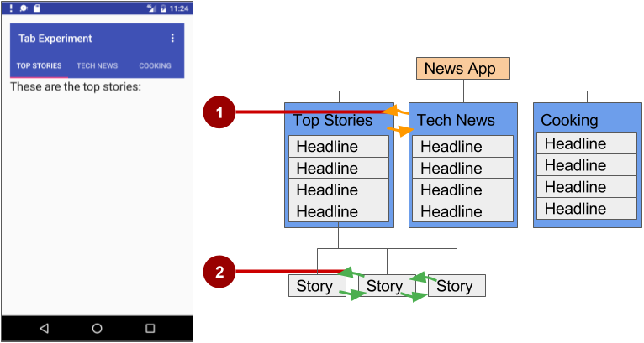

In the figure above:

1. Lateral navigation from one category screen to another
2. Lateral navigation from one story screen to another

Another example of lateral navigation is the ability to swipe left or right in a Gmail conversation to view a newer or older email in the same inbox.

You can implement lateral navigation with tabs that represent each screen. Tabs appear across the top of a screen, as shown on the left side of the figure above, providing navigation to other screens. Tab navigation is a common solution for lateral navigation from one child screen to another child screen that is a sibling—in the same position in the hierarchy and sharing the same parent screen.

Tabs are most appropriate for small sets (four or fewer) of sibling screens. You can combine tabs with swipe views, so that the user can swipe across from one screen to another as well as tap a tab.

Tabs offer two benefits:

* Because there is a single, initially selected tab, users already have access to that tab's content from the parent screen without any further navigation.
* Users can navigate quickly between related screens, without needing to first revisit the parent.

Keep in mind the following best practices when using tabs:

* Tabs are usually laid out horizontally.
* Tabs should always run along the top of the screen, and should not be aligned to the bottom of the screen.
* Tabs should be persistent across related screens. Only the designated content region should change when tapping a tab, and tab indicators should remain available at all times.
* Switching to another tab should not be treated as history. For example, if a user switches from tab A to tab B, pressing the **Up** button in the app bar should not reselect tab A but should instead return the user to the parent screen.

The key steps for implementing tabs are as follows:

1. Define the tab layout. The main class used for displaying tabs is [TabLayout](https://developer.android.com/reference/android/support/design/widget/TabLayout.html). It provides a horizontal layout to display tabs. You can show the tabs below the app bar.
2. Implement a [Fragment](https://developer.android.com/reference/android/app/Fragment.html) for each tab content screen. A Fragment is a behavior or a portion of a UI within an Activity. It's like a mini-Activity within the main Activity, with its own lifecycle. One benefit of using a Fragment for each tabbed content is that you can isolate the code for managing the tabbed content inside the Fragment. To learn about Fragment, see [Fragments](http://developer.android.com/guide/components/fragments.html) in the API Guide.
3. Add a pager adapter. Use the [PagerAdapter](https://developer.android.com/reference/android/support/v4/view/PagerAdapter.html) class to populate "pages" (screens) inside of a [ViewPager](https://developer.android.com/reference/android/support/v4/view/ViewPager.html), which is a layout manager that lets the user flip left and right through screens of data. You supply an implementation of a [PagerAdapter](https://developer.android.com/reference/android/support/v4/view/PagerAdapter.html) to generate the screens that the View shows. ViewPager is most often used in conjunction with Fragment, which is a convenient way to supply and manage the lifecycle of each screen.
4. Create an instance of the tab layout, and set the text for each tab.
5. Use PagerAdapter to manage screens ("pages"). Each screen is represented by its own Fragment.
6. Set a listener to determine which tab is tapped.

There are standard adapters for using a Fragment with the ViewPager:

* [FragmentPagerAdapter](https://developer.android.com/reference/android/support/v4/app/FragmentPagerAdapter.html): Designed for navigating between sibling screens (pages) representing a fixed, small number of screens.
* [FragmentStatePagerAdapter](https://developer.android.com/reference/android/support/v4/app/FragmentStatePagerAdapter.html): Designed for paging across a collection of screens (pages) for which the number of screens is undetermined. It destroys each Fragment as the user navigates to another screen, minimizing memory usage.

### Defining tab layout

To use a TabLayout, you can design the main Activity layout to use a Toolbar for the app bar, a TabLayout for the tabs below the app bar, and a ViewPager within the root layout to switch child elements. The layout should look similar to the following, assuming each child element fills the screen:

<android.support.v7.widget.Toolbar

android:id="@+id/toolbar"

android:layout_width="match_parent"

android:layout_height="wrap_content"

android:layout_alignParentTop="true"

android:background="?attr/colorPrimary"

android:minHeight="?attr/actionBarSize"

android:theme="@style/ThemeOverlay.AppCompat.Dark.ActionBar"

app:popupTheme="@style/ThemeOverlay.AppCompat.Light"/>

<android.support.design.widget.TabLayout

android:id="@+id/tab_layout"

android:layout_width="match_parent"

android:layout_height="wrap_content"

android:layout_below="@id/toolbar"

android:background="?attr/colorPrimary"

android:minHeight="?attr/actionBarSize"

android:theme="@style/ThemeOverlay.AppCompat.Dark.ActionBar"/>

<android.support.v4.view.ViewPager

android:id="@+id/pager"

android:layout_width="match_parent"

android:layout_height="fill_parent"

android:layout_below="@id/tab_layout"/>

For each child view, create a layout for each Fragment such as tab_fragment1.xml, tab_fragment2.xml, and so on.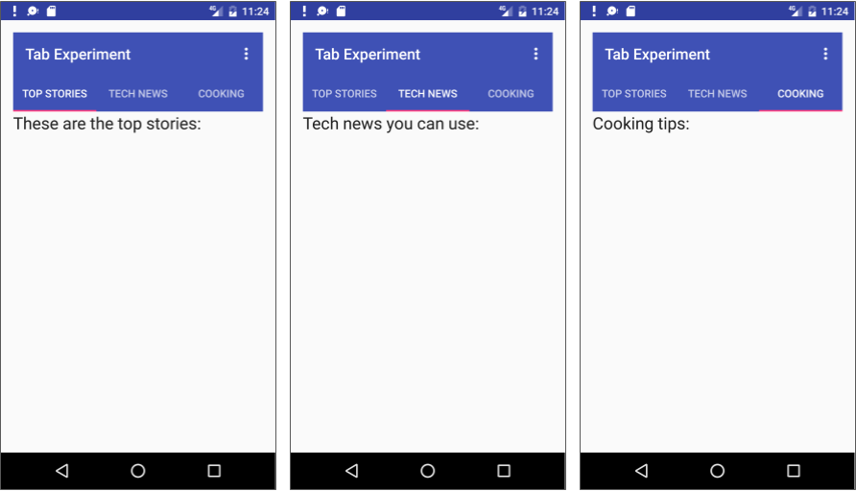

### Implementing each fragment

A [Fragment](https://developer.android.com/reference/android/app/Fragment.html) is a behavior or a portion of a UI within an Activity. It's like a mini-Activity within the main Activity, with its own lifecycle. To learn about Fragment, see [Fragments](http://developer.android.com/guide/components/fragments.html) in the API Guide.

Add a class for each Fragment (such as TabFragment1.java, TabFragment2.java, and TabFragment3.java) representing each screen the user can visit by clicking a tab. Each class should extend Fragment and inflate the layout associated with the screen (tab_fragment1.xml, tab_fragment2.xml, and tab_fragment3.xml). For example, TabFragment1.java looks like this:

public class TabFragment1 extends Fragment {

@Override

public View onCreateView(LayoutInflater inflater,

ViewGroup container, Bundle savedInstanceState) {

return inflater.inflate(R.layout.tab_fragment1, container, false);

}

}

### Adding a pager adapter

Add a PagerAdapter that extends [FragmentStatePagerAdapter](https://developer.android.com/reference/android/support/v4/app/FragmentStatePagerAdapter.html). The code should do the following:

1. Define the number of tabs.
2. Use the [getItem()](https://developer.android.com/reference/android/widget/Adapter.html#getItem(int)) method of the [Adapter](https://developer.android.com/reference/android/widget/Adapter.html) class to determine which tab is clicked.
3. Use a switch case block to return the screen (page) to show based on which tab is clicked.

The following is an example:

public class PagerAdapter extends FragmentStatePagerAdapter {

int mNumOfTabs;

public PagerAdapter(FragmentManager fm, int NumOfTabs) {

super(fm);

this.mNumOfTabs = NumOfTabs;

}

@Override

public Fragment getItem(int position) {

switch (position) {

case 0: return new TabFragment1();

case 1: return new TabFragment2();

case 2: return new TabFragment3();

default: return null;

}

}

@Override

public int getCount() {

return mNumOfTabs;

}

}

### Creating an instance of the tab layout

In the onCreate() method of the main Activity, create an instance of the tab layout from the tab_layout element in the layout, and set the text for each tab using [addTab()](https://developer.android.com/reference/android/support/design/widget/TabLayout.html#addTab(android.support.design.widget.TabLayout.Tab)):

@Override

protected void onCreate(Bundle savedInstanceState) {

// ... Rest of onCreate code

// Create an instance of the tab layout from the view.

TabLayout tabLayout = (TabLayout) findViewById(R.id.tab_layout);

// Set the text for each tab.

tabLayout.addTab(tabLayout.newTab().setText("Top Stories"));

tabLayout.addTab(tabLayout.newTab().setText("Tech News"));

tabLayout.addTab(tabLayout.newTab().setText("Cooking"));

// Set the tabs to fill the entire layout.

tabLayout.setTabGravity(TabLayout.GRAVITY_FILL);

// Use PagerAdapter to manage page views in fragments.

}

### Managing screen views in fragments with a listener

Use PagerAdapter in the onCreate() method of the main Activity to manage screen ("page") views in each Fragment. Each screen is represented by its own Fragment. You also need to set a listener to determine which tab is tapped. The following code should appear after the code from the previous section in the onCreate() method:

@Override

protected void onCreate(Bundle savedInstanceState) {

// ... Rest of onCreate code

// Use PagerAdapter to manage page views in fragments.

final ViewPager viewPager = (ViewPager) findViewById(R.id.pager);

final PagerAdapter adapter = new PagerAdapter

(getSupportFragmentManager(), tabLayout.getTabCount());

viewPager.setAdapter(adapter);

// Setting a listener for clicks.

viewPager.addOnPageChangeListener(new

TabLayout.TabLayoutOnPageChangeListener(tabLayout));

tabLayout.addOnTabSelectedListener(new

TabLayout.OnTabSelectedListener() {

@Override

public void onTabSelected(TabLayout.Tab tab) {

viewPager.setCurrentItem(tab.getPosition());

}

@Override

public void onTabUnselected(TabLayout.Tab tab) {

}

@Override

public void onTabReselected(TabLayout.Tab tab) {

}

});

}

### Using ViewPager for swipe views (horizontal paging)

[ViewPager](https://developer.android.com/reference/android/support/v4/view/ViewPager.html) is a layout manager that lets the user flip left and right through "pages" (screens) of content. ViewPager is most often used in conjunction with [Fragment](https://developer.android.com/reference/android/app/Fragment.html), which is a convenient way to supply and manage the lifecycle of each "page". ViewPager also provides the ability to swipe "pages" horizontally.

In the previous example, you used a ViewPager within the root layout to switch child screens. This provides the ability for the user to swipe from one child screen to another. Users are able to navigate to sibling screens by touching and dragging the screen horizontally in the direction of the desired adjacent screen.

Swipe views are most appropriate where there is some similarity in content type among sibling pages, and when the number of siblings is relatively small. In these cases, this pattern can be used along with tabs above the content region to indicate the current page and available pages, to aid discoverability and provide more context to the user.

**Tip**: It's best to avoid horizontal paging when child screens contain horizontal panning surfaces (such as maps), as these conflicting interactions may deter your screen's usability.

4.5: RecyclerView

**Contents:**

* [RecyclerView components](https://google-developer-training.github.io/android-developer-fundamentals-course-concepts-v2/unit-2-user-experience/lesson-4-user-interaction/4-5-c-recyclerview/4-5-c-recyclerview.html#components)
* [Implementing a RecyclerView](https://google-developer-training.github.io/android-developer-fundamentals-course-concepts-v2/unit-2-user-experience/lesson-4-user-interaction/4-5-c-recyclerview/4-5-c-recyclerview.html#implementing)
* [Related practical](https://google-developer-training.github.io/android-developer-fundamentals-course-concepts-v2/unit-2-user-experience/lesson-4-user-interaction/4-5-c-recyclerview/4-5-c-recyclerview.html#relatedpractical)
* [Learn more](https://google-developer-training.github.io/android-developer-fundamentals-course-concepts-v2/unit-2-user-experience/lesson-4-user-interaction/4-5-c-recyclerview/4-5-c-recyclerview.html#learnmore)

About RecyclerView

When you display a large number of items in a scrollable list, most of the items aren't visible. For example, in a long list of words or news headlines, the user only sees a few items at a time.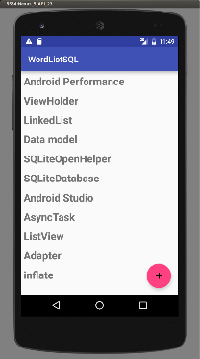

Or you may have a dataset that changes as the user interacts with it. If you create a new View every time the data changes, that's a lot of View items, even for a small dataset.

From a performance perspective, you want to conserve memory and save time:

* To conserve memory, minimize the number of View items that exist at any given point.
* To save time, minimize the number of View items you have to create.

To accomplish both these goals, create more View items than the user can see on the screen and cache the created View items. Then reuse the View items with different data as list items scroll in and out of the display.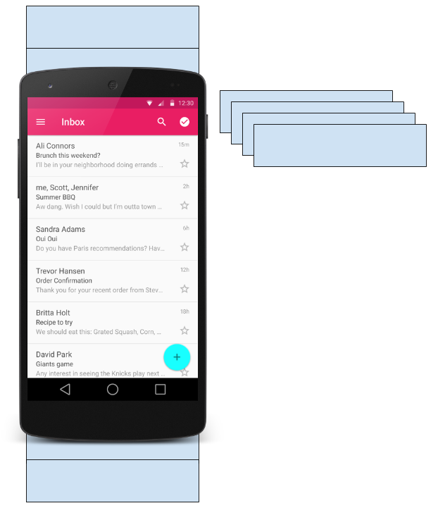

The [RecyclerView](https://developer.android.com/reference/android/support/v7/widget/RecyclerView.html) class is a more advanced and flexible version of [ListView](https://developer.android.com/reference/android/widget/ListView.html). It's a container for displaying large, scrollable data sets efficiently by maintaining a limited number of View items.

Use RecyclerView when you need to display a large amount of scrollable data, or data collections whose elements change at runtime based on user action or network events.

RecyclerView components

To display data in a [RecyclerView](https://developer.android.com/reference/android/support/v7/widget/RecyclerView.html), you need the following (refer to the figure below):

* **Data.** It doesn't matter where the data comes from. You can create the data locally, as you do in the practical, get it from a database on the device as you will do in a later practical, or pull it from the cloud.
* **A RecyclerView.** The scrolling list that contains the list items. An instance of RecyclerView as defined in the Activity layout file to act as the container for the View items.
* **Layout for one item of data.** All list items look the same, so you can use the same layout for all of them. The item layout has to be created separately from the Activity layout, so that one View item at a time can be created and filled with data.
* **A layout manager.** The layout manager handles the organization (layout) of user interface components in a View. Each ViewGroup has a layout manager. For LinearLayout, the Android system handles the layout for you. RecyclerView requires an explicit layout manager to manage the arrangement of list items contained within it. This layout could be vertical, horizontal, or a grid. The layout manager is an instance of [Recyclerview.LayoutManager](https://developer.android.com/reference/android/support/v7/widget/RecyclerView.LayoutManager) to organize the layout of the items in the RecyclerView.
* **An adapter.** Use an extension of [RecyclerView.Adapter](https://developer.android.com/reference/android/support/v7/widget/RecyclerView.Adapter.html) to connect your data to the RecyclerView. It prepares the data and how will be displayed in a ViewHolder. When the data changes, the adapter updates the contents of the respective list item view in the RecyclerView.
* **A ViewHolder.** Use an extension of [RecyclerView.ViewHolder](https://developer.android.com/reference/android/support/v7/widget/RecyclerView.ViewHolder) to contain the information for displaying one View item using the item's layout.

The diagram below shows the relationship between these components.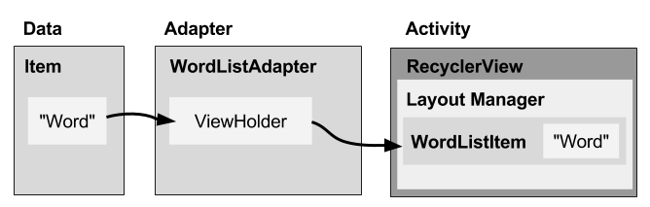

Data

Any displayable data can be shown in a RecyclerView.

* Text
* Images
* Icons

Data can come from any source.

* Created by the app. For example, scrambled words for a game.
* From a local database. For example, a list of contacts.
* From cloud storage or the internet. For example news headlines.

RecyclerView

A [RecyclerView](https://developer.android.com/reference/android/support/v7/widget/RecyclerView.html) is a ViewGroup for a scrollable container. It is Ideal for long lists of similar items.

A RecyclerView uses a limited number of View items that are reused when they go off-screen. This saves memory and makes it faster to update list items as the user scrolls through data, because it is not necessary to create a new View for every item that appears.

In general, the RecyclerView keeps as many View items as can fit on the screen, plus a few extra at each end of the list to make sure that scrolling is fast and smooth.

Item Layout

The layout for a list item is kept in a separate XML layout file so that the adapter can create View items and edit their contents independently from the layout of the Activity.

Layout Manager

A layout manager positions View items inside a ViewGroup, such as the [RecyclerView](https://developer.android.com/reference/android/support/v7/widget/RecyclerView.html), and determines when to reuse View items that are no longer visible to the user. To reuse (or recycle) a View, a layout manager may ask the adapter to replace the contents of the View with a different element from the dataset. Recycling View items in this manner improves performance by avoiding the creation of unnecessary View items or performing expensive [findViewById()](https://developer.android.com/reference/android/app/Activity.html#findViewById(int)) lookups.

[RecyclerView](https://developer.android.com/reference/android/support/v7/widget/RecyclerView.html) provides these built-in layout managers:

* [LinearLayoutManager](https://developer.android.com/reference/android/support/v7/widget/LinearLayoutManager.html) shows items in a vertical or horizontal scrolling list.
* [GridLayoutManager](https://developer.android.com/reference/android/support/v7/widget/GridLayoutManager.html) shows items in a grid.
* [StaggeredGridLayoutManager](https://developer.android.com/reference/android/support/v7/widget/StaggeredGridLayoutManager.html) shows items in a staggered grid.

To create a custom layout manager, extend the [RecyclerView.LayoutManager](https://developer.android.com/reference/android/support/v7/widget/RecyclerView.LayoutManager.html) class.

Animations

Animations for adding and removing items are enabled by default in [RecyclerView](https://developer.android.com/reference/android/support/v7/widget/RecyclerView.html). To customize these animations, extend the [RecyclerView.ItemAnimator](https://developer.android.com/reference/android/support/v7/widget/RecyclerView.ItemAnimator.html) class and use the [RecyclerView.setItemAnimator()](https://developer.android.com/reference/android/support/v7/widget/RecyclerView.html#setItemAnimator(android.support.v7.widget.RecyclerView.ItemAnimator))method.

Adapter

An *adapter*helps two incompatible interfaces to work together. In a RecyclerView, the adapter connects data with View items. It acts as an intermediary between the data and the View. The adapter receives or retrieves the data, does any work required to make it displayable in a View, and places the data in a View.

For example, the adapter may receive data from a database as a [Cursor](https://developer.android.com/reference/android/database/Cursor.html) object, extract the the word and its definition, convert them to strings, and place the strings in a View item that has two TextViewelements—one for the word and one for the definition. You will learn more about cursors in a later chapter.

The [RecyclerView.Adapter](https://developer.android.com/reference/android/support/v7/widget/RecyclerView.Adapter.html) implements a ViewHolder, and must override the following callbacks:

* onCreateViewHolder() inflates a View item and returns a new ViewHolder that contains it. This method is called when the RecyclerView needs a new ViewHolder to represent an item.
* onBindViewHolder() sets the contents of a View item at a given position in the RecyclerView. This is called by the RecyclerView, for example, when a new View item scrolls onto the screen.
* getItemCount() returns the total number of items in the data set held by the adapter.

ViewHolder

A [RecyclerView.ViewHolder](https://developer.android.com/reference/android/support/v7/widget/RecyclerView.ViewHolder.html) describes a View item and metadata about its place within the RecyclerView. Each ViewHolder holds one set of data. The adapter adds data to each ViewHolder for the layout manager to display.

You define your ViewHolder layout in an XML resource file. It can contain (almost) any type of View, including clickable elements.

Implementing a RecyclerView

Implementing a RecyclerView requires the following steps:

1. Add the RecyclerView dependency if needed (depending on which template is used for the Activity).
2. Add the RecyclerView to the Activity layout.
3. Create a layout XML file for one View item.
4. Extend RecyclerView.Adapter and implement the onCreateViewHolder() and onBindViewHolder()methods.
5. Extend RecyclerView.ViewHolder to create a ViewHolder for your item layout. You can add click behavior by overriding the onClick() method.
6. In the Activity, inside the onCreate() method, create a RecyclerView and initialize it with the adapter and a layout manager.

Adding the dependency

The RecyclerView library ([android.support.v7.widget.RecyclerView](https://developer.android.com/reference/android/support/v7/widget/RecyclerView.html)) is part of the [Support Library](https://developer.android.com/topic/libraries/support-library/packages.html). Some Activity templates, such as the Basic Activity template, already include the Support Library dependency in the app's build.gradle (Module: app) file.

If Android Studio doesn't suggest <android.support.v7.widget.RecyclerView when entering **<RecyclerView** in the layout editor, you need to add the Support Library dependency for RecyclerView to the dependencies section of the app's build.gradle (Module: app) file:

compile 'com.android.support:recyclerview-v7:26.1.0'

If Android Studio highlights the above dependency and suggests a newer version, enter the version numbers for the newer version.

Adding a RecyclerView to the Activity layout

Add the RecyclerView to the Activity layout file:

<android.support.v7.widget.RecyclerView

android:id="@+id/recyclerview"

android:layout_width="match_parent"

android:layout_height="match_parent">

</android.support.v7.widget.RecyclerView>

Use the RecyclerView from the Support Library ([android.support.v7.widget.RecyclerView](https://developer.android.com/reference/android/support/v7/widget/RecyclerView.html)) to be compatible with older versions of Android. The only required attributes are the id, the layout_width, and the layout_height. For customizing with more attributes, add the attributes to the items, not to this RecyclerView, which is a ViewGroup.

Creating the layout for one item

Create an XML resource file and specify the layout of one item. The adapter uses this code to create the ViewHolder.

<LinearLayout xmlns:android="http://schemas.android.com/apk/res/android"

android:layout_width="match_parent"

android:layout_height="wrap_content"

android:orientation="vertical"

android:padding="6dp">

<TextView

android:id="@+id/word"

style="@style/word_title" />

</LinearLayout>

The TextView has a @style element. A style is a collection of properties that specifies the look of a View. You can use styles to share display attributes with multiple View elements. An easy way to create a style is to extract the style of a View element that you already created. For example, after styling a TextView:

1. Right-click (or Control-click) the TextView.
2. Choose**Refactor > Extract > Style**.
3. Name your style, leave all other options selected, and select the L**aunch 'Use Style Where Possible**' option. Then click **OK**.
4. When prompted, apply the style to the **Whole Project**.

You learn more about styles in another lesson.

Creating an adapter with a ViewHolder

Extend [RecyclerView.Adapter](https://developer.android.com/reference/android/support/v7/widget/RecyclerView.Adapter.html) and implement the onCreateViewHolder() and onBindViewHolder()methods.

Create a new Java class with the following signature:

public class WordListAdapter extends

RecyclerView.Adapter<WordListAdapter.WordViewHolder> {

In the constructor, get an inflater from the current context, and your data.

public WordListAdapter(Context context, LinkedList<String> wordList) {

mInflater = LayoutInflater.from(context);

this.mWordList = wordList;

}

For this adapter, you have to implement three methods:

1. onCreateViewHolder() creates a View and returns it.
2. @Override
3. public WordViewHolder onCreateViewHolder(ViewGroup parent,
4. int viewType){
5. // Inflate an item view.
6. View mItemView =
7. mInflater.inflate(R.layout.wordlist_item,
8. parent, false);
9. return new WordViewHolder(mItemView, this);
10. }
11. onBindViewHolder() associates the data with the ViewHolder for a given position in the RecyclerView.
12. @Override
13. public void onBindViewHolder(
14. WordViewHolder holder, int position) {
15. // Retrieve the data for that position
16. String mCurrent = mWordList.get(position);
17. // Add the data to the view
18. holder.wordItemView.setText(mCurrent);
19. }
20. getItemCount() returns to number of data items available for displaying.
21. @Override
22. public int getItemCount() {
23. return mWordList.size();
24. }

Implementing the ViewHolder class

The ViewHolder class for your item layout is usually defined as an inner class to the adapter. Extend [RecyclerView.ViewHolder](https://developer.android.com/reference/android/support/v7/widget/RecyclerView.ViewHolder.html) to create the ViewHolder. You can add click behavior by overriding the onClick()method.

class WordViewHolder extends RecyclerView.ViewHolder {

If you want to add click handling, you need to implement [View.onClickListener](https://developer.android.com/reference/android/view/View.OnClickListener.html). One way to do this is to have the ViewHolder implement the View.onClickListener methods.

// Extend the signature of WordViewHolder to implement a click listener.

class WordViewHolder extends RecyclerView.ViewHolder

implements View.OnClickListener {

In its constructor, the ViewHolder has to inflate its layout, associate with its adapter, and, if applicable, set a click listener.

public WordViewHolder(View itemView, WordListAdapter adapter) {

super(itemView);

wordItemView = itemView.findViewById(R.id.word);

this.mAdapter = adapter;

itemView.setOnClickListener(this);

}

And, if you implementing [View.onClickListener](https://developer.android.com/reference/android/view/View.OnClickListener.html), you also have to implement onClick().

@Override

public void onClick(View v) {

wordItemView.setText ("Clicked! "+ wordItemView.getText());

}

If you want to attach click listeners to other elements of the ViewHolder, do that dynamically in onBindViewHolder() (you will do this in another practical).

Creating the RecyclerView

Finally, to tie it all together, add to the Activity the following:

1. Declare a RecyclerView.
2. private RecyclerView mRecyclerView;
3. In the Activity onCreate() method, get a handle to the RecyclerView in the layout:
4. mRecyclerView = findViewById(R.id.recyclerview);
5. Create an adapter and supply the data to be displayed.
6. mAdapter = new WordListAdapter(this, mWordList);
7. Connect the adapter with the RecyclerView.
8. mRecyclerView.setAdapter(mAdapter);
9. Give the RecyclerView a default layout manager.
10. mRecyclerView.setLayoutManager(new LinearLayoutManager(this));

RecyclerView is an efficient way to display scrolling list data. It uses the adapter pattern to connect data with list item views. To implement a RecyclerView, you need to create an adapter and a ViewHolder. You also need to create the methods that take the data and add it to the list items.

# 5.1: Drawables, styles, and themes

**Contents:**

* [Introduction](https://google-developer-training.github.io/android-developer-fundamentals-course-concepts-v2/unit-2-user-experience/lesson-5-delightful-user-experience/5-1-c-drawables-styles-and-themes/5-1-c-drawables-styles-and-themes.html#chaperstart)
* [Drawables](https://google-developer-training.github.io/android-developer-fundamentals-course-concepts-v2/unit-2-user-experience/lesson-5-delightful-user-experience/5-1-c-drawables-styles-and-themes/5-1-c-drawables-styles-and-themes.html#drawables)
* [Images](https://google-developer-training.github.io/android-developer-fundamentals-course-concepts-v2/unit-2-user-experience/lesson-5-delightful-user-experience/5-1-c-drawables-styles-and-themes/5-1-c-drawables-styles-and-themes.html#create_assets)
* [Styles](https://google-developer-training.github.io/android-developer-fundamentals-course-concepts-v2/unit-2-user-experience/lesson-5-delightful-user-experience/5-1-c-drawables-styles-and-themes/5-1-c-drawables-styles-and-themes.html#styles)
* [Themes](https://google-developer-training.github.io/android-developer-fundamentals-course-concepts-v2/unit-2-user-experience/lesson-5-delightful-user-experience/5-1-c-drawables-styles-and-themes/5-1-c-drawables-styles-and-themes.html#themes)
* [Related practical](https://google-developer-training.github.io/android-developer-fundamentals-course-concepts-v2/unit-2-user-experience/lesson-5-delightful-user-experience/5-1-c-drawables-styles-and-themes/5-1-c-drawables-styles-and-themes.html#relatedpractical)
* [Learn more](https://google-developer-training.github.io/android-developer-fundamentals-course-concepts-v2/unit-2-user-experience/lesson-5-delightful-user-experience/5-1-c-drawables-styles-and-themes/5-1-c-drawables-styles-and-themes.html#learnmore)

In this chapter you learn how to use drawables, which are compiled images that you can use in your app. Android provides classes and resources to help you include rich images in your application with a minimal impact to your app's performance.

You also learn how to use styles and themes to provide a consistent appearance to all the elements in your app while reducing the amount of code.

## Drawables

A [Drawable](https://developer.android.com/reference/android/graphics/drawable/Drawable.html) is a graphic that can be drawn to the screen. You retrieve a Drawable using APIs such as [getDrawable(int)](https://developer.android.com/reference/android/content/res/Resources.html#getDrawable(int,%20android.content.res.Resources.Theme)), and you apply a Drawable to an XML resource using attributes such as android:drawable and android:icon.

Android includes several types of drawables, most of which are covered in this chapter.

Covered in this chapter:

* Image files
* Nine-patch files
* Layer lists
* Shape drawables
* State lists
* Level lists
* Transition drawables
* Vector drawables

Not covered in this chapter:

* Scale drawables
* Inset drawables
* Clip drawables

### Using drawables

To display a Drawable, use the [ImageView](https://developer.android.com/reference/android/widget/ImageView.html) class to create a View. In the <ImageView> element in your XML file, define how the Drawable is displayed and where the Drawable file is located. For example, this ImageView displays an image called "birthdaycake.png":

<ImageView

android:id="@+id/tiles"

android:layout_width="wrap_content"

android:layout_height="wrap_content"

android:src="@drawable/birthdaycake" />

About the <ImageView> attributes:

* The android:id attribute sets a shortcut name that you use to call the image later.
* The android:layout_width and android:layout_height attributes specify the size of the View. In the above example the height and width are set to wrap_content, which means the View is only big enough to enclose the image within it, plus padding.
* The android:src attribute gives the location where this image is stored. If you have versions of the image that are appropriate for different screen resolutions, store them in folders named res/drawable-density/. For example, store a version of birthdaycake.png appropriate for hdpi screens in res/drawable-hdpi/birthdaycake.png. For more information, see [Screen Compatibility Overview](https://developer.android.com/guide/practices/screens_support.html).
* <ImageView> also has attributes that you can use to crop your image if it is too large or has a different aspect ratio than the layout or the View. For complete details, see [ImageView](https://developer.android.com/reference/android/widget/ImageView.html).

To represent a drawable in your app, use the [Drawable](https://developer.android.com/reference/android/graphics/drawable/Drawable.html) class or one of its subclasses. For example, this code retrieves the birthdaycake.png image as a Drawable:

Resources res = getResources();

Drawable drawable = res.getDrawable(R.drawable.birthdaycake);

### Image files

An image file is a generic bitmap file. Android supports image files in several formats: [WebP](https://developers.google.com/speed/webp/) (preferred), PNG (preferred), and JPG (acceptable). GIF and BMP formats are supported, but discouraged.

The WebP format is fully supported from Android 4.2. WebP compresses better than other formats for lossless and lossy compression, potentially resulting in images more than 25% smaller than JPEG formats. You can [convert](https://developers.google.com/speed/webp/#webp_converter_download_stylefont-weight_bold) existing PNG and JPEG images into WebP format before upload. For more about WebP, see the [WebP documentation](https://developers.google.com/speed/webp/faq).

Store image files in the res/drawable folder. Use them with the android:src attribute for an ImageViewand its descendants, or to create a [BitmapDrawable](https://developer.android.com/reference/android/graphics/drawable/BitmapDrawable.html) class in Java code.

Be aware that images look different on screens with different pixel densities and aspect ratios. For information on supporting different screen sizes, see [Speeding up your app](https://google-developer-training.github.io/android-developer-fundamentals-course-concepts-v2/unit-2-user-experience/lesson-5-delightful-user-experience/5-1-c-drawables-styles-and-themes/5-1-c-drawables-styles-and-themes.html#speeding_up) (below) and [Support Different Screen Sizes](https://developer.android.com/training/multiscreen/screensizes.html).

**Note:** Always use appropriately sized images, because images can use up a lot of disk space and affect your app's performance.

### Nine-patch files

A 9-patch is a PNG image in which you define stretchable regions. Use a 9-patch as the background image for a View to make sure the View looks correct for different screen sizes and orientations.

For example, in a View that has layout_width set to "wrap_content", the View stays big enough to enclose its content (plus padding). If you use a normal PNG image as the background image for the View, the image might be too small for the View on some devices, because the View stretches to accommodate the content inside it. If you use a 9-patch image instead, the 9-patch stretches as the Viewstretches.

The Android standard [Button](https://developer.android.com/reference/android/widget/Button.html) is an example of a View that uses a 9-patch as its background image. The 9-patch stretches to accommodate the text or image inside the Button.

Save 9-patch files with a .9.png extension and store them in the res/drawable folder. Use them with the android:src attribute for an ImageView and its descendants, or to create a [NinePatchDrawable](https://developer.android.com/reference/android/graphics/drawable/NinePatchDrawable.html) class in Java code.

To create a 9-patch, use the [Draw 9-Patch tool](https://developer.android.com/studio/write/draw9patch.html) in Android Studio. The tool lets you start with a regular PNG and define a 1-pixel border around the image in places where it's okay for the Android system to stretch the image if needed. To use the tool:

1. Put a PNG file into the res/drawable folder. (To do this, copy the image file into the **app/src/main/res/drawable** folder of your project.)
2. In Android Studio, **right-click** (or **Control-click**) the file and choose **Create 9-Patch file**. Android Studio saves the file with a .9.png extension.
3. In Android Studio, double-click the **.9.png** file to open the editor.
4. Specify which regions of the image are okay to stretch.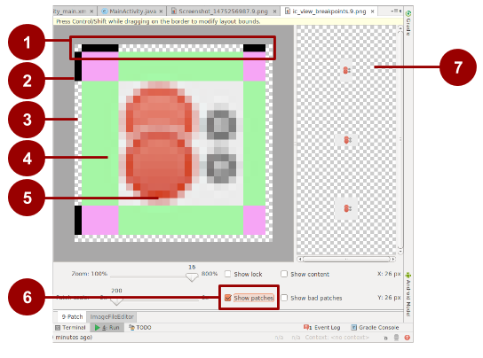

In this figure:

1. Border to indicate which regions are okay to stretch for width (horizontally). For example, in a Viewthat is wider than the image, the green stripes on the left- and right-hand sides of this 9-patch can be stretched to fill the View. Places that can stretch are marked with black. Click to turn pixels black.
2. Border to indicate regions that are okay to stretch for height (vertically). For example, in a View that is taller than the image, the green stripes on the top and bottom of this 9-patch can be stretched to fill the View.
3. Turn off pixels by pressing **Shift-click** (**Control-click** in macOS).
4. Stretchable area.
5. Not stretchable.
6. Check **Show patches** to preview the stretchable patches in the drawing area.
7. Previews of stretched image.

**Tip:**Make sure that stretchable regions are at least 2x2 pixels in size. Otherwise, they may disappear when the image is scaled down.

For a more detailed discussion about how to create a 9-patch file with stretchable regions, see the [9-patch drawables](https://developer.android.com/guide/topics/graphics/2d-graphics.html#nine-patch).

### Layer list drawables

In Android you can build up an image by layering other images together, just as you can in Gimp and other image-manipulation programs. Each layer is represented by an individual Drawable. The drawables that make up a single image are organized and managed in a <layer-list> element in XML. Within the <layer-list>, each Drawable is represented by an <item> element.

Layers are drawn on top of each other in the order defined in the XML file, which means that the last Drawable in the list is drawn on top. For example, this layer list Drawable is made up of three drawables superimposed on each other:

In the following XML, which defines this layer list, the android_blue image is defined last, so it's drawn last and shown on top:

<layer-list xmlns:android="http://schemas.android.com/apk/res/android">

<item>

<bitmap android:src="@drawable/android_red"

android:gravity="center" />

</item>

<item android:top="10dp" android:left="10dp">

<bitmap android:src="@drawable/android_green"

android:gravity="center" />

</item>

<item android:top="20dp" android:left="20dp">

<bitmap android:src="@drawable/android_blue"

android:gravity="center" />

</item>

</layer-list>

A [LayerDrawable](https://developer.android.com/reference/android/graphics/drawable/LayerDrawable.html) is a Drawable object that manages an array of other drawables. For more information about how to use a layer list Drawable, see the [Layer list in Drawable Resources](https://developer.android.com/guide/topics/resources/drawable-resource.html#LayerList).

### Shape drawables

A shape Drawable is a rectangle, oval, line, or ring that you define in XML. You specify the size and style of the shape using XML attributes.

For example, this XML file creates a rectangle with rounded corners and a color gradient. The rectangle's fill color shifts from white (#000000) in the lower left corner to blue (#0000dd) in the upper right corner. The angle attribute determines how the gradient is tilted:

<shape xmlns:android="http://schemas.android.com/apk/res/android"

android:shape="rectangle">

<corners android:radius="8dp" />

<gradient

android:startColor="#000000"

android:endColor="#0000dd"

android:angle="45"/>

<padding android:left="7dp"

android:top="7dp"

android:right="7dp"

android:bottom="7dp" />

</shape>

Assuming that the shape Drawable XML file is saved at res/drawable/gradient_box.xml, the following layout XML applies the shape Drawable as the background to a View:

<TextView

android:background="@drawable/gradient_box"

android:layout_height="wrap_content"

android:layout_width="wrap_content" />

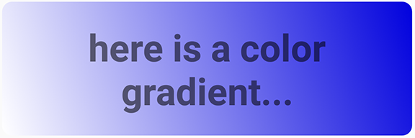

The following code shows how to programmatically get the shape Drawable and use it as the background for a View, as an alternative to defining the background attribute in XML:

Resources res = getResources();

Drawable shape = res. getDrawable(R.drawable.gradient_box);

TextView tv = (TextView)findViewByID(R.id.textview);

tv.setBackground(shape);

You can set other attributes for a shape Drawable. The complete syntax is as follows:

<shape

xmlns:android="http://schemas.android.com/apk/res/android"

android:shape=["rectangle" | "oval" | "line" | "ring"] >

<!-- If it's a line, the stroke element is required. -->

<corners

android:radius="integer"

android:topLeftRadius="integer"

android:topRightRadius="integer"

android:bottomLeftRadius="integer"

android:bottomRightRadius="integer" />

<gradient

android:angle="integer"

<!-- The angle must be 0 or a multiple of 45 -->

android:centerX="float"

android:centerY="float"

android:centerColor="integer"

android:endColor="color"

android:gradientRadius="integer"

android:startColor="color"

android:type=["linear" | "radial" | "sweep"]

android:useLevel=["true" | "false"] />

<padding

android:left="integer"

android:top="integer"

android:right="integer"

android:bottom="integer" />

<size

android:width="integer"

android:height="integer" />

<solid

android:color="color" />

<stroke

android:width="integer"

android:color="color"

android:dashWidth="integer"

android:dashGap="integer" />

</shape>

For details about these attributes, see [Shape drawable in Drawable Resources](https://developer.android.com/guide/topics/resources/drawable-resource.html#Shape).

### State list drawables

A [StateListDrawable](https://developer.android.com/reference/android/graphics/drawable/StateListDrawable.html) is a Drawable object that uses a different image to represent the same object, depending on what state the object is in. For example, a [Button](https://developer.android.com/reference/android/widget/Button.html) can exist in one of several states (pressed, focused on, hovered over, or none of these). Using a state list Drawable, you can provide a different background image for each state.

You describe the state list in an XML file. Each graphic is represented by an <item> element inside a single <selector> element. Each <item> uses a state_ attribute to indicate the situation in which the graphic is used.

During each state change, Android traverses the state list from top to bottom. The first item that matches the current state is used, which means that the selection is not based on the best match, but is simply the first item that meets the minimum criteria of the state.

The state list in the following example defines which image is shown for a Button when the Button is in different states. When the Button is pressed—that is, when state_pressed="true"—the app shows an image named button_pressed. When the Button is in focus (state_focused="true"), or when the Button is being hovered over (state_hovered="true"), the app shows a different Drawable for the Button.

<selector xmlns:android="http://schemas.android.com/apk/res/android">

<item android:state_pressed="true"

android:drawable="@drawable/button_pressed" /> <!-- pressed -->

<item android:state_focused="true"

android:drawable="@drawable/button_focused" /> <!-- focused -->

<item android:state_hovered="true"

android:drawable="@drawable/button_focused" /> <!-- hovered -->

<item android:drawable="@drawable/button_normal" /> <!-- default -->

</selector>

Other available states include android:state_selected, android:state_checkable, android:state_checked, and others. For details about all the options, see [State list in Drawable Resources](https://developer.android.com/guide/topics/resources/drawable-resource.html#StateList).

### Level list drawables

A level list drawable defines alternate drawables, each assigned a maximum numerical value. To select which drawable to use, call the setLevel() method, passing in an integer that is matched against the maximum level integer defined in XML. The resource with the lowest maximum level greater than or equal to the integer passed into setLevel() is selected.

For example, the following XML defines a level list that includes two alternate drawables, status_off and status_on:

<level-list xmlns:android="http://schemas.android.com/apk/res/android" >

<item

android:drawable="@drawable/status_off"

android:maxLevel="0" />

<item

android:drawable="@drawable/status_on"

android:maxLevel="1" />

</level-list>

To select the status_off Drawable, call setLevel(0). To select the status_on Drawable, call setLevel(1).

An example use of a [LevelListDrawable](https://developer.android.com/reference/android/graphics/drawable/LevelListDrawable.html) is a battery level indicator icon  that uses different images to indicate different current battery levels. #WIDTH: 24.00[IMAGEINFO]: ic_battery_charging_icon.png, Battery icon

### Transition drawables

A [TransitionDrawable](https://developer.android.com/reference/android/graphics/drawable/TransitionDrawable.html) is a Drawable that crossfades between two other drawables. To define a TransitionDrawable in XML, use the <transition> element. Each Drawable is represented by an <item> element inside the <transition> element. No more than two <item> elements are supported.

For example, this drawable crossfades between an "on" state and an "off" state drawable:

<transition xmlns:android="http://schemas.android.com/apk/res/android">

<item android:drawable="@drawable/on" />

<item android:drawable="@drawable/off" />

</transition>

To transition forward, meaning to shift from the first Drawable to the second, call [startTransition()](https://developer.android.com/reference/android/graphics/drawable/TransitionDrawable.html#startTransition(int)). To transition in the other direction, call [reverseTransition()](https://developer.android.com/reference/android/graphics/drawable/TransitionDrawable.html#reverseTransition(int)). Each of these methods takes an argument of type int, representing the number of milliseconds for the transition.

### Vector drawables

In Android 5.0 (API Level 21) and above, you can define vector drawables, which are images that are defined by a path. A vector Drawable scales without losing definition. Most vector drawables use SVG files, which are plain text files or compressed binary files that include two-dimensional coordinates for how the image is drawn on the screen.

Because SVG files are text, they are more space efficient than most other image files. Also, you only need one file for a vector image instead of a file for each screen density, as is the case for bitmap images.

To bring an existing vector image or a Material Design icon into your Android Studio project as a vector Drawable:

1. **Right-click** (or **Control-click**) on the **drawable** folder in the **Project > Android** pane.
2. Select **New > Vector Asset**. The Vector Asset Studio opens and guides you through the process.

To create a vector image, define the details of the shape inside a <vector> XML element. For example, the following code defines the shape of a heart and fills it with a red color (#f00):

<vector xmlns:android="http://schemas.android.com/apk/res/android"

<!-- intrinsic size of the drawable -->

android:height="256dp"

android:width="256dp"

<!-- size of the virtual canvas -->

android:viewportWidth="32"

android:viewportHeight="32">

<!-- draw a path -->

<path android:fillColor="#f00"

android:pathData="M20.5,9.5

c-1.955,0,-3.83,1.268,-4.5,3

c-0.67,-1.732,-2.547,-3,-4.5,-3

C8.957,9.5,7,11.432,7,14

c0,3.53,3.793,6.257,9,11.5

c5.207,-5.242,9,-7.97,9,-11.5

C25,11.432,23.043,9.5,20.5,9.5z" />

</vector>

Android Studio shows a preview of vector drawables. For example, here's the result of creating the XML file described above: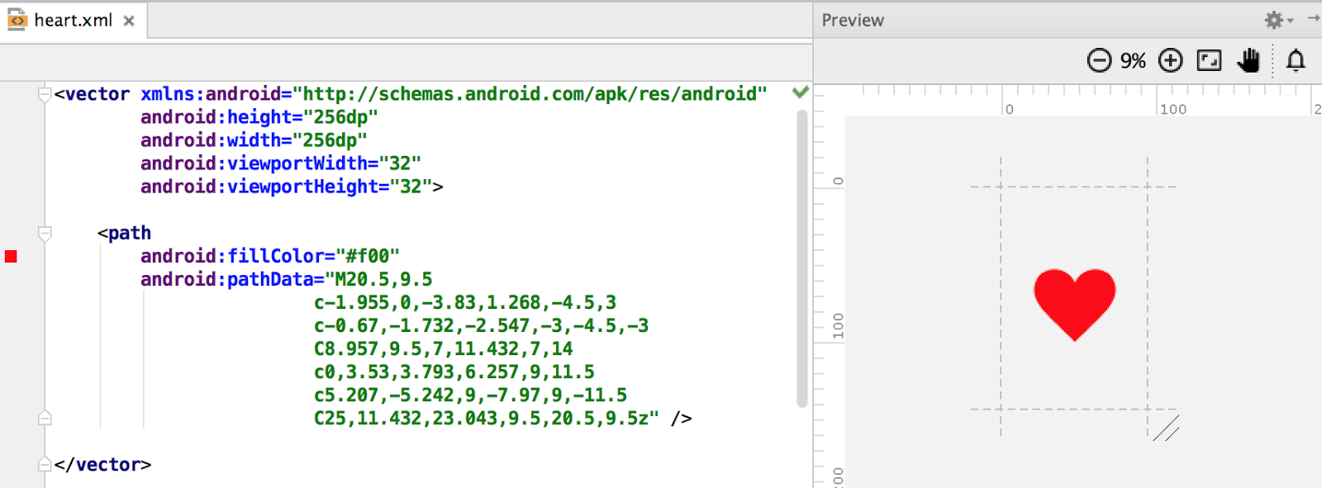

If you already have an image in SVG format, there are several ways to get the image's pathDatainformation:

* In Android Studio, **right-click** (or **Control-click**) on the **drawable** folder and select **New > Vector Asset** to open the Vector Asset Studio tool. Use the tool to import a local SVG file.
* Use a file-conversion tool such as [svg2android](http://inloop.github.io/svg2android/).
* Open the image in a text editor, or if you're viewing the image in a browser, view the page source. Look for the d= information, which is equivalent to the pathData in your XML.

Vector images are represented in Android as [VectorDrawable](https://developer.android.com/reference/android/graphics/drawable/VectorDrawable.html) objects. For details about the pathDatasyntax, see the [SVG Path reference](http://www.w3.org/TR/SVG11/paths.html#PathData). To learn how to animate the properties of vector drawables, see [Animate Drawable Graphics](https://developer.android.com/guide/topics/graphics/drawable-animation.html).

## Images

Images, from launcher icons to banner images, are used in many ways in Android. Each use case has different requirements for image resolution, scalability and simplicity. In this section you learn about the different ways to generate images and include them in your app.

### Creating icons

Every app requires at least a launcher icon, and apps often include icons for [action bar actions](https://developer.android.com/training/appbar/actions.html), [notifications](https://developer.android.com/guide/topics/ui/notifiers/notifications.html), and other use cases.

There are two approaches to creating icons:

* Create a set of image files of the same icon in different resolutions and sizes so that the icon looks the same across devices with different screen densities. You can use Image Asset Studio to do this.
* Use vector drawables, which scale automatically without the image becoming pixelated or blurry. You can use Vector Asset Studio to do this.

#### **Image Asset Studio**

Android Studio includes a tool called Image Asset Studio that helps you generate your own app icons from [Material Design icons](https://design.google.com/icons/), custom images, and text strings. It generates a set of icons at the appropriate resolution for each [generalized screen density](https://developer.android.com/guide/practices/screens_support) that your app supports. Image Asset Studio places the newly generated icons in density-specific folders under the res/ folder in your project. At runtime, Android uses the appropriate resource based on the screen density of the device your app is running on.

Image Asset Studio helps you generate the following icon types:

* Launcher icons
* Action bar and tab icons
* Notification icons

To use Image Asset Studio, **right-click** (or **Control-click**) on the **res** folder in the **Project > Android**pane of Android Studio, and select **New > Image Asset**. The Configure Asset Studio wizard opens and guides you through the process.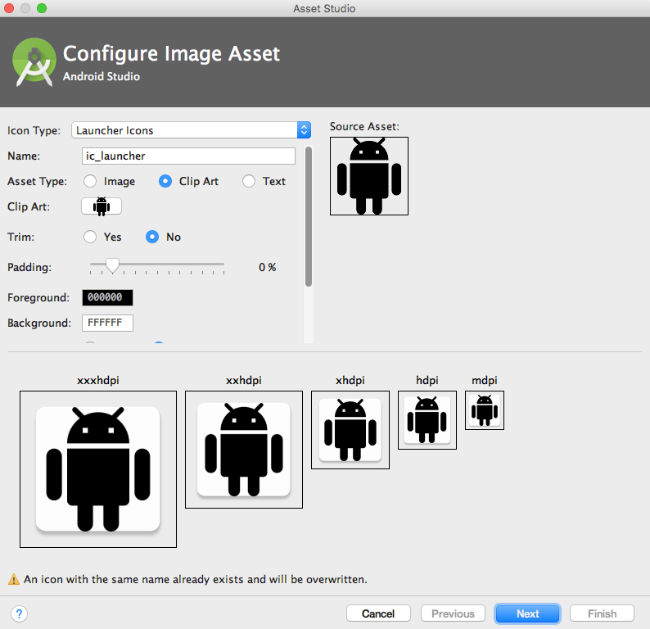

For more about Image Asset Studio, see [Image Asset Studio](https://developer.android.com/studio/write/image-asset-studio.html#access).

#### **Vector Asset Studio**

Starting with API 21, you can use vector drawables instead of image files for your icons.

Advantages of using vector drawables as icons:

* Vector drawables can reduce your APK file size dramatically, because you don't have to include multiple versions of each icon image. You can use one vector image to scale seamlessly to any resolution.
* Users might be more likely to download an app that has smaller files and a smaller package size.

Disadvantages of using vector drawables as icons:

* A vector drawable can include only a limited amount of detail. Vector drawables are mostly used for less detailed icons such as the [Material Design icons](https://design.google.com/icons/). Icons with more detail usually need image files.
* Vector drawables are not supported on devices running API level 20 or below.

To use vector drawables on devices running API level 20 or below, you have to decide between two methods of backward-compatibility:

* By default, at build time the system creates bitmap versions of your vector drawables in different resolutions. This allows the icons to run on devices that aren't able to draw vector drawables.
* The [VectorDrawableCompat](https://developer.android.com/reference/android/support/graphics/drawable/VectorDrawableCompat.html) class in the Android Support Library allows you to support vector drawables in Android 2.1 (API level 7) and higher.

Vector Asset Studio is a tool that helps you add Material Design icons and vector drawables to your Android project. To use it, **right-click** (or **Control-click**) on the **res** folder in the **Project > Android** pane of Android Studio, and select **New > Vector Asset**. The Configure Asset Studio wizard opens and guides you through the process.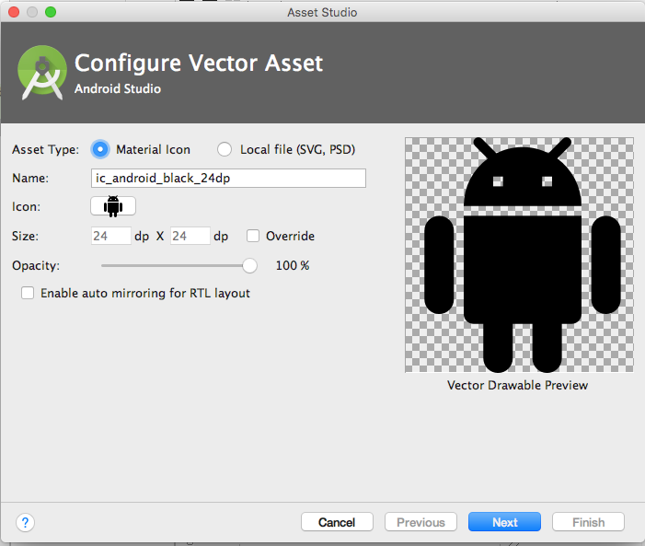

For more information on using the Vector Asset Studio and supporting backward compatibility, see [Vector Asset Studio](https://developer.android.com/studio/write/vector-asset-studio.html#running).

### Creating other images

Banner images, user profile pictures, and other images come in all shapes and sizes. In many cases they are larger than they need to be for a typical app UI. For example, the system Gallery app displays photos taken using an Android device's camera, and these photos are typically much higher resolution than the screen density of the device.

Android devices have finite memory, so ideally, you want to load only a lower resolution version of a photo in memory. The lower resolution version should match the size of the UI component that displays it. An image with a higher resolution doesn't provide any visible benefit, but still takes up precious memory and adds additional performance overhead due to additional on-the-fly scaling.

You can load resized images manually (see [Loading Large Bitmaps Efficiently](https://developer.android.com/topic/performance/graphics/load-bitmap.html)), but several third party libraries have been created to help with loading, scaling and caching images.

### Using image-loading libraries

Image-loading libraries like [Glide](https://github.com/bumptech/glide) and [Picasso](http://square.github.io/picasso/) can handle image sizing, caching, and display. These third-party libraries are optimized for mobile, and they are well-documented.

Glide supports fetching, decoding, and displaying video stills, images, and animated GIFs. You can use Glide to load images from Web APIs, as well as ones located in your resource files. Glide includes features such as loading placeholder images (for loading more detailed images), cross-fade animations, and automatic caching.

To use Glide:

1. [Download the library](https://github.com/bumptech/glide#download).
2. Include the dependency in your app-level build.gradle file, replacing *n.n.n* with [the latest version of Glide](https://github.com/bumptech/glide/releases):

compile 'com.github.bumptech.glide:glide:n.n.n'

You can use Glide to load any image into a UI element. The following example loads an image from a URL into an ImageView:

ImageView imageView = (ImageView) findViewById(R.id.my_image_view);

Glide.with(this).load("URL").into(imageView);

In the code snippet, this refers to the context of the application. Replace URL with the URL of the image's location. By default, the image is stored in a local cache and accessed from there the next time it's called.

* For more examples, see the [Glide wiki](https://github.com/bumptech/glide/wiki).
* For more about Glide, see the [Glide documentation](https://github.com/bumptech/glide#glide) and the [[glide] tag on stack overflow](http://stackoverflow.com/questions/tagged/glide).
* For more about Picasso, see the [Picasso documentation](http://square.github.io/picasso/) and the [[picasso] tag on stack overflow](http://stackoverflow.com/questions/tagged/picasso).
* To compare the features of different libraries, search on stack overflow, for example [Glide vs. Picasso](http://stackoverflow.com/search?q=glide+vs.+picasso).

### Testing image rendering

Images render differently on different devices. To avoid surprises, use the [Android Virtual Device (AVD) manager](http://developer.android.com/tools/devices/managing-avds.html) to create virtual devices that simulate screens of different sizes and densities. Use these AVDs to test all your images.

### Speeding up your app

#### **Fetching and caching images**

When your app fetches an image, it can use a lot of data. To conserve data, make sure your request starts out as small as possible. Define and store pre-sized images on the server side, then request images that are already sized to the View.

Cache your images so that each image only needs to travel over the network once. When an image is requested, check your cache first. Only request the image over the network if the image is not in the cache. Use an image-loading library like Glide or Picasso to handle caching. These libraries also manage the size of the cache, getting rid of old or unused images. For more about libraries, see the libraries section of this chapter.

To maximize performance in different contexts, set conditional rules for how your app handles images, depending on connection type and stability. Use [ConnectivityManager](https://developer.android.com/reference/android/net/ConnectivityManager.html) to determine the connection type and status, then set conditional rules accordingly. For example, when a user is on a data connection (not WiFi), downgrade the requested image resolution to less than screen resolution. Upgrade the requested screen resolution again when the user is on WiFi.

When your app is fetching images over a network, a slow connection might leave your user waiting. Here are ways to keep your app feeling fast, even if images load slowly:

* Prioritize more important images so that they load first. Libraries like Glide and Picasso let you order requests by image priority.
* Prioritize requests for text before requests for images. If your app is usable without images, for example if it's a news feed app, letting a user scroll past your image can make the app functional and might even render the image request obsolete.
* Display placeholder colors while fetching images.

If you display placeholder colors, you want the look of your app to stay consistent while the app loads images. Use the [Palette library](https://developer.android.com/topic/libraries/support-library/packages#v7-palette) to select a placeholder color based on the requested image's color balance. First, include the Palette library in your build.gradle (Module:app) file:

dependencies: {

compile 'com.android.support:palette-v7:26.1.0'

}

Pull the dominant color for the image you want and set it as the background color in your ImageView. If you fetch the image using a library, put the following code after you've defined the URL to load into the ImageView:

Palette palette = Palette.from(tiles).generate(new PaletteAsyncListener(){

Public void onGenerated(Pallet pallette) {

Palette.Swatch background = palette.getDominantSwatch();

if (background != null) {

ImageView.setBackgroundColor(background.getRgb());

}

}

}

#### **Serving images over a network**

To save bandwidth and keep your app moving fast, use [WebP](https://developers.google.com/speed/webp/) formats to serve and send images.

Another way to save bandwidth is to serve and cache custom-sized images. To do this, allow clients to specify the resolution and size required for their device and View, then generate and cache the needed image on the server side before you send it.

For example, a news feed landing page might request only a thumbnail image. Instead of sending a full-sized image, send only the thumbnail specified by that ImageView. You can further reduce the size of the thumbnail by producing images at different resolutions.

**Tip:** Use the [Activity.isLowRamDevice()](https://developer.android.com/reference/android/app/ActivityManager.html#isLowRamDevice()) method to find out whether a device defines itself as "low RAM." If the method returns true, send low-resolution images so that your app uses less on-device memory.

## Styles

In Android, a style is a collection of attributes that define the look and format of a View. You can apply the same style to any number of View elements in your app; for example, several TextView elements might have the same text size and layout. Using styles allows you to keep these common attributes in one location and apply them to each TextView using a single line of code in XML.

You can define styles yourself or use one of the platform styles that Android provides.

### Defining and applying styles

To create a style, add a <style> element inside a <resources> element in any XML file located in the values folder inside the res folder in the **Project > Android** pane. When you create a project in Android Studio, a styles.xml file is created for you.

A <style> element includes the following:

* A name attribute. Use the style's name when you apply the style to a View.
* An optional parent attribute. You learn about using parent attributes in the Inheritance section below.
* Any number of <item> elements as child elements of <style>. Each <item> element includes one style attribute.

This example creates a style that formats text to use a light gray monospace typeface so it looks like code:

<resources>

<style name="CodeFont">

<item name="android:typeface">monospace</item>

<item name="android:textColor">#D7D6D7</item>

</style>

</resources>

The following XML applies the new CodeFont style to a TextView:

<TextView

style="@style/CodeFont"

android:text="@string/code_string" />

### Inheritance

A new style can inherit the properties of an existing style. When you create a style that inherits properties, you define only the properties that you want to change or add. You can inherit properties from platform styles and from styles that you create yourself.

**To inherit a platform style,**use the parent attribute to specify the resource ID of the style you want to inherit. For example, here's how to inherit the Android platform's default text appearance (the TextAppearance style) and change its color:

<style name="GreenText" parent="@android:style/TextAppearance">

<item name="android:textColor">#00FF00</item>

</style>

To apply this style, use @style/GreenText.

**To inherit a style that you created yourself,** use the name of the style you want to inherit as the first part of the new style's name, and separate the parts with a period:

name="StyleToInherit.Qualifier"

For example, to create a style that inherits the CodeFont style defined above, use CodeFont as the first part of the new style's name:

<style name="CodeFont.RedLarge">

<item name="android:textColor">#FF0000</item>

<item name="android:textSize">34sp</item>

</style>

This example includes the typeface attribute from the original CodeFont style, overrides the original textColor attribute with red, and adds a new attribute, textSize. To apply this style, use @style/CodeFont.RedLarge.

## Themes

You create a theme the same way you create a style, which is by adding a <style> element inside a <resources> element in any XML file located in the values folder inside the res folder in the **Project > Android** pane.

What's the difference between a style and a theme?

* A style applies to a View. In XML, you apply a style using the style attribute.
* A theme applies to an Activity or an entire app, rather than to an individual View. In XML, you apply a theme using the android:theme attribute.

Any style can be used as a theme. For example, you could apply the CodeFont style as a theme for an Activity, and all the text inside the Activity would use gray monospace font.

### Applying themes

To apply a theme to your app, declare it inside an <application> element inside the AndroidManifest.xml file. This example applies the AppTheme theme to the entire application:

android:theme="@style/AppTheme"

To apply a theme to an Activity, declare it inside an <activity> element in the AndroidManifest.xmlfile. In this example, the android:theme attribute applies the [Theme_Dialog](https://developer.android.com/reference/android/R.style.html#Theme_Dialog) platform theme to the Activity:

<activity android:theme="@android:style/Theme.Dialog">

### Default theme

When you create a new project in Android Studio, a default theme is defined for you within the styles.xml file. For example, this code might be in your styles.xml file:

<style name="AppTheme" parent="Theme.AppCompat.Light.DarkActionBar">

<!-- Customize your theme here. -->

<item name="colorPrimary">@color/colorPrimary</item>

<item name="colorPrimaryDark">@color/colorPrimaryDark</item>

<item name="colorAccent">@color/colorAccent</item>

</style>

In this example, AppTheme inherits from Theme.AppCompat.Light.DarkActionBar, which is one of the many Android platform themes available to you. (You'll learn about the color attributes in the unit on Material Design.)

### Platform styles and themes

The Android platform provides a collection of styles and themes that you can use in your app. To find a list of all of them, you need to look in two places:

* The [R.style](https://developer.android.com/reference/android/R.style.html) class lists most of the available platform styles and themes.
* The [support.v7.appcompat.R.style](https://developer.android.com/reference/android/support/v7/appcompat/R.style.html) class lists more of them. These styles and themes have "AppCompat" in their names, and they are supported by the [v7 appcompat library](https://developer.android.com/topic/libraries/support-library/packages#v7-appcompat).

The style and theme names include underscores. To use them in your code, replace the underscores with periods. For example, here's how to apply the [Theme_NoTitleBar](https://developer.android.com/reference/android/R.style.html#Theme_NoTitleBar) theme to an activity:

<activity android:theme="@android:style/Theme.NoTitleBar">

And here's how to apply the [AlertDialog_AppCompat](https://developer.android.com/reference/android/support/v7/appcompat/R.style.html#AlertDialog_AppCompat) style to a View:

<TextView

style="@style/AlertDialog.AppCompat"

android:text="@string/code_string" />

The documentation doesn't describe all the styles and themes in detail, but you can infer things about them from their names. For example, in [Theme.AppCompat.Light.DarkActionBar](https://developer.android.com/reference/android/support/v7/appcompat/R.style.html#Theme_AppCompat_Light_DarkActionBar):

* "Theme" indicates that this style is meant to be used as a theme.
* "AppCompat" indicates that this theme is supported by the [v7 appcompat library](https://developer.android.com/topic/libraries/support-library/packages#v7-appcompat).
* "Light" indicates that the theme consists of light background, white by default. All the text colors in this theme are dark, to contrast with the light background. (If you wanted a dark background and light text, your theme could inherit from a theme such as [Theme.AppCompat](https://developer.android.com/reference/android/support/v7/appcompat/R.style.html#Theme_AppCompat), without "Light" in the name.)
* "DarkActionBar" indicates that a dark color is used for the action bar, so any text or icons in the action bar are a light color.

Another useful theme is Theme.AppCompat.DayNight, which enables the user to browse in a low-contrast "night mode" at night. It automatically changes the theme from Theme.AppCompat.Light to Theme.AppCompat, based on the time of day. To learn more about the DayNight theme, read [Chris Banes's blog post](https://medium.com/@chrisbanes/appcompat-v23-2-daynight-d10f90c83e94).

5.2: Material Design

**Contents:**

* [Introduction](https://google-developer-training.github.io/android-developer-fundamentals-course-concepts-v2/unit-2-user-experience/lesson-5-delightful-user-experience/5-2-c-material-design/5-2-c-material-design.html#chapterstart)
* [Principles of Material Design](https://google-developer-training.github.io/android-developer-fundamentals-course-concepts-v2/unit-2-user-experience/lesson-5-delightful-user-experience/5-2-c-material-design/5-2-c-material-design.html#principles)
* [Colors](https://google-developer-training.github.io/android-developer-fundamentals-course-concepts-v2/unit-2-user-experience/lesson-5-delightful-user-experience/5-2-c-material-design/5-2-c-material-design.html#colors)
* [Typography](https://google-developer-training.github.io/android-developer-fundamentals-course-concepts-v2/unit-2-user-experience/lesson-5-delightful-user-experience/5-2-c-material-design/5-2-c-material-design.html#typography)
* [Layout](https://google-developer-training.github.io/android-developer-fundamentals-course-concepts-v2/unit-2-user-experience/lesson-5-delightful-user-experience/5-2-c-material-design/5-2-c-material-design.html#layout)
* [Components and patterns](https://google-developer-training.github.io/android-developer-fundamentals-course-concepts-v2/unit-2-user-experience/lesson-5-delightful-user-experience/5-2-c-material-design/5-2-c-material-design.html#components_patterns)
* [Motion](https://google-developer-training.github.io/android-developer-fundamentals-course-concepts-v2/unit-2-user-experience/lesson-5-delightful-user-experience/5-2-c-material-design/5-2-c-material-design.html#motion)
* [Related practical](https://google-developer-training.github.io/android-developer-fundamentals-course-concepts-v2/unit-2-user-experience/lesson-5-delightful-user-experience/5-2-c-material-design/5-2-c-material-design.html#relatedpractical)
* [Learn more](https://google-developer-training.github.io/android-developer-fundamentals-course-concepts-v2/unit-2-user-experience/lesson-5-delightful-user-experience/5-2-c-material-design/5-2-c-material-design.html#learnmore)

*Material Design* is a visual design philosophy that Google created in 2014. The aim of Material Design is a unified user experience across platforms and device sizes. Material Design includes a set of guidelines for style, layout, motion, and other aspects of app design. The complete guidelines are available in the [Material Design spec](https://material.google.com/).

Material Design is for desktop web applications as well as for mobile apps. This chapter focuses only on Material Design for mobile apps on Android.

Principles of Material Design

In Material Design, elements in your Android app behave like real world materials: they cast shadows, occupy space, and interact with each other.

Bold, graphic, intentional

Material Design involves deliberate color choices, edge-to-edge imagery, large-scale typography, and intentional white space that create a bold and graphic interface.

Emphasize user actions in your app so that the user knows right away what to do, and how to do it. For example, highlight things that users can interact with, such as buttons, EditText fields, and switches.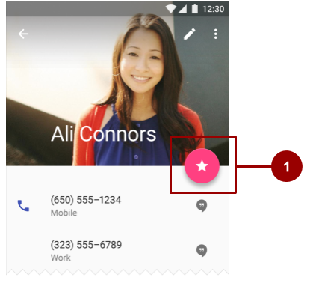

In the above figure, #1 is a [FloatingActionButton](https://developer.android.com/reference/android/support/design/widget/FloatingActionButton.html) with a pink accent color.

Meaningful motion

Make animations and other motions in your app meaningful, so they don't happen at random. Use motions to reinforce the idea that the user is the app's primary mover. For example, design your app so that most motions are initiated by the user's actions, not by events outside the user's control. You can also use motion to focus the user's attention, give the user subtle feedback, or highlight an element of your app.

When your app presents an object to the user, make sure the motion doesn't break the continuity of the user's experience. For example, the user shouldn't have to wait for an animation or transition to complete.

The Motion section in this chapter goes into more detail about how to use motion in your app.

Colors

Material Design principles include the use of bold color.

Material Design color palette

The [Material Design color palette](https://material.io/design/color/#tools-for-picking-colors) contains colors to choose from, each with a primary color and shades labeled from 50 to 900:

* Choose a color labeled "500" as the primary color for your brand. Use that color and shades of that color in your app.
* Choose a contrasting color as your accent color and use it to create highlights in your app. Select any color that starts with "A".

When you create an Android project in Android Studio, a sample Material Design color scheme is selected for you and applied to your theme. In colors.xml in the values folder, three <color> elements are defined, colorPrimary, colorPrimaryDark, and colorAccent:

<resources>

<color name="colorPrimary">#3F51B5</color>

<!-- Indigo. -->

<color name="colorPrimaryDark">#303F9F</color>

<!-- A darker shade of indigo. -->

<color name="colorAccent">#FF4081</color>

<!-- A shade of pink. -->

</resources>

In styles.xml in the values folder, the three defined colors are applied to the default theme, which applies the colors to some app elements by default:

* colorPrimary is used by several View elements by default. For example, in the AppTheme theme, colorPrimary is used as the background color for the action bar. Change this value to the "500" color that you select as your brand's primary color.
* colorPrimaryDark is used in areas that need to slightly contrast with your primary color, for example the status bar above the app bar. Set this value to a slightly darker version of your primary color.
* colorAccent is used as the highlight color for several View elements. It's also used for switches in the "on" position, [FloatingActionButton](https://developer.android.com/reference/android/support/design/widget/FloatingActionButton.html), and more.

In the screenshot below, the background of the action bar uses colorPrimary (indigo), the status bar uses colorPrimaryDark (a darker shade of indigo), and the switch in the "on" position (#1 in the figure below) uses colorAccent (a shade of pink).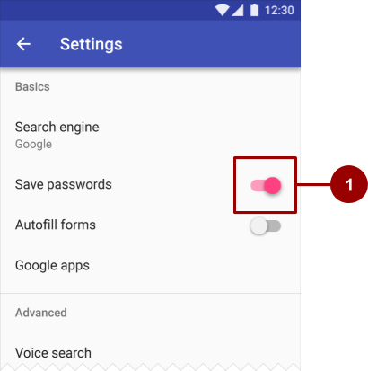

In summary, here's how to use the Material Design color palette in your Android app:

1. Pick a primary color for your app from [Material Design color palette](https://material.io/design/color/#tools-for-picking-colors) and copy its hex value into the colorPrimary item in colors.xml.
2. Pick a darker shade of this color and copy its hex value into the colorPrimaryDark item.
3. Pick an accent color from the shades starting with an "A" and copy its hex value into the colorAccent item.
4. If you need more colors, create additional <color> elements in the colors.xml file. For example, you could pick a lighter version of indigo and create an additional <color> element named colorPrimaryLight. (The name is up to you.)
5. <color name="colorPrimaryLight">#9FA8DA</color>
6. <!-- A lighter shade of indigo. -->

To use this color, reference it as @color/colorPrimaryLight.

Changing the values in colors.xml automatically changes the colors of the View elements in your app, because the colors are applied to the theme in styles.xml.

Contrast

Make sure all the text in your app's UI contrasts with its background. Where you have a dark background, make the text on top of it a light color, and vice versa. This kind of contrast is important for readability and [accessibility](https://material.google.com/usability/accessibility.html), because not all people see colors the same way.

If you use a platform theme such as [Theme.AppCompat](https://developer.android.com/reference/android/support/v7/appcompat/R.style.html#Theme_AppCompat), contrast between text and its background is handled for you. For example:

* If your theme inherits from Theme.AppCompat, the system assumes you are using a dark background. Therefore all of the text is near white by default.
* If your theme inherits from Theme.AppCompat.Light, the text is near black, because the theme has a light background.
* If you use the Theme.AppCompat.Light.DarkActionBar theme, the text in the action bar is near white, to contrast with the action bar's dark background. The rest of the text in the app is near black, to contrast with the light background.

Use color contrast to create visual separation among the elements in your app. Use your colorAccentcolor to call attention to key UI elements such as FloatingActionButton and switches in the "on" position.

Opacity

Your app can display text with different degrees of opacity to convey the relative importance of information. For example, text that's less important might be nearly transparent (low opacity).

Set the android:textColor attribute using any of these formats: "#rgb", "#rrggbb", "#argb", or "#aarrggbb". To set the opacity of text, use the "#argb" or "#aarrggbb" format and include a value for the *alpha channel*. The alpha channel is the a or the aa at the start of the textColor value.

The maximum opacity value, FF in hex, makes the color completely opaque. The minimum value, 00 in hex, makes the color complete transparent.

To determine what hex number to use in the alpha channel:

1. Decide what level of opacity you want to use, as a percentage. The level of opacity used for text depends on whether your background is dark or light. To find out what level of opacity to use in different situations, see the [Text color portion](https://material.io/design/color/text-legibility.html#text-backgrounds) of the Material Design guide.
2. Multiply that percentage, as a decimal value, by 255. For example, if you need primary text that's 87% opaque, multiply 0.87 x 255. The result is 221.85.
3. Round the result to the nearest whole number: 222.
4. Use a hex converter to convert the result to hex: DE. If the result is a single value, prefix it with 0.

In the following XML code, the background of the text is dark, and the color of the primary text is 87% white (deffffff). The first two numbers of the color code (de) indicate the opacity.

<TextView

android:layout_width="wrap_content"

android:layout_height="wrap_content"

android:text="Hello World!"

android:textSize="45dp"

android:background="@color/colorPrimaryDark"

android:textColor="#deffffff"/>

Typography

The Android design language relies on traditional typographic tools such as scale, space, rhythm, and alignment with an underlying grid. Successful deployment of these tools is essential to help users quickly understand a screen of information. To support such use of typography, Android supplies a type family named [Roboto](http://www.google.com/fonts/specimen/Roboto), created specifically for the requirements of UI and high-resolution screens.

With Android 8.0 (API level 26), you can also choose to provide a font as a resource in XML that is bundled with the app package (APK), or download a font from a font provider app. These features are available on devices running Android API versions 14 and higher through the Support Library 26.

Typeface

[Roboto](http://www.google.com/fonts/specimen/Roboto) is the standard Material Design typeface on Android. Roboto has six weights: Thin, Light, Regular, Medium, Bold, and Black.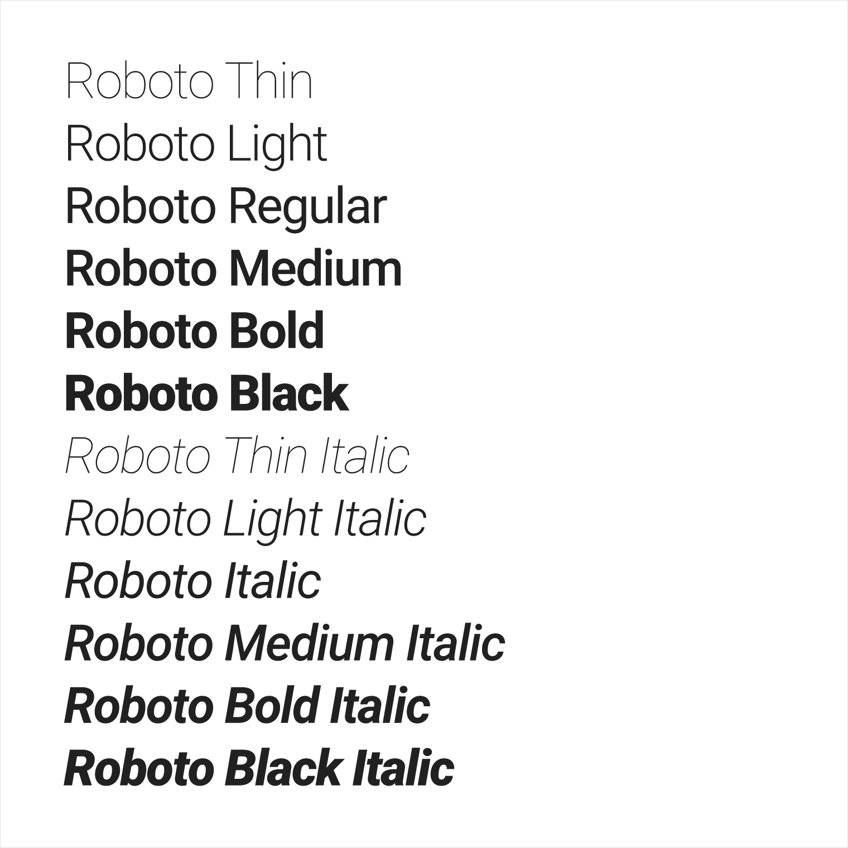

Font styles

The Android platform provides predefined font styles and sizes that you can use in your app. These styles and sizes were developed to balance content density and reading comfort under typical conditions. Type sizes are specified with sp (scaleable pixels) to enable large type modes for [accessibility](https://material.google.com/usability/accessibility.html).

Be careful not to use too many different type sizes and styles together in your layout.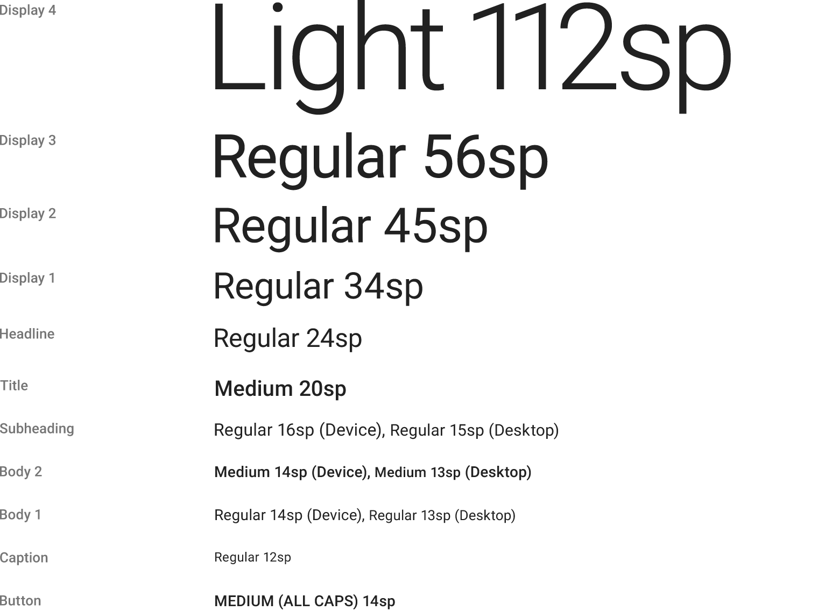

To use one of these predefined styles in a View, set the android:textAppearance attribute. This attribute defines the default appearance of the text: its color, typeface, size, and style. Use the backward-compatible [TextAppearance.AppCompat](https://developer.android.com/reference/android/support/v7/appcompat/R.style.html#TextAppearance_AppCompat) style.

For example, to make a TextView appear in the Display 3 style, add the following attribute to the TextView in XML:

android:textAppearance="@style/TextAppearance.AppCompat.Display3"

For more information on styling text, view the [Typography](https://material.google.com/style/typography.html) Material Design guidelines.

Fonts as resources

Android 8.0 (API level 26) introduces Fonts in XML, which lets you bundle fonts as resources in your app package (APK). You can create a font folder within the res folder as a resource directory using Android Studio, and then add a font XML file to the font folder. The fonts are compiled in your R file and are automatically available in Android Studio. To access a font resource, use @font/myfont, or R.font.myfont.

To use the Fonts in XML feature, the device that runs your app must run Android 8.0 (API level 26). To use the feature on devices running Android 4.1 (API level 16) and higher, use the Support Library 26. For more information on using the support library, refer to the [Using the support library](https://developer.android.com/guide/topics/ui/look-and-feel/fonts-in-xml.html#using-support-lib) section.

To learn how to add fonts as XML resources, see [Fonts in XML](https://developer.android.com/guide/topics/ui/look-and-feel/fonts-in-xml.html).

Downloadable fonts

An alternative to bundling fonts with the app package (APK) is to download the fonts from a provider app. Android 8.0 (API level 26) enables APIs to request fonts from a provider app, and the feature is available on devices running Android API versions 14 and higher through the Support Library 26. A font provider app is an app that retrieves fonts and caches them locally so that other apps can request and share fonts.

Downloadable fonts offer the following benefits:

* Reduces the APK size.
* Increases the app installation success rate.
* Improves the overall system health, as multiple APKs can share the same font through a provider. This saves users cellular data, phone memory, and disk space. In this model, the font is fetched over the network when needed.

You can set your app to download fonts by using the layout editor in Android Studio 3.0. For detailed instructions, see [Downloadable Fonts](https://developer.android.com/guide/topics/ui/look-and-feel/downloadable-fonts.html).

Layout

You specify View elements for your app's UI in layout resource files. Layout resources are written in XML and listed within the **layout** folder in the **res** folder in the **Project > Android** pane. The following guide explains some of the best practices for designing a layout.

Metrics

Components in the Material Design templates that are meant for mobile, tablet, and desktop devices align to an 8dp square grid. A *dp* is a [density-independent pixel](https://material.io/design/layout/understanding-layout.html#pixel-density), an abstract unit based on screen density. A *dp*is similar to an *sp*, but *sp* is also scaled by the user's font size preference. That's why *sp* is preferred for accessibility.

The 8dp square grid guides the placement of elements in your layout. Every square in the grid is 8dp x 8dp, so the height and width of every element in the layout is a multiple of 8dp.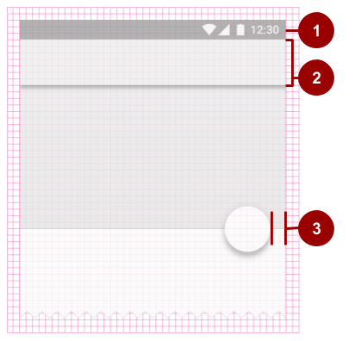

In the above figure:

1. The status bar in this layout is 24dp tall, the height of three grid squares.
2. The toolbar is 56dp tall, the height of seven grid squares.
3. One of the right-hand content margins is 16dp from the edge of the screen, the width of two grid squares.

Iconography in toolbars aligns to a 4dp square grid instead of an 8dp square grid, so the dimensions of icons in the toolbar are multiples of 4dp.

Keylines

*Keylines* are outlines in a layout grid that determine the placement of text and icons. For example, keylines mark the edges of the margins in a layout.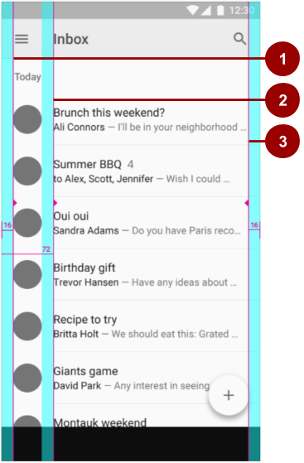

In the above figure:

1. Keyline showing the left margin for the screen edge, which in this case is 16dp.
2. Keyline showing the left margin for content associated with an icon or avatar, 72dp.
3. Keyline showing the right margin for the screen edge, 16dp.

Material Design typography aligns to a 4dp *baseline grid*, which is a grid made up only of horizontal lines.

To learn more about metrics and keylines in Material Design, visit the [metrics and keylines guide](https://material.google.com/layout/metrics-keylines.html).

Components and patterns

Button elements and many other View elements used in Android conform by default to Material Design principles. The Material Design guide includes *components and patterns* that you can build on to help your users intuit how the elements in your UI work, even if users are new to your app.

Use Material Design [components](https://material.google.com/components/) to guide the specs and behavior of buttons, chips, cards, and many other UI elements. Use Material Design [patterns](https://material.google.com/patterns/) to guide how you format dates and times, gestures, the navigation drawer, and many other aspects of your UI.

This section teaches you about the Design Support Library and some of the components and patterns that are available to you. For complete documentation about all the components and patterns that you can use, see the [Material Design guide](https://material.google.com/).

Design Support Library

The [Design](https://developer.android.com/reference/android/support/design/package-summary.html) package provides APIs to support adding Material Design components and patterns to your apps. The [Design Support Library](https://developer.android.com/topic/libraries/support-library/packages#design) adds support for various Material Design components and patterns for you to build on. To use the library, include the following dependency in your build.gradle (Module: app)file:

compile 'com.android.support:design:26.1.0'

To make sure you have the most recent version number for the Design Support Library, check the [Support Library page](https://developer.android.com/topic/libraries/support-library/packages#design).

Floating action buttons (FABs)

Use a *floating action button* (FAB) for actions you want to encourage users to take. A FAB is a circled icon that floats "above" the UI. On focus it changes color slightly, and it appears to lift up when selected. When tapped, it can contain related actions.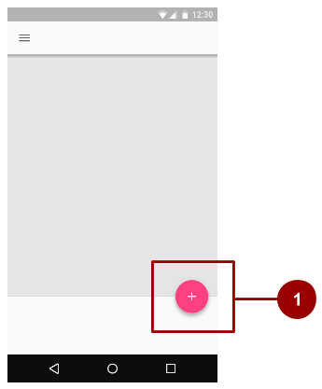

In this figure:

1. A normal-sized FAB

To implement a FAB, use [FloatingActionButton](https://developer.android.com/reference/android/support/design/widget/FloatingActionButton.html) and set the FAB's attributes in your layout XML. For example:

<android.support.design.widget.FloatingActionButton

android:id="@+id/addNewItemFAB"

android:layout_width="wrap_content"

android:layout_height="wrap_content"

android:src="@drawable/ic_plus_sign"

app:fabSize="normal"

app:elevation="10%" />

The [fabSize](https://developer.android.com/reference/android/support/design/widget/FloatingActionButton.html#attr_FloatingActionButton_fabSize) attribute sets the FAB's size. It can be "normal" (56dp), "mini" (40dp), or "auto", which changes based on the window size.

The FAB's *elevation* is the distance between its surface and the depth of its shadow. You can set the elevation attribute as a reference to another resource, a string, a boolean, or several other ways.

To learn about all the attributes you can set for a FAB including clickable, rippleColor, and backgroundTint, see [FloatingActionButton](https://developer.android.com/reference/android/support/design/widget/FloatingActionButton.html). To make sure you're using FABs as intended, check the extensive [FAB usage information in the Material Design guide](https://material.google.com/components/buttons-floating-action-button.html).

Navigation drawers

A *navigation drawer* is a panel that slides in from the left and contains navigation destinations for your app. A navigation drawer (shown as #1 in the figure below) spans the height of the screen, and everything behind it is visible, but darkened.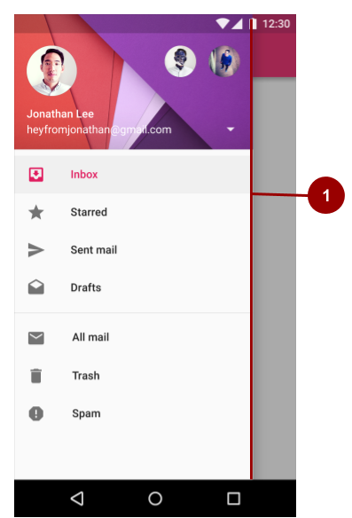

To implement a navigation drawer, use the [DrawerLayout](https://developer.android.com/reference/android/support/v4/widget/DrawerLayout.html) APIs available in the Support Library.

In your XML, use a DrawerLayout object as the root view of your layout. Inside it, add two views, one for your primary layout when the drawer is hidden, and one for the contents of the drawer.

For example, the following layout has two child views: a [FrameLayout](https://developer.android.com/reference/android/widget/FrameLayout.html) to contain the main content (populated by a [Fragment](https://developer.android.com/reference/android/app/Fragment.html) at runtime), and a [ListView](https://developer.android.com/reference/android/widget/ListView.html) for the navigation drawer.

<android.support.v4.widget.DrawerLayout

xmlns:android="http://schemas.android.com/apk/res/android"

android:id="@+id/drawer_layout"

android:layout_width="match_parent"

android:layout_height="match_parent">

<!-- The main content view -->

<FrameLayout

android:id="@+id/content_frame"

android:layout_width="match_parent"

android:layout_height="match_parent" />

<!-- The navigation drawer -->

<ListView android:id="@+id/left_drawer"

android:layout_width="240dp"

android:layout_height="match_parent"

android:layout_gravity="start"

android:choiceMode="singleChoice"

android:divider="@android:color/transparent"

android:dividerHeight="0dp"

android:background="#111"/>

</android.support.v4.widget.DrawerLayout>

The lesson on user navigation in this course provides a complete example of using a DrawerLayout. For more information, see [Creating a Navigation Drawer](https://developer.android.com/training/implementing-navigation/nav-drawer.html) and the [usage information in the Material Design guide](https://material.google.com/components/buttons-floating-action-button.html).

Snackbars

A *snackbar* provides brief feedback about an operation through a message in a horizontal bar on the screen. It contains a single line of text directly related to the operation performed. A snackbar (shown as #1 in the figure below) can contain a text action, but no icons.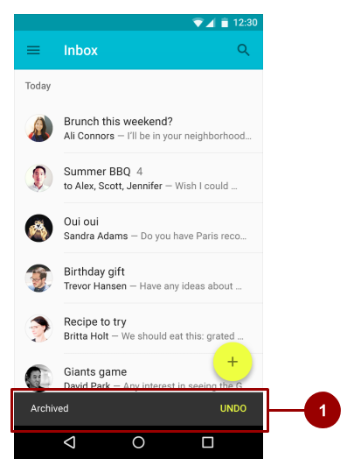

Snackbars automatically disappear after a timeout or after a user interaction elsewhere on the screen. You can associate a snackbar with any kind of view (any object derived from the [View](https://developer.android.com/reference/android/view/View.html) class). However, if you associate the snackbar with a [CoordinatorLayout](https://developer.android.com/reference/android/support/design/widget/CoordinatorLayout.html), the snackbar gains additional features:

* The user can dismiss the snackbar by swiping it away.
* The layout moves some other UI elements when the snackbar appears. For example, if the layout has a FAB, the layout moves the FAB up when it shows the snackbar, instead of drawing the snackbar on top of the FAB.

To create a Snackbar object, use the [Snackbar.make()](https://developer.android.com/reference/android/support/design/widget/Snackbar.html#make(android.view.View,%20int,%20int)) method. Specify the ID of the CoordinatorLayoutto use for the snackbar, the message that the snackbar displays, and the length of time to show the message. For example, this statement creates the snackbar and calls show() to show the snackbar to the user:

Snackbar.make(findViewById(R.id.myCoordinatorLayout),

R.string.email_sent,Snackbar.LENGTH_SHORT).show;

For more information, see [Building and Displaying a Pop-Up Message](https://developer.android.com/training/snackbar/showing.html) and the [Snackbar](https://developer.android.com/reference/android/support/design/widget/Snackbar.html) reference. To make sure you're using snackbars as intended, see the [snackbar usage information in the Material Design guide](https://material.google.com/components/snackbars-toasts.html).

**Tip:** A Toast is similar to a Snackbar, except that a Toast is usually used for a system message, and a Toast can't be swiped off the screen.

Tabs

Use *tabs* to organize content at a high level. For example, the user might use tabs to switch between View elements, data sets, or functional aspects of an app. Present tabs as a single row above their associated content. Make tab labels short and informative. For example, in the figure below, the app shows three tabs (marked by #1), with the **All** tab selected.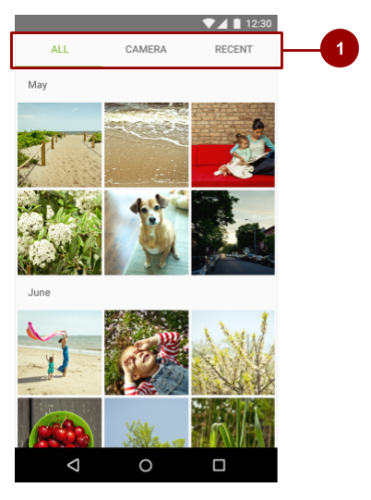

You can you use tabs with *swipe views* in which users navigate between tabs with a horizontal finger gesture (horizontal paging). If your tabs use swipe views, don't pair the tabs with content that also supports swiping. For an example, see the lesson in this course on providing user navigation.

For information on implementing tabs, see [Creating Swipe Views with Tabs](https://developer.android.com/training/implementing-navigation/lateral.html). To make sure you're using tabs as intended, see the extensive [tab usage information in the Material Design guide](https://material.io/design/components/tabs.html#tabs-usage).

Cards

A *card*is a sheet of material that serves as an entry point to more detailed information. Each card covers only one subject. A card may contain a photo, text, and a link. It can display content containing elements of varying size, such as photos with captions of variable length.

A *card collection* is a layout of cards on the same plane. The figure below shows one card in a card collection (marked by #1).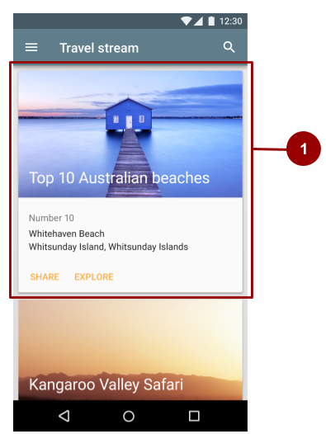

[CardView](https://developer.android.com/reference/android/support/v7/widget/CardView.html) is included as part of the v7 support library. To use the library, include the following dependency in your build.gradle (Module: app) file:

compile 'com.android.support:cardview-v7:26.1.0'

Lists

A *list* is a single continuous column of rows of equal width. Each row functions as a container for a tile. *Tiles* hold content, and can vary in height within a list.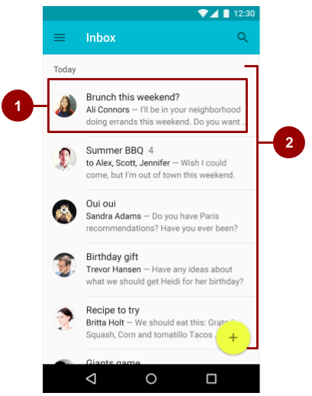

In the figure above:

1. A tile within the list
2. A list with rows of equal width, each containing a tile

To create a list, use the [RecyclerView](https://developer.android.com/reference/android/support/v7/widget/RecyclerView.html) widget. include the following dependency in your build.gradle (Module: app) file:

compile 'com.android.support:recyclerview-v7:26.1.0'

For more information on creating lists in Android, see [Create a List with RecyclerView](https://developer.android.com/guide/topics/ui/layout/recyclerview#RecyclerView).

Motion

Motion in the world of Material Design is used to describe spatial relationships, functionality, and intention with beauty and fluidity. Motion shows how an app is organized and what it can do.

Motion in Material Design must be:

1. **Responsive**. It quickly responds to user input precisely where the user triggers it.
2. **Natural**. Movement is inspired by forces in the natural world. For example, real-world forces like gravity inspire an element's movement along an arc rather than in a straight line.
3. **Aware**. Material is aware of its surroundings, including the user and other material around it. Objects can be attracted to other objects in the UI, and they respond appropriately to user intent. As elements transition into view, their movement is choreographed in a way that defines their relationships.
4. **Intentional**. Movement guides the user's focus to the right place at the right time. Movement can communicate different signals, such as whether an action is unavailable.

To put these principles into practice in Android, use animations and transitions.

Animations

There are three ways you can create animation in your app:

* [Property animation](https://developer.android.com/guide/topics/graphics/prop-animation.html) changes an object's properties over a specified period of time.The property animation system was introduced in Android 3.0 (API level 11). Property animation is more flexible than View animation, and it offers more features.
* [View animation](https://developer.android.com/guide/topics/graphics/view-animation.html) calculates animation using start points, endpoints, rotation, and other aspects of animation. The Android view animation system is older than the property animation system and can only be used for View elements. It's relatively easy to set up and offers enough capabilities for many use cases.
* [Drawable animation](https://developer.android.com/guide/topics/graphics/drawable-animation.html) lets you load a series of drawable resources one after another to create an animation. Drawable animation is useful if you want to animate things that are easier to represent with drawable resources, such as a progression of bitmap images.

For complete details about these three types for animation, see the [Animation and Graphics Overview](https://developer.android.com/guide/topics/graphics/overview.html).

The Material Design theme provides some default animations for touch feedback and activity transitions. The animation APIs let you create custom animations for touch feedback in UI controls, changes in view state, and activity transitions.

Touch feedback

*Touch feedback* provides instant visual confirmation at the point of contact when a user interacts with a UI element. The default touch feedback animation for a Button uses the [RippleDrawable](https://developer.android.com/reference/android/graphics/drawable/RippleDrawable.html) class, which transitions between different states with a ripple effect.

In this example, ripples of ink expand outward from the point of touch to confirm user input. The card "lifts" and casts a shadow to indicate an active state:

In most cases, you apply ripple functionality in your view XML by specifying the view background as follows:

* ?android:attr/selectableItemBackground for a bounded ripple.
* ?android:attr/selectableItemBackgroundBorderless for a ripple that extends beyond the View. It is drawn upon, and bounded by, the nearest parent of the View with a non-null background.

**Note:** The selectableItemBackgroundBorderless attribute was introduced in API level 21.

Alternatively, you can define a [RippleDrawable](https://developer.android.com/reference/android/graphics/drawable/RippleDrawable.html) as an XML resource using the <ripple> element.

You can assign a color to RippleDrawable objects. To change the default touch feedback color, use the theme's android:colorControlHighlight attribute.

Circular reveal

A *reveal animation* shows or hides a group of UI elements by animating the clipping boundaries for a View. In *circular reveal*, you reveal or hide a View by animating a clipping circle. (A *clipping circle* is a circle that crops or hides the part of an image that's outside the circle.)

To animate a clipping circle, use the [ViewAnimationUtils.createCircularReveal()](https://developer.android.com/reference/android/view/ViewAnimationUtils.html#createCircularReveal(android.view.View,%20int,%20int,%20float,%20float)) method. For example, here's how to reveal a previously invisible view using circular reveal:

// Previously invisible view

View myView = findViewById(R.id.my_view);

// Get the center for the clipping circle.

int cx = myView.getWidth() / 2;

int cy = myView.getHeight() / 2;

// Get the final radius for the clipping circle.

float finalRadius = (float) Math.hypot(cx, cy);

// Create the animator for this view (the start radius is zero).

Animator anim = ViewAnimationUtils

.createCircularReveal(myView, cx, cy, 0, finalRadius);

// Make the view visible and start the animation.

myView.setVisibility(View.VISIBLE);

anim.start();

Here's how to hide a previously visible View using circular reveal:

// Previously visible view

final View myView = findViewById(R.id.my_view);

// Get the center for the clipping circle.

int cx = myView.getWidth() / 2;

int cy = myView.getHeight() / 2;

// Get the initial radius for the clipping circle.

float initialRadius = (float) Math.hypot(cx, cy);

// Create the animation (the final radius is zero.

Animator anim = ViewAnimationUtils.

createCircularReveal(myView, cx, cy, initialRadius, 0);

// Make the view invisible when the animation is done.

anim.addListener(new AnimatorListenerAdapter() {

@Override

public void onAnimationEnd(Animator animation) {

super.onAnimationEnd(animation);

myView.setVisibility(View.INVISIBLE);

}

});

// Start the animation.

anim.start();

Activity transitions

*Activity transitions* are animations that provide visual connections between different states in your UI. You can specify custom animations for *enter* and *exit* transitions, and for transitions of shared elements between activities.

* An *enter transition* determines how View elements in an Activity enter the scene. For example in an *explode enter transition*, View elements enter the scene from the outside and fly towards the center of the screen.
* An *exit transition* determines how View elements in an Activity exit the scene. For example in an *explode exit transition*, View elements exit the scene by moving away from the center.
* A *shared elements transition* determines how View elements that are shared between two activities transition between these activities. For example, if two activities have the same image in different positions and sizes, the changeImageTransform shared element transition translates and scales the image smoothly between these activities.

To use these transitions, set transition attributes in a <style> element in your XML. The following example creates a theme named BaseAppTheme that inherits one of the Material Design themes. The BaseAppTheme theme uses all three types of Activity transitions:

<style name="BaseAppTheme" parent="android:Theme.Material">

<!-- enable window content transitions -->

<item name="android:windowActivityTransitions">true</item>

<!-- specify enter and exit transitions -->

<item name="android:windowEnterTransition">@transition/explode</item>

<item name="android:windowExitTransition">@transition/explode</item>

<!-- specify shared element transitions -->

<item name="android:windowSharedElementEnterTransition">

@transition/change_image_transform</item>

<item name="android:windowSharedElementExitTransition">

@transition/change_image_transform</item>

</style>

The change_image_transform transition in this example is defined as follows:

<!-- res/transition/change_image_transform.xml -->

<!-- (see also Shared Transitions below) -->

<transitionSet xmlns:android="http://schemas.android.com/apk/res/android">

<changeImageTransform/>

</transitionSet>

The changeImageTransform element corresponds to the [ChangeImageTransform](https://developer.android.com/reference/android/transition/ChangeImageTransform.html) class. For more information, see the API reference for [Transition](https://developer.android.com/reference/android/transition/Transition.html).

To enable window content transitions in your Java code instead, call the [Window.requestFeature()](https://developer.android.com/reference/android/view/Window.html#requestFeature(int))method:

// Inside your activity

// (if you did not enable transitions in your theme)

getWindow().requestFeature(Window.FEATURE_CONTENT_TRANSITIONS);

// Set an exit transition

getWindow().setExitTransition(new Explode());



To specify transitions in your code, call the following methods with a [Transition](https://developer.android.com/reference/android/transition/Transition.html) object:

* Window.setEnterTransition()
* Window.setExitTransition()
* Window.setSharedElementEnterTransition()
* Window.setSharedElementExitTransition()

For details about these methods, see [Window](https://developer.android.com/reference/android/view/Window.html).

To start an activity that uses transitions, use the [ActivityOptions.makeSceneTransitionAnimation()](https://developer.android.com/reference/android/app/ActivityOptions.html#makeSceneTransitionAnimation(android.app.Activity,%20android.view.View,%20java.lang.String))method.

For more about implementing transitions in your app, see [Start an Activity with an Animation](https://developer.android.com/training/transitions/start-activity.html).

Curved motion

In Android 5.0 (API level 21) and newer, you can define custom timing curves and curved motion patterns for animations. To do this, use the [PathInterpolator](https://developer.android.com/reference/android/view/animation/PathInterpolator.html) class, which interpolates an object's path based on a Bézier curve or a [Path](https://developer.android.com/reference/android/graphics/Path.html) object. The interpolator specifies a motion curve in a 1x1 square, with anchor points at (0,0) and (1,1) and control points that you specify using the constructor arguments. You can also define a path interpolator as an XML resource:

<pathInterpolator xmlns:android="http://schemas.android.com/apk/res/android"

android:controlX1="0.4"

android:controlY1="0"

android:controlX2="1"

android:controlY2="1"/

The system provides XML resources for the three basic curves in the Material Design specification:

* @interpolator/fast_out_linear_in.xml
* @interpolator/fast_out_slow_in.xml
* @interpolator/linear_out_slow_in.xml

To use a [PathInterpolator](https://developer.android.com/reference/android/view/animation/PathInterpolator.html) object, pass it to the [Animator.setInterpolator()](https://developer.android.com/reference/android/animation/Animator.html#setInterpolator(android.animation.TimeInterpolator)) method.

The [ObjectAnimator](https://developer.android.com/reference/android/animation/ObjectAnimator.html) class has constructors you can use to animate coordinates along a path using two or more properties at once. For example, the following code uses a [Path](https://developer.android.com/reference/android/graphics/Path.html) object to animate the X and Y properties of a View:

ObjectAnimator mAnimator;

mAnimator = ObjectAnimator.ofFloat(view, View.X, View.Y, path);

// ... Rest of code

mAnimator.start();

Other custom animations

Other custom animations are possible, including animated state changes (using the [StateListAnimator](https://developer.android.com/reference/android/animation/StateListAnimator.html)class) and animated vector drawables (using the [AnimatedVectorDrawable](https://developer.android.com/reference/android/graphics/drawable/AnimatedVectorDrawable.html) class). For complete details, see [Defining Custom Animations](https://developer.android.com/training/material/animations.html).

Related practi

# 6.1: UI testing

**Contents:**

* [Properly testing a user interface (UI)](https://google-developer-training.github.io/android-developer-fundamentals-course-concepts-v2/unit-2-user-experience/lesson-6-testing-your-ui/6-1-c-ui-testing/6-1-c-ui-testing.html#introduction)
* [Setting up your test environment](https://google-developer-training.github.io/android-developer-fundamentals-course-concepts-v2/unit-2-user-experience/lesson-6-testing-your-ui/6-1-c-ui-testing/6-1-c-ui-testing.html#setting)
* [Using Espresso for tests that span a single app](https://google-developer-training.github.io/android-developer-fundamentals-course-concepts-v2/unit-2-user-experience/lesson-6-testing-your-ui/6-1-c-ui-testing/6-1-c-ui-testing.html#espresso)
* [Using UI Automator for tests that span multiple apps](https://google-developer-training.github.io/android-developer-fundamentals-course-concepts-v2/unit-2-user-experience/lesson-6-testing-your-ui/6-1-c-ui-testing/6-1-c-ui-testing.html#auto)
* [Related practical](https://google-developer-training.github.io/android-developer-fundamentals-course-concepts-v2/unit-2-user-experience/lesson-6-testing-your-ui/6-1-c-ui-testing/6-1-c-ui-testing.html#relatedpractical)
* [Learn more](https://google-developer-training.github.io/android-developer-fundamentals-course-concepts-v2/unit-2-user-experience/lesson-6-testing-your-ui/6-1-c-ui-testing/6-1-c-ui-testing.html#learnmore)

## Properly testing a user interface (UI)

Writing and running tests is an important part of the Android app-development cycle. Well-written tests can help you catch bugs early in your development cycle, where bugs are easier to fix. Tests also help you gain confidence in your code.

In user interface (UI) testing, you focus on aspects of the UI and the app's interactions with users. Recognizing and acting on user input is a high priority in UI testing and validation. You need to make sure that your app not only recognizes the type of input but also acts accordingly.

As a developer, you should get into the habit of testing user interactions to ensure that users don't encounter unexpected results or have a poor experience when interacting with your app. UI testing can help you recognize the input controls where unexpected input should be handled gracefully or should trigger input validation.

**Note:** We strongly encourage you to use Android Studio for building your test apps, because it provides project setup, library inclusion, and packaging conveniences. You can run UI tests on a variety of physical or virtual Android devices, and you can then analyze the results and make changes to your code without leaving the development environment.

An app's UI contains View elements such as buttons, menus, and text fields, each with a set of properties. To properly test a UI, you need to do the following:

* Exercise all UI events that use View elements. To do this, tap a View in the app and enter data or make a choice. Then examine the values of the properties of each View—referred to as the state of the UI—at different times during execution.
* Provide inputs to all UI View elements. Use this opportunity to test improper inputs. For example, input letters in a view where numbers are expected.
* Check the outputs and UI representations of data—such as strings and integers—to see if they are consistent with what you expect.

In addition to functionality, UI testing evaluates design elements such as layout, colors, fonts, font sizes, labels, text boxes, text formatting, captions, buttons, lists, icons, links, and content.

### Manual testing

As the developer of an app, you probably test each UI component manually as you add the component to the app's UI. As development continues, one approach to UI testing is to simply have a human tester perform a set of user operations on the target app and verify that it is behaving correctly.

However, this manual approach can be time-consuming, tedious, and error-prone. By manually testing a UI for a complex app, you can't possibly cover all permutations of user interactions. You would also have to manually perform these repetitive tests on many different device configurations in an emulator, and on many different devices. To summarize, the problems inherent with manual testing fall into two categories:

* Domain size: A UI has many operations that need to be tested. Even a relatively small app can have hundreds of possible UI operations. Over a development cycle a UI may change significantly, even though the underlying app doesn't change. Manual tests with instructions to follow a certain path through the UI may fail over time, because a button, menu item, or dialog may have changed location or appearance.
* Sequences: Some functionality of the app may only be accomplished with a sequence of UI events. For example, to add an image to a message about to be sent, a user may have to tap a camera button and use the camera to take a picture, or a photo button to select an existing picture, and then associate that picture with the message—usually by tapping a share or send button. Increasing the number of possible operations also increases the sequencing problem.

### Automated testing

When you automate tests of user interactions, you free yourself and your resources for other work. To generate a set of test cases, test designers attempt to cover all of the functionality of the system and fully exercise the UI. Performing all of the UI interactions automatically makes it easier to run tests for different device states (such as orientations) and different configurations.

For testing Android apps, you typically create these types of automated UI tests:

* UI tests that work within a single app: Verifies that the app behaves as expected when a user performs a specific action or enters a specific input. It allows you to check that the app returns the correct UI output in response to user interactions in each app Activity. UI testing frameworks like Espresso allow you to programmatically simulate user actions and test complex intra-app user interactions.
* UI tests that span multiple apps: Verifies the correct behavior of interactions between different user apps or between user apps and system apps. For example, you can test an app that launches the Maps app to show directions, or that launches the Android contact picker to select recipients for a message. UI testing frameworks that support cross-app interactions, such as UI Automator, allow you to create tests for such user-driven scenarios.

### Using Espresso for tests that span a single app

The Espresso testing framework, in the Android Testing Support Library, provides APIs for writing UI tests to simulate user interactions within a single app. Espresso tests run on actual device or emulator and behave as if an actual user is using the app.

You can use Espresso to create UI tests to automatically verify the following:

* The app returns the correct UI output in response to a sequence of user actions on a device.
* The app's navigation and input controls bring up the correct Activity and View elements.
* The app responds correctly with mocked-up dependencies, such as data from an outside server, or can work with stubbed out backend methods to simulate real interactions with backend components which can be programmed to reply with a set of defined responses.

A key benefit of using Espresso is that it has access to instrumentation information, such as the context for the app, so that you can monitor all of the interaction the Android system has with the app. Another key benefit is that it automatically synchronizes test actions with the app's UI. Espresso detects when the main thread is idle, so it is able to run your test at the appropriate time, improving the reliability of your tests. This capability also relieves you from having to add any timing workarounds, such as a sleep period, in your test code.

The Espresso testing framework works with the [AndroidJUnitRunner](https://developer.android.com/reference/android/support/test/runner/AndroidJUnitRunner.html) test runner and requires instrumentation, which is described later in this section. Espresso tests can run on devices running Android 2.2 (API level 8) and higher.

### Using UI Automator for tests that span multiple apps

The UI Automator testing framework in the Android Testing Support Library can help you verify the correct behavior of interactions between different user apps or between user apps and system apps. It can also show you what is happening on the device before and after an app is launched.

The UI Automator APIs let you interact with visible elements on a device. Your test can look up a UI element by using descriptors such as the text displayed in that element or its content description. A viewer tool provides a visual interface to inspect the layout hierarchy and view the properties of UI elements that are visible on the foreground of the device.

The following are important functions of UI Automator:

* Like Espresso, UI Automator has access to system interaction information so that you can monitor all of the interaction the Android system has with the app.
* Your test can send an [Intent](https://developer.android.com/reference/android/content/Intent.html) or launch an [Activity](https://developer.android.com/reference/android/app/Activity.html) (without using shell commands) by getting a [Context](https://developer.android.com/reference/android/content/Context.html) object through [getContext()](https://developer.android.com/reference/android/support/test/InstrumentationRegistry.html#getContext()).
* You can simulate user interactions on a collection of items, such as songs in a music album or a list of emails in an inbox.
* You can simulate vertical or horizontal scrolling across a display.
* You can use standard JUnit [Assert](http://junit.org/javadoc/latest/org/junit/Assert.html) methods to test that UI components in the app return the expected results.

The UI Automator testing framework works with the [AndroidJUnitRunner](https://developer.android.com/reference/android/support/test/runner/AndroidJUnitRunner.html) test runner and requires instrumentation, which is described in the next section. UI Automator tests can run on devices running Android 4.3 (API level 18) or higher.

### What is instrumentation?

Android instrumentation is a set of control methods, or hooks, in the Android system, which control Android components and how the Android system loads apps.

Normally the system runs all the components of an app in the same process. You can allow some components, such as content providers, to run in a separate process, but you typically can't force an app onto the same process as another running app.

Instrumentation tests, however, can load both a test package and the app into the same process. Since the app components and their tests are in the same process, your tests can invoke methods in the components, and modify and examine fields in the components.

Instrumentation allows you to monitor all of the interaction the Android system has with the application, and makes it possible for tests to invoke methods in the app, and modify and examine fields in the app, independently of the app's normal lifecycle.

Normally, an Android component runs in a lifecycle that the system determines. For example, an Activity object's lifecycle starts when an Intent activates the Activity. The system calls the object's onCreate() method, and then the onResume() method. When the user starts another app, the system calls the onPause() method. If the Activity code calls the finish() method, the system calls the onDestroy() method.

The Android framework API does not provide a way for your app's code to invoke these callback methods directly, but you can do so using an Espresso or UI Automator test with instrumentation.

## Setting up your test environment

To use the Espresso and UI Automator frameworks, you need to store the source files for instrumented tests at module-name/src/androidTests/java/ (in which module-name is the name of the app or module).

This directory already exists when you create a new Android Studio project. In the **Project > Android**view of Android Studio, show this directory by navigating to **app > java > module-name (androidTest)**.

You also need to do the following:

* Install the Android Support Repository and the Android Testing Support Library.
* Add dependencies to the project's build.gradle (Module: app) file.
* Create test files in the androidTest directory.

### Installing the Android Support Repository and Testing Support Library

You may already have the Android Support Repository and its Android Testing Support Library installed with Android Studio. To check for the Android Support Repository, follow these steps:

1. In Android Studio select **Tools > Android > SDK Manager**.
2. Click the **SDK Tools** tab and look for the Support Repository.
3. If necessary, update or install the library.

### Adding the dependencies

When you start a project for the Phone and Tablet form factor using **API 15: Android 4.0.3 (Ice Cream Sandwich)** as the minimum SDK, Android Studio automatically includes the dependencies you need to use Espresso.

**Note:** If you created your project in a previous version of Android Studio, you may have to add the dependencies and instrumentation statement yourself.

To ensure that you have these dependencies, follow these steps:

1. Open the **build.gradle (Module: app)** file.
2. Check if the following is included (along with other dependencies) in the dependencies section:
3. testImplementation 'junit:junit:4.12'
4. androidTestImplementation 'com.android.support.test:runner:1.0.1'
5. androidTestImplementation
6. 'com.android.support.test.espresso:espresso-core:3.0.1'

If the file doesn't include the above dependency statements, enter them into the dependenciessection.

1. Android Studio also adds the following instrumentation statement to the end of the defaultConfigsection of a new project:
2. testInstrumentationRunner
3. "android.support.test.runner.AndroidJUnitRunner"

If the file doesn't include the above instrumentation statement, enter it at the end of the defaultConfig section.

1. If you modified the **build.gradle (Module: app)** file, click the **Sync Now** link in the notification about Gradle files in top right corner of the window.

### Setting up the test rules and annotations

To write tests, Espresso and UI Automator use [JUnit](http://junit.org/junit4/) as their testing framework. JUnit is the most popular and widely-used unit testing framework for Java. Your test class using Espresso or UI Automator should be written as a JUnit 4 test class.

**Note:**The most current JUnit revision is JUnit 5. However for the purposes of using Espresso or UI Automator, version 4.12 is recommended.

To create a basic JUnit 4 test class, create a Java class for testing in the directory specified at the beginning of this section. It should contain one or more methods and behavior rules defined by JUnit annotations.

For example, the following shows a test class definition with annotations:

@RunWith(AndroidJUnit4.class)

public class ActivityInputOutputTest {

@Rule

public ActivityTestRule mActivityRule = new ActivityTestRule<>(

MainActivity.class);

@Test

public void useAppContext() throws Exception {

// Context of the app under test.

Context appContext =

InstrumentationRegistry.getTargetContext();

assertEquals("com.example.android.twoactivities",

appContext.getPackageName());

}

@Test

public void activityLaunch() {

onView(withId(R.id.button_main)).perform(click());

onView(withId(R.id.text_header))

.check(matches(isDisplayed()));

onView(withId(R.id.button_second)).perform(click());

onView(withId(R.id.text_header_reply))

.check(matches(isDisplayed()));

}

// More tests...

}

The following annotations are useful for testing:

#### **@RunWith**

To create an instrumented JUnit 4 test class, add the @RunWith(AndroidJUnit4.class) annotation at the beginning of your test class definition, which indicates the runner that will be used to run the tests in this class. A test runner is a library or set of tools that enables testing to occur and the results to be printed to a log.

#### **@SmallTest, @MediumTest, and @LargeTest**

The @SmallTest, @MediumTest, and @LargeTest Android annotations provide some clarity about what resources and features the test uses. For example, the @SmallTest annotation tells you that the test doesn't interact with any file system or network.

The following table summarizes what the annotations mean:

|  |  |  |  |
| --- | --- | --- | --- |
| **Feature** | **Small** | **Medium** | **Large** |
| Network access | No | localhost only | Yes |
| Database | No | Yes | Yes |
| File system access | No | Yes | Yes |
| Use external systems | No | Discouraged | Yes |
| Multiple threads | No | Yes | Yes |
| Sleep statements | No | Yes | Yes |
| System properties | No | Yes | Yes |
| Time limit (seconds) | 60 | 300 | 900+ |

For a description of the Android @SmallTest, @MediumTest, and @LargeTest annotations, see [Test Sizes](http://googletesting.blogspot.com/2010/12/test-sizes.html)in the Google Testing Blog. For a summary of JUnit annotations, see [Package org.junit](http://junit.sourceforge.net/javadoc/org/junit/package-summary.html).

#### **@Rule**

Before declaring the test methods, use the @Rule annotation, such as [ActivityTestRule](https://developer.android.com/reference/android/support/test/rule/ActivityTestRule.html) or [ServiceTestRule](https://developer.android.com/reference/android/support/test/rule/ServiceTestRule.html). The @Rule establishes the context for the testing code. For example:

@Rule

public ActivityTestRule mActivityRule = new ActivityTestRule<>(

MainActivity.class);

This rule uses an ActivityTestRule object, which provides functional testing of a single Activity—in this case, MainActivity.class.

ServiceTestRule is a JUnit rule that provides a simplified mechanism to start and shut down your service before and after the duration of your test. It also guarantees that the service is successfully connected when starting (or binding to) a service.

#### **@Test**

A test method begins with the @Test annotation and contains the code to exercise and verify a single function in the component that you want to test:

@Test

public void testActivityLaunch() {//...}

The Activity under test will be launched before each test annotated with @Test. During the duration of the test you will be able to manipulate your Activity directly.

#### **@Before and @After**

In certain rare cases you may need to set up variables or execute a sequence of steps before or afterperforming the UI test. You can specify methods to run before running a @Test method, using the @Before annotation, and methods to run after, using the @After annotation.

* @Before: The @Test method will execute after the methods designated by the @Before annotation. The @Before methods terminate prior to the execution of the @Test method.
* @After: The @Test method will execute before the methods designated by the @After annotation.

## Using Espresso for tests that span a single app

When writing tests it is sometimes difficult to get the balance right between over-specifying the test or not specifying enough. Over-specifying the test can make it brittle to changes, while under-specifying may make the test less valuable, since it continues to pass even when the UI element and its code under test is broken.

To make tests that are balanced, it helps to have a tool that allows you to pick out precisely the aspect under test and describe the values it should have. Such tests fail when the behavior of the aspect under test deviates from the expected behavior, yet continue to pass when minor, unrelated changes to the behavior are made. The tool available for Espresso is the Hamcrest framework.

Hamcrest (an anagram of "matchers") is a framework that assists writing software tests in Java. The framework lets you create custom assertion matchers, allowing match rules to be defined declaratively.

**Tip**: To learn more about Hamcrest, see [The Hamcrest Tutorial](https://code.google.com/archive/p/hamcrest/wikis/Tutorial.wiki).

### Writing Espresso tests with Hamcrest Matchers

You write Espresso tests based on what a user might do while interacting with your app. The key concepts are locating and then interacting with UI elements. These are the basic steps:

1. **Match a View:**Find a View.
2. **Perform an action:**Perform a click or other action that triggers an event with the View.
3. **Assert and verify the result:** Check the state of the View to see if it reflects the expected state or behavior defined by the assertion.

With Espresso you use the following types of Hamcrest expressions to help find View elements and interact with them:

* ViewMatchers: Hamcrest matcher expressions in the [ViewMatchers](https://developer.android.com/reference/android/support/test/espresso/matcher/ViewMatchers.html) class that lets you find a View in the current View hierarchy so that you can examine something or perform some action.
* ViewActions: Hamcrest action expressions in the [ViewActions](https://developer.android.com/reference/android/support/test/espresso/action/ViewActions.html) class that lets you perform an action on a View found by a ViewMatcher.
* ViewAssertions: Hamcrest assertion expressions in the [ViewAssertions](https://developer.android.com/reference/android/support/test/espresso/assertion/ViewAssertions.html) class that lets you assert or check the state of a View found by a ViewMatcher.

The following shows how all three expressions work together:

1. Use a ViewMatcher to find a View: onView(withId(R.id.my_view))
2. Use a ViewAction to perform an action: .perform(click())
3. Use a ViewAssertion to check if the result of the action matches an assertion: .check(matches(isDisplayed()))

The following shows how the above expressions are used together in a statement:

onView(withId(R.id.my_view))

.perform(click())

.check(matches(isDisplayed()));

Use onView() with a ViewMatcher so that you can examine something or perform some action. The most common ones are:

* withId(): Find a view with a specific android:id (which is typically defined in the layout XML file). For example:
* onView(withId(R.id.my_view))
* withText(): Find a View with specific text, typically used with allOf() and withId(). For example, the following uses allOf to cause a match if the examined object matches all of the specified conditions—the View uses the word id (withId), and the View has the text "Clicked! Word 15" (withText):
* onView(allOf(withId(R.id.word), withText("Clicked! Word 15"),
* isDisplayed()))
* Others including matchers for state (selected, focused, enabled), and content description and hierarchy (root and children).

You would typically combine a ViewMatcher and a ViewAction in a single statement, followed by a ViewAssertion expression in a separate statement or included in the same statement.

You can see how all three expressions work in the following statement, which combines a ViewMatcher to find a view, a ViewAction to perform an action, and a ViewAssertion to check if the result of the action matches an assertion:

// withId(R.id.my_view) is a ViewMatcher

onView(withId(R.id.my_view))

// click() is a ViewAction

.perform(click())

// matches(isDisplayed()) is a ViewAssertion

.check(matches(isDisplayed()));

Why is the Hamcrest framework useful for tests? A simple assertion, such as assert (x == y), lets you assert during a test that a particular condition must be true. If the condition is false, the test fails. But the simple assertion provides no useful error message. With a family of assertions, you can produce more useful error messages, but this leads to an explosion in the number of assertions.

With the Hamcrest framework, it is possible to define operations that take matchers as arguments and return them as results, leading to a grammar that can generate a huge number of possible matcher expressions from a small number of primitive matchers.

For a Hamcrest tutorial, see [The Hamcrest Tutorial](https://code.google.com/archive/p/hamcrest/wikis/Tutorial.wiki). For a quick summary of Hamcrest matcher expressions, see the [Espresso cheat sheet](https://developer.android.com/training/testing/espresso/cheat-sheet).

### Testing an AdapterView

In an [AdapterView](https://developer.android.com/reference/android/widget/AdapterView.html) such as a [Spinner](https://developer.android.com/reference/android/widget/Spinner.html), the View is dynamically populated with child View elements at runtime. If the target View you want to test is inside a spinner, the onView() method might not work because only a subset of the View elements may be loaded in the current view hierarchy.

Espresso handles this by providing a separate onData() method, which is able to first load the adapter item and bring it into focus prior to operating on it or any of its children views. The onData() method uses a [DataInteraction](https://developer.android.com/reference/android/support/test/espresso/DataInteraction.html) object and its methods, such as atPosition(), check(), and perform() to access the target View. Espresso handles loading the target View element into the current View hierarchy, scrolling to the target child View, and putting that View into focus.

For example, the following onView() and onData() statements test a Spinner item click:

1. Find and click the Spinner itself (the test must first click the Spinner itself in order to click any item in the Spinner):
2. onView(withId(R.id.spinner_simple)).perform(click());
3. Find and then click the item in the Spinner that matches all of the following conditions:
   * An item that is a String
   * An item that is equal to the String "Americano"
   * onData(allOf(is(instanceOf(String.class)),
   * is("Americano"))).perform(click());

As you can see in the above statement, matcher expressions can be combined to create flexible expressions of intent:

* allOf: Causes a match if the examined object matches all of the specified matchers. You can use allOf() to combine multiple matchers, such as containsString() and instanceOf().
* is: Hamcrest strives to make your tests as readable as possible. The is matcher is a wrapper that doesn't add any extra behavior to the underlying matcher, but makes your test code more readable.
* instanceOf: Causes a match when the examined object is an instance of the specified type; in this case, a string. This match is determined by calling the [Class.isInstance(Object)](https://developer.android.com/reference/java/lang/Class.html#isInstance(java.lang.Object)) method, passing the object to examine.

The following example illustrates how you would test a Spinner using a combination of onView() and onData() methods:

@RunWith(AndroidJUnit4.class)

public class SpinnerSelectionTest {

@Rule

public ActivityTestRule mActivityRule = new ActivityTestRule<>(

MainActivity.class);

@Test

public void useAppContext() throws Exception {

// Context of the app under test.

Context appContext =

InstrumentationRegistry.getTargetContext();

assertEquals("com.example.android.phonenumberspinner",

appContext.getPackageName());

}

/**

* Iterate through the spinner, selecting each item and

* checking to see if it matches the string in the array.

*/

@Test

public void iterateSpinnerItems() {

String[] myArray = mActivityRule.getActivity().getResources()

.getStringArray(R.array.labels_array);

// Iterate through the spinner array of items.

int size = myArray.length;

for (int i=0; i<size; i++) {

// Find the spinner and click on it.

onView(withId(R.id.label_spinner)).perform(click());

// Find the spinner item and click on it.

onData(is(myArray[i])).perform(click());

// Find the text view and check that the spinner item

// is part of the string.

onView(withId(R.id.text_phonelabel))

.check(matches(withText(containsString(myArray[i]))));

}

}

}

The test clicks each Spinner item from top to bottom, checking to see if the item appears in the text field. It doesn't matter how many Spinner items are defined in the array, or what language is used for the Spinner items—the test performs all of them and checks their output against the array.

The following is a step-by-step description of the above test:

1. The iterateSpinnerItems() method begins by getting the array used for the spinner items:
2. public void iterateSpinnerItems() {
3. String[] myArray =
4. mActivityRule.getActivity().getResources()
5. .getStringArray(R.array.labels_array);

In the statement above, the test accesses the array (with the id labels_array) by establishing the context with the getActivity() method of the [ActivityTestRule](https://developer.android.com/reference/android/support/test/rule/ActivityTestRule.html) class, and getting a resources instance in the app's package using getResources().

1. Using the length (size) of the array, the for loop iterates through each Spinner item.
2. int size = myArray.length;
3. for (int i=0; i<size; i++) {
4. // Find the spinner and click on it.
5. The onView() statement within the for loop finds the Spinner and clicks on it. The test must click the Spinner itself in order to click any item in the Spinner:
6. // Find the spinner and click on it.
7. onView(withId(R.id.label_spinner)).perform(click());
8. The onData() statement finds and clicks a spinner item:
9. // Find the spinner item and click on it.
10. onData(is(myArray[i])).perform(click());

The Spinner is populated from the myArray array, so myArray[i] represents a Spinner element from the array. As the for loop iterates, it performs a click on each Spinner element (myArray[i])it finds.

1. The last onView() statement finds the TextView (text_phonelabel) and checks that the Spinneritem is part of the string:
2. onView(withId(R.id.text_phonelabel))
3. .check(matches(withText(containsString(myArray[i]))));

### Recording a test

An Android Studio feature (in version 2.2 and newer) lets you record an Espresso test, creating the test automatically.

After choosing to record a test, use your app as a normal user would. As you click through the app UI, editable test code is generated for you. Add assertions to check if a View holds a certain value.

You can record multiple interactions with the UI in one recording session. You can also record multiple tests, and edit the tests to perform more actions, using the recorded code as a snippet to copy, paste, and edit.

Follow these steps to record a test:

1. Select **Run > Record Espresso Test**, select your deployment target (an emulator or a device), and click **OK**.
2. Interact with the UI to do what you want to test. In this case, tap the plus (**+**) ImageButton for Team 1 in the app. The Record Your Test window shows the action that was recorded ("Tap AppCompatImageButton with the content description **Plus Button**").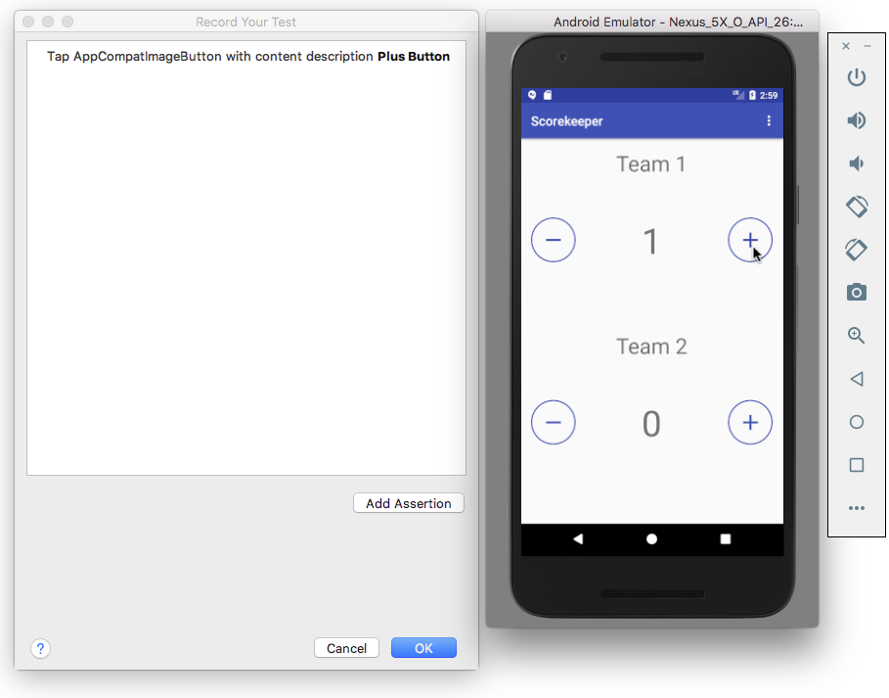
3. Click **Add Assertion** in the Record Your Test window. A screenshot of the app's UI appears in a pane on the right side of the window, and the **Select an element from screenshot** option appears in the dropdown menu. Select the score (**1**) in the screenshot as the UI element you want to check, as shown in the figure below.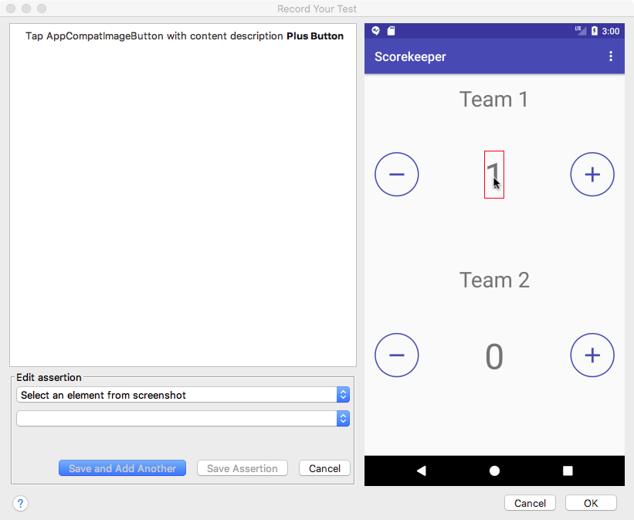
4. Select **text is** from the second dropdown menu, as shown in the figure below. The text you expect to see (**1**) is already entered in the field below the dropdown menu.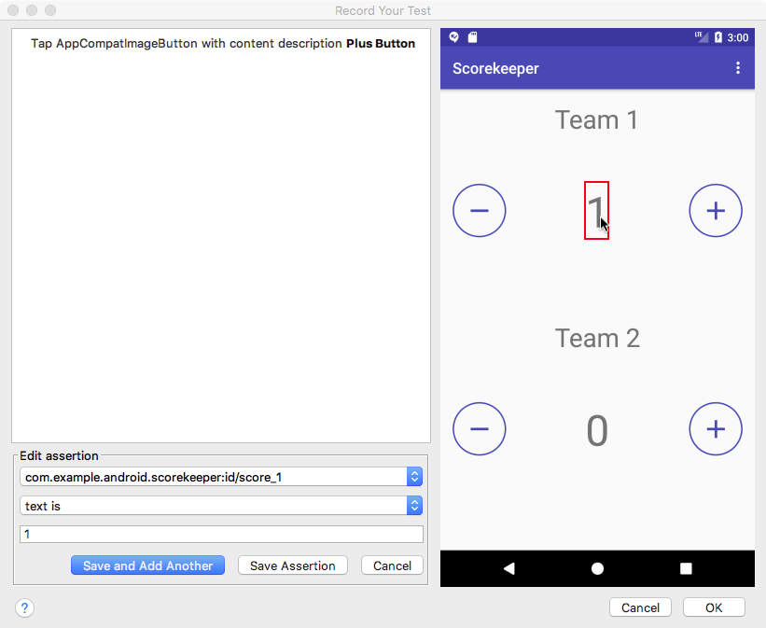
5. Click **Save Assertion**, and then click **OK**.
6. In the dialog that appears, edit the name of the test so that it is easy for others to understand the purpose of the test.
7. Android Studio may display a request to add more dependencies to your Gradle Build file. Click **Yes**to add the dependencies. Android Studio adds the following to the dependencies section of the build.gradle (Module: app) file:
8. androidTestCompile
9. 'com.android.support.test.espresso:espresso-contrib:2.2.2', {
10. exclude group: 'com.android.support', module: 'support-annotations'
11. exclude group: 'com.android.support', module: 'support-v4'
12. exclude group: 'com.android.support', module: 'design'
13. exclude group: 'com.android.support', module: 'recyclerview-v7'
14. }
15. Expand **com.example.android.**appname**(androidTest)** to see the test, and **right-click** (or **Control-click**) the test to run it.

### Using RecyclerViewActions for a RecyclerView

A [RecyclerView](https://developer.android.com/reference/android/support/v7/widget/RecyclerView.html) is useful when you have data collections with elements that change at runtime based on user action or network events. RecyclerView is a UI component designed to render a collection of data, but is not a subclass of AdapterView but of ViewGroup. This means that you can't use onData(), which is specific to AdapterView, to interact with list items.

However, there is a class called [RecyclerViewActions](https://developer.android.com/reference/android/support/test/espresso/contrib/RecyclerViewActions.html) that exposes an API to operate on a RecyclerView. For example, the following test clicks on an item from the list by position:

onView(withId(R.id.recyclerView))

.perform(RecyclerViewActions.actionOnItemAtPosition(0, click()));

## Using UI Automator for tests that span multiple apps

UI Automator is a set of APIs that can help you verify the correct behavior of interactions between different user apps, or between user apps and system apps. It lets you interact with visible elements on a device. A viewer tool provides a visual interface to inspect the layout hierarchy and view the properties of UI components that are visible on the foreground of the device. Like Espresso, UI Automator has access to system interaction information so that you can monitor all of the interaction the Android system has with the app.

To use UI Automator, you must already have set up your test environment in the same way as for Espresso:

* Install the Android Support Repository and the Android Testing Support Library.
* Add the following dependency to the project's build.gradle (Module: app) file in the dependenciessection:
* androidTestCompile
* 'com.android.support.test.uiautomator:uiautomator-v18:2.1.3'
* If the minSdkVersion is older than 18, switch it to 18. The library works only with version 18 of Android or newer:

### Use UI Automator Viewer to inspect the UI on a device

UI Automator Viewer (uiautomatorviewer) provides a convenient visual interface to inspect the layout hierarchy and view the properties of UI elements that are visible on the foreground of the device.

To launch the uiautomatorviewer tool, follow these steps:

1. Install and then launch the app on a physical device such as a smartphone.
2. Connect the device to your development computer.
3. Open a terminal window and navigate to the **/tools/** directory. To find the specific path, select **Preferences** in Android Studio, and select **Appearance & Behavior > System Settings > Android SDK**. The full path for appears in the Android SDK Location box at the top of the screen.
4. Run the tool with this command: **uiautomatorviewer**

To ensure that your UI Automator tests can access the app's UI elements, check that the elements have visible text labels, [android:contentDescription](http://developer.android.com/reference/android/view/View.html#attr_android:contentDescription) values, or both. You can view the properties of a UI element by following these steps (refer to the figure below):

1. After launching uiautomatorviewer, the viewer is empty. Click the **Device Screenshot** button.
2. Hover over a UI element in the snapshot in the left-hand panel to see the element in the layout hierarchy in the upper right panel.
3. The layout attributes and other properties for the UI element appear in the lower right panel. Use this information to create tests that select a UI element that matches a specific visible attribute or property.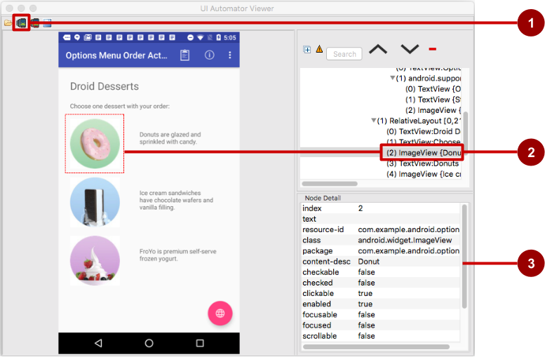

In the above figure:

1. **Device Screenshot** button
2. Selected component in the snapshot and in the layout hierarchy
3. Properties for the selected component

In the app shown above, the red floating action button launches the Maps app. Follow these steps to test the action performed by the floating action button:

1. Tap the floating action button.
2. The code for the button makes an implicit intent to launch the Maps app.
3. Click the **Device Screenshot** button to see the result of the implicit Intent (the Maps screen).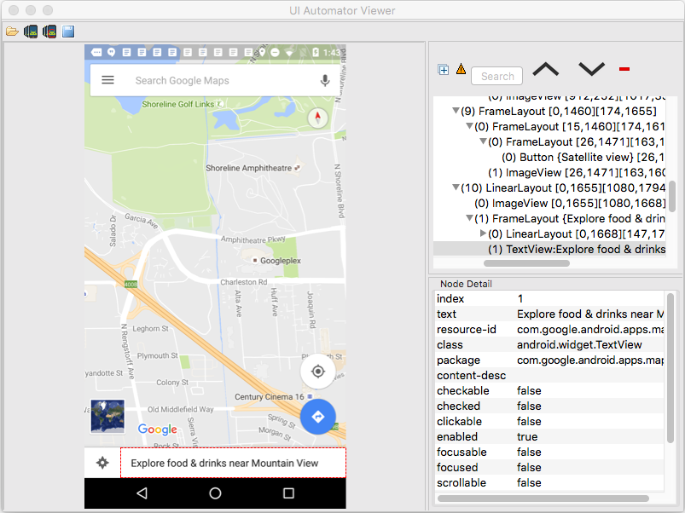

Using the viewer, you can determine which UI elements are accessible to the UI Automator framework.

### Setup: Ensuring that UI elements are accessible

The UI Automator framework depends on the accessibility features of the Android framework to look up individual UI elements. Implement view properties as follows:

* Include the [android:contentDescription](https://developer.android.com/reference/android/view/View.html#attr_android:contentDescription) attribute in your XML layout to label each [ImageButton](https://developer.android.com/reference/android/widget/ImageButton.html), [ImageView](https://developer.android.com/reference/android/widget/ImageView.html), [CheckBox](https://developer.android.com/reference/android/widget/CheckBox.html), and other user input controls. The following shows the android:contentDescription attribute added to a RadioButton using the same string resource used for the android:text attribute:
* <RadioButton
* android:id="@+id/sameday"
* android:layout_width="wrap_content"
* android:layout_height="wrap_content"
* android:text="@string/same_day_messenger_service"
* android:contentDescription=
* "@string/same_day_messenger_service"
* android:onClick="onRadioButtonClicked"/>

You can make input controls more accessible for the sight-impaired by using the android:contentDescription XML layout attribute. The text in this attribute does not appear on screen, but if the user enables accessibility services that provide audible prompts, then when the user navigates to that control, the text is spoken.

* Provide an [android:hint](https://developer.android.com/reference/android/widget/TextView.html#attr_android:hint) attribute for [EditText](https://developer.android.com/reference/android/widget/EditText.html) elements (in addition to android:contentDescription, which is useful for accessibility services). With EditText elements, UI Automator looks for the android:hint attribute.
* Associate an android:hint attribute with any graphical icons used by controls that provide feedback to the user (for example, status or state information).

As a developer, you should implement the above minimum optimizations to support your users as well as UI Automator.

### Creating a test class

A UI Automator test class generally follows this programming model:

1. **Access the device to test:** An instance of the [InstrumentRegistry](https://developer.android.com/reference/android/support/test/InstrumentationRegistry.html) class holds a reference to the instrumentation running in the process along with the instrumentation arguments. It also provides an easy way for callers to get instrumentation, app context, and an instrumentation arguments Bundle. You can get a [UiDevice](https://developer.android.com/reference/android/support/test/uiautomator/UiDevice.html) object by calling the [getInstance()](https://developer.android.com/reference/android/support/test/uiautomator/UiDevice.html#getInstance(android.app.Instrumentation)) method and passing it an [Instrumentation](https://developer.android.com/reference/android/app/Instrumentation.html) object—InstrumentationRegistry.getInstrumentation()—as the argument. For example:
2. mDevice = UiDevice
3. .getInstance(InstrumentationRegistry.getInstrumentation());
4. **Access a UI element displayed on the device:** Get a [UiObject](https://developer.android.com/reference/android/support/test/uiautomator/UiObject.html) by calling the [findObject()](https://developer.android.com/reference/android/support/test/uiautomator/UiDevice.html#findObject(android.support.test.uiautomator.UiSelector))method. For example:
5. UiObject okButton = mDevice.findObject(new UiSelector()
6. .text("OK"))
7. .className("android.widget.Button"));
8. **Perform an action:** Simulate a specific user interaction to perform on that UI element by calling a UiObject method. For example:
9. if(okButton.exists() && okButton.isEnabled()) {
10. okButton.click();
11. }

You may want to call [setText()](https://developer.android.com/reference/android/support/test/uiautomator/UiObject.html#setText(java.lang.String)) to set the text for a TextView, or [performMultiPointerGesture()](https://developer.android.com/reference/android/support/test/uiautomator/UiObject.html#performMultiPointerGesture(android.view.MotionEvent.PointerCoords[]...)) to simulate a multi-touch gesture.

You can repeat steps 2 and 3 as needed to test more complex user interactions that involve multiple UI elements or sequences of user actions.

1. **Verify results:** Check that the UI reflects the expected state or behavior after these user interactions are performed. You can use standard JUnit [Assert](http://junit.org/javadoc/latest/org/junit/Assert.html) methods to test that UI elements in the app return the expected results. For example:
2. UiObject result = mDevice.findObject(By.res(CALC_PACKAGE, "result"));
3. assertEquals("5", result.getText());

#### **Accessing the device**

The [UiDevice](https://developer.android.com/reference/android/support/test/uiautomator/UiDevice.html) class provides the methods for accessing and manipulating the state of the device. Unlike Espresso, UI Automator can verify the correct behavior of interactions between different user apps, or between user apps and system apps. It lets you interact with visible elements on a device. In your tests, you can call UiDevice methods to check for the state of various properties, such as current orientation or display size. Your test can use the UiDevice object to perform device-level actions, such as forcing the device into a specific rotation, pressing D-pad hardware buttons, and pressing the Home button.

It's a good practice to start your test from the Home screen of the device. From the Home screen you can call the methods provided by the UI Automator API to select and interact with specific UI elements. The following code snippet shows how your test can get an instance of UiDevice, simulate a Home button press, and launch the app:

import org.junit.Before;

import android.support.test.runner.AndroidJUnit4;

import android.support.test.uiautomator.UiDevice;

import android.support.test.uiautomator.By;

import android.support.test.uiautomator.Until;

// ...

@RunWith(AndroidJUnit4.class)

@SdkSuppress(minSdkVersion = 18)

public class ChangeTextBehaviorTest {

private static final String BASIC_SAMPLE_PACKAGE

= "com.example.android.testing.uiautomator.BasicSample";

private static final int LAUNCH_TIMEOUT = 5000;

private static final String STRING_TO_BE_TYPED = "UiAutomator";

private UiDevice mDevice;

@Before

public void startMainActivityFromHomeScreen() {

// Initialize UiDevice instance

mDevice = UiDevice

.getInstance(InstrumentationRegistry.getInstrumentation());

// Start from the home screen

mDevice.pressHome();

// Wait for launcher

final String launcherPackage =

mDevice.getLauncherPackageName();

assertThat(launcherPackage, notNullValue());

mDevice.wait(Until

.hasObject(By.pkg(launcherPackage).depth(0)),

LAUNCH_TIMEOUT);

// Launch the app

Context context = InstrumentationRegistry.getContext();

final Intent intent = context.getPackageManager()

.getLaunchIntentForPackage(BASIC_SAMPLE_PACKAGE);

// Clear out any previous instances

intent.addFlags(Intent.FLAG_ACTIVITY_CLEAR_TASK);

context.startActivity(intent);

// Wait for the app to appear

mDevice.wait(Until

.hasObject(By.pkg(BASIC_SAMPLE_PACKAGE).depth(0)),

LAUNCH_TIMEOUT);

}

}

The @SdkSuppress(minSdkVersion = 18) annotation ensures that tests will only run on devices with Android 4.3 (API level 18) or newer, as required by the UI Automator framework.

#### **Accessing a UI element**

Use the [findObject()](https://developer.android.com/reference/android/support/test/uiautomator/UiDevice.html#findObject(android.support.test.uiautomator.UiSelector)) method of the [UiObject](https://developer.android.com/reference/android/support/test/uiautomator/UiObject.html) class to retrieve a UiObject instance that represents a UI element matching a given selector criteria. To access a specific UI element, use the [UiSelector](https://developer.android.com/reference/android/support/test/uiautomator/UiSelector.html) class, which represents a query for specific elements in the currently displayed UI.

You can reuse the UiObject instances that you created in other parts of your app testing. The UI Automator test framework searches the current display for a match every time your test uses a UiObject instance to click on a UI element or query an attribute.

The following shows how your test might construct UiObject instances using findObject() with a UiSelector for a **Cancel** button, and one for an **OK** button:

UiObject cancelButton = mDevice.findObject(new UiSelector()

.text("Cancel"))

.className("android.widget.Button"));

UiObject okButton = mDevice.findObject(new UiSelector()

.text("OK"))

.className("android.widget.Button"));

If more that one element matches, the first matching element in the layout hierarchy (found by moving from top to bottom, left to right) is returned as the target [UiObject](https://developer.android.com/reference/android/support/test/uiautomator/UiObject.html). When constructing a UiSelector, you can chain together multiple attributes and properties to refine your search. If no matching UI element is found, an exception ([UiAutomatorObjectNotFoundException](https://developer.android.com/reference/android/support/test/uiautomator/UiObjectNotFoundException.html)) is thrown.

To nest multiple UiSelector instances, use the [childSelector()](https://developer.android.com/reference/android/support/test/uiautomator/UiSelector.html#childSelector(android.support.test.uiautomator.UiSelector)) method of the UiSelector class. For example, the following shows how your test might specify a search to find the first [ListView](https://developer.android.com/reference/android/widget/ListView.html) in the currently displayed UI, then search within that ListView to find a UI element with the android:textattribute "List Item 14":

UiObject appItem = new UiObject(new UiSelector()

.className("android.widget.ListView")

.instance(1)

.childSelector(new UiSelector()

.text("List Item 14")));

While it may be useful to refer to the android:text attribute of an element of a ListView or RecycleViewbecause there is no resource id (android:id attribute) for such an element, it is best to use a resource id when specifying a selector rather than the android:text or android:contentDescription attributes. Not all elements have a text attribute (for example, icons in a toolbar). Tests might fail if there are minor changes to the text of a UI element, and the tests would not be usable for apps translated into other languages because your text selectors would not match the translated string resources.

#### **Performing actions**

Once your test has retrieved a UiObject object, you can call the methods in the [UiObject](https://developer.android.com/reference/android/support/test/uiautomator/UiObject.html) class to perform user interactions on the UI element represented by that object. For example, the constructed UiObject instances in the previous section for the **OK** and **Cancel** buttons can be used to perform a click:

// Simulate a user-click on the OK button, if found.

if(okButton.exists() && okButton.isEnabled()) {

okButton.click();

}

You can use UiObject methods to perform actions such as:

* [click()](https://developer.android.com/reference/android/support/test/uiautomator/UiObject.html#click()): Tap (click) the center of the visible bounds of the UI element.
* [dragTo()](https://developer.android.com/reference/android/support/test/uiautomator/UiObject#dragto): Drag the object to arbitrary coordinates.
* [setText()](https://developer.android.com/reference/android/support/test/uiautomator/UiObject.html#setText(java.lang.String)): Set the text in an editable field, after clearing the field's content. Conversely, you use the [clearTextField()](https://developer.android.com/reference/android/support/test/uiautomator/UiObject.html#clearTextField()) method to clear the existing text in an editable field.
* [swipeUp()](https://developer.android.com/reference/android/support/test/uiautomator/UiObject.html#swipeUp(int)): Perform the swipe up action on the UiObject. Similarly, the [swipeDown()](https://developer.android.com/reference/android/support/test/uiautomator/UiObject.html#swipeDown(int)), [swipeLeft()](https://developer.android.com/reference/android/support/test/uiautomator/UiObject.html#swipeLeft(int)), and [swipeRight()](https://developer.android.com/reference/android/support/test/uiautomator/UiObject.html#swipeRight(int)) methods perform corresponding actions.

##### **Sending an Intent or launching an Activity**

The UI Automator testing framework enables you to send an [Intent](https://developer.android.com/reference/android/content/Intent.html) or launch an [Activity](https://developer.android.com/reference/android/app/Activity.html) without using shell commands, by getting a [Context](https://developer.android.com/reference/android/content/Context.html) object through the getContext() method. For example, the following shows how your test can use an Intent to launch the app under test:

public void setUp() {

// Setup code ...

// Launch a simple calculator app.

Context context = getInstrumentation().getContext();

Intent intent = context.getPackageManager()

.getLaunchIntentForPackage(CALC_PACKAGE);

intent.addFlags(Intent.FLAG_ACTIVITY_CLEAR_TASK);

// Clear out any previous instances.

context.startActivity(intent);

mDevice.wait(Until

.hasObject(By.pkg(CALC_PACKAGE).depth(0)), TIMEOUT);

}

##### **Performing actions on collections**

Use the [UiCollection](https://developer.android.com/reference/android/support/test/uiautomator/UiCollection.html) class if you want to simulate user interactions on a collection of UI elements (for example, song titles or emails in a list). To create a UiCollection object, specify a [UiSelector](https://developer.android.com/reference/android/support/test/uiautomator/UiSelector.html) that searches for a UI container or a wrapper of other child UI elements, such as a layout group that contains child UI elements.

The following shows how a test can use a UiCollection to represent a video album that is displayed within a [FrameLayout](https://developer.android.com/reference/android/widget/FrameLayout.html):

UiCollection videos = new UiCollection(new UiSelector()

.className("android.widget.FrameLayout"));

// Retrieve the number of videos in this collection:

int count = videos.getChildCount(new UiSelector()

.className("android.widget.LinearLayout"));

// Find a specific video and simulate a user-click on it

UiObject video = videos.getChildByText(new UiSelector()

.className("android.widget.LinearLayout"), "Cute Baby Laughing");

video.click();

// Simulate selecting a checkbox that is associated with the video

UiObject checkBox = video.getChild(new UiSelector()

.className("android.widget.Checkbox"));

if(!checkBox.isSelected()) checkbox.click();

##### **Performing actions on scrollable views**

Use the [UiScrollable](https://developer.android.com/reference/android/support/test/uiautomator/UiScrollable.html) class to simulate vertical or horizontal scrolling across a display. This technique is helpful when a UI element is positioned off-screen and you need to scroll to bring it into view. For example, the following code snippet shows how to simulate scrolling down the **Settings** menu and clicking on the **About phone** option:

UiScrollable settingsItem = new UiScrollable(new UiSelector()

.className("android.widget.ListView"));

UiObject about = settingsItem.getChildByText(new UiSelector()

.className("android.widget.LinearLayout"), "About phone");

about.click();

##### **Verifying results**

You can use standard JUnit [Assert](http://junit.org/javadoc/latest/org/junit/Assert.html) methods to test that UI components in the app return the expected results. For example, you can use [assertFalse()](http://junit.org/junit4/javadoc/latest/org/junit/Assert.html#assertFalse(boolean)) to assert that a condition is false in order to test if the condition truly is false as a result. Use [assertEquals()](http://junit.org/junit4/javadoc/latest/org/junit/Assert.html#assertEquals(float,%20float,%20float)) to test if a floating point number result is equal to the assertion:

assertEquals("5", result.getText());

The following shows how your test can locate several buttons in a calculator app, click on them in order, then verify that the correct result is displayed:

private static final String CALC_PACKAGE = "com.myexample.calc";

public void testTwoPlusThreeEqualsFive() {

// Enter an equation: 2 + 3 = ?

mDevice.findObject(new UiSelector()

.packageName(CALC_PACKAGE).resourceId("two")).click();

mDevice.findObject(new UiSelector()

.packageName(CALC_PACKAGE).resourceId("plus")).click();

mDevice.findObject(new UiSelector()

.packageName(CALC_PACKAGE).resourceId("three")).click();

mDevice.findObject(new UiSelector()

.packageName(CALC_PACKAGE).resourceId("equals")).click();

// Verify the result = 5

UiObject result = mDevice.findObject(By.res(CALC_PACKAGE, "result"));

assertEquals("5", result.getText());

}

#### **Running instrumented tests**

* To run a single test, **right-click** (or **Control-click**) the test in Android Studio, and select **Run**from the pop-up menu.
* To test a method in a test class, **right-click** (or **Control-click**) the method in the test file and click **Run**.
* To run all tests in a directory, **right-click** (or **Control-click**) on the directory and select **Run tests**.

Android Studio displays the results of the test in the Run window.

7.1: AsyncTask and AsyncTaskLoader

**Contents:**

* [The UI thread](https://google-developer-training.github.io/android-developer-fundamentals-course-concepts-v2/unit-3-working-in-the-background/lesson-7-background-tasks/7-1-c-asynctask-and-asynctaskloader/7-1-c-asynctask-and-asynctaskloader.html#uithread)
* [AsyncTask](https://google-developer-training.github.io/android-developer-fundamentals-course-concepts-v2/unit-3-working-in-the-background/lesson-7-background-tasks/7-1-c-asynctask-and-asynctaskloader/7-1-c-asynctask-and-asynctaskloader.html#asynctask)
* [AsyncTask usage](https://google-developer-training.github.io/android-developer-fundamentals-course-concepts-v2/unit-3-working-in-the-background/lesson-7-background-tasks/7-1-c-asynctask-and-asynctaskloader/7-1-c-asynctask-and-asynctaskloader.html#asynctask_usage)
* [Example of an AsyncTask](https://google-developer-training.github.io/android-developer-fundamentals-course-concepts-v2/unit-3-working-in-the-background/lesson-7-background-tasks/7-1-c-asynctask-and-asynctaskloader/7-1-c-asynctask-and-asynctaskloader.html#example)
* [Executing an AsyncTask](https://google-developer-training.github.io/android-developer-fundamentals-course-concepts-v2/unit-3-working-in-the-background/lesson-7-background-tasks/7-1-c-asynctask-and-asynctaskloader/7-1-c-asynctask-and-asynctaskloader.html#execute)
* [Cancelling an AsyncTask](https://google-developer-training.github.io/android-developer-fundamentals-course-concepts-v2/unit-3-working-in-the-background/lesson-7-background-tasks/7-1-c-asynctask-and-asynctaskloader/7-1-c-asynctask-and-asynctaskloader.html#cancel)
* [Limitations of AsyncTask](https://google-developer-training.github.io/android-developer-fundamentals-course-concepts-v2/unit-3-working-in-the-background/lesson-7-background-tasks/7-1-c-asynctask-and-asynctaskloader/7-1-c-asynctask-and-asynctaskloader.html#asynctask_limitations)
* [Loaders](https://google-developer-training.github.io/android-developer-fundamentals-course-concepts-v2/unit-3-working-in-the-background/lesson-7-background-tasks/7-1-c-asynctask-and-asynctaskloader/7-1-c-asynctask-and-asynctaskloader.html#loaders)
* [AsyncTaskLoader](https://google-developer-training.github.io/android-developer-fundamentals-course-concepts-v2/unit-3-working-in-the-background/lesson-7-background-tasks/7-1-c-asynctask-and-asynctaskloader/7-1-c-asynctask-and-asynctaskloader.html#asynctaskloader)
* [AsyncTaskLoader usage](https://google-developer-training.github.io/android-developer-fundamentals-course-concepts-v2/unit-3-working-in-the-background/lesson-7-background-tasks/7-1-c-asynctask-and-asynctaskloader/7-1-c-asynctask-and-asynctaskloader.html#asynctaskloader_usage)
* [Related practical](https://google-developer-training.github.io/android-developer-fundamentals-course-concepts-v2/unit-3-working-in-the-background/lesson-7-background-tasks/7-1-c-asynctask-and-asynctaskloader/7-1-c-asynctask-and-asynctaskloader.html#relatedpractical)
* [Learn more](https://google-developer-training.github.io/android-developer-fundamentals-course-concepts-v2/unit-3-working-in-the-background/lesson-7-background-tasks/7-1-c-asynctask-and-asynctaskloader/7-1-c-asynctask-and-asynctaskloader.html#learnmore)

There are several ways to do background processing in Android. Two of those ways are:

* You can do background processing directly, using the AsyncTask class.
* You can do background processing indirectly, using the Loader framework and then the AsyncTaskLoader class.

In most situations the Loader framework is a better choice, but it's important to know how AsyncTaskworks.

**Note:** The Loader framework provides special-purpose classes that manage loading and reloading updated data asynchronously in the background. You learn more about loaders in a later lesson.

In this chapter you learn why it's important to process some tasks in the background, off the UI thread. You learn how to use AsyncTask, when *not* to use AsyncTask, and the basics of using loaders.

The UI thread

When an Android app starts, it creates the *main thread*, which is often called the *UI thread*. The UI thread dispatches events to the appropriate user interface (UI) widgets. The UI thread is where your app interacts with components from the Android UI toolkit (components from the [android.widget](https://developer.android.com/reference/android/widget/package-summary.html) and [android.view](https://developer.android.com/reference/android/view/package-summary.html) packages).

Android's thread model has two rules:

* Do not block the UI thread.
* Do UI work only on the UI thread.

The UI thread needs to give its attention to drawing the UI and keeping the app responsive to user input. If everything happened on the UI thread, long operations such as network access or database queries could block the whole UI. From the user's perspective, the app would appear to hang. Even worse, if the UI thread were blocked for more than a few seconds (about 5 seconds currently) the user would be presented with the "[application not responding](http://developer.android.com/guide/practices/responsiveness.html)" (ANR) dialog. The user might decide to quit your app and uninstall it.

To make sure your app doesn't block the UI thread:

* Complete all work in [less than 16 ms for each UI screen](https://www.youtube.com/watch?v=CaMTIgxCSqU).
* Don't run asynchronous tasks and other long-running tasks on the UI thread. Instead, implement tasks on a background thread using [AsyncTask](https://developer.android.com/reference/android/os/AsyncTask) (for short or interruptible tasks) or [AsyncTaskLoader](https://developer.android.com/reference/android/content/AsyncTaskLoader)(for tasks that are high-priority, or tasks that need to report back to the user or UI).

Conversely, don't use a background thread to manipulate your UI, because the Android UI toolkit is not thread-safe.

AsyncTask

A *worker thread* is any thread which is not the main or UI thread. Use the [AsyncTask](https://developer.android.com/reference/android/os/AsyncTask.html) class to implement an asynchronous, long-running task on a worker thread. AsyncTask allows you to perform background operations on a worker thread and publish results on the UI thread without needing to directly manipulate threads or handlers.

When AsyncTask is executed, it goes through four steps:

1. onPreExecute() is invoked on the UI thread before the task is executed. This step is normally used to set up the task, for instance by showing a progress bar in the UI.
2. doInBackground(Params...) is invoked on the background thread immediately after onPreExecute()finishes. This step performs a background computation, returns a result, and passes the result to onPostExecute(). The doInBackground() method can also call publishProgress(Progress...) to publish one or more units of progress.
3. onProgressUpdate(Progress...) runs on the UI thread after publishProgress(Progress...) is invoked. Use onProgressUpdate() to report any form of progress to the UI thread while the background computation is executing. For instance, you can use it to pass the data to animate a progress bar or show logs in a text field.
4. onPostExecute(Result) runs on the UI thread after the background computation has finished. The result of the background computation is passed to this method as a parameter.

For complete details on these methods, see the [AsyncTask reference](https://developer.android.com/reference/android/os/AsyncTask.html). Below is a diagram of their calling order.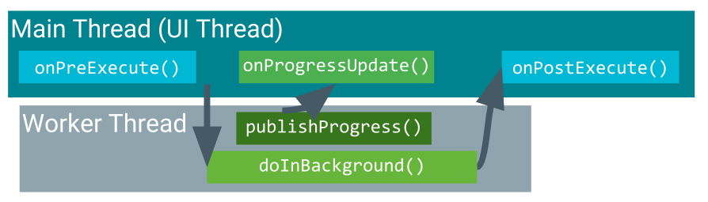

AsyncTask usage

To use the AsyncTask class, define a subclass of AsyncTask that overrides the doInBackground(Params...) method (and usually the onPostExecute(Result) method as well). This section describes the parameters and usage of AsyncTask, then shows a complete example.

AsyncTask parameters

In your subclass of AsyncTask, provide the data types for three kinds of parameters:

* "Params" specifies the type of parameters passed to doInBackground() as an array.
* "Progress" specifies the type of parameters passed to publishProgress() on the background thread. These parameters are then passed to the onProgressUpdate() method on the main thread.
* "Result" specifies the type of parameter that doInBackground() returns. This parameter is automatically passed to onPostExecute() on the main thread.

Specify a data type for each of these parameter types, or use Void if the parameter type will not be used. For example:

public class MyAsyncTask extends AsyncTask <String, Void, Bitmap>{}

In this class declaration:

* The "Params" parameter type is String, which means that MyAsyncTask takes one or more strings as parameters in doInBackground(), for example to use in a query.
* The "Progress" parameter type is Void, which means that MyAsyncTask won't use the publishProgress() or onProgressUpdate() methods.
* The "Result" parameter type is Bitmap. MyAsyncTask returns a Bitmap in doInbackground(), which is passed into onPostExecute().

Example of an AsyncTask

private class DownloadFilesTask extends AsyncTask<URL, Integer, Long> {

protected Long doInBackground(URL... urls) {

int count = urls.length;

long totalSize = 0;

for (int i = 0; i < count; i++) {

totalSize += Downloader.downloadFile(urls[i]);

publishProgress((int) ((i / (float) count) * 100));

// Escape early if cancel() is called

if (isCancelled()) break;

}

return totalSize;

}

protected void onProgressUpdate(Integer... progress) {

setProgressPercent(progress[0]);

}

protected void onPostExecute(Long result) {

showDialog("Downloaded " + result + " bytes");

}

}

The example above goes through three of the four basic AsyncTask steps:

* doInBackground() downloads content, a long-running task. It computes the percentage of files downloaded from the index of the for loop and passes it to publishProgress(). The check for isCancelled() inside the for loop ensures that if the task has been cancelled, the system does not wait for the loop to complete.
* onProgressUpdate() updates the percent progress. It is called every time the publishProgress()method is called inside doInBackground(), which updates the percent progress.
* doInBackground() computes the total number of bytes downloaded and returns it. onPostExecute()receives the returned result and passes it into onPostExecute(), where it is displayed in a dialog.

The parameter types used in this example are:

* URL for the "Params" parameter type. The URL type means you can pass any number of URLs into the call, and the URLs are automatically passed into the doInBackground() method as an array.
* Integer for the "Progress" parameter type.
* Long for the "Result" parameter type.

Executing an AsyncTask

After you define a subclass of AsyncTask, instantiate it on the UI thread. Then call execute() on the instance, passing in any number of parameters. (These parameters correspond to the "Params" parameter type discussed above).

For example, to execute the DownloadFilesTask task defined above, use the following line of code:

new DownloadFilesTask().execute(url1, url2, url3);

Cancelling an AsyncTask

You can cancel a task at any time, from any thread, by invoking the [cancel()](https://developer.android.com/reference/android/os/AsyncTask.html#cancel(boolean)) method.

* The cancel() method returns false if the task could not be cancelled, typically because it has already completed normally. Otherwise, cancel() returns true.
* To find out whether a task has been cancelled, check the return value of isCancelled() periodically from doInBackground(Object[]), for example from inside a loop as shown in the example below. The isCancelled() method returns true if the task was cancelled before it completed normally.
* After an AsyncTask task is cancelled, onPostExecute() will not be invoked after doInBackground()returns. Instead, [onCancelled(Object)](https://developer.android.com/reference/android/os/AsyncTask.html#onCancelled(Result)) is invoked. The default implementation of onCancelled(Object) calls [onCancelled()](https://developer.android.com/reference/android/os/AsyncTask.html#onCancelled()) and ignores the result.
* By default, in-process tasks are allowed to complete. To allow cancel() to interrupt the thread that's executing the task, pass true for the value of mayInterruptIfRunning.

Limitations of AsyncTask

AsyncTask is impractical for some use cases:

* Changes to device configuration cause problems.

When device configuration changes while an AsyncTask is running, for example if the user changes the screen orientation, the activity that created the AsyncTask is destroyed and re-created. The AsyncTask is unable to access the newly created activity, and the results of the AsyncTask aren't published.

* Old AsyncTask objects stay around, and your app may run out of memory or crash.

If the activity that created the AsyncTask is destroyed, the AsyncTask is not destroyed along with it. For example, if your user exits the app after the AsyncTask has started, the AsyncTask keeps using resources unless you call cancel().

When to use AsyncTask:

* Short or interruptible tasks.
* Tasks that don't need to report back to UI or user.
* Low-priority tasks that can be left unfinished.

For all other situations, use AsyncTaskLoader, which is part of the Loader framework described next.

Loaders

Background tasks are commonly used to load data such as forecast reports or movie reviews. Loading data can be memory intensive, and you want the data to be available even if the device configuration changes. For these situations, use *loaders*, which are classes that facilitate loading data into an activity.

Loaders use the [LoaderManager](https://developer.android.com/reference/android/app/LoaderManager.html) class to manage one or more loaders. LoaderManager includes a set of callbacks for when the loader is created, when it's done loading data, and when it's reset.

Starting a loader

Use the [LoaderManager](https://developer.android.com/reference/android/app/LoaderManager.html) class to manage one or more Loader instances within an activity or fragment. Use initLoader() to initialize a loader and make it active. Typically, you do this within the activity's onCreate() method. For example:

// Prepare the loader. Either reconnect with an existing one,

// or start a new one.

getLoaderManager().initLoader(0, null, this);

If you're using the [Support Library](https://developer.android.com/topic/libraries/support-library/index.html), make this call using [getSupportLoaderManager()](https://developer.android.com/reference/android/support/v4/app/FragmentActivity.html#getSupportLoaderManager()) instead of getLoaderManager(). For example:

getSupportLoaderManager().initLoader(0, null, this);

The initLoader() method takes three parameters:

* A unique ID that identifies the loader. This ID can be whatever you want.
* Optional arguments to supply to the loader at construction, in the form of a [Bundle](https://developer.android.com/reference/android/os/Bundle.html). If a loader already exists, this parameter is ignored.
* A [LoaderCallbacks](https://developer.android.com/reference/android/app/LoaderManager.LoaderCallbacks.html) implementation, which the LoaderManager calls to report loader events. In this example, the local class implements the LoaderManager.LoaderCallbacks interface, so it passes a reference to itself, this.

The initLoader() call has two possible outcomes:

* If the loader specified by the ID already exists, the last loader created using that ID is reused.
* If the loader specified by the ID doesn't exist, initLoader() triggers the [onCreateLoader()](https://developer.android.com/reference/android/app/LoaderManager.LoaderCallbacks.html#onCreateLoader(int,%20android.os.Bundle)) method. This is where you implement the code to instantiate and return a new loader.

**Note:**Whether initLoader() creates a new loader or reuses an existing one, the given LoaderCallbacks implementation is associated with the loader and is called when the loader's state changes. If the requested loader exists and has already generated data, then the system calls onLoadFinished() immediately (during initLoader()), so be prepared for this to happen. Put the call to initLoader() in onCreate() so that the activity can reconnect to the same loader when the configuration changes. That way, the loader doesn't lose the data it has already loaded.

Restarting a loader

When initLoader() reuses an existing loader, it doesn't replace the data that the loader contains, but sometimes you want it to. For example, when you use a user query to perform a search and the user enters a new query, you want to reload the data using the new search term. In this situation, use the restartLoader() method and pass in the ID of the loader you want to restart. This forces another data load with new input data.

About the restartLoader() method:

* restartLoader() uses the same arguments as initLoader().
* restartLoader() triggers the onCreateLoader() method, just as initLoader() does when creating a new loader.
* If a loader with the given ID exists, restartLoader() restarts the identified loader and replaces its data.
* If no loader with the given ID exists, restartLoader() starts a new loader.

LoaderManager callbacks

The LoaderManager object automatically calls onStartLoading() when creating the loader. After that, the LoaderManager manages the state of the loader based on the state of the activity and data, for example by calling onLoadFinished() when the data has loaded.

To interact with the loader, use one of the [LoaderManager callbacks](https://developer.android.com/reference/android/app/LoaderManager.LoaderCallbacks.html) in the activity where the data is needed:

* Call onCreateLoader() to instantiate and return a new loader for the given ID.
* Call onLoadFinished() when a previously created loader has finished loading. This is typically the point at which you move the data into activity views.
* Call onLoaderReset() when a previously created loader is being reset, which makes its data unavailable. At this point your app should remove any references it has to the loader's data.

The subclass of the Loader is responsible for actually loading the data. Which Loader subclass you use depends on the type of data you are loading, but one of the most straightforward is AsyncTaskLoader, described next. AsyncTaskLoader uses an AsyncTask to perform tasks on a worker thread.

AsyncTaskLoader

[AsyncTaskLoader](https://developer.android.com/reference/android/content/AsyncTaskLoader.html) is the loader equivalent of AsyncTask. AsyncTaskLoader provides a method, loadInBackground(), that runs on a separate thread. The results of loadInBackground() are automatically delivered to the UI thread, by way of the onLoadFinished() LoaderManager callback.

AsyncTaskLoader usage

To define a subclass of AsyncTaskLoader, create a class that extends AsyncTaskLoader<D>, where D is the data type of the data you are loading. For example, the following AsyncTaskLoader loads a list of strings:

public static class StringListLoader extends AsyncTaskLoader<List<String>> {}

Next, implement a constructor that matches the superclass implementation:

* Your constructor takes the application context as an argument and passes it into a call to super().
* If your loader needs additional information to perform the load, your constructor can take additional arguments.

In the example shown below, the constructor takes a query term.

public StringListLoader(Context context, String queryString) {

super(context);

mQueryString = queryString;

}

To perform the load, use the loadInBackground() override method, the corollary to the doInBackground()method of AsyncTask. For example:

@Override

public List<String> loadInBackground() {

List<String> data = new ArrayList<String>;

//TODO: Load the data from the network or from a database

return data;

}

Implementing the callbacks

Use the constructor in the onCreateLoader() LoaderManager callback, which is where the new loader is created. For example, this onCreateLoader() callback uses the StringListLoader constructor defined above:

@Override

public Loader<List<String>> onCreateLoader(int id, Bundle args) {

return new StringListLoader(this, args.getString("queryString"));

}

The results of loadInBackground() are automatically passed into the onLoadFinished() callback, which is where you can display the results in the UI. For example:

public void onLoadFinished(Loader<List<String>> loader, List<String> data) {

mAdapter.setData(data);

}

The onLoaderReset() callback is only called when the loader is being destroyed, so you can leave onLoaderReset() blank most of the time, because you won't try to access the data after the loader is destroyed.

When you use AsyncTaskLoader, your data survives device-configuration changes. If your activity is permanently destroyed, the loader is destroyed with it, with no lingering tasks that consume system resources.

Loaders have other benefits too, for example, they let you monitor data sources for changes and reload the data if a change occurs. You learn more about the specifics of loaders in a future lesson.

7.2: Internet connection

**Contents:**

* [Introduction](https://google-developer-training.github.io/android-developer-fundamentals-course-concepts-v2/unit-3-working-in-the-background/lesson-7-background-tasks/7-2-c-internet-connection/7-2-c-internet-connection.html#chapterstart)
* [Network security](https://google-developer-training.github.io/android-developer-fundamentals-course-concepts-v2/unit-3-working-in-the-background/lesson-7-background-tasks/7-2-c-internet-connection/7-2-c-internet-connection.html#security)
* [Including permissions in the manifest](https://google-developer-training.github.io/android-developer-fundamentals-course-concepts-v2/unit-3-working-in-the-background/lesson-7-background-tasks/7-2-c-internet-connection/7-2-c-internet-connection.html#permissions)
* [Performing network operations on a worker thread](https://google-developer-training.github.io/android-developer-fundamentals-course-concepts-v2/unit-3-working-in-the-background/lesson-7-background-tasks/7-2-c-internet-connection/7-2-c-internet-connection.html#threads)
* [Making an HTTP connection](https://google-developer-training.github.io/android-developer-fundamentals-course-concepts-v2/unit-3-working-in-the-background/lesson-7-background-tasks/7-2-c-internet-connection/7-2-c-internet-connection.html#connection)
* [Parsing the results](https://google-developer-training.github.io/android-developer-fundamentals-course-concepts-v2/unit-3-working-in-the-background/lesson-7-background-tasks/7-2-c-internet-connection/7-2-c-internet-connection.html#parse_results)
* [Managing the network state](https://google-developer-training.github.io/android-developer-fundamentals-course-concepts-v2/unit-3-working-in-the-background/lesson-7-background-tasks/7-2-c-internet-connection/7-2-c-internet-connection.html#manage_state)
* [Related practical](https://google-developer-training.github.io/android-developer-fundamentals-course-concepts-v2/unit-3-working-in-the-background/lesson-7-background-tasks/7-2-c-internet-connection/7-2-c-internet-connection.html#relatedpractical)
* [Learn more](https://google-developer-training.github.io/android-developer-fundamentals-course-concepts-v2/unit-3-working-in-the-background/lesson-7-background-tasks/7-2-c-internet-connection/7-2-c-internet-connection.html#learnmore)

Most Android apps engage the user with useful data. That data might be news articles, weather information, contacts, game statistics, and more. Often, data is provided over the network by a web API.

In this chapter you learn about network security and how to make network calls, which involves these general steps:

* Include permissions in your AndroidManifest.xml file.
* On a worker thread, make an HTTP client connection that connects to the network and downloads or uploads data.
* Parse the results, which are usually in JSON format.
* Check the state of the network and respond accordingly.

Network security

Network transactions are inherently risky, because they involve transmitting data that could be private to the user. People are increasingly aware of these risks, especially when their devices perform network transactions, so it's very important that your app implement best practices for keeping user data secure at all times.

Security best practices for network operations include:

* Use appropriate protocols for sensitive data. For example for secure web traffic, use the [HttpsURLConnection](https://developer.android.com/reference/javax/net/ssl/HttpsURLConnection.html) subclass of HttpURLConnection.
* Use HTTPS instead of HTTP anywhere that HTTPS is supported on the server, because mobile devices frequently connect on insecure networks such as public Wi-Fi hotspots. Consider using [SSLSocketClass](https://developer.android.com/reference/javax/net/ssl/SSLSocket.html) to implement authenticated, encrypted socket-level communication.
* Don't use localhost network ports to handle sensitive interprocess communication (IPC), because other apps on the device can access these local ports. Instead, use a mechanism that lets you use authentication, for example, a [Service](https://developer.android.com/reference/android/app/Service).
* Don't trust data downloaded from HTTP or other insecure protocols. Validate input that's entered into a WebView and responses to intents that you issue against HTTP.

For more best practices and security tips, take a look at the [Security Tips article](https://developer.android.com/training/articles/security-tips.html).

Including permissions in the manifest

Before your app can make network calls, you need to include a permission in your AndroidManifest.xmlfile. Add the following tag inside the <manifest> tag:

<uses-permission android:name="android.permission.INTERNET" />

When using the network, it's a best practice to monitor the network state of the device so that you don't attempt to make network calls when the network is unavailable. To access the network state of the device, your app needs an additional permission:

<uses-permission

android:name="android.permission.ACCESS_NETWORK_STATE" />

Performing network operations on a worker thread

Always perform network operations on a worker thread, separate from the UI thread. For example, in your Java code you could create an [AsyncTask](https://developer.android.com/reference/android/os/AsyncTask) (or [AsyncTaskLoader](https://developer.android.com/reference/android/content/AsyncTaskLoader)) implementation that opens a network connection and queries an API. Your main code checks whether a network connection is active. If so, it runs the AsyncTask in a separate thread, then displays the results in the UI.

**Note:** If you run network operations on the main thread instead of on a worker thread, your code will throw a [NetworkOnMainThreadException](https://developer.android.com/reference/android/os/NetworkOnMainThreadException) and your app will close.

Making an HTTP connection

Most network-connected Android apps use HTTP and HTTPS to send and receive data over the network. For a refresher on HTTP, visit this [Learn HTTP tutorial](http://www.tutorialspoint.com/http/).

**Note:** If a web server offers HTTPS, you should use it instead of HTTP for improved security.

The [HttpURLConnection](https://developer.android.com/reference/java/net/HttpURLConnection.html) Android client supports HTTPS, streaming uploads and downloads, configurable timeouts, IPv6, and connection pooling. To use the HttpURLConnection client, build a URI (the request's destination). Then obtain a connection, send the request and any request headers, download and read the response and any response headers, and disconnect.

Building your URI

To open an HTTP connection, you need to build a request URI as a [Uri](https://developer.android.com/reference/android/net/Uri) object. A URI object is usually made up of a base URL and a collection of query parameters that specify the resource in question. For example to search for the first five book results for "Pride and Prejudice" in the Google Books API, use the following URI:

https://www.googleapis.com/books/v1/volumes?q=pride+prejudice&maxResults=5&printType=books

To construct a request URI programmatically, use the URI.parse() method with the buildUpon() and appendQueryParameter() methods. The following code builds the complete URI shown above:

// Base URL for the Books API.

final String BOOK_BASE_URL =

"https://www.googleapis.com/books/v1/volumes?";

// Parameter for the search string

final String QUERY_PARAM = "q";

// Parameter to limit search results.

final String MAX_RESULTS = "maxResults";

// Parameter to filter by print type

final String PRINT_TYPE = "printType";

// Build up the query URI, limiting results to 5 printed books.

Uri builtURI = Uri.parse(BOOK_BASE_URL).buildUpon()

.appendQueryParameter(QUERY_PARAM, "pride+prejudice")

.appendQueryParameter(MAX_RESULTS, "5")

.appendQueryParameter(PRINT_TYPE, "books")

.build();

To convert the Uri object to a string, use the toString() method:

String myurl = builtURI.toString();

Connecting and downloading data

In the worker thread that performs your network transactions, for example within your override of the doInBackground() method in an AsyncTask, use the [HttpURLConnection](https://developer.android.com/reference/java/net/HttpURLConnection.html) class to perform an HTTP GETrequest and download the data your app needs. Here's how:

1. To obtain a new HttpURLConnection, call [URL.openConnection()](https://developer.android.com/reference/java/net/URL.html#openConnection()) using the URI that you've built. Cast the result to HttpURLConnection.

The URI is the primary property of the request, but request headers can also include metadata such as credentials, preferred content types, and session cookies.

1. Set optional parameters. For a slow connection, you might want a long [connection timeout](https://developer.android.com/reference/java/net/URLConnection.html#setConnectTimeout(int)) (the time to make the initial connection to the resource) or [read timeout](https://developer.android.com/reference/java/net/URLConnection.html#setReadTimeout(int)) (the time to actually read the data).

To change the request method to something other than GET, use the [setRequestMethod()](https://developer.android.com/reference/java/net/HttpURLConnection.html#setRequestMethod(java.lang.String)) method. If you won't use the network for input, call the [setDoInput()](https://developer.android.com/reference/java/net/URLConnection.html#setDoInput(boolean)) method with an argument of false. (The default is true.)

For more methods you can set, see the [HttpURLConnection](https://developer.android.com/reference/java/net/HttpURLConnection.html) and [URLConnection](https://developer.android.com/reference/java/net/URLConnection.html) reference documentation.

1. Open an input stream using the [getInputStream()](https://developer.android.com/reference/java/net/URLConnection.html#getInputStream()) method, then read the response and convert it into a string. Response headers typically include metadata such as the response body content type and length, modification dates, and session cookies. If the response has no body, getInputStream()returns an empty stream.
2. Call the [disconnect()](https://developer.android.com/reference/java/net/HttpURLConnection.html#disconnect()) method to close the connection. Disconnecting releases the resources held by a connection so they can be closed or reused.

These steps are shown in the [Request example](https://google-developer-training.github.io/android-developer-fundamentals-course-concepts-v2/unit-3-working-in-the-background/lesson-7-background-tasks/7-2-c-internet-connection/7-2-c-internet-connection.html#request_example), below.

Uploading data

If you're uploading (posting) data to a web server, you need to upload a *request body*, which holds the data to be posted. To do this:

1. Configure the connection so that output is possible by calling [setDoOutput(true)](https://developer.android.com/reference/java/net/URLConnection.html#setDoOutput(boolean)). By default, HttpURLConnection uses HTTP GET requests. When setDoOutput is true, HttpURLConnection uses HTTP POST requests instead.
2. Open an output stream by calling the [getOutputStream()](https://developer.android.com/reference/java/net/URLConnection.html#getOutputStream()) method.

For more about posting data to the network, see "Posting Content" in the [HttpURLConnectiondocumentation](https://developer.android.com/reference/java/net/HttpURLConnection.html).

**Note:**All network calls must be performed in a worker thread and not on the UI thread.

Request example

The following example sends a request to the URL built in the [Building your URI](https://google-developer-training.github.io/android-developer-fundamentals-course-concepts-v2/unit-3-working-in-the-background/lesson-7-background-tasks/7-2-c-internet-connection/7-2-c-internet-connection.html#building_uri) section, above. The request obtains a new HttpURLConnection, opens an [InputStream](https://developer.android.com/reference/java/io/InputStream.html), reads the response, converts the response into a string, and closes the connection.

private String downloadUrl(String myurl) throws IOException {

InputStream inputStream = null;

// Only display the first 500 characters of the retrieved

// web page content.

int len = 500;

try {

URL url = new URL(myurl);

HttpURLConnection conn =

(HttpURLConnection) url.openConnection();

conn.setReadTimeout(10000 /* milliseconds */);

conn.setConnectTimeout(15000 /* milliseconds */);

// Start the query

conn.connect();

int response = conn.getResponseCode();

Log.d(DEBUG_TAG, "The response is: " + response);

inputStream = conn.getInputStream();

// Convert the InputStream into a string

String contentAsString =

convertInputToString(inputStream, len);

return contentAsString;

// Close the InputStream and connection

} finally {

conn.disconnect();

if (inputStream != null) {

inputStream.close();

}

}

}

Converting the InputStream to a string

An [InputStream](https://developer.android.com/reference/java/io/InputStream.html) is a readable source of bytes. Once you get an InputStream, it's common to decode or convert it into the data type you need. In the example above, the InputStream represents plain text from the web page located at <https://www.googleapis.com/books/v1/volumes?q=pride+prejudice&maxResults=5&printType=books>

The convertInputToString method defined below converts the InputStream to a string so that the activity can display it in the UI. The method uses an InputStreamReader instance to read bytes and decode them into characters:

// Reads an InputStream and converts it to a String.

public String convertInputToString(InputStream stream, int len)

throws IOException, UnsupportedEncodingException {

Reader reader = null;

reader = new InputStreamReader(stream, "UTF-8");

char[] buffer = new char[len];

reader.read(buffer);

return new String(buffer);

}

**Note:** If you expect a long response, wrap your InputStreamReader inside a BufferedReader for more efficient reading of characters, arrays, and lines. For example: ``` reader = new BufferedReader(new InputStreamReader(stream, "UTF-8")); ```

Parsing the results

When you make web API queries, the results are often in [JSON](http://www.json.org/) format. Below is an example of a JSON response from an HTTP request. It shows the names of three menu items in a popup menu and the methods that are triggered when the menu items are clicked:

{"menu": {

"id": "file",

"value": "File",

"popup": {

"menuitem": [

{"value": "New", "onclick": "CreateNewDoc()"},

{"value": "Open", "onclick": "OpenDoc()"},

{"value": "Close", "onclick": "CloseDoc()"}

]

}

}

To find the value of an item in the response, use methods from the [JSONObject](https://developer.android.com/reference/org/json/JSONObject.html) and [JSONArray](https://developer.android.com/reference/org/json/JSONArray.html) classes. For example, here's how to find the "onclick" value of the third item in the "menuitem" array:

JSONObject data = new JSONObject(responseString);

JSONArray menuItemArray = data.getJSONArray("menuitem");

JSONObject thirdItem = menuItemArray.getJSONObject(2);

String onClick = thirdItem.getString("onclick");

Managing the network state

Making network calls can be expensive and slow, especially if the device has little connectivity. Being aware of the network connection state can prevent your app from attempting to make network calls when the network isn't available.

Sometimes it's also important for your app to know what kind of connectivity the device has: Wi-Fi networks are typically faster than data networks, and data networks are often metered and expensive. To control when certain tasks are performed, monitor the network state and respond appropriately. For example, you may want to wait until the device is connected to Wifi to perform a large file download.

To check the network connection, use the following classes:

* [ConnectivityManager](https://developer.android.com/reference/android/net/ConnectivityManager.html) answers queries about the state of network connectivity. It also notifies apps when network connectivity changes.
* [NetworkInfo](https://developer.android.com/reference/android/net/NetworkInfo.html) describes the status of a network interface of a given type (currently either mobile or Wi-Fi).

The following code snippet tests whether Wi-Fi and mobile are connected. In the code:

* The [getSystemService()](https://developer.android.com/reference/android/content/Context#getSystemService(java.lang.Class%3CT%3E)) method gets an instance of ConnectivityManager from the context.
* The [getNetworkInfo()](https://developer.android.com/reference/android/net/ConnectivityManager#getnetworkinfo_3) method gets the status of the device's Wi-Fi connection, then its mobile connection. The getNetworkInfo() method returns a NetworkInfo object, which contains information about the given network's connection status (whether that connection is idle, connecting, and so on).
* The [networkInfo.isConnected()](https://developer.android.com/reference/android/net/NetworkInfo#isconnected) method returns true if the given network is connected. If the network is connected, it can be used to establish sockets and pass data.
* private static final String DEBUG_TAG = "NetworkStatusExample";
* ConnectivityManager connMgr = (ConnectivityManager)
* getSystemService(Context.CONNECTIVITY_SERVICE);
* NetworkInfo networkInfo =
* connMgr.getNetworkInfo(ConnectivityManager.TYPE_WIFI);
* boolean isWifiConn = networkInfo.isConnected();
* networkInfo =
* connMgr.getNetworkInfo(ConnectivityManager.TYPE_MOBILE);
* boolean isMobileConn = networkInfo.isConnected();
* Log.d(DEBUG_TAG, "Wifi connected: " + isWifiConn);

Log.d(DEBUG_TAG, "Mobile connected: " + isMobileConn);

# 7.3 Broadcasts

**Contents:**

* [Introduction](https://google-developer-training.github.io/android-developer-fundamentals-course-concepts-v2/unit-3-working-in-the-background/lesson-7-background-tasks/7-3-c-broadcasts/7-3-c-broadcasts.html#chapterstart)
* [Broadcasts](https://google-developer-training.github.io/android-developer-fundamentals-course-concepts-v2/unit-3-working-in-the-background/lesson-7-background-tasks/7-3-c-broadcasts/7-3-c-broadcasts.html#broadcasts)
* [Broadcast receivers](https://google-developer-training.github.io/android-developer-fundamentals-course-concepts-v2/unit-3-working-in-the-background/lesson-7-background-tasks/7-3-c-broadcasts/7-3-c-broadcasts.html#broadcast_receivers)
* [Restricting broadcasts](https://google-developer-training.github.io/android-developer-fundamentals-course-concepts-v2/unit-3-working-in-the-background/lesson-7-background-tasks/7-3-c-broadcasts/7-3-c-broadcasts.html#restricting_broadcasts)
* [Best practices](https://google-developer-training.github.io/android-developer-fundamentals-course-concepts-v2/unit-3-working-in-the-background/lesson-7-background-tasks/7-3-c-broadcasts/7-3-c-broadcasts.html#bestpractices)
* [Related practical](https://google-developer-training.github.io/android-developer-fundamentals-course-concepts-v2/unit-3-working-in-the-background/lesson-7-background-tasks/7-3-c-broadcasts/7-3-c-broadcasts.html#relatedpractical)
* [Learn more](https://google-developer-training.github.io/android-developer-fundamentals-course-concepts-v2/unit-3-working-in-the-background/lesson-7-background-tasks/7-3-c-broadcasts/7-3-c-broadcasts.html#learnmore)

In this chapter you learn about broadcasts and broadcast receivers. Broadcasts are messaging components used for communicating across different apps, and also with the Android system, when an event of interest occurs. Broadcast receivers are the components in your Android app that listen for these events and respond accordingly.

## Broadcasts

Broadcasts are messages that the Android system and Android apps send when events occur that might affect the functionality of other apps. For example, the Android system sends an event when the system boots up, when power is connected or disconnected, and when headphones are connected or disconnected. Your Android app can also broadcast events, for example when new data is downloaded.

In general, broadcasts are messaging components used for communicating across apps when events of interest occur. There are two types of broadcasts:

* System broadcasts are delivered by the system.
* Custom broadcasts are delivered by your app.

### System broadcasts

A system broadcast is a message that the Android system sends when a system event occurs. System broadcasts are wrapped in Intent objects. The intent object's action field contains event details such as [android.intent.action.HEADSET_PLUG](https://developer.android.com/reference/android/content/Intent#ACTION_HEADSET_PLUG), which is sent when a wired headset is connected or disconnected. The intent can also contain more data about the event in its extra field, for example a boolean extra indicating whether a headset is connected or disconnected.

Examples:

* When the device boots, the system broadcasts a system Intent with the action [ACTION_BOOT_COMPLETED](https://developer.android.com/reference/android/content/Intent.html#ACTION_BOOT_COMPLETED).
* When the device is disconnected from external power, the system sends a system Intent with the action field [ACTION_POWER_DISCONNECTED](https://developer.android.com/reference/android/content/Intent.html#ACTION_POWER_DISCONNECTED).

System broadcasts aren't targeted at specific recipients. Interested apps must register a component to "listen" for these events. This listening component is called a broadcast receiver.

As the Android system evolves, significant changes are made to improve the system's performance. For example, starting from Android 7.0, the system broadcast actions [ACTION_NEW_PICTURE](https://developer.android.com/reference/android/hardware/Camera.html#ACTION_NEW_PICTURE) and [ACTION_NEW_VIDEO](https://developer.android.com/reference/android/hardware/Camera.html#ACTION_NEW_VIDEO) are not supported. Apps can no longer receive broadcasts about these actions, regardless of the targetSDK version on the device. This is because device cameras take pictures and record videos frequently, so sending a system broadcast every time one of these actions occurred would strain a device's memory and battery.

To get the complete list of broadcast actions that the system can send for a particular SDK version, check the broadcast_actions.txt file in your SDK folder, at the following path: Android/sdk/platforms/android-*xx*/data, where *xx* is the SDK version.

### Custom broadcasts

Custom broadcasts are broadcasts that your app sends out. Use a custom broadcast when you want your app to take an action without launching an activity. For example, use a custom broadcast when you want to let other apps know that data has been downloaded to the device and is available for them to use. More than one broadcast receiver can be registered to receive your broadcast.

To create a custom broadcast, define a custom Intent action.

**Note:** When you specify the action for the Intent, use your unique package name (for example com.example.myproject) to make sure that your intent doesn't conflict with an intent that is broadcast from a different app or from the Android system.

There are three ways to deliver a custom broadcast:

* For a normal broadcast, pass the intent to [sendBroadcast()](https://developer.android.com/reference/android/content/Context#sendBroadcast(android.content.Intent)).
* For an ordered broadcast, pass the intent to [sendOrderedBroadcast()](https://developer.android.com/reference/android/content/Context#sendOrderedBroadcast(android.content.Intent,%20java.lang.String)).
* For a local broadcast, pass the intent to [LocalBroadcastManager.sendBroadcas](https://developer.android.com/reference/android/support/v4/content/LocalBroadcastManager.html#sendBroadcast(android.content.Intent))t().

Normal, ordered, and local broadcasts are described in more detail below.

#### **Normal broadcasts**

The [sendBroadcast()](https://developer.android.com/reference/android/content/Context#sendBroadcast(android.content.Intent)) method sends broadcasts to all the registered receivers at the same time, in an undefined order. This is called a normal broadcast. A normal broadcast is the most efficient way to send a broadcast. With normal broadcasts, receivers can't propagate the results among themselves, and they can't cancel the broadcast.

The following method sends a normal broadcast to all interested broadcast receivers:

public void sendBroadcast() {

Intent intent = new Intent();

intent.setAction("com.example.myproject.ACTION_SHOW_TOAST");

// Set the optional additional information in extra field.

intent.putExtra("data","This is a normal broadcast");

sendBroadcast(intent);

}

#### **Ordered broadcasts**

To send a broadcast to one receiver at a time, use the sendOrderedBroadcast() method:

* The android:priority attribute that's specified in the intent filter determines the order in which the broadcast is sent.
* If more than one receiver with same priority is present, the sending order is random.
* The Intent is propagated from one receiver to the next.
* During its turn, a receiver can update the Intent, or it can cancel the broadcast. (If the receiver cancels the broadcast, the Intent can't be propagated further.)

For example, the following method sends an ordered broadcast to all interested broadcast receivers:

public void sendOrderedBroadcast() {

Intent intent = new Intent();

// Set a unique action string prefixed by your app package name.

intent.setAction("com.example.myproject.ACTION_NOTIFY");

// Deliver the Intent.

sendOrderedBroadcast(intent);

}

#### **Local broadcasts**

If you don't need to send broadcasts to a different app, use the [LocalBroadcastManager.sendBroadcas](https://developer.android.com/reference/android/support/v4/content/LocalBroadcastManager.html#sendBroadcast(android.content.Intent))t()method, which sends broadcasts to receivers within your app. This method is efficient, because it doesn't involve interprocess communication. Also, using local broadcasts protects your app against some security issues.

To send a local broadcast:

1. To get an instance of LocalBroadcastManager, call getInstance() and pass in the application context.
2. Call sendBroadcast() on the instance. Pass in the intent that you want to broadcast.
3. LocalBroadcastManager.getInstance(this).sendBroadcast(customBroadcastIntent);

## Broadcast receivers

Broadcast receivers are app components that can register for system events or app events. When an event occurs, registered broadcast receivers are notified via an Intent. For instance, if you are implementing a media app and you're interested in knowing when the user connects or disconnects a headset, register for the ACTION_HEADSET_PLUG intent action.

Use broadcast receivers to respond to messages that have been broadcast from apps or from the Android system. To create a broadcast receiver:

1. Define a subclass of the [BroadcastReceiver](https://developer.android.com/reference/android/content/BroadcastReceiver) class and implement the onReceive() method.
2. Register the broadcast receiver, either statically or dynamically.

These steps are described below.

### Subclass a BroadcastReceiver

To create a broadcast receiver, define a subclass of the [BroadcastReceiver](https://developer.android.com/reference/android/content/BroadcastReceiver.html) class. This subclass is where Intent objects are delivered if they match the intent filters you register for.

Within your subclass:

* Implement the [onReceive()](https://developer.android.com/reference/android/content/BroadcastReceiver#onReceive(android.content.Context,%20android.content.Intent)) method, which is called when the BroadcastReceiver object receives an Intent broadcast .
* Inside onReceive(), include any other logic that your broadcast receiver needs.

### Example: Create a broadcast receiver

In this example, the myReceiver class a subclass of BroadcastReceiver. If the incoming broadcast intent has the ACTION_SHOW_TOAST action, the myReceiver class shows a toast message:

//Subclass of the BroadcastReceiver class.

private class myReceiver extends BroadcastReceiver {

// Override the onReceive method to receive the broadcasts

@Override

public void onReceive(Context context, Intent intent) {

//Check the Intent action and perform the required operation

if (intent.getAction().equals(ACTION_SHOW_TOAST)) {

CharSequence text = "Broadcast Received!";

int duration = Toast.LENGTH_SHORT;

Toast toast = Toast.makeText(context, text, duration);

toast.show();

}

}

}

The onReceive() method is called when your app receives a registered Intent broadcast. The onReceive() method runs on the main thread unless it is explicitly asked to run on a different thread in the [registerReceiver()](https://developer.android.com/reference/android/content/Context#registerReceiver(android.content.BroadcastReceiver,%20android.content.IntentFilter,%20java.lang.String,%20android.os.Handler)) method.

The onReceive() method has a timeout of 10 seconds. After 10 seconds, the Android system considers your receiver to be blocked, and the system might show the user an "application not responding" error. For this reason, you shouldn't implement long-running operations in onReceive().

**Important:** Don't use asynchronous operations to run a long-running operation in your onReceive()implementation, because once your code returns from onReceive(), the system considers the BroadcastReceiver component to be finished. If onReceive() started an asynchronous operation, the system would stop the BroadcastReceiver process before the asynchronous operation had a chance to complete.

In particular:

* Don't try to show a dialog from within a BroadcastReceiver. Instead, display a notification using the [NotificationManager](https://developer.android.com/reference/android/app/NotificationManager.html) API.
* Don't try to bind to a service from within a BroadcastReceiver. Instead, use [Context.startService()](https://developer.android.com/reference/android/content/Context.html#startService(android.content.Intent))to send a command to the service.

If you need to perform a long-running operation inside BroadcastReceiver, use [WorkManager](https://developer.android.com/topic/libraries/architecture/workmanager) to schedule a job. When you schedule a task with WorkManager, the task is guaranteed to run. WorkManager chooses the appropriate way to run your task, based on such factors as the device API level and the app state.

### Register your broadcast receiver and set intent filters

There are two types of broadcast receivers:

* Static receivers, which you register in the Android manifest file.
* Dynamic receivers, which you register using a context.

#### **Static receivers**

Static receivers are also called manifest-declared receivers. To register a static receiver, include the following attributes inside the <receiver> element in your AndroidManifest.xml file:

* [android:name](https://developer.android.com/guide/topics/manifest/receiver-element#nm)

The value for this attribute is the fully classified name of the BroadcastReceiver subclass, including the package name. To use the package name that's specified in the manifest, prefix the subclass name with a period, for example .AlarmReceiver.

* [android:exported](https://developer.android.com/guide/topics/manifest/receiver-element#exported) (optional)

If this boolean value is set to false, other apps cannot send broadcasts to your receiver. This attribute is important for security.

* [<intent-filter>](https://developer.android.com/guide/topics/manifest/intent-filter-element)

Include this nested element to specify the broadcast Intent actions that your broadcast receiver component is listening for.

The following code snippet shows static registration of a broadcast receiver that listens for a custom broadcast Intent with the action "ACTION_SHOW_TOAST":

* The receiver's name is the name of the BroadcastReceiver subclass (.AlarmReceiver).
* The receiver is not exported, meaning that no other apps can deliver broadcasts to this app.
* The intent filter checks whether incoming intents include an action named ACTION_SHOW_TOAST, which is a custom Intent action defined within the app.
* <receiver
* android:name=".AlarmReceiver"
* android:exported="false">
* <intent-filter>
* <action android:name=
* "com.example.myproject.intent.action.ACTION_SHOW_TOAST"/>
* </intent-filter>
* </receiver>

**Note:** For Android 8.0 (API level 26) and higher, static receivers can't receive most implicit broadcasts. (Implicit broadcasts are broadcasts that don't target your app specifically.) Even if you register for these broadcasts in the manifest, the Android system won't deliver them to your app. However, you can still use a dynamic receiver to register for these broadcasts.

A few broadcasts, such as [ACTION_BOOT_COMPLETED](https://developer.android.com/reference/android/content/Intent.html#ACTION_BOOT_COMPLETED) and [ACTION_TIMEZONE_CHANGED](https://developer.android.com/reference/android/content/Intent.html#ACTION_TIMEZONE_CHANGED), are excepted from this restriction. You can declare them in the manifest, no matter what the target API level. To learn more, see the complete list of [implicit broadcast exceptions](https://developer.android.com/guide/components/broadcast-exceptions).  
</div>

#### **Intent filters**

An intent filter specifies the types of intents that a component can receive. When the system receives an Intent as a broadcast, it searches the broadcast receivers based on the values specified in receivers' intent filters.

To create an intent filter statically, use the <intent-filter> element in the Android manifest. An <intent-filter> element has one required element, [<action>](https://developer.android.com/guide/topics/manifest/action-element.html). The Android system compares the Intent action of the incoming broadcast to the filter action's android:name strings. If any of the names in the filter match the action name in the incoming broadcast, the broadcast is sent to your app.

This <intent-filter> listens for a system broadcast that's sent when the device boots up. Only Intentobjects with an action named BOOT_COMPLETED match the filter:

<intent-filter>

<action android:name="android.intent.action.BOOT_COMPLETED"/>

</intent-filter>

If no intent filters are specified, the broadcast receiver can only be activated with an explicit broadcast Intent that specifies the component by name. (This is similar to how explicit intents are used to launch activities by their class names.)

To learn more about using intent filters, see the [Intent resolution](https://developer.android.com/guide/components/intents-filters.html#Resolution) section of the Intent guide.

#### **Dynamic receivers**

Dynamic receivers are also called context-registered receivers. You register a dynamic receiver using an application context or an Activity context. A dynamic receiver receives broadcasts as long as the registering context is valid:

* If you use the application context to register your receiver, your app receives relevant broadcasts as long as your app is running in either the foreground or the background.
* If you use an Activity context to register your receiver, your app receives relevant broadcasts until that Activity is destroyed.

To use the context to register your receiver dynamically:

1. Create an IntentFilter and add the Intent actions that you want your app to listen for. You can add more than one action to the same IntentFilter object.
2. IntentFilter intentFilter = new IntentFilter();
3. filter.addAction(Intent.ACTION_POWER_CONNECTED);
4. filter.addAction(Intent.ACTION_POWER_DISCONNECTED);

When the device power is connected or disconnected, the Android system broadcasts the Intent.ACTION_POWER_CONNECTED and Intent.ACTION_POWER_DISCONNECTED intent actions.

1. Register the receiver by calling [registerReceiver()](https://developer.android.com/reference/android/content/Context#registerReceiver(android.content.BroadcastReceiver,%20android.content.IntentFilter)) method on the context. Pass in the BroadcastReceiver object and the IntentFilter object.
2. mReceiver = new AlarmReceiver();
3. this.registerReceiver(mReceiver, intentFilter);

In this example the Activity context (this) is used to register your receiver. So the app will receive the broadcast as long as the Activity is running.

#### **Local broadcasts**

You must register local receivers dynamically, because static registration in the manifest is not possible for a local broadcasts.

To register a receiver for local broadcasts:

1. Get an instance of LocalBroadcastManager by calling the getInstance() method.
2. Call registerReceiver(), passing in the receiver and an IntentFilter object.
3. LocalBroadcastManager.getInstance(this)
4. .registerReceiver(mReceiver,
5. new IntentFilter(CustomReceiver.ACTION_CUSTOM_BROADCAST));

#### **Unregister the receiver**

To save system resources and avoid leaks, unregister dynamic receivers when your app no longer needs them, or before the Activity or app is destroyed. This is also true for local broadcast receivers, because they're registered dynamically.

To unregister a normal broadcast receiver:

1. Call [unregisterReceiver()](https://developer.android.com/reference/android/support/v4/content/LocalBroadcastManager.html#unregisterReceiver(android.content.BroadcastReceiver)) and pass in your BroadcastReceiver object:
2. unregisterReceiver(mReceiver);

To unregister a local broadcast receiver:

1. Get an instance of the LocalBroadcastManager.
2. Call [LocalBroadcastManager.unregisterReceiver()](https://developer.android.com/reference/android/support/v4/content/LocalBroadcastManager.html#unregisterReceiver(android.content.BroadcastReceiver)) and pass in your BroadcastReceiver object:
3. LocalBroadcastManager.getInstance(this)
4. .unregisterReceiver(mReceiver);

Where you call these unregisterReceiver() methods depends on the desired lifecycle of your BroadcastReceiver object:

1. Sometimes the receiver is only needed when your activity is visible, for example to disable a network function when the network is not available. In these cases, register the receiver in onResume() and unregister the receiver in onPause().
2. You can also use the onStart()/onStop() or onCreate()/onDestroy() method pairs, if they are more appropriate for your use case.

## Restricting broadcasts

An unrestricted broadcast can pose a security threat, because any registered receiver can receive it. For example, if your app uses a normal broadcast to send an implicit Intent that includes sensitive information, an app that contains malware could receive that broadcast. Restricting your broadcast is strongly recommended.

Ways to restrict a broadcast:

* If possible, use a [LocalBroadcastManager](https://developer.android.com/reference/android/support/v4/content/LocalBroadcastManager.html), which keeps the data inside your app, avoiding any security leaks. You can only use LocalBroadcastManager if you don't need interprocess communication or communication with other apps.
* Use the [setPackage()](https://developer.android.com/reference/android/content/Intent.html#setPackage(java.lang.String)) method and pass in the package name. Your broadcast is restricted to apps that match the specified package name.
* Enforce access permissions on the sender side, on the receiver side, or both.

To enforce a permission when sending a broadcast:

* Supply a non-null permission argument to sendBroadcast(). Only receivers that request this permission using the [<uses-permission>](https://developer.android.com/reference/android/R.styleable.html#AndroidManifestUsesPermission) tag in their AndroidManifest.xml file can receive the broadcast.

To enforce a permission when receiving a broadcast:

* If you register your receiver dynamically, supply a non-null permission to registerReceiver().
* If you register your receiver statically, use the android:permission attribute inside the <receiver>tag in your AndroidManifest.xml.

## Best practices

* In your intent actions, prefix String constants with your app's package name. Otherwise, you may conflict with other apps' intents. The Intent namespace is global.
* Restrict broadcast receivers, as described above.
* Prefer dynamic receivers over static receivers.
* Do not start an Activity from a broadcast receiver—use a notification instead. Starting an activity from a broadcast receiver causes a bad user experience if more than one receiver is listening for the same broadcast event.
* Never perform a long running operation in the broadcast receiver's [onReceive(Context, Intent)](https://developer.android.com/reference/android/content/BroadcastReceiver.html#onReceive(android.content.Context,%20android.content.Intent))method, because the method runs on the main UI thread. Consider using a [JobScheduler](https://developer.android.com/reference/android/app/job/JobScheduler.html) or a [WorkManager](https://developer.android.com/topic/libraries/architecture/workmanager) instead.

7.4: Services

**Contents:**

* [Introduction](https://google-developer-training.github.io/android-developer-fundamentals-course-concepts-v2/unit-3-working-in-the-background/lesson-7-background-tasks/7-4-c-services/7-4-c-services.html#chapterstart)
* [What is a service?](https://google-developer-training.github.io/android-developer-fundamentals-course-concepts-v2/unit-3-working-in-the-background/lesson-7-background-tasks/7-4-c-services/7-4-c-services.html#services)
* [Declaring services in the manifest](https://google-developer-training.github.io/android-developer-fundamentals-course-concepts-v2/unit-3-working-in-the-background/lesson-7-background-tasks/7-4-c-services/7-4-c-services.html#declare)
* [Started services](https://google-developer-training.github.io/android-developer-fundamentals-course-concepts-v2/unit-3-working-in-the-background/lesson-7-background-tasks/7-4-c-services/7-4-c-services.html#started)
* [Bound services](https://google-developer-training.github.io/android-developer-fundamentals-course-concepts-v2/unit-3-working-in-the-background/lesson-7-background-tasks/7-4-c-services/7-4-c-services.html#bound)
* [Service lifecycle](https://google-developer-training.github.io/android-developer-fundamentals-course-concepts-v2/unit-3-working-in-the-background/lesson-7-background-tasks/7-4-c-services/7-4-c-services.html#lifecycle)
* [Foreground services](https://google-developer-training.github.io/android-developer-fundamentals-course-concepts-v2/unit-3-working-in-the-background/lesson-7-background-tasks/7-4-c-services/7-4-c-services.html#foreground)
* [Background services and API 26](https://google-developer-training.github.io/android-developer-fundamentals-course-concepts-v2/unit-3-working-in-the-background/lesson-7-background-tasks/7-4-c-services/7-4-c-services.html#limitations)
* [Scheduled services](https://google-developer-training.github.io/android-developer-fundamentals-course-concepts-v2/unit-3-working-in-the-background/lesson-7-background-tasks/7-4-c-services/7-4-c-services.html#scheduled)
* [Learn more](https://google-developer-training.github.io/android-developer-fundamentals-course-concepts-v2/unit-3-working-in-the-background/lesson-7-background-tasks/7-4-c-services/7-4-c-services.html#learnmore)

In this chapter you learn about the different types of services, how to use them, and how to manage their lifecycles within your app.

What is a service?

A *service* is an app component that performs long-running operations, usually in the background. Unlike an Activity, a service doesn't provide a user interface (UI). Services are defined by the [Service](https://developer.android.com/reference/android/app/Service) class or one of its subclasses.

A service can be *started*, *bound*, or both:

* A *started service* is a service that an app component starts by calling [startService()](https://developer.android.com/reference/android/content/Context#startService(android.content.Intent)).

Use started services for tasks that run in the background to perform long-running operations. Also use started services for tasks that perform work for remote processes.

* A *bound service* is a service that an app component binds to itself by calling [bindService()](https://developer.android.com/reference/android/content/Context#bindService(android.content.Intent,%20android.content.ServiceConnection,%20int)).

Use bound services for tasks that another app component interacts with to perform interprocess communication (IPC). For example, a bound service might handle network transactions, perform file I/O, play music, or interact with a database.

A service runs in the main thread of its hosting process—the service doesn't create its own thread and doesn't run in a separate process unless you specify that it should.

If your service is going to do any CPU-intensive work or blocking operations (such as MP3 playback or networking), create a new thread within the service to do that work. By using a separate thread, you reduce the risk of the user seeing "application not responding" (ANR) errors, and the app's main thread can remain dedicated to user interaction with your activities.

In Android 8.0 (Oreo, API 26) or higher, the system imposes some new restrictions on running background services when the app itself isn't in the foreground. For details about these restrictions, see [Background services and API 26](https://google-developer-training.github.io/android-developer-fundamentals-course-concepts-v2/unit-3-working-in-the-background/lesson-7-background-tasks/7-4-c-services/7-4-c-services.html#limitations).

To implement any kind of service in your app, do the following steps:

1. Declare the service in the manifest.
2. Extend a Service class such as [IntentService](https://developer.android.com/reference/android/app/IntentService) and create implementation code, as described in [Started services](https://google-developer-training.github.io/android-developer-fundamentals-course-concepts-v2/unit-3-working-in-the-background/lesson-7-background-tasks/7-4-c-services/7-4-c-services.html#started) and [Bound services](https://google-developer-training.github.io/android-developer-fundamentals-course-concepts-v2/unit-3-working-in-the-background/lesson-7-background-tasks/7-4-c-services/7-4-c-services.html#bound), below.
3. Manage the [service lifecycle](https://google-developer-training.github.io/android-developer-fundamentals-course-concepts-v2/unit-3-working-in-the-background/lesson-7-background-tasks/7-4-c-services/7-4-c-services.html#lifecycle).

Declaring services in the manifest

As with activities and other components, you must declare all services in your Android manifest. To declare a service, add a <service> element as a child of the <application> element. For example:

<manifest ... >

...

<application ... >

<service android:name="ExampleService"

android:exported="false" />

...

</application>

</manifest>

To block access to a service from other apps, declare the service as private. To do this, set the android:exported attribute to false. This stops other apps from starting your service, even when they use an explicit intent.

Started services

How a service starts:

1. An app component such as an Activity calls startService() and passes in an [Intent](https://developer.android.com/reference/android/content/Intent.html). The Intent specifies the service and includes any data for the service to use.
2. The system calls the service's onCreate() method and any other appropriate callbacks on the main thread. It's up to the service to implement these callbacks with the appropriate behavior, such as creating a secondary thread in which to work.
3. The system calls the service's onStartCommand() method, passing in the Intent supplied by the client in step 1. (The *client* in this context is the app component that calls the service.)

Once started, a service can run in the background indefinitely, even if the component that started it is destroyed. Usually, a started service performs a single operation and does not return a result to the caller. For example, it might download or upload a file over the network. When the operation is done, the service should stop itself by calling [stopSelf()](https://developer.android.com/reference/android/app/Service#stopSelf()), or another component can stop it by calling [stopService()](https://developer.android.com/reference/android/content/Context#stopService(android.content.Intent)).

For instance, suppose an Activity needs to save data to an online database. The Activity starts a companion service by passing an Intent to startService(). The service receives the intent in onStartCommand(), connects to the internet, and performs the database transaction. When the transaction is done, the service uses stopSelf() to stop itself and is destroyed. (This is an example of a service you want to run in a worker thread instead of the main thread.)

IntentService

Most started services don't need to handle multiple requests simultaneously, and if they did, it could be a complex and error-prone multi-threading scenario. For these reasons, the [IntentService](https://developer.android.com/reference/android/app/IntentService.html) class is a useful subclass of Service on which to base your service:

* IntentService automatically provides a worker thread to handle your Intent.
* IntentService handles some of the boilerplate code that regular services need (such as starting and stopping the service).
* IntentService can create a work queue that passes one intent at a time to your onHandleIntent()implementation, so you don't have to worry about multi-threading.

**Note**:IntentService is subject to the new restrictions on background services in Android 8.0 (API 26). For this reason, [Android Support Library 26.0.0](https://developer.android.com/topic/libraries/support-library/revisions.html#26-0-0) introduces a new [JobIntentService](https://developer.android.com/reference/android/support/v4/app/JobIntentService.html) class, which provides the same functionality as IntentService but uses jobs instead of services when running on Android 8.0 or higher.

To implement IntentService:

1. Provide a small constructor for the service.
2. Create an implementation of onHandleIntent() to do the work that the client provides.

Here's an example implementation of IntentService:

public class HelloIntentService extends IntentService {

/**

* A constructor is required, and must call the

* super IntentService(String) constructor with a name

* for the worker thread.

*/

public HelloIntentService() {

super("HelloIntentService");

}

/**

* The IntentService calls this method from the default

* worker thread with the intent that started the service.

* When this method returns, IntentService stops the service,

* as appropriate.

*/

@Override

protected void onHandleIntent(Intent intent) {

// Normally we would do some work here, like download a file.

// For our sample, we just sleep for 5 seconds.

try {

Thread.sleep(5000);

} catch (InterruptedException e) {

// Restore interrupt status.

Thread.currentThread().interrupt();

}

}

}

Bound services

A service is "bound" when an app component binds to it by calling [bindService()](https://developer.android.com/reference/android/content/Context#bindService(android.content.Intent,%20android.content.ServiceConnection,%20int)). A bound service offers a client-server interface that allows components to interact with the service, send requests, and get results, sometimes using interprocess communication (IPC) to send and receive information across processes. A bound service runs only as long as another app component is bound to it. Multiple components can bind to the service at once, but when all of them unbind, the service is destroyed.

A bound service generally does not allow components to start it by calling startService().

Implementing a bound service

To implement a bound service, define the interface that specifies how a client can communicate with the service. This interface, which your service returns from the [onBind()](https://developer.android.com/reference/android/app/Service#onBind(android.content.Intent)) callback method, must be an implementation of [IBinder](https://developer.android.com/reference/android/os/IBinder.html).

To retrieve the IBinder interface, a client app component calls bindService(). Once the client receives the IBinder, the client interacts with the service through that interface.

There are multiple ways to implement a bound service, and the implementation is more complicated than a started service. For complete details about bound services, see [Bound Services](https://developer.android.com/guide/components/bound-services.html).

Binding to a service

To bind to a service that is declared in the manifest and implemented by an app component, use [bindService()](https://developer.android.com/reference/android/content/Context.html#bindService(android.content.Intent,%20android.content.ServiceConnection,%20int)) with an explicit [Intent](https://developer.android.com/reference/android/content/Intent.html).

**Caution:** Do not use an implicit intent to bind to a service. Doing so is a security hazard, because you can't be certain what service will respond to your intent, and the user can't see which service starts. Beginning with Android 5.0 (API level 21), the system throws an exception if you call bindService() with an implicit Intent .

Service lifecycle

The lifecycle of a service is simpler than the Activity lifecycle. However, it's even more important that you pay close attention to how your service is created and destroyed. Because a service has no UI, services can continue to run in the background with no way for the user to know, even if the user switches to another app. This situation can potentially consume resources and drain the device battery.

Similar to an Activity, a service has lifecycle callback methods that you can implement to monitor changes in the service's state and perform work at the appropriate times. The following skeleton service implementation demonstrates each of the lifecycle methods:

public class ExampleService extends Service {

// indicates how to behave if the service is killed.

int mStartMode;

// interface for clients that bind.

IBinder mBinder;

// indicates whether onRebind should be used

boolean mAllowRebind;

@Override

public void onCreate() {

// The service is being created.

}

@Override

public int onStartCommand(Intent intent,

int flags, int startId) {

// The service is starting, due to a call to startService().

return mStartMode;

}

@Override

public IBinder onBind(Intent intent) {

// A client is binding to the service with bindService().

return mBinder;

}

@Override

public boolean onUnbind(Intent intent) {

// All clients have unbound with unbindService()

return mAllowRebind;

}

@Override

public void onRebind(Intent intent) {

// A client is binding to the service with bindService(),

// after onUnbind() has already been called

}

@Override

public void onDestroy() {

// The service is no longer used and is being destroyed

}

}

Lifecycle of started services vs. bound services

A bound service exists only to serve the app component that's bound to it, so when no more components are bound to the service, the system destroys it. Bound services don't need to be explicitly stopped the way started services do (using stopService() or stopSelf()).

The diagram below shows a comparison between the started and bound service lifecycles.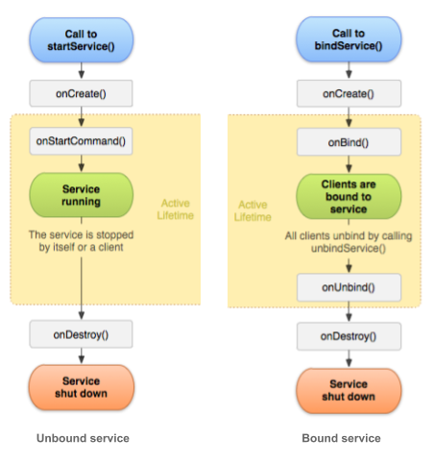

Foreground services

While most services run in the background, some run in the foreground. A *foreground service* is a service that the user is aware is running. Although both Activities and Services can be killed if the system is low on memory, a foreground service has priority over other resources.

For example, a music player that plays music from a service should be set to run in the foreground, because the user is aware of its operation. The notification in the status bar might indicate the current song and allow the user to launch an Activity to interact with the music player.

To request that a service run in the foreground, call [startForeground()](https://developer.android.com/reference/android/app/Service#startForeground(int,%20android.app.Notification)) instead of startService(). This method takes two parameters: an integer that uniquely identifies the notification and the [Notification](https://developer.android.com/reference/android/app/Notification.html)object for the status bar notification. This notification is *ongoing*, meaning that it can't be dismissed. It stays in the status bar until the service is stopped or removed from the foreground.

For example:

Intent notificationIntent = new Intent(this, ExampleActivity.class);

PendingIntent pendingIntent =

PendingIntent.getActivity(this, 0, notificationIntent, 0);

Notification notification =

new Notification.Builder(this, CHANNEL_DEFAULT_IMPORTANCE)

.setContentTitle(getText(R.string.notification_title))

.setContentText(getText(R.string.notification_message))

.setSmallIcon(R.drawable.icon)

.setContentIntent(pendingIntent)

.setTicker(getText(R.string.ticker_text))

.build();

startForeground(ONGOING_NOTIFICATION_ID, notification);

**Note**: The integer ID for the notification you give to startForeground() must not be 0.

To remove the service from the foreground, call stopForeground(). This method takes a boolean, indicating whether to remove the status bar notification. This method doesn't stop the service. However, if you stop the service while it's still running in the foreground, then the notification is also removed.

Background services and API 26

Services running in the background can consume device resources, potentially using device battery and resulting in a worse user experience. To mitigate this problem, the system now applies limitations on started services running in the background, beginning with Android version 8.0 (Oreo, API 26) or higher. These limitations don't affect foreground services or bound services.

Here are a few of the specific changes:

* The startService() method now throws an [IllegalStateException](https://developer.android.com/reference/java/lang/IllegalStateException.html) if an app targeting API 26 tries to use that method in a situation when it isn't permitted to create background services.
* The new [startForegroundService()](https://developer.android.com/reference/android/content/Context.html#startForegroundService(android.content.Intent)) method starts a foreground service from an app component. The system allows apps to call this method even while the app is in the background. However, the app must call that service's [startForeground()](https://developer.android.com/reference/android/app/Service.html#startForeground(int,%20android.app.Notification)) method within five seconds after the service is created.

While an app is in the foreground, it can create and run both foreground and background services freely. When an app goes into the background, it has several minutes in which it is still allowed to create and use services. At the end of that time, the app is considered to be idle. The system stops the app's background services, just as if the app had called the services' [Service.stopSelf()](https://developer.android.com/reference/android/app/Service.html#stopSelf()) methods.

Android 8.0 and higher does not allow a background app to create a background service. Android 8.0 introduces the new method [startForegroundService()](https://developer.android.com/reference/android/content/Context.html#startForegroundService(android.content.Intent)) to start a new service in the foreground. After the system has created the service, the app has five seconds to call the service's [startForeground()](https://developer.android.com/reference/android/app/Service.html#startForeground(int,%20android.app.Notification)) method to show the new service's user-visible notification. If the app does not call startForeground() within the time limit, the system stops the service and declares the app to be ANR (Application Not Responding).

For more information on these changes, see [Background Execution Limits](https://developer.android.com/about/versions/oreo/background.html).

Scheduled services

For API level 21 and higher, you can launch services using the JobScheduler API, and with the background service restrictions in API 26 this may be a better alternative to services altogether. To use JobScheduler, you need to register jobs and specify their requirements for network and timing. The system schedules jobs for execution at appropriate times.

The JobScheduler interface provides many methods to define service-execution conditions. For details, see the [JobScheduler reference](https://developer.android.com/reference/android/app/job/JobScheduler.html).

**Note**: JobScheduler is only available on devices running API 21+, and is not available in the support library. If your app targets devices with earlier API levels, look into the backwards compatible [WorkManager](https://developer.android.com/topic/libraries/architecture/workmanager), a new API currently in alpha, that allows you to schedule background tasks that need guaranteed completion (regardless of whether the app process is around or not). WorkManagerprovides JobScheduler-like capabilities to API 14+ devices, even those without Google Play Services.

# 8.1: Notifications

## Contents

* [What is a notification?](https://google-developer-training.github.io/android-developer-fundamentals-course-concepts-v2/unit-3-working-in-the-background/lesson-8-alarms-and-schedulers/8-1-c-notifications/8-1-c-notifications.html#what_is_it)
* [Notification channels](https://google-developer-training.github.io/android-developer-fundamentals-course-concepts-v2/unit-3-working-in-the-background/lesson-8-alarms-and-schedulers/8-1-c-notifications/8-1-c-notifications.html#notification_channels)
* [Delivering notifications](https://google-developer-training.github.io/android-developer-fundamentals-course-concepts-v2/unit-3-working-in-the-background/lesson-8-alarms-and-schedulers/8-1-c-notifications/8-1-c-notifications.html#deliver)
* [Updating and reusing notifications](https://google-developer-training.github.io/android-developer-fundamentals-course-concepts-v2/unit-3-working-in-the-background/lesson-8-alarms-and-schedulers/8-1-c-notifications/8-1-c-notifications.html#reusing)
* [Clearing notifications](https://google-developer-training.github.io/android-developer-fundamentals-course-concepts-v2/unit-3-working-in-the-background/lesson-8-alarms-and-schedulers/8-1-c-notifications/8-1-c-notifications.html#clearing)
* [Notification compatibility](https://google-developer-training.github.io/android-developer-fundamentals-course-concepts-v2/unit-3-working-in-the-background/lesson-8-alarms-and-schedulers/8-1-c-notifications/8-1-c-notifications.html#compatibility)
* [Notification design guidelines](https://google-developer-training.github.io/android-developer-fundamentals-course-concepts-v2/unit-3-working-in-the-background/lesson-8-alarms-and-schedulers/8-1-c-notifications/8-1-c-notifications.html#design)
* [Related practical](https://google-developer-training.github.io/android-developer-fundamentals-course-concepts-v2/unit-3-working-in-the-background/lesson-8-alarms-and-schedulers/8-1-c-notifications/8-1-c-notifications.html#relatedpractical)
* [Learn more](https://google-developer-training.github.io/android-developer-fundamentals-course-concepts-v2/unit-3-working-in-the-background/lesson-8-alarms-and-schedulers/8-1-c-notifications/8-1-c-notifications.html#learnmore)

In this chapter you learn how to create, deliver, and reuse [notifications](https://developer.android.com/guide/topics/ui/notifiers/notifications). You also learn how to make notifications compatible with different Android versions.

## What is a notification?

A notification is a message your app displays to the user outside your app's normal UI. When your app tells the system to issue a notification, the notification appears to the user as an icon in the notification area, on the left side of the status bar.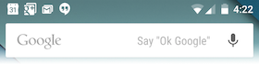

If the device is unlocked, the user opens the notification drawer to see the details of the notification. If the device is locked, the user views the notification on the lock screen. The notification area, lock screen, and notification drawer are system-controlled areas that the user can view at any time.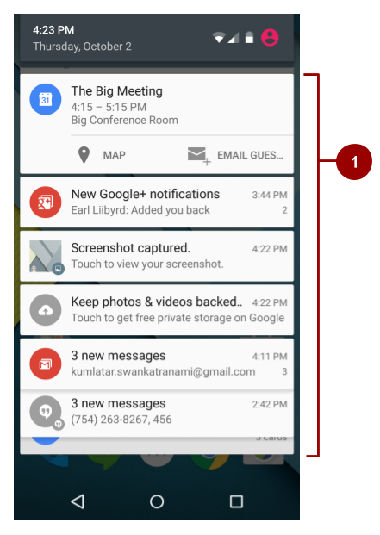

1. An "open" notification drawer. The status bar isn't visible in this screenshot, because the notification drawer is open.

### App icon badge

In supported launchers on devices running Android 8.0 (API level 26) and higher, an app icon changes its appearance slightly when the app has a new notification to show to the user. The app icon shows a colored badge, also known as a notification dot, as shown on four of the five app icons in the screenshot below.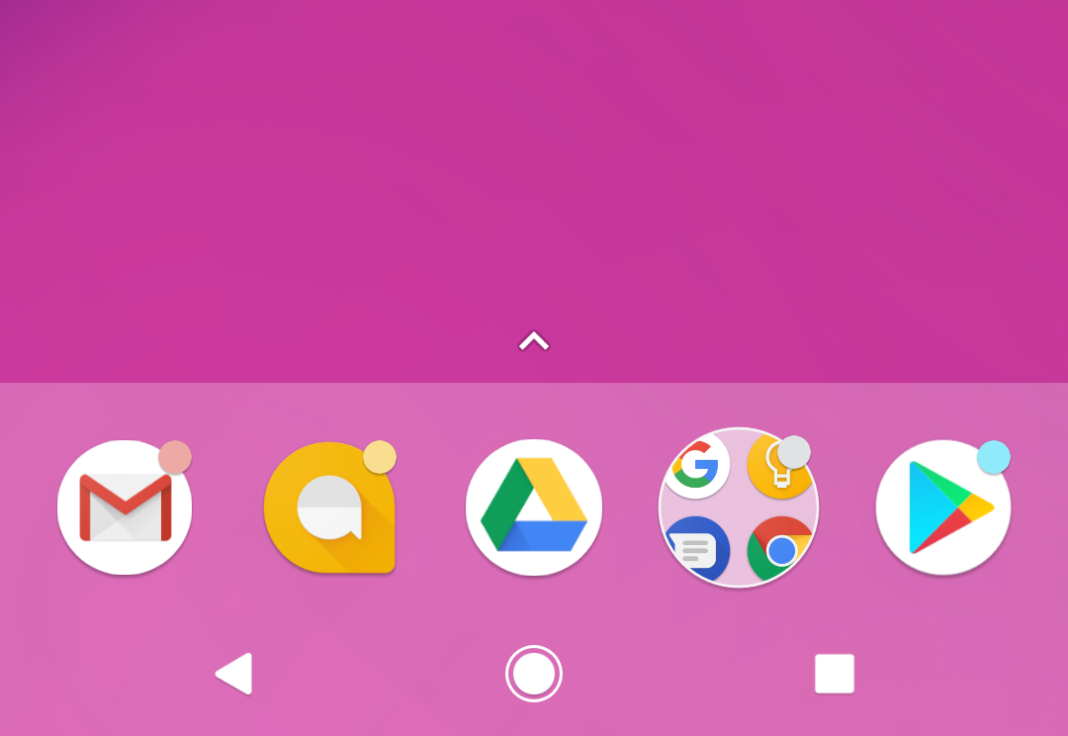

To see the notification for an app with a notification dot, the user long-presses the app icon. The notification menu appears, as shown below, and the user dismisses the notification or acts on it from the menu. This is similar to the way the user interacts with a notification in the notification drawer.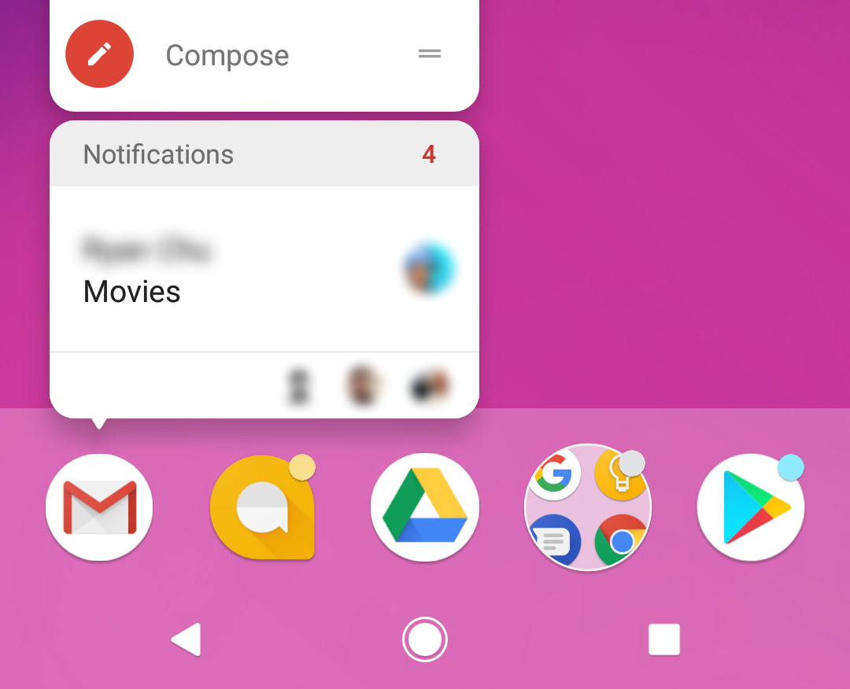

## Notification channels

In the Settings app on an Android-powered device, users can adjust the notifications they receive. Starting with Android 8.0 (API level 26), you can assign each of your app's notifications to a notification channel. Each notification channel represents a type of notification, and you can group several notifications in each channel.

If you target only lower-end devices, you don't need to implement notification channels to display notifications, but it's good practice to target the latest available SDK, then check the device's SDK version before building the notification channel.

Notification channels are called **Categories** in the user-visible Settings app. For example, the screenshot on the left shows the notification settings for the Clock app, which has five notification channels. The screenshot on the right shows the settings for the "Firing alarms & timers" notification channel.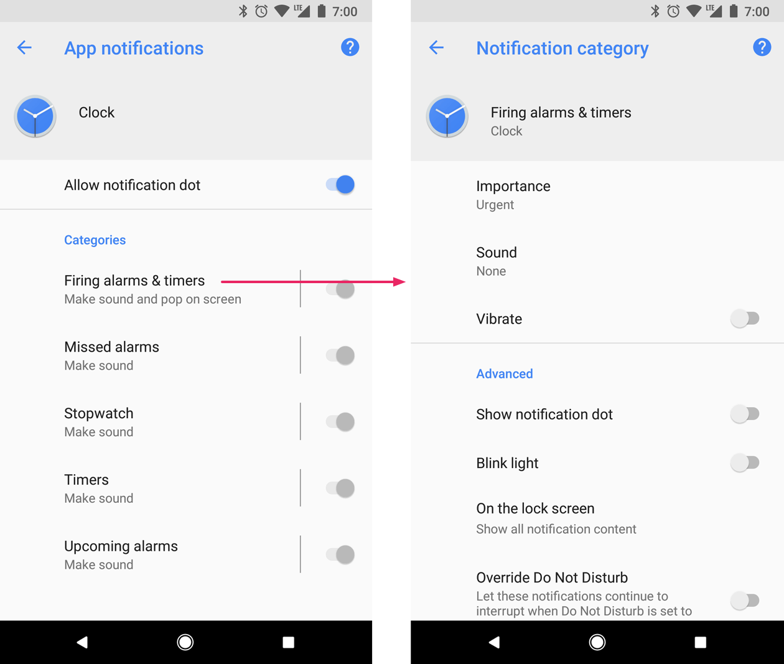

When you create a notification channel in your code, you set behavior for that channel, and the behavior is applied to all of the notifications in the channel. For example, your app might set the notifications in a channel to play a sound, blink a light, or vibrate. Whatever behavior you set for a notification channel, the user can change it, and they can turn off notifications from your app altogether.

**Note:** If your app targets Android 8.0 (API level 26) or higher, you must implement one or more notification channels. If your targetSdkVersion is set to 25 or lower, when your app runs on Android 8.0 (API level 26) or higher, it behaves the same as it would on devices running Android 7.1 (API level 25) or lower.

### Creating a notification channel

To create a notification channel instance, use the [NotificationChannel](https://developer.android.com/reference/android/app/NotificationChannel.html) constructor. Specify an ID that's unique within your package, a user-visible channel name, and an importance for the channel:

if (Build.VERSION.SDK_INT >= Build.VERSION_CODES.O) {

NotificationChannel notificationChannel =

new NotificationChannel(CHANNEL_ID, "Mascot Notification",

NotificationManager.IMPORTANCE_DEFAULT);

}

**Important:** Before you use the notification-channel APIs, check the SDK version. Notification channels are only available in Android 8.0 (API level 26) and higher. Notification channels are not available in the Android Support Library.

#### **Set the importance level**

The [NotificationChannel](https://developer.android.com/reference/android/app/NotificationChannel.html) constructor, which is available in Android 8.0 (API level 26) and higher, requires an importance level. The channel's importance determines the instrusiveness of the notifications posted in that channel. For example, notifications with a higher importance might make sound and show up in more places than notifications with a lower importance. There are five importancelevels, ranging from [IMPORTANCE_NONE(0)](https://developer.android.com/reference/android/app/NotificationManager.html#IMPORTANCE_NONE) to [IMPORTANCE_HIGH(4)](https://developer.android.com/reference/android/app/NotificationManager#IMPORTANCE_HIGH).

To support Android 7.1 (API level 25) or lower, you must also set a priority for each notification. To set a priority, use the [setPriority()](https://developer.android.com/reference/android/support/v4/app/NotificationCompat.Builder.html#setPriority(int)) method with a priority constant from the [NotificationCompat](https://developer.android.com/reference/android/support/v4/app/NotificationCompat) class.

mBuilder.setPriority(NotificationCompat.PRIORITY_HIGH);

[On devices running Android 8.0 and higher, a](https://developer.android.com/guide/topics/ui/notifiers/notifications#icon-badge)ll notifications, regardless of priority and importance level, appear in the notification drawer and as [app icon badges. After a notification is created and delivered](https://developer.android.com/guide/topics/ui/notifiers/notifications#icon-badge), the user can change the notification channel's importance level in the Android Settings app. The following table shows how the user-visible importance level maps to the notification-channel importance level and the priority constants.

|  |  |  |
| --- | --- | --- |
| **User-visible importance level** | **Importance (Android 8.0 and higher)** | **Priority (Android 7.1 and lower)** |
| **Urgent** Notifications make a sound and appear as heads-up notifications. | [IMPORTANCE_HIGH](https://developer.android.com/reference/android/app/NotificationManager.html#IMPORTANCE_HIGH) | [PRIORITY_HIGH](https://developer.android.com/reference/android/support/v4/app/NotificationCompat.html#PRIORITY_HIGH) or [PRIORITY_MAX](https://developer.android.com/reference/android/support/v4/app/NotificationCompat.html#PRIORITY_MAX) |
| **High** Notifications make a sound. | [IMPORTANCE_DEFAULT](https://developer.android.com/reference/android/app/NotificationManager.html#IMPORTANCE_DEFAULT) | [PRIORITY_DEFAULT](https://developer.android.com/reference/android/support/v4/app/NotificationCompat.html#PRIORITY_DEFAULT) |
| **Medium** Notifications make no sound. | [IMPORTANCE_LOW](https://developer.android.com/reference/android/app/NotificationManager.html#IMPORTANCE_LOW) | [PRIORITY_LOW](https://developer.android.com/reference/android/support/v4/app/NotificationCompat.html#PRIORITY_LOW) |
| **Low** Notifications make no sound and do not appear in the status bar. | [IMPORTANCE_MIN](https://developer.android.com/reference/android/app/NotificationManager.html#IMPORTANCE_MIN) | [PRIORITY_MIN](https://developer.android.com/reference/android/support/v4/app/NotificationCompat.html#PRIORITY_MIN) |

#### **Configure the initial settings**

Configure the notification channel object with initial settings such as an alert sound, a notification light color, and an optional user-visible description.

notificationChannel.enableLights(true);

notificationChannel.setLightColor(Color.RED);

notificationChannel.enableVibration(true);

notificationChannel.setDescription("Notification from Mascot");

Starting from Android 8.1 (API Level 27), apps can only make a notification alert sound once per second. Alert sounds that exceed this rate aren't queued and are lost. This change doesn't affect other aspects of notification behavior, and notification messages still post as expected.

#### **Create the notification channel**

To create the notification channel, pass the instance of [NotificationChannel](https://developer.android.com/reference/android/app/NotificationChannel.html) to the [createNotificationChannel()](https://developer.android.com/reference/android/app/NotificationManager.html#createNotificationChannel(android.app.NotificationChannel)) method from the NotificationManager class.

if (Build.VERSION.SDK_INT >= Build.VERSION_CODES.O) {

NotificationManager mNotificationManager =

(NotificationManager) getSystemService(Context.NOTIFICATION_SERVICE);

mNotifyManager.createNotificationChannel(notificationChannel);

}

Check the SDK version before using createNotificationChannel(), because this API is only available on Android 8.0 and higher and in support packages.

Once you create a notification and notification channel and submit it to the [NotificationManager](https://developer.android.com/reference/android/app/NotificationManager.html), you cannot change the importance level using code. However, the user can change their preferences for your app's channels using the Android Settings app on their device.

### Creating notifications

You create a notification using the [NotificationCompat.Builder](https://developer.android.com/reference/android/support/v4/app/NotificationCompat.Builder.html) class. ([NotificationCompat](https://developer.android.com/reference/android/support/v4/app/NotificationCompat) from the Android Support Library provides compatibility back to Android 4.0, API level 14. For more information, see [Notification compatibility](https://google-developer-training.github.io/android-developer-fundamentals-course-concepts-v2/unit-3-working-in-the-background/lesson-8-alarms-and-schedulers/8-1-c-notifications/8-1-c-notifications.html#compatibility), below.) The builder classes simplify the creation of complex objects.

To create a NotificationCompat.Builder, pass the application context and notification channel ID to the constructor:

NotificationCompat.Builder mBuilder = new NotificationCompat.Builder(this, CHANNEL_ID);

The NotificationCompat.Builder constructor takes the notification channel ID as one of its parameters. This parameter is only used by Android 8.0 (API level 26) and higher. Lower versions of Android ignore it.

#### **Set notification contents**

You can assign components to the notification like a small icon, a title, and the notification message.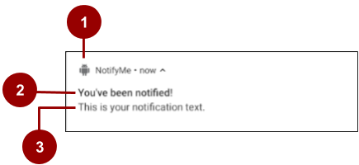

In the screenshot above:

1. A small icon, set by [setSmallIcon()](https://developer.android.com/reference/android/support/v4/app/NotificationCompat.Builder.html#setSmallIcon(int)). This is the only content that's required.
2. A title, set by [setContentTitle()](https://developer.android.com/reference/android/support/v4/app/NotificationCompat.Builder.html#setContentTitle(java.lang.CharSequence)).
3. The body text, set by [setContentText()](https://developer.android.com/reference/android/support/v4/app/NotificationCompat.Builder.html#setContentText(java.lang.CharSequence)). This text must be fewer than 40 characters, and it should not repeat what is in the title.

NotificationCompat.Builder mBuilder =

new NotificationCompat.Builder(this, CHANNEL_ID)

.setSmallIcon(R.drawable.android_icon)

.setContentTitle("You've been notified!")

.setContentText("This is your notification text.");

#### **Set the intent for the notification's tap action**

Every notification must respond when it is tapped, usually by launching an Activity in your app. To launch an Activity in your app, set a content intent using the [setContentIntent()](https://developer.android.com/reference/android/support/v4/app/NotificationCompat.Builder.html#setContentIntent(android.app.PendingIntent)) method, passing in the Intent wrapped in a [PendingIntent](https://developer.android.com/reference/android/app/PendingIntent.html) object. When your app uses a PendingIntent, the system can launch the Activity in your app on your behalf.

To instantiate a PendingIntent, use one of the following methods, depending on how you want the contained Intent to be delivered:

* To launch an Activity when a user taps the notification, use [PendingIntent.getActivity()](https://developer.android.com/reference/android/app/PendingIntent#getActivity(android.content.Context,%20int,%20android.content.Intent,%20int)). Pass in an explicit Intent for the Activity you want to launch. The getActivity() method corresponds to an Intent delivered using startActivity().
* For an Intent passed into startService(), for example a service to download a file, use [PendingIntent.getService()](https://developer.android.com/reference/android/app/PendingIntent#getService(android.content.Context,%20int,%20android.content.Intent,%20int)).
* For a broadcast Intent delivered with sendBroadcast(), use [PendingIntent.getBroadcast()](https://developer.android.com/reference/android/app/PendingIntent.html#getBroadcast(android.content.Context,%20int,%20android.content.Intent,%20int)).

Each of these PendingIntent methods takes the following arguments:

* The application context.
* A request code, which is a constant integer ID for the PendingIntent.
* The Intent to be delivered.
* A PendingIntent flag that determines how the system handles multiple PendingIntent objects from the same app.

The following snippet shows how to create a basic Intent to open an Activity when the user taps the notification:

// Create an explicit intent for an Activity in your app

Intent contentIntent = new Intent(this, ExampleActivity.class);

PendingIntent pendingContentIntent = PendingIntent.getActivity(this, 0,

contentIntent, PendingIntent.FLAG_UPDATE_CURRENT);

// Set the intent that will fire when the user taps the notification

mBuilder.setContentIntent(pendingContentIntent);

#### **Add notification action buttons**

Notification action buttons allow the user to perform an app-related task without launching the app. The system typically displays action buttons adjacent to the notification content. A notification can have up to three notification action buttons.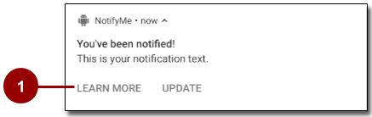

1. "Learn more" and "Update" action buttons

Using action buttons, you can let the user perform a variety of actions, beyond just launching an Activity after the user taps the notification itself. For example, you can use action buttons to let the user start a background task to upload a file, place a phone call, snooze an alarm, or play music. For Android 7.0 (API level 24) and higher, you can use an action button to let the user reply to a message directly from a notification.

Adding an action button is similar to setting up the notification's default tap action: pass a PendingIntentto the [addAction()](https://developer.android.com/reference/android/support/v4/app/NotificationCompat.Builder.html#addAction(android.support.v4.app.NotificationCompat.Action)) method in the NotificationCompat.Builder class. But this action should not replicate what happens when the user taps the notification itself.

The following code shows how to add an action button using the addAction() method with the NotificationCompat.Builder object, passing in the icon, the title string for the label, and the PendingIntent to trigger when the user taps the action button.

mBuilder.addAction(R.drawable.car, "Get Directions", mapPendingIntent);

Starting from Android 7.0, icons are not displayed in notifications. Instead, more room is provided for the notification labels themselves. But notification action icons are still required, and they are used on older versions of Android and on devices such as Android Wear.

#### **Expandable notifications**

Notifications in the notification drawer appear in two main layouts, normal view (which is the default) and expanded view. Expanded view notifications were introduced in Android 4.1. Use them sparingly, because they take up more space and attention than normal view layouts.

To create notifications that appear in an expanded layout, use one of these helper classes to set the style object to the [setStyle()](https://developer.android.com/reference/android/support/v4/app/NotificationCompat.Builder.html#setStyle(android.support.v4.app.NotificationCompat.Style)) method:

* Use [NotificationCompat.BigTextStyle](https://developer.android.com/reference/android/support/v4/app/NotificationCompat.BigTextStyle.html) for large-format notifications that include a lot of text.
* Use [NotificationCompat.InboxStyle](https://developer.android.com/reference/android/support/v4/app/NotificationCompat.InboxStyle.html) for displaying a list of summary lines, for example for incoming messages or emails.
* Use [NotificationCompat.MediaStyle](https://developer.android.com/reference/android/support/v4/media/app/NotificationCompat.MediaStyle.html) for media playback notifications.
* Use [NotificationCompat.MessagingStyle](https://developer.android.com/reference/android/support/v4/app/NotificationCompat.MessagingStyle.html) to display sequential messages in an ongoing conversation. This style currently applies only on devices running Android 7.0 and higher. On lower devices, these notifications are displayed in the supported style.
* Use [NotificationCompat.BigPictureStyle](https://developer.android.com/reference/android/support/v4/app/NotificationCompat.BigPictureStyle.html) for large-format notifications that include large image attachments, as shown in the screenshot below.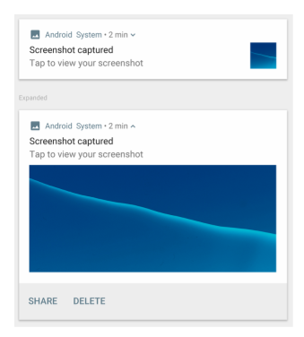

For example, here's how you'd set the BigPictureStyle on a notification:

NotificationCompat notif = new NotificationCompat.Builder(mContext, channelId)

.setContentTitle("New photo from " + sender.toString())

.setContentText(subject)

.setSmallIcon(R.drawable.new_post)

.setLargeIcon(aBitmap)

.setStyle(new NotificationCompat.BigPictureStyle()

.bigPicture(aBigBitmap)

.setBigContentTitle("Large Notification Title"))

.build();

To learn more about implementing expanded styles, see the [NotificationCompat.Style documentation](https://developer.android.com/reference/android/support/v4/app/NotificationCompat.Style.html).

#### **Ongoing notifications**

Ongoing notifications are notifications that the user can't dismiss. Use ongoing notifications for background tasks that the user actively engages with, for example playing music. You can also use ongoing notifications to show tasks that are occupying the device, for example file downloads, sync operations, and active network connections.

Ongoing notifications can be a nuisance to your users, because users can't cancel them, so use them sparingly.

To make a notification ongoing, set [setOngoing()](https://developer.android.com/reference/android/app/Notification.Builder.html#setOngoing(boolean)) to true.

Your app must explicitly cancel ongoing notifications by calling cancel() or cancelAll().

## Delivering notifications

Use the [NotificationManager](https://developer.android.com/reference/android/app/NotificationManager.html) class to deliver notifications:

1. To create an instance of NotificationManager, call getSystemService(), passing in the [NOTIFICATION_SERVICE](https://developer.android.com/reference/android/content/Context.html#NOTIFICATION_SERVICE) constant.
2. To deliver the notification, call notify().

Pass these two values in the notify() method:

* A notification ID, which is used to update or cancel the notification.
* The NotificationCompat object that you created using the NotificationCompat.Builder object.

The following example creates a NotificationManager instance, then builds and delivers a notification:

mNotifyManager = (NotificationManager)

getSystemService(NOTIFICATION_SERVICE);

//Builds the notification with all the parameters

NotificationCompat.Builder notifyBuilder =

new NotificationCompat.Builder(this, PRIMARY_CHANNEL)

.setContentTitle(getString(R.string.notification_title))

.setContentText(getString(R.string.notification_text))

.setSmallIcon(R.drawable.ic_android)

.setContentIntent(notificationPendingIntent)

.setPriority(NotificationCompat.PRIORITY_HIGH)

.setDefaults(NotificationCompat.DEFAULT_ALL);

//Delivers the notification

mNotifyManager.notify(NOTIFICATION_ID, notifyBuilder.build());

## Updating and reusing notifications

Sometimes you need to issue a notification multiple times for the same type of event. In this situation, you can update a previous notification by changing some of the notification's values, adding to the notification, or both.

To reuse an existing notification:

1. Update a NotificationCompat.Builder object and build a Notification object from it, as when you first created and built the notification.
2. Deliver the notification with the same ID you used previously.

**Important:** If the previous notification is still visible, the system updates it from the contents of the [Notification](https://developer.android.com/reference/android/app/Notification.html) object. If the previous notification has been dismissed, a new notification is created and displayed.

## Clearing notifications

Notifications remain visible until one of the following happens:

* If the notification can be cleared, it disappears when the user dismisses it by swiping it or by using "Clear All".
* If you called [setAutoCancel()](https://developer.android.com/reference/android/support/v4/app/NotificationCompat.Builder.html#setAutoCancel(boolean)) when you created the notification, the notification cancels itself automatically. When the user taps the notification, the notification is removed from the status bar.
* If you call [cancel()](https://developer.android.com/reference/android/app/NotificationManager.html#cancel(int)) on the Notification object for a specific notification ID, the notification is removed from the status bar.
* If you call [cancelAll()](https://developer.android.com/reference/android/app/NotificationManager.html#cancelAll()) on the Notification object, all the notifications you've issued are removed from the status bar.

Because the user can't cancel [ongoing notifications](https://google-developer-training.github.io/android-developer-fundamentals-course-concepts-v2/unit-3-working-in-the-background/lesson-8-alarms-and-schedulers/8-1-c-notifications/8-1-c-notifications.html#ongoing), your app must cancel them by calling cancel() or cancelAll() on the Notification object.

## Notification compatibility

To ensure the best compatibility, create notifications with NotificationCompat and its subclasses. In particular, use [NotificationCompat.Builder](https://developer.android.com/reference/android/support/v4/app/NotificationCompat.Builder.html) from the Android Support library.

Keep in mind that not all notification features are available for every Android version, even though the methods to set them are in the NotificationCompat.Builder class. For example, expanded view layouts for notifications are only available on Android 4.1 and higher, but action buttons depend on expanded view layouts. If you use notification action buttons, they don't show up on devices running Android versions lower than 4.1.

To solve this:

* Don't rely only on notification action buttons to carry out a notification's action. Instead, give your users a way to perform the same functionality from inside your app.

For example, if you set a notification action that lets the user stop and start media playback, first implement this functionality in an Activity in your app.

* Have the Activity start when the user taps the notification.
* Use [addAction()](https://developer.android.com/reference/android/support/v4/app/NotificationCompat.Builder.html#addAction(android.support.v4.app.NotificationCompat.Action)) to add features to the notification as needed. Remember that any functionality you add also has to be available in the Activity that starts when users tap the notification.

## Notification design guidelines

Notifications always interrupt the user, so they should be short, timely, and most of all, relevant.

* **Relevant:** Ask yourself whether this information is essential for the user. What happens if the user doesn't get the notification? For example, scheduled calendar events are probably relevant.
* **Timely:** Notifications need to appear when they are useful. For example, notifying the user when it's time to leave for an appointment is useful.
* **Short:** Use as few words as possible.

For more notification design guidelines, see the [Material Design spec for notifications](https://material.io/design/platform-guidance/android-notifications.html).

# 8.2 Alarms

## Contents

* [Introduction](https://google-developer-training.github.io/android-developer-fundamentals-course-concepts-v2/unit-3-working-in-the-background/lesson-8-alarms-and-schedulers/8-2-c-alarms/8-2-c-alarms.html#chapterstart)
* [Alarm types](https://google-developer-training.github.io/android-developer-fundamentals-course-concepts-v2/unit-3-working-in-the-background/lesson-8-alarms-and-schedulers/8-2-c-alarms/8-2-c-alarms.html#alarm_types)
* [Alarm best practices](https://google-developer-training.github.io/android-developer-fundamentals-course-concepts-v2/unit-3-working-in-the-background/lesson-8-alarms-and-schedulers/8-2-c-alarms/8-2-c-alarms.html#best_practices)
* [Scheduling an alarm](https://google-developer-training.github.io/android-developer-fundamentals-course-concepts-v2/unit-3-working-in-the-background/lesson-8-alarms-and-schedulers/8-2-c-alarms/8-2-c-alarms.html#scheduling)
* [Checking for an existing alarm](https://google-developer-training.github.io/android-developer-fundamentals-course-concepts-v2/unit-3-working-in-the-background/lesson-8-alarms-and-schedulers/8-2-c-alarms/8-2-c-alarms.html#check_alarm)
* [Canceling an alarm](https://google-developer-training.github.io/android-developer-fundamentals-course-concepts-v2/unit-3-working-in-the-background/lesson-8-alarms-and-schedulers/8-2-c-alarms/8-2-c-alarms.html#cancel)
* [User-visible alarms ("alarm clocks")](https://google-developer-training.github.io/android-developer-fundamentals-course-concepts-v2/unit-3-working-in-the-background/lesson-8-alarms-and-schedulers/8-2-c-alarms/8-2-c-alarms.html#user_visible)
* [Related practical](https://google-developer-training.github.io/android-developer-fundamentals-course-concepts-v2/unit-3-working-in-the-background/lesson-8-alarms-and-schedulers/8-2-c-alarms/8-2-c-alarms.html#relatedpractical)
* [Learn more](https://google-developer-training.github.io/android-developer-fundamentals-course-concepts-v2/unit-3-working-in-the-background/lesson-8-alarms-and-schedulers/8-2-c-alarms/8-2-c-alarms.html#learnmore)

You already know how to use broadcast receivers to make your app respond to system events even when your app isn't running. In this chapter, you learn how to use alarms to trigger tasks at specific times, whether or not your app is running when the alarms go off. Alarms can either be [single use](https://google-developer-training.github.io/android-developer-fundamentals-course-concepts-v2/unit-3-working-in-the-background/lesson-8-alarms-and-schedulers/8-2-c-alarms/8-2-c-alarms.html#single_alarm) or [repeating](https://google-developer-training.github.io/android-developer-fundamentals-course-concepts-v2/unit-3-working-in-the-background/lesson-8-alarms-and-schedulers/8-2-c-alarms/8-2-c-alarms.html#repeating_alarm). For example, you can use a repeating alarm to schedule a download every day at the same time.

To create alarms, you use the AlarmManager class. Alarms in Android have the following characteristics:

* Alarms let you send an Intent at set times or intervals. You can use alarms with broadcast receivers to start services and perform other operations.
* Alarms operate outside your app. You can use them to trigger events or actions even when your app isn't running, and even if the device is asleep.
* When used correctly, alarms can help you minimize your app's resource requirements. For example, you can schedule operations without relying on timers or continuously running background services.

When not to use alarms:

* Don't use alarms for timing events such as ticks and timeouts, or for timed operations that are guaranteed to happen during the lifetime of your app. Instead, use the [Handler](https://developer.android.com/reference/android/os/Handler.html) class with [Timer](https://developer.android.com/reference/java/util/Timer.html)and [Thread](https://developer.android.com/reference/java/lang/Thread.html). This approach gives Android better control over system resources than if you used alarms.
* Don't use alarms for server sync operations. Instead, use [SyncAdapter](https://developer.android.com/training/sync-adapters/creating-sync-adapter.html) with [Firebase Cloud Messaging](https://firebase.google.com/docs/cloud-messaging/).
* You might not want to use alarms for tasks that can wait until conditions are favorable, such as when the device is connected to Wi-Fi and is charging. (These tasks include things like updating weather information or news stories.) For these tasks on devices running API 21 or higher, consider using [JobScheduler](https://developer.android.com/reference/android/app/job/JobScheduler.html), which you learn about in an upcoming lesson.
* Don't use alarms for tasks that have to happen even if the device is idle. When a device is in [Doze mode](https://developer.android.com/training/monitoring-device-state/doze-standby) (idle), scheduled alarms are deferred until the device exits Doze. To guarantee that alarms execute even if the device is idle, use [setAndAllowWhileIdle()](https://developer.android.com/reference/android/app/AlarmManager.html#setAndAllowWhileIdle(int,%20long,%20android.app.PendingIntent)) or [setExactAndAllowWhileIdle()](https://developer.android.com/reference/android/app/AlarmManager.html#setExactAndAllowWhileIdle(int,%20long,%20android.app.PendingIntent)). Another option is to use the new WorkManager API, which is built to perform background work either once or periodically. For details, see [Schedule tasks with WorkManager](https://developer.android.com/arch/work).

## Alarm types

There are two general types of alarms in Android: elapsed real-time alarms and real-time clock (RTC)alarms, and both use PendingIntent objects.

### Elapsed real-time alarms

Elapsed real-time alarms use the time, in milliseconds, since the device was booted. Time zones don't affect elapsed real-time alarms, so these alarms work well for alarms based on the passage of time. For example, use an elapsed real-time alarm for an alarm that fires every half hour.

The AlarmManager class provides two types of elapsed real-time alarm:

* [ELAPSED_REALTIME](https://developer.android.com/reference/android/app/AlarmManager.html#ELAPSED_REALTIME): Fires a PendingIntent based on the amount of time since the device was booted, but doesn't wake the device. The elapsed time includes any time during which the device was asleep. All repeating alarms fire when your device is next awake.
* [ELAPSED_REALTIME_WAKEUP](https://developer.android.com/reference/android/app/AlarmManager#ELAPSED_REALTIME_WAKEUP): Fires the PendingIntent after the specified length of time has elapsed since device boot. If the screen is off, this alarm wakes the device's CPU. If your app has a time dependency, for example if your app has a limited window during which to perform an operation, use this alarm instead of ELAPSED_REALTIME.

### Real-time clock (RTC) alarms

Real-time clock (RTC) alarms are clock-based alarms that use Coordinated Universal Time (UTC). Only choose an RTC alarm in these types of situations:

* You need your alarm to fire at a particular time of day.
* The alarm time is dependent on current locale.

Apps with clock-based alarms might not work well across locales, because they might fire at the wrong times. And if the user changes the device's time setting, it could cause unexpected behavior in your app.

The AlarmManager class provides two types of RTC alarm:

* [RTC](https://developer.android.com/reference/android/app/AlarmManager.html#RTC): Fires the pending intent at the specified time but doesn't wake the device. All repeating alarms fire when your device is next awake.
* [RTC_WAKEUP](https://developer.android.com/reference/android/app/AlarmManager.html#RTC_WAKEUP): Fires the pending intent at the specified time. If the screen is off, this alarm wakes the device's CPU.

## Alarm best practices

Alarms affect how your app uses (or abuses) system resources. For example, imagine a popular app that syncs with a server, and imagine that the sync operation is based on clock time. If every instance of the app connects to the server at the same time, the load on the server can delay responses or even create a "denial of service" condition.

To avoid this problem, add randomness (jitter) to network requests that trigger as a result of a repeating alarm. Here's one way to add randomness:

* Schedule an exact alarm that performs any local work. "Local work" is any task that doesn't contact a server over a network or require data from that server.
* Schedule a separate alarm that contains the network requests, and have this alarm fire after a random period of time. The component that receives the PendingIntent from the first alarm usually sets this second alarm. (You can also set this alarm at the same time as you set the first alarm.)

Other best practices:

* Keep your alarm frequency to a minimum.
* Don't wake the device unnecessarily.
* Use the least precise timing possible to allow the AlarmManager to be the most efficient it can be. For example, when you schedule a repeating alarm, use setInexactRepeating() instead of setRepeating(). For details, see [Scheduling a repeating alarm](https://google-developer-training.github.io/android-developer-fundamentals-course-concepts-v2/unit-3-working-in-the-background/lesson-8-alarms-and-schedulers/8-2-c-alarms/8-2-c-alarms.html#repeating_alarm), below.
* Avoid basing your alarm on clock time and use ELAPSED_REALTIME for repeating alarms whenever possible. Repeating alarms that are based on a precise trigger time don't scale well.

## Scheduling an alarm

The AlarmManager class gives you access to the Android system alarm services. AlarmManager lets you broadcast an Intent at a scheduled time, or after a specific interval.

To schedule an alarm:

1. Call [getSystemService(ALARM_SERVICE)](https://developer.android.com/reference/android/content/Context.html#ALARM_SERVICE) to get an instance of the [AlarmManager](https://developer.android.com/reference/android/app/AlarmManager.html) class.
2. Use one of the set...() methods available in AlarmManager (as described below). Which method you use depends on whether the alarm is elapsed real time, or RTC.

All the AlarmManager.set...() methods include a type argument and a PendingIntent argument:

* Use the type argument to specify the [alarm type](https://google-developer-training.github.io/android-developer-fundamentals-course-concepts-v2/unit-3-working-in-the-background/lesson-8-alarms-and-schedulers/8-2-c-alarms/8-2-c-alarms.html#alarm_types). Alarms can be elapsed real-time alarms ([ELAPSED_REALTIME](https://developer.android.com/reference/android/app/AlarmManager.html#ELAPSED_REALTIME) or [ELAPSED_REALTIME_WAKEUP](https://developer.android.com/reference/android/app/AlarmManager#ELAPSED_REALTIME_WAKEUP)) or real-time clock alarms ([RTC](https://developer.android.com/reference/android/app/AlarmManager.html#RTC) or [RTC_WAKEUP](https://developer.android.com/reference/android/app/AlarmManager.html#RTC_WAKEUP)).
* A [PendingIntent](https://developer.android.com/reference/android/app/PendingIntent.html) object, which is how you specify which task to perform at the given time.

### Scheduling a single-use alarm

To schedule a single alarm, use one of the following methods on the AlarmManager instance:

* [set()](https://developer.android.com/reference/android/app/AlarmManager.html#set(int,%20long,%20android.app.PendingIntent)): For devices running API 19+, this method schedules a single, inexactly timed alarm, meaning that the system shifts the alarm to minimize wakeups and battery use. For devices running lower API versions, this method schedules an exactly timed alarm.
* [setWindow()](https://developer.android.com/reference/android/app/AlarmManager.html#setWindow(int,%20long,%20long,%20android.app.PendingIntent)): For devices running API 19+, use this method to set a window of time during which the alarm should be triggered.
* [setExact()](https://developer.android.com/reference/android/app/AlarmManager.html#setExact(int,%20long,%20android.app.PendingIntent)): For devices running API 19+, this method triggers the alarm at an exact time. Use this method only for alarms that must be delivered at an exact time, for example an alarm clock that rings at a requested time. Exact alarms reduce the OS's ability to minimize battery use, so don't use them unnecessarily.

Here's an example of using set() to schedule a single-use alarm:

alarmMgr.set(AlarmManager.ELAPSED_REALTIME,

SystemClock.elapsedRealtime() + 1000*300,

alarmIntent);

In this example:

* The type is ELAPSED_REALTIME, so this is an [elapsed real-time alarm](https://google-developer-training.github.io/android-developer-fundamentals-course-concepts-v2/unit-3-working-in-the-background/lesson-8-alarms-and-schedulers/8-2-c-alarms/8-2-c-alarms.html#elapsed). If the device is idle when the alarm is sent, the alarm does not wake the device.
* The alarm is sent 5 minutes (300,000 milliseconds) after the method returns.
* alarmIntent is a PendingIntent broadcast that contains the action to perform when the alarm is sent.

**Note**: For timing operations like ticks and timeouts, and events that happen more often than once a minute, it's easier and more efficient to use a [Handler](https://developer.android.com/reference/android/os/Handler.html) rather than an alarm.

#### **Doze and App Standby**

API 23+ devices sometimes enter Doze or App Standby mode to save power:

* Doze mode is triggered when a user leaves a device unplugged and stationary for a period, with the screen off. During short "maintenance windows," the system exits Doze to let apps complete deferred activities, including firing standard alarms, then returns to Doze. Doze mode ends when the user returns to their device.
* App Standby mode is triggered on idle apps that haven't been used recently. App Standby mode ends when the user returns to your app or plugs in the device.

Some alarms can wait for a maintenance window, or until the device comes out of Doze or App Standby mode. For these alarms, use the standard set() and setExact() methods to optimize battery life.

If you need an alarm that fires during Doze mode or App Standby mode without waiting for a maintenance window:

* For inexact alarms, use setAndAllowWhileIdle() and for exact alarms, use setExactAndAllowWhileIdle(), or
* Set a [user-visible alarm](https://google-developer-training.github.io/android-developer-fundamentals-course-concepts-v2/unit-3-working-in-the-background/lesson-8-alarms-and-schedulers/8-2-c-alarms/8-2-c-alarms.html#user_visible) (API 21 and higher).

### Scheduling a repeating alarm

You can also use the AlarmManager to schedule repeating alarms, using one of the following methods:

* [setRepeating()](https://developer.android.com/reference/android/app/AlarmManager.html#setRepeating(int,%20long,%20long,%20android.app.PendingIntent)): On devices running Android versions lower than 4.4 (API Level 19), this method creates a repeating, exactly timed alarm. On devices running API 19 and higher, setRepeating()behaves exactly like setInexactRepeating().
* [setInexactRepeating()](https://developer.android.com/reference/android/app/AlarmManager.html#setInexactRepeating(int,%20long,%20long,%20android.app.PendingIntent)): This method creates a repeating, inexact alarm that allows for batching. When you use setInexactRepeating(), Android synchronizes repeating alarms from multiple apps and fires them at the same time. This reduces the total number of times the system must wake the device, thus reducing drain on the battery. As of API 19, all repeating alarms are inexact.

To decrease possible battery drain:

* Schedule repeating alarms to be as infrequent as possible.
* Use inexact timing, which allows the system to batch alarms from different apps together.

**Note:** while setInexactRepeating() is an improvement over setRepeating(), it can still overwhelm a server if every instance of an app reaches the server around the same time. Therefore, for network requests, add some randomness to your alarms, as described in [Alarm best practices](https://google-developer-training.github.io/android-developer-fundamentals-course-concepts-v2/unit-3-working-in-the-background/lesson-8-alarms-and-schedulers/8-2-c-alarms/8-2-c-alarms.html#best_practices). If you really need exact repeating alarms on API 19+, set a [single-use alarm](https://google-developer-training.github.io/android-developer-fundamentals-course-concepts-v2/unit-3-working-in-the-background/lesson-8-alarms-and-schedulers/8-2-c-alarms/8-2-c-alarms.html#single_alarm) with setExact() and set the next alarm once that alarm has triggered. This second alarm is set by whatever component receives the PendingIntent—usually a service or a broadcast receiver.

Here's an example of using setInexactRepeating() to schedule a repeating alarm:

alarmMgr.setInexactRepeating(AlarmManager.RTC_WAKEUP,

calendar.getTimeInMillis(),

AlarmManager.INTERVAL_FIFTEEN_MINUTES,

alarmIntent);

In this example:

* The type is RTC_WAKEUP, which means that this alarm is [clock-based](https://google-developer-training.github.io/android-developer-fundamentals-course-concepts-v2/unit-3-working-in-the-background/lesson-8-alarms-and-schedulers/8-2-c-alarms/8-2-c-alarms.html#rtc), and it wakes the device.
* The first occurrence of the alarm is sent immediately, because calendar.getTimeInMillis() returns the current time as UTC milliseconds.
* After the first occurrence, the alarm is sent approximately every 15 minutes.

If the method were setRepeating() instead of setInexactRepeating(), and if the device were running an API version lower than 19, the alarm would be sent exactly every 15 minutes.

Possible values for this argument are INTERVAL_DAY, INTERVAL_FIFTEEN_MINUTES, INTERVAL_HALF_DAY, INTERVAL_HALF_HOUR, INTERVAL_HOUR.

* alarmIntent is the PendingIntent that contains the action to perform when the alarm is sent. This Intent typically comes from [IntentSender.getBroadcast()](https://developer.android.com/reference/android/app/PendingIntent.html#getBroadcast(android.content.Context,%20int,%20android.content.Intent,%20int)).

## Checking for an existing alarm

It's often useful to check whether an alarm is already set. For example, if an alarm exists, you may want to disable the ability to set another alarm.

To check for an existing alarm:

1. Create a PendingIntent that contains the same Intent used to set the alarm, but this time, use the [FLAG_NO_CREATE](https://developer.android.com/reference/android/app/PendingIntent.html#FLAG_NO_CREATE) flag.

With FLAG_NO_CREATE, a PendingIntent is only created if one with the same Intent exists. Otherwise, the request returns null.

1. Check whether the PendingIntent is null:

If the PendingIntent is null, the alarm has not yet been set. If the PendingIntent is not null, the PendingIntent exists, meaning that the alarm has been set.

For example, the following code returns true if the alarm contained in alarmIntent already exists:

boolean alarmExists =

(PendingIntent.getBroadcast(this, 0,

alarmIntent,

PendingIntent.FLAG_NO_CREATE) != null);

## Canceling an alarm

To cancel an alarm, use [cancel()](https://developer.android.com/reference/android/app/AlarmManager.html#cancel(android.app.PendingIntent)) and pass in the PendingIntent. For example:

alarmManager.cancel(alarmIntent);

## User-visible alarms ("alarm clocks")

For API 21+ devices, you can set a user-visible alarm clock by calling [setAlarmClock()](https://developer.android.com/reference/android/app/AlarmManager.html#setAlarmClock(android.app.AlarmManager.AlarmClockInfo,%20android.app.PendingIntent)). Apps can retrieve the next user-visible alarm clock that's set to go off by calling getNextAlarmClock().

Alarm clocks set with setAlarmClock() work even when the device or app is idle, similar to the way setExactAndAllowWhileIdle() works. Using setAlarmClock() gets you as close to an exact-time wake-up call as possible.

# 8.3 Efficient data transfer

## Contents

* [Wireless radio state](https://google-developer-training.github.io/android-developer-fundamentals-course-concepts-v2/unit-3-working-in-the-background/lesson-8-alarms-and-schedulers/8-3-c-efficient-data-transfer/8-3-c-efficient-data-transfer.html#radio_state)
* [Bundling network transfers](https://google-developer-training.github.io/android-developer-fundamentals-course-concepts-v2/unit-3-working-in-the-background/lesson-8-alarms-and-schedulers/8-3-c-efficient-data-transfer/8-3-c-efficient-data-transfer.html#bundling_transfers)
* [Prefetching](https://google-developer-training.github.io/android-developer-fundamentals-course-concepts-v2/unit-3-working-in-the-background/lesson-8-alarms-and-schedulers/8-3-c-efficient-data-transfer/8-3-c-efficient-data-transfer.html#prefetching)
* [Monitor connectivity state](https://google-developer-training.github.io/android-developer-fundamentals-course-concepts-v2/unit-3-working-in-the-background/lesson-8-alarms-and-schedulers/8-3-c-efficient-data-transfer/8-3-c-efficient-data-transfer.html#monitor_connectivity)
* [Monitor battery state](https://google-developer-training.github.io/android-developer-fundamentals-course-concepts-v2/unit-3-working-in-the-background/lesson-8-alarms-and-schedulers/8-3-c-efficient-data-transfer/8-3-c-efficient-data-transfer.html#monitor_battery)
* [JobScheduler](https://google-developer-training.github.io/android-developer-fundamentals-course-concepts-v2/unit-3-working-in-the-background/lesson-8-alarms-and-schedulers/8-3-c-efficient-data-transfer/8-3-c-efficient-data-transfer.html#job_scheduler)
* [Related practical](https://google-developer-training.github.io/android-developer-fundamentals-course-concepts-v2/unit-3-working-in-the-background/lesson-8-alarms-and-schedulers/8-3-c-efficient-data-transfer/8-3-c-efficient-data-transfer.html#relatedpractical)
* [Learn more](https://google-developer-training.github.io/android-developer-fundamentals-course-concepts-v2/unit-3-working-in-the-background/lesson-8-alarms-and-schedulers/8-3-c-efficient-data-transfer/8-3-c-efficient-data-transfer.html#learnmore)

Transferring data is an essential part of most Android apps, but it can affect battery life and increase data usage. Using the wireless radio to transfer data is potentially one of your app's most significant sources of battery drain.

Users care about battery drain because they would rather use their mobile device without it connected to the charger. And users care about data usage, because every bit of data transferred can cost them money.

In this chapter, you learn how your app's networking activity affects the device's radio hardware so you can minimize the battery drain associated with network activity. You also learn how to wait for the proper conditions to accomplish resource-intensive tasks.

## Wireless radio state

A fully active wireless radio consumes significant power. To conserve power when not in use, the radio transitions between different energy states. However, there is a trade-off between conserving power and the time it takes to power up when needed.

For a typical 3G network the radio has these three energy states:

* **Full power:** Used when a connection is active. Allows the device to transfer data at its highest possible rate.
* **Low power:** An intermediate state that uses about 50% less battery.
* **Standby:** The minimal energy state, during which no network connection is active or required.

While the low and standby states use much less battery, they also introduce latency to network requests. Returning to full power from the low state takes around 1.5 seconds, while moving from standby to full can take over 2 seconds.

Android uses a state machine to determine how to transition between states. To minimize latency, the state machine waits a short time before it transitions to lower energy states.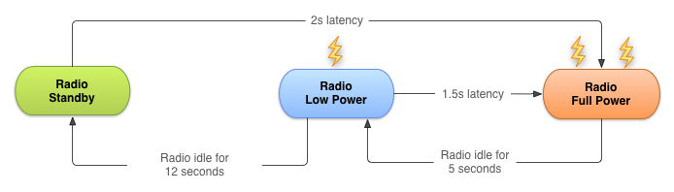

The radio state machine on each device, particularly the transition delay ("tail time") and startup latency, vary based on the wireless radio technology employed, for example 2G, 3G, or LTE. The state machine is defined and configured by the carrier network over which the device is operating.

This chapter describes a representative state machine for a typical 3G wireless radio. However, the general principles and resulting best practices are applicable for all wireless radio implementations.

As with any best practices, there are trade-offs that you need to consider for your own app development.

## Bundling network transfers

Every time you create a new network connection, the radio transitions to the full power state. In the case of the 3G radio state machine described above, the radio remains at full power for the duration of your transfer. Then there are 5 seconds of tail time, followed by 12 seconds at the low energy state. Then the radio turns off. For a typical 3G device, every data transfer session causes the radio to draw power for almost 20 seconds.

What this means in practice:

* An app that transfers unbundled data for 1 second every 18 seconds keeps the wireless radio always active.
* An app that transfers bundled data for 3 seconds every minute keeps the radio in the high power state for only 8 seconds. Then the radio is in the low power state for an additional 12 seconds.

The second example allows the radio to be idle for 40 seconds out of every minute, resulting in a massive reduction in battery consumption.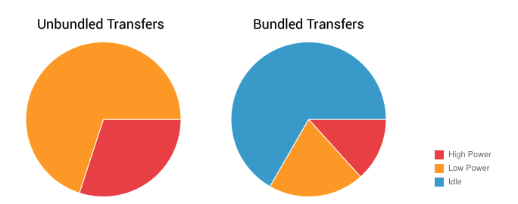

It's important to bundle and queue up your data transfers. You can bundle transfers that are due to occur within a time window and make them all happen simultaneously, ensuring that the radio draws power for as little time as possible.

## Prefetching

To prefetch data means that your app takes a guess at what content or data the user will want next, and fetches the data ahead of time. For example, when the user looks at the first part of an article, a good guess is to prefetch the next part. If a user is watching a video, fetching the next minutes of the video is also a good guess.

Prefetching allows you to download all the data you are likely to need for a given time period in a single burst, over a single connection, at full capacity. This reduces the number of radio activations required to download the data. As a result, you conserve battery life, improve latency for the user, lower the required bandwidth, and reduce download times.

Prefetching has trade-offs. If you download too much data or the wrong data, you might increase the drain on the battery. If you download at the wrong time, users might end up waiting. Optimizing prefetching data is an advanced topic not covered in this course, but the following guidelines cover common situations:

* How aggressively you prefetch data depends on the size of the data being downloaded and the likelihood of the data being used. Here's a rough guide, based on the state machine described above: for data that has a 50% chance of being used within the current user session, you can typically prefetch for around 6 seconds (approximately 1-2 MB). After this point, the potential cost of downloading unused data matches the potential savings of not downloading that data to begin with.
* It's good practice to prefetch data in such a way that you only need to initiate downloads of 1-5 MB every 2-5 minutes. For example, for a large video file, you would download a chunk of the data every 2-5 minutes, effectively prefetching only the video data likely to be viewed in the next few minutes.

### Prefetching example

Many news apps attempt to reduce bandwidth by downloading headlines only after a category has been selected, full articles only when the user wants to read them, and thumbnails just as they scroll into view.

Using this approach, the radio is forced to remain active for the majority of a news-reading session as users scroll headlines, change categories, and read articles. Not only that, but the constant switching between energy states results in significant latency when switching categories or reading articles.

Here's a better approach:

1. Prefetch a reasonable amount of data at startup, beginning with the first set of news headlines and thumbnails. This ensures a quick startup time.
2. Continue with the remaining headlines, the remaining thumbnails, and the article text for each article from the first set of headlines.

## Monitor connectivity state

Devices can network using different types of hardware:

* Wireless radios use varying amounts of battery depending on technology, and higher bandwidth consumes more energy. Higher bandwidth means you can prefetch more aggressively, downloading more data during the same amount of time. However, because the tail-time battery cost is relatively higher, it's also more efficient to keep the radio active for longer periods during each transfer session to reduce the frequency of updates.
* Wi-Fi radio uses significantly less battery than wireless and offers greater bandwidth.

**Note:** Perform data transfers when connected over Wi-Fi whenever possible.

You can use the [ConnectivityManager](https://www.google.com/url?sa=t&rct=j&q=&esrc=s&source=web&cd=1&cad=rja&uact=8&ved=0ahUKEwjc4pqM3e_QAhUD3GMKHScPAQ0QFggcMAA&url=https%3A%2F%2Fdeveloper.android.com%2Freference%2Fandroid%2Fnet%2FConnectivityManager.html&usg=AFQjCNFDdEYPDpyHa2Aw42YMibNABSQYww&sig2=I3wzWUuhRVk4XCFjX3WBnw) to determine the active wireless radio and modify your prefetching routines depending on network type:

ConnectivityManager cm =

(ConnectivityManager)getSystemService(Context.CONNECTIVITY_SERVICE);

TelephonyManager tm =

(TelephonyManager)getSystemService(Context.TELEPHONY_SERVICE);

NetworkInfo activeNetwork = cm.getActiveNetworkInfo();

int PrefetchCacheSize = DEFAULT_PREFETCH_CACHE;

switch (activeNetwork.getType()) {

case (ConnectivityManager.TYPE_WIFI):

PrefetchCacheSize = MAX_PREFETCH_CACHE;

break;

case (ConnectivityManager.TYPE_MOBILE): {

switch (tm.getNetworkType()) {

case (TelephonyManager.NETWORK_TYPE_LTE |

TelephonyManager.NETWORK_TYPE_HSPAP):

PrefetchCacheSize *= 4;

break;

case (TelephonyManager.NETWORK_TYPE_EDGE |

TelephonyManager.NETWORK_TYPE_GPRS):

PrefetchCacheSize /= 2;

break;

default: break;

}

break;

}

default: break;

}

The system sends out broadcast intents when the connectivity state changes, so you can listen for these changes using a [BroadcastReceiver](https://developer.android.com/reference/android/content/BroadcastReceiver.html).

## Monitor battery state

To minimize battery drain, monitor the state of your battery and wait for specific conditions before initiating a battery-intensive operation.

The [BatteryManager](https://developer.android.com/reference/android/os/BatteryManager.html) broadcasts all battery and charging details in a broadcast [Intent](https://developer.android.com/reference/android/content/Intent.html) that includes the charging status.

To check the current battery status, examine the broadcast intent:

IntentFilter ifilter = new IntentFilter(Intent.ACTION_BATTERY_CHANGED);

Intent batteryStatus = context.registerReceiver(null, ifilter);

// Are we charging / charged?

int status = batteryStatus.getIntExtra(BatteryManager.EXTRA_STATUS, -1);

boolean isCharging = status == BatteryManager.BATTERY_STATUS_CHARGING ||

status == BatteryManager.BATTERY_STATUS_FULL;

// How are we charging?

int chargePlug = batteryStatus.getIntExtra(BatteryManager.EXTRA_PLUGGED, -1);

boolean usbCharge = chargePlug == BatteryManager.BATTERY_PLUGGED_USB;

boolean acCharge = chargePlug == BatteryManager.BATTERY_PLUGGED_AC;

If you want to react to changes in the battery charging state, use a BroadcastReceiver to register for the battery status actions in your code:

public void registerBatteryChargingStateReceiver()

{

// Create Receiver Object

BroadcastReceiver receiver = new MyPowerReceiver();

//Create Intent Filter

IntentFilter intentFilter = new IntentFilter();

intentFilter.addAction(Intent.ACTION_POWER_CONNECTED);

intentFilter.addAction(Intent.ACTION_POWER_DISCONNECTED);

// Register broadcast receiver

this.registerReceiver(receiver, intentFilter);

}

Broadcast intents are also delivered when the battery level changes in a significant way:

|  |  |
| --- | --- |
| **Broadcast action** | **Constant value** |
| [Intent.ACTION_BATTERY_LOW](https://developer.android.com/reference/android/content/Intent.html#ACTION_BATTERY_LOW) | "android.intent.action.BATTERY_LOW" |
| [Intent.ACTION_BATTERY_OKAY](https://developer.android.com/reference/android/content/Intent.html#ACTION_BATTERY_OKAY) | "android.intent.action.BATTERY_OKAY" |

## JobScheduler

Constantly monitoring the connectivity and battery status of the device can be a challenge. It requires using components such as broadcast receivers, which can consume system resources even when your app isn't running. Because transferring data efficiently is such a common task, the Android SDK provides a class that makes efficient data transfer much easier: [JobScheduler](https://developer.android.com/reference/android/app/job/JobScheduler.html).

Introduced in API level 21, JobScheduler allows you to schedule a task around specific conditions, rather than a specific time as with AlarmManager.

JobScheduler has three components:

* [JobInfo](https://developer.android.com/reference/android/app/job/JobInfo.html) uses the builder pattern to set the conditions for the task.
* [JobService](https://developer.android.com/reference/android/app/job/JobService.html) is a wrapper around the Service class where the task is actually completed.
* [JobScheduler](https://developer.android.com/reference/android/app/job/JobScheduler.html) schedules and cancels tasks.

**Note**: JobScheduler is only available on devices running API 21+, and is not available in the support library. If your app targets devices with earlier API levels, look into the backwards compatible [WorkManager](https://developer.android.com/topic/libraries/architecture/workmanager), a new API currently in alpha, that allows you to schedule background tasks that need guaranteed completion (regardless of whether the app process is around or not). WorkManagerprovides JobScheduler-like capabilities to API 14+ devices, even those without Google Play Services.

### JobInfo

Set the job conditions by constructing a [JobInfo](https://developer.android.com/reference/android/app/job/JobInfo) object using the [JobInfo.Builder](https://developer.android.com/reference/android/app/job/JobInfo.Builder) class. The JobInfo.Builder class is instantiated from a constructor that takes two arguments: a job ID (which can be used to cancel the job), and the [ComponentName](https://developer.android.com/reference/android/content/ComponentName.html) of the JobService that contains the task. Your JobInfo.Builder must set at least one, non-default condition for the job. For example:

JobScheduler scheduler = (JobScheduler) getSystemService(JOB_SCHEDULER_SERVICE);

ComponentName serviceName = new ComponentName(getPackageName(),

NotificationJobService.class.getName());

JobInfo.Builder builder = new JobInfo.Builder(JOB_ID, serviceName);

builder.setRequiredNetworkType(NETWORK_TYPE_UNMETERED);

JobInfo jobInfo = builder.build();

**Note**: See the related practical for a complete example.

The [JobInfo.Builder](https://developer.android.com/reference/android/app/job/JobInfo.Builder.html#setBackoffCriteria(long,%20int)) class has many set() methods that allow you to determine the conditions of the task. Below is a list of few available constraints with their respective set() methods and class constants:

* **Minimum Latency:** The minimum amount of time to wait before completing the task. Set this condition using the [setMinimumLatency()](https://developer.android.com/reference/android/app/job/JobInfo.Builder#setMinimumLatency(long)) method, which takes a single argument: the amount of time to wait in milliseconds.
* **Override Deadline:** The maximum time to wait before running the task, even if other conditions aren't met. Set this condition using the [setOverrideDeadline()](https://developer.android.com/reference/android/app/job/JobInfo.Builder#setOverrideDeadline(long)) method, which is the maximum time to wait in milliseconds.
* **Periodic:** Repeats the task after a certain amount of time. Set this condition using the [setPeriodic()](https://developer.android.com/reference/android/app/job/JobInfo.Builder#setPeriodic(long)) method, passing in the repetition interval. This condition is mutually exclusive with the minimum-latency and override-deadline conditions: setting setPeriodic() with one of them results in an error.
* **Required Network Type:** The kind of network type your job needs. If the network isn't necessary, you don't need to call this function, because the default is [NETWORK_TYPE_NONE](https://developer.android.com/reference/android/app/job/JobInfo.html#NETWORK_TYPE_NONE). Set this condition using the [setRequiredNetworkType()](https://developer.android.com/reference/android/app/job/JobInfo.Builder#setRequiredNetworkType(int)) method, passing in one of the following constants: [NETWORK_TYPE_NONE](https://developer.android.com/reference/android/app/job/JobInfo.html#NETWORK_TYPE_NONE), [NETWORK_TYPE_ANY](https://developer.android.com/reference/android/app/job/JobInfo.html#NETWORK_TYPE_ANY), [NETWORK_TYPE_NOT_ROAMING](https://developer.android.com/reference/android/app/job/JobInfo.html#NETWORK_TYPE_NOT_ROAMING), [NETWORK_TYPE_UNMETERED](https://developer.android.com/reference/android/app/job/JobInfo.html#NETWORK_TYPE_UNMETERED).
* **Required Charging State:** Whether the device needs to be plugged in to run this job. Set this condition using the [setRequiresCharging()](https://developer.android.com/reference/android/app/job/JobInfo.Builder.html#setRequiresCharging(boolean)) method, passing in a boolean. The default is false.
* **Requires Device Idle:** Whether the device needs to be in idle mode to run this job. "Idle mode" means that the device isn't in use and hasn't been for some time, as loosely defined by the system. When the device is in idle mode, it's a good time to perform resource-heavy jobs. Set this condition using the [setRequiresDeviceIdle()](https://developer.android.com/reference/android/app/job/JobInfo.Builder.html#setRequiresDeviceIdle(boolean))method, passing in a boolean. The default is false.

### JobService

Once the conditions for a task are met, the framework launches a subclass of [JobService](https://developer.android.com/reference/android/app/job/JobService.html), which is where you implement the task itself. The JobService runs on the UI thread, so you need to offload blocking operations to a worker thread.

Declare the JobService subclass in the Android Manifest, and include the BIND_JOB_SERVICE permission:

<service android:name="MyJobService"

android:permission="android.permission.BIND_JOB_SERVICE" >

In your subclass of JobService, override two methods, onStartJob() and onStopJob().

#### **onStartJob()**

The system calls [onStartJob()](https://developer.android.com/reference/android/app/job/JobService#onStartJob(android.app.job.JobParameters)) and automatically passes in a [JobParameters](https://developer.android.com/reference/android/app/job/JobParameters.html) object, which the system creates with information about your job. If your task contains long-running operations, offload the work onto a separate thread. The onStartJob() method returns a boolean: true if your task has been offloaded to a separate thread (meaning it might not be completed yet) and false if there is no more work to be done.

Use the [jobFinished()](https://developer.android.com/reference/android/app/job/JobService#jobFinished(android.app.job.JobParameters,%20boolean)) method from any thread to tell the system that your task is complete. This method takes two parameters: the JobParameters object that contains information about the task, and a boolean that indicates whether the task needs to be rescheduled, according to the defined backoff policy.

#### **onStopJob()**

If the system determines that your app must stop execution of the job, even before jobFinished() is called, the system calls [onStopJob()](https://developer.android.com/reference/android/app/job/JobService#onStopJob(android.app.job.JobParameters)). This happens if the requirements that you specified when you scheduled the job are no longer met.

Examples:

* If your app requests Wi-Fi with [setRequiredNetworkType()](https://developer.android.com/reference/android/app/job/JobInfo.Builder#setRequiredNetworkType(int)) but the user turns off Wi-Fi while your job is executing, the system calls onStopJob().
* If your app specifies [setRequiresDeviceIdle()](https://developer.android.com/reference/android/app/job/JobInfo.Builder#setRequiresDeviceIdle(boolean)) but the user starts interacting with the device while your job is executing, the system calls onStopJob().

You're responsible for how your app behaves when it receives onStopJob(), so don't ignore it. This method returns a boolean, indicating whether you'd like to reschedule the job based on the defined backoff policy, or drop the task.

### JobScheduler

The final part of scheduling a task is to use the JobScheduler class to schedule the job. To obtain an instance of this class, call [getSystemService(JOB_SCHEDULER_SERVICE)](https://developer.android.com/reference/android/content/Context#getSystemService(java.lang.Class%3CT%3E)). Then schedule a job using the [schedule()](https://developer.android.com/reference/android/app/job/JobScheduler.html#schedule(android.app.job.JobInfo)) method, passing in the JobInfo object you created with the JobInfo.Builder. For example:

mScheduler.schedule(myJobInfo);

The framework is intelligent about when you receive callbacks, and it attempts to batch and defer them as much as possible. If you don't specify a deadline on your job, the system can run the job at any time, depending on the current state of the JobScheduler object's internal queue. However, the job might be deferred as long as until the next time the device is connected to a power source.

To cancel a job, call [cancel()](https://developer.android.com/reference/android/app/job/JobScheduler.html#cancel(int)), passing in the job ID from the JobInfo.Builder object, or call [cancelAll()](https://developer.android.com/reference/android/app/job/JobScheduler.html#cancelAll()). For example:

mScheduler.cancelAll();

# 9.0: Data storage

**Contents:**

* [Shared preferences](https://google-developer-training.github.io/android-developer-fundamentals-course-concepts-v2/unit-4-saving-user-data/lesson-9-preferences-and-settings/9-0-c-data-storage/9-0-c-data-storage.html#sharedprefs)
* [Files](https://google-developer-training.github.io/android-developer-fundamentals-course-concepts-v2/unit-4-saving-user-data/lesson-9-preferences-and-settings/9-0-c-data-storage/9-0-c-data-storage.html#files)
* [SQLite database](https://google-developer-training.github.io/android-developer-fundamentals-course-concepts-v2/unit-4-saving-user-data/lesson-9-preferences-and-settings/9-0-c-data-storage/9-0-c-data-storage.html#sqlite)
* [Room persistence library](https://google-developer-training.github.io/android-developer-fundamentals-course-concepts-v2/unit-4-saving-user-data/lesson-9-preferences-and-settings/9-0-c-data-storage/9-0-c-data-storage.html#room)
* [Other storage options](https://google-developer-training.github.io/android-developer-fundamentals-course-concepts-v2/unit-4-saving-user-data/lesson-9-preferences-and-settings/9-0-c-data-storage/9-0-c-data-storage.html#otherstorage)
* [Learn more](https://google-developer-training.github.io/android-developer-fundamentals-course-concepts-v2/unit-4-saving-user-data/lesson-9-preferences-and-settings/9-0-c-data-storage/9-0-c-data-storage.html#learnmore)

Android provides several options for you to save persistent app data. The solution you choose depends on your specific needs, such as whether the data should be private to your app or accessible to other apps (and the user) and how much space your data requires.

Your data storage options include the following:

* [Shared preferences](https://developer.android.com/guide/topics/data/data-storage.html#pref): Store private primitive data in key-value pairs. This is covered in the next chapter.
* [Internal storage](https://developer.android.com/guide/topics/data/data-storage.html#filesInternal): Store private data on the device memory.
* [External storage](https://developer.android.com/guide/topics/data/data-storage.html#filesExternal): Store public data on the shared external storage.
* [SQLite databases](https://developer.android.com/guide/topics/data/data-storage.html#db): Store structured data in a private database.
* [Room persistence library](https://developer.android.com/training/data-storage/room/): Part of the [Android Architecture Component](https://developer.android.com/topic/libraries/architecture/) libraries. Room caches an SQLite database locally, and automatically syncs changes to a network database
* [Cloud backup](https://developer.android.com/training/backup/index.html): Back up your app and user data in the cloud.
* [Firebase realtime database](https://firebase.google.com/docs/database/): Store and sync data with a NoSQL cloud database. Data is synced across all clients in real time, and remains available when your app goes offline.
* [Custom data store](https://developer.android.com/guide/topics/ui/settings#custom-data-store): Configure the [Preference APIs](https://developer.android.com/guide/topics/ui/settings) to store preferences in a storage location you provide.

## Shared preferences

Using shared preferences is a way to read and write key-value pairs of information persistently to and from a file. Shared Preferences is covered in its [own chapter](https://google-developer-training.github.io/android-developer-fundamentals-course-concepts-v2/unit-4-saving-user-data/lesson-9-preferences-and-settings/9-1-c-shared-preferences/9-1-c-shared-preferences.html).

**Note:**The [Preference](https://developer.android.com/reference/android/preference/Preference.html) APIs are used to create and store user settings for your app. Although the Preference APIs use shared preferences to store their data, they are not the same thing. You will learn more about settings and preferences in a later chapter.

## Files

Android uses a file system that's similar to disk-based file systems on other platforms such as Linux. File-based operations should be familiar to anyone who has used Linux file I/O or the java.io package.

All Android devices have two file storage areas: "internal" and "external" storage. These names come from the early days of Android, when most devices offered built-in non-volatile memory (internal storage), plus a removable storage medium such as a micro SD card (external storage).

Today, some devices divide the permanent storage space into "internal" and "external" partitions, so even without a removable storage medium, there are always two storage spaces and the API behavior is the same whether the external storage is removable or not. The following lists summarize the facts about each storage space.

|  |  |
| --- | --- |
| **Internal storage** | **External storage** |
| Always available. | Not always available, because the user can mount the external storage as USB storage and in some cases remove it from the device. |
| Only your app can access files. Specifically, your app's internal storage directory is specified by your app's package name in a special location of the Android file system. Other apps cannot browse your internal directories and do not have read or write access unless you explicitly set the files to be readable or writable. | World-readable. Any app can read. |
| When the user uninstalls your app, the system removes all your app's files from internal storage. | When the user uninstalls your app, the system removes your app's files from here only if you save them in the directory from [getExternalFilesDir()](https://developer.android.com/reference/android/content/Context.html#getExternalFilesDir(java.lang.String)). |
| Internal storage is best when you want to be sure that neither the user nor other apps can access your files. | External storage is the best place for files that don't require access restrictions and for files that you want to share with other apps or allow the user to access with a computer. |

### Internal storage

You don't need any permissions to save files on the internal storage. Your app always has permission to read and write files in its internal storage directory.

You can create files in two different directories:

* Permanent storage: [getFilesDir()](https://developer.android.com/reference/android/content/Context.html#getFilesDir())
* Temporary storage: [getCacheDir()](https://developer.android.com/reference/android/content/Context.html#getCacheDir()). Recommended for small, temporary files totaling less than 1MB. Note that the system may delete temporary files if it runs low on memory.

To create a new file in one of these directories, you can use the [File()](https://developer.android.com/reference/java/io/File.html#File(java.io.File,%20java.lang.String)) constructor, passing the [File](https://developer.android.com/reference/java/io/File.html)provided by one of the above methods that specifies your internal storage directory. For example:

File file = new File(context.getFilesDir(), filename);

Alternatively, you can call [openFileOutput()](https://developer.android.com/reference/android/content/Context.html#openFileOutput(java.lang.String,%20int)) to get a [FileOutputStream](https://developer.android.com/reference/java/io/FileOutputStream.html) that writes to a file in your internal directory. For example, here's how to write some text to a file:

String filename = "myfile";

String string = "Hello world!";

FileOutputStream outputStream;

try {

outputStream = openFileOutput(filename, Context.MODE_PRIVATE);

outputStream.write(string.getBytes());

outputStream.close();

} catch (Exception e) {

e.printStackTrace();

}

Or, if you need to cache some files, instead use [createTempFile()](https://developer.android.com/reference/java/io/File.html#createTempFile(java.lang.String,%20java.lang.String)). For example, the following method extracts the filename from a [URL](https://developer.android.com/reference/java/net/URL.html) and creates a file with that name in your app's internal cache directory:

public File getTempFile(Context context, String url) {

File file;

try {

String fileName = Uri.parse(url).getLastPathSegment();

file = File.createTempFile(fileName, null, context.getCacheDir());

} catch (IOException e) {

// Error while creating file

}

return file;

}

### External storage

Use external storage for files that should be permanently stored, even if your app is uninstalled, and be available freely to other users and apps, such as pictures, drawings, or documents made by your app.

Some private files that are of no value to other apps can also be stored on external storage. Such files might be additional downloaded app resources, or temporary media files. Make sure you delete those when your app is uninstalled.

### Obtain permissions for external storage

To write to the external storage, you must request the [WRITE_EXTERNAL_STORAGE](https://developer.android.com/reference/android/Manifest.permission.html#WRITE_EXTERNAL_STORAGE) permission in your Android manifest. This implicitly includes permission to read.

<manifest ...>

<uses-permission android:name="android.permission.WRITE_EXTERNAL_STORAGE" />

...

</manifest>

If your app needs to read the external storage (but not write to it), then you will need to declare the [READ_EXTERNAL_STORAGE](https://developer.android.com/reference/android/Manifest.permission.html#READ_EXTERNAL_STORAGE) permission.

<manifest ...>

<uses-permission android:name="android.permission.READ_EXTERNAL_STORAGE" />

...

</manifest>

### Always check whether external storage is mounted

Because the external storage may be unavailable—such as when the user has mounted the storage to a PC or has removed the SD card that provides the external storage—you should always verify that the volume is available before accessing it. You can query the external storage state by calling [getExternalStorageState()](https://developer.android.com/reference/android/os/Environment.html#getExternalStorageState()). If the returned state is equal to [MEDIA_MOUNTED](https://developer.android.com/reference/android/os/Environment.html#MEDIA_MOUNTED), then you can read and write your files. For example, the following methods are useful to determine the storage availability:

/* Checks if external storage is available for read and write */

public boolean isExternalStorageWritable() {

String state = Environment.getExternalStorageState();

if (Environment.MEDIA_MOUNTED.equals(state)) {

return true;

}

return false;

}

/* Checks if external storage is available to at least read */

public boolean isExternalStorageReadable() {

String state = Environment.getExternalStorageState();

if (Environment.MEDIA_MOUNTED.equals(state) ||

Environment.MEDIA_MOUNTED_READ_ONLY.equals(state)) {

return true;

}

return false;

}

### Public and private external storage

External storage is very specifically structured by the Android system for various purposes. There are public and private directories specific to your app. Each of these file trees has directories identified by system constants.

For example, any files that you store into the public ringtone directory [DIRECTORY_RINGTONES](https://developer.android.com/reference/android/os/Environment.html#DIRECTORY_RINGTONES) are available to all other ringtone apps.

On the other hand, any files you store in a private ringtone directory [DIRECTORY_RINGTONES](https://developer.android.com/reference/android/os/Environment.html#DIRECTORY_RINGTONES) can, by default, only be seen by your app and are deleted along with your app.

See [list of public directories](https://developer.android.com/reference/android/os/Environment.html) for the full listing.

### Getting file descriptors

To access a public external storage directory, get a path and create a file calling [getExternalStoragePublicDirectory()](https://developer.android.com/reference/android/os/Environment.html#getExternalStoragePublicDirectory(java.lang.String)).

File path = Environment.getExternalStoragePublicDirectory(

Environment.DIRECTORY_PICTURES);

File file = new File(path, "DemoPicture.jpg");

To access a private external storage directory, get a path and create a file calling [getExternalFilesDir()](https://developer.android.com/reference/android/content/Context.html#getExternalFilesDir(java.lang.String)).

File file = new File(getExternalFilesDir(null), "DemoFile.jpg");

### Querying storage space

If you know ahead of time how much data you're saving, you can find out whether sufficient space is available without causing an [IOException](https://developer.android.com/reference/java/io/IOException.html) by calling [getFreeSpace()](https://developer.android.com/reference/java/io/File.html#getFreeSpace()) or [getTotalSpace()](https://developer.android.com/reference/java/io/File.html#getTotalSpace()). These methods provide the current available space and the total space in the storage volume, respectively.

You aren't required to check the amount of available space before you save your file. You can instead try writing the file right away, then catch an [IOException](https://developer.android.com/reference/java/io/IOException.html) if one occurs. You may need to do this if you don't know exactly how much space you need.

### Deleting files

You should always delete files that you no longer need. The most straightforward way to delete a file is to have the opened file reference call [delete()](https://developer.android.com/reference/java/io/File.html#delete()) on itself.

myFile.delete();

If the file is saved on internal storage, you can also ask the [Context](https://developer.android.com/reference/android/content/Context.html) to locate and delete a file by calling [deleteFile()](https://developer.android.com/reference/android/content/Context.html#deleteFile(java.lang.String)):

myContext.deleteFile(fileName);

As a good citizen, you should also regularly delete cached files that you created with getCacheDir().

### Interacting with files: summary

Once you have the file descriptors, use standard[java.io](https://developer.android.com/reference/java/io/package-summary) file operators or streams to interact with the files. This topic is not Android-specific, so it's not covered here.

## SQLite database

Saving data to a database is ideal for repeating or structured data, such as contact information. Android provides an SQL-like database for this purpose.

The SQLite Primer chapter gives you an overview on using an SQLite database.

## Room persistence library

The [Room](https://developer.android.com/training/data-storage/room/index.html) persistence library provides an abstraction layer over SQLite to allow fluent database access while harnessing the full power of SQLite.

The library helps you create a cache of your app's data on a device that's running your app. This cache, which serves as your app's single source of truth, allows users to view a consistent copy of key information within your app, regardless of whether users have an internet connection.

You will learn more about Room in the [Room, LiveData, and ViewModel chapter](https://google-developer-training.github.io/android-developer-fundamentals-course-concepts-v2/unit-4-saving-user-data/lesson-10-storing-data-with-room/10-1-c-room-livedata-viewmodel/10-1-c-room-livedata-viewmodel.html). For more information see the [Room](https://developer.android.com/training/data-storage/room/index.html) training guide.

## Other storage options

Android provides additional storage options that are beyond the scope of this introductory course. If you'd like to explore them, see the [Learn More](https://google-developer-training.github.io/android-developer-fundamentals-course-concepts-v2/unit-4-saving-user-data/lesson-9-preferences-and-settings/9-0-c-data-storage/9-0-c-data-storage.html#learnmore) section below.

### Network connection

You can use the network (when it's available) to store and retrieve data on your own web-based services. To do network operations, use classes in the following packages:

* [java.net](https://developer.android.com/reference/java/net/package-summary.html)
* [android.net](https://developer.android.com/reference/android/net/package-summary.html)

### Backing up app data

Users often invest significant time and effort creating data and setting preferences within apps. Preserving that data for users if they replace a broken device or upgrade to a new one is an important part of ensuring a great user experience.

#### **Auto backup for Android 6.0 (API level 23) and higher**

For apps whose [target SDK version](https://developer.android.com/guide/topics/manifest/uses-sdk-element.html#target) is Android 6.0 (API level 23) and higher, devices running Android 6.0 and higher automatically backup app data to the cloud. The system performs this automatic backup for nearly all app data by default, and does so without you writing any additional app code.

When a user installs your app on a new device, or re-installs your app on one (for example, after a factory reset), the system automatically restores the app data from the cloud. The automatic backup feature preserves the data your app creates on a user device by uploading it to the user's Google Drive account and encrypting it. There is no charge to you or the user for data storage, and the saved data does not count towards the user's personal Google Drive quota. Each app can store up to 25MB. Once its backed-up data reaches 25MB, the app no longer sends data to the cloud. If the system performs a data restore, it uses the last data snapshot that the app had sent to the cloud.

Automatic backups occur when the following conditions are met:

* The device is idle.
* The device is charging.
* The device is connected to a Wi-Fi network.
* At least 24 hours have elapsed since the last backup.

You can customize and configure auto backup for your app. See [Configuring Auto Backup for Apps](https://developer.android.com/training/backup/autosyncapi.html).

#### **Backup API for Android 5.1 (API level 22) and lower**

For users with previous versions of Android, you need to use the Backup API to implement data backup. In summary, this requires you to:

1. Register for the Android Backup Service to get a Backup Service Key.
2. Configure your Manifest to use the Backup Service.
3. Create a backup agent by extending the BackupAgentHelper class.
4. Request backups when data has changed.

More information and sample code:

* [Using the Backup AP](https://developer.android.com/training/backup/backupapi.html)I
* [Data Backup](https://developer.android.com/guide/topics/data/backup.html)

### Firebase

Firebase is a mobile platform that helps you develop apps, grow your user base, and earn more money. Firebase is made up of complementary features that you can mix-and-match to fit your needs.

Some [features](https://firebase.google.com/features/) are Analytics, Cloud Messaging, Notifications, and the Test Lab.

For data management, Firebase offers a [Realtime Database](https://firebase.google.com/docs/database/).

* Store and sync data with a NoSQL cloud database.
* Connected apps share data
* Hosted in the cloud
* Data is stored as JSON
* Data is synchronized in real time to every connected client
* Data remains available when your app goes offline

See the [Firebase home](https://firebase.google.com/) for more information.

### Custom data store for preferences

By default, the [Preference](https://developer.android.com/reference/android/preference/Preference.html) class stores its values into the [SharedPreferences](https://developer.android.com/reference/android/content/SharedPreferences.html) interface, which is the recommended way to persist user preferences. However, providing a custom data store to your preferences can be useful if your app stores the preferences in a cloud or local database, or if the preferences are device-specific.

On devices running Android 8.0 (API level 26) or higher, you can achieve this by providing any [Preference](https://developer.android.com/reference/android/preference/Preference.html) object with your implementation of the [PreferenceDataStore](https://developer.android.com/reference/android/preference/PreferenceDataStore.html) interface.

# 9.1: Shared preferences

**Contents:**

* [Shared preferences vs. saved instance state](https://google-developer-training.github.io/android-developer-fundamentals-course-concepts-v2/unit-4-saving-user-data/lesson-9-preferences-and-settings/9-1-c-shared-preferences/9-1-c-shared-preferences.html#whentouse)
* [Creating a shared preferences file](https://google-developer-training.github.io/android-developer-fundamentals-course-concepts-v2/unit-4-saving-user-data/lesson-9-preferences-and-settings/9-1-c-shared-preferences/9-1-c-shared-preferences.html#creating)
* [Saving shared preferences](https://google-developer-training.github.io/android-developer-fundamentals-course-concepts-v2/unit-4-saving-user-data/lesson-9-preferences-and-settings/9-1-c-shared-preferences/9-1-c-shared-preferences.html#saving)
* [Restoring shared preferences](https://google-developer-training.github.io/android-developer-fundamentals-course-concepts-v2/unit-4-saving-user-data/lesson-9-preferences-and-settings/9-1-c-shared-preferences/9-1-c-shared-preferences.html#restoring)
* [Clearing shared preferences](https://google-developer-training.github.io/android-developer-fundamentals-course-concepts-v2/unit-4-saving-user-data/lesson-9-preferences-and-settings/9-1-c-shared-preferences/9-1-c-shared-preferences.html#clearing)
* [Listening for preference changes](https://google-developer-training.github.io/android-developer-fundamentals-course-concepts-v2/unit-4-saving-user-data/lesson-9-preferences-and-settings/9-1-c-shared-preferences/9-1-c-shared-preferences.html#listening)
* [Related practical](https://google-developer-training.github.io/android-developer-fundamentals-course-concepts-v2/unit-4-saving-user-data/lesson-9-preferences-and-settings/9-1-c-shared-preferences/9-1-c-shared-preferences.html#relatedpractical)
* [Learn more](https://google-developer-training.github.io/android-developer-fundamentals-course-concepts-v2/unit-4-saving-user-data/lesson-9-preferences-and-settings/9-1-c-shared-preferences/9-1-c-shared-preferences.html#learnmore)

Shared preferences allow you to store small amounts of primitive data as key/value pairs in a file on the device. To get a handle to a preference file, and to read, write, and manage preference data, use the [SharedPreferences](https://developer.android.com/reference/android/content/SharedPreferences) class. The Android framework manages the shared preferences file itself. The file is accessible to all the components of your app, but it is not accessible to other apps.

For managing large amounts of data, use an SQLite database or other suitable storage option, which is discussed in a later chapter.

## Shared preferences vs. saved instance state

In a previous chapter you learned about preserving state using saved instance states. Here is a comparison between the two:

|  |  |
| --- | --- |
| **Shared preferences** | **Saved instance state** |
| Persists across user sessions, even if your app is stopped and restarted, or if the device is rebooted. | Preserves state data across activity instances in the same user session. |
| Used for data that should be remembered across user sessions, such as a user's preferred settings or their game score. | Used for data that should not be remembered across sessions, such as the currently selected tab, or any current state of an activity. |
| Represented by a small number of key/value pairs. | Represented by a small number of key/value pairs. |
| Data is private to the app. | Data is private to the app. |
| Common use is to store user preferences. | Common use is to recreate state after the device has been rotated. |

**Note:**The SharedPreference APIs are different from the Preference APIs. The Preference APIs can be used to build a user interface for a settings page, and they use shared preferences for their underlying implementation. For more information on settings and the Preference APIs, see [Settings](https://developer.android.com/guide/topics/ui/settings.html).

## Creating a shared preferences file

You need only one shared preferences file for your app, and it is customarily named with the package name of your app. This makes its name unique and easily associated with your app.

You create the shared preferences file in the onCreate() method of your main activity and store it in a member variable.

private String sharedPrefFile =

"com.example.android.hellosharedprefs";

mPreferences = getSharedPreferences(sharedPrefFile, MODE_PRIVATE);

The mode argument is required, because older versions of Android had other modes that allowed you to create a world-readable or world-writable shared preferences file. These modes were deprecated in API 17, and are now **strongly discouraged** for security reasons. If you need to share data with other apps, use a service or a content provider.

## Saving shared preferences

You save preferences in the onPause() state of the activity lifecycle using the [SharedPreferences.Editor](https://developer.android.com/reference/android/content/SharedPreferences.Editor.html)interface.

1. Get a [SharedPreferences.Editor](https://developer.android.com/reference/android/content/SharedPreferences.Editor.html). The editor takes care of all the file operations for you. When two editors are modifying preferences at the same time, the last one to call [apply()](https://developer.android.com/reference/android/content/SharedPreferences.Editor.html#apply()) wins.
2. Add key/value pairs to the editor using the "put" method appropriate for the data type, for example, [putInt()](https://developer.android.com/reference/android/content/SharedPreferences.Editor.html#putInt(java.lang.String,%20int)) or [putString()](https://developer.android.com/reference/android/content/SharedPreferences.Editor.html#putString(java.lang.String,%20java.lang.String)). These methods will overwrite previously existing values of an existing key.
3. Call apply() to write out your changes. The apply() method saves the preferences asynchronously, off of the UI thread. The shared preferences editor also has a [commit()](https://developer.android.com/reference/android/content/SharedPreferences.Editor.html#commit())method to synchronously save the preferences. The commit() method is discouraged as it can block other operations. As [SharedPreferences](https://developer.android.com/reference/android/content/SharedPreferences.html) instances are singletons within a process, it's safe to replace any instance of [commit()](https://developer.android.com/reference/android/content/SharedPreferences.Editor.html#commit()) with [apply()](https://developer.android.com/reference/android/content/SharedPreferences.Editor.html#apply()) if you were already ignoring the return value.

You don't need to worry about Android component lifecycles and their interaction with apply()writing to disk. The framework makes sure in-flight disk writes from apply() complete before switching states.

@Override

protected void onPause() {

super.onPause();

SharedPreferences.Editor preferencesEditor = mPreferences.edit();

preferencesEditor.putInt("count", mCount);

preferencesEditor.putInt("color", mCurrentColor);

preferencesEditor.apply();

}

## Restoring shared preferences

You restore shared preferences in the onCreate() method of your activity. The "get" methods such as [getInt()](https://developer.android.com/reference/android/content/SharedPreferences.html#getInt(java.lang.String,%20int)) or [getString()](https://developer.android.com/reference/android/content/SharedPreferences.html#getString(java.lang.String,%20java.lang.String)) take two arguments—one for the key and one for the default value if the key cannot be found. Using the default argument, you don't have to test whether the preference exists in the file.

mPreferences = getSharedPreferences(sharedPrefFile, MODE_PRIVATE);

if (savedInstanceState != null) {

mCount = mPreferences.getInt("count", 1);

mShowCount.setText(String.format("%s", mCount));

mCurrentColor = mPreferences.getInt("color", mCurrentColor);

mShowCount.setBackgroundColor(mCurrentColor);

} else { ... }

## Clearing shared preferences

To clear all the values in the shared preferences file, call the [clear()](https://developer.android.com/reference/android/content/SharedPreferences.Editor.html#clear()) method on the shared preferences editor and apply the changes.

SharedPreferences.Editor preferencesEditor = mPreferences.edit();

preferencesEditor.putInt("number", 42);

preferencesEditor.clear();

preferencesEditor.apply();

You can combine calls to put and clear. However, when applying the preferences, the clear is always done first, regardless of whether you called clear before or after the put methods on this editor.

## Listening for preference changes

There are several reasons you might want to be notified as soon as the user changes one of the preferences. In order to receive a callback when a change happens to any one of the preferences, implement the [SharedPreference.OnSharedPreferenceChangeListener](https://developer.android.com/reference/android/content/SharedPreferences.OnSharedPreferenceChangeListener.html) interface and register the listener for the [SharedPreferences](https://developer.android.com/reference/android/content/SharedPreferences.html) object by calling [registerOnSharedPreferenceChangeListener()](https://developer.android.com/reference/android/content/SharedPreferences.html#registerOnSharedPreferenceChangeListener(android.content.SharedPreferences.OnSharedPreferenceChangeListener)).

The interface has only one callback method, [onSharedPreferenceChanged()](https://developer.android.com/reference/android/content/SharedPreferences.OnSharedPreferenceChangeListener.html#onSharedPreferenceChanged(android.content.SharedPreferences,%20java.lang.String)), and you can implement the interface as a part of your activity.

public class SettingsActivity extends PreferenceActivity

implements OnSharedPreferenceChangeListener {

public static final String KEY_PREF_SYNC_CONN =

"pref_syncConnectionType";

// ...

public void onSharedPreferenceChanged(

SharedPreferences sharedPreferences,

String key) {

if (key.equals(KEY_PREF_SYNC_CONN)) {

Preference connectionPref = findPreference(key);

// Set summary to be the user-description for

// the selected value

connectionPref.setSummary(

sharedPreferences.getString(key, ""));

}

}

}

In this example, the method checks whether the changed setting is for a known preference key. It calls [findPreference()](https://developer.android.com/reference/android/preference/PreferenceActivity.html#findPreference(java.lang.CharSequence)) to get the [Preference](https://developer.android.com/reference/android/preference/Preference.html) object that was changed so it can modify the item's summary to be a description of the user's selection.

For proper lifecycle management in the activity, register and unregister your [SharedPreferences.OnSharedPreferenceChangeListener](https://developer.android.com/reference/android/content/SharedPreferences.OnSharedPreferenceChangeListener.html) during the [onResume()](https://developer.android.com/reference/android/app/Activity.html#onResume()) and [onPause()](https://developer.android.com/reference/android/app/Activity.html#onPause()) callbacks, respectively:

@Override

protected void onResume() {

super.onResume();

getPreferenceScreen().getSharedPreferences()

.registerOnSharedPreferenceChangeListener(this);

}

@Override

protected void onPause() {

super.onPause();

getPreferenceScreen().getSharedPreferences()

.unregisterOnSharedPreferenceChangeListener(this);

}

#### **Hold a reference to the listener**

When you call [registerOnSharedPreferenceChangeListener()](https://developer.android.com/reference/android/content/SharedPreferences.html#registerOnSharedPreferenceChangeListener(android.content.SharedPreferences.OnSharedPreferenceChangeListener)), the preference manager does not currently store a reference to the listener. You must hold onto a reference to the listener, or it will be susceptible to garbage collection. Keep a reference to the listener as a class member variable in an object such as an activity that will exist as long as you need the listener.

SharedPreferences.OnSharedPreferenceChangeListener listener =

new SharedPreferences.OnSharedPreferenceChangeListener() {

public void onSharedPreferenceChanged(

SharedPreferences prefs, String key) {

// listener implementation

}

};

prefs.registerOnSharedPreferenceChangeListener(listener);

9.2: App settings

**Contents:**

* [Determining appropriate setting controls](https://google-developer-training.github.io/android-developer-fundamentals-course-concepts-v2/unit-4-saving-user-data/lesson-9-preferences-and-settings/9-2-c-app-settings/9-2-c-app-settings.html#settings)
* [Providing navigation to settings](https://google-developer-training.github.io/android-developer-fundamentals-course-concepts-v2/unit-4-saving-user-data/lesson-9-preferences-and-settings/9-2-c-app-settings/9-2-c-app-settings.html#navigating)
* [The settings UI](https://google-developer-training.github.io/android-developer-fundamentals-course-concepts-v2/unit-4-saving-user-data/lesson-9-preferences-and-settings/9-2-c-app-settings/9-2-c-app-settings.html#ui)
* [Displaying the settings](https://google-developer-training.github.io/android-developer-fundamentals-course-concepts-v2/unit-4-saving-user-data/lesson-9-preferences-and-settings/9-2-c-app-settings/9-2-c-app-settings.html#activity)
* [Setting the default values for settings](https://google-developer-training.github.io/android-developer-fundamentals-course-concepts-v2/unit-4-saving-user-data/lesson-9-preferences-and-settings/9-2-c-app-settings/9-2-c-app-settings.html#defaults)
* [Reading the settings values](https://google-developer-training.github.io/android-developer-fundamentals-course-concepts-v2/unit-4-saving-user-data/lesson-9-preferences-and-settings/9-2-c-app-settings/9-2-c-app-settings.html#reading)
* [Listening for a setting change](https://google-developer-training.github.io/android-developer-fundamentals-course-concepts-v2/unit-4-saving-user-data/lesson-9-preferences-and-settings/9-2-c-app-settings/9-2-c-app-settings.html#listening)
* [Using the Settings Activity template](https://google-developer-training.github.io/android-developer-fundamentals-course-concepts-v2/unit-4-saving-user-data/lesson-9-preferences-and-settings/9-2-c-app-settings/9-2-c-app-settings.html#template)
* [Related practical](https://google-developer-training.github.io/android-developer-fundamentals-course-concepts-v2/unit-4-saving-user-data/lesson-9-preferences-and-settings/9-2-c-app-settings/9-2-c-app-settings.html#relatedpractical)
* [Learn more](https://google-developer-training.github.io/android-developer-fundamentals-course-concepts-v2/unit-4-saving-user-data/lesson-9-preferences-and-settings/9-2-c-app-settings/9-2-c-app-settings.html#learnmore)

This chapter describes app settings that let users indicate their preferences for how an app or service should behave.

Determining appropriate setting controls

Apps often include settings that allow users to modify app features and behaviors. For example, some apps allow users to specify whether notifications are enabled, or how often the app syncs data with the cloud.

The controls that belong in the app's settings should capture user preferences that affect most users or provide critical support to a minority of users. For example, notification settings affect all users, while a currency setting for a foreign market provides critical support for the users in that market.

Most settings are accessed infrequently, because once users change a setting, they rarely need to go back and change it again. If users need to access a control or preference frequently, consider moving the control or preference to the app bar options menu, or to a side navigation menu such as a navigation drawer.

For your setting controls, set defaults that are familiar to users and make the app experience better. The initial default value for a setting should do the following:

* Represent the value most users would choose. For example, in the Contacts app, **All contacts** is the default for "Contacts to display".
* Use less battery power. For example, in the Android Settings app, Bluetooth is off until the user turns it on.
* Pose the least risk to security and data loss. For example, in the Gmail app, the default action is to archive rather than delete messages.
* Interrupt only when important. For example, the default setting for when calls and notifications arrive is to interrupt only when important.

**Tip**: If the setting contains information about the app, such as a version number or licensing information, move the setting to a separately accessed **Help** screen.

Providing navigation to settings

Users should be able to navigate to app settings by tapping **Settings**, which should be located in side navigation, such as a navigation drawer, as shown on the left side of the figure below, or in the options menu in the app bar, as shown on the right side of the figure below.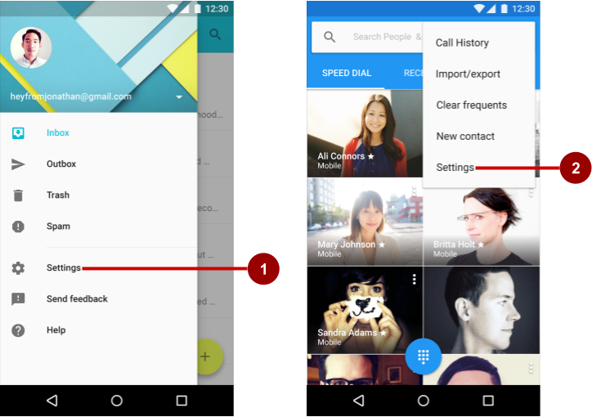

In the figure above:

1. Settings in side navigation (a navigation drawer)
2. Settings in the options menu of the app bar

Follow these design guidelines for navigating to settings:

* If your app offers side navigation such as a navigation drawer, include **Settings** below all other items (except **Help**and**Send Feedback**).
* If your app doesn't offer side navigation, place **Settings** in the app bar menu's options menu below all other items (except **Help**and**Send Feedback**).

**Note:** Use the word **Settings** in the app's navigation to access the settings. Do not use synonyms such as "Options" or "Preferences."

**Tip**: Android Studio provides a shortcut for setting up an options menu with **Settings**. If you start an Android Studio project for a phone or tablet using the Basic Activity template, the new app includes **Settings** as shown below: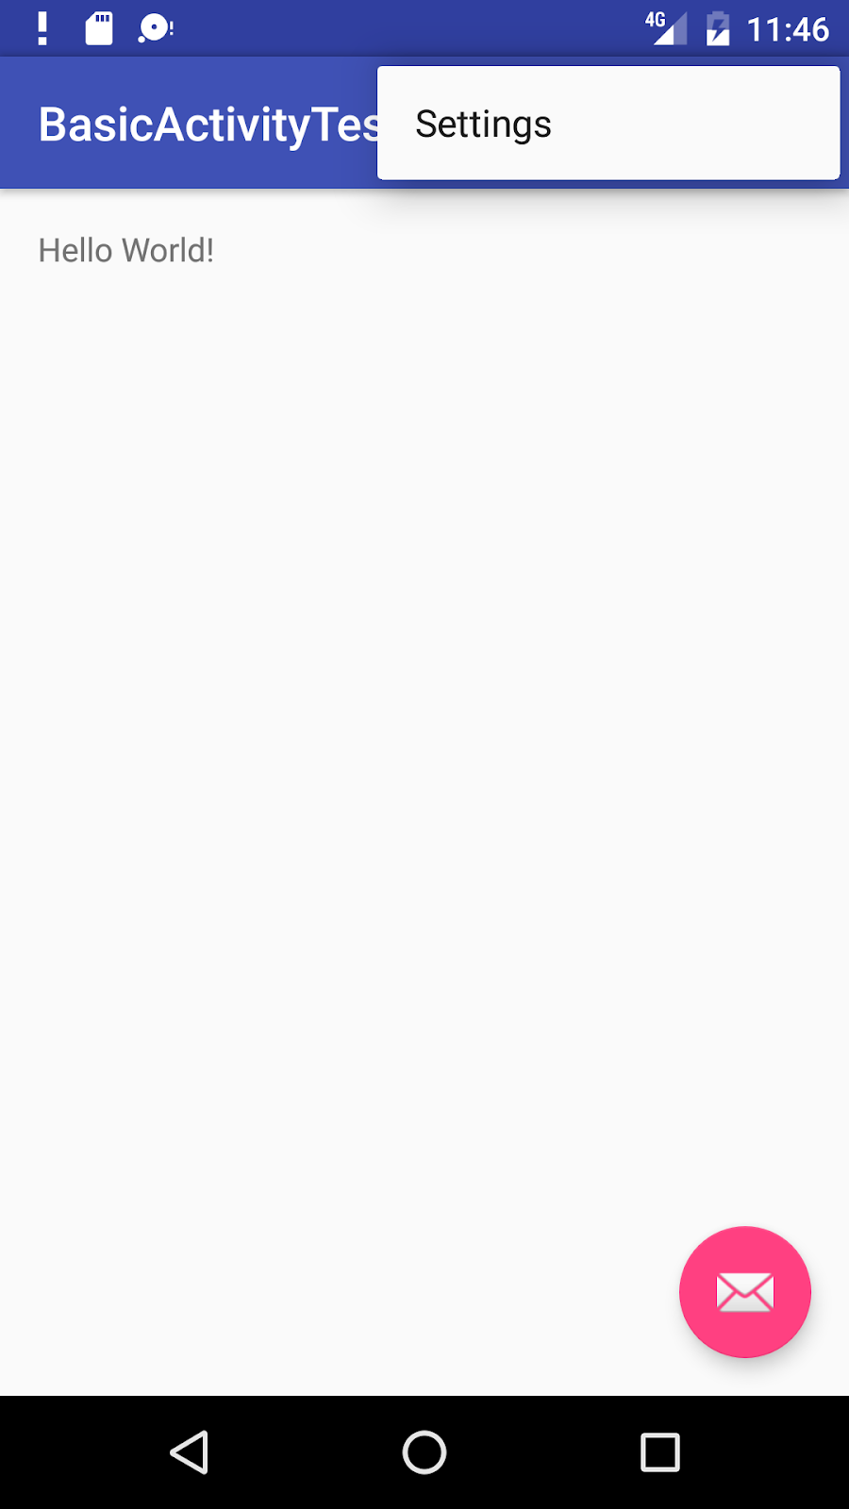

The settings UI

Settings should be well-organized, predictable, and contain a manageable number of options. A user should be able to quickly understand all available settings and their current values. Follow these design guidelines:

* **7 or fewer settings**: Arrange them according to priority with the most important ones at the top.
* **7-15 settings**: Group related settings under section dividers. For example, in the figure below, "Priority interruptions" and "Downtime (priority interruptions only)" are section dividers.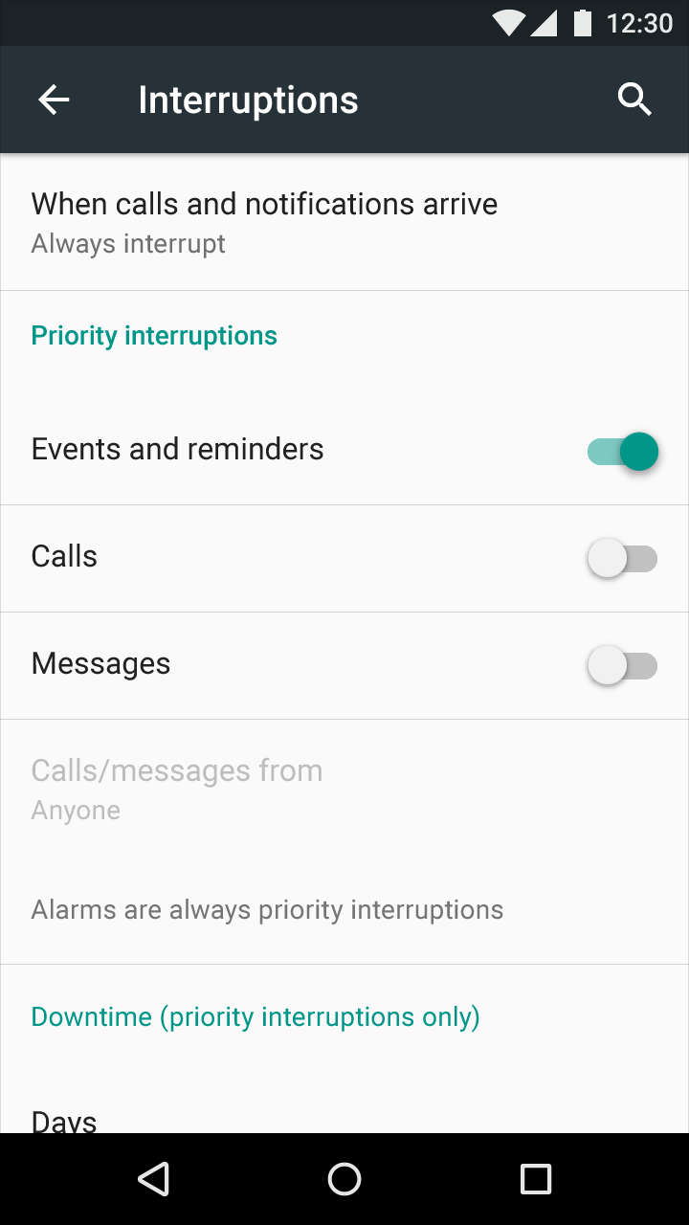
* **16 or more settings**: Group related settings into separate screens. Use headings, such as **Display**on the main Settings screen (as shown on the left side of the figure below) to enable users to navigate to the display settings (shown on the right side of the figure below):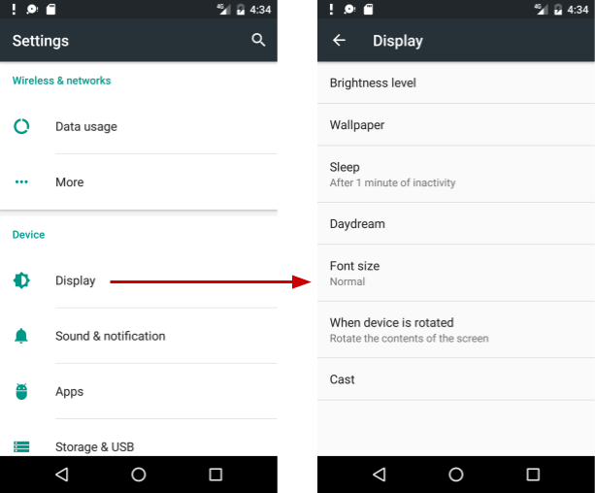

Building the settings

Build an app's settings using various subclasses of the [Preference](https://developer.android.com/reference/android/preference/Preference.html) class rather than using [View](https://developer.android.com/reference/android/view/View.html)elements. Preference provides the View to be displayed for each setting, and associates with it a [SharedPreferences](https://developer.android.com/reference/android/content/SharedPreferences.html) interface to store and retrieve the preference data.

Each [Preference](https://developer.android.com/reference/android/preference/Preference.html) appears as an item in a list. Direct subclasses provide containers for layouts involving multiple settings. For example:

* [PreferenceGroup](https://developer.android.com/reference/android/preference/PreferenceGroup.html): Represents a group of settings (Preference objects).
* [PreferenceCategory](https://developer.android.com/reference/android/preference/PreferenceCategory.html): Provides a disabled title above a group as a section divider.
* [PreferenceScreen](https://developer.android.com/reference/android/preference/PreferenceScreen.html): Represents a top-level Preference that is the root of a Preference hierarchy. Use a PreferenceScreen in a layout at the top of each screen of settings.

For example, to provide dividers with headings between groups of settings (as shown in the previous figure for 7-15 settings), place each group of Preference objects inside a PreferenceCategory. To use separate screens for groups, place each group of Preference objects inside a PreferenceScreen.

Other Preference subclasses for settings provide the appropriate UI for users to change the setting. For example:

* [CheckBoxPreference](https://developer.android.com/reference/android/preference/CheckBoxPreference.html): Creates a list item that shows a checkbox for a setting that is either enabled or disabled. The saved value is a boolean (true if it's checked).
* [ListPreference](https://developer.android.com/reference/android/preference/ListPreference.html): Creates an item that opens a dialog with a list of radio buttons.
* [SwitchPreference](https://developer.android.com/reference/android/preference/SwitchPreference.html): Creates a two-state option that can be toggled (such as on/off or true/false).
* [EditTextPreference](https://developer.android.com/reference/android/preference/EditTextPreference.html): Creates an item that opens a dialog with an [EditText](https://developer.android.com/reference/android/widget/EditText.html) element. The saved value is a [String](https://developer.android.com/reference/java/lang/String.html).
* [RingtonePreference](https://developer.android.com/reference/android/preference/RingtonePreference.html): Lets the user choose a ringtone from those available on the device.

Define your list of settings in XML, which provides an easy-to-read structure that's simple to update. Each Preference subclass can be declared with an XML element that matches the class name, such as <CheckBoxPreference>.

XML attributes for settings

The following example from the Settings Activity template defines a screen with three settings as shown in the figure below: a SwitchPreference toggle switch (at the top of the screen on the left side), an EditTextPreference text entry field (center), and a ListPreference list of radio buttons (right):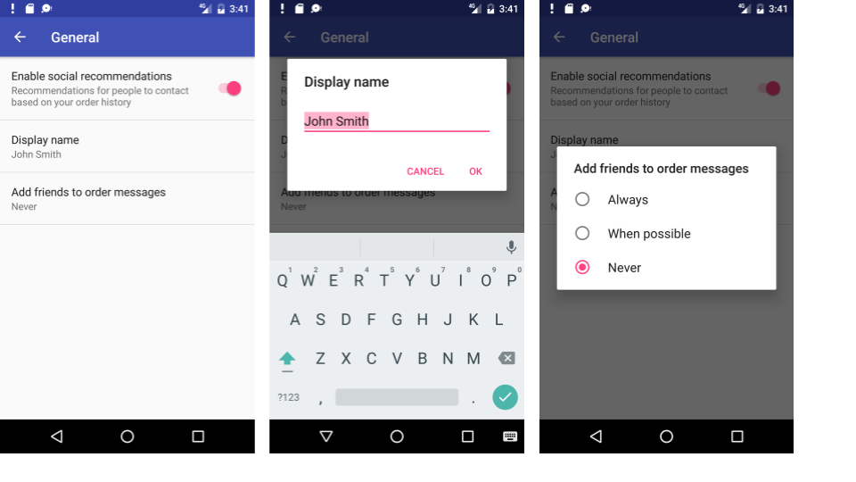

The root of the settings hierarchy is a PreferenceScreen layout:

<PreferenceScreen xmlns:android="http://schemas.android.com/apk/res/android">

<android.support.v7.preference.SwitchPreferenceCompat

android:defaultValue="true"

android:key="example_switch"

android:summary="@string/switch_summary"

android:title="@string/switch_title" />

</PreferenceScreen>

Inside the above layout is a SwitchPreference that shows a toggle switch to disable or enable an option.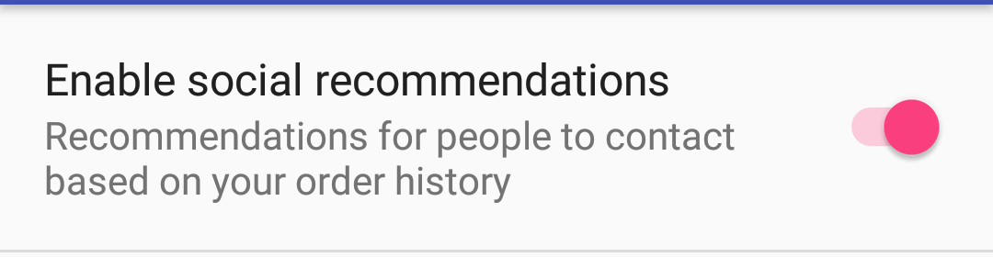

The setting has the following attributes:

* android:defaultValue: The option is enabled (set to true) by default.
* android:key: The key to use for storing the setting value. Each setting ([Preference](https://developer.android.com/reference/android/preference/Preference.html)) has a corresponding key-value pair that the system uses to save the setting in a default [SharedPreferences](https://developer.android.com/reference/android/content/SharedPreferences.html)file for your app's settings.
* android:summary: The text summary appears underneath the setting. For some settings, the summary should change to show whether the option is enabled or disabled.
* android:title: The title of the setting. For a SwitchPreference, the title appears to the left of the toggle switch.

An EditTextPreference shows a text field for the user to enter text.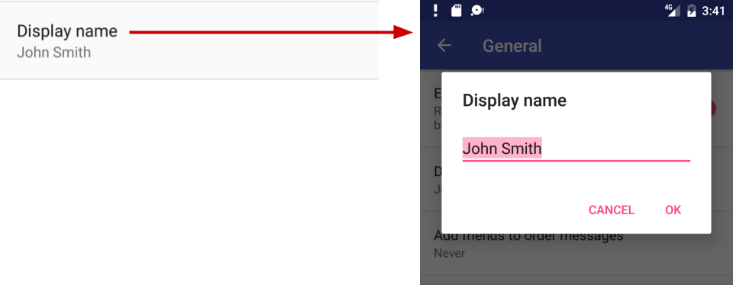

* Use EditText attributes such as android:capitalize and android:maxLines to define the text field's appearance and input control.
* The default setting is the pref_default_display_name string resource.

Example:

<EditTextPreference

android:capitalize="words"

android:defaultValue="@string/pref_default_display_name"

android:inputType="textCapWords"

android:key="example_text"

android:maxLines="1"

android:selectAllOnFocus="true"

android:singleLine="true"

android:title="@string/pref_title_display_name" />

A ListPreference shows a dialog with radio buttons for the user to make one choice.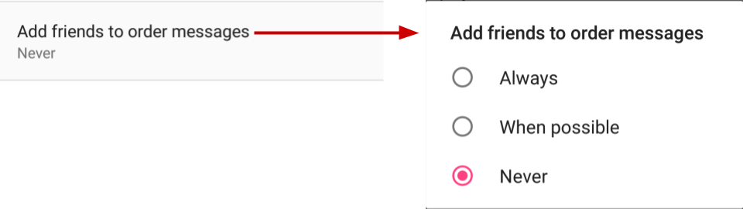

* The default value is set to -1 for no choice.
* The text for the radio buttons (**Always**, **When possible**, and **Never**) are defined in the pref_example_list_titles array and specified by the android:entries attribute.
* The values for the radio button choices are defined in the pref_example_list_values array and specified by the android:entryValues attribute.
* The radio buttons are displayed in a dialog, which usually have positive (**OK** or **Accept**) and negative (**Cancel**) buttons. However, a settings dialog doesn't need these buttons, because the user can touch outside the dialog to dismiss it. To hide these buttons, set the android:positiveButtonText and android:negativeButtonText attributes to "@null".

Example:

<ListPreference

android:defaultValue="-1"

android:entries="@array/pref_example_list_titles"

android:entryValues="@array/pref_example_list_values"

android:key="example_list"

android:negativeButtonText="@null"

android:positiveButtonText="@null"

android:title="@string/pref_list_title" />

Save the XML file in the res/xml directory. Although you can name the file anything you want, it is traditionally named preferences.xml.

If you are using the [support v7 appcompat library](https://developer.android.com/topic/libraries/support-library/packages#v7-appcompat) and extending the Settings Activity with [AppCompatActivity](https://developer.android.com/reference/android/support/v7/app/AppCompatActivity.html) and the Fragment with [PreferenceFragmentCompat](https://developer.android.com/reference/android/support/v7/preference/PreferenceFragmentCompat.html), as shown in the next section, change the setting's XML attribute to use the support v7 appcompat library version. For example, for a SwitchPreference setting, change <SwitchPreference in the code to:

<android.support.v7.preference.SwitchPreferenceCompat

Displaying the settings

Use a specialized [Activity](https://developer.android.com/reference/android/app/Activity.html) or [Fragment](https://developer.android.com/reference/android/app/Fragment.html) subclass to display a list of settings.

* For an app that supports Android 3.0 and newer versions, the best practice for settings is to use a Settings Activity and a Fragment for each preference XML file. Add a Settings Activity class that extends Activity and hosts a fragment that extends [PreferenceFragment](https://developer.android.com/reference/android/preference/PreferenceFragment.html).
* To remain compatible with the [v7 appcompat library](https://developer.android.com/topic/libraries/support-library/packages#v7-appcompat), extend the Settings Activity with [AppCompatActivity](https://developer.android.com/reference/android/support/v7/app/AppCompatActivity.html), and extend the Fragment with [PreferenceFragmentCompat](https://developer.android.com/reference/android/support/v7/preference/PreferenceFragmentCompat.html).
* If your app must support versions of Android older than 3.0 (API level 10 and lower), build a special settings Activity as an extension of the [PreferenceActivity](https://developer.android.com/reference/android/preference/PreferenceActivity.html) class.

A Fragment like PreferenceFragment provides a more flexible architecture for your app, compared to using an Activity alone. A Fragment is like a modular section of an Activity—it has its own lifecycle and receives its own input events, and you can add or remove a Fragment while the Activity is running. Use PreferenceFragment to control the display of your settings instead of PreferenceActivity whenever possible.

However, to create a two-pane layout for large screens when you have multiple groups of settings, you can use an Activity that extends PreferenceActivity and also use PreferenceFragment to display each list of settings. You will see this pattern with the Settings Activity template as described later in this chapter in "[Using the Settings Activity template](https://google-developer-training.github.io/android-developer-fundamentals-course-concepts-v2/unit-4-saving-user-data/lesson-9-preferences-and-settings/9-2-c-app-settings/9-2-c-app-settings.html#template)".

The following examples show you how to remain compatible with the [v7 appcompat library](https://developer.android.com/topic/libraries/support-library/packages#v7-appcompat) by extending the Settings Activity with [AppCompatActivity](https://developer.android.com/reference/android/support/v7/app/AppCompatActivity.html), and extending the Fragment with [PreferenceFragmentCompat](https://developer.android.com/reference/android/support/v7/preference/PreferenceFragmentCompat.html). To use this library and the PreferenceFragmentCompat version of PreferenceFragment, you must also add the android.support:preference-v7 library to the build.gradle (Module: app) file's dependencies section:

implementation 'com.android.support:preference-v7:26.1.0'

You also need to add the following preferenceTheme declaration to the AppTheme in the styles.xml file:

<style name="AppTheme" parent="Theme.AppCompat.Light.DarkActionBar">

<!-- Other items -->

<item name="preferenceTheme">@style/PreferenceThemeOverlay</item>

</style>

Using a PreferenceFragment

The following shows how to use a [PreferenceFragment](https://developer.android.com/reference/android/preference/PreferenceFragment.html) to display a list of settings, and how to add a PreferenceFragment to an Activity for settings. To remain compatible with the [v7 appcompat library](https://developer.android.com/topic/libraries/support-library/packages#v7-appcompat), extend the Settings Activity with [AppCompatActivity](https://developer.android.com/reference/android/support/v7/app/AppCompatActivity.html), and extend the Fragment with [PreferenceFragmentCompat](https://developer.android.com/reference/android/support/v7/preference/PreferenceFragmentCompat.html) for each preferences XML file.

In the Fragment, replace the automatically generated onCreate() method with the [onCreatePreferences()](https://developer.android.com/reference/android/support/v7/preference/PreferenceFragmentCompat.html#onCreatePreferences(android.os.Bundle,%20java.lang.String)) method to load a preferences file with setPreferencesFromResource():

public static class SettingsFragment extends PreferenceFragment {

@Override

public void onCreatePreferences(Bundle savedInstanceState,

String rootKey) {

setPreferencesFromResource(R.xml.preferences, rootKey);

}

}

As shown in the code above, you associate an XML layout of settings with the Fragment during the onCreatePreferences() callback by calling [setPreferencesFromResource()](https://developer.android.com/reference/android/support/v7/preference/PreferenceFragmentCompat.html#setPreferencesFromResource(int,%20java.lang.String)) with two arguments:

* R.xml. and the name of the XML file (preferences).
* the rootKey to identify the preference root in PreferenceScreen.

You can then create an Activity for settings (named SettingsActivity) that extends [AppCompatActivity](https://developer.android.com/reference/android/support/v7/app/AppCompatActivity.html), and add the settings Fragment to it:

public class SettingsActivity extends AppCompatActivity {

@Override

protected void onCreate(Bundle savedInstanceState) {

super.onCreate(savedInstanceState);

// Display the fragment as the main content.

getSupportFragmentManager().beginTransaction()

.replace(android.R.id.content, new SettingsFragment())

.commit();

}

}

The above code is the typical pattern used to add a [Fragment](https://developer.android.com/reference/android/app/Fragment.html) to an Activity so that the Fragmentappears as the main content of the Activity. You use:

* getFragmentManager() if the class extends Activity and the Fragment extends PreferenceFragment.
* getSupportFragmentManager() if the class extends AppCompatActivity and the Fragment extends PreferenceFragmentCompat.

To set Up navigation for the SettingsActivity, be sure to declare the SettingsActivity parent to be MainActivity in the AndroidManifest.xml file.

Calling the settings Activity

If you implement the options menu with the **Settings** item, use the following Intent to call the Settings Activity from with the onOptionsItemSelected() method when the user taps **Settings** (using action_settings for the **Settings** menu resource id):

@Override

public boolean onOptionsItemSelected(MenuItem item) {

int id = item.getItemId();

// ... Handle other options menu items.

if (id == R.id.action_settings) {

Intent intent = new Intent(this, SettingsActivity.class);

startActivity(intent);

return true;

}

return super.onOptionsItemSelected(item);

}

If you implement a navigation drawer with the **Settings** item, use the following Intent to call the Settings Activity from with the onNavigationItemSelected() method when the user taps **Settings**(using action_settings for the **Settings** menu resource id):

@Override

public boolean onNavigationItemSelected(MenuItem item) {

int id = item.getItemId();

if (id == R.id.action_settings) {

Intent intent = new Intent(this, SettingsActivity.class);

startActivity(intent);

} else if ...

// ... Handle other navigation drawer items.

return true;

}

Setting the default values for settings

When the user changes a setting, the system saves the changes to a [SharedPreferences](https://developer.android.com/reference/android/content/SharedPreferences.html) file. As you learned in another practical, shared preferences allow you to read and write small amounts of primitive data as key/value pairs to a file on the device storage.

The app must initialize the SharedPreferences file with default values for each setting when the user first opens the app. Follow these steps:

1. Be sure to specify a default value for each setting in your XML file using the android:defaultValueattribute:
2. <SwitchPreference
3. android:defaultValue="true"
4. From the [onCreate()](https://developer.android.com/reference/android/app/Activity.html#onCreate(android.os.Bundle)) method in MainActivity—and in any other Activity through which the user may enter your app for the first time—call [setDefaultValues()](https://developer.android.com/reference/android/preference/PreferenceManager.html#setDefaultValues(android.content.Context,%20int,%20boolean)):
5. PreferenceManager.setDefaultValues(this,
6. R.xml.preferences, false);

Step 2 ensures that the app is properly initialized with default settings. The setDefaultValues()method takes three arguments:

1. The app [context](https://developer.android.com/reference/android/content/Context.html), such as this.
2. The resource ID (preferences) for the settings layout XML file which includes the default values set by Step 1 above.
3. A boolean indicating whether the default values should be set more than once. When false, the system sets the default values only if this method has never been called in the past (or the [KEY_HAS_SET_DEFAULT_VALUES](https://developer.android.com/reference/android/preference/PreferenceManager.html#KEY_HAS_SET_DEFAULT_VALUES) in the default value SharedPreferences file is false). As long as you set this third argument to false, you can safely call this method every time MainActivity starts without overriding the user's saved settings values. However, if you set it to true, the method will override any previous values with the defaults.

Reading the settings values

Each [Preference](https://developer.android.com/reference/android/preference/Preference.html) you add has a corresponding key/value pair that the system uses to save the setting in a default [SharedPreferences](https://developer.android.com/reference/android/content/SharedPreferences.html) file for your app's settings. When the user changes a setting, the system updates the corresponding value in the SharedPreferences file for you. The only time you should directly interact with the associated SharedPreferences file is when you need to read the value in order to determine your app's behavior based on the user's setting.

All of an app's preferences are saved by default to a file that is accessible from anywhere within the app by calling the static method [PreferenceManager.getDefaultSharedPreferences()](https://developer.android.com/reference/android/preference/PreferenceManager.html#getDefaultSharedPreferences(android.content.Context)). This method takes the context and returns the SharedPreferences object containing all the key/value pairs that are associated with the Preference objects.

For example, the following code snippet shows how you can read one of the preference values from the MainActivity onCreate() method:

SharedPreferences sharedPref =

PreferenceManager.getDefaultSharedPreferences(this);

Boolean switchPref = sharedPref

.getBoolean("example_switch", false);

The above code snippet uses PreferenceManager.getDefaultSharedPreferences(this) to get the settings as a SharedPreferences object (sharedPref).

It then uses getBoolean() to get the boolean value of the preference that uses the key "example_switch". If there is no value for the key, the getBoolean() method sets the value to false.

Listening for a setting change

There are several reasons why you might want to set up a listener for a specific setting:

* If a change to the value of a setting also requires changing the summary of the setting, you can listen for the change, and then change the summary with the new setting value.
* If the setting requires several more options, you may want to listen for the change and immediately respond by displaying the options.
* If the setting makes another setting obsolete or inappropriate, you may want to listen for the change and immediately respond by disabling the other setting.

To listen to a setting, use the [Preference.OnPreferenceChangeListener](https://developer.android.com/reference/android/preference/Preference.OnPreferenceChangeListener.html) interface, which includes the [onPreferenceChange()](https://developer.android.com/reference/android/preference/Preference.OnPreferenceChangeListener.html#onPreferenceChange(android.preference.Preference,%20java.lang.Object)) method that returns the new value of the setting.

In the following example, the listener retrieves the new value after the setting is changed, and changes the summary of the setting (which appears below the setting in the UI) to show the new value. Follow these steps:

1. Use a shared preferences file, as described in another practical, to store the value of the preference (setting). Declare the following variables in the SettingsFragment class definition:
2. public class SettingsFragment extends PreferenceFragment {
3. private SharedPreferences mPreferences;
4. private String sharedPrefFile =
5. "com.example.android.settingstest";
6. }
7. Add the following to the onCreate() method of SettingsFragment to get the preference defined by the key example_switch, and to set the initial text (the string resource option_on) for the summary:
8. @Override
9. public void onCreate(Bundle savedInstanceState) {
10. // ... Rest of onCreate code.
11. mPreferences = this.getActivity()
12. .getSharedPreferences(sharedPrefFile, MODE_PRIVATE);
13. Preference preference =
14. this.findPreference("example_switch");
15. preference.setSummary(mPreferences.getString("summary",
16. getString(R.string.option_on)));
17. }
18. Add the following code to onCreate() after the code in the previous step:
19. preference.setOnPreferenceChangeListener(new
20. Preference.OnPreferenceChangeListener() {
21. @Override
22. public boolean onPreferenceChange(Preference preference,
23. Object newValue) {
24. if ((Boolean) newValue == true) {
25. preference.setSummary(R.string.option_on);
26. SharedPreferences.Editor preferencesEditor =
27. mPreferences.edit();
28. preferencesEditor.putString("summary",
29. getString(R.string.option_on)).apply();
30. } else {
31. preference.setSummary(R.string.option_off);
32. SharedPreferences.Editor preferencesEditor =
33. mPreferences.edit();
34. preferencesEditor.putString("summary",
35. getString(R.string.option_off)).apply();
36. }
37. return true;
38. }
39. });

The code listens to a change in the switch setting using [onPreferenceChange()](https://developer.android.com/reference/android/preference/Preference.OnPreferenceChangeListener.html#onPreferenceChange(android.preference.Preference,%20java.lang.Object)), and returns true. It then determines the new boolean value (newValue) for the setting after the change (true or false).

If true, the code edits the SharedPreferences file (as described in a previous practical) using [SharedPreferences.Editor](https://developer.android.com/reference/android/content/SharedPreferences.Editor.html), putting the new value (string.option.on) as a string in the summary using [putString()](https://developer.android.com/reference/android/content/SharedPreferences.Editor.html#putString(java.lang.String,%20java.lang.String)) and applies the change using [apply()](https://developer.android.com/reference/android/content/SharedPreferences.Editor.html#apply()). If false, the code does the same thing with the new value (string.option.off) as a string in the summary.

Using the Settings Activity template

If you need to build several screens of settings and you want to take advantage of tablet-sized screens as well as maintain compatibility with older versions of Android for tablets, Android Studio provides a shortcut: the Settings Activity template.

The Settings Activity template is populated with settings you can customize for an app, and provides a different layout for phones and tablets:

* *Phones*: A main Settings screen with a header link for each group of settings, such as General for general settings, as shown below.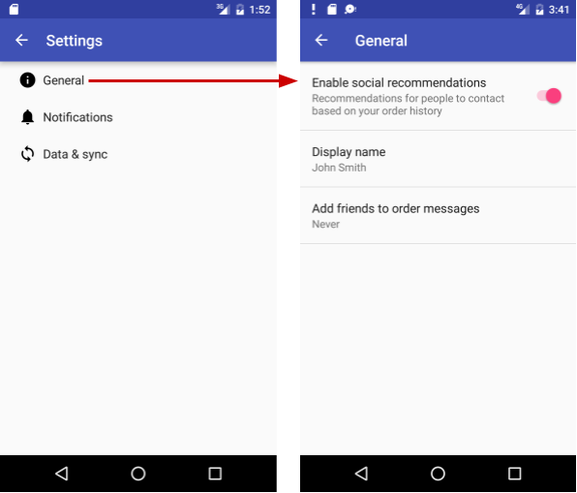
* *Tablets*: A master/detail screen layout with a header link for each group on the left (master) side, and the group of settings on the right (detail) side, as shown in the figure below.

The Settings Activity template also provides the function of listening to a settings change, and changing the summary to reflect the settings change. For example, if you change the "Add friends to messages" setting (the choices are **Always**, **When possible**, or **Never**), the choice you make appears in the summary underneath the setting: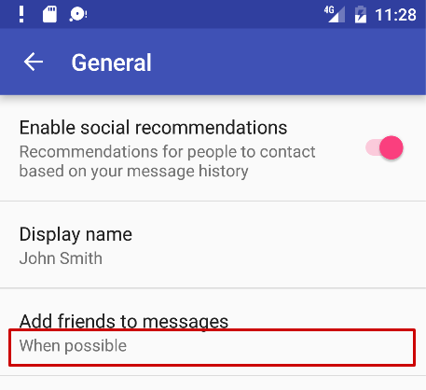

In general, you need not change the Settings Activity template code in order to customize SettingsActivity for the settings you want in your app. You can customize the settings titles, summaries, possible values, and default values without changing the template code, and even add more settings to the groups that are provided. To customize the settings, edit the string and string array resources in the strings.xml file and the layout attributes for each setting in the files in the res > xml folder in the **Project > Android** pane.

You use the Settings Activity template code as-is. To make it work for your app, add code to MainActivity to set the default settings values, and to *read* and *use* the settings values, as shown later in this chapter.

Including the Settings Activity template in your project

To include the Settings Activity template in your app project in Android Studio, follow these steps:

1. Select **app** at the top of the **Project > Android** pane, and choose **New > Activity > Settings Activity**.
2. In the dialog that appears, accept the Activity Name (**SettingsActivity** is the suggested name) and the Title (**Settings**).
3. Click the three dots at the end of the **Hierarchical Parent** field and choose the parent Activity(usually **MainActivity**), so that the **Up** app bar button in SettingsActivity returns the user to MainActivity. Choosing the parent Activity automatically updates the AndroidManifest.xml file to support **Up** navigation.

The Settings Activity template creates XML files in the **res > xml** folder of the **Project > Android** pane, which you can add to or customize for the settings you want:

* pref_data_sync.xml: PreferenceScreen layout for "Data & sync" settings.
* pref_general.xml: PreferenceScreen layout for "General" settings.
* pref_headers.xml: Layout of headers for the Settings main screen.
* pref_notification.xml: PreferenceScreen layout for "Notifications" settings.

The above XML layouts use various subclasses of the [Preference](https://developer.android.com/reference/android/preference/Preference.html) class rather than [View](https://developer.android.com/reference/android/view/View.html), and direct subclasses provide containers for layouts involving multiple settings. For example, [PreferenceScreen](https://developer.android.com/reference/android/preference/PreferenceScreen.html)represents a top-level Preference that is the root of a Preference hierarchy. The above files use PreferenceScreen at the top of each screen of settings. Other Preference subclasses for settings provide the appropriate UI for users to change the setting. For example:

* [CheckBoxPreference](https://developer.android.com/reference/android/preference/CheckBoxPreference.html): A checkbox for a setting that is either enabled or disabled.
* [ListPreference](https://developer.android.com/reference/android/preference/ListPreference.html): A dialog with a list of radio buttons.
* [SwitchPreference](https://developer.android.com/reference/android/preference/SwitchPreference.html): A two-state option that can be toggled (such as on/off or true/false).
* [EditTextPreference](https://developer.android.com/reference/android/preference/EditTextPreference.html): A dialog with an [EditText](https://developer.android.com/reference/android/widget/EditText.html).
* [RingtonePreference](https://developer.android.com/reference/android/preference/RingtonePreference.html): A dialog with ringtones on the device.

The Settings Activity template also provides the following:

* String resources in the strings.xml file in the res > values folder of the **Project > Android** pane, which you can customize for the settings you want.

All strings used in the Settings Activity, such as the titles for settings, string arrays for lists, and descriptions for settings, are defined as string resources at the end of this file. They are marked by comments such as <!-- Strings related to Settings --> and <!-- Example General settings -->.

**Tip**: You can edit these strings to customize the settings you need for your app.

* SettingsActivity in the java > com.example.android.*projectname* folder, which you can use as is. This is the Activity that displays the settings. SettingsActivity extends AppCompatPreferenceActivity for maintaining compatibility with older versions of Android.
* AppCompatPreferenceActivity in the java > com.example.android.*projectname*folder, which you use as is. This Activity is a helper class that SettingsActivity uses to maintain backwards compatibility with previous versions of Android.

Using preference headers

The Settings Activity template shows preference headers on the main screen that separate the settings into categories (**General**, **Notifications**, and **Data & sync**). The user taps a heading to access the settings under that heading. On larger tablet displays (see previous figure), the headers appear in the left pane and the settings for each header appears in the right pane.

To implement the headers, the template provides the pref_headers.xml file:

<preference-headers xmlns:android="http://schemas.android.com/apk/res/android">

<header

android:fragment="com.example.android.droidcafe.SettingsActivity$GeneralPreferenceFragment"

android:icon="@drawable/ic_info_black_24dp"

android:title="@string/pref_header_general" />

<header

android:fragment="com.example.android.droidcafe.SettingsActivity$NotificationPreferenceFragment"

android:icon="@drawable/ic_notifications_black_24dp"

android:title="@string/pref_header_notifications" />

<header

android:fragment="com.example.android.droidcafe.SettingsActivity$DataSyncPreferenceFragment"

android:icon="@drawable/ic_sync_black_24dp"

android:title="@string/pref_header_data_sync" />

</preference-headers>

The XML headers file lists each preferences category and declares the fragment that contains the corresponding preferences.

To display the headers, the template uses the following onBuildHeaders() method:

@Override

@TargetApi(Build.VERSION_CODES.HONEYCOMB)

public void onBuildHeaders(List<Header> target) {

loadHeadersFromResource(R.xml.pref_headers, target);

}

The above code snippet uses the loadHeadersFromResource() method of the [PreferenceActivity](https://developer.android.com/reference/android/preference/PreferenceActivity.html) class to load the headers from the XML resource (pref_headers.xml). The [TargetApi](https://developer.android.com/reference/android/annotation/TargetApi.html) annotation tells Android Studio's [Lint](https://developer.android.com/studio/write/lint.html) code scanning tool that the class or method is targeting a particular API level regardless of what is specified as the min SDK level in manifest. Lint would otherwise produce errors and warnings when using new functionality that is not available in the target API level.

Using PreferenceActivity with a Fragment

The Settings Activity template provides an Activity (SettingsActivity) that extends [PreferenceActivity](https://developer.android.com/reference/android/preference/PreferenceActivity.html) to create a two-pane layout to support large screens, and *also* includes a Fragmentfor each group of settings. This is a useful pattern if you have multiple groups of settings and need to support tablet-sized screens as well as phones.

The following shows how to use an Activity that extends PreferenceActivity to host a Fragment([PreferenceFragment](https://developer.android.com/reference/android/preference/PreferenceFragment.html)) that displays a group of settings. The Activity can host more than one Fragment, such as GeneralPreferenceFragment and NotificationPreferenceFragment, and each Fragment definition uses addPreferencesFromResource to load the settings from the XML preferences file:

public class SettingsActivity extends AppCompatPreferenceActivity {

// ... SettingsActivity code

public static class GeneralPreferenceFragment extends

PreferenceFragment {

@Override

public void onCreate(Bundle savedInstanceState) {

super.onCreate(savedInstanceState);

addPreferencesFromResource(R.xml.pref_general);

// ... onCreate code

}

public static class NotificationPreferenceFragment extends

PreferenceFragment {

// ... Similar code as in above fragment

}

10.0: SQLite primer

**Contents:**

* [SQL databases](https://google-developer-training.github.io/android-developer-fundamentals-course-concepts-v2/unit-4-saving-user-data/lesson-10-storing-data-with-room/10-0-c-sqlite-primer/10-0-c-sqlite-primer.html#databases)
* [SQLite](https://google-developer-training.github.io/android-developer-fundamentals-course-concepts-v2/unit-4-saving-user-data/lesson-10-storing-data-with-room/10-0-c-sqlite-primer/10-0-c-sqlite-primer.html#sqlite)
* [Example table](https://google-developer-training.github.io/android-developer-fundamentals-course-concepts-v2/unit-4-saving-user-data/lesson-10-storing-data-with-room/10-0-c-sqlite-primer/10-0-c-sqlite-primer.html#table)
* [Transactions](https://google-developer-training.github.io/android-developer-fundamentals-course-concepts-v2/unit-4-saving-user-data/lesson-10-storing-data-with-room/10-0-c-sqlite-primer/10-0-c-sqlite-primer.html#transactions)
* [Query language](https://google-developer-training.github.io/android-developer-fundamentals-course-concepts-v2/unit-4-saving-user-data/lesson-10-storing-data-with-room/10-0-c-sqlite-primer/10-0-c-sqlite-primer.html#language)
* [Queries for Android SQLite](https://google-developer-training.github.io/android-developer-fundamentals-course-concepts-v2/unit-4-saving-user-data/lesson-10-storing-data-with-room/10-0-c-sqlite-primer/10-0-c-sqlite-primer.html#queries)
* [Cursors](https://google-developer-training.github.io/android-developer-fundamentals-course-concepts-v2/unit-4-saving-user-data/lesson-10-storing-data-with-room/10-0-c-sqlite-primer/10-0-c-sqlite-primer.html#cursors)
* [Learn more](https://google-developer-training.github.io/android-developer-fundamentals-course-concepts-v2/unit-4-saving-user-data/lesson-10-storing-data-with-room/10-0-c-sqlite-primer/10-0-c-sqlite-primer.html#learnmore)

This course assumes that you are familiar with databases in general, SQL databases in particular, and the SQL language used to interact with them. This chapter is a refresher and quick reference only.

SQL databases

SQL databases store data in tables of rows and columns:

* The intersection of a row and column is called a *field*.
* Fields contain data, references to other fields, or references to other tables.
* Rows are identified by unique IDs.
* Columns are identified by names that are unique per table.

Think of a database as a spreadsheet with rows, columns, and cells, where cells can contain data, references to other cells, and links to other sheets.

SQLite

SQLite is a software library. SQLite implements an SQL database engine that has the following characteristics:

* Self-contained (requires no other components)
* Serverless (requires no server backend)
* Zero-configuration (does not need to be configured for your app)
* Transactional (changes within a single transaction in SQLite either occur completely or not at all)

SQLite is the most widely deployed database engine in the world. The source code for SQLite is in the public domain.

For details of the SQLite database, see the [SQLite website](https://www.sqlite.org/about.html).

Example table

SQLite stores data in tables.

Assume the following:

* A database named DATABASE_NAME
* A table named WORD_LIST_TABLE
* Columns for _id, word, and definition

After inserting the words alpha and beta, where alpha has two definitions, the DATABASE_NAMEdatabase table named WORD_LIST_TABLE might look like this:

|  |
| --- |
| WORD_LIST_TABLE |
| _id | word | definition |
| 1 | "alpha" | "first letter" |
| 2 | "beta" | "second letter" |
| 3 | "alpha" | "particle" |

You can find what's in a specific row using the _id, or you can retrieve rows by formulating queries that select rows from the table by specifying constraints. You use the SQL query language discussed below to create queries.

Transactions

A *transaction* is a sequence of operations performed as a single logical unit of work. A logical unit of work must exhibit four properties, called the atomicity, consistency, isolation, and durability (ACID) properties, to qualify as a transaction:

* **Atomicity.** Either all of a transaction's data modifications are performed, or none of them are performed. This is true even if the act of writing the change to the disk is interrupted by a program crash, operating system crash, or power failure.
* **Consistency.** When completed, a transaction must leave all data in a consistent state.
* **Isolation.** Modifications made by concurrent transactions must be isolated from the modifications made by any other concurrent transactions. A transaction either recognizes data in the state it was in before another concurrent transaction modified it, or it recognizes the data after the second transaction has completed, but it does not recognize an intermediate state.
* **Durability.** After a transaction has completed, its effects are permanently in place in the system. The modifications persist even in the event of a system failure.

Examples of transactions:

* Transferring money from a savings account to a checking account.
* Entering a term and definition into dictionary.
* Committing a changelist to the master branch.

[More on transactions](https://www.sqlite.org/atomiccommit.html).

Query language

You use a special SQL query language to interact with the database. Queries can be very complex, but there are four basic operations:

* Inserting rows
* Deleting rows
* Updating values in rows
* Retrieving rows that meet given criteria

On Android, the database object provides convenient methods for inserting, deleting, and updating the database. You only need to understand SQL for retrieving data.

[Full description of the query language](https://www.sqlite.org/lang.html).

Query structure

An SQL query is highly structured and contains the following basic parts:

* SELECT word,*description*FROM WORD_LIST_TABLE WHERE word="alpha"

Generic version of sample query:

* SELECT *columns*FROM *table*WHERE *column="value"*

Parts:

* SELECT *columns*: Select the columns to return. Use * to return all columns.
* FROM *table*: Specify the table from which to get results.
* WHERE: Keyword that precedes conditions that have to be met, for example *column="value"*. Common operators are =, LIKE, <, and <code> style="box-sizing: border-box; -webkit-tap-highlight-color: transparent; text-size-adjust: none; -webkit-font-smoothing: antialiased; font-size: inherit;">. To connect multiple conditions, use AND or OR.</code>>
* ORDER BY: Specify ASC for ascending, or DESC for descending. For default order, omit ORDER BY.
* LIMIT: Very useful keyword if you want to only get a limited number of results.

Sample queries

|  |  |  |
| --- | --- | --- |
| 1 | SELECT * FROM WORD_LIST_TABLE | Gets the whole table. |
| 2 | SELECT word, definition FROM WORD_LIST_TABLE WHERE _id > 2 | Returns [["alpha", "particle"]] |
| 3 | SELECT _id FROM WORD_LIST_TABLE WHERE word="alpha" AND definition LIKE "%art%" | Returns the id of the word alpha with the substring art in the definition. [["3"]] |
| 4 | SELECT * FROM WORD_LIST_TABLE ORDER BY word DESC LIMIT 1 | Sorts in reverse and gets the first item. This gives you the last item per sort order. Sorting is by the first column, in this case, the _id. [["3", "alpha", "particle"]] |
| 5 | SELECT * FROM WORD_LIST_TABLE LIMIT 2,1 | Returns 1 item starting at position 2. Position counting starts at 1 (not zero!). Returns [["2", "beta", "second letter"]] |

You can practice creating and querying databases at this [Fiddle website](http://sqlfiddle.com/).

Queries for Android SQLite

You can send queries to the SQLite database of the Android system as raw queries or as parameters.

The [rawQuery(String sql, String[] selectionArgs)](https://developer.android.com/reference/android/database/sqlite/SQLiteDatabase.html#rawQuery(java.lang.String,%20java.lang.String[])) method runs the provided SQL and returns a [Cursor](https://developer.android.com/reference/android/database/Cursor.html) of the result set. The following table shows how the first two sample queries from above would look as raw queries:

|  |  |
| --- | --- |
| 1 | String query = "SELECT * FROM WORD_LIST_TABLE"; rawQuery(query, null); |
| 2 | query = "SELECT word, definition FROM WORD_LIST_TABLE WHERE _id> ? "; String[] selectionArgs = new String[]{"2"} rawQuery(query, selectionArgs) ; |

The [query(String table, String[] columns, String selection, String[] selectionArgs, String groupBy, String having, String orderBy, String limit)](https://developer.android.com/reference/android/database/sqlite/SQLiteDatabase.html#query(java.lang.String,%20java.lang.String[],%20java.lang.String,%20java.lang.String[],%20java.lang.String,%20java.lang.String,%20java.lang.String,%20java.lang.String)) method queries the given table, returning a Cursor over the result set. Here's a query showing how to fill in the arguments:

SELECT * FROM WORD_LIST_TABLE

WHERE word="alpha"

ORDER BY word ASC

LIMIT 2,1;

This query returns:

[["alpha", "particle"]]

Argument examples:

String table = "WORD_LIST_TABLE"

String[] columns = new String[]{"*"};

String selection = "word = ?"

String[] selectionArgs = new String[]{"alpha"};

String groupBy = null;

String having = null;

String orderBy = "word ASC"

String limit = "2,1"

query(table, columns, selection, selectionArgs, groupBy, having, orderBy, limit);

Note that in real code, you wouldn't create variables for null values. See the [SQLiteDatabase documentation](https://developer.android.com/reference/android/database/sqlite/SQLiteDatabase.html) for versions of this method with different parameters.

Cursors

A *cursor* is a pointer into a row of structured data. You can think of a cursor as a pointer to a table row.

A query returns a [Cursor](http://developer.android.com/reference/android/database/Cursor.html) object that points to the first element in the query result. The Cursor class provides methods for moving the cursor through the query result, and methods to get the data from the columns of each row in the result.

When a method returns a Cursor object, you iterate over the result, extract the data, do something with the data, and close the cursor to release the memory.

10.1: Room, LiveData, and ViewModel

**Contents:**

* [What are Android Architecture Components?](https://google-developer-training.github.io/android-developer-fundamentals-course-concepts-v2/unit-4-saving-user-data/lesson-10-storing-data-with-room/10-1-c-room-livedata-viewmodel/10-1-c-room-livedata-viewmodel.html#chapterstart)
* [Recommended Architecture Components](https://google-developer-training.github.io/android-developer-fundamentals-course-concepts-v2/unit-4-saving-user-data/lesson-10-storing-data-with-room/10-1-c-room-livedata-viewmodel/10-1-c-room-livedata-viewmodel.html#recommended)
* [Example app architecture](https://google-developer-training.github.io/android-developer-fundamentals-course-concepts-v2/unit-4-saving-user-data/lesson-10-storing-data-with-room/10-1-c-room-livedata-viewmodel/10-1-c-room-livedata-viewmodel.html#example)
* [Gradle files](https://google-developer-training.github.io/android-developer-fundamentals-course-concepts-v2/unit-4-saving-user-data/lesson-10-storing-data-with-room/10-1-c-room-livedata-viewmodel/10-1-c-room-livedata-viewmodel.html#gradle)
* [Entity](https://google-developer-training.github.io/android-developer-fundamentals-course-concepts-v2/unit-4-saving-user-data/lesson-10-storing-data-with-room/10-1-c-room-livedata-viewmodel/10-1-c-room-livedata-viewmodel.html#entity)
* [The DAO (data access object)](https://google-developer-training.github.io/android-developer-fundamentals-course-concepts-v2/unit-4-saving-user-data/lesson-10-storing-data-with-room/10-1-c-room-livedata-viewmodel/10-1-c-room-livedata-viewmodel.html#dao)
* [LiveData](https://google-developer-training.github.io/android-developer-fundamentals-course-concepts-v2/unit-4-saving-user-data/lesson-10-storing-data-with-room/10-1-c-room-livedata-viewmodel/10-1-c-room-livedata-viewmodel.html#livedata)
* [Room database](https://google-developer-training.github.io/android-developer-fundamentals-course-concepts-v2/unit-4-saving-user-data/lesson-10-storing-data-with-room/10-1-c-room-livedata-viewmodel/10-1-c-room-livedata-viewmodel.html#room)
* [Repository](https://google-developer-training.github.io/android-developer-fundamentals-course-concepts-v2/unit-4-saving-user-data/lesson-10-storing-data-with-room/10-1-c-room-livedata-viewmodel/10-1-c-room-livedata-viewmodel.html#repository)
* [ViewModel](https://google-developer-training.github.io/android-developer-fundamentals-course-concepts-v2/unit-4-saving-user-data/lesson-10-storing-data-with-room/10-1-c-room-livedata-viewmodel/10-1-c-room-livedata-viewmodel.html#viewmodel)
* [Displaying LiveData](https://google-developer-training.github.io/android-developer-fundamentals-course-concepts-v2/unit-4-saving-user-data/lesson-10-storing-data-with-room/10-1-c-room-livedata-viewmodel/10-1-c-room-livedata-viewmodel.html#displaying)
* [Lifecycle-aware components](https://google-developer-training.github.io/android-developer-fundamentals-course-concepts-v2/unit-4-saving-user-data/lesson-10-storing-data-with-room/10-1-c-room-livedata-viewmodel/10-1-c-room-livedata-viewmodel.html#lifecycle)
* [Paging library](https://google-developer-training.github.io/android-developer-fundamentals-course-concepts-v2/unit-4-saving-user-data/lesson-10-storing-data-with-room/10-1-c-room-livedata-viewmodel/10-1-c-room-livedata-viewmodel.html#paginglibrary)
* [Summary](https://google-developer-training.github.io/android-developer-fundamentals-course-concepts-v2/unit-4-saving-user-data/lesson-10-storing-data-with-room/10-1-c-room-livedata-viewmodel/10-1-c-room-livedata-viewmodel.html#summary)
* [Related practicals](https://google-developer-training.github.io/android-developer-fundamentals-course-concepts-v2/unit-4-saving-user-data/lesson-10-storing-data-with-room/10-1-c-room-livedata-viewmodel/10-1-c-room-livedata-viewmodel.html#relatedpractical)
* [Learn more](https://google-developer-training.github.io/android-developer-fundamentals-course-concepts-v2/unit-4-saving-user-data/lesson-10-storing-data-with-room/10-1-c-room-livedata-viewmodel/10-1-c-room-livedata-viewmodel.html#learnmore)

What are Android Architecture Components?



The Android OS manages resources aggressively to perform well on a huge range of devices, and sometimes that makes it challenging to build robust apps. [Android Architecture Components](https://developer.android.com/topic/libraries/architecture/index.html) provide guidance on app architecture, with libraries for common tasks like lifecycle management and data persistence.

Architecture Components help you structure your app in a way that is robust, testable, and maintainable with less boilerplate code. Architecture Components provide a simple, flexible, and practical approach that frees you from some common problems so you can focus on building great experiences.

Recommended Architecture Components

To introduce the terminology, here is a short introduction to the Architecture Components and how they work together. Each component is explained more in the following sections. This diagram shows a basic form of this architecture.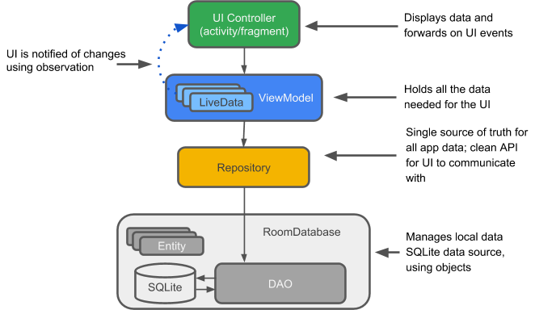

*Entity:* When working with Architecture Components, the entity is an annotated class that describes a database table.

*SQLite database:* On the device, data is stored in an SQLite database. For simplicity, additional storage options, such as a web server, are omitted from this chapter. The [Room persistence library](https://developer.android.com/training/data-storage/room/index.html) creates and maintains this database for you.

*DAO:* Data access object. A mapping of SQL queries to functions. You used to have to define these queries in a helper class, such as [SQLiteOpenHelper](https://developer.android.com/reference/android/database/sqlite/SQLiteOpenHelper.html). When you use a DAO, you call the methods, and the components take care of the rest.

*Room database:* Database layer on top of SQLite database that takes care of mundane tasks that you used to handle with a helper class, such as SQLiteOpenHelper. Provides easier local data storage. The Room database uses the DAO to issue queries to the SQLite database.

*Repository:* A class that you create for managing multiple data sources, for example using the WordRepository class.

*ViewModel:* Provides data to the UI and acts as a communication center between the Repository and the UI. Hides the backend from the UI. ViewModel instances survive device configuration changes.

*LiveData:* A data holder class that follows the [observer pattern](https://en.wikipedia.org/wiki/Observer_pattern), which means that it can be observed. Always holds/caches latest version of data. Notifies its observers when the data has changed. LiveDatais lifecycle aware. UI components observe relevant data. LiveData automatically manages stopping and resuming observation, because it's aware of the relevant lifecycle status changes.

Example app architecture

The following diagram shows the same basic architecture form as the diagram above, but in the context of an app. The following sections delve deeper into each component.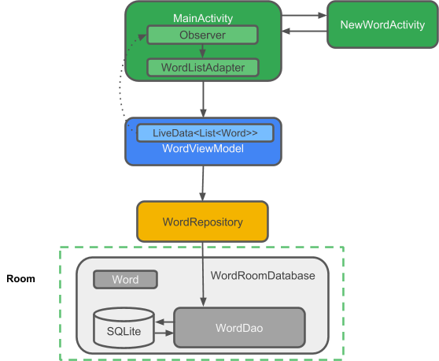

Gradle files

To use the Architecture Components libraries, you must manually add the latest version of the libraries to your Gradle files.

Add the following code to your build.gradle (Module: app) file, at the end of the dependencies block:

// Room components

implementation "android.arch.persistence.room:runtime:$rootProject.roomVersion"

annotationProcessor "android.arch.persistence.room:compiler:$rootProject.roomVersion"

androidTestImplementation "android.arch.persistence.room:testing:$rootProject.roomVersion"

// Lifecycle components

implementation "android.arch.lifecycle:extensions:$rootProject.archLifecycleVersion"

annotationProcessor "android.arch.lifecycle:compiler:$rootProject.archLifecycleVersion"

Get the current version numbers from the [Adding Components to your Project](https://developer.android.com/topic/libraries/architecture/adding-components.html) page. In your build.gradle (Project: RoomWordsSample) file, add the version numbers to the end of the file, as shown in the code below:

ext {

roomVersion = '1.0.0'

archLifecycleVersion = '1.0.0'

}

Entity

The data for an app with a database centers around the data stored in the database. Of course, there can be other data from different sources, but for simplicity, this discussion ignores other data.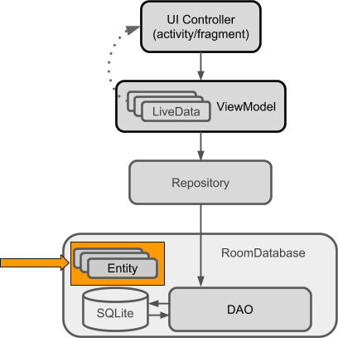

Room models an SQLite database, and is implemented with an SQLite database as its backend. SQLite databases store their data in tables of rows and columns. Each row represents one entity (or record), and each column represents a value in that entity. For example, an entity for a dictionary entry might include a unique ID, the word, a definition, grammatical information, and links to more info.

Another common entity is for a person, with a unique ID, first name, last name, email address, and demographic information. The entities in such a database might look like this:

|  |  |  |  |
| --- | --- | --- | --- |
| **ID** | **First name** | **Last name** | **...** |
| 12345 | Aleks | Becker | ... |
| 12346 | Jhansi | Kumar | ... |

When you write an app using Architecture Components (or an SQLite database), you define your entity or entities in classes. Each instance of the class represents a row, and each column is represented by a member variable.

Here is code representing a Person entity:

public class Person {

private int uid;

private String firstName;

private String lastName;

}

Entity annotations

For Room to work with an entity, you need to give Room information that relates the contents of the entity's Java class (for example Person) to what you want to represent in the database table. You do this using annotations.

Here are some commonly used annotations:

* @Entity(tableName =**"word_table"**) Each @Entity instance represents an entity in a table. Specify the name of the table if you want it to be different from the name of the class.
* @PrimaryKey Every entity needs a primary key. To [auto-generate](https://developer.android.com/reference/android/arch/persistence/room/PrimaryKey.html) a unique key for each entity, add and annotate a primary integer key with autoGenerate=true, as shown in the code below. See [Defining data using Room entities](https://developer.android.com/training/data-storage/room/defining-data.html).
* @NonNull Denotes that a parameter, field, or method return value can never be null. The primary key should always use the @NonNull annotation. Use this annotation for mandatory fields in your rows.
* @ColumnInfo(name =**"word"**) Specify the name of the column in the table, if you want the column name to be different from the name of the member variable.

Every field that's stored in the database must either be public or have a "getter" method so that Room can access it. The code below provides a getWord() "getter" method rather than exposing member variables directly.

Here is annotated code representing a Person entity:

@Entity

public class Person {

@PrimaryKey (autoGenerate=true)

private int uid;

@ColumnInfo(name = "first_name")

private String firstName;

@ColumnInfo(name = "last_name")

private String lastName;

// Getters and setters are not shown for brevity,

// but they're required for Room to work if variables are private.

}

You can also use annotations to define relationships between entities. For details and a complete list of annotations, see the [Room package summary reference](https://developer.android.com/reference/android/arch/persistence/room/package-summary.html).

The DAO (data access object)

To access your app's data using the [Room persistence library](https://developer.android.com/training/data-storage/room/index.html), you work with *data access objects*, or *DAO*s. A set of [Dao](https://developer.android.com/reference/android/arch/persistence/room/Dao.html) objects (DAOs) forms the main component of a Room database. Each DAO includes methods that offer abstract access to your app's database.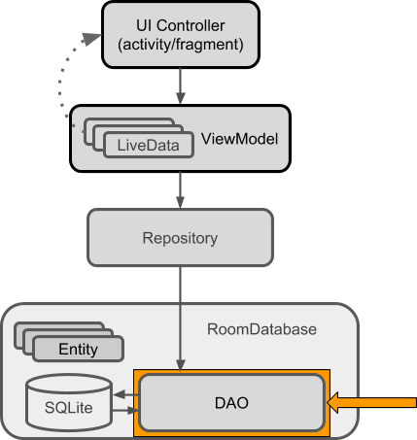

You annotate the DAO to specify SQL queries and associate them with method calls. The compiler checks the SQL for errors, then generates queries from the annotations. For common queries, the libraries provide convenience annotations, such as @Insert, @Delete, and @Update.

Note that:

* The DAO must be an interface or abstract class.
* Room uses the DAO to create a clean API for your code.
* By default, queries (@Query) must be executed on a thread other than the main thread. For operations such as inserting or deleting, Room takes care of thread management for you if you use the appropriate annotations.
* The default action when you ask Room to insert an entity that is already in the database is to ABORT. You can specify a different conflict strategy, such as REPLACE.

Here is code that demonstrates these annotations along with different types of queries:

@Dao

public interface WordDao {

// The conflict strategy defines what happens,

// if there is an existing entry.

// The default action is ABORT.

@Insert(onConflict = OnConflictStrategy.REPLACE)

void insert(Word word);

// Update multiple entries with one call.

@Update

public void updateWords(Word... words);

// Simple query that does not take parameters and returns nothing.

@Query("DELETE FROM word_table")

void deleteAll();

// Simple query without parameters that returns values.

@Query("SELECT * from word_table ORDER BY word ASC")

List<Word> getAllWords();

// Query with parameter that returns a specific word or words.

@Query("SELECT * FROM word_table WHERE word LIKE :word ")

public List<Word> findWord(String word);

}

Learn more about [Room DAOs](https://developer.android.com/training/data-storage/room/accessing-data.html).

LiveData

When your app displays data or uses data in other ways, you usually want to take action when the data changes. This means your app has to observe the data so that when it changes, the app can react. Depending on how the data is stored, this can be tricky. Observing changes to data across multiple components of your app can create explicit, rigid dependency paths between the components. This makes testing and debugging, among other things, difficult.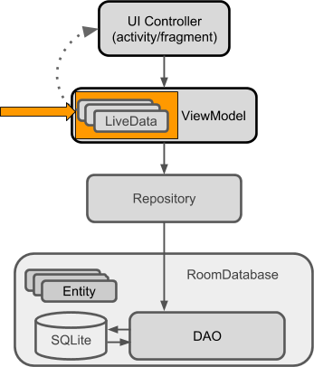

To avoid these problems, use LiveData, which is a [lifecycle library](https://developer.android.com/topic/libraries/architecture/lifecycle.html)class for data observation. If you use a return value of type [LiveData](https://developer.android.com/reference/android/arch/lifecycle/LiveData.html) in your method description, Room generates all necessary code to update the LiveData when the database is updated.

Benefits of using LiveData

*Ensures that your UI matches your data state*

LiveData follows the [observer pattern](https://en.wikipedia.org/wiki/Observer_pattern), so it notifies [Observer](https://developer.android.com/reference/android/arch/lifecycle/Observer.html) objects when the lifecycle state changes. You can consolidate your code to update the UI within these observer objects. Instead of updating the UI every time the app data changes, your observer can update the UI every time there's a state change.

*No memory leaks*

Observers are bound to [Lifecycle](https://developer.android.com/reference/android/arch/lifecycle/Lifecycle.html) objects, and the observers clean up after themselves when their associated lifecycle is destroyed.

*No crashes due to stopped activities*

If the observer's lifecycle is inactive, as in the case of an activity in the back stack, then it doesn't receive any LiveData events.

*No more manual lifecycle handling*

UI components just observe relevant data and don't stop or resume observation. LiveData is aware of relevant lifecycle status changes while observing, so LiveData automatically manages stopping and resuming observation.

*Data is always up-to-date*

If a lifecycle becomes inactive, it receives the latest data upon becoming active again. For example, an activity that was in the background receives the latest data right after it returns to the foreground.

*Configuration changes handled properly*

If an activity or fragment is re-created due to a configuration change, like device rotation, the activity or fragment immediately receives the latest available data.

*Resources can be shared*

You can extend a LiveData object using the [singleton](https://en.wikipedia.org/wiki/Singleton_pattern) pattern. Do this, for example, for services or a database. The LiveData object connects to the system service once, and then any observer that needs the resource can just watch the LiveData object. For more information, see [Extend LiveData](https://developer.android.com/topic/libraries/architecture/livedata.html#extend_livedata).

Using LiveData

Follow these general steps to work with [LiveData](https://developer.android.com/reference/android/arch/lifecycle/LiveData.html) objects:

1. Create an instance of LiveData to hold a certain type of data. This is usually done within your [ViewModel](https://developer.android.com/reference/android/arch/lifecycle/ViewModel.html) class.
2. Create an [Observer](https://developer.android.com/reference/android/arch/lifecycle/Observer.html) object that defines the [onChanged()](https://developer.android.com/reference/android/arch/lifecycle/Observer.html#onChanged(T)) method, which controls what happens when the LiveData object's held data changes. You usually create an Observer object in a UI controller, such as an activity or fragment.
3. Attach the Observer object to the LiveData object using the [observe()](https://developer.android.com/reference/android/arch/lifecycle/LiveData.html#observe(android.arch.lifecycle.LifecycleOwner,%20%20%20android.arch.lifecycle.Observer%3CT%3E)) method. The observe()method takes a [LifecycleOwner](https://developer.android.com/reference/android/arch/lifecycle/LifecycleOwner.html) object. This subscribes the Observer object to the LiveData object so that the observer is notified of changes. You usually attach the Observer object in a UI controller, such as an activity or fragment.

**Note:** You can register an observer without an associated [LifecycleOwner](https://developer.android.com/reference/android/arch/lifecycle/LifecycleOwner.html) object using the [observeForever(Observer)](https://developer.android.com/reference/android/arch/lifecycle/LiveData.html#observeForever(android.arch.lifecycle.Observer%3CT%3E)) method. In this case, the observer is considered to be always active and is therefore always notified about modifications. To remove these observers, call the [removeObserver(Observer)](https://developer.android.com/reference/android/arch/lifecycle/LiveData.html#removeObserver(android.arch.lifecycle.Observer%3CT%3E)) method.

When you update the value stored in the LiveData object, all registered observers are notified and will take specified actions, such as updating the UI, as long as the attached LifecycleOwner is in the active state.

LiveData allows UI-controller observers to subscribe to updates. When the data held by the LiveDataobject changes, the UI automatically updates in response.

These steps are explained in more detail in the rest of this chapter.

Making data observable with LiveData

To make data observable, wrap it with LiveData. That's it.

For the Person example, in the DAO you would wrap the returned data into LiveData, as shown in this code:

@Query("SELECT * from word_table ORDER BY word ASC")

LiveData<List<Word>> getAllWords();

**Important:** When you pass data through the layers of your app architecture from a Room database to your UI, that data has to be LiveData in all layers: All the data that Room returns to the Repository, and the Repository then passes to the ViewModel, must be LiveData. You can then create an observer in the activity that observes the data in the ViewModel.

MutableLiveData

You can use LiveData independently from Room, but to do so you must manage data updates. However, LiveData has no publicly available methods to update the stored data.

Therefore, if you want to update the stored data, you must use [MutableLiveData](https://developer.android.com/reference/android/arch/lifecycle/MutableLiveData.html) instead of LiveData. The MutableLiveData class adds two public methods that allow you to set the value of a LiveDataobject: [setValue(T)](https://developer.android.com/reference/android/arch/lifecycle/MutableLiveData.html#setValue(T)) and [postValue(T)](https://developer.android.com/reference/android/arch/lifecycle/MutableLiveData.html#postValue(T)).

MutableLiveData is usually used in the [ViewModel](https://developer.android.com/reference/android/arch/lifecycle/ViewModel.html), and then the ViewModel only exposes immutable LiveData objects to the observers.

See the Architecture Components' [BasicSample](https://github.com/googlesamples/android-architecture-components/tree/master/BasicSample) code for examples of using MutableLiveData. The example in [Guide to App Architecture](https://developer.android.com/topic/libraries/architecture/guide.html) also shows a use MutableLiveData.

Observing LiveData

To update the data that is shown to the user, create an observer of the data in the onCreate() method of MainActivity and override the observer's onChanged() method. When the LiveData changes, the observer is notified and onChanged() is executed. You then update the cached data, for example in the adapter, and the adapter updates what the user sees.

Usually you observe data in a ViewModel, not directly in the Repository or in Room. [ViewModel is described in a later section](https://google-developer-training.github.io/android-developer-fundamentals-course-concepts-v2/unit-4-saving-user-data/lesson-10-storing-data-with-room/10-1-c-room-livedata-viewmodel/10-1-c-room-livedata-viewmodel.html#viewmodel).

The following code shows how to attach an observer to LiveData:

// Create the observer which updates the UI.

final Observer<String> nameObserver = new Observer<String>() {

@Override

public void onChanged(@Nullable final String newName) {

// Update the UI, in this case, a TextView.

mNameTextView.setText(newName);

}

};

mModel.getCurrentName().observe(this, nameObserver);

See the [LiveData](https://developer.android.com/topic/libraries/architecture/livedata.html) documentation to learn other ways to use LiveData, or watch this [Architecture Components: LiveData and Lifecycle](https://www.youtube.com/watch?v=jCw5ib0r9wg) video.

Room database

Room is a database layer on top of an SQLite database. Room takes care of mundane tasks that you used to handle with an [SQLiteOpenHelper](https://developer.android.com/reference/android/database/sqlite/SQLiteOpenHelper.html).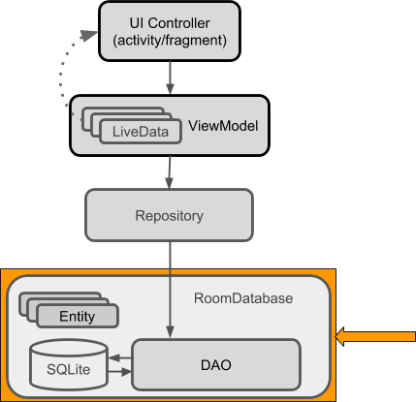

To use Room:

1. Create a public abstract class that extends RoomDatabase.
2. Use annotations to declare the entities for the database and set the version number.
3. Use Room's database builder to create the database if it doesn't exist.
4. Add a migration strategy for the database. When you modify the database schema, you'll need to update the version number and define how to handle migrations. For a sample, destroying and re-creating the database is a fine migration strategy. For a real app, you must implement a migration strategy. See [Understanding migrations with Room](https://medium.com/google-developers/understanding-migrations-with-room-f01e04b07929).

Note that:

* Room provides compile-time checks of SQLite statements.
* By default, to avoid poor UI performance, Room doesn't allow you to issue database queries on the main thread. [LiveData](https://developer.android.com/reference/android/arch/lifecycle/LiveData.html) applies this rule by automatically running the query asynchronously on a background thread, when needed.
* Usually, you only need one instance of the Room database for the whole app. Make your RoomDatabase a [singleton](https://en.wikipedia.org/wiki/Singleton_pattern) to prevent having multiple instances of the database opened at the same time, which would be a bad thing.

Here is a sample of a complete Room class:

@Database(entities = {Word.class}, version = 1)

public abstract class WordRoomDatabase extends RoomDatabase {

public abstract WordDao wordDao();

private static WordRoomDatabase INSTANCE;

static WordRoomDatabase getDatabase(final Context context) {

if (INSTANCE == null) {

synchronized (WordRoomDatabase.class) {

if (INSTANCE == null) {

INSTANCE = Room.databaseBuilder(context.getApplicationContext(),

WordRoomDatabase.class, "word_database")

// Wipes and rebuilds instead of migrating

// if no Migration object.

.fallbackToDestructiveMigration()

.build();

}

}

}

return INSTANCE;

}

}

Repository

A *Repository* is a class that abstracts access to multiple data sources. The Repository is not part of the Architecture Components libraries, but is a suggested best practice for code separation and architecture. A Repository class handles data operations. It provides a clean API to the rest of the app for app data.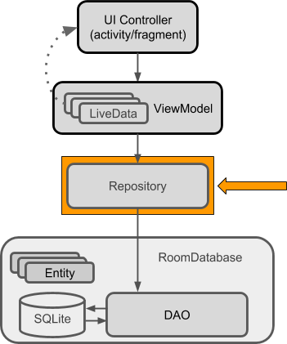

A Repository is where you would put the code to manage query threads and use multiple backends, if appropriate. Once common use for a Repository is to implement the logic for deciding whether to fetch data from a network or use results cached in the database.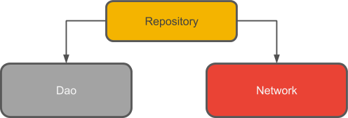

Here is the complete code for a basic Repository:

public class WordRepository {

private WordDao mWordDao;

private LiveData<List<Word>> mAllWords;

WordRepository(Application application) {

WordRoomDatabase db = WordRoomDatabase.getDatabase(application);

mWordDao = db.wordDao();

mAllWords = mWordDao.getAllWords();

}

LiveData<List<Word>> getAllWords() {

return mAllWords;

}

public void insert (Word word) {

new insertAsyncTask(mWordDao).execute(word);

}

private static class insertAsyncTask extends AsyncTask<Word, Void, Void> {

private WordDao mAsyncTaskDao;

insertAsyncTask(WordDao dao) {

mAsyncTaskDao = dao;

}

@Override

protected Void doInBackground(final Word... params) {

mAsyncTaskDao.insert(params[0]);

return null;

}

}

}

**Note:** In this example, the Repository doesn't do much. See the [BasicSample](https://github.com/googlesamples/android-architecture-components/tree/master/BasicSample) for an applied implementation.

The [Guide to App Architecture](https://developer.android.com/topic/libraries/architecture/guide.html) includes a more complex example that uses a web service to fetch data.

ViewModel

The ViewModel is a class whose role is to provide data to the UI and survive configuration changes. A ViewModel acts as a communication center between the Repository and the UI. You can also use a ViewModel to share data between fragments. The ViewModel is part of the [lifecycle library](https://developer.android.com/topic/libraries/architecture/lifecycle.html). For an introductory guide to this topic, see the [ViewModel](https://developer.android.com/topic/libraries/architecture/viewmodel.html) overview.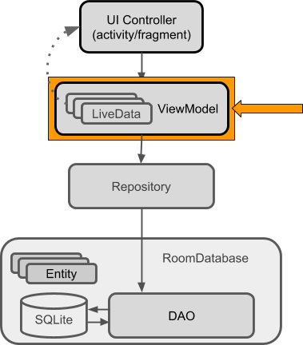

A ViewModel holds your app's UI data in a lifecycle-conscious way that survives configuration changes. Separating your app's UI data from your Activity and Fragment classes lets you better follow the single responsibility principle: Your activities and fragments are responsible for drawing data to the screen, while your ViewModel is responsible for holding and processing all the data needed for the UI.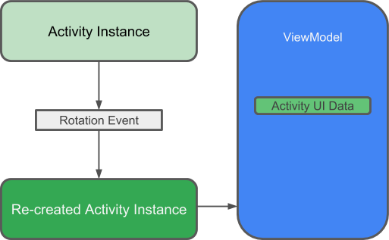

**Warning:**Never pass context into ViewModel instances. Do not store Activity, Fragment, or View instances or their Context in the ViewModel. An Activity can be destroyed and created many times during the lifecycle of a ViewModel, such as when the device is rotated. If you store a reference to the Activity in the ViewModel, you end up with references that point to the destroyed Activity. This is a memory leak. If you need the application context, use AndroidViewModel instead of ViewModel.

In the ViewModel, use LiveData for changeable data that the UI will use or display, so that you can add an observer and respond to changes.

Here is the complete code for a sample ViewModel:

public class WordViewModel extends AndroidViewModel {

private WordRepository mRepository;

private LiveData<List<Word>> mAllWords;

public WordViewModel (Application application) {

super(application);

mRepository = new WordRepository(application);

mAllWords = mRepository.getAllWords();

}

LiveData<List<Word>> getAllWords() { return mAllWords; }

public void insert(Word word) { mRepository.insert(word); }

}

**Important:**ViewModel is not a replacement for onSaveInstanceState(), because the ViewModeldoes not survive a process shutdown. See [Saving UI States](https://developer.android.com/topic/libraries/architecture/saving-states.html).

To learn more, watch this [Architecture Components: ViewModel](https://www.youtube.com/watch?v=c9-057jC1ZA) video.

Displaying LiveData

Finally, you can display all this interesting data to the user.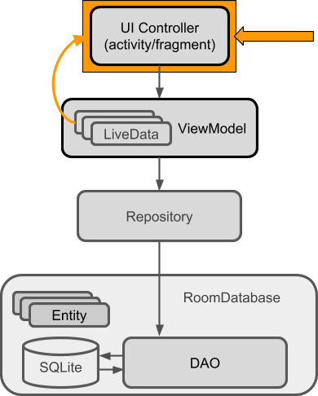

Whenever the data changes, the onChanged() method of your observer is called.

In the most basic case, this can update the contents of a TextView, as shown in this code:

final Observer<String> nameObserver = new Observer<String>() {

@Override

public void onChanged(@Nullable final String newName) {

// Update the UI, in this case, a TextView.

mNameTextView.setText(newName);

}

};

Another common case is to display data in a View that works with an adapter. For example, if you are showing data in a RecyclerView, the onChanged() method updates the data cached in the adapter:

mWordViewModel.getAllWords().observe(this, new Observer<List<Word>>() {

@Override

public void onChanged(@Nullable final List<Word> words) {

// Update the cached copy of the words in the adapter.

adapter.setWords(words);

}

});

**Tip:** One way to get a reference to the application context in a data repository is to extend the Application class and add a member of type Context to that custom subclass.

Lifecycle-aware components

Most of the app components that are defined in the Android framework have lifecycles attached to them. Lifecycles are managed by the operating system or the framework code running in your process. They are core to how Android works and your app must respect them. Not doing so may trigger memory leaks or even app crashes. Activities and fragments are examples of lifecycle-aware components, and LiveDatais lifecycle aware.

A common pattern is to implement the actions of the dependent components in the lifecycle methods of activities and fragments. For example, you might have a listener class that connects to a service when the activity starts, and disconnects when the activity is stopped. In the activity, you then override the onStart() and onStop() methods to start and stop the listener.

@Override

public void onStart() {

super.onStart();

myListener.start();

}

This code snippet looks innocent enough. However, once you have multiple components, using this pattern leads to poor code organization and a proliferation of errors, such as possible race conditions.

Lifecycle-aware components perform actions in response to a change in the lifecycle status of another component. For example, a listener could start and stop itself in response to an activity starting and stopping. This results in code that is better-organized, usually shorter, and always easier to maintain.

The [android.arch.lifecycle](https://developer.android.com/reference/android/arch/lifecycle/package-summary.html) package provides classes and interfaces that let you build lifecycle-aware components that automatically adjust their behavior based on the lifecycle state of an activity or fragment. That is, you can make any class lifecycle aware.

* To import [android.arch.lifecycle](https://developer.android.com/reference/android/arch/lifecycle/package-summary.html) into your Android project, see [Adding Components to your Project](https://developer.android.com/topic/libraries/architecture/adding-components.html).
* See [Handling Lifecycles with Lifecycle-Aware Components](https://developer.android.com/topic/libraries/architecture/lifecycle.html) for more details on using these components.

Use cases for lifecycle-aware components

Lifecycle-aware components can make it much easier for you to manage lifecycles in a variety of cases. For example, you can use lifecycle-aware components to:

* *Switch between coarse and fine-grained location updates.*

Use lifecycle-aware components to enable fine-grained location updates while your location app is visible, then switch to coarse-grained updates when the app is in the background. Add [LiveData](https://developer.android.com/reference/android/arch/lifecycle/LiveData.html) to automatically update the UI when your user changes locations.

* *Stop and start video buffering.*

Use lifecycle-aware components to start video buffering as soon as possible, but defer playback until the app is fully started. You can also use lifecycle-aware components to end buffering when your app is destroyed.

* *Start and stop network connectivity.*

Use lifecycle-aware components to enable live updating (streaming) of network data while an app is in the foreground, then automatically pause when the app moves into the background.

* *Pause and resume animated drawables.*

Use lifecycle-aware components to pause animated drawables while the app is in the background, then resume drawables after the app returns to the foreground.

Lifecycle basic example

To use basic lifecycle observation, add an observer to the lifecycle that you want to observe, and specify what you want to happen for the lifecycle events you are interested in.

Below is the code for a very simple LifecycleObserver implementation. In a real project, you would want to do more useful things, such as connecting to a service or polling a sensor.

**Note:** You can display a toast on start and stop, because the method for starting is executed after the activity is started, while the method associated with stopping executes before the activity is stopped or destroyed.

public class MainActivity extends AppCompatActivity {

private Aquarium myAquarium;

protected void onCreate(Bundle savedInstanceState) {

super.onCreate(savedInstanceState);

setContentView(R.layout.activity_main);

// Create an aquarium. Pass in the context and lifecycle you

// want to observe. In this case, the context is the application,

// and the lifecycle of this activity.

myAquarium = new Aquarium(this.getApplication(), getLifecycle());

}

}

// Add lifecycle awareness to this POJO that could be doing much more

// complex things. For example, if you have fish, they could stop moving

// when the app is not in the foreground, to save resources.

public class Aquarium {

// Constructor that receives the Application and a lifecycle.

public Aquarium(final Application app, Lifecycle lifecycle) {

// Create and add a new observer to the lifecycle.

lifecycle.addObserver(new LifecycleObserver() {

// Use annotation to indicate where in the lifecycle the

// following method should run. In the method, do whatever

// you want to happen on start.

@OnLifecycleEvent(Lifecycle.Event.ON_START)

public void start() {

Log.d("LifecycleListener", "LIGHTS ON");

Toast.makeText(app, "LIGHTS ON",

Toast.LENGTH_SHORT).show();

}

@OnLifecycleEvent(Lifecycle.Event.ON_STOP)

public void stop() {

Log.d("LifecycleListener", "LIGHTS OFF");

Toast.makeText(app, "LIGHTS OFF",

Toast.LENGTH_SHORT).show();

}

});

}

}

Paging library

The [paging library](https://developer.android.com/topic/libraries/architecture/paging.html) makes it easier for your app to gradually load information as needed from a data source, without overloading the device or waiting too long for a big database query.

Many apps work with large sets of data, but only need to load and display a small portion of that data at a time. An app might have thousands of items that it can display, but it might only need access to a few dozen of these items at once. If the app isn't designed with care, it can request data that it doesn't need, which places a performance burden on the device, and on the network. If the data is stored or synchronized with a remote database, this can also slow the app and waste the user's data plan.

The paging library addresses issues with existing solutions. This library contains several classes to streamline the process of requesting data as you need it. These classes also work seamlessly with existing Architecture Components like [Room](https://developer.android.com/topic/libraries/architecture/room.html).

Learn more about the [paging library](https://developer.android.com/topic/libraries/architecture/paging.html) in the official documentation.

Summary

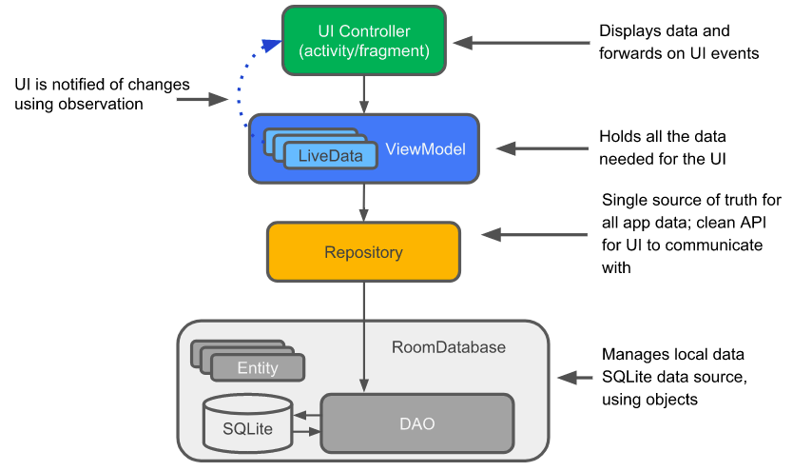

Suppose you have an app that displays data, for example in a list in a RecyclerView, and you can add data to that list, or change data in the list. If the app implements the architecture shown in the diagram above, then the following are true:

* Some of that data is based on an instance of an Entity class, which represents an entity in a repository.
* The Adapter caches the list of data, and the list is automatically updated and redisplayed when the data changes.
* The automatic update happens because in the MainActivity, there is an Observer that observes the data and is notified when it changes. When there is a change, the observer's onChange() method is executed and updates the cached data in the Adapter.
* The data can be observed because it is LiveData. And what is observed is the LiveData<List<Entity>> that is returned by a method in the ViewModel object.
* The ViewModel hides everything about the backend from the user interface. It provides methods for accessing the UI data, and it returns LiveData so that MainActivity can set up the observer relationship. Views, activities, and fragments only interact with the data through the ViewModel. As such, it doesn't matter where the data comes from.
* In this case, the data comes from a Repository. The ViewModel does not need to know what that Repository interacts with. It just needs to know how to interact with the Repository, which is through the methods exposed by the Repository.
* The Repository manages one or more data sources. For this architecture, that backend is a Room database. Room is a wrapper around and implements an SQLite database. Room does a lot of work for you that you used to have to do yourself. For example, Room does everything that you used to use an SQLiteOpenHelper class to do.
* The DAO maps method calls to database queries, so that when the Repository calls a method such as getAllEntities(), Room can execute **SELECT * from table ORDER BY entity ASC.**
* The result returned from the query is observed LiveData. Therefore, every time the data in Room changes, the Observer interface's onChanged() method is executed and the UI is updated.

# Appendix: Utilities

**Contents:**

* [How to copy and rename a project](https://google-developer-training.github.io/android-developer-fundamentals-course-concepts-v2/appendix/appendix-utilities/appendix-utilities.html#copy_project)
* [How to delete a project](https://google-developer-training.github.io/android-developer-fundamentals-course-concepts-v2/appendix/appendix-utilities/appendix-utilities.html#delete_project)
* [How to extract resources](https://google-developer-training.github.io/android-developer-fundamentals-course-concepts-v2/appendix/appendix-utilities/appendix-utilities.html#extractresources)
* [How to add Android support libraries](https://google-developer-training.github.io/android-developer-fundamentals-course-concepts-v2/appendix/appendix-utilities/appendix-utilities.html#add_support_libraries)
* [How to create images in Asset Studio](https://google-developer-training.github.io/android-developer-fundamentals-course-concepts-v2/appendix/appendix-utilities/appendix-utilities.html#asset_studio)
* [How to compare custom objects](https://google-developer-training.github.io/android-developer-fundamentals-course-concepts-v2/appendix/appendix-utilities/appendix-utilities.html#compare_objects)
* [How to save the state of custom objects](https://google-developer-training.github.io/android-developer-fundamentals-course-concepts-v2/appendix/appendix-utilities/appendix-utilities.html#save_objects)

This appendix is a collection of tasks you might need to do as you develop the apps in the [Android Developer Fundamentals practical codelabs](https://developer.android.com/courses/fundamentals-training/toc-v2). The tasks are not specific to one practical.

## How to copy and rename a project

For some of the practical codelabs, you need to make a copy of a project before you make new changes to the project. You might also want to copy a project to use some of its code in a new project. In either case, you can copy the existing project, then rename and refactor the new project's components to use the new project's name.

In the instructions below, substitute your actual project names for **ExistingProject** and **NewProject**.

### 1. Copy the project

1. On your computer's file system (not in Android Studio), make a copy of the **ExistingProject** directory.
2. Rename the copied directory to **NewProject**.

### 2. Rename and refactor the project components

The old name of the project, **ExistingProject**, still appears throughout the packages and files in the **NewProject** project.

Here's how to change the file and the package references in your app to the new name:

1. Start Android Studio.
2. Select **Open an existing Android Studio project**. If you already have a project open in Android Studio, select **File > Open**.
3. Navigate to the **NewProject** directory, select it, and click **OK**.
4. Select **Build > Clean Project** to remove the auto-generated files.
5. Click the **1:Project** side-tab and choose **Android** from the drop-down menu to see your files in the Project: Android view.
6. Expand the **app > java** folder.
7. Right-click **com.example.android.existingproject** and select **Refactor > Rename**. A **Warning**dialog is displayed. Select **Rename package.**
8. The **Rename** dialog is displayed. Give a new name to your project.
9. Select **Search in comments and strings** and **Search for text occurrences**. Click **Refactor**.
10. The **Find: Refactoring Preview** pane appears, showing the code to be refactored. Click **Do Refactor**.
11. Expand the **res > values** folder and double-click the **strings.xml**file.
12. Change the app_name string value to "*New Project*".

### 3. Update the build.gradle and AndroidManifest.xml files

Each app you create must have a unique application ID, as defined in the app's build.gradle file. The steps above should have changed the build.gradle file.

To make sure, check the file and sync the project with the Gradle file by following these steps:

1. In Android Studio **Project** pane, expand **Gradle Scripts** and open **build.gradle (Module: app)**.
2. Under defaultConfig, check to make sure that the value of the applicationID key is **"com.example.android.newproject"**. If the value isn't correct, change it manually.
3. Click **Sync Now** in the top-right corner of the Android Studio window.

**Tip:** Another way to sync your Gradle files is to select **Tools > Android > Sync Project with Gradle Files**.

To make sure that the app name and package name are correct in the AndroidManifest.xml file, follow these steps:

1. Expand the **app > manifests** folder and double-click **AndroidManifest.xml**.
2. Check that the package name is correct. It should be "com.example.android.newproject". If not, change it manually.
3. Find the statement below. If necessary, change the label to the string resource for the new app name:
4. android:label="@string/app_name"

## How to delete a project

All the files for an Android project are contained in the project's directory on the computer's file system. To delete a project, delete its directory from your computer's file system.

Android Studio also keeps a list of recent projects that you've opened. You can remove a project from the list of recent projects, but doing so doesn't affect the actual project files. Doing this step is optional.

To remove a project from the list of recent projects in Android Studio, do one of the following:

* In the Android Studio welcome screen, place the cursor on the deleted project. Click the **X** that's displayed on it, or press the delete key.
* In the Android Studio welcome screen, click on the project name and select **Remove From List**.
* Select **File > Open Recent > Manage Projects**, select the project, and press the delete key or click the **X** that's displayed on it.

## How to extract resources

### Strings

For your app to be translatable into multiple languages, you must keep all your string resources in the res/values/strings.xml file.

#### **Creating string resources**

You can manually add string resources to the strings.xml file using the following syntax:

<string name="*string_name*">*String Value*</string>

To extract a string that you've hardcoded:

1. Select the existing, hardcoded string in either XML or Java.
2. Press Alt+Enter (Option+Enter on a Mac), or click the orange light bulb to the right of the string.
3. Select **Extract string resource**.
4. The **Extract Resource** window is displayed. Supply a name for **Resource name:** and click **OK**.

#### **Accessing string resources**

To reference a string resource:

* In XML, use the following syntax: @string/*string_name*
* In Java, use the following syntax: getString(R.string.*string_name*)

### Extracting dimensions

In general, keep [dimensions](https://developer.android.com/guide/topics/resources/more-resources#Dimension) in the dimens.xml file instead of hardcoding them. Keeping dimensions in dimens.xml allows you to specify different dimensions using [resource qualifiers](https://developer.android.com/guide/topics/resources/providing-resources#AlternativeResources).

You extract dimensions the same way you extract strings: press Alt+Enter (Option+Enter on a Mac), or click the orange light bulb to the right of the dimension.

### Extracting styles

If you have several elements in your app that share the same attributes, you can create a style in the style.xml file for those attributes.

To extract existing attributes into a style, do the following:

1. In the layout editor **Design** tab, right-click on the view in the **Component Tree** and select **Refactor > Extract Style...**.
2. The **Extract Android Style** window is displayed. Name the style and select attributes. If you want Android Studio to search the rest of the file for the selected attributes and apply the style to views where the attributes match, select **Launch 'Use Style Where Possible' refactoring after the style is extracted**.
3. Click **OK**.

## How to add Android support libraries

The [Android Support Library](http://developer.android.com/tools/support-library/index.html) provides backward-compatible versions of Android framework APIs, additional UI components, and a set of useful utilities.

For example, the RecyclerView class is located in the Android Support package. To use RecyclerView, you must include the RecyclerView support library dependency in your project's build.gradle file. The process is the same for other Android Support Library components.

To add support libraries for RecyclerView to your Gradle file, follow these steps and refer to the screenshot below: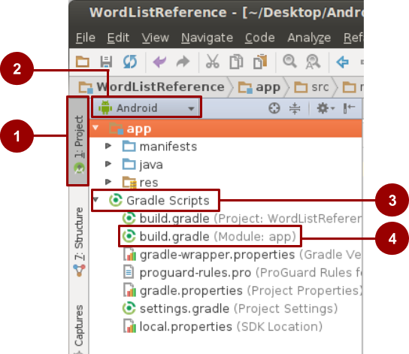

1. In Android Studio, in your project, make sure that you are in the **Project** pane (1 in the screenshot) and in the **Android** view (2).
2. In the hierarchy of files, find the **Gradle Scripts** folder (3).
3. Expand **Gradle Scripts**, if necessary, and open the **build.gradle (Module: app)** file (4).
4. Toward the end of the **build.gradle (Module: app)** file, find the dependencies section. There is probably a line similar to the following one:
5. implementation 'com.android.support:appcompat-v7:27.1.1'
6. Below that line, add the following code:
7. implementation 'com.android.support:recyclerview-v7:27.1.1'
8. Change the version number of the new line to match the latest version or version number of the existing library.
9. Make sure the version numbers of all the libraries are the same and match up with the compileSdkVersion number. If they don't, you will get an error.
10. Sync your Gradle files.
11. Build and run your app.

The following example shows the dependencies section of the build.gradle file with support libraries added for RecyclerView, if the version number were 27.1.1.

dependencies {

implementation fileTree(dir: 'libs', include: ['*.jar'])

testImplementation 'junit:junit:4.12'

implementation 'com.android.support:appcompat-v7:27.1.1'

implementation 'com.android.support:recyclerview-v7:27.1.1'

implementation 'com.android.support.constraint:constraint-layout:1.1.3'

}

## How to create images in Asset Studio

Use [Image Asset Studio](http://developer.android.com/tools/help/image-asset-studio.html) to create image assets for a launcher icon, a notification icon, or action bar icons:

1. Open your app in Android Studio.
2. Right-click the **res** folder of your project and select **New > Image Asset** from menu.

The **Asset Studio** window opens. You can create a text icon, choose from available clip art, or add your own custom image.

### Custom text icons

Default launcher icons called ic_launcher and ic_launcher_round come with your project template. To add a custom text icon:

1. Open the Asset Studio, as described above.
2. So that you won't overwrite the ic_launcher icon, change the **Name** of the icon to ic_launcher_text.
3. In the **Asset Type** row, select **Text**.
4. Enter "Hello World!" into the **Text** field. Experiment with changing the font and the font color.
5. Experiment with changing the background color in the **Background Layer** tab.
6. Click **Next.** The **Confirm Icon Path** window shows how an icon with your specified text will be created for each resolution.
7. Click **Finish**. The **res/mipmap** folder now contains the new icons.

To use the new icon:

1. Open the AndroidManifest.xml file. Change the android:icon line so that instead of referencing ic_launcher_round, it references ic_launcher_text_round:
2. android:icon="@mipmap/ic_launcher_text_round"
3. Run your app.
4. After the app has launched, go to the home screen and open the list of apps.
5. Scroll to find the new app icon listed along with the other installed apps.

### Clip art icons

To add a clip art icon, follow the steps to add a custom text icon, with the following changes:

1. Set the **Name** of the icon to ic_launcher_clipart.
2. Choose **Clip Art** as the **Asset Type**.
3. In the **Clip Art** row, click the button that shows the current icon, the default Android.
4. Select an icon from the **Select Icon** dialog.

### Custom icons

To add a custom icon, follow the steps to add a custom text icon, with the following changes:

1. Set the **Name** of the icon to ic_launcher_image.
2. Choose **Image** as the **Asset Type**.
3. In the **Path** field, choose an image. The image can be one that you've added to your project, or an image on your computer.

## How to compare custom objects

If your data model calls for objects to be sorted, you need to define how the objects can be compared to each other. To specify how to compare two objects and determine whether one object is bigger, smaller, or the same as the other object, use the [Comparable](https://developer.android.com/reference/java/lang/Comparable.html) interface.

The Comparable interface requires you to implement a single method: compareTo(<T> another), where is the parameterized type you implemented Comparable with, and the type of object you are comparing to.

For example, to compare your Foobar instance to other Foobar instances, you implement Comparable<Foobar>. Your compareTo() method takes Foobar as a parameter.

The compareTo() method should do the following:

* Return a negative integer if the object is less than the parameter.
* Return a positive integer if the object is greater than the parameter.
* Return zero if the objects are equal.

For example, to compare a list of books by publication date, you could use the following code:

@Override

public int compareTo(Book book) {

if (this.publication == book.publication) { return 0; }

else { return this.publication > book.publication ? 1 : -1;}

}

## How to save the state of custom objects

In Android, you often create custom objects to represent your data model. To preserve the state of custom objects, you must be able to pass them into the savedInstanceState bundle, and therefore your custom class must implement the [Parcelable](https://developer.android.com/reference/android/os/Parcelable.html)interface. The Parcelable implementation allows for primitive types (int, string, byte, etc.) to be saved in the savedInstanceState callback.

To save the state of custom objects, follow these steps:

1. Set up the data in your custom class.
2. Add the Parcelable implementation to your class declaration. Remember that only the primitive data types will be saved.
3. In Android Studio, the class declaration is underlined in red, because you need to implement the interface methods. With your cursor on the underlined text, press Alt+Enter (Option+Enter on a Mac) and select **Implement methods**.
4. Select describeContents() and writeToParcel(Parcel dest, int flags).
5. Click **OK.** The class name is still underlined, indicating that the interface is not fully implemented yet.
6. Select the class name and press Alt+Enter (Option+Enter on a Mac) and select **Add Parcelable implementation**. Android Studio adds the required code. The variables for which you want to preserve the state (primitive types) are written to the Parcel in the writeToParcel method.

You can now save the state of these objects using the savedInstanceState bundles methods: putParcelable(), putParcelableArray(), putParcelableArrayList(), and the respective "getter" methods.